Targed/Target 1 | Proofread work to ensure accuracy of punctuation and grammar, clarity of expression and choice of vocabulary.
Targed/Target 2 | Further develop critical thinking and synthesise ideas.
Targed/Target 3 | Learn how to use possessive apostrophes accurately.

ECAD6008: Professional and Pedagogic Studies: Leading the Learning: what, how and why am I teaching?

TITLE: Critically reflect on your pedagogical progress demonstrated through required elements of the Professional Learning Passport, identifying a specific area for professional development and justifying next steps for improvement.

PART ONE

Part 1: Professional Learning Passport

REFLECTION ON SUBJECT KNOWLEDGE DEVELOPMENT (TAB 5)

ASSET ONE: Literacy - Phonics

During PTE3, I expressed an interest in learning more about how to teach phonics to the Year 2 pupils. The class teacher modelled some strategies and techniques that she uses to teach the pupils. I also went online and watched a few Ruth Miskin You Tube videos to practise my pronunciation of the phonics to ensure that I would deliver the phonic lessons to the best of my own ability for the pupils to be taught the accurate pronunciations. I also looked at the Ruth Miskin website for 'Read Write Inc. Phonics' to gain a better understanding of the phonics programme. By accessing these materials online, I was able to practise my own pronunciation of the phonics and felt more confident to deliver a phonics lesson to Year 2 pupils. After the class teacher had modelled some strategies and techniques for me and I practised my pronunciation of the phonics, I was then able to plan appropriate phonic lessons for the pupils. Vygotsky (1896-1934) 'emphasised the social and the central role of language in cognitive development' (Grigg, 2015, p.139). Therefore, I believe that it is paramount for phonics to be taught correctly in order to aid pupil progression in the Languages, Literacy and Communication (AoLE) as well as other (AoLE's) as pupils develop their skills.

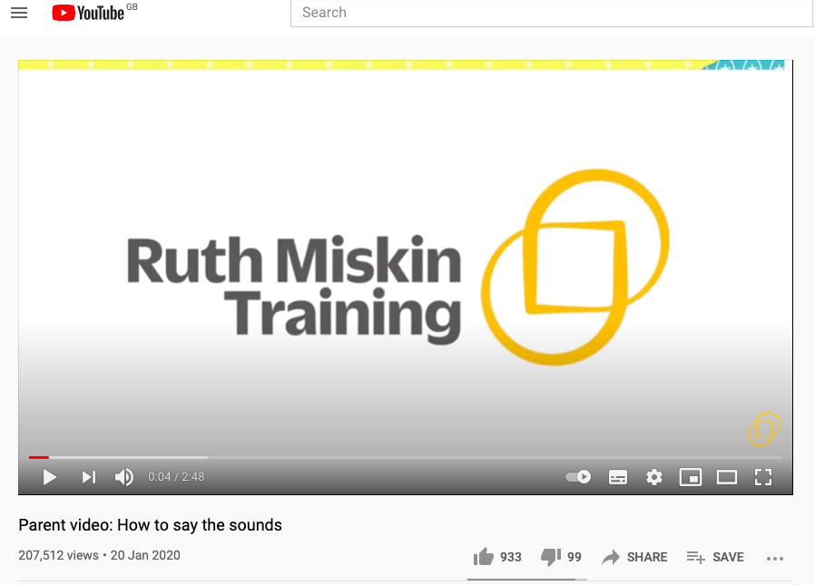

ASSET TWO: Numeracy – Long division

During PTE2, I taught a Year 6 Maths MAT class. The class teacher had taught them long multiplication, I then taught the pupils how to do long division. As maths is not a subject which I am very confident with, I had to re-teach myself the long division method in order to be able to teach the pupils the correct way of using the method. I practised many division questions including: 3 digits by 2-digit division, 4-digit by 2-digit division and decimal by decimal division. The National Centre For Excellence In The Teaching Of Mathematics (2021) state that continuing professional development can be very effective in order to improve pedagogy and classroom practice, especially when it involves collaborating with others and then planning and teaching lessons based on what has been learned. As I had asked the class teacher for advice on which method he would like me to use to teach the pupils long division, he showed me an example before I started planning the lesson and practising numerous questions myself. After quite a few hours of practise, I gained confidence and was then able to introduce and teach the pupils long division. I was very nervous initially when introducing the concept to the pupils however, I was able to teach the pupils the method correctly and after a few lessons, the pupils were then able to understand the concept of long division and were even doing the inverse operation to check their answers.
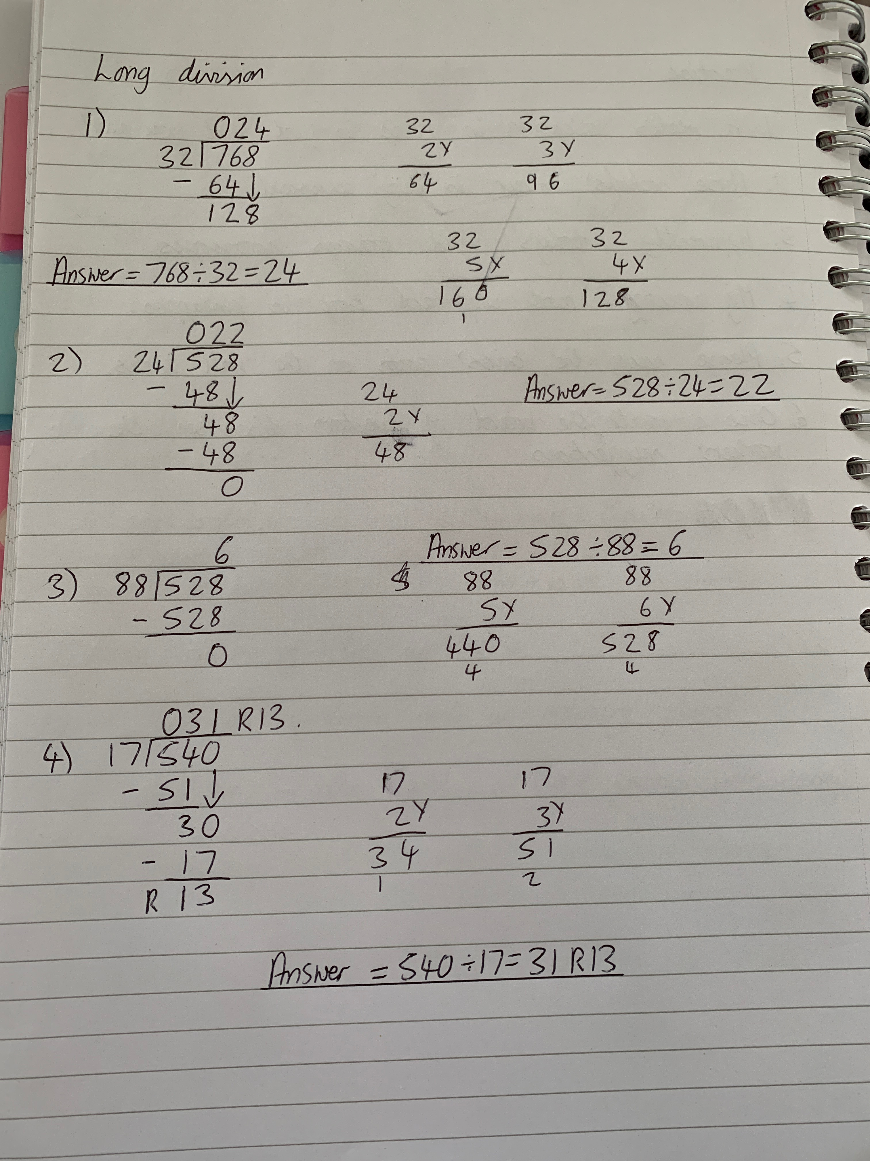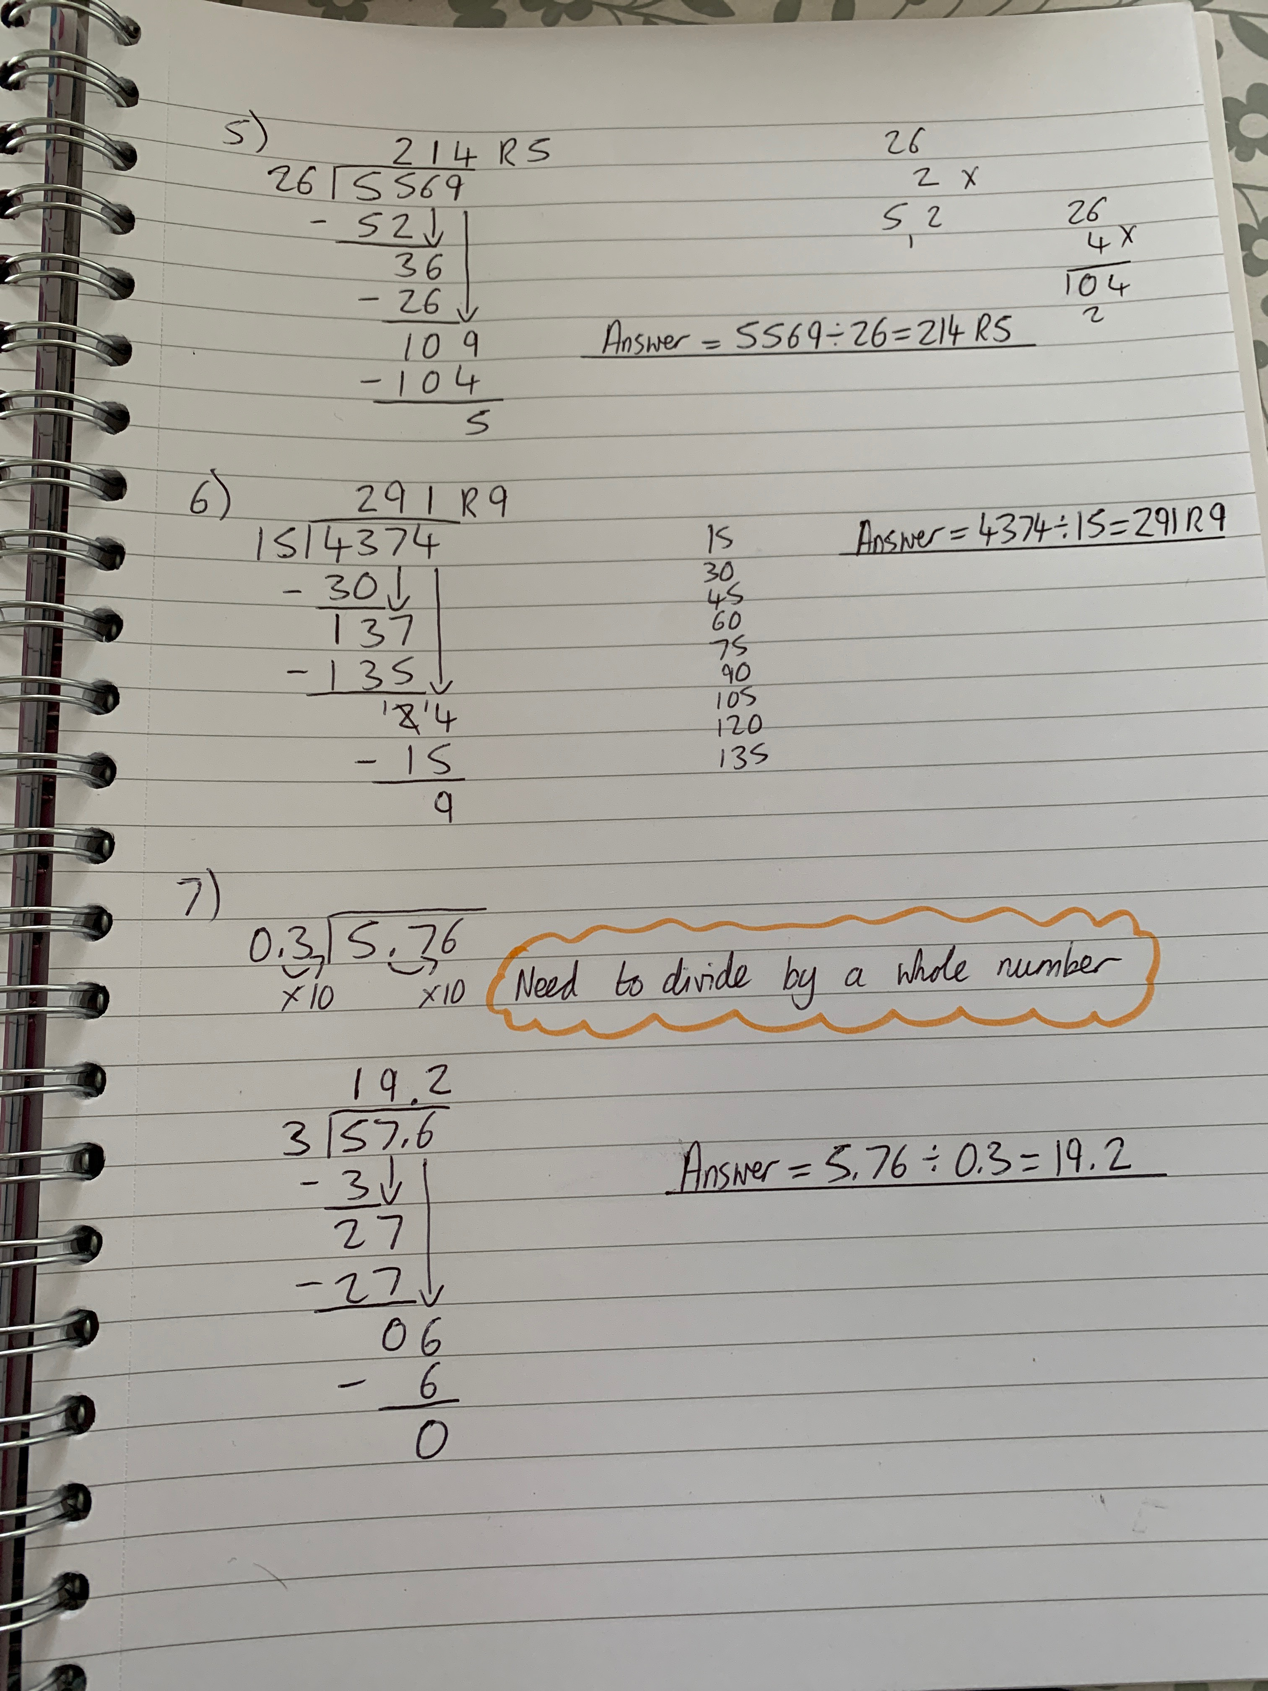

ASSET THREE: Welsh Language Development – Parts of the body lesson

I taught a Welsh lesson about parts of the body to a year 1/2 class. In order to teach the pupils parts of the body in Welsh, I had to learn what the parts of the body were in Welsh before teaching the pupils. I wrote key Welsh words onto a post it note for me to refer to during the lesson to ensure that I did not mix up any of the Welsh words. This ensured that I was teaching the pupils the correct Welsh vocabulary. As this lesson was taught during PTE1, there were elements of the lesson that could have been improved to aid pupil engagement e.g., by having a hook to initially engage the pupils at the start of the lesson. On reflection of the lesson and with feedback from the class teacher, I realised that I needed to differentiate the activities in the lesson more for the lower ability group in Year 1 as the activity was too difficult for them. As the Welsh Government’s ambition is to ‘see the number of people able to enjoy speaking and using Welsh reach a million by 2050’ (Welsh Government, 2017). I believe that in order for this to be achieved, it is essential for all practitioners to learn and use as much Welsh in the classroom and around schools as possible to transfer these skills to pupils. I personally believe that teaching pupils Welsh is a vital part of their education as they are learning the language of the country that they live in.

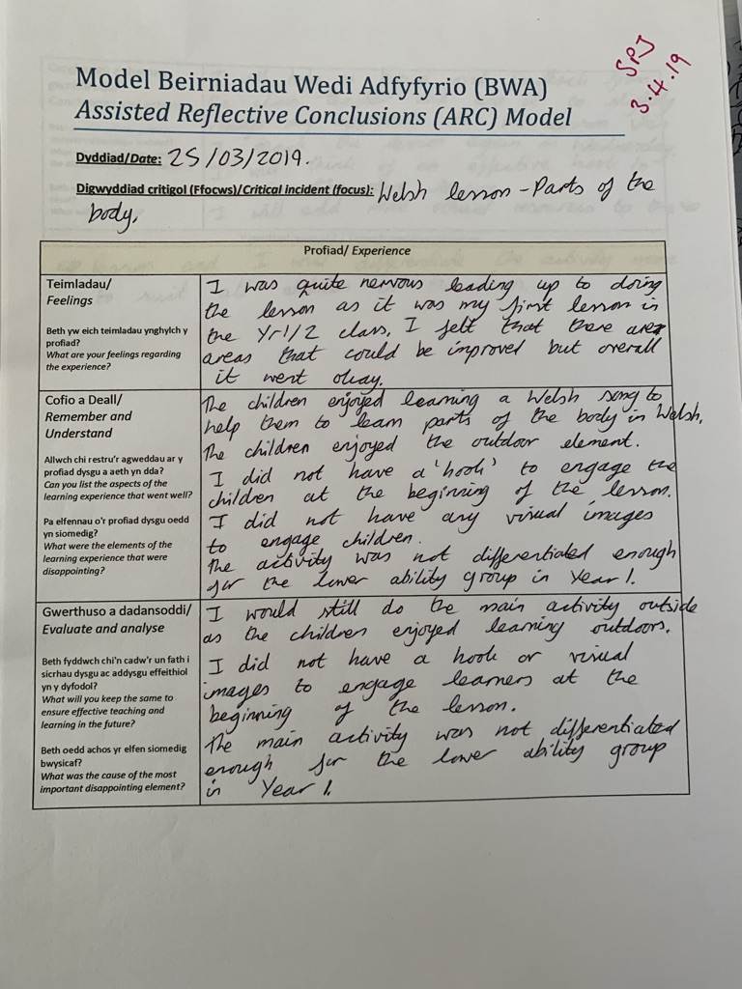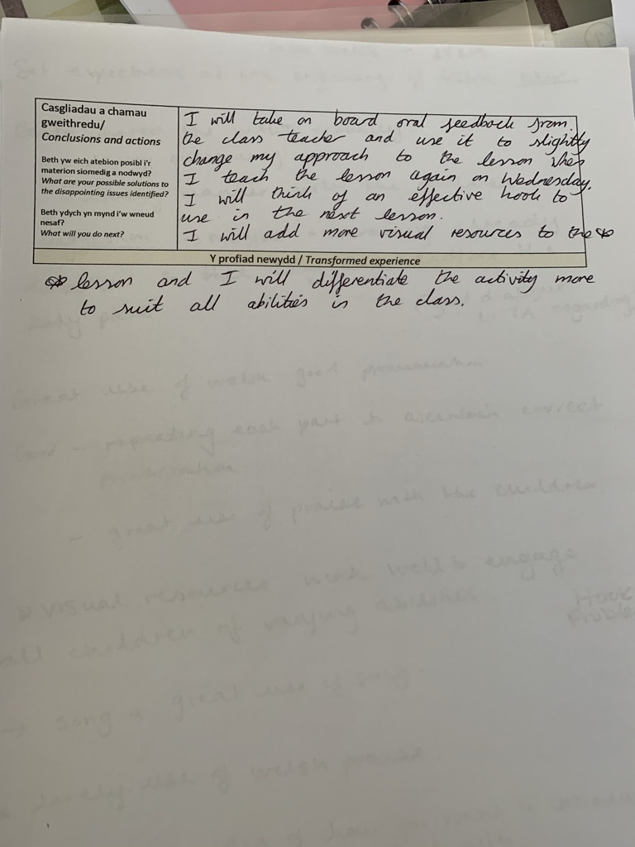
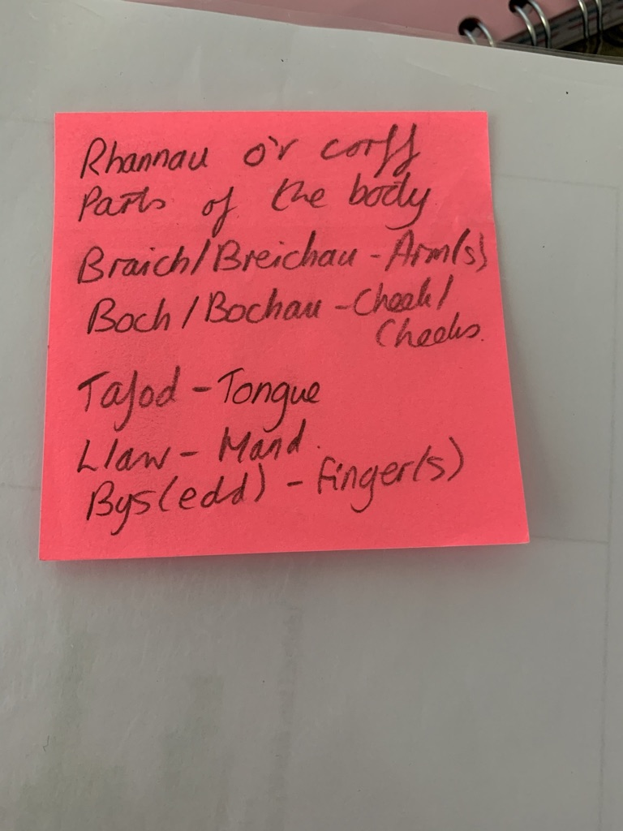

REFLECTION ON PLANNING FOR PROGRESSION (TAB 7)

PROFESSIONAL LEARNING TEMPLATE 1 – Mathematics lesson – addition word problems

What did you do and why?

Progression in learning

I planned an asynchronous Maths lesson for Year 2 pupils which involved the pupils solving addition word problems. The class teacher had introduced addition word problems to the pupils via asynchronous lessons earlier that week, therefore I planned differentiated work for the three ability groups to further extend their skills. The work that I planned for the pupils challenged them further and enabled them to show their thinking by using a number line whilst adding larger numbers. The pupils in each group had to listen/read the addition word problems carefully on the PowerPoint to select the appropriate information to put into their written calculation. I initially scaffolded the first question for each ability group to remind them of how to set their work out and how to use a number line as a checking strategy. After the first question, I prompted the pupils (depending on the ability group) instead of fully scaffolding the questions for them as they have to be able to work the questions out for themselves. Grigg (2015) highlights that Piaget (1896-1980) believed that pupils needed to do things for themselves as he believed that pupils learned best this way, rather than continuously receiving instructions from adults.

What have you learned?

Progression in learning

I have learnt that it is important for pupils to consolidate what they have learnt by being challenged further in order to allow the pupils to utilise their thinking skills when learning a new maths skill. I have also learnt how important it is to clearly explain the expectations to the pupils as this will allow them to produce work of a high standard. I have learnt that it is important for pupils to demonstrate their thinking skills by using checking strategies such as a number line, this enables the teacher to see how the pupil is working their answer out. It also allows the teacher to correct the pupils if they have made an error e.g. not completed the number line correctly which resulted in getting the wrong answer.

What next?

Progression in learning

Moving forward in my teaching career, I would definitely challenge pupils further when they have grasped the concept of a Mathematical skill such as solving word addition problems using a checking strategy such as a number line. I would ensure that the pupils fully understand the concept of using the number line to e.g. add or subtract before introducing word problems when teaching e.g. addition word problems from the start myself.

PROFESSIONAL LEARNING TEMPLATE 2 – Languages, Literacy and Communication lesson – Punctuation

What did you do and why?

Progression in learning
I taught an English (literacy) lesson to a year 4, 5 and 6 mixed class. The lesson was planned to help pupils gain skills and confidence with regard to punctuation. In order to plan the lesson, I had to look at what skills the pupils were able to do and what they were not yet able to do. I planned the lesson for four ability groups and differentiated the tasks to ensure that the work was suitable for the pupils' abilities and needs. The tasks that were set for this lesson involved the pupils further developing their punctuation skills. In the Literacy Framework, at progression step 3, pupils should be able to ‘use a range of punctuation accurately (including apostrophe for possession) to clarify and expand meaning’ (Welsh Government, 2020). Therefore, it is crucial for pupils to be working on improving their punctuation skills to ensure that they are able to use punctuation correctly. As this was a Year 4, 5 and 6 mixed class, all pupils will be working through different progression steps due to their abilities. However, the majority of the pupils in this class were working through progression step 3.
What have you learned?
Progression in learning
I have learnt that it is very important to be aware of the pupils' prior knowledge when planning a lesson as it enables the pupil's learning to move forward and is linked to their previously learnt skills. I have also learnt that it important to set pupils tasks which will further develop their skills as well as activating their prior knowledge. This will ensure that they are progressing in their learning.
What next?
Progression in learning
In similar circumstances I would ensure that all groups within the class would have appropriate tasks to do and depending on the punctuation task and age of the pupils, may introduce different learning resources to aid their development e.g. a WAGOLL (what a good one looks like). I would definitely use 'hint sheets' again for a higher ability group if working independently as it enabled them to complete the task independently.

REFLECTION ON PLANNING FOR THE FOUR PURPOSES (TAB 7)

PROFESSIONAL LEARNING EXPERIENCE TEMPLATE 1, related to ambitious, capable learners. Addition word problems lesson.

What did you do and why?

Four Purposes

As this was an asynchronous lesson via Teams, I had to ensure that I created appropriate resources for all of the pupils depending on their ability. Therefore, I created 3 differentiated PowerPoints which included different addition word problems to suit the abilities of each pupil. Each differentiated PowerPoint for every ability group included challenges specifically for that group of pupils, which encouraged the pupils to develop as ambitious, capable learners. This was an important aspect of the lesson as the pupils had to be supported however, also encouraged to use the skills that they had learned to answer the questions. By providing more challenging questions at the end of the PowerPoint, this enabled the pupils to gain confidence with the mathematical concept of addition using a number line. The aim of the lesson was to encourage the pupils to independently solve the addition word problems which would then enable them to explain the concept that they had learned about if asked in the future. I also included voice overs in each PowerPoint to ensure that all pupils would be able to complete the work regardless of their reading ability in relation to the questions. By including voice overs, it enabled the pupils to work independently if there was not an adult present to help them with their work. Grigg (2015) highlights that the cognitive theory of learning states that teachers are facilitators rather than instructors and that teachers are more ‘the guide on the side’ rather than ‘the stage on the stage’. This supports that pupils do need scaffolding however, they need to learn to use the skills that they have been taught to solve problems themselves.

What have you learned?

Four Purposes

I have learnt that it is important to aid the pupils to become confident in relation to the skills that they have learned and that it is important to challenge their abilities as this will help them to develop as ambitious, capable learners. I have also learned that as well as initially scaffolding the pupils' learning, it is also equally important to allow the pupils to be independent learners and work problems out for themselves. By giving the pupils the opportunity to demonstrate their thinking skills by using a number line as a checking strategy, this encourages the pupils to think creatively when solving problems. As a result of this experience, the pupils should be able to use the skills that they have learned and possibly connect and apply that knowledge in different contexts in the future.

What next?

Four Purposes

As a result of this experience, I would definitely encourage pupils to become independent by using their newly learned skills in order to gain confidence in their own ability. By giving the pupils opportunities to be challenged, think creatively and work independently to solve problems, this enables them to develop as ambitious, capable learners.

PROFESSIONAL LEARNING EXPERIENCE TEMPLATE 2, related to healthy, confident individuals. Children’s Mental Health Week activity (February 2021)

What did you do and why?

Four Purposes

As it was Children's Mental Health Week, I created an asynchronous lesson for the pupils in Year 2 which was based on thinking about emotions. As the theme for Children's Mental Health Week this year was 'Express Yourself', I created a PowerPoint to briefly explain to the pupils what 'Express Yourself' means and added a link to a You Tube video of a book called 'The Day the Crayons Quit'. I chose this story as it is all about different emotions and the crayons elaborate on why they are feeling a certain way. Before the pupils watched the You Tube video of the book being read, I asked the pupils to think about how the crayons were feeling and why they were feeling like that when they were reading/listening to the story. I then asked the pupils to think about the story that they had just listened to/read. I pointed out that each crayon was a different colour and that the colour the crayon was represented an emotion e.g., the red crayon was tired. I then asked the pupils to create their own emotion poster/diary for the week (Monday-Friday), to draw a picture of themselves, colour their clothes in using the colour of how they felt that day (or write the colour word) and then write a sentence about why they felt that way. I created my own emotion poster to show the pupils what a good one looks like (WAGOLL). By watching the You Tube video of the story and completing an emotion diary for the week, the pupils are developing as healthy, confident individuals as they ‘are building their own mental and emotional wellbeing, which will aid them to develop confidence, resilience and empathy’ (Welsh Government, 2020).

What have you learned?

Four Purposes

​​​​I have learned how important it is to address wellbeing with pupils as it is something that needs to be more openly discussed as many pupils may need to express how they feel due to various reasons. I have learned that there are appropriate ways of addressing parts of the curriculum such as wellbeing with pupils in the Foundation Phase. Although I have witnessed many wellbeing activities in the Foundation Phase such as daily check ins, I had never planned or taught a lesson which was related to wellbeing. By teaching the pupils about different emotions and showing them that there are many emotions that are perfectly normal to experience, I felt that it aided the pupils to develop as healthy, confident individuals. This is due to the fact that the pupils were becoming aware of how others feel and thinking about why they may feel that way but also as the pupils were addressing their own mental and emotional wellbeing, which encouraged the pupils to become confident, resilient and empathetic.

What next?

Four Purposes

As a result of this experience, I will definitely explore the four purposes more in depth. I believe that it is vital for pupils to develop knowledge and skills that will enable them to develop as healthy, confident individuals therefore, I would like to explore this purpose more in depth and research more about health and wellbeing and how it is being implemented in schools across Wales. I would definitely deliver this lesson again in the future and would amend the lesson and resources appropriately depending on the age of the pupils. I will definitely familiarise myself more with the four purposes in the curriculum for Wales 2022 document as this is crucial for my professional development moving forward as a soon to be NQT. By gaining a good understanding of the four purposes, it will enable me to plan and teach appropriate lessons which embed the four purposes for pupils in my class.

PLP LINK: https://v3.pebblepad.co.uk/spa/#/public/kwhG4Zmy5GZydtjkfwRkMtMr6r
PART TWO

Part 2: Written assignment

Throughout this assignment, I have chosen to focus on one of the four purposes of the curriculum. The primary focus of this assignment will be to critically analyse and discuss how to enable pupils to develop and progress through their education as ‘healthy, confident individuals, who are building their mental and emotional well-being by developing confidence, resilience and empathy.’ (Donaldson, 2015, p.30). The professional learning experience template 2 which can be found on pages 7-9 in part 1, illustrates how the Four Purposes standard correlates with the focus of this assignment.

I have identified this area of practice as I need to develop further understanding of how I can promote pupils to develop as ‘healthy, confident individuals.’ To facilitate this understanding, when pertinent to planning I will include the appropriate purpose to support pupil progression. I believe that children’s health and well-being is paramount, especially during and after the effects that Covid-19 have had on children and young people. In a recent survey with parents and carers undertaken by YoungMinds (2021), it was identified that ‘67% of respondents agreed they are concerned about the long-term impact of coronavirus on their child’s mental health.’ Therefore, it is imperative that I gain more of an understanding as to how children’s health and well-being can affect their progress in education. I will be critically analysing various perspectives on how pupils can develop as ‘healthy, confident individuals’ in relation to pupils’ health and well-being.

There are various views and opinions on pupils’ health and well-being and how it is promoted in school settings. In order for pupils to develop as ‘healthy, confident individuals’, it is essential that all staff in schools and settings provide pupils with the appropriate knowledge, skills and support. Within the Professional Standards, in relation to ‘the standard for effective Pedagogy, teaching and learning is paramount’ (Welsh Government, 2018, p.2). Under the Pedagogy standard, there are numerous descriptors, one of those descriptors is ‘Advancing learning through effective application of subject knowledge and discipline’ and under this descriptor is ‘four purposes for learners’ standard (Welsh Government, 2018). This is the standard that I planned to demonstrate when planning the Children’s Mental Health Week lesson to develop the pupils as ‘healthy, confident individuals which is reflected in part 1 of this assignment.

In Part 1, I have reflected on an asynchronous lesson that I planned and uploaded for Children’s Mental Health Week for a Year 2 class that I was teaching. With the lesson being asynchronous, I tried to ensure that it was a simple but effective lesson for the pupils. It was difficult to gauge whether the pupils fully understood the concept of emotions and feelings as they were watching the lesson from home. I included voice overs in the PowerPoint to aid the pupils’ understanding of the lesson and activity. By inserting voice overs into the PowerPoint, I was able to elaborate on specific points made on each slide and give more in-depth explanations to aid the pupils’ understanding. This was also effective as it brought familiarity with being taught in a classroom environment. I also created a WAGOLL for the activity that I asked the pupils to complete to ensure that they had a good understanding of the activity that they had to undertake. This was the first well-being lesson that I had planned and delivered, which was online therefore, I am interested to understand how health and wellbeing lessons would be taught in a classroom environment.

As the lesson that I planned and taught for Children’s Mental Health Week was an asynchronous lesson online, as such I did not gain experience of teaching a well-being lesson in a classroom environment. There were inherent limitations with asynchronous teaching due to the fact that teaching online is very different to teaching in the classroom for a multitude of reasons. The main limitation being interactions between the teacher and pupils is completely absent during asynchronous lessons as they are pre-recorded lessons. The only interaction between the teacher and pupils occurs when pupils upload a piece of work and the teacher returns the work with written feedback attached. In a classroom environment, there is continuous interaction between the teacher and pupils, this enables the pupils to have the appropriate support from the teacher when needed.

Asynchronous lessons do not allow for any instant feedback to take place. Durrington Research School (2020) supports this as they state that the online classroom can restrict opportunities for teachers to give feedback to pupils. Although the lesson that I planned did not require instant feedback, the pupils may have wanted to engage in verbal dialogue about an aspect of the lesson that they did not understand. If this lesson would have been taught in a classroom environment, it would have enabled me to have supported the pupils with how they were feeling, if they needed support. Online teaching does not give pupils a personalised approach towards their learning, although lessons are differentiated to suit the needs and abilities of the pupils, human interaction is very much lacking especially for Foundation Phase pupils.

Estyn (2019) identified in their ‘Healthy and happy’ report that ‘around two-thirds of primary schools and a third of secondary schools in Wales have an inclusive whole-school approach to supporting pupils’ health and wellbeing.’ From this report it is evident that primary schools seem to be more efficient in relation to supporting pupils’ wellbeing as a whole school approach compared to secondary schools. It is also highlighted in the report that the schools that have embedded a whole school approach to supporting pupils’ health and wellbeing are aiding pupils to develop as healthy, confident individuals in various ways including ‘continuing professional learning for all staff that enables them to support pupils’ health and wellbeing’ (Estyn, 2019). This is crucial as school staff should have the knowledge and skills which enable them to appropriately support pupils’ health and wellbeing.

Similarly, the recommendations of the review within the Successful Futures (2015) document would have ‘major implications for the professional development of teachers and other practitioners.’ Health and wellbeing were highlighted as a part of the curriculum that would need to be addressed as ‘the need to extend teachers’ capacity’ (Donaldson, 2015, p.112) in this part and other parts of the curriculum was stated. Another main finding by Estyn (2019) was that in other schools ‘few teachers enter the profession with substantial background training in child or adolescent development, or how best to support children’s health and wellbeing.’ This is quite an alarming finding as this means that in approximately one third of primary schools and two thirds of secondary schools do not have staff with the appropriate knowledge or understanding to support pupils’ health and wellbeing. This statistic is the reason that I am undertaking further reading and research into how to support and develop pupils’ health and wellbeing as part of the four purposes of the curriculum.

One of the recommendations that was made by Estyn (2019) is that ‘schools should develop a coherent whole-school approach that supports all pupils’ health and wellbeing.’ By schools implementing a whole school approach in relation to supporting pupils’ health and wellbeing, it ensures all staff are aware of how to support pupils and that pupils are fully aware of the support available to them. Likewise, Weare (2015) recognises the importance of using effective approaches in school settings to support pupils’ health and wellbeing. Weare (2015) is aware from research that has been undertaken over many decades that multi-component approaches are more effective in promoting social and emotional well-being than those which only focus on one or two parts of school life, provided that they are coherent in schools. On the other hand, Weare (2015) is also aware that schools face many challenges in relation to pupils’ health and wellbeing. She believes that schools need to be clearly aware of the problems that children and young people face in relation to mental health problems and to what extent and nature these problems are as these problems are not likely to go away.

Estyn (2016) stated how Ysgol Bryn Deva in Flintshire ‘increased the life-chances of pupils through improving their wellbeing and standards of attainments’ and how the two new programmes they introduced to the school are having a positive impact. ‘Clwb Seren Bach’ which is a nurture provision, was set up to aid the improvement of academic and social performance of pupils who were identified in the Foundation Phase as they were finding it difficult to cope in a whole class setting. Three members of staff who were appropriately trained run the project, which is funded through the school’s Pupil Deprivation Grant (PDG). The intervention is short term, inclusive and has a clear focus however, the provision should have a long-term effect on pupils’ confidence. The pupils remain active members of their own class however, they attend the nurture group for two to four terms. Pupils are re-assessed by staff each term. There is a specific intervention room for the provision which is visually stimulating and appropriately resourced. The provision has been set up to assess individual needs of the pupils and to ensure that each nurture session is organised to reflect their individual needs. An important part of each session is mealtime which gives the pupils the high-quality opportunity for social learning and to develop trusting relationships with peers within the group. Parents of pupils who attend the nurture group are invited into the school for a coffee morning once every six weeks. Estyn (2016) state that ‘the school’s tracking data shows that the initiative is highly effective, and pupils’ skills improve very rapidly.’ Pupils in KS2 who have previously attended the group have ‘nurture passes’ which allows them to re-attend the group if they feed that they need to.

The Welsh Assembly Government (2010) agree with Estyn by stating that research which has been previously been conducted illustrates that the outcomes are significantly improved for all pupils who attend schools that provide nurture groups. However, there are potential limitations as the Welsh Assembly Government (2010) point out that there are many steps that need to be followed in order to set up a nurture group. These steps include ‘planning the group, selecting the staff and ensuring preparation is undertaken.’ In order to undertake these steps, staff may have to be covered for training purposes, planning purposes and to ensure that the appropriate resources are available and ready for the group to start. According to the Welsh Assembly Government (2010), ‘at the time of writing the document course costs ranged from £450-£700 for the four-day training certificate in nurture groups theory and practice in places such as London.’ Ysgol Bryn Deva as aforementioned by Estyn (2016) were fortunate enough to cover the costs of setting up the nurture group by using the PDG, other schools may not have enough funding which allows them to allocate the PDG to set up provisions such as nurture groups.

To conclude, I firmly believe that the further reading and research I have conducted in relation to health and wellbeing in schools will give me confidence to incorporate the four purposes in future planning aiding pupil progression. I have learned that although there are effective provisions being implemented in primary schools, which are raising attainment levels, it is not always possible to be fully aware of the challenges that pupils face in relation to health and wellbeing. There also seems to be a common theme throughout the assignment, that school staff need to be more knowledgeable and preferably trained in relation to dealing with children and young peoples’ health and wellbeing challenges and issues.

During future teaching practices, I will ask the Well-Being Co-Ordinator of the school if I am able to observe any health and wellbeing lessons that are delivered in classroom environment. In recent years, classroom observation has become an essential tool in relation to measuring, assuring and improving teachers’ professional knowledge and skills (O’Leary (2014 p.10). Therefore, by observing a health and wellbeing lesson, this will enable me to gain ideas as to how I can teach pupils to develop and progress as ‘healthy, confident individuals.’ It will also enable me to gain an insight as to what strategies and activities are effective in relation to pupil progress.

Moving forward as a practitioner, I could encourage pupils to develop and progress as ‘healthy, confident individuals’ by setting up an afterschool club or a club during school time, which could promote pupils’ health and wellbeing. The pupils could decide which club they would like to start e.g., a cooking club, a club which promotes physical health such as yoga etc. The pupils could vote on which club they would like to start in school and would be very much involved in planning activities within the club. This ensures that pupil voice is promoted as this a crucial part of many schools’ ethos. Mentally Health Schools (2020), believe that it is crucial for pupils to have ‘meaningful opportunities to share their experiences, views and hopes about their school.’

Word count for part 2: 2175 words.
Reference List

Donaldson, G. (2015) Successful Futures: Independent Review of Curriculum and Assessment Arrangements in Wales. Cardiff: Crown.

Durrington Research School. (2020) Getting Feedback Right in the Online Classroom. Available at: https://researchschool.org.uk/durrington/news/getting-feedback-right-in-the-online-classroom (Accessed on 20th April 2021).

Estyn. (2016) Effective practice - Improving wellbeing and standards of attainment. Cardiff: Crown.

Estyn. (2019) Healthy and happy – School impact on pupils’ health and wellbeing. Cardiff: Crown.

Grigg, R. (2015) Becoming An Outstanding Primary School Teacher. London: Routledge.

Mentally Healthy Schools. (2020) Pupil Voice. Available at: https://www.mentallyhealthyschools.org.uk/whole-school-approach/pupil-voice/ (Accessed: 3rd May 2021).

National Centre For Excellence In The Teaching Of Mathematics. (2021) Available at: https://www.ncetm.org.uk/professional-development/ (Accessed on 6th April).

O’Leary, Matt. (2014) Classroom Observation – A Guide To The Effective Observation Of Teaching And Learning. London: Routledge.

Weare, K. (2015) What works in promoting social and emotional well-being and responding to mental health problems in schools? – Advice for Schools and Framework Document. London: NCB.

Welsh Assembly Government. (2010) Nurture groups: A handbook for schools. Cardiff: Crown.

Welsh Government. (2017) Cymraeg 2050 – A million Welsh speakers. Cardiff: Crown.

Welsh Government. (2018). An introduction to the professional standards for teaching and leadership. Cardiff: Crown.

Welsh Government. (2020) Literacy Framework. Cardiff: Crown.

YoungMinds. (2021) Beyond Tomorrow. Available at: https://youngminds.org.uk/get-involved/campaign-with-us/beyond-tomorrow/?gclid=Cj0KCQjwvr6EBhDOARIsAPpqUPHyUqe53nuFSkQodc7zuBM52XUOO7wCcJ1kUOUUlgH8-a6dnIvE50IaAtPiEALw_wcB (Accessed: 12th April 2021).

Appendices

Appendix 1 - REFLECTION ON PLANNING FOR PROGRESSION (TAB 7)
PROFESSIONAL LEARNING TEMPLATE 1. Weekly review – addition word problems.

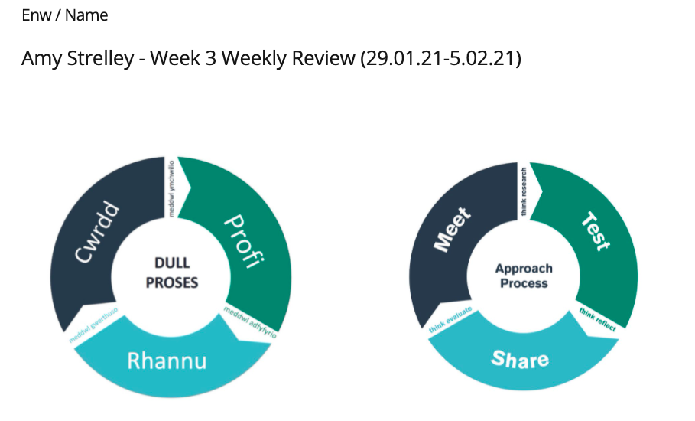
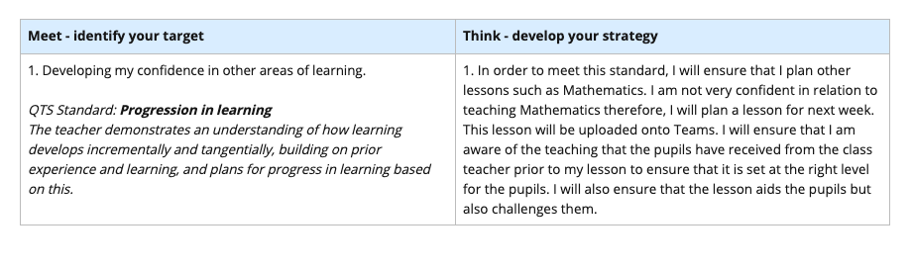
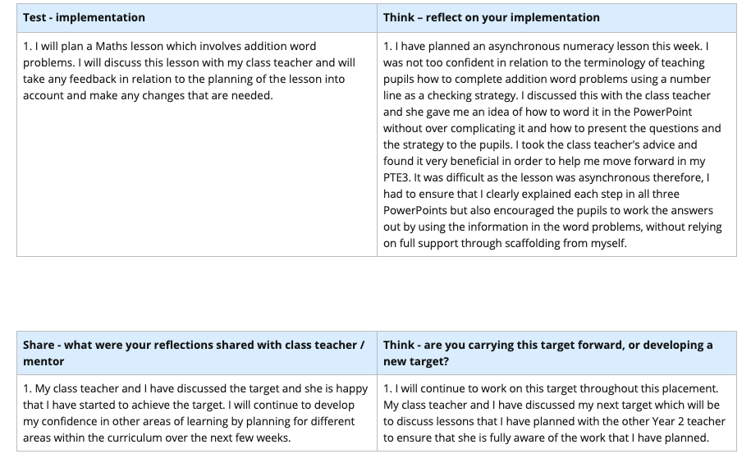

Appendix 2 – REFLECTION ON PLANNING FOR PROGRESSION (TAB 7)
PROFESSIONAL LEARNING TEMPLATE 1. Slide from the HA PowerPoint for the addition word problems lesson.

I have included a screenshot from a PowerPoint which the HA group worked through during the asynchronous lesson. This slide shows that although there is scaffolding in place to aid the learners, I have also ensured that I have encouraged the pupils to take the key information from the question by leaving blank spaces for the pupils to work out which information goes where, and which point they need to start on the number line to work the answer out.

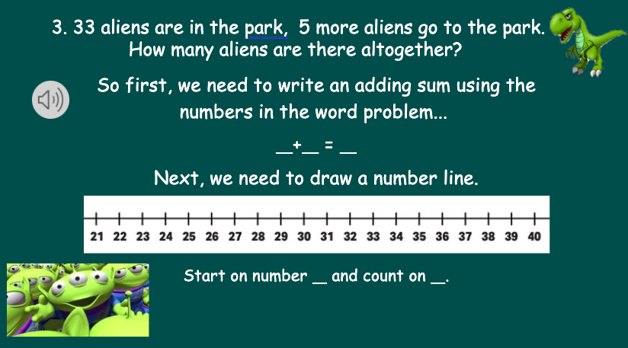

Appendix 3 - REFLECTION ON PLANNING FOR PROGRESSION (TAB 7) PROFESSIONAL LEARNING TEMPLATE 2. Languages, Literacy and Communication lesson plan – Punctuation.

I have included a plan of the Languages, Literacy and Communication lesson, which was taught during PTE2. This lesson plan will include details of how I have planned to aid the pupils’ progression in learning. Before I planned the lesson, I looked through the pupils’ books which enabled me to know what they were able to do in relation to punctuation and what they needed to work on. This aided my decision in relation to what punctuation skills each group would be working on and the tasks that I planned for them to complete.

Lesson Plan – Step 1 Cynllun Gwers – Cam 1

Student-teacher | Amy Strelley | Class: | Oaktrees TC (Year 4/5/6)
AoLE or Subject | Languages, Literacy and Communication. | Date: | 28.01.2020
Lesson Focus: | Punctuation.
Meaningful links to Curriculum | LNF:  Literacy:  Reading across the curriculum (reading strategies):  -Year 3 (Table 4): I can read aloud using punctuation to aid expression.  -Year 4 (Table 1): I can understand how sentence structure and punctuation makes meaning.  -Year 5 (Table 2): I can identify how punctuation links to sentence structure.  -Year 6(Task 3): I know how punctuation can vary and affect sentence structure and meaning e.g. I had chocolate(,) cake and cheese for tea.  Writing across the curriculum (handwriting, grammar, punctuation, spelling):  Year 3 (Table 4): I can use full stops, questions marks, exclamation marks and commas for lists.  Year 4 (Table 1): I can use punctuation to demarcate sentences.  Year 5 (Table 2): I can use the full range of punctuation to guide the reader in complex sentences, e.g. commas, bullet points, speech marks and apostrophes for possession.  Year 6 (Task 3): I can use all the punctuation marks I have learnt correctly to add meaning.
Meaningful links to:  Cross Curricular Responsibilities | YCC:  Use incidental Welsh throughout the lesson.
Personal Targets (Linked to QTS and identifed in weekly review)

Differentiate appropriately for the groups.
The student-teacher demonstrates knowledge, understanding and experience of high expectations and effective practice in meeting the needs of all learners, whatever their different needs.

Build on pupils’ prior knowledge when planning new lessons. Progression in learning.
The student-teacher demonstrates an understanding of how learning develops incrementally and tangentially, building on prior experience and learning, and plans for progress in learning based on this.

Learning Objectives (focus on Learning- use accessible vocabulary):
The pupils will learn to:

Year 3 (Table 4): I can use full stops, questions marks, exclamation marks and commas for lists.

Year 4 (Table 1): I can use punctuation to demarcate sentences.

Year 5 (Table 2): I can use the full range of punctuation to guide the reader in complex sentences, e.g. commas, bullet points, speech marks and apostrophes for possession.

Year 6 (Task 3): I can use all the punctuation marks I have learnt correctly to add meaning.

Success Criteria (clearly linked to each Learning Objective and related to the process and/or product of learning) | Assessment of Pupils’ Learning  Evidence  (What have the learners to say/write/do/produce – to demonstrate learning)
-Groups 1 and 4: I can identify where capital letters and full stops need to be placed in sentences for them to make sense. | -Pupils in both groups 1 and 4 will need to be able to identify where capital letters and full stops need to be in sentences.  -This will be demonstrated through the sorting activity and the worksheet activity.

Time | Activities/Methodology/Key Concepts  (Teacher’s Role – including key teaching points, differentiation strategies and key questions) | Pupil Tasks  (Pupils’ role –including differentiation, engagement in formative assessment and homework) | Resources  (Including Health and Safety requirement)
Opening phase (with links to prior learning) | -Pupils will sit on the carpet.  -Pupils in groups 2 and 3 will be working independently. Explain to both tables what they will be doing and then send them to do the task. (Table 3 will work outside in the corridor)  -Go through the capital letters and full stops PowerPoint with pupils from groups 1 and 4. Explain to pupils that today, they will be doing an activity which involves them sorting words. | -Pupils in groups 2 and 3 will go to do their independent task.  -Pupils will answer questions asked by the teacher. | -Capital letters and full stops PowerPoint
Teaching & Core Learning | -Pupils in groups 2 and 3 will be working independently.  -Pupils in groups 1 and 4 will do a sorting activity at the beginning of the focus task. TA will work with group 4 and teacher will work work with group 1.  -When pupils have put the correct words into the correct columns, the pupils will come back to sit on the carpet.  -When pupils are sat on the carpet, explain to them that they will have a text from a book and it is their job to find the missing punctuation and correct it. Show the pupils the sheets that they will be completing.  -Do blind 5 (AfL) to see if all pupils understand – if not all pupils understand, get a pupil who had 5 fingers up to explain the activity again. | -Pupils in groups 2 and 3 will have a sheet which will have punctuation mistakes on. The pupils will have to highlight the mistakes and re-write the paragraph correctly.  -Pupils will do a sorting activity in pairs.  -Pupils from groups 1 and 4 will sit on the carpet.  -Pupils will listen to their instructions for the next part of their activity.  -Pupils will do blind 5 (AfL) to show the teacher who understands the task and who may need help. | -Trick sheet for groups 2 and 3  -Worksheets for groups 2 and 3  -Sorting activity for groups 1 and 4  -main worksheets for tables 1 and 4 with punctuation mistakes (capital letters and full stops)
Plenary | -Mini plenaries will be done in the groups throughout the activities to monitor pupils progress. | -Pupils will be continuously feeding back to the TA/teacher during the focus tasks.

Appendix 4 – REFLECTION ON PLANNING FOR PROGRESSION (TAB 7) PROFESSIONAL LEARNING TEMPLATE 2. Languages, Literacy and Communication lesson plan – Punctuation.

I have included an example of a piece of work produced by a LA pupil during the LLC punctuation lesson. The pupil highlighted the mistakes and corrected them using a purple pen. This task was done with support. The QR code underneath is of an independent activity that the pupil completed, the activity involved sorting words into a capital letters and no capital letters column. The pupils had to decide if the words should start with a capital letter or not. This was an aspect of punctuation that the pupil found difficult and needed to practise.

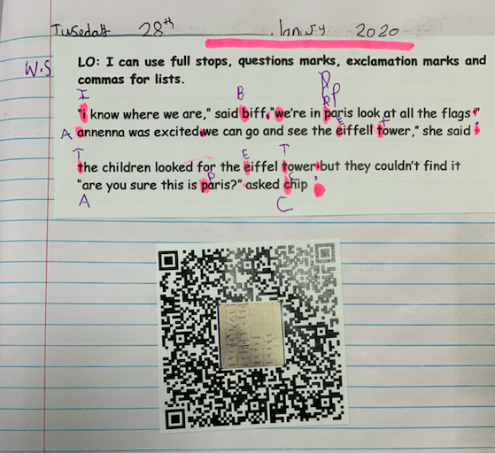
Appendix 5 – REFLECTION ON PLANNING FOR PROGRESSION (TAB 7) PROFESSIONAL LEARNING TEMPLATE 2. Languages, Literacy and Communication lesson plan – Punctuation.

I have included an example of a piece of work produced by a HA pupil during the LLC punctuation lesson. The pupil corrected the mistakes using a purple pen and re-wrote the paragraph underneath correctly. This task was done independently.

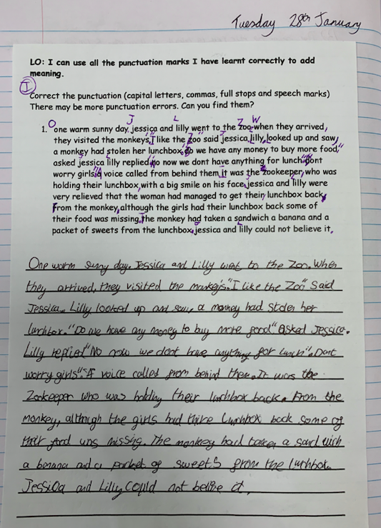
Appendix 6 - REFLECTION ON PLANNING FOR THE FOUR PURPOSES (TAB 7) PROFESSIONAL LEARNING EXPERIENCE TEMPLATE 1, related to ambitious, capable learners. Addition word problems lesson.

I have included the lesson plan for the Maths lesson which was asynchronous. The lesson plan will include details of how I have planned and prepared appropriate resources to aid the pupils’ to develop as ambitious, capable learners.

Lesson Plan – BA3

Student-teacher | Amy Strelley | Class: | Year 2
AoLE/Subject | Mathematics | Date: | 4.02.21
Lesson Focus: | Combining two groups of objects to find out ‘how many altogether?’  Solve one step word problems involving addition.
Relevant/meaningful links to:  Curriculum  &  Cross-curricular responsibilities | Mathematical development  Strand – Using number skills  Element – Calculate using mental and written methods  LA (Reception) – Combine two groups of objects to find ‘how many altogether?’  MA (Year 1) - Use ‘counting on’ strategies to add two collections, starting with the larger number, e.g. 8+5.  HA (Year 2) - Find small differences within 20 by using ‘counting on’ strategies.  LA – Talk about addition and subtration in play activities.  MA – Understand and use the mathematical symbols for addition, subtraction and equals.  HA – Understand and use mathematical symbols for addition, subtraction, multiplication, division and equals.  HA – Use checking strategies: repeat addition in a different order  -Use halving and doubling within 20.  Language, Literacy and Communication  Oracy  Element - Developing and presenting information and ideas  Aspect – Speaking  LA – Talk about things they have made or done, adding some description.  MA – Talk about things they have made or done, explaining the process.  HA – Talk in detail about things they have made or done, explaining the process.  Four Purposes  Ambitious, capable learners who:  - Set themseleves high standards and seek and enjoy challenge  - Are building up a body of knowledge and have the skills to connect and apply that knowledge in different contexts.  - Are questioning and enjoy solving problems.  - Can explain the ideas and concepts they are learning about.  - Can use number effectively in different contexts.
Personal Targets  (Linked to QTS and identfied in weekly review) | Developing confidence in other areas of learning such as numeracy.  QTS Standard: Progession in Learning  The teacher demonstrates an understanding of how learning develops  incrementally and tangentially, building on prior experience and learning, and plans for progress in learning based on this.

Learning Objectives (Focus on Learning) | Combining two groups of objects to find out ‘how many altogether?’  Solve one step word problems involving addition.
Success Criteria  (process/product) | LA – I can use a number line as a checking strategy when adding numbers to 10.  MA - I can use a number line as a checking strategy when adding number to 20.  HA – I can use a number line as a checking strategy when adding numbers to 55.

Key Resources Health & Safety | -3 differentiated PowerPoints  -Orange books to write in  -Ruler and a pencil

Time | Content, Pedagogy & Assessment Opportunities (key teaching points and questions)
Links to Previous Learning | -The pupils have previously been introduced to addition word problems. The work set for this lesson is an extension of what they have learnt to enable them to practise their skills. The main part of the lesson is to ensure that pupils use a checking strategy to check their work (using a number line will enable the pupils to check that their answer is correct). By using a number line, pupils are also able to show their thinking in terms of addition.
Opening Phase | -Pupils will open the PowerPoint and read the brief introduction of what the lesson will be about. The lesson will be following on from the pupils learning how to work solve addition word problems using a checking strategy, which in this case is a number line.
Teaching & Core Learning | -Pupils will write the addition sum in their orange books.  -Pupils will then draw a number line with a ruler and a pencil, marking the number line appropriately depending on the sum.  -Pupils will put a circle around the biggest number in the sum on the number line.  -Pupils will then draw ‘bunny hops’ on top of the number line to show that they are ‘counting on’ before arriving at the answer.  -When the pupils have reached their answer, they will circle the answer on the number line before writing the number after the equals sign in their sum.  -There are questions on the last slide of each differentiated PowerPoint with questions which will challenge the pupils and allow them to work independently.
Plenary | -As this lesson will be uploaded to Teams, written feedback will be given to pupils who submit the work.  -The feedback will praise the pupils for their efforts and will give them appropriate guidance if they have made an error.

Lesson Plan – Phase 2
Evaluation of the Learning Experience
(include references to QTS)

Evaluation of Pupil Learning

Evidence of Learning (including attitude to learning over time) | 10 pupils completed the work, 6 pupils viewed the work but did not complete it and 9 pupils did not engage with this lesson at all.
Next Steps for Progress | Next week, the pupils will be learning how to solve on step word problems involving subtraction.

Reflective Analysis of Teaching and Strategies for Development – including justification/rationale for pedagogical choices

Evidence of my Effective Practice | I created 3 differentiated PowerPoints to ensure that all pupils of all abilities had work to complete.  I added voice overs to the PowerPoints to ensure that the pupils understood what was on each slide.
Areas for my Development  Personal Targets for Progress | Next time, ensure that I add a challenge slide at the end of the PowerPoint without being prompted to do this by the class teacher.  To share and discuss planned lessons with the other Year 2 teacher to ensure that she is aware of the lesson that I have planned as her class will also be completing the work.

Appendix 7 - REFLECTION ON PLANNING FOR THE FOUR PURPOSES (TAB 7) PROFESSIONAL LEARNING EXPERIENCE TEMPLATE 2, related to healthy, confident individuals. Children’s Mental Health Week activity (February 2021)

I have included a lesson plan for the Children’s Mental Health Week asynchronous activity. The lesson plan demonstrates how I have planned the lesson to aid the pupils to develop as healthy, confident individuals.

Lesson Plan – BA3

Student-teacher | Amy Strelley | Class: | Year 2
AoLE/Subject | Personal and Social Development, Well-being and Cultural Diversity Area of Learning. | Date: | 1.02.21
Lesson Focus: | To express and communicate different feelings and emotions – their own and those of others.
Relevant/meaningful links to:  Curriculum  &  Cross-curricular responsibilities | Personal and Social Development, Well-being and Cultural Diversity  Range:  - Activities that allow them to become independent learners.  Skills:  Personal development  - Express and communicate different feelings and emotions – their own and those of others.  Moral and spiritual development  - Express ideas and feelings creatively , explaining why they are significant.  Well-being  - Be aware of their own feelings and develop the ability to express them in an appropriate way.  Language, Literacy and Communication  Reading  Reading strategies:  ALN – Make meaning from pictures in books, adding detail to their explanation.  LA – Use pictures to aid understanding of text.  MA – Look for clues in the text to understand information.  HA - Look for key words to find out what the text is about.  Comprehension:  ALN – Begin to make links to own experiences when listening to or exploring books/texts.  LA – Relate information and ideas from a text to personal experience.  MA – Use personal experience to support understanding of texts.  HA - Draw upon relevant personal experience and prior knowledge to support understanding of texts.  Writing  ALN – write letters, numbers and/or symbols randomly.  LA – copy and write letters, words and phrases.  MA – Write words, phrases and simple sentences and read back own attempts.  HA – Experiment with different formats and layouts on-screen, using the facility to move text and pictures around easily.  Creative Development  Range:  - Be involved in activities that allow them to work as individuals and in groups.  Skills:  Art, craft and design  - Develop and use their understanding of planning, designing, modelling, modifying and reflecting.  Four purposes – Currciculum for Wales  Enterprising, creative contributors who:  - Express ideas and emotions through different media.  Healthy, confident individuals who:  - Are building their mental and emotional well-being by developing confidence, resilience and empathy.
Personal Targets  (Linked to QTS and identfied in weekly review) | Developing confidence in other areas of learning such as numeracy.  QTS Standard: Progession in Learning  The teacher demonstrates an understanding of how learning develops incrementally and tangentially, building on prior experience and learning, and plans for progress in learning based on this.

Learning Objectives (Focus on Learning) | To express and communicate different feelings and emotions – their own and those of others.
Success Criteria  (process/product) | I can express how I am feeling everyday by drawing a picture of myself and explaining why I feel like this.

Key Resources Health & Safety | The day the crayons quit – YouTube link  https://www.youtube.com/watch?v=489micE6eHU

Time | Content, Pedagogy & Assessment Opportunities (key teaching points and questions)
Links to Previous Learning | As it is Children’s Well-Being Week, it is important for pupils to be able to express their feelings. Whole school focus for the week.
Opening Phase | Online  -Pupils will go through the PowerPoint (with help from an adult if needed).  -Pupils will watch ‘the day the crayons quit’ short video on YouTube (link is in the Powerpoint).
Teaching & Core Learning | -Pupils will complete their task everyday – pupils will be drawing a picture of themselves and writing how and why they feel that way next to their picture.  -Pupils will also be colour their clothes in the same colour as their feeling (will look at the crayons to see which colour felt which emotion).  Differentiation would be by outcome as all pupils will produce work to the best of their ability.  LA – Will colour the illustrations.  MA – Will colour the illustrations and write the emotion word.  HA – Will colour the illustration, write the emotion and use connectives such as because to explain why they were feeling that way.
Plenary | -Pupils will submit their posters via Teams on the Friday .

Lesson Plan – Phase 2
Evaluation of the Learning Experience
(include references to QTS)

Evaluation of Pupil Learning

Evidence of Learning (including attitude to learning over time) | 5 pupils completed the work, 12 pupils viewed the work but did not complete it and 8 pupils did not engage with the lesson at all.
Next Steps for Progress | Ensure that I go to weekly check ins until the pupils are back in school, we will then be able to check ins in class.

Reflective Analysis of Teaching and Strategies for Development – including justification/rationale for pedagogical choices

Evidence of my Effective Practice | I created a PowerPoint which included a story ‘the day the crayons quit’ and I explained how the coloured crayons felt different emotions.  I created a poster with the crayons on and put which emotion they were feeling to help the pupils to colour their pictures in the colour for how they were feeling.  I also created my own emotion poster to ensure that the pupils could see an example of what I was asking for.
Areas for my Development  Personal Targets for Progress | As the pupils had ‘screen free Friday’, next time I could ask the pupils to submit their work on a Thursday instead of a Friday.  To share and discuss planned lessons with the other Year 2 teacher to ensure that  she is aware of the lesson that I have planned as her class will also be completing the work.

Appendix 8 - REFLECTION ON PLANNING FOR THE FOUR PURPOSES (TAB 7) PROFESSIONAL LEARNING EXPERIENCE TEMPLATE 2, related to healthy, confident individuals. Children’s Mental Health Week activity (February 2021)

I have included a screenshot of emails that were sent from myself to the Well-Being co-ordinator in my PTE3 school and then from the Well-Being co-ordinator back to me. These emails demonstrate that the lesson had a very positive affect on the pupils in the Year 2 class and that I was able to support the school by delivering an effective Well-being lesson. The work that was produced by the pupils will also be added to the school website and used for the school’s Healthy Schools evidence which directly links to supporting the pupils to become healthy, confident individuals.

Email evidence for Children’s Mental Health Week

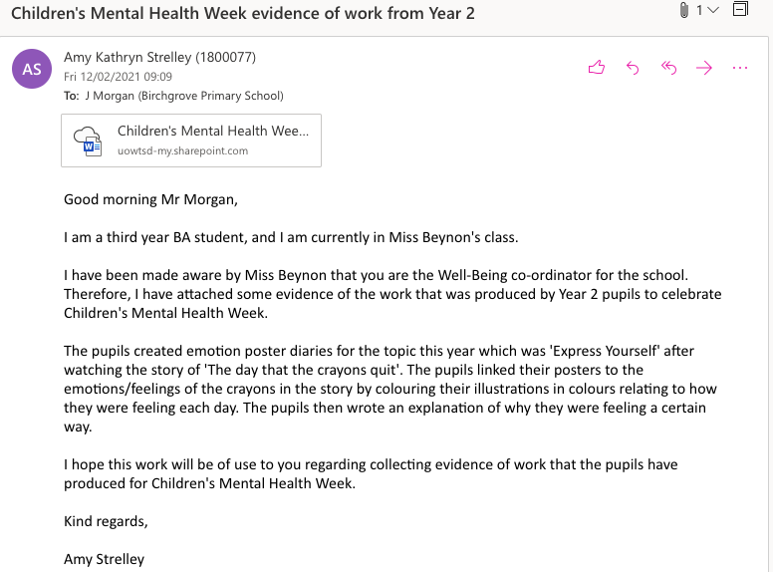

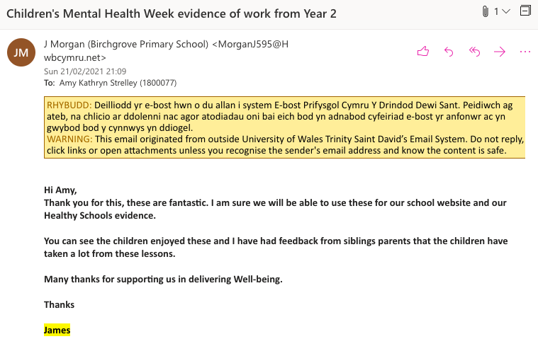

Appendix 9 - REFLECTION ON PLANNING FOR THE FOUR PURPOSES (TAB 7) PROFESSIONAL LEARNING EXPERIENCE TEMPLATE 2, related to healthy, confident individuals. Children’s Mental Health Week activity (February 2021)

I have included some of the work that the pupils produced as a result of the asynchronous lesson that I planned and uploaded. This work illustrates that the pupils watched the video of ‘The Day the Crayons Quit’ and took into account how each crayon was feeling and related it back to themselves by using the correct colour to colour their clothes in. The pupils were also able to write sentences which enabled them to express their feelings and emotions each day and explained why. This aids pupils to develop as healthy, confident individuals as they are becoming more aware of their mental and emotional wellbeing.

Evidence of pupils work for Children’s Mental Health Week (Express Yourself) -Year 2



