Problem Solving Report

Part I: Issue Solving Aptitude

AC 1.1 Issue Evaluation
Issues are can be of many types. And its identification and solving process can be a tedious task. Issues exist in some way or the other at almost every stage of one’s life be it personal or professional. However, in order to solve an issue it is essential to understand and identify it. One needs to solve it at the root level of an issue so that it is solved for once and for all. The various stages in issue identification and resolution is shown below:

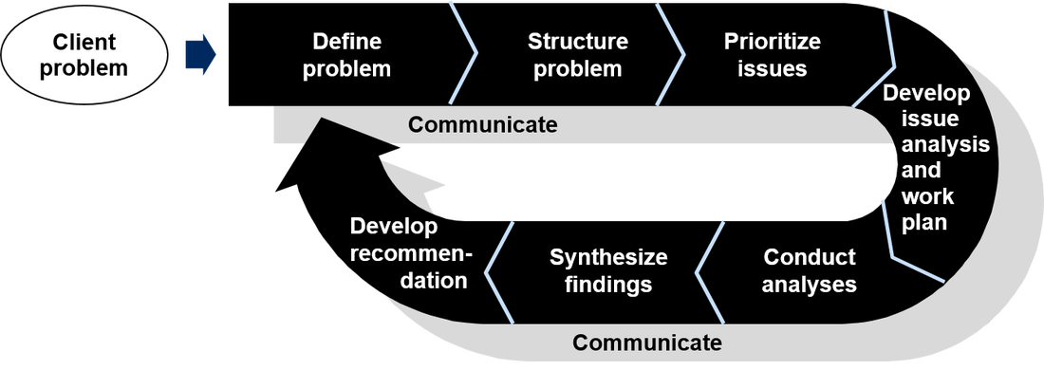
Identification of issues and its solving stages (Kirschner, et al., 2011)
It is essential for one to identify an issue in order to solve it (Kirschner, et al., 2011). Time taken for an individual to overcome an issue is completely based on that individual. Issues can be simple or complex. In my case, I faced some simple issues while I was working as sales personnel in Nandos. The dissatisfaction of the consumers due to the unavailability of good quality product of the organization is something I had to face while I was working there. And some of the complex issues that the company faces in general that I observed in my time as a sales personnel there is lack of proper planning, resolution, and human resources as sales personnel in the organization. Especially during the holiday times, when the demand of products is at its peak. This makes it essential on the part of the organization to have a better and planed implementation of the policies.

AC 1.2 Evaluative Reasoning and Variation
Evaluative reasoning is the constructive way of solving a problem at hand. This gives a proper manual for solving an issue at hand step by step. The reasoning requires, a disciplined and more planned perspective (Ge & Land, 2003). Such as identification of the issue, analysis of the issue and finally the evaluation and combining the information gathered. There are six primary stages of this evaluative reasoning process. The first stage is to gather in-depth information for the issue at hand. This will help in the next process that is understanding the issue better and identifying the root cause of the issue. Identifying the root cause of the issues will help in better understanding as well as better solving of the issue for once and for all. Then comes the stage where one needs to properly evaluate as well as synthesise the information gathered regarding the issue at hand. This will help in coming up with an action plan for the resolution of the issue better and more effectively. And the final stage involves actually taking action of the proper plan, processed through all the previous stages. One can be innovative at this stage and make use of their full potential to come up with a solution for the issue at hand. And this will be beneficiary in managing a situation that involves an issue as well as its resolution.

Stages of Evaluative Reasoning (Crismond & Adams, 2012)

Part 2

AC 2.1 PEST Analysis of Nandos
The PEST evaluation of Nandos deals with its political, economic, social and technological environment that it has at the present moment. The restaurant industry is saturated with many businesses however Nandos find itself in an Industry where it currently enjoys a good competition (Baraban, 2010). In terms of political factors, the current political environment encourages growth of businesses. Although, the increase in taxes in the form of VAT by the government impacts the organization’s profits as it reduces it (Mitchell, 2005). And another factor being the Brexit, this might result in less availability of trained employees. Coming to the economic environment, Nandos is operating in a good economic environment as the customers have not change much in terms of eating from restaurants and helping to increase sales of the restaurant. The coming to the social environment that the organization is operating in, is one of the ideal environment. As UK has a very diverse population and people residing belong to a variety of backgrounds. Although, this might enhance the challenge of accommodating the diversity a little, the overall outcome will be positive as there is a better opportunity for business as a whole. And the technological environment that the company is operation in is a rather modern one. The trend of social media and online marketing and selling of goods has made things much easier for the organization. E-marketing is something Nandos is already good at, thus, that is never an issue (Humby, et al., 2004). And the social media trends make it easy on the company to have the feedbacks from their customers. The consumers can now easily write their reviews of their product on the social media pages and can post it on the social media pages of the company. This will help both the parties have easy access to each other’s opinion. Further adding up to the productivity of the company in the long-run.

AC 2.2
Address:
The Manager
Sales Department
Nandos Stores
Dear Manager
A Letter to the Manager – Pest Analysis of Nandos
I would like to give out some advices for the company’s improvement based on the macro environmental analysis which I have conducted. The PEST evaluation highlighted some of the problems that I got to discover in the process. For example, the increase in the taxes by the UK government might hamper the profitability of the company. Since the tax is on the foods that promote obesity. Thus, it would be ideal for the company to portray itself as a healthy brand so that the taxes are reduced and so that people indulge in it more. The lack of skilled human resources might be another challenge that the company might face. This can be a result of the Brexit. This the company can overcome by making suitable changes in the recruitment policies of the organization. This will ensure that there is no lack of human resources if the situation arises. And suitable changes in the training culture in order to make it more accommodating will further enhance the situation. Through the economic analysis, it was found that the capacity of purchasing has increased in the people of the UK, thus, the company should target the middle class people to establish their loyalty as consumers for the organization. As the middle class is the one evolving consistently and will be easy targets for the company with seasonal sales, etc. The social environment evaluation has resulted in the idea of what the company should do. The company should be more active on the various social media platforms, i.e. Instagram, Twitter, Facebook, etc. The various cultural diversity found in the country can be easily accessed through these media platforms and will be easy on the part of the company to establish, manage as well as maintain a strong bond with their consumers. These are my understanding based on the PEST evaluation that I did. And I hope it will beneficial for the company in some way or the other.
Regards,
Olinda

Part 3
Employees are the most essential part of any organization. No technology is invented till date that can replace employees in an organization. Thus, their conduct affects an organization in various ways. Employees are the chief resource of any company as they constitute it (Abraham, 2012). Therefore, their manner of behaviour affects an organization significantly. The employees are the primary part of any organizational culture.
The employees are further categorized into two major categories based on their conduct and contribution to the company’s culture. They are positive outlier and negative outlier. The positive outlier are the smart ones that work very efficiently and are an asset to the company. These employees are placed above the average employees and the organization sees them as an asset. Their performances are above the expectations of the organization, and they are dedicated and motivated employees (Little & Little, 2006). This dedication and motivation is well reflected on their performance.
Then there are negative outliers employees. There are the employees that are slow and are inefficient in their approach towards finishing up work for the company. Their behaviour is nowhere near that of the positive outliers and these employees are more of a liability for the company. These employees do not take even a small change in their workplace environment in a healthy manner, thus, creating inconvenience for the company. In case of any slight change, these employees usually showcase their discomfort through negligence, anger, etc. Thus, the proper management of the employees exhibiting such behaviour will determine the success or failure of the organization.
Therefore, the management of the different types of behaviours exhibited by the employees of a company is essential in leading the organization in the path for success. It is a challenge on the part of the management department to bring the conduct of the negative outlier to a level, if not same, somewhere near the behaviour of the positive outlier so that the company can reach its maximum efficiency level. It also needs to have a check on the ethicality of the culture in an organization as well as its liability (John, 2012). It should also check the harassment inside the company. And if there comes any case to notice, the management should highly discourage it and take stern actions against the wrong-doers. The management department should encourage the behaviour of the positive outliers in such a manner that even the negative outlier would want to behave in that way. And this will then increase the efficiency of the organization as a whole.

Part 4
This part deal with the various advantages and disadvantages of using Information Technology in Nandos. The ever growing stiff competition by remarkable contemporaries in the same business as Nandos has pushed these organisations to work harder and use better resources in order to achieve better results (Brannen, et al., 2013). Information Technology is one of such resources that the organizations are upgrading. However, this part only gives out the advantages and disadvantages faced by Nandos.
The following explains some of the advantages of using Information Technology in Nandos:
Upgrading the Information Technology enhances an organization’s efficiency and accuracy as most of the companies use technology based resources as it saves time and manual labour. In processes such as billings and other finance handling, upgraded Information Technology, as stated above saves time and increases the accuracy of the processes as there is no scope of human error. It also minimizes the tedious process of collecting and storing the information of the customers availing the services offered by the company and makes it quick and easy. This also makes the process of building a brand name, its promotion and advertisement easier and very accessible to its consumers. The communication between the avid parties involved in the entire process of giving out the service to the consumers by an organization better and keeps them better connected with each other. Which further adds up to the efficiency of the final outcome (Mitchell, 2005). The use of better information technology has resulted in better planning of schemes for the development of a project or just the company as a whole. The e-marketing of a company has helped tremendously in reaching a wide range of crowd and has also helped in decreasing daily expenditure of the company.
Then following describes some of the disadvantages of up gradation of Information Technology in Nandos:
The cost of using and application of information and technology totals to a fortune as because Nandos is a global company and it implication are present all over the globe. The overuse of information technology is expensive as well as inefficient for the business. And since the business is so widespread, its IT’s management and maintenance become quite a complicated process altogether (Humby, et al., 2004). And since the technology is used for almost everything in the organization, the training and learning of the employees becomes another time consuming as well as pricey process.
Therefore, it is suggested that, although the information technology up gradation is an advantageous situation for the organization, only its judicious use and implementation can result in the desired results. As because the overuse of any commodity can lead to its inefficient behaviour in general.

References
Abraham, S., 2012. Job Satisfaction as an Antecedent to Employee Engagement. SIES Journal of Management, 8(2), pp. 27-36.
Baraban, R.S. (2010) Successful Restaurant Design. London, John Wiley & Sons.
Brannen, M., Moore, F. & Mughan, T., 2013. Strategic ethnography and reinvigorating Nandos plc: Leveraging inside/out bicultural bridging in multicultural teams. Ethnographic Praxis in Industry Conference Proceedings. London, Sage.
Crismond, D. P. & Adams, R. S., 2012. The informed design teaching and learning matrix. Journal of Engineering Education, 101(4), p. 738–797.
Ge, X. & Land, S. M., 2003. Scaffolding students’ problem-solving processes in an ill-structured task using question prompts and peer interactions. Educational Technology Research and Development, 51(1), p. 21–38..
Humby, C., Terry, H. & Tim, P., 2004. Scoring points: How Nandos is winning customer loyalty. London: Kogan Page.
John, B., 2012. Employee Job Satisfaction: Understanding the Factors That Make Work Gratifying. Society for Human Resource Management , 14 Feb, pp. 6-17.
Kirschner, F., Paas, F., Kirschner, P. A. & Janssen, J., 2011. Differential effects of problem-solving demands on individual and collaborative learning outcomes. Learning and Instruction, 21(4), p. 587–599.
Little, B. & Little, P., 2006. Employee engagement: Conceptual issues.. Journal of Organizational Culture, Communications and Conflict, 10(1), p. 111.
Mitchell, A., 2005. With chains and loops, Nandos is surreptitiously reinventing retail. Marketing Week, 17(33), pp. 22-25.
McGrath, E.M. (2004) Next generation product development. USA, McGraw-Hill.

