Assignment
Virtualisation, Containerisation and Serverless Architectures

Student Name:
Md Hasibul Islam
Student ID:
2421865
Module:
Cloud Engineering Principles and Practice

Table of Contents

Abstract 2
1. Introduction 4
2. Cloud Technology: Docker and Containerisation 4
2.1 Principles of Virtualisation 4
2.1.1 Types of Virtualisation 4
2.1.2 Virtualisation of Shared Hardware 5
2.2 Principles and Benefits of Containerisation 5
2.2.1 How Containers Work 5
2.2.2 Benefits of Containerisation over Virtual Machines 5
2.2.3 Constructing a Dockerfile 6
2.3 Images and Publishing to DockerHub 9
2.3.1 Pushing an Image to DockerHub 9
2.4 Container Volumes 10
2.4.1 Creating and Using a Docker Volume 10
2.5.2 Creating a Docker Network 12
2.6 End-to-End Demonstration: Multi-Container Web Application with Docker Compose 12
3. Cloud Computing Concepts: Load Balancing, Scalability and Application Gateways 15
3.1.1 Load Balancing 15
3.1.2 Scalability 15
3.1.3 Application Gateways 15
3.2 Why Load Balancing and Scaling are Complementary Concepts 16
3.3 Benefits of Combining Load Balancing, Scalability and Application Gateways 16
4. Main Driving Forces Behind Cloud Computing Expansion 18
4.1 Overview 18
4.2 Key Driving Forces 18
4.2.2 Flexibility and Agility 18
4.3 Serverless Functions: A New Paradigm for Cloud-Based Web Services 19
4.3.1 What is Serverless Computing? 19
4.3.2 A Serverless Web Service Example: AWS Lambda with API Gateway 19
4.3.3 Comparing Serverless Functions and Containerisation 20
4.3.4 Serverless and the Driving Forces 20
5. Conclusion 22
References 23

1. Abstract
Virtualisation, containerisation, and serverless architectures are the fundamental technologies behind current cloud computing. First, the paper covers hardware virtualisation, then Docker-based containerisation. They use Dockerfiles, publish images to DockerHub, manage volumes, network containers, and deploy numerous containers using Docker Compose. Following a comprehensive analysis of load balancing, scalability, and application gateways using Microsoft Azure as a reference platform, the paper concludes that these technologies work best together. Finally, we examine why cloud use is increasing so fast, including cost-effectiveness, flexibility, global reach, and managed services. For performance, affordability, portability, and applicability, serverless computing, as shown by AWS Lambda, is contrasted against containerisation. Based on workload characteristics, the best cloud-native designs use both containerisation and serverless functionalities.

1. Introduction
The global digital transformation of enterprises has accelerated due to the growth of cloud computing. Technologies at the center of this shift include virtualization, containerization, and, more recently, serverless computing. Together, these paradigms enable enterprises to develop, scale, and manage applications more effectively, affordably, and adaptably than in the past [1].
Docker, which Solomon Hykes launched in 2013, swiftly rose to prominence as the key technology of the containerization age. By packing an application and its entire runtime environment into a portable, lightweight unit known as a container, Docker resolved the long-standing issue of environmental inconsistencies between development and production systems [2]. Containerization has now grown to be an essential component of contemporary cloud-native and DevOps designs.
Both the theoretical and practical aspects of these technologies are examined in this research. In Section 2, the concepts of virtualization and containerization are discussed together with practical Docker examples. The fundamental concepts of cloud computing, including load balancing, scalability, and application gateways, are examined in Section 3. In Section 4, the primary motivations for cloud computing are examined, along with a critical comparison of serverless and containerization approaches. A video that demonstrates the practical exercises discussed in this paper is included with it.

2. Cloud Technology: Docker and Containerisation

2.1 Principles of Virtualisation
Modern cloud computing is made feasible mostly by virtualization. The technique of separating physical hardware resources, such as CPU, memory, storage, and networking, and making them accessible to several distinct software environments simultaneously is known as virtualization [3]. The software layer that manages this abstraction is called a hypervisor, or Virtual Machine Monitor (VMM).

2.1.1 Types of Virtualisation
Type 1 (Bare-Metal) Hypervisors: These run on real hardware without an operating system. Some examples are KVM, VMware ESXi, and Microsoft Hyper-V. Type 1 hypervisors are the best choice for enterprise data centers and cloud provider infrastructure because they work directly with hardware and offer better performance [4].
Type 2 (Hosted) Hypervisors: These work like an app on a regular host operating system. Oracle VirtualBox and VMware Workstation are two examples. People often use type 2 hypervisors for development and testing because they are easy to install, but they slow down the system because of the extra operating system layer [4].
One cannot overstate the importance of cloud virtualization. Amazon Web Services (AWS), Microsoft Azure, and Google Cloud Platform (GCP) run massive data centers with thousands of real servers and dozens of virtual machines. Multi-tenancy allows suppliers maximize hardware use while delivering clients on-demand computing resources [5]. Public cloud computing's economic model requires virtualization.

2.1.2 Virtualisation of Shared Hardware
When many virtual machines share a physical host, the hypervisor shares resources. Eight VMs can run on a 64-core, 256-GB-RAM physical server. All VMs have eight cores and 32 GB RAM. The hypervisor controls input and output, schedules physical resource consumption, and prevents VMs from sharing memory. This division protects and controls performance [3].
The Nitro System in AWS uses dedicated hardware cards and a thin software layer as a hypervisor. It underpins most EC2 instances. Virtualization activities are moved to separate hardware. This frees up practically all of the physical host's resources for client VMs and reduces virtualization's performance overhead [6].

2.2 Principles and Benefits of Containerisation
Containers virtualize the operating system, while virtual machines virtualize the hardware and computer. A container houses an application, its dependencies, libraries, and configuration files. It also uses the host OS kernel [2]. This architecture has many advantages over typical VM-based ones.

2.2.1 How Containers Work
Docker containers employ Linux kernel namespaces and control groups (cgroups). Namespaces divide process IDs, network interfaces, filesystem mounts, and users. This prevents container processes from communicating with other containers or the host. To prevent containers from using more CPU and memory than allocated, cgroups limit resources [7].
Docker Engine runs containers. For container creation, starting, stopping, and removing, the Docker CLI employs a RESTful API. Containers employ read-only, multilayer file system images. Docker's union file system effectively stacks layers [8]. Each layer in an image changes somewhat, like installing a package.

2.2.2 Benefits of Containerisation over Virtual Machines
Dimension | Virtual Machine | Docker Container
Startup time | Minutes (full OS boot) | Milliseconds
Image size | GBs (full OS image) | MBs (application only)
Resource overhead | High (full OS per VM) | Very low (shared kernel)
Density (per host) | Tens | Hundreds
Portability | Limited (hypervisor tied) | High (OCI standard)
Isolation level | Strong (hardware boundary) | Process-level (kernel shared)
Table 1: Comparison of Virtual Machines and Docker Containers
Table 1 shows that containers make it faster to start up, use fewer resources, and move around. Microservices designs and CI/CD pipelines need fast, reliable deployment, which is why these traits are important [9].

2.2.3 Constructing a Dockerfile
A Dockerfile is a text file that lists the steps needed to make a Docker image. The following example shows a Dockerfile for a basic Node.js web app that serves a static HTML page. This example is the basis for the practical demonstration in Section 2.5 and the video that goes with it.
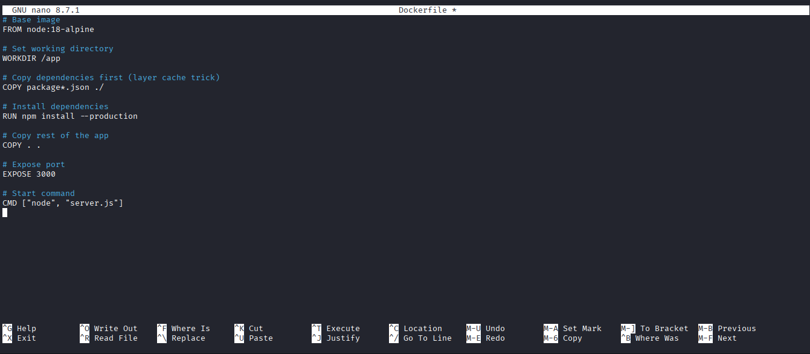
Figure 1: Dockerfile for a Node.js web application (author's own)
Every command in a Dockerfile makes a layer of an image. The base image in the FROM instruction is the official Node.js 18 Alpine edition. It takes up less space (about 40 MB compared to about 900 MB for the Debian-based version). Docker's layer caching speeds up builds by storing packages.JSON doesn't change as often as application source code [10]. The planned order of the COPY and RUN commands takes advantage of this.

The accompanying Node.js server.js file and index.html are as follows:
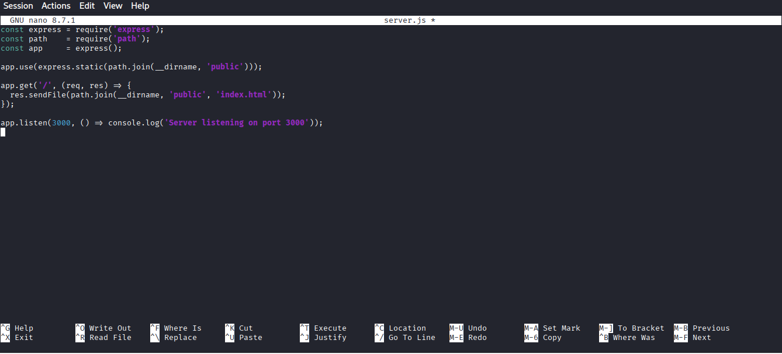
Figure 2: Node.js Express server (server.js) – author's own
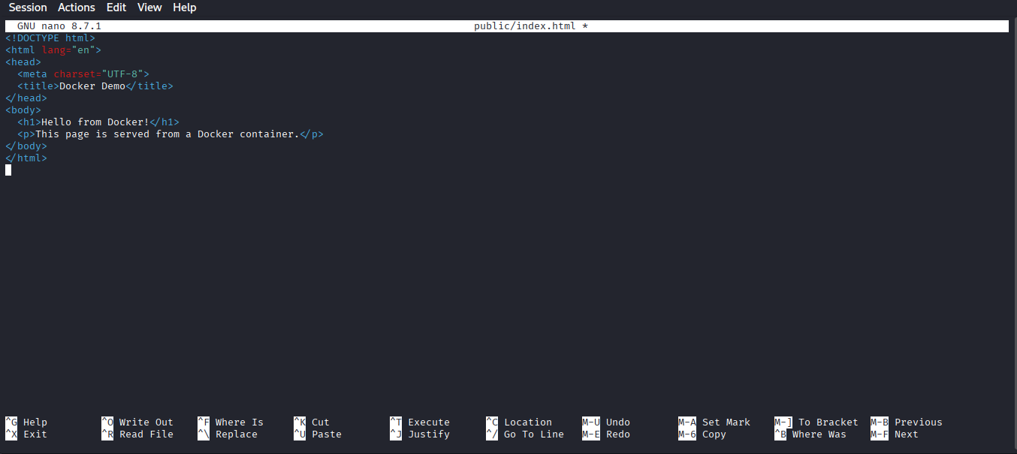
Figure 3: Static HTML page served by the containerised web application (author's own)
The image is built with the following command, where the -t flag tags the image with a human-readable name and version:
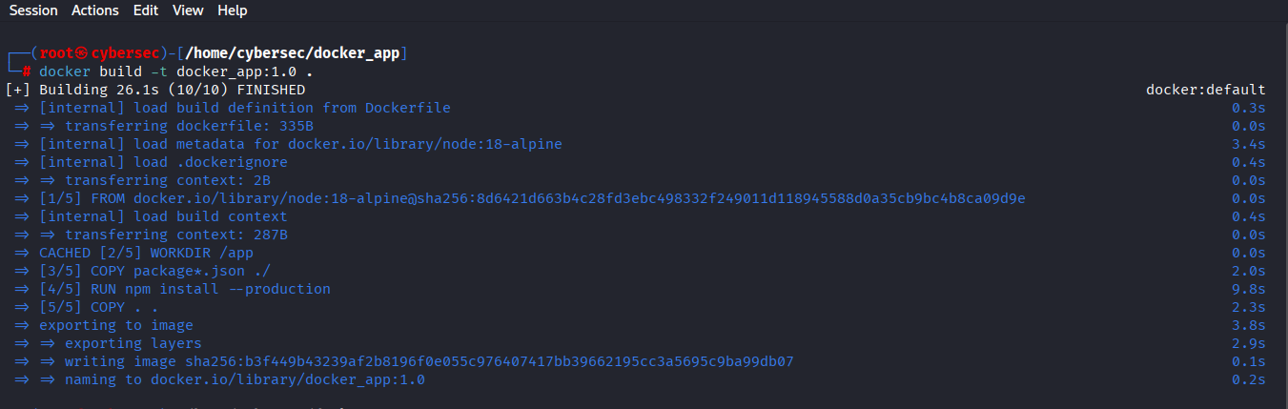
Figure 4: Build Docker image (author's own)
You can check the image after it has been built by using docker images, which shows you all the images you have on your computer along with their tags and sizes. After that, an image starts a container:
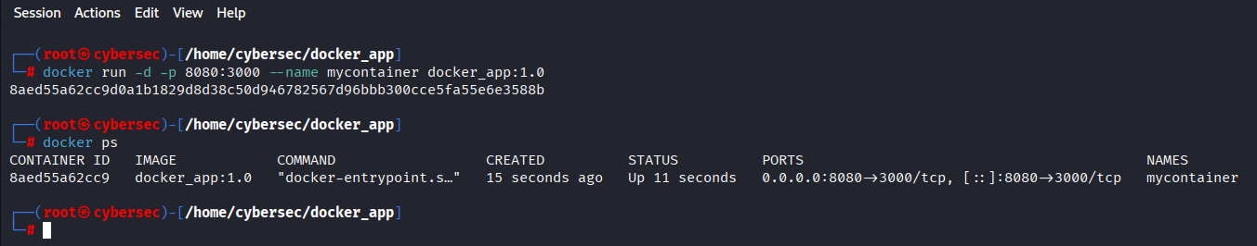
Figure 5: Run Docker Container (author's own)
The -d flag makes the container run as a background daemon, -p 8080:3000 connects port 8080 on the host to port 3000 inside the container, and --name gives it a name that people can understand. You can check that the web application is running inside the container by going to http://localhost:8080 in a browser [8].
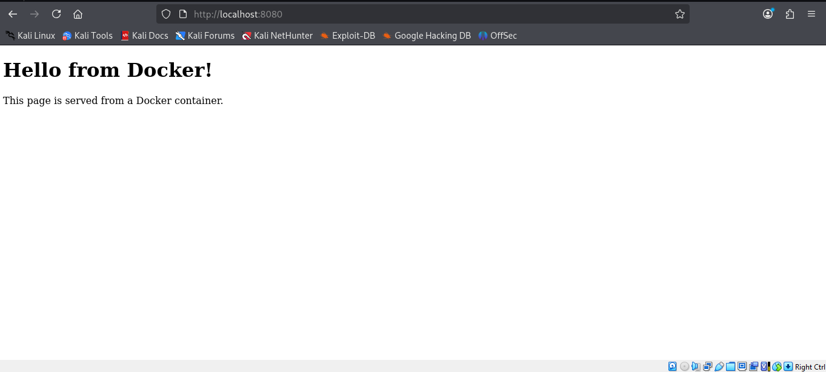
Figure 6: Run web application in a browser (author's own)

2.3 Images and Publishing to DockerHub
A Docker image is a snapshot of a file system that can't be changed and is made up of layers. Registries are like version control systems for code, but for images. They are centralized places where images are stored. DockerHub is the default public registry and has millions of official and community images. Companies often use private registries like AWS Elastic Container Registry or Azure Container Registry to keep control of their own images [11].

2.3.1 Pushing an Image to DockerHub
Publishing the web application image created in Section 2.2 to DockerHub involves the following steps. First, the image must be tagged with the DockerHub username and repository name. Next, authenticate with DockerHub:
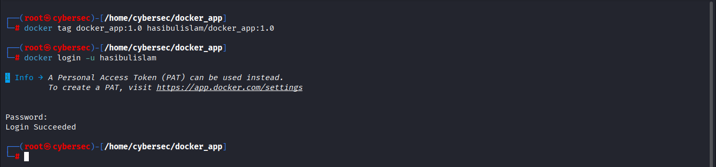
Figure 7: DockerHub username, repository name and authenticate (author's own)
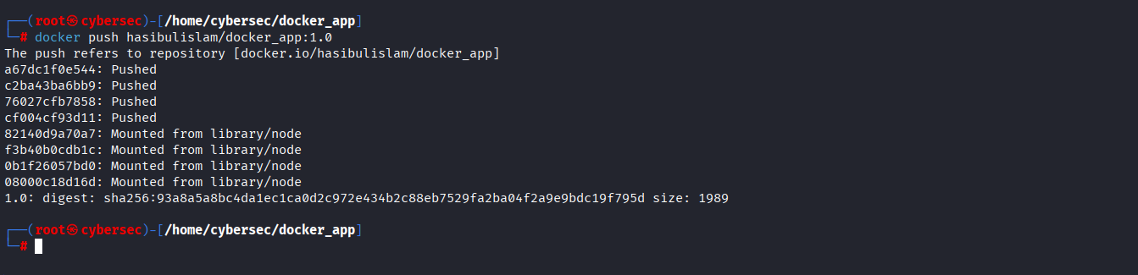
Figure 8: Push a Docker image to DockerHub (author's own)
The image is available all over the world once it is pushed. You can pull and run it with docker pull hasibulislam/docker_app:1.0 and then the right docker run command. This works for any developer or automated deployment system. This feature of "publish once, run anywhere" is at the heart of Docker's value for CI/CD workflows and distributed development teams [12].
Tagging images is an important operational issue for versioning. Best practice says that the latest tag should never be used in production because it can change and cause unexpected changes. Use semantic versioning (like 1.0.0 or 1.1.0) or content-addressable digests (like sha256:93a8a5a8bc4da1ec1ca0d2c972e434b2c88eb7529fa2ba04f2a9e9bdc19f795d) to pin deployments to specific, known-good image states [11].

2.4 Container Volumes
Containers are meant to be temporary. When a container is destroyed, any data that was written to its writable layer is lost. This is a big problem for stateful apps like databases. Docker solves this problem with volumes, which are a type of managed, long-lasting storage that is separate from the container lifecycle [13].

2.4.1 Creating and Using a Docker Volume
A named volume is created with the following command:
Figure 9: Create a volume (author's own)
The volume can be inspected to reveal its mount point on the host:
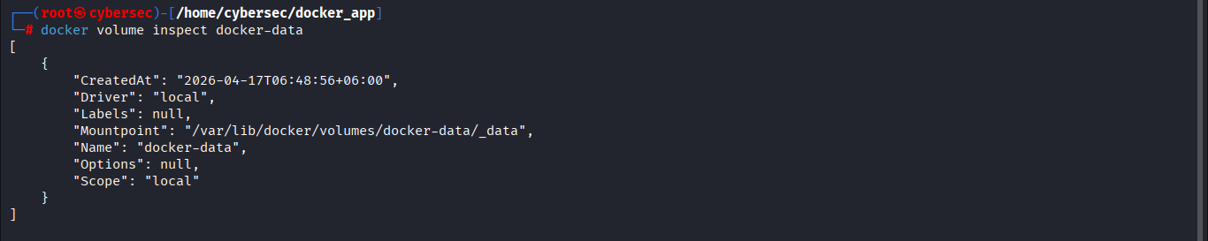
Figure 10: Inspected volume (author's own)

A container is then launched with the volume mounted at a specified path inside the container:
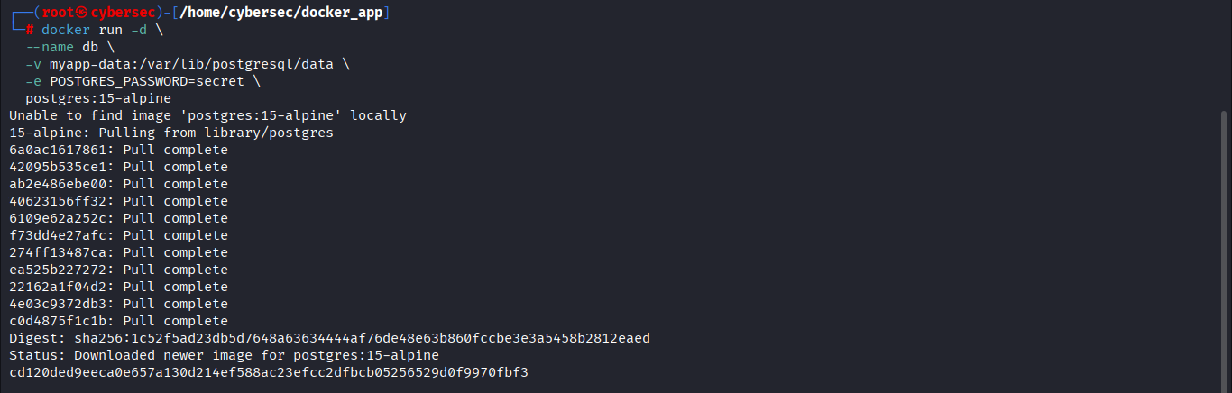
Figure 11: Launched with the Volume (author's own)
The PostgreSQL database saves its data files to /var/lib/postgresql/data in the container, as shown in Figure 5. This path is linked to the named volume myapp-data, so the data stays there even if the container is stopped, removed, and made again from the same or a different image version. This is very important for production database deployments where data durability is not up for debate [13].
Docker also lets you use bind mounts, which let you mount a directory from the host file system into a container. In development, bind mounts are often used to let you hot-reload source code without having to rebuild the image. But they make the connection between the container and the host environment stronger, so named volumes are the best way to keep production data [8].
2.5 Container Networking
Containers should be able to talk to each other, the host system, and networks that aren't part of the host system. Docker has a flexible networking subsystem that hides the network infrastructure below it and makes sure that everything works the same in both development and production environments [14].
2.5.1 Docker Network Drivers
Bridge (default): Creates a private network on the host that can't connect to the internet. Containers on the same bridge network can talk to each other by name (thanks to built-in DNS), but traffic from outside needs to have port mapping set up. This is how you normally set up a single-host deployment.
Host: This takes away the network separation between the container and the host, so they can share the host's network stack. This makes things run as fast as they can, but it also takes away privacy, which makes it not good for most production situations.
Overlay: This lets containers that are running on different Docker hosts in a Swarm cluster talk to each other without any problems. This driver lets Docker Swarm connect to more than one host.
None: This turns off all networking for the container. This is helpful for batch jobs that need to be completely isolated from the network for security reasons [14].

2.5.2 Creating a Docker Network
A user-defined bridge network is created with:
Figure 12: User-defined bridge network (author's own)
Containers are then connected to this network either at launch or after creation:
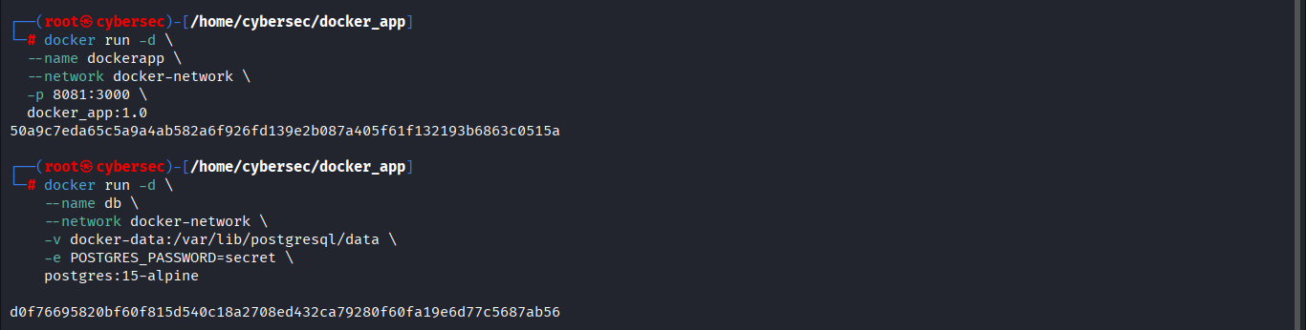
Figure 13: Connecting multiple containers (author's own)
The web application can connect to the database by using the container name "db" as the hostname because both the webapp and db containers are on the same user-defined bridge network. The built-in DNS resolver in Docker automatically changes this name to the container's IP address. This means that you don't have to hardcode IP addresses, and the configuration can be used in different environments [14].

2.6 End-to-End Demonstration: Multi-Container Web Application with Docker Compose
The previous sections explained how each Docker feature works by itself. This section has a full example of how to use Docker Compose, which is a tool for defining and running multi-container apps from a single YAML configuration file [15]. It has networking, volume management, building images, and managing containers.
A Node.js web app, a PostgreSQL database, and a Nginx reverse proxy make up the whole application stack. The Docker Compose file is shown in Figure 14.
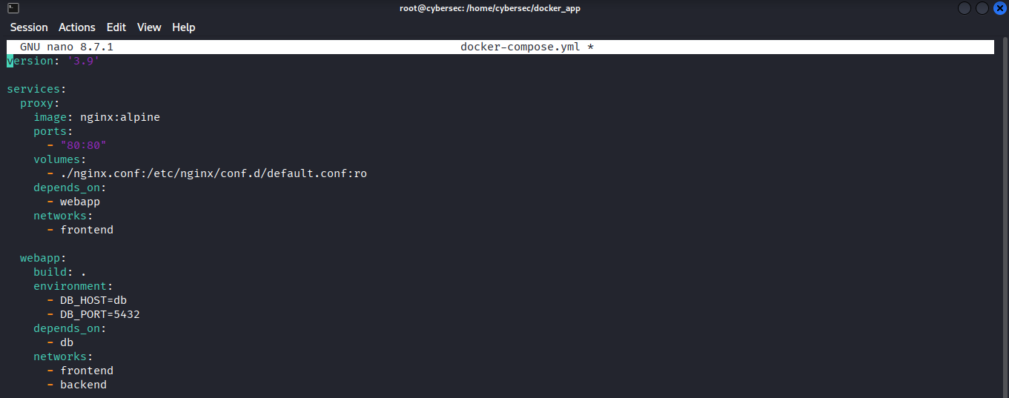
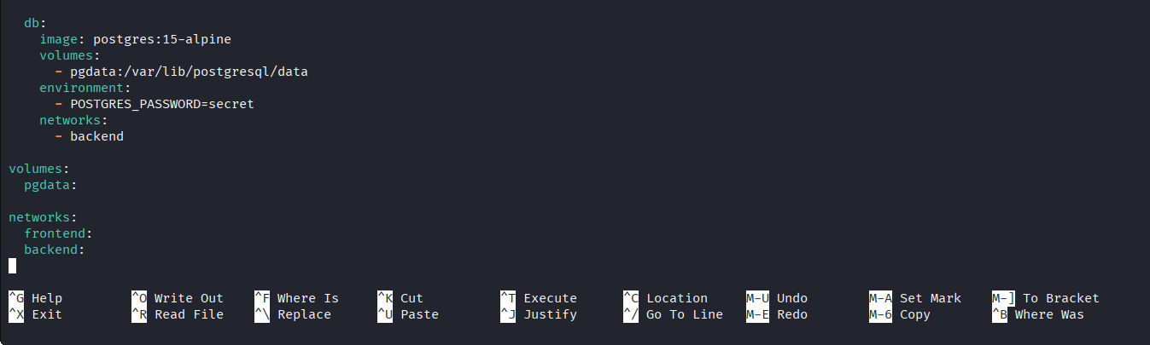
Figure 14: Docker Compose file defining a three-service application stack (author's own)

Figure 14 shows the architecture that follows some important design and security rules. First, there are two networks: the frontend and the backend. The frontend network is shared by the Nginx proxy and the web application. The backend network is shared by the web application and the database. The database is only on the backend network, which means that the public-facing Nginx proxy can't reach it. This separation of networks makes it harder for attackers to get in. Also, port mapping [14] never lets the host see the database.
You can start the whole application stack with just one command:
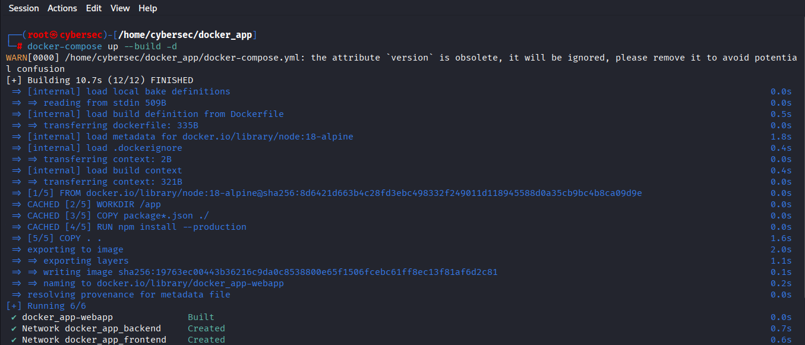
Figure 15: Entire application stack is launched (author's own)
Nginx listens for HTTP requests on port 80 and sends them to the webapp container on port 3000. The web app writes permanent data to PostgreSQL, which keeps its files in a volume called pgdata. Data is kept safe if the database container is rebuilt or updated. This end-to-end demo shows the Docker workflow: define once, run anywhere, with environments that can be reproduced and are separate at every stage [15].
You can watch a video that shows you how to do all of this, from making the image to running containers, making volumes and networks, and publishing to DockerHub. The video talks you through each command and its output step by step.
Video Demonstration: [https://youtu.be/_JCUr6-MVV8]

3. Cloud Computing Concepts: Load Balancing, Scalability and Application Gateways

3.1.1 Load Balancing
Load balancing distributes incoming network traffic across numerous backend servers (or application instances) to prevent bottlenecks and ensure service continuity [16]. Cloud providers offer elastic, managed load balancing.
Microsoft Azure balances load with multiple services. On Layer 4 (TCP/UDP) of the OSI architecture, Azure Load Balancer is best for sending large amounts of data fast within a region. Azure Application Gateway has Layer 7 (HTTP/HTTPS) application-layer protocol knowledge. This enables URL-path-based routing, SSL termination, and WAF [17]. Azure Front Door distributes traffic globally using intelligent DNS-based routing, health probing, and automatic failover.
In e-commerce, Azure Application Gateway fronts online application servers. The gateway ends the SSL connection, looks at the HTTP request, delivers it to the application server with the least load using a round-robin algorithm (or a more advanced method like least connections or IP hash), and sends the response back to the consumer when a customer buys something. The gateway automatically removes a backend server from rotation if it fails its health probe, a periodic HTTP request to an endpoint. This prevents failing instances from receiving requests [17].

3.1.2 Scalability
Scalability is the ability of a system to add more resources as the amount of work it has to do grows. When you scale up, you add more resources to an instance (for example, upgrading from a 4-core to a 16-core VM). When you scale out, you add new instances [5]. Horizontal scaling makes it less likely that something will go wrong and can grow as much as needed. This is why it's so popular in cloud-native designs.
The Horizontal Pod Autoscaler and Virtual Machine Scale Sets (VMSS) in Azure Kubernetes Service (AKS) let you horizontally scale containerized apps. Setting up the autoscaling rule is very important. An example of a metric-based autoscaling rule for the e-commerce application's VMSS in Azure Monitor is to add two instances when the average CPU usage across all instances is above 70% for five minutes and delete one instance when the average CPU usage falls below 30% for ten minutes [18]. This rule shows how autoscaling works: when demand is high, you should scale out, and when demand is low, you should scale in to save money.
The Azure Kubernetes Service (AKS) Horizontal Pod Autoscaler (HPA) keeps an eye on CPU and custom metrics like request queue depth and automatically changes the number of deployment replicas for workloads in containers. The e-commerce platform's product catalog microservice may have between two and twenty copies. It can automatically scale up when the CPU usage of a pod goes above 60% [18].

3.1.3 Application Gateways
Application gateways are Layer 7 load balancers that offer more than TCP distribution. Because it understands HTTP and HTTPS, it can do URL-based routing, cookie-based session affinity, SSL/TLS termination, content-based routing, and integrated Web Application Firewall [17].
Azure Application Gateway demonstrates these features' potential. URL-based routing sends requests to //api/* to the API server pool and //static/* to Azure Blob Storage. Legacy applications without external session stores can use session affinity, which uses a gateway-managed cookie to pin subsequent requests to the same backend server. Gateway SSL termination offloads computationally intensive cryptographic procedures [17]. This speeds up the backend server and simplifies certificate management.
The Azure Application Gateway WAF prevents OWASP Core Rule Set web vulnerabilities like SQL injection, XSS, and remote file inclusion. Fraud must be prevented at checkout and customer account endpoints in e-commerce [19].

3.2 Why Load Balancing and Scaling are Complementary Concepts
Scaling and load balancing are connected in the architecture, so one can't work without the other. Two main methods show how they work together. Scaling sets up the resource pool for load balancing. The autoscaler adds more compute instances to meet demand, but they don't do anything without traffic. The load balancer dynamically finds new instances and sends traffic to them by registering with the backend pool or connecting to the cloud provider's metadata service on a regular basis [16]. A load balancer sends traffic and money to new instances.
Load balancing can only spread load over fixed resources if scaling is not possible. When there is a lot of traffic, the load balancer can spread the load across the servers that are already there. However, if the demand is too high, response times will slow down and errors will happen. The autoscaler [5] avoids this limit by making the resource pool more flexible.
Second, Load balancing makes it easy to scale. When scaling in (removing instances), the load balancer's ability to drain connections lets connections that are already on the instance that is being decommissioned finish before it is shut down. This stops scale-in operations from suddenly stopping requests that are already in progress [16]. Because of this strong operational connection, load balancing and autoscaling are set up and managed together in any production cloud architecture.

3.3 Benefits of Combining Load Balancing, Scalability and Application Gateways
When used together, all three technologies can do more than they can do on their own. The unified system gives the e-commerce platform even more benefits.
Traffic on the Black Friday platform goes up 500% in minutes. The WAF in the Application Gateway stops bad traffic before it gets to the application tier, which reduces the load on the backend server. The load balancing based on health probes only sends traffic to healthy instances. The autoscaler adds application server instances every two minutes as valid traffic rises, and the load balancer easily adds them to the distribution pool. During the peak, response times for customers stay below 200ms.
The Application Gateway's SSL termination speeds up traffic between the gateway and backend servers, and the WAF enforces security rules from one place. URL-based routing enforces least privilege at the network level: only the API server pool can get API requests, and static assets are never sent to application servers, which makes them less vulnerable.
This mix changes the economy. The autoscaler cuts the number of instances down to the minimum during off-peak hours, which saves 60–80% compared to statically provided capacity scaled for peak load [5]. The load balancer's health probing automatically handles errors without operators having to watch instances, which saves time and money. Cloud computing's main promise is that it will be more available, safer, and cheaper.

4. Main Driving Forces Behind Cloud Computing Expansion

4.1 Overview
In 2024, the global cloud computing market was worth about $676 billion. By 2029, it is expected to be worth more than $1.4 trillion, which is a growth rate of more than 15% per year [20]. This incredible growth isn't due to just one thing; it's the result of a combination of economic, technical, and organizational needs that have made the on-premises data center a less competitive option for most workloads.

4.2 Key Driving Forces
4.2.1 Cost Reduction and the Capital-to-Operating Expenditure Shift
Traditionally, deploying IT infrastructure required a lot of money (CapEx): buying servers, networking gear, and storage, building or renting data center space, and hiring people to run it. With cloud computing, this model changes because CapEx is replaced by operating expenditure (OpEx). This is a pay-as-you-go model where businesses only pay for the resources they use [21]. This change has big effects on businesses of all sizes. The cloud makes it possible for new businesses to get started without having to spend a lot of money on infrastructure up front. This makes it much easier for new businesses to get started. For big businesses, moving to the cloud lets them move money from infrastructure to their main business activities. According to a report by McKinsey & Company, businesses that move to the cloud can save 20% to 40% on their total cost of ownership if they do so with architectural modernization [22]. Companies no longer need to overprovision for peak load because they can scale resources elastically. This means that there is no more idle infrastructure and costs follow demand.

4.2.2 Flexibility and Agility
The acceleration with which cloud assets can be virtualised- seconds to minutes versus weeks or months to buy on-premises hardware is a paradigm shift in the connection between organisations and the IT infrastructure [21]. This agility lets organisations experiment, iterate, and scale without having to load hardware on a scale. Development groups are able to spin full test infrastructures of a feature branch, experiment with multiple architectures simultaneously and spin down resources when unnecessary.
This agility is increased by the fact that cloud providers have a wide range of managed services. Instead of creating and managing databases, message queues, machine-learning platforms, or analytics pipelines directly, organisations can use them as managed services, and use engineering resources to create differentiated business-facing features instead of undifferentiated infrastructure work [21].

4.2.3 Global Reach and Resilience
Cloud providers operate globally distributed infrastructure, with AWS offering over 105 availability zones across 33 geographic regions as of 2024 [6]. This global footprint enables organisations to deploy applications close to their users, reducing latency and improving the user experience. Simultaneously, multi-region deployments provide resilience against regional failures, enabling business continuity strategies that would be prohibitively expensive to implement with owned infrastructure.
4.2.4 Innovation and the Managed Services Ecosystem
Every year, cloud providers spend billions of dollars to create and run services for all parts of enterprise IT, including databases, analytics, AI, IoT, security, and tools for developers. Companies can use these services to get access to features that are built and run at hyperscale without having to hire experts in-house [5]. This democratization of advanced technology has made it easier for businesses of all sizes to use features like large language model APIs, vector databases, and distributed stream processing that would have required a lot of engineering work to set up and run in the past.

4.3 Serverless Functions: A New Paradigm for Cloud-Based Web Services

4.3.1 What is Serverless Computing?
Function-as-a-Service (FaaS), also known as serverless computing, is a new way to run programs in the cloud that takes the idea of cloud execution to the next level by completely abstracting the infrastructure. In a serverless architecture, programs are published as separate business logic units, or "functions," to a system that handles everything needed to run the functions. This includes adding new compute power, scaling between zero and thousands of running instances, managing the runtime environment, and charging for the functions based on how long they run [23].

AWS Lambda (2014), Azure Functions (2016), and Google Cloud Functions are the best FaaS platforms. For example, AWS Lambda can run code written in Node.js, Python, Java, Go, Ruby, and other languages. An HTTP request through API Gateway, a message on a SQS queue, a file upload on S3, or a scheduled CloudWatch Events rule can all trigger a function to run. The function handler gets the event's payload and a context object from the Lambda runtime system and runs it. AWS is in charge of everything that happens in the execution system, including how computing resources are allocated, how the network is set up, and how the system runs; [23].

4.3.2 A Serverless Web Service Example: AWS Lambda with API Gateway
For example, you could replace the Node.js web server from Section 2.2 with a serverless one. This is how an AWS Lambda function that handles HTTP GET requests might look:
# ── AWS Lambda Handler (Python) ─────────────────────────────────────────
import json

def lambda_handler(event, context):
"""Respond to HTTP GET requests via API Gateway."""
return {
'statusCode': 200,
'headers': {'Content-Type': 'text/html'},
'body': '<h1>Hello from AWS Lambda!</h1>'
}

This function is set up to run on Lambda, and an API Gateway trigger sends GET requests to it. AWS sets up, scales, and shuts down execution environments all by itself. The company only pays for each invocation (about $0.20 per million requests) and for the amount of time the compute takes (per GB-second of execution) [23].

4.3.3 Comparing Serverless Functions and Containerisation
Containerization (Docker) and serverless functions tackle the same core issue—efficiently deploying applications in the cloud—but from distinct perspectives, each presenting unique trade-offs as outlined in Section 4.2. A structured comparison comes next.

Dimension | Containerisation (Docker) | Serverless (AWS Lambda)
Unit of deployment | Container image (application + runtime) | Function (single handler)
Infrastructure management | Developer manages container runtime & orchestration (e.g., Kubernetes) | Provider manages all infrastructure
Scaling granularity | Instance-level (pod/container) | Request-level (automatic)
Cold start latency | Low (container ready in ms) | Variable: ms to seconds for infrequently invoked functions
Execution duration | Unlimited | Limited (max 15 min for AWS Lambda)
State management | In-process state possible (with caution) | Stateless by design; external state required
Cost model | Pay per instance-hour (idle costs exist) | Pay per invocation + compute time (zero idle cost)
Vendor lock-in | Low (OCI standard; portable across providers) | High (provider-specific triggers, SDKs, limits)
Observability | Full control over logging, tracing, metrics | Provider-managed; CloudWatch/Application Insights
Best fit | Long-running services, complex applications, strict performance SLAs | Event-driven, intermittent workloads, rapid prototyping
Table 2: Structured Comparison of Containerisation and Serverless Functions

4.3.4 Serverless and the Driving Forces
Serverless strengthens several Section 4.2 driving factors. Serverless is the perfect pay-per-use example since it costs nothing when there is no traffic. Serverless eliminates the danger of paying for underutilised computer capacity for workloads with unexpected, intermittent demand, such as image processing when users upload files or API endpoints for a new product that may not be adopted [24].
Serverless functions reduce tasks, improving agility. No container building, orchestration platforms, or OS changes required. Developers can build up a new endpoint in minutes and concentrate on business logic. This matches what makes companies flexible and developers productive [23].
Serverless cannot replace containerisation altogether. Due to its 15-minute execution period, AWS Lambda can't be utilised for long-running data processing activities. User-facing apps that demand low latency may experience cold start latency when calling a function after inactivity. Costlier provisioned concurrency (pre-warming function instances) may help [24]. Vendor lock-in is severe. Lambda functions that leverage AWS-specific event sources like SQS, DynamoDB Streams, and S3 events are difficult to migrate. However, any compatible runtime may execute an OCI-compliant Docker container image.
Cloud architects are realising that containerisation and serverless are complementary features of a contemporary cloud infrastructure. Kubernetes manages long-running containers like API gateways, web servers, and background workers. Serverless functions are ideal for event-driven, low-volume operations like data processing, alerts, and scheduled reporting. Combining both in one application and sending workloads to the correct execution model depending on their characteristics is the bleeding edge of cloud-native architecture [25].

5. Conclusion
From virtualisation to serverless operations, this article analysed cloud computing's network. Through virtualisation, clouds abstract physical resources. OS-level applications are portable, dense, and repeatable with Docker containerisation. Deploying Docker images from Dockerfiles, publishing them to DockerHub, building volumes to store data, constructing custom networks for security segmentation, and managing multi-container applications using Docker Compose demonstrate these principles.
For cloud applications, load balancing, autoscaling, and application gateways enable platform-level flexibility, fault tolerance, and safety. According to the e-commerce example, the Application Gateway enforces a security policy, load balancing distributes authenticated traffic, and the autoscaler changes capacity in real time to provide a consistent experience at a cheaper cost than static providing
Structural and growing reasons are driving cloud adoption. Flexible, cost-effective, global, and managed services. New cloud execution framework enhancements include serverless functions. Extending infrastructure abstraction helps event-driven workloads avoid idle costs. Containerisation shows that both paradigms have uses. To maximise impacts, advanced cloud designs mix them.
Edge computing, WebAssembly-based runtimes, and AI-infused serverless systems will elevate cloud computing, keeping this report's concepts current. Will spark new ideas.

References
- Buyya, R., Broberg, J. and Goscinski, A. (2011) Cloud Computing: Principles and Paradigms. Hoboken, NJ: Wiley.
- Merkel, D. (2014) 'Docker: Lightweight Linux containers for consistent development and deployment', Linux Journal, 2014(239), p. 2.
- Popek, G.J. and Goldberg, R.P. (1974) 'Formal requirements for virtualizable third generation architectures', Communications of the ACM, 17(7), pp. 412–421.
- Smith, J.E. and Nair, R. (2005) 'The architecture of virtual machines', Computer, 38(5), pp. 32–38.
- Mell, P. and Grance, T. (2011) The NIST Definition of Cloud Computing. NIST Special Publication 800-145. Gaithersburg, MD: National Institute of Standards and Technology.
- Amazon Web Services (2024) AWS Global Infrastructure. Available at: https://aws.amazon.com/about-aws/global-infrastructure/ (Accessed: 14 April 2025).
- Rosen, R. (2014) 'Linux containers and the future cloud', Linux Journal, 2014(240), p. 86.
- Docker Inc. (2024) Docker Documentation. Available at: https://docs.docker.com/ (Accessed: 14 April 2025).
- Turnbull, J. (2023) The Docker Book: Containerization is the New Virtualization. 4th edn. James Turnbull.
- Reis, J. and Housley, M. (2022) Fundamentals of Data Engineering. Sebastopol, CA: O'Reilly Media.
- Docker Inc. (2024) Docker Hub Documentation. Available at: https://docs.docker.com/docker-hub/ (Accessed: 14 April 2025).
- Mouat, A. (2016) Using Docker: Developing and Deploying Software with Containers. Sebastopol, CA: O'Reilly Media.
- Docker Inc. (2024) Manage data in Docker. Available at: https://docs.docker.com/storage/ (Accessed: 14 April 2025).
- Docker Inc. (2024) Networking overview. Available at: https://docs.docker.com/network/ (Accessed: 14 April 2025).
- Docker Inc. (2024) Docker Compose documentation. Available at: https://docs.docker.com/compose/ (Accessed: 14 April 2025).
- Kleppmann, M. (2017) Designing Data-Intensive Applications. Sebastopol, CA: O'Reilly Media.
- Microsoft Azure (2024) Azure Application Gateway documentation. Available at: https://learn.microsoft.com/en-us/azure/application-gateway/ (Accessed: 14 April 2025).
- Microsoft Azure (2024) Autoscale with Azure Monitor. Available at: https://learn.microsoft.com/en-us/azure/azure-monitor/autoscale/autoscale-overview (Accessed: 14 April 2025).
- OWASP Foundation (2024) OWASP ModSecurity Core Rule Set. Available at: https://owasp.org/www-project-modsecurity-core-rule-set/ (Accessed: 14 April 2025).
- Statista (2024) Cloud computing market revenue worldwide 2017–2029. Available at: https://www.statista.com/statistics/1491012/cloud-computing-market-revenue-worldwide/ (Accessed: 14 April 2025).
- Armbrust, M. et al. (2010) 'A view of cloud computing', Communications of the ACM, 53(4), pp. 50–58.
- McKinsey & Company (2021) Cloud's trillion-dollar prize is up for grabs. Available at: https://www.mckinsey.com/business-functions/mckinsey-digital/our-insights/clouds-trillion-dollar-prize-is-up-for-grabs (Accessed: 14 April 2025).
- Amazon Web Services (2024) AWS Lambda Developer Guide. Available at: https://docs.aws.amazon.com/lambda/latest/dg/ (Accessed: 14 April 2025).
- Roberts, M. (2018) 'Serverless architectures', Martin Fowler's Blog. Available at: https://martinfowler.com/articles/serverless.html (Accessed: 14 April 2025).
- Burns, B., Beda, J., Hightower, K. and Evenson, L. (2022) Kubernetes: Up and Running. 3rd edn. Sebastopol, CA: O'Reilly Media.

