

Student name: | Yizhi Chen | Student ID number: | 2105786
Programme: | Professional Doctorate Art & Design
Module: | Art & Design Work-based Learning Project
Module code: | ADAD7019 | Contribution to Overall Module Assessment (%): | Component 1 – 80% Component 2 – 20%
Lecturer: | Timi O’Neill | Internal Verifier: | David Jarvis
Assignment Title: | Professional Practice Project | Word count (or equivalent): | 7500 words
Submission deadline: | 19th August at 11.59pm | Return date of provisional marks & written feedback: | 1st Sept 2022
Submission Type | Component 1 – 80% weighting: Coursework:  Project Proposal and Project Report  A 3000 word written essay and a complete E1 Ethic Approval Form (1000 words). Possible headings might include the following.  - Project Proposal  - Project aims and objectives  - Research design  - Data analysis of research.  - Visual research ( 5 minute edit)  Component 2 – 20% weighting Practical: Presentation  A 10-minute presentation that reflects upon the project and relates key findings and recommendations for part two.

Ethics forms: https://www.uwtsd.ac.uk/academic-office/other-forms-and-policies/

Project Proposal

Avatar as an Image:
An Ethnography Explores on Artists’ Digital Avatar in the Social Media Age
Yizhi Chen

Abstract:
Keywords: Digital self, Digital avatar, Decolonization, Intersubjectivity

- Overview
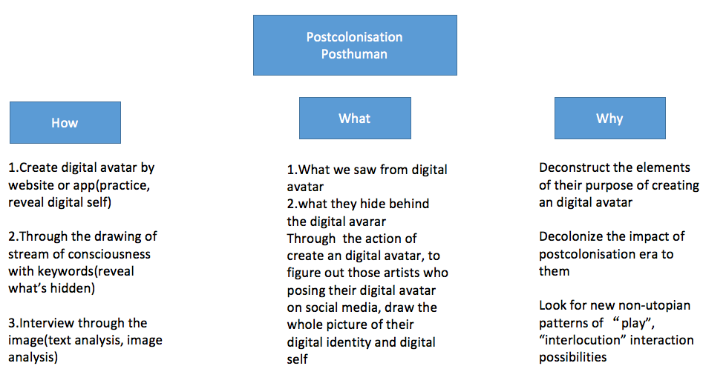
Before the formal proposal, there are several basics elements should be presented in the beginning.
1)How?
The workshop would be separated to three parts.
- Create digital avatar by website or app(practice, reveal digital self)
- Through the drawing of stream of consciousness with keywords(reveal what’s hidden)
- Interview through the image(text analysis, image analysis)
Did we have an opportunity to understand what the artists actually try to express by the action of create an digital avatar, if it is possible, what’s the pattern to understand their dialogue through the three levels of sociological(Symbolic interaction), psychological(Intersubjectivity), philosophical(Ontology, beyond subject-and-object division) perspective, if we set artist as a player in a game(Gadamer play as art), their purpose of creating avatar might for communication, so the research design would provide a method to understand their purpose, thereby exploring the decolonization power of their action. “Draw upon a philosophical distinction between knowledge and technology or art, examining how virtual selfhood is becoming predicated on the idea that people can craft their lifeworlds through intentional creativity.” “For instance, unlike books, newspapers, radio, and television, the existence of separate classes of people to produce and consume content does not always predominate in virtual worlds: it is much easier for “user” and “creator” to be the same person. Yet old forms of social inequality persist and new ones may appear.” (Boellstorff, 2008)

2) What?
This research drawing an ethnographic portrait of the culture of artists’ digital avatar on the fieldwork of social media. Which would main focus on the social media as Instagram (which been most used by artist in the UK), Redbook and Wechat (which been most used by artist in China). It would be started with an auto-ethnography method through researching on myself past established of the digital avatar in the beginning of the emerge of social media in China. I am trying to find out the reason why they create an avatar, what’s the purpose of the action, what’s hid behind the action.
- What we saw from digital avatar
- what they hide behind the digital avarar
- Through the action of create an digital avatar, to figure out those artists who posing their digital avatar on social media, draw the whole picture of their digital identity and digital self。

3)Why?
In the book “Why Hasn't Everything Already Disappeared?”, Jean Baudrillard claim that power control by minority, colonization, The power of homogenization haven’t disappeared, they just change a path to hide behind the technology in a more hidden way. It controls every action of us, but we might not awake of its existence. When artist create an avatar it always conveys one’s desire of being someone beyond themselves, “re-configured and organized differently” (Nayar, 2004), sharping an new character by their own experience, effects, and something they wanna break through. To explore the meanings of digital avatar is to dive into the deepest part of ourselves through the action of creating an avatar, just like we understand ourselves by our parents, by a mirror. And it’s a deconstructing way to figure out the impact of post-colonization, post-human culture. “At issue is the simple fact that not so long ago, the percentage of human social life spent in virtual worlds was zero, that percentage is increasing, and social inquiry must follow this movement online.” (Boellstorff, 2008)
- Deconstruct the elements of their purpose of creating an digital avatar
- Decolonize the impact of postcolonisation era to them
- Look for new non-utopian patterns of “play”, “interlocution” interaction possibilities.

- framework
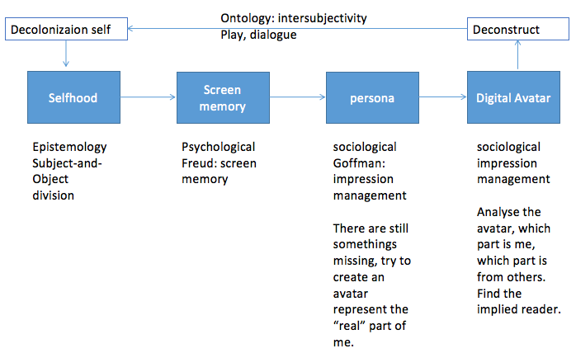

- Background and Literature review
In the age of social media, people’s action on it impact by the Post-colonization, no matter from the definition of gender, or the Instrumental rationality, and the object-and-subject division, and also what they chase about the figure they looks like online. In China, many people would posing the photo that been manipulate themselves like a hybrid, or a Japanese doll. Through the impression management they already have more than one avatars online(The phenomenon has been discussed in ADAD7016). Moreover, the avatar online would affect their actual life.

But the avatar that artist created looks much more novel, it represents individual’s aesthetic standard rather than the popular one. It would be tackled by the research that insight into the deep logic of why artist create their own digital avatars. This research would explore in the field and the period of social media, the place that artist posing their avatar and interact with audience.

From a theoretical framework aspect it would divide into the sociological, ontological, and the technological parts. This research provide the new fieldwork of research inter-subjectivity, it would produce new knowledge and achieve the new understand of the action, thereby reinforces the value of the study.

sociological
In the last article, from the perspective of social elements, the symbolic interaction theory been apply as the main thought of how artists’ digital self been established, how their digital avatar represent themselves. From this aspect it would use Goffman’s insight of people’s representation in everyday life to investigate the simulate world on social media.

ontological
From the perspective of Inter-subjectivity, retrospect Husserl, Martin Buber, Heidegger, Gadamer, and Habermas theories, to understand the digital native artist action. Unlike conventional theories of aesthetic experience based solely on subjectivity, the understanding of art as an event necessitates a new ontological structure. An artwork is not something that exists entirely apart from the viewer but is nonetheless provided to the viewer for his or her own enjoyment. The game analogy, on the other hand, indicates that the act of viewing enhances the being of the artwork by making what is at play within it more fully realised. The development of the subject-matters that art stimulates depends on the audience just as much as it does on the artist. The aesthetic spectator is engrossed in the artistic experience, engrossed in its play, and perhaps even transformed by that which spectatorship contributes to.

technological
It would be separate to four parts about the background of this research to trace the path of how digital avatar could be create, and the background of it.
Prehistories of the digital avatar
Histories of digital avatar technology
A personal digital avatar history
A histories of virtual worlds
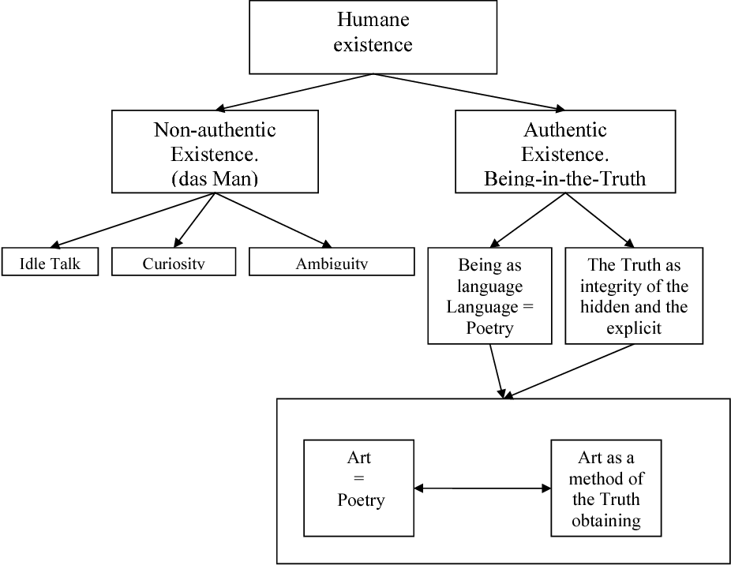
Heidegger
There could be a new truth in the digital world, an new authentic existence possibility of being-in-the-truth, we might have no idea to go back the life before network emerge, but in a Web 3.0 era, there could be some way to balance the actual and virtual life to avert the alienation. To build up an new “life-world” but not just in a utopia imaginations.

- limitations
Using the “traditional” ethnography method to research on a new flied, there might be some different to the research on actual world. Some readers would not be familiar with artists’ avatar on social media, so it gave me a chance to describe artist’s digital avatar to them, comparing with the commercial digital idol or virtual human. The scope should be clarify otherwise, readers would mix up the concept of digital avatar. Digital avatar is profound topic would contain different aspects, such as feminism, gender, economics and politics. It’s tough to decide which part of the digital avatar should be included, because of the thesis-length and time-consuming, in this project would just explore the purpose of why artist tend to create their own avatar, and generality.

- Potential significance
1)Use digital avatar as a channel to understand the creator himself, making understanding possible.
2)To explore how digital avatar can become art
3) If the self we share on social media is the "I" that is socially influenced and managed, the artist's attempt to convey the hidden or socially unacceptable behavior with the created avatars is a possibility for dialogue and play. This behavior may even be a critique of homogenization, hoping to embody the possibility of heterogeneity and break the shackles of fixed systems.
4) The created digital avatar is an exaggerated and magnified approach to the alienation of human beings. We can see more intuitively from the digital avatar what has been obscured and what the post-human race will look like under the rule of technology. Is this the future we want? Or have we entered a trajectory of impossible change, and is there a possibility of non-utopian communication that is worth exploring in the digital world, and is it possible to have a "living world" in a digital world ruled by technology?
5) When an artist creates a digital avatar, he or she is creating a player, essentially inviting other players to join him or her. This process is actually creating a new possibility of interaction.
6) Although the ego is a product of society, it is also the result of the interaction between the main self and the guest self. To change the influence of the guest ego on the subject ego and to find the value of the existence of the subject ego, we need to go beyond the dichotomy of subject and guest, find a new way of "communication", and reduce the influence of alienation on us.

Project aims and objectives

- Aims
To provide an ethnographic portrait of the artists’ digital avatar on social media.
To demonstrate the potential of ethnography of research on digital avatar.
To contribute toward a progress understanding the contextual background and diversity transforming complexity of digital avatar.

- Objectives
Through searching on social media for a long time to capture the digital avatar of artist, using the visual research methods to draw the portrait of artists’ digital avatar.
“The visual is therefore inextricably interwoven with our personal identities, narratives, lifestyles, culture and societies, as well as with definitions of history, time, space, place, reality and truth.” (Pink, 2013) To understand the aim, purpose and objectives that artists created digital avatars, explore the contextual cultural of what urge them create the one different to who they are in actual world, using “Art as Interlocutor” “Play and the play of art ”concept of Gadamer of who was the implied reader interact with artists’ avatar. Explore how’s their screen memory modify them , how they try to break out the trap, create an new avatar to express themselves, although it might be just wonderful fantasies, but they try as a pioneer.

Research design

1.Research questions
What’s the purpose of the action that artist create their own digital avatar?
Sub-question would be what’s the culture influences the action of creating digital avatar?


The first avatar I’ve been used in the emerge of social media, it called QQ shows. You could create an avatar based on different cloths, make-up, and backgrounds. It would showed up in the chat box, when you talk to others they could see your QQ shows. The other scenes it could be used is in the virtual space (Like the sims or second life), your avatar could talk to others, you would spend your life in that space, for example, have marriage with others, date, get to work, feed pets and so on.
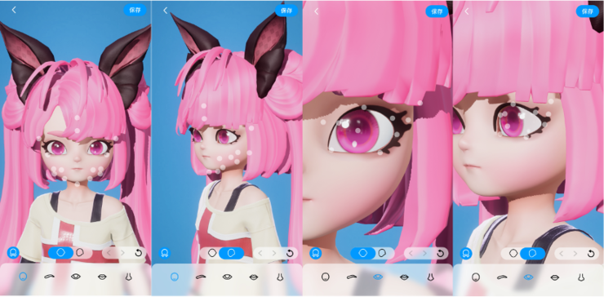
Recently, the QQ shows company develops QQ shows to Super QQ shows, it’s like the Metaverse, you could interact with others in the virtual space use an 3D avatar. But the fundamental vision is same, for people to interact.
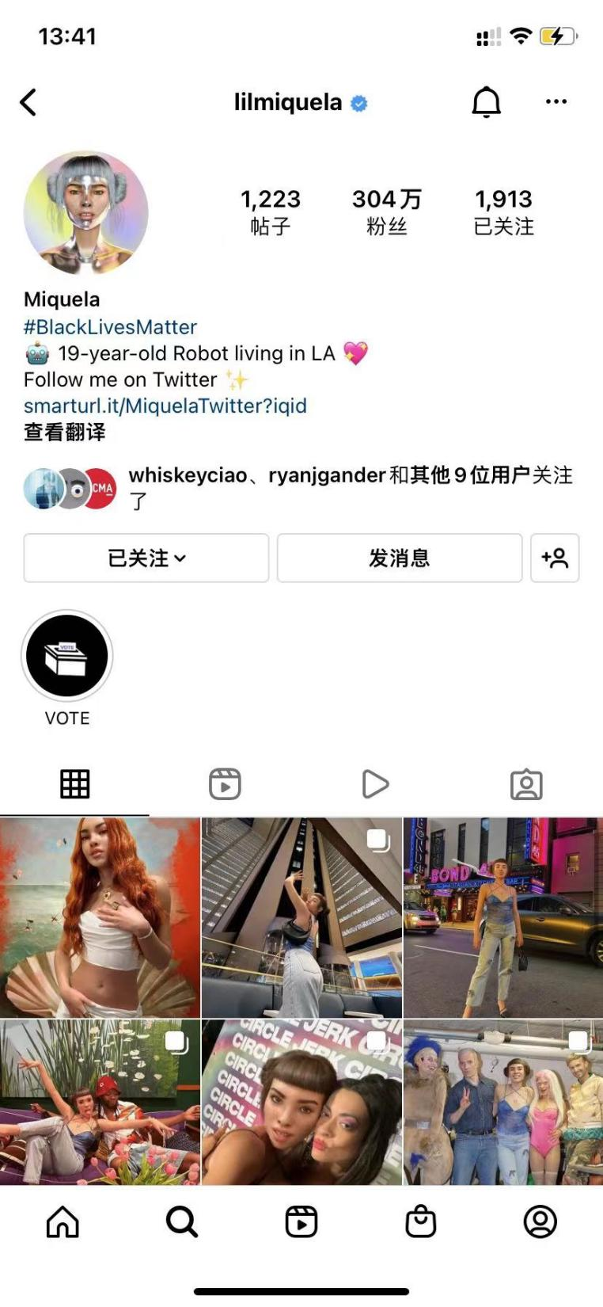
Nowadays, increasingly artists create their own digital avatar, posing it on social media, in the period of commercial digital avatar been created by different companies, why artist still chose to create the outstanding avatar not for earning money. What’s the original intention impel them to do such thing? What the culture affect their behaviour? It could be demonstrated by the research.

2.Design and methodology
Using the ethnography way to investigate the culture of the group of artist who posing digital avatar on social media, through the online discovery bleeding to the offline, research would combine the actual and virtual world. “online and offline experiences blend into a single, albeit multifaceted, narrative of life”(Campbell, 2004). Although sometime the personas online and offline didn’t match up, but the gap between them could become a data of the culture as well. Different to lots research on “Second Life”, they tend to do the ethnography only online, considerate the platform as the new fieldwork place. But talking about avatar, it’s unpersuasive that far form the actual world. It’s like talking about a online game, you could say that the game is the component of data, but you can’t say the creation and action of the digital avatar could be established without the ideology of actual human. However there are some problems that the virtual wold sociality could not be totally explained by actual world ones, so it demands the researcher to involve into the social media world, explore the actions that artist did on the social media. To demonstrate the different cultural logic by investigating the existence of a continuously cultural logic shared by those artist who posing digital avatar online.

As we’ve discussed before, the fieldwork would be conduct base on the social media network, but it would be extend to the actual work. In the steps of research, it would contain the art students who have the avatar online, but they didn’t intense to create digital avatar for themselves, this research would record the process of what and how they create one. And the other part would be interview the artists who already created their digital avatar and posed it online.

Before gather the image participants’ creation and interview, there would be ethics form and informed consent form been discussed with my tutor, then would be signed by the participants.

Data analysis of research.
Methods: In this research, the qualitative method would be used, such as context analysis, interview, image analysis under the methodology of ethnography. “one current limitation of the study of virtual world is that we know little about how online behaviors affect users’ behavior offline” (Schroeder, 2002) Ethnography is way to understand the culture of the digital native artists who posing digital avatar online. Using qualitative method is to understand their purpose through the behaviors, using the inter-subjectivity perspective way to interpret the culture.

The use of participant observation is appropriate because Tom Boellstorff using the classical anthropologist way “participant observation” through interview and analyse the context in Second life in “Coming of age in second life: an anthropologist explores the virtually human.”

Use of a web-based interview has some distinct advantages over the use of face to face interview because a lot of artist would not stay in a same place, they could be worldwide just with their computer and smart phone.

Data collection and analysis:
The data would be the images, words produced by the artist, it would be collect in a ethnography way by observation and interviewing.

The qualitative data from young artists’ digital avatar will be analysed using both content analysis and discourse analysis. Visual images and the interviews will be interpreted using narrative analysis.

In the third procedure of the workshop, there would be a interview for the feedback of how they treat the one they created.
Stage one: descriptive coding
Stage two: interpretive coding
Stage three: overarching themes

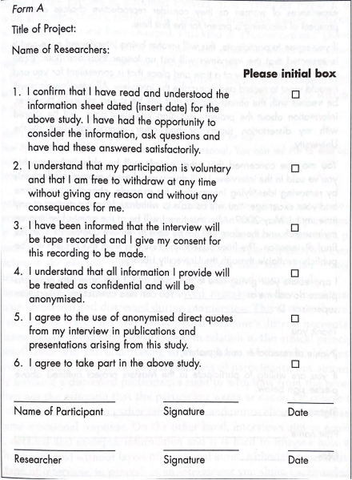

Assessment of the creation of digital avatar
Questions | Interview extract | Comments | Descriptive codes | Interpretative codes

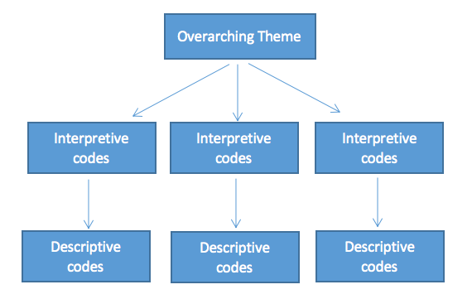

The research will be conducted during a two-month period starting August, 2022. Create digital avatar by website or app(practice, reveal digital self. Through the drawing of stream of consciousness with keywords(reveal what’s hidden). Interview through the image(text analysis, image analysis)

The interview and data collection phase of the research will take place during a four-month period starting in Nov, 2022. Create my own digital avatar, use the identity to constantly stay in social media observing the artist who posed digital avatar online, have the interview with them, collect data under the permission of artists.

The analysis of data stage of the research will takes a three-month period beginning from Apr, 2023.

Writing the articles through the gather of data start from Aug, 2023.

Visual research

1.Planning and resources
Aug, 2022 | Writing the proposal of research
Sep-Oct, 2022 | Start conducting research  1.Create digital avatar by website or app(practice, reveal digital self)  2.Through the drawing of stream of consciousness with keywords(reveal what’s hidden)  3.Interview through the image(text analysis, image analysis)
Nov, 2022-Mar, 2023 | Collect data by interviewing artists.
Apr-July, 2023 | Analysis of data, assessment of the value of data
Aug-Oct, 2023 | Write the articles through the gather of data.
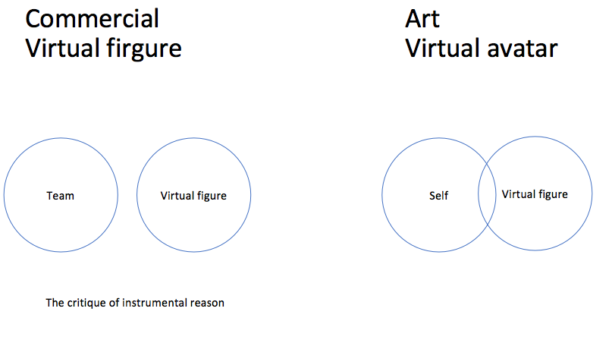

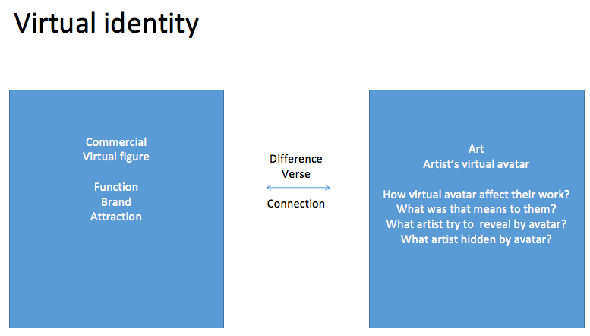

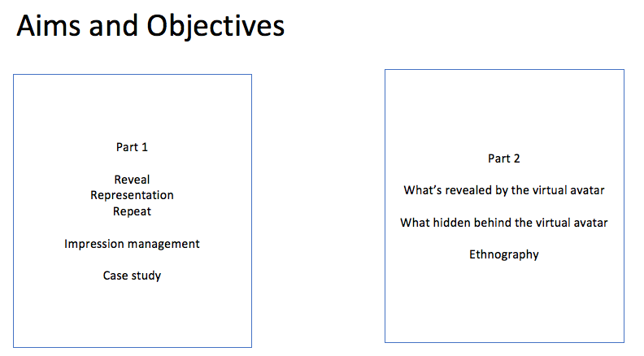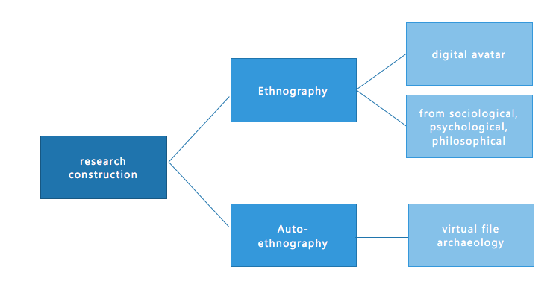
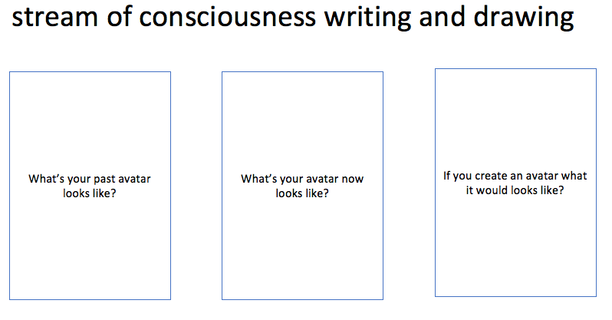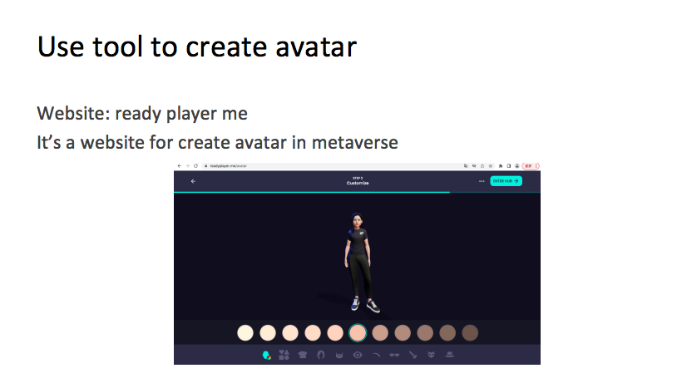

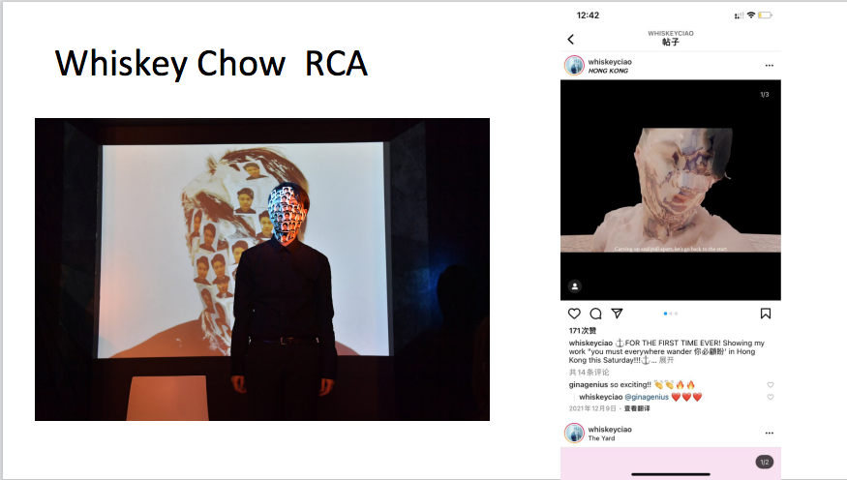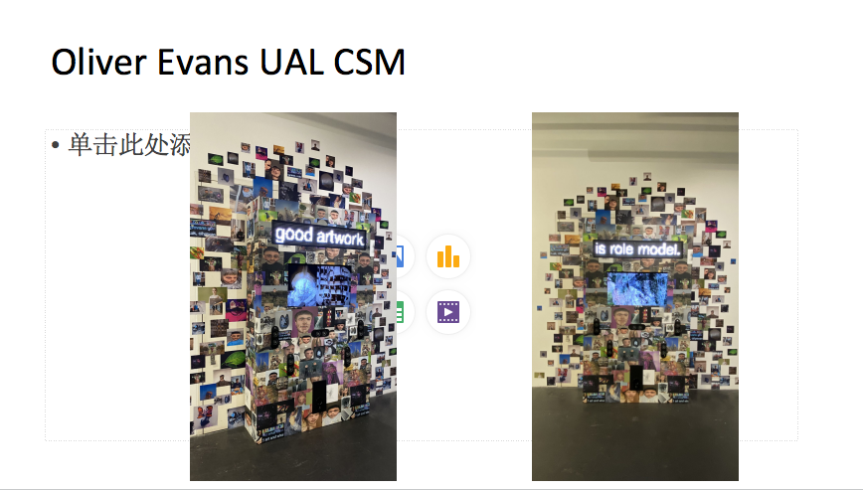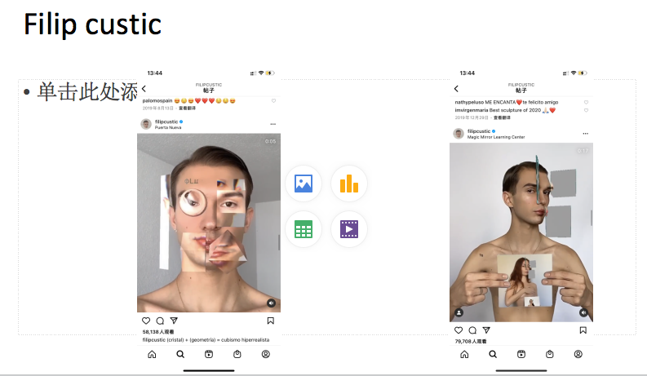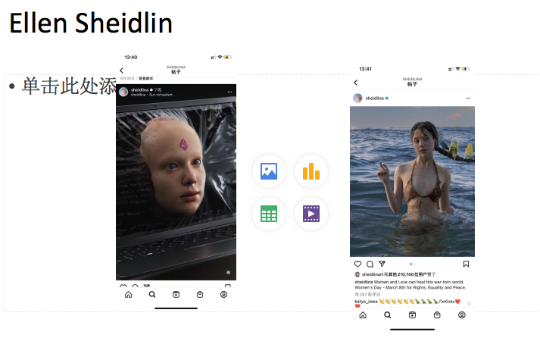

Ethics Form Appendix (1000words)

Reference
Boud, D., 2001. Using journal writing to enhance reflective practice. New directions for adult and continuing education, 2001(90), pp.9-18.

Boellstorff, T., Nardi, B., Pearce, C., & Taylor, T. L. (2012) Ethnography and Virtual Worlds: A Handbook of Method. Princeton University Press. https://doi.org/10.2307/j.cttq9s20

Boellstorff, T. (2008) Coming of age in Second Life : an anthropologist explores the virtually human. Princeton ;: Princeton University Press.

Costley, C., Elliott, G.C. and Gibbs, P., 2010. Doing work- based research: Approaches to enquiry for insider- researchers. Sage.

Coffey, A. (1999) The ethnographic self : fieldwork and the representation of identity. London: Sage.

Creswell, J.W. and Poth, C.N. (2018) Qualitative inquiry & research design : choosing among five approaches. Fourth edition. Los Angeles: SAGE.

Creswell, J.W. and Creswell, J.D. (2018) Research design : qualitative, quantitative and mixed methods approaches. 5th edition. Los Angeles: SAGE.

Czarniawska-Joerges. (2004). Narratives in social science research. SAGE.

Coffield, F., Moseley, D., Hall, E. and Ecclestone, K. (2004) Learning Styles and Pedagogy in Post-16 Learning: a systematic and critical review. London: Learning and Skills Research Centre. University of Newcastle upon

Collins R. and Fillery-Travis A. 2015 Transdisciplinary Problems: The Teams Addressing them and their Support Through Team Coaching. In: Gibbs P. (eds) Transdisciplinary Professional Learning and Practice.

Coffey, A. (1999) The ethnographic self : fieldwork and the representation of identity. London: Sage.

Emmison, M., Smith, P. and Mayall, M. (2012) Researching the visual. 2nd ed. London: SAGE.

Fillery-Travis, A.J., 2014. The framework of a generic DProf programme–a reflection on its design, the relational dimension for candidates and advisers and the potential for knowledge co-creation. Studies in Higher Education, 39(4)

Honey, P. and Mumford, A. (1995) Using Your Learning Styles. Maidenhead: Peter Honey Publications

King, N. (2010) Interviews in qualitative research. London: SAGE.

Moon, J. A. (2006). Learning Journals - A Handbook for Reflective Practice and Professional Development, Abingdon: Routledge.

Nuñez-Janes, M. et al. (2017) Deep Stories : Practicing, Teaching, and Learning Anthropology with Digital Storytelling. Warsaw ;: De Gruyter Open Poland,. doi:10.1515/9783110539356.

Nayar, P. K. (2004). Virtual worlds: culture and politics in the age of cybertechnology. SAGE Publications India.

Reed-Danahay, D. (1997) Auto/ethnography : rewriting the self and the social. Oxford: Berg.

Scohn, D.A., 1983. The reflective practitioner: How Professionals Think In Action. Basic Books.

Silverman, D. (2022) Doing qualitative research. Sixth edition. Los Angeles ;: SAGE.

Salmons, J.E. (2013) Doing qualitative research online.

Tyne Lundgren, H. and Poell, R.F., 2016. On critical reflection: A review of Mezirow’s theory and its operationalization. Human Resource Development Review,

Wallace, R.A. and Wolf, A. (2005) Contemporary sociological theory. 6th rev.ed. New Jersey: Prentice Hall.


