Student Name: Dawid Lagwa
Student Number: 1703488
Module Name: Electrical & Electronic Principles
Module Code: ACDA4002
Assignment Title: Electrical & Electronic Principles
Lecturers Name: Dr.Steve Mosey

Table of the Contest

1. Introduction

2. RLC Circuit
2.1. Circuit Components
2.2. Terms

3. Resonant Frequency
3.1. Theoretical
3.2. Measured & Comparison

4. Q Factor
4.1. Theoretical

5. Conclusion

6. Appendix

1. Introduction

This paper is written by a HND Electronics Engineering student in his first year of studies in a University. As a part of practical/theoretical assignment this paper will cover two very important principles used in world of physics and electronics engineering. The first topic that will be covered is Resonance and what it is but also where it’s used most commonly. Second topic is Q factor and what it is and how it applies to real world physics. As a part of the assignment the student has researched previously mentioned topics and has carried out a practical exercise on commonly used circuit. The results and calculations of previously mentioned practical exercise will be included and explain in this paper.

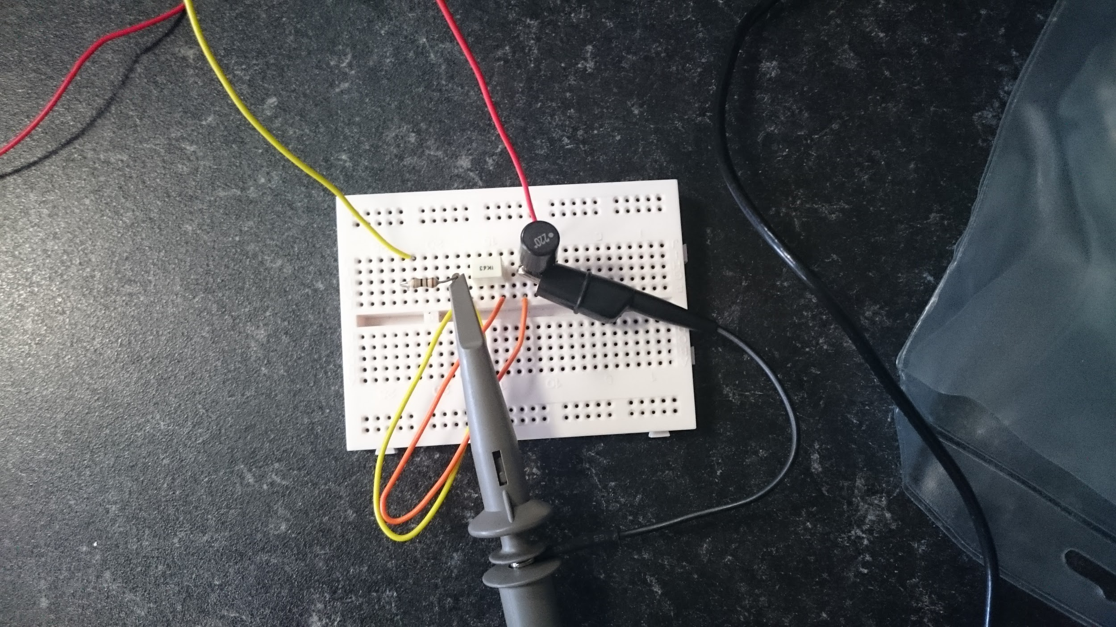

2. RLC Circuit

The Resistor, Inductor, Capacitor circuit or RLC circuit. Is an electrical circuit consisting of three simple widely available components. A clue to the identity of these components is within its name RLC or if using their representative Letters in mathematical equations it would be called LCR (Inductor, Capacitor, and Resistor) circuit.

If these components are connected in parallel or series they will form something called Harmonic Oscillator. Which if using its classical definition harmonic oscillator is a system that when displaced from its equilibrium position (Particle on which total net force equals zero) it experiences a restoring force (In physical context it has tendency to bring back the system to equilibrium) proportional to the displacement.

RLC circuit is a tuned circuit which are dominantly used in Oscillating circuits and Radio and Communication engineering (Tuning Radios or Audio Receivers) but they also see wide application in: Low-Pass filter, High-Pass filter, Band-stop filter, and voltage multiplier and oscillator circuits.

RLC circuits have an ability to select a narrow range of frequencies from a spectrum of an ambient radio waves. The example of this ability is that old fashion AM/FM (Amplitude/Frequency Modulation) radios which had analogue tuners which used RLC.

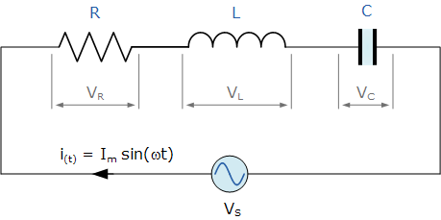

This is a RLC circuit diagram

2.1. Circuit Components

Resistor is a passive component that’s used in most of electronic circuits to limit the current flowing through active components inside of the circuit such as Operational Amplifier or Light Emitting Diode, which can be easily damaged by unregulated current.

Each produced resistor has a printed colour code on it to identify its resistance to current and how accurate the resistor is. Which is an important factor in circuit design most common circuits are within 10% accuracy range but resistors used in more complex and often more sensitive circuits are within 1%.

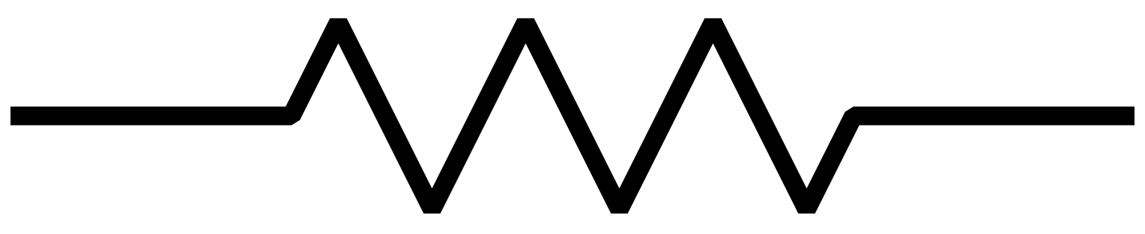
This is the American circuit diagram symbol for a resistor
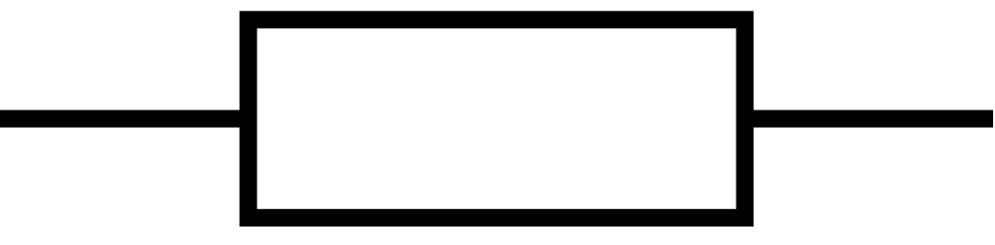
This is a European circuit diagram of a resistor.

Capacitor can be described as a small battery as it stores current flowing through it for a short term before discharging back again releasing all the current it has stored inside. The capacitor stores the charge in between two metal plates and separated by dielectric material like air or glass.

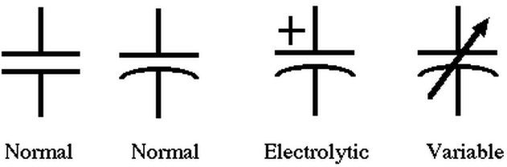
Inside of the circuit the capacitor can be configured to be used as for variety of things like power storage,flexible filter or noise reduction. Below you can see all the circuit diagram symbols for all capacitor varieties.
Inductor is a passive component which stores energy in a form of a magnetic field which is created by current flowing through tightly tied copper wire in a loop or a coil. This also creates inductance which depends on a span of the coil or copper wire loop.

Inductors are used as form of a current filter what this means is that the inductor blocks incoming Alternating current (AC) while letting a Direct current (DC) pass without a problem. Another common use for inductors is to filter signals of different frequencies, if the inductor is combined with capacitors to turn it to a functional circuit it can be used for purpose of tuning radio and television receivers.
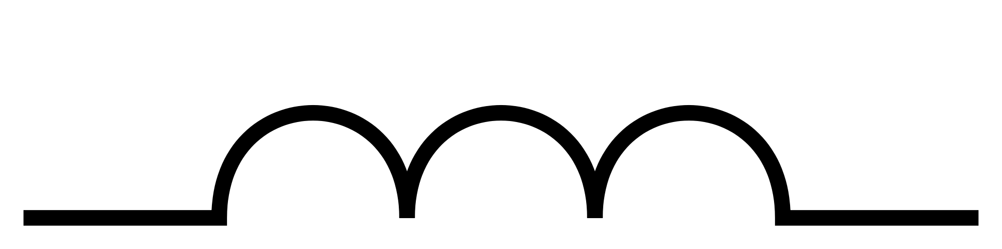

Here is a symbol for inductor.

2.2. Terms

Many factors apply to electronic circuits both in design and how they work one of those factors is reactance which creates opposition of inductance in AC which is equal to creation of angular frequency of the current times by self-inductance. Within mathematical formula Retance is shown as a X.

Within the RLC circuit reactance occurs in two forms which are produced by the components. First form of retance that occurs in this circuit is Inductive reactance or XL which is produced by the inductor and second is capacitive reactance XC which is produced by a capacitor.

Impedance or Z in mathematical formulas is an opposition that an electronic component or a circuit as a whole offers to AC and/or DC current. In other words this can be described as a form of a resistor to a specific type of either of currents.

3. Resonant Frequency

Resonance occurs in Mechanical, Electronic and it also occurs in materials but this paper will only cover Electronic systems. Resonance is increase of amplitude of oscillation in electronic, mechanical systems or materials. In electronic system resonance occurs when capacitive and inductive resonance are matched in magnitude which causes a electric energy to oscillate between inductors magnetic field.

3.1. Theoretical Resonant Frequency

Theory behind the resonant frequency is that vibrating system ie external force drives another to oscillate with great amplitude at specific frequencies. Below there’s a graphed with number of frequencies starting at five thousand Hertz ending at seventy thousand Hertz.

As shown on the graph below, it can be seen that impedance and capacitive reactance, rapidly decrease as the frequency raises and gets closer to resonant frequency. At which point the impedance starts to raise creating a parallel line with inductive reactance. From the Theoretical Resonant Frequency graph below it is shown that starting at five thousand Hertz inductive reactance has been rising and will continue to rise until and beyond it reaches seventy thousand Hertz.

Another thing that can be observed from the graph below, before thirty four thousand Hertz the circuit is capacitive and after thirty four thousand Hertz the circuit is inductive.

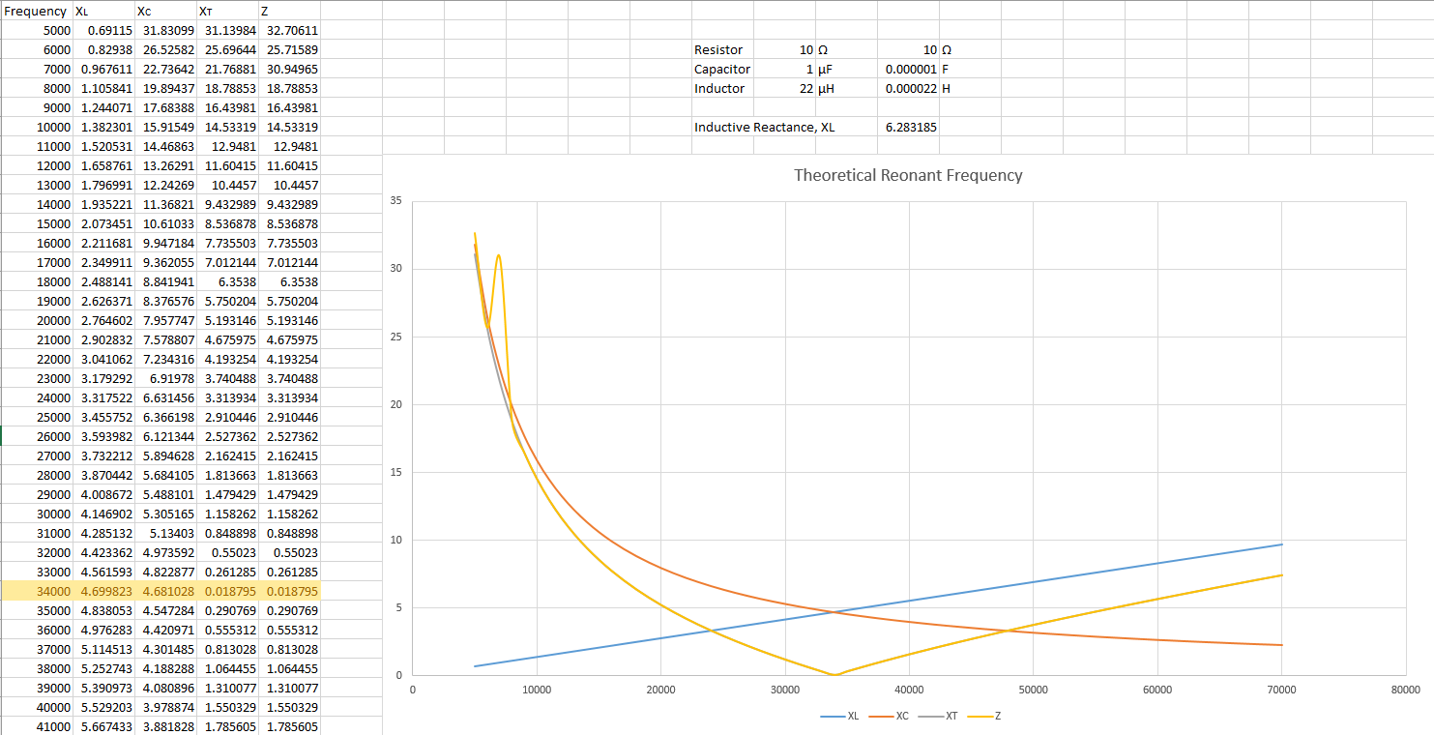

3.2.Measured Resonant Frequency & Comparison.

During the Lab exercise the student has created a graph similar one that has been presented above but this time it was created based on real world measurements only difference between the two graphs is that the student has not included Capacitive, Inductive and Total Reactance only line that has been left is Impedance for ease of comparison. Upon examination it is revealed that

On the Measured Resonant Frequency graph the student has not included Capacitive, Inductive Reactance and total reactance. But upon examination of both theoretical and measured graphs created by the student during the Lab Exercise carried out by the student. It is shown that results different by a margin of two thousand Hertz that’s due to the fact that Theoretical physics do not include real world factors.

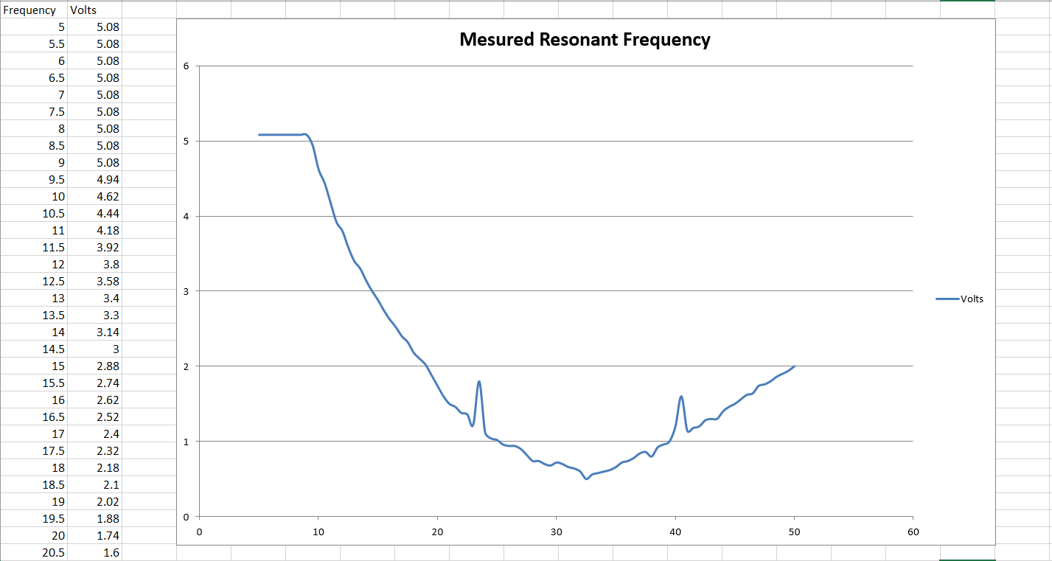

4. Q Factor

World of engineering is an advanced and complicated place because of many different fields of study and how often they intertwine with each other and different scientific fields.

One of scientific fields that is inseparable with world of engineering and other four fundamental sciences. (Chemistry, Astrology, Earth Science and Biology) is Physics. Which is a study of matter and its motion along with behaviour through time and space, in addition to this physics covers related concepts such as: energy and forces.

For a purposes of this paper and because that world of science and engineering is a vast place covering great variety of things, this paper will only cover Quality “Q” Factor.

Quality Factor (Q Factor) in RLC circuit describes maximum or peak energy stored in the circuit compared to energy used during each cycle of oscillation, what this simply means is that it’s a ratio of resonant frequency to bandwidth (Higher the circuit Q the smaller Bandwidth).

4.1. Theoretical Q Factor
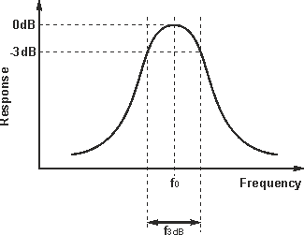

This graph has been taken from a Radio-Electronics.Com as to regards to a graph created to represent a theoretical Q factor with in RLC Circuits.

5. Conclusion

In process of writing this the student came to conclusion that Resonant Frequency and Quality factor will differ depending on the materials and circuits that are in use.

6. Appendix

Q factor:
https://www.electronics-tutorials.com/basics/q.htm
http://mriquestions.com/angular-frequency-omega.html

resonance:
https://www.electronics-tutorials.com/basics/resonance.htm
http://hyperphysics.phy-astr.gsu.edu/hbase/Sound/reson.html
https://www.electronics-tutorials.ws/accircuits/series-resonance.html
http://hyperphysics.phy-astr.gsu.edu/hbase/electric/serres.html

Restoring force:
https://en.wikipedia.org/wiki/Restoring_force

Mechanical equilibrium:
https://en.wikipedia.org/wiki/Mechanical_equilibrium

Harmonic Oscillator:
https://en.wikipedia.org/wiki/Harmonic_oscillator

RLC circuit:
https://en.wikiversity.org/wiki/RLC_circuit

Angular Frequency:
http://mriquestions.com/angular-frequency-omega.html

Radiant:
https://www.mathopenref.com/radians.html

