Effective Team Working and comunication

COMMUNICATION IN WORKPLACE
Name: Alina G Mucenic
Student number: 2108840
University of Wales Trinity Saint David
Date: 18/03/2022
Word count:2188
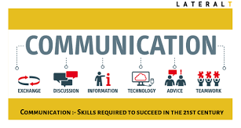
((Communication:- Skills Required To Succeed In The 21st Century, n.d.)

Executive Summary
In this report, I will describe how Tuckman and Belbin's teamwork ideas may be applied to increase cooperation in the Janet fashion shop. The study presents Belbin's team role models as well as Tuckman's group development stage. Ultimately, the objective is to foster improved communication in cooperation, both virtual and in person, as well as a better knowledge of individual job preferences. These will be discussed in further detail to aid these outcomes in their attempts to develop a team. The team provides an ideal atmosphere for learners to develop vital skills and form meaningful relationships while learning new things via activities, engagement, and virtual communication. Janet's fashion shop will overcome their obstacles to become a proficient virtual communication user in both verbal and nonverbal modes, resulting in exceptional teamwork and cooperation. Teamwork aids in the development of skills, allowing workers at the Janet Store to be more productive. Additionally, the use of communication tools and training may aid in the resolution of difficulties and emphasise the effectiveness of communication approaches.

Contents Page

Executive Summary 1
Procedure 2
Introduction 3
Findings 4

Teamwork theories Tuckman Belbin
Importance of communication models Shannon and Weaver Model Berlo’s Model
Impact of virtual communication
Conclusion 5
Recommendations 6
Reference List 7-8
Appendix 9

Procedure to write this repot

For this report on the workplace and communication, I used reflective journals, academic books, websites, and researched various topics from those sources in order to improve my work performance and to put Belbin's and Tuckman's theories into practise, as well as motivating examples of communication methods in relation to the case study and why effective communication is important for the continued success of the Janet Laddie fashion shop.

Introduction

The capacity to communicate effectively is a crucial business talent, and it may also be considered an important employability skill. Communication is essential in order to maintain a good working relationship between employers and their staff and between companies and their customers. Therefore, the study case report will discuss the importance of effective communication in the workplace with regard to Janet's fashion ladies store in Swansea. However, there are several issues that arise as a result of it. To solve the problem, the Tuckerman theory of teamwork and the Belbin theory of teamwork may be used. Both are successful in resolving difficulties and increasing teamwork performance. The case study indicates that in order to establish a formal team and communicate effectively, it is necessary to have the cooperation of all employees. To put it another way, it may be claimed that collaboration, whether virtual or in the real world, is very crucial. The research will thus concentrate on the importance of effective workplace communication at Janet Williams' ladies' fashion store in Swansea, which will be the purpose of the research.

Findings
The Tuckman and Belbin theories of team building may be used to address the problems of formality and team building. According to the case study, all staff must work together in order to successfully run the store. The implementation of ideas of teamwork may help the teams become formal and operate better together. The Tuckman theory of teamwork and the Belbin theory may be used to address the problems of formality and team building.

Tuckman's teamwork theory is a model of collaboration.
According to Tuckman, Bruce W., and Mary Ann C. Jensen (1977), there are five steps that should be taken in order to improve and make the team official. It consists of the following stages: forming, storming, norming, performing, and adjourning.
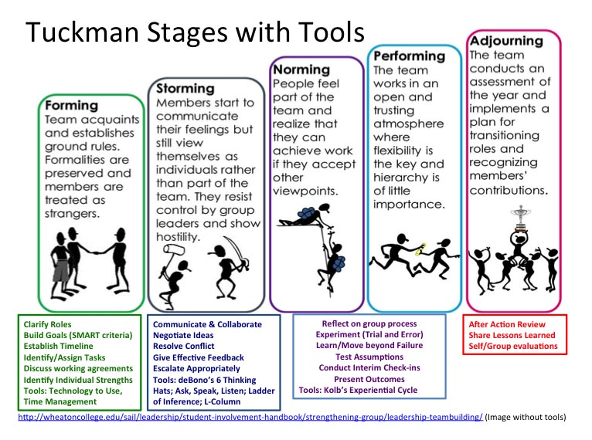
((Empower Groups | Wentworth, n.d.)

Forming
The formation stage is the initial stage in which the leader has the greatest amount of influence. This is a fascinating psychological event since team members are more likely to act autonomously at this point (Tuckman’s Theory: Five Stages of Team Development, 2000, oline). Team members concentrate on the leader, accepting only his leadership and authority, while being friendly but distant with the others. This is the stage at which new employees are eager to learn about the shop job and the people that make up the team. Before beginning any task, it is critical that the team members get to know each other and establish a working relationship.
Storming
The next step is storming, during which team members are assigned roles and duties. Therefore, the desire for confrontation cannot be neglected. Managers and leaders must take the necessary initiative to resolve the issue. It is critical at this point to seek a strong leader for advice and direction. At this point, compromises may be necessary to finish the operation within the specified time frame.
Norming
At this point, roles and duties have not only been defined but are also accepted by all parties involved. During this phase, work-related improvement begins. It is possible that the group may create a feeling of synergy, which implies that the members will believe that they can do more collectively than they could do alone. (Norming Stage of Group Development: Definition & Explanation-Video & Lesson Transcript | Study.Com, 2021). Commitment is a major aspect of this stage, and it helps in the process of completing the project and team development. Another component that contributes to the development of a strong team bond is open communication between the members of the team. Leaders' responsibilities aren't as important as they were in prior phases.

Performing
The team should raise awareness of the importance of strategy implementation throughout the phases they are in. According to the "PERFORMING" Stage of Group Development – Project Arrive, (2017), in this stage, group morale and loyalty are high, and the group is characterised by trust, experience, intimacy, and competence. The ability to communicate the team's vision is a key component of this stage, and it leads to the formation of the team as a whole. From this point on, it is possible to fully comprehend the strengths and limitations of the members of the Janet's women's fashion shop team.
Adjourning
Adjournment is the last phase of the fashion store's staff, during which the efforts of the team members are recognised and rewarded, and they express their appreciation to the general public. Rewarding and recognising employees has been shown to help organisations strengthen their values, boost their teams' efforts, improve customer happiness, and drive employees to particular behaviours. (M. Jones, 2019, online)It not only serves as a motivational element, but it also contributes to the development of online sales. However, if you deal with some of these folks again, having pleasant shared experiences will make it simpler. According to Ghalager (2021), when your employees feel valued and rewarded, everyone benefits.
Belbin theory of teamwork
According to Belbin's theory, there are nine responsibilities that must be filled in order for a team to function effectively. Individuals may get an understanding of their own inner strength by using Belbin's philosophy. In order for people to utilise their strengths on a consistent basis, they must be placed in settings that allow them to do so. This necessitates more than a focus on abilities.

It is less about skills and experience and more about a varied blend of interpersonal characteristics that lead to successful cooperation. (Meredith Belbin's, 2011, online) . Each side has its own set of advantages and disadvantages. All of the strengths may be combined in a team, allowing Janet's store to function properly.
These are : Shaper, Coordinator, Plant, Resource Investigator, Monitor Evaluator, Specialist, Teamworker, Implementer, Completer Finisher.

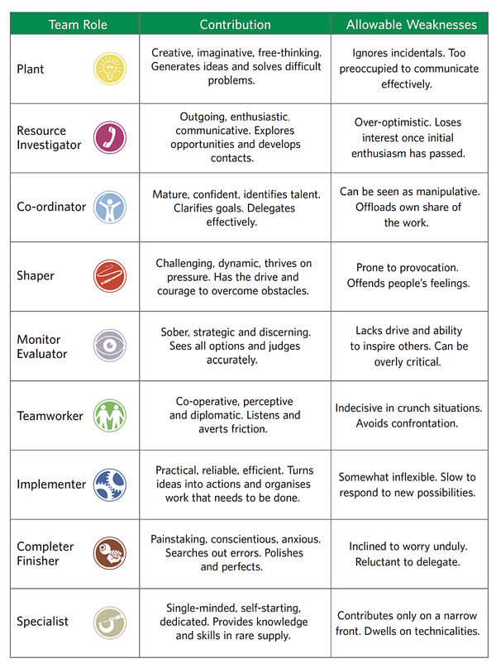
(Belbin Team Roles - PrePearl Training Development, 2016)

A shaper is a staff member at a business who is always on the go and has a lot of energy. The shaper's duty is to give assistance to other team members in order to help them improve. Implemented are those team members who have a clear understanding of how the strategy will be implemented in practise. These sorts of individuals are capable of maintaining a high degree of consistency in the right manner.
Complete finishers are individuals whose work is of very high quality in every aspect. The Janet shop should hire more of these sorts of personnel in order to keep everything running smoothly.
The coordinator may be regarded as personnel who have the ability to behave as leaders but who are not necessarily the real leaders of the company.
Team workers are employees that provide a hand with a variety of tasks. They are not in charge of the major aspects of the job's performance. Their assistance, on the other hand, is critical to effective sales.
The work of resource investigators is critical to the progress of the team. When a member of the team has a difficulty connected to their work, their job is to come up with a solution for them.
Plants are the ones that come up with new ideas, and they also play an important part in the formation of successful teams. In light of this, it's critical to point out that these are the primary drivers of a strong market position.
Even if the monitor evaluator isn't actively involved in the task, their influence on it can't be discounted. The experts' subordinates share their expertise, resulting in a more efficient work environment. The Janet women fashion business should first split its team members into various tasks in order to achieve efficiency and a fast beginning on online sales.

Importance of communication models
By using the Shannon and Weaver Model of Communication, Janet fashion retailer may solve its communication issues. Since the model incorporates a number of different variables that aid in pinpointing the precise issue, this is the case.
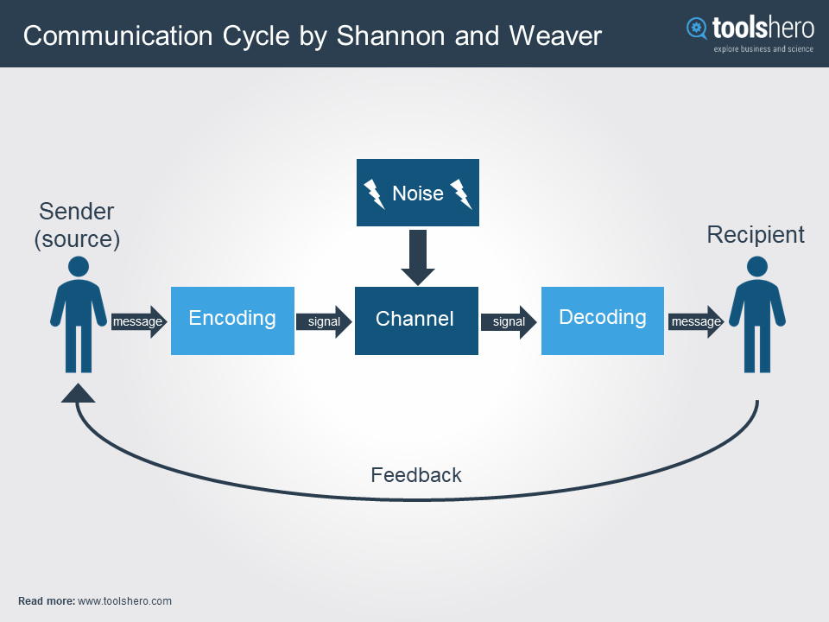
An coder and decoder are all included in this system as well.
(Communication Cycle Model by Shannon and Weaver | Effective Communication Skills, Communication Skills, Shannon, n.d.)
The proper process followed by the model can be understood by the above figure. The problem may be associated with only one factor or multiple factors. Based on the provided information, it can be said that the problem is related to both encoders as well as the decoder.
Using this specific model will assist Janet fashion store in understanding the process of adopting communication, which will be beneficial in overcoming the issue at its source. The model may assist to transform the way meetings and communication are conducted to a certain level. In the time that passes between sending and receiving a communication, information might be lost or misconstrued. (Chris Drew, PhD,2019)
Apart from this model, Berlo's model of communication can also be adopted. The fact that this specific model has a great deal in common with the preceding one should be mentioned in this aspect.
The sender of a communication is the originator of the message, or the person that sent the message. (Sender-Message-Channel-Receiver Model of Communication - Wikipedia, 2017)
Therefore the model is centred on developing communication skills, the Janet fashion shop may exploit it to its advantage. The model gives information that may be used to enhance one's ability to communicate effectively. It's a critical consideration in the effort to lessen workplace conflict. This model also takes into account a person's cultural background. As a result, the Janet fashion store's decision to use this specific model might be seen as reasonable theory to ensure that new employees get a thorough and efficient introduction while also addressing communication
challenges that the organization challenges.

Impact of virtual communication
The significance of effective virtual communication and teamwork,to assist Janet's fashion shop function smoothly and prevent the risk of being affected by COVID 19 effective virtual communication is critical.
Employees of Janet fashion shop may give a better solution to their issues by using excellent virtual communication. More information may be given with the us e of virtual communication, which is beneficial to the team's success.
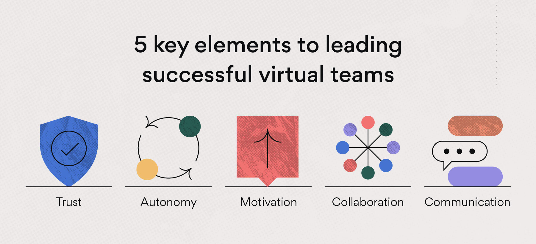
The team's use of suggestions might lead to increased levels of client contentment. Taking this into consideration, it is crucial to note that virtual communication may be accomplished via email, virtual conferencing, and the use of the phone system. According to Belbin and Tuckman ( n.d) finally, aspects such as performance, quality of the product or service obtained and member satisfaction are relevant for the results. Of course, performance is the essential variable and is the usual interest of research into virtual teams. Janet's fashion ladies' store should have the appropriate communication tools in order to be successful.
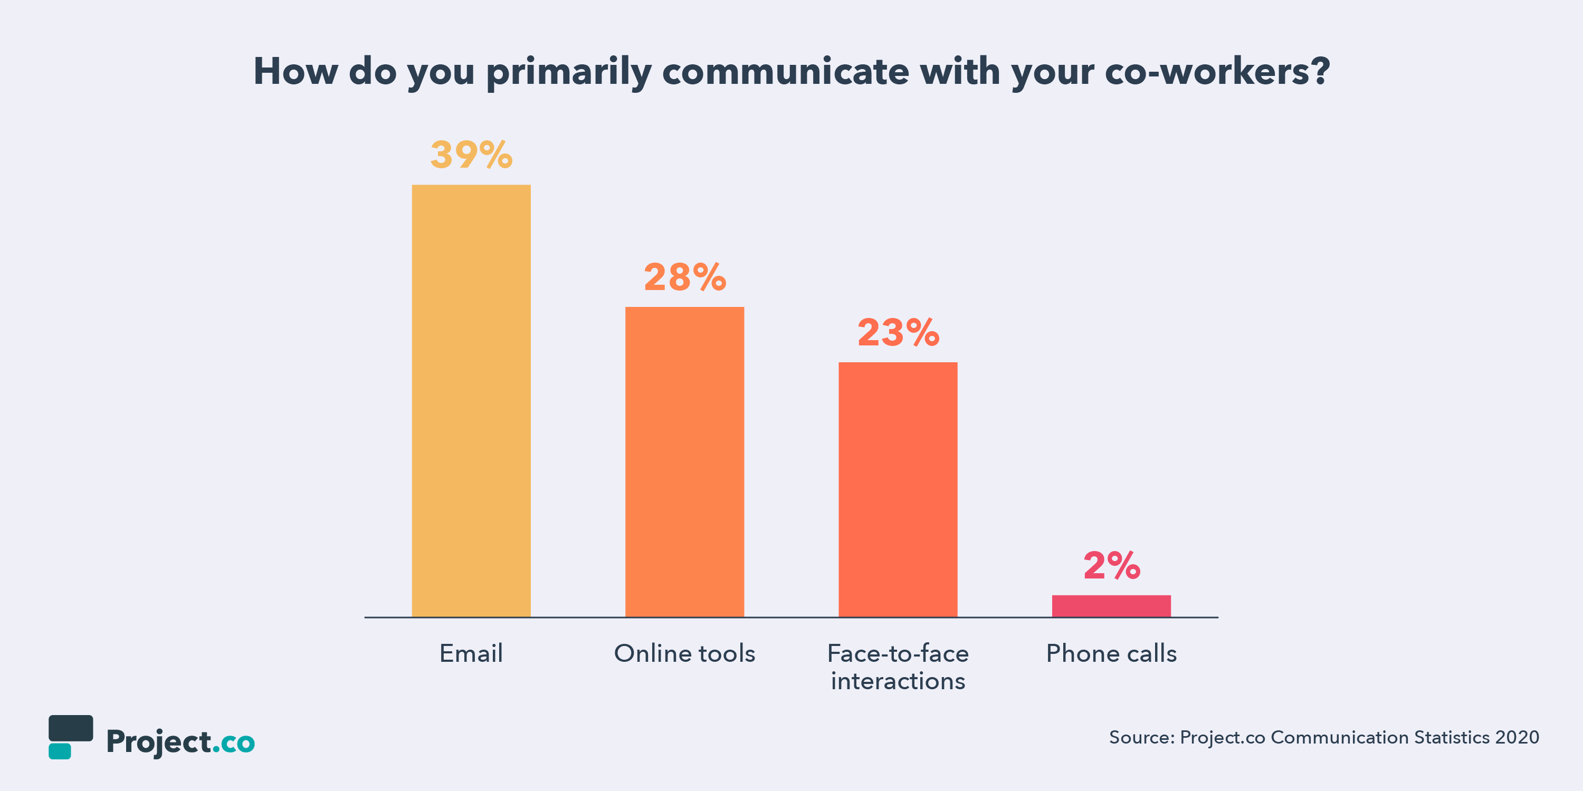
(Hayes, n.d, online)
Taking into consideration the current situation, it can be said that video conferencing will be the most appropriate technology to use.

Conclusion
Based on the foregoing discussion, it can be concluded that the Janet ladies fashion shop may use many theories and models to overcome the communication barrier, team issues and identify their group dynamics. Virtual communication was also shown to be successful in the present circumstances, according to the debate. Additionally, the usage of communication tools and training may help solve the issues.
Recommendations
This case study demonstrates that there is no relationship between the workers, that the team is not formal at this time, and that there is no link between the employees.
In this stage the likelihood of having conflicts and preventing poor communication between employees can be reduced significantly with the help of the Hannon and Weaver Model of communication, which assists in identifying the precise problem and developing communication recommendations for Janet's fashion store in order to succeed as a team and grow significantly larger in a short period of time. Customer service will be improved by an excellent communication level. To address the communication and team building issues at the Janet fashion shop, From team creation through job completion, Tuckman looked at the stages of team development and came up with four distinct types of teams: those that are forming, storming, norming, and performing. The nine Belbin Team Roles, based on Belbin's observations on teams, explain ways in which members of a team might contribute and interact with one another (Belbin and Tuckman, n.d.online)

Appendix

Reference
- Belbin Team Roles - PrePearl Training Development. (2016, March 19). PrePearl Training Development; www.prepearl.net. https://www.prepearl.net/belbin-team-roles/

- Belbin, R. M. (2010). Team roles at work. Oxford: Butterworth-Heinemann.6th ed .

- Belbin and Tuckman. (n.d.). Belbin and Tuckman; www.belbin.com. Retrieved March 16, 2022, from https://www.belbin.com/resources/blogs/belbin-and-tuckman#:~:text=Tuckman%20studied%20teams%20from%20formation,and%20interrelating%20in%20a%20team. Accesed on 12March 2022

- Belbin and Tuckman. (n.d.). Belbin and Tuckman; www.belbin.com. Retrieved March 16, 2022, from https://www.belbin.com/resources/blogs/belbin-and-tuckman#:~:text=Tuckman%20studied%20teams%20from%20formation,and%20interrelating%20in%20a%20team. Accesed on 13March 2022

- Belbin and Tuckman. (n.d.). Belbin and Tuckman; www.belbin.com. Retrieved March 16, 2022, from https://www.belbin.com/resources/blogs/belbin-and-tuckman#:~:text=Tuckman%20studied%20teams%20from%20formation,and%20interrelating%20in%20a%20team. Accesed on 13March 2022
- Ghalager Reward and recognition stratedy (2021) https://www.ajg.com/uk/reward-recognition-strategy/?utm_medium=search_paid_sales&utm_source=Google&utm_campaign=GBS_2021_UK_Reward-and-Recognition-Strategy-LP&gclid=CjwKCAjw8sCRBhA6EiwA6_IF4fHCIQ7_N5bhwFoam5kgVEaV5BHUjCLyIerFxu2V6yYWYgtj71e1GhoC98UQAvD_BwE accesd on 15 March 2022

- Hayes, A. (n.d.). Businesses Still Can’t Nail Effective Communication [New Data]. Businesses Still Can’t Nail Effective Communication [New Data]; blog.hubspot.com. Retrieved March 17, 2022, from https://blog.hubspot.com/marketing/businesses-still-cant-nail-effective-communication
Accesed on 10March 2022

- Jones, M. (2019, October 8). Why is Employee Reward and Recognition Important? -. Petaurum Solutions; petaurumsolutions.co.uk. https://petaurumsolutions.co.uk/blog/why-are-employee-rewards-and-recognition-so-important/ Accesed on 9March 2022

- Norming Stage of Group Development: Definition & Explanation - Video & Lesson Transcript | Study.com. (2021, August 14). Study.Com; study.com. https://study.com/academy/lesson/norming-stage-of-group-development-definition-lesson-quiz.html Accesed on 117March 2022

- Pugalis, & Bentley, G. (2013). Storming or performing? Local Enterprise Partnerships two years on. Local Economy, 28(7-8), 863–874. https://doi.org/10.1177/0269094213503066 Accesed on 8March 2022

- PhD, C. D. (2019, August 29). Shannon Weaver Model of Communication - 7 Key Concepts (2022). Helpful Professor; helpfulprofessor.com. https://helpfulprofessor.com/shannon-weaver-model/ Accesed on 18March 2022

- Sender-Message-Channel-Receiver Model of Communication - Wikipedia. (2017, March 1). Sender-Message-Channel-Receiver Model of Communication - Wikipedia; en.wikipedia.org. https://en.wikipedia.org/wiki/Sender-Message-Channel-Receiver_Model_of_Communication Accesed on 11March 2022

- The “PERFORMING” Stage of Group Development – Project Arrive. (2017, March 21). Project Arrive; sites.gsu.edu. http://sites.gsu.edu/project-arrive/the-performing-stage-of-group-development/#:~:text=In%20the%20performing%20stage%2C%20it’s,experience%2C%20intimacy%2C%20and%20competence. Accesed on 17March 2022

- Tuckman’s Theory: Five Stages of Team Development. (2000, 0 1). FreshBooks; www.freshbooks.com. https://www.freshbooks.com/hub/other/tuckmans-theory#:~:text=Tuckman’s%20theory%20was%20first%20proposed,last%20until%20the%20project%20ends. Accesed on 17March 2022

- Tuckman, Bruce W., and Mary Ann C. Jensen. "Stages of small-group development revisited." Group & organization studies 2.4 (1977): 419-427.

- Tisocco, & Fernández Liporace, M. (2021). THE TUCKMAN PROCRASTINATION SCALE: PSYCHOMETRIC FEATURES AMONG BUENOS AIRES UNDERGRADUATES. Psychological Thought, 14(2), 444–466. https://doi.org/10.37708/psyct.v14i2.603
Accesed on 17March 2022

