8/17/2026
University of Wales Trinity Saint David
London campus
Assessment 2
Practical and Professional Development of the Proposed Project
Module Name: Changemakers, Creativity and Value creation

Module Code: ACCA 5033

Student Name: Maksim Zanev

Student ID: 2436811

Lecturer: Dr. Fahad Ahmed
Table of Contents
Introduction 2
Task 1: Project Management 3
Q1. Project Management & Planning: 3
Q2. Project Design: 4
Task 2: Enterprise & Innovation: 6
T2-Enterprise: 6
Q1. PEST and SWOT Analysis of CrowdStrike. 6
Q2. MaxTronyx Start-up Proposal 8
Task 3: Project reflection: 10
Conclusion 11
References 12
Appendices: 13
Appendix A: Work Breakdown Structure 13
Appendix B: Incident Response Storyboard 14
Appendix C: Dashboard Design Evidence 14
Appendix D: Business Strategy Summary 15
Appendix E: Project Risk Register 16

Introduction
Cybersecurity remains a significant operational, financial and reputational challenge for small and medium-sized enterprises (SMEs). These organisations increasingly depend on digital services, connected devices and cloud platforms, but often have limited budgets and insufficient specialist security staff. As a result, suspicious endpoint activity may be detected too late, misunderstood by non-specialist users or handled without a structured incident-response process. This creates a need for security technology that is affordable, understandable and appropriate for the resources available within an SME[1].
MaxTronyx is an AI-assisted Endpoint Detection and Response (EDR) prototype designed to address this problem. The project aims to investigate, design and evaluate a system that can help SMEs identify, prioritise and respond to cybersecurity incidents more effectively. The proposed solution combines a lightweight Go endpoint agent, a Node.js and Express backend, rule-based threat detection, host risk scoring, MITRE ATT&CK mapping and a browser-based Security Operations Centre dashboard. Collected endpoint telemetry is converted into prioritised incidents, visual attack timelines and controlled response options. AI assistance supports incident analysis and explanation, while potentially disruptive actions, such as endpoint isolation, remain subject to human authorisation.
This report examines how MaxTronyx could be planned, designed and developed within realistic technical, financial and time constraints[2], [3]. It documents the project scope, required technologies and resources, schedule, Gantt chart and development method. It also presents design evidence, evaluates the enterprise environment through PEST and SWOT analysis, proposes a legal structure and funding strategy for MaxTronyx Ltd., and reflects on skill development, social contribution and project risks.

Task 1: Project Management
Q1. Project Management & Planning:
The project aim is to investigate, design and evaluate an AI-assisted EDR prototype that can help SMEs identify, prioritise and respond to cybersecurity incidents more effectively. NIST provides a Cybersecurity Framework 2.0 quick-start guide specifically for smaller organisations with modest or no formal security plans, supporting the need for an accessible solution [1]. MaxTronyx will address this need through a lightweight endpoint agent, central backend and Security Operations Centre dashboard.
The project scope defines a manageable academic prototype. In scope are agent registration, endpoint telemetry, rule-based threat detection, incident creation, host risk scoring, MITRE ATT&CK mapping, an attack timeline, action logging and controlled contain, resolve and isolate responses. AI will assist with incident explanation and prioritisation, but disruptive actions will remain subject to human approval. Out of scope are a 24-hour managed SOC, global cloud deployment, fully autonomous self-learning, commercial threat-intelligence feeds and support for every operating system. These boundaries reduce scope creep and maintain the balance between scope, time and cost described by the project-management triple constraint [2].
The required technologies are a Go endpoint agent, Node.js with Express for the REST API and backend services, and HTML, CSS and JavaScript for the dashboard. Git will provide version control, Postman will test API endpoints, and isolated Windows and Linux virtual machines will support safe simulation. The project also requires a development computer, test data, documented detection rules and access to MITRE ATT&CK. ISO/IEC/IEEE 12207 provides a current framework for software life-cycle processes from conception through development, operation and retirement [3].
A twelve-week schedule will be managed in Microsoft Excel and presented as a Gantt chart in Figure 1. Planning and requirements occupy the first three weeks; architecture and interface design run from weeks three to four; agent, backend, detection and risk engines are developed from weeks four to nine; integration and testing continue to week ten; and the final two weeks cover pilot deployment, evaluation and closure. Dependencies include completing requirements before final architecture, completing core services before integration testing, and completing security tests before the pilot.
The principal constraints are limited time, a single-developer workload, minimal budget, unfamiliar technologies, false-positive detections and the need to protect endpoint data. The schedule includes contingency through overlapping low-risk activities and reserving the final two weeks for evaluation and correction. A risk register will be reviewed at each milestone, and changes will be accepted only when they support the agreed aim.
An Agile incremental method combined with evolutionary prototyping is the most suitable development approach. Agile encourages frequent delivery, customer collaboration and adaptation to changing requirements [4]. Each two-week iteration will produce a testable improvement, such as registration, incident ingestion, risk scoring or response control. However, Agile will be supported by written requirements, architecture documentation and testing gates so that flexibility does not become uncontrolled change. Incident-response testing will follow the NIST recommendation that detection, response, recovery and continuous improvement should be integrated into cybersecurity risk management [5].

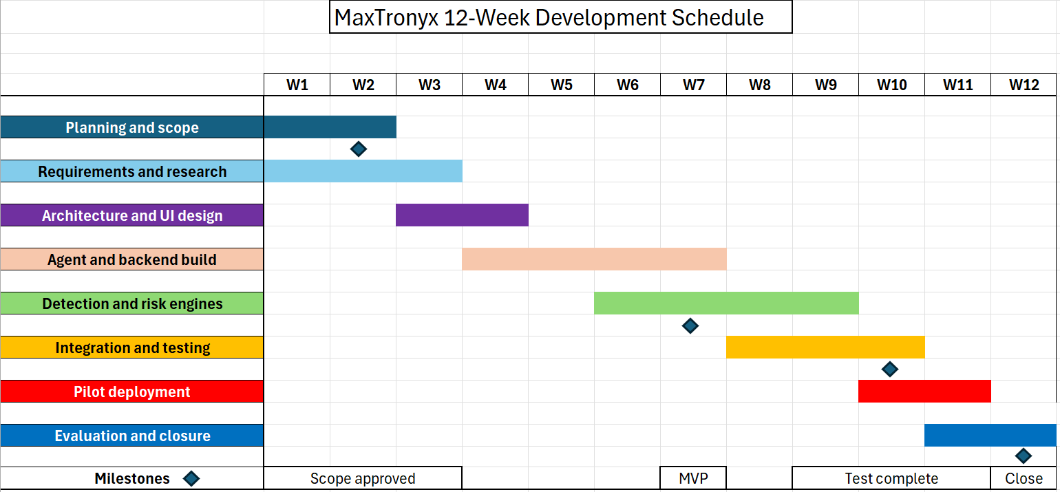
Figure 1. MaxTronyx twelve-week project Gantt chart

Q2. Project Design:
The first design component is a requirements specification. Functional requirements define what the prototype must do, while non-functional requirements define how securely and reliably it must operate. The second component is the security architecture in Figure 2. Telemetry moves from the endpoint through an authenticated API to backend detection, risk and incident services. Results are stored and displayed in the dashboard, while response commands return only after authorised user action. MITRE ATT&CK supplies a common structure for relating observed behaviour to enterprise tactics and techniques [6]. The design separates collection, analysis, storage and presentation so that each component can be tested and replaced independently.

ID | Type | Requirement | Acceptance criterion
FR1 | Functional | Register and identify endpoint agents. | A valid agent appears in the dashboard.
FR2 | Functional | Detect suspicious process and file activity. | A simulated event creates an incident.
FR3 | Functional | Calculate a host risk score and severity. | Risk changes when incident evidence changes.
FR4 | Functional | Allow authorised contain, isolate and resolve actions. | The action is executed or safely simulated and logged.
NFR1 | Security | Authenticate requests and encrypt data in transit. | Unauthorised requests are rejected; HTTPS is enforced.
NFR2 | Reliability | Preserve incident and action audit records. | Records remain traceable after restart.
NFR3 | Usability | Present clear severity, device and action information. | Pilot users can identify a critical incident without assistance.
Table 1. Core MaxTronyx requirements specification.

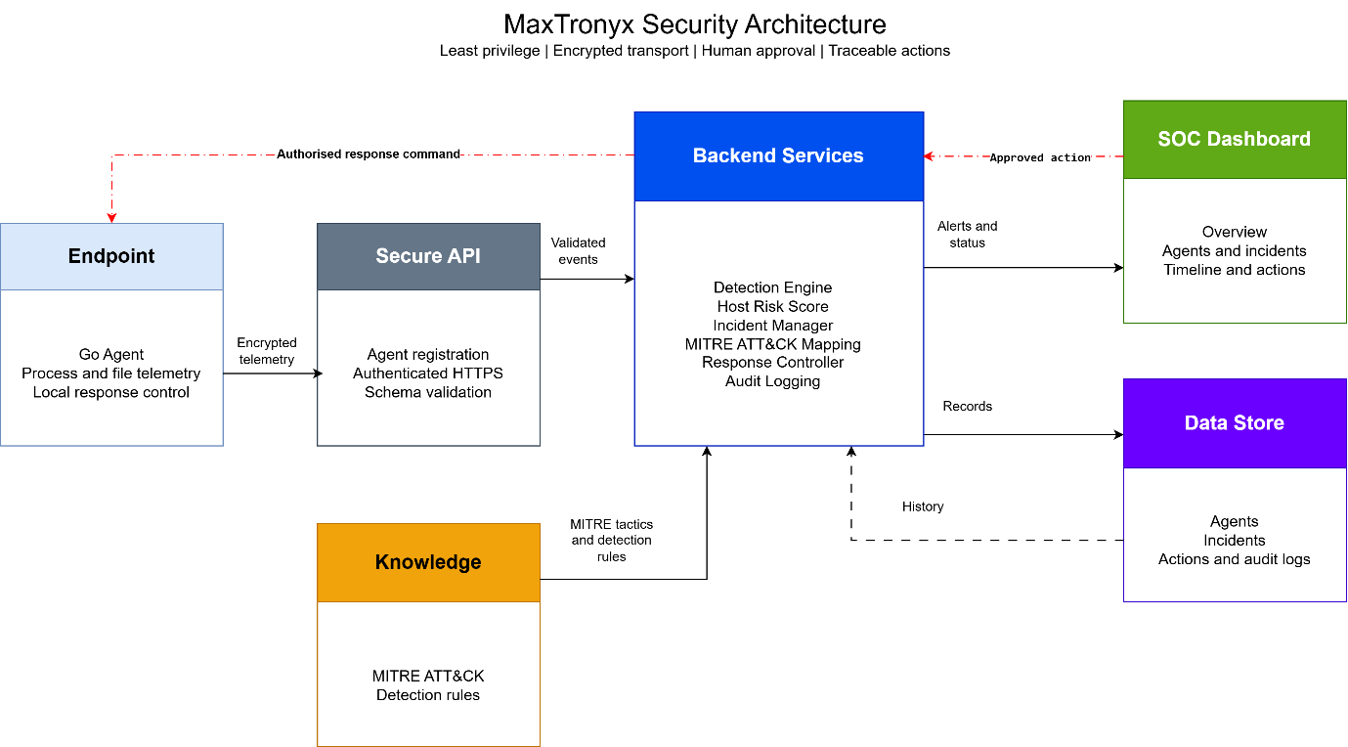
Figure 2. Proposed MaxTronyx security architecture.

Task 2: Enterprise & Innovation:
T2-Enterprise:

Q1. PEST and SWOT Analysis of CrowdStrike.

CrowdStrike is a relevant comparison because its cloud-native Falcon platform combines endpoint, identity, intelligence and security-operation capabilities. Its fiscal-year 2026 results reported ending annual recurring revenue of $5.25 billion, representing 24% year-on-year growth [7]. It is therefore a useful benchmark for the narrower SME-focused MaxTronyx proposal.
Political factors include government pressure to improve national resilience and secure digital supply chains. In the United Kingdom, the Cyber Security and Resilience Bill has progressed through its House of Commons committee stage and proposes stronger security and incident-reporting requirements for important services [8]. Cybersecurity demand is strong, but SMEs remain price-sensitive. Social factors include dependence on online services and shortages of specialist personnel. Technological factors include AI-assisted attacks, cloud-native detection and integrated platforms. Legal factors include privacy, software liability and authorised testing, while environmental considerations include cloud energy use and service resilience.
CrowdStrike's strengths are its recognised platform, recurring revenue, threat intelligence and ability to deliver many security functions through one agent. Weaknesses include platform complexity, premium cost and reputational exposure when a central update fails. CrowdStrike confirmed that a July 2024 Rapid Response Content update caused Windows system crashes, while CISA described the resulting outage as widespread [9], [10]. Opportunities include continued platform consolidation, AI-assisted SOC workflows and organisations seeking managed detection. Threats include strong competition, regulation, cyberattacks against the security supply chain and customer concern about vendor concentration.
Legal and ethical controls are essential because endpoint telemetry may reveal user behaviour, process names and device information. The UK GDPR requires lawfulness, purpose limitation, data minimisation, security and accountability [11]. Security testing must also remain authorised because the Computer Misuse Act protects computer material against unauthorised access or modification [12]. Ethically, detection should be explainable, false positives reviewable and disruptive isolation subject to proportionate human judgement.

Factor | CrowdStrike consideration | Implication for MaxTronyx
Political | Rising national resilience and reporting expectations. | Align product controls with UK guidance.
Economic | Strong cyber demand but price pressure for SMEs. | Use simple per-endpoint subscription tiers.
Social | Skills shortages and demand for clear incident guidance. | Design for non-specialist administrators.
Technological | AI, cloud-native EDR and platform consolidation. | Use modular AI assistance and open mapping.
Legal | Privacy, authorised testing and software accountability. | Minimise telemetry and maintain audit evidence.
Environmental | Cloud energy use and operational resilience. | Start local-first and measure infrastructure needs.
Table 2. PEST analysis and relevance to MaxTronyx.

Strengths  Cloud-native integrated platform  Strong recurring revenue and threat intelligence  Broad security module portfolio | Weaknesses  Complexity and premium positioning  Vendor concentration  Reputational impact from the July 2024 outage
Opportunities  AI-assisted SOC workflows  Demand for consolidated protection  Growth in managed and SME security | Threats  Powerful competitors  Regulatory and litigation exposure  Supply-chain attacks and reduced customer trust
Figure 3. Summary SWOT matrix for CrowdStrike.

Q2. MaxTronyx Start-up Proposal

The proposed start-up name is MaxTronyx Ltd. The logo in Figure 4 combines a protective shield with a circuit-based letter M to communicate cybersecurity, monitoring and technical innovation. The recommended legal classification is a UK private company limited by shares. This structure separates the company from its owners, supports share-based investment and requires registration with Companies House, including directors, shareholders, articles of association and persons with significant control [13].
The business strategy is focused differentiation. MaxTronyx will not initially compete with CrowdStrike across the enterprise market. It will provide a narrower, understandable EDR service for SMEs that lack a dedicated SOC. The minimum viable product will combine lightweight endpoint monitoring, risk-based prioritisation, AI-assisted incident explanation and controlled response. Initial pilots will be offered through local SMEs and university or industry networks. Evidence will be collected on deployment time, alert clarity, false positives and response speed. The commercial model will use a monthly per-endpoint subscription with optional onboarding and support, allowing customers to begin with a small number of devices.
Funding will be staged to reduce loss of control and avoid premature scaling. The first stage will use bootstrapping for development and testing. A government-backed Start Up Loan can provide between £500 and £25,000 per owner, with mentoring and a fixed repayment term [14]. The project could also seek support through future Innovate UK competitions or CyberASAP, which helps academic cybersecurity research move towards commercialisation [15]. Angel or seed investment should be considered only after a secure pilot, evidence of SME demand and a credible recurring-revenue model. This sequence links funding to measurable progress rather than speculative growth.


Figure 4. Proposed MaxTronyx logo and brand position [16].

Task 3: Project reflection:

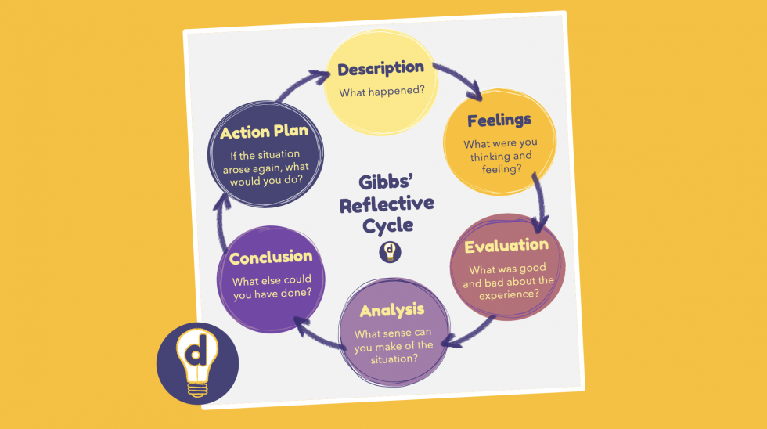
Figure 5. Gibbs reflective cycle image [17].

I have used Gibbs' reflective cycle to consider what I have learned from MaxTronyx and how I could take the project forward. Gibbs structures reflection around description, feelings, evaluation, analysis, conclusion and an action plan [17]. The project began as a cybersecurity idea for SMEs and developed into a prototype containing a Go agent, Node.js backend, SOC dashboard, incident handling, host risk scoring, MITRE ATT&CK mapping and response actions. Seeing these separate components exchange data was encouraging because it turned an abstract proposal into something testable. At the same time, connection errors, unfamiliar code and the difficulty of integrating several technologies showed me that a promising interface is not the same as a reliable security product.
The main opportunity is to develop deeper technical and professional skills. I intend to improve my Go and JavaScript knowledge, secure API design, detection engineering, Windows and Linux telemetry, automated testing and incident-response analysis. I also need stronger skills in Git workflows, deployment, documentation and communicating technical risk to non-specialists. The NICE Workforce Framework describes cybersecurity work through tasks, knowledge and skill statements, which gives me a structured way to record progress rather than claiming general improvement [18]. I will create a development log, connect each sprint to a defined skill and demonstrate evidence through tests, diagrams and short technical explanations.
MaxTronyx could contribute positively to society by helping smaller organisations recognise threats before they become major incidents. SMEs support employment and local services but may not have a specialist security team. The NCSC provides practical small-organisation guidance on protecting devices and accounts, backups and identifying scams [19]. MaxTronyx could complement these controls by making endpoint alerts easier to understand and by helping an administrator prioritise the most urgent host. My new skills could also be shared through documentation, demonstrations and responsible open components. However, social value depends on avoiding exaggerated claims. The system should be presented as decision support and not as a replacement for trained professionals.
The most serious technical risk is that a false positive could isolate a legitimate device and interrupt business. I would reduce this through severity thresholds, staged testing, explainable evidence and human approval before disruptive actions. A second risk is that the security platform could itself become an attack target. Controls should include authenticated agents, encrypted transport, least privilege, input validation, secure secrets, dependency checks and independent penetration testing before any real deployment. A third risk is privacy because telemetry may reveal employee activity. Data collection will therefore be limited to what is necessary, supported by retention rules, role-based access and auditable use. These decisions follow the ACM expectation that computing professionals avoid harm, respect privacy and make the public good a central concern [20].
Project risks also include limited time, cost, scope creep and insufficient user feedback. The twelve-week plan, scope baseline and risk register will separate the academic MVP from future commercial features such as multi-tenancy, threat-intelligence subscriptions and autonomous learning. If a feature does not support the aim or acceptance criteria, it will be moved to the roadmap. Pilot feedback will be collected from users with different levels of cybersecurity knowledge, supporting the project’s user-centred and evidence-based development approach.
My action plan is to complete the documented MVP, build repeatable unit, API and system tests, measure detection and response behaviour in an isolated laboratory, and conduct a small usability review of the dashboard. This reflection confirms that project value depends on a secure, understandable and demonstrably useful system for SMEs.

Conclusion
This report has developed the MaxTronyx concept into a structured technical, project-management and enterprise plan for an AI-assisted Endpoint Detection and Response solution aimed at small and medium-sized enterprises. The defined project scope, required technologies, twelve-week schedule and Agile incremental development method provide a realistic pathway from the current prototype to a secure and testable SME pilot. The requirements specification, system architecture, Gantt chart and incident-response storyboard demonstrate how endpoint telemetry can be collected, analysed and converted into prioritised incidents, host risk scores and controlled response actions.
The PEST and SWOT analysis of CrowdStrike highlights the commercial opportunities within the cybersecurity sector, while also demonstrating the challenges created by strong competition, regulatory responsibilities, complex platforms and the consequences of operational failure. In response, MaxTronyx Ltd. is positioned as a focused UK private limited company offering an affordable and understandable subscription-based service for SMEs that do not have a dedicated Security Operations Centre. Bootstrapping, government-backed loans, innovation programmes and later-stage investment provide a practical funding pathway linked to measurable development progress.
The project reflection also demonstrates that successful implementation will require more than technical functionality. Secure engineering, privacy protection, human authorisation, reliable testing, user feedback and honest communication will be essential for building trust. Overall, the proposed plans provide a responsible foundation for developing MaxTronyx while strengthening technical, project-management, research and entrepreneurial skills.

References
[1] D. Eliot, "NIST Cybersecurity Framework 2.0: Small Business Quick-Start Guide," NIST SP 1300, Feb. 2024. [Online]. Available: https://doi.org/10.6028/NIST.SP.1300. [Accessed: Jul. 30, 2026].
[2] Project Management Institute, "Manager’s challenges: Managing constraints," PMI. [Online]. Available: https://www.pmi.org/learning/library/managing-challenges-triple-constraints-6884. [Accessed: Jul. 30, 2026].
[3] ISO, "ISO/IEC/IEEE 12207:2026: Systems and software engineering—Software life cycle processes," 2026. [Online]. Available: https://www.iso.org/standard/90219.html. [Accessed: Jul. 30, 2026].
[4] K. Beck et al., "Principles behind the Agile Manifesto," 2001. [Online]. Available: https://agilemanifesto.org/principles.html. [Accessed: Jul. 30, 2026].
[5] A. Nelson, S. Rekhi, M. Souppaya and K. Scarfone, "Incident Response Recommendations and Considerations for Cybersecurity Risk Management," NIST SP 800-61 Rev. 3, Apr. 2025. [Online]. Available: https://doi.org/10.6028/NIST.SP.800-61r3.
[6] MITRE, "Enterprise Matrix," MITRE ATT&CK, 2026. [Online]. Available: https://attack.mitre.org/matrices/enterprise/. [Accessed: Jul. 30, 2026].
[7] CrowdStrike Holdings, Inc., "CrowdStrike reports fourth quarter and fiscal year 2026 financial results," Mar. 3, 2026. [Online]. Available: https://ir.crowdstrike.com/news-releases/news-release-details/crowdstrike-reports-fourth-quarter-and-fiscal-year-2026.
[8] Department for Science, Innovation and Technology, "Cyber Security and Resilience Bill," GOV.UK, 2026. [Online]. Available: https://www.gov.uk/government/collections/cyber-security-and-resilience-bill. [Accessed: Jul. 30, 2026].
[9] CrowdStrike, "Falcon Content Update: Preliminary Post Incident Report," Jul. 25, 2024. [Online]. Available: https://www.crowdstrike.com/en-us/blog/falcon-content-update-preliminary-post-incident-report/.
[10] Cybersecurity and Infrastructure Security Agency, "Widespread IT outage due to CrowdStrike update," Jul. 19, 2024. [Online]. Available: https://www.cisa.gov/news-events/alerts/2024/07/19/widespread-it-outage-due-crowdstrike-update.
[11] Information Commissioner’s Office, "A guide to the data protection principles," 2026. [Online]. Available: https://ico.org.uk/for-organisations/uk-gdpr-guidance-and-resources/data-protection-principles/a-guide-to-the-data-protection-principles/. [Accessed: Jul. 30, 2026].
[12] United Kingdom, Computer Misuse Act 1990, c. 18. [Online]. Available: https://www.legislation.gov.uk/ukpga/1990/18/contents.
[13] GOV.UK, "Set up a private limited company," 2026. [Online]. Available: https://www.gov.uk/limited-company-formation. [Accessed: Jul. 30, 2026].
[14] British Business Bank, "What is a Start Up Loan?" 2026. [Online]. Available: https://www.startuploans.co.uk/about-the-loan/what-is-a-start-up-loan. [Accessed: Jul. 30, 2026].
[15] UK Research and Innovation, "Cyber Security Academic Startup Accelerator Programme Y10 Phase 1," 2026. [Online]. Available: https://apply-for-innovation-funding.service.gov.uk/competition/2376/overview/1b9b9265-ca4b-4f8c-a0c2-577cb8713642.
[16] https://www.canva.com/account-checkup?flow=webauthn&redirect=%2Fen_gb%2F

[17] G. Gibbs, Learning by Doing: A Guide to Teaching and Learning Methods. Oxford, U.K.: Further Education Unit, Oxford Polytechnic, 1988.
[18] R. Petersen et al., "Workforce Framework for Cybersecurity (NICE Framework)," NIST SP 800-181 Rev. 1, Nov. 2020. [Online]. Available: https://doi.org/10.6028/NIST.SP.800-181r1.
[19] National Cyber Security Centre, "Small organisations guide to cyber security," 2026. [Online]. Available: https://www.ncsc.gov.uk/collection/small-organisations-guide-to-cyber-security. [Accessed: Jul. 30, 2026].
[20] Association for Computing Machinery, "ACM Code of Ethics and Professional Conduct," 2018. [Online]. Available: https://www.acm.org/code-of-ethics. [Accessed: Jul. 30, 2026].

Appendices:

Appendix A: Work Breakdown Structure
WBS | Deliverable | Main activities | Output
1.0 | Initiation | Confirm aim, stakeholders, scope and measures. | Approved scope statement
2.0 | Requirements | Research SME needs; define functional and security requirements. | Requirements specification
3.0 | Design | Create architecture, data flows, dashboard and storyboard. | Design pack
4.0 | Development | Build agent, API, engines, dashboard and action logging. | Integrated MVP
5.0 | Testing | Run unit, API, system, security and usability tests. | Test evidence and fixes
6.0 | Pilot | Deploy in an isolated environment and collect feedback. | Pilot evaluation
7.0 | Closure | Compare against acceptance criteria and document lessons. | Final report and roadmap
Table A1. MaxTronyx work breakdown structure.

Appendix B: Incident Response Storyboard
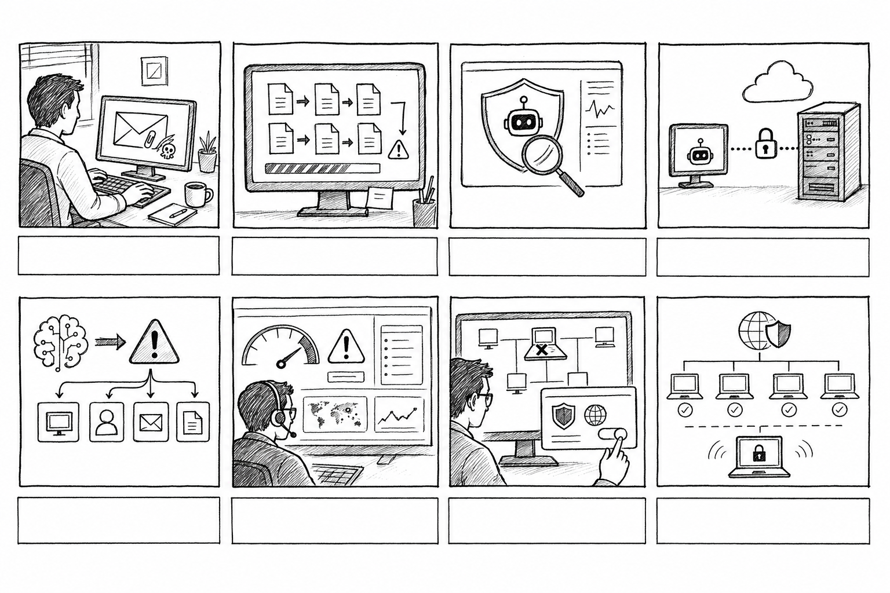
Figure B1. Eight-shot MaxTronyx ransomware-response storyboard.

• Shot 1: An employee opens a suspicious email attachment.
• Shot 2: Files begin changing rapidly and ransomware behaviour becomes visible.
• Shot 3: The endpoint agent identifies abnormal activity.
• Shot 4: Telemetry is transmitted securely to the MaxTronyx backend.
• Shot 5: Detection services create a critical incident.
• Shot 6: The dashboard displays a high host risk score.
• Shot 7: The administrator authorises endpoint isolation.
• Shot 8: The affected endpoint is contained while the remaining network stays protected.

Appendix C: Dashboard Design Evidence

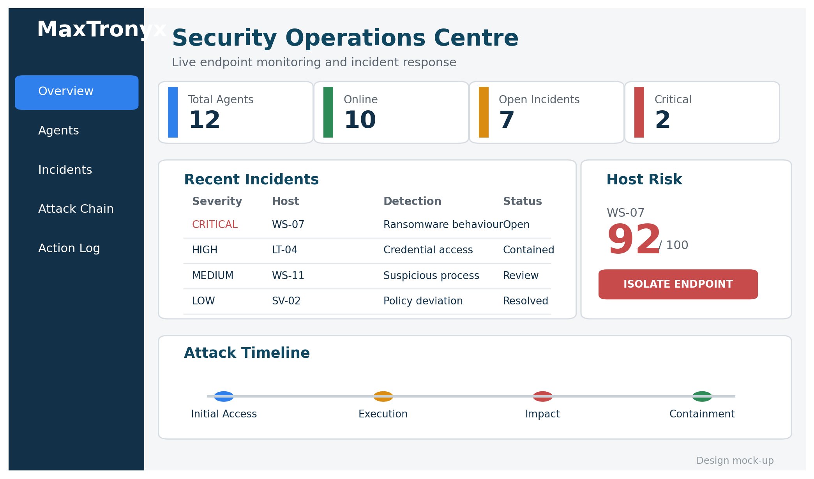
Figure C1. High-fidelity MaxTronyx SOC dashboard design mock-up.

Appendix D: Business Strategy Summary
Area | MaxTronyx proposal
Customer | UK SMEs without a dedicated SOC or large security budget.
Value proposition | Understandable endpoint monitoring, risk-based prioritisation and controlled response.
Product | Lightweight agent, secure backend, SOC dashboard and AI-assisted explanation.
Revenue | Monthly per-endpoint subscription plus optional onboarding and support.
Channels | Direct pilots, managed-service partners, university and cyber-innovation networks.
Evidence | Deployment time, detection behaviour, false positives, response time and usability feedback.
Funding sequence | Bootstrapping, Start Up Loan, suitable Innovate UK or CyberASAP support, then seed funding after validation.
Table D1. MaxTronyx business strategy.

Appendix E: Project Risk Register
Risk | Likelihood | Impact | Mitigation | Owner
False-positive isolation | Medium | High | Human approval, test thresholds and rollback. | Developer
Telemetry privacy | Medium | High | Data minimisation, retention rules and RBAC. | Project owner
Agent or API compromise | Low | Critical | Authentication, encryption, validation and security testing. | Developer
Scope creep | High | Medium | Scope baseline, backlog and formal change review. | Project owner
Schedule delay | Medium | Medium | Two-week iterations, milestones and contingency. | Project owner
Insufficient feedback | Medium | Medium | Recruit mixed-skill pilot users and document limitations. | Researcher
Funding unavailable | Medium | Medium | Bootstrap MVP and apply only after measurable validation. | Founder
Table E1. MaxTronyx project risk register.

