GLOBAL BUSINESS ENVIRONMENT

Executive summary
Business environment means the forces that affect a business for expanding internationally and functions as a support or a barrier in its path. It determines the functioning of a company through it can stay competitive in the market and meet the demand of the market. It reports aims at explaining the factors that influence the changing business environment of a company. This describes the models that had been used in the model to know about the factors and the competitive advantage for the brand. It highlights the actions taken in the market that has influenced the long and short-run changes.

Table of Contents
Introduction 4
Forces shaping the global business environment and changing global business environment 4
PESTEL 4
Porter’s Diamond Theory 6
Porters value network 7
Porter’s five forces 8
SWOT 9
Reasons for international trade engagement of organisation 10
Micro and macroeconomic foundations 11
Market structures and their influence 11
Conclusion 12
Reference list 13
Appendices 16
Appendix 1: Porter’s Diamond Model 16
Appendix 2: Porter’s Value network 17

Introduction
The global business environment means the factors that are affecting the business of an organisation in different countries and influence the business decisions as well (Radović-Marković et al., 2019). In this report, there is an analysis of the forces that shape the business environment along with the changing business environment globally. This presents the business models that include Porter's Five Forces, Value Chain, PESTEL and SWOT analysis through which the impact of the business environment can be identified. It also explains the reasons to engage internationally to know about the macro and microeconomic factors that influence market structures.
Rolls-Royce is a brand that manufactures luxurious cars for consumers by using cutting edge technology to present clean and safe products to consumers. It was established in the year 1904 in the United Kingdom and develops engines for defence and civil aircraft (rolls-royce.com, 2021).

Forces shaping the global business environment and changing global business environment
The global business environment is shaped by looking at the factors that can directly or indirectly affect the working culture of the firm. It covers the factors and their influence on the changing business environment through which the company can run the business smoothly. Models that are used to look at the global factors of a business are Porter’s five forces, Value chain, PESTEL and SWOT.

PESTEL
Factors | Influence
Political | The corporate tax rate of the world is 15% presents that the taxes that are generated by the businesses in the world directly influence the economy (weforum.org, 2021). Rolls-Royce will have to pay 10% of its profit as the taxes for expanding the business globally.  The trade barriers across the world can be a major cause that is affecting the business (imf.org, 2021). Rolls-Royce will have to accept the trading policies of the countries to make an alliance and make the business globally stable. The company is committed to accepting the protection and personal information that gets involved while running the business.
Economical | The inflation rate of the world is 3.5% present the cost of living of the people around the world (statista.com, 2021). Rolls (Royce has recorded a loss of £4.6 billion in some recent years that highlight the impact of fluctuating taxes within the countries.  Covid has shown a big shift within the market that affects the business globally and has affected the economy as well (bbc.com, 2021).  Rolls-Royce has gone through a loss of £5.4 due to the pandemic and this shows the company will have to expand the business globally to overcome the loss (theguardian.com, 2021).
Social | Disposable income of the world highlights that the people spend 7.5% more with the passing year (statista.com, 2021). It can be beneficial for Rolls-Royce to expand the business and involve people with its brand.
Technological | The internet penetration rate across the world is 59% signifies the audience is getting more involved in digital media (statista.com, 2021). Rolls-Royce has used the Applied Technology Group (ATG) through which it can innovate the models and capture the audience globally (rolls-royce.com, 2021).
Environmental | Rolls-Royce is focusing to maintain sustainability in the environment for its expansion as it can help to grow the business for a better tomorrow. It will reach zero carbon emission by the year 2050 (rolls-royce.com, 2021).
Legal | The company is focused on the HSE programme (health, safety and environment) through which it can have a minimum impact on the people of the society worldwide (rolls-royce.com, 2021).
Table 1: PESTEL Analysis
(Source: created by the learner)

Porter’s Diamond Theory
This theory is used to know about the competitive advantages of a company that help to stay competitive in the business environment and expand the business (Erboz, 2020). The factors include the strategy of the firm, rivalry and its structure. related supporting industries, demand conditions and factor conditions (refer to appendix 1).
Structure of the firm, rivalry and strategy | Related supporting industries | Demand conditions | Factor conditions
This means the competition that is done by the company to enhance productivity and develop the technology. The structure, strategy and rivalry of Rolls-Royce defend the core business to nurture the business and create more businesses to make brand expansion (rolls-royce.com, 2021). | It describes the suppliers and the population that can affect the business to have a global presence in the market. Rolls-Royce involves innovation with the help of its engineers that differentiate the performance of the product and invests 1.25 billion in R&D (rolls-royce.com, 2021). | This shows the nature and size of the audience that prefer the products and services of a brand. It also helps to bring innovation and demand for the services. Rolls-Royce has reached an unprecedented level that shows its demand globally and it builds competition in the firm to produce attractive cars for the consumers (press.rolls-roycemotorcars.com, 2021). | It indicates the economy of the country that can bring innovation to improve the technology and infrastructure of the country (Barghouthi, 2017). All the people in the world are opting to buy the services provided by Rolls-Royce and this presents the innovative approach of the firm to attract more audience.

Table 2: Porter’s Diamond Theory
(Source: created by the learner)

Porters value network
It consists of two activities namely primary and supportive activities-
Primary activities
Inbound logistics means the delivery of raw materials to the company. At Rolls-Royce, the materials are processed and then delivered to the industry. Operations highlight the functioning process of the firm. The supply chain management at Rolls-Royce shows the quality management within the firm. Outbound logistics present the delivery of products from the company to the market (Simatupang et al., 2017). The cars of Rolls-Royce that are delivered to the market are unique in design. Sales and marketing develop strategies to target the market and attract more consumers for the services (refer to appendix 2). The marketing and sales are done by the company make a profit to the annual income of the firm. Services show the creativity in the company and the demand of the market. Rolls-Royce always brings innovation to the workplace with the help of R&D (press.rolls-roycemotorcars.com, 2021).
Supportive activities
The infrastructure of Rolls-Royce shows the importance of strengthening the global network and building sustainability in the market. The Human Resource Management of the firm maintains the high performance of the employees by improving their potential. The technology department of the company presents its constant focus on pushing the boundaries and adapting the new technologies (rolls-royce.com, 2021). The procurement of the firm highlights its experts to deliver the best service in the market and help to expand the business globally.

Porter’s five forces
This framework analyses the environment that creates competition for an organisation and provides ways to maintain competition in the market.
Factors | Influence | Impact
Supplier’s bargaining power | The suppliers of the organisations can put pressure by increasing the cost of raw materials. Rolls-Royce has zero tolerance on the partners that disturbs the business from being globalised (rolls-royce.com, 2021). They have built mutual trust with the suppliers to be the expert in the market. | Moderate
Internal competition | The competition within the firm can create rivalry within the firm and the employees can perform their level best. Rolls-Royce transforms the organisation to build competition within the firm (rolls-royceyoungdesignercompetition.com, 2021). | High
Threat of substitute | The competitive brand in the market can produce the same kind of products and start attracting people by lowering the cost. Some major competitors of Rolla Royce are BMW, Aston Martin and Jaguar that comes out with a unique model in the market. | High
Customer bargaining power | Customers can pressurise the companies to provide the best quality products at low prices. Rolls-Royce has built a strong relationship with the customers to provide excellent services (rolls-royce.com, 2021). | High
The threat of new entrants | New competitors can create competition in the market by suddenly entering. The company has 115 years of experience in the field and it will be very difficult for a new brand to take its position (press.rolls-roycemotorcars.com, 2021). | Low
Table 3: Porter’s five forces
(Source: created by the learner)

SWOT
Strengths  - Strong brand image (rolls-roycemotorcars.com, 2021)  - Preferred by people all around the world | Weaknesses  - Models are somewhere look alike  - High pricing of the products
Opportunities  - Introduce some EVs  - Producing affordable cars  - Promoting through digital media (statista.com, 2021) | Threat  - Trade barriers of different countries  - Increasing competition globally
Table 4: SWOT Analysis
(Source: created by the learner)
From the above table, it can be observed that Rolls-Royce is having some strengths that include a strong brand image in the market that makes it different from others (rolls-roycemotorcars.com, 2021). People prefer maintaining their standing in society by showing off the brand and luxurious products of this company. On the other hand, it also has some weaknesses that show the models of the company are similar to each other. Along with this, it presents the higher pricing strategy of the company that acts as a negative factor for the firm.
The opportunities for the company show the introduction of EVs in the market because people are more involved in Electric vehicles now. Producing affordable cars and promoting them through digital media can increase its productivity all around the world. People show their interest in advertisement that is done through online platforms (statista.com, 2021). On the other hand, the threats for the company highlight the increasing competition in the market that is making it difficult for the brand to run the business smoothly. It also shows the trade barriers across the world that somewhere interrupts the business.

Reasons for international trade engagement of the organisation
The reasons for expanding the business globally describe the growth and development of the company through which it gets the opportunity to attract more consumers (Hopkinson et al., 2018). It can help Rolls-Royce to stay in a long run and change the working culture within the firm so that it can build a global presence. On the other hand, expansion of business internationally also provide short-term changes through which it can maintain sustainability (Brown et al., 2019). This will help Rolls-Royce to enhance the advantage of being competitive in the market and lead the market.

Micro and macroeconomic foundations
The micro economic foundation presents the agents and their behaviours that determine the actions taken by the companies to make competition in the market (Parente et al., 2018). It shows that the behaviour of the consumers never changes with the changing policy and the company focuses on delivering the products and services according to their choice. This can help Rolls-Royce to make strategies and make a profit through which it can maintain its brand image in the market. Macroeconomic foundation examines the supply and demand of the market through which the companies meet the requirement of the population. It decides the pricing strategy of a company through which it can stay competitive (Yevdokimov et al., 2018). Rolls-Royce can use this idea to meet the higher demand of the public and produce the best quality services.

Market structures and their influence
Market structure means the classification and differentiation of different industries in the market that build competition by delivering the products and services (Lábaj et al., 2018). There are four types of organisational structure namely perfect competition, monopolistic competition, oligopoly and monopoly. Perfect competition describes the producers and the audience that have the information about the product without any transactional costs (Azevedo and Gottlieb, 2017). It can be influenced Rolls-Royce as the audience can choose this brand and it will build a competitive advantage for the firm. Monopolistic competition shows the combination of monopoly and markets that are competitive. It can provide an advantage to Rolls-Royce to enter and exit with freedom within a market in which it will expand the business. Oligopoly mainly highlights a small number of organisations that can influence the market through its services. Rolls-Royce can implement this idea to target a small market and lead the market with competitive nature. Monopoly signifies that a single seller produces and delivers the products at different places across the world (Ara et al., 2017). This strategy is used by Rolls-Royce to maximise the profit and make revenue in the market.

Conclusion
It has been concluded that expanding the business internationally provides a competitive advantage to the company to build innovative ideas within the firm. It shows that the company can lead the market through strategies and ideas that can be beneficial for the firm. The environmental factors affect the business directly by making a profit or loss to the company while expanding the services. Along with this, it determines the longevity of the business by accepting and following the trade barriers. The main reason behind the expansion of the business shows the growth and opportunities for the business that can create a way to success. Market structure within the firm signifies the different structures that help the organisation to make a profit globally. It also influences the operations within the firm that are conducted to determine the opportunities for the firm.

Reference list
Ara, T., Ghosh, A. and Zhang, H., 2017. Tariffs, Vertical Oligopoly, and Market Structure. RIETI.
Azevedo, E.M. and Gottlieb, D., 2017. Perfect competition in markets with adverse selection. Econometrica, 85(1), pp.67-105.
Barghouthi, O.A., 2017. Analysis of Competitive Advantage of the Basic Industries in Palestine Based on the Porter’s Diamond Model. International Journal of Marketing Research Innovation, 1(1), pp.25-39.
bbc.com, 2021. Coronavirus: How the pandemic has changed the world economy [Online] Available at: https://www.bbc.com/news/business-51706225 [Accessed 29 December 2021]
Brown, P., Bocken, N. and Balkenende, R., 2019. Why do companies pursue collaborative circular oriented innovation?. Sustainability, 11(3), p.635.
Hopkinson, P., Zils, M., Hawkins, P. and Roper, S., 2018. Managing a complex global circular economy business model: opportunities and challenges. California Management Review, 60(3), pp.71-94.
imf.org, 2021. Global Trade Liberalization and the Developing Countries [Online] Available at: https://www.imf.org/external/np/exr/ib/2001/110801.htm [Accessed 29 December 2021]
Lábaj, M., Morvay, K., Silanič, P., Weiss, C. and Yontcheva, B., 2018. Market structure and competition in transition: results from a spatial analysis. Applied Economics, 50(15), pp.1694-1715.
Parente, R.C., Geleilate, J.M.G. and Rong, K., 2018. The sharing economy globalization phenomenon: A research agenda. Journal of International Management, 24(1), pp.52-64.
press.rolls-roycemotorcars.com, 2021. GLOBAL DEMAND FOR ROLLS-ROYCE BESPOKE REACHES ALL TIME HIGH [Online] Available at: https://www.press.rolls-roycemotorcars.com/rolls-royce-motor-cars-pressclub/article/detail/T0302009EN/global-demand-for-rolls-royce-bespoke-reaches-all-time-high?language=en [Accessed 29 December 2021]
press.rolls-roycemotorcars.com, 2021. ROLLS-ROYCE MARKS 115 YEARS OF EXCELLENCE AND INNOVATION [Online] Available at: https://www.press.rolls-roycemotorcars.com/rolls-royce-motor-cars-pressclub/article/detail/T0295405EN/rolls-royce-marks-115-years-of-excellence-and-innovation?language=en [Accessed 29 December 2021]
Radović-Marković, M., Salamzadeh, A. and Vujičić, S., 2019. Selection of organization models and creation of competences of the employed people for the sake of competitiveness growth in global business environment. International Review, (1-2), pp.64-71.
rolls-royce.com, 2021. Our vision and strategy [Online] Available at: https://www.rolls-royce.com/about/our-strategy.aspx [Accessed 29 December 2021 [Accessed 29 December 2021]
rolls-royce.com, 2021. An environmental, social and ethically sustainable business [Online] Available at: https://www.rolls-royce.com/sustainability.aspx [Accessed 29 December 2021]
rolls-royce.com, 2021. Engineering and innovation [Online] Available at: https://www.rolls-royce.com/sustainability/engineering-and-innovation.aspx#section-research-and-development
rolls-royce.com, 2021. Our customers [Online] Available at: https://www.rolls-royce.com/country-sites/uk/our-uk-story/customers.aspx [Accessed 29 December 2021]
rolls-royce.com, 2021. OUR GROUP POLICIES [Online] Available at: https://www.rolls-royce.com/~/media/Files/R/Rolls-Royce/documents/sustainability/our-group-policies.pdf [Accessed 29 December 2021]
rolls-royce.com, 2021. Our suppliers and partners [Online] Available at: https://www.rolls-royce.com/sustainability/customers-and-suppliers.aspx#section-customer-information [Accessed 29 December 2021]
rolls-royce.com, 2021. Products & Services [Online] Available at: https://www.rolls-royce.com/products-and-services.aspx [Accessed 29 December 2021]
rolls-royce.com, 2021. The world's most advanced engineering [Online] Available at: https://www.rolls-royce.com/country-sites/sea/partners-in-progress/research-and-technology.aspx [Accessed 29 December 2021]
rolls-roycemotorcars.com, 2021. VALUES [Online] Available at: https://www.rolls-roycemotorcars.com/en_GB/inspiring-greatness/values.html [Accessed 29 December 2021]
rolls-royceyoungdesignercompetition.com, 2021. GLOBAL WINNERS [Online] Available at: https://rolls-royceyoungdesignercompetition.com/ [Accessed 29 December 2021]
Simatupang, T.M., Piboonrungroj, P. and Williams, S.J., 2017. The emergence of value chain thinking. International Journal of value chain management, 8(1), pp.40-57.
spectator.co.uk, 2021. Inflation, housing, savers and Rolls-Royce [Online] Available at: https://www.spectator.co.uk/article/inflation-housing-savers-and-rolls-royce [Accessed 29 December 2021]
statista.com, 2021. Global digital population as of January 2021 [Online] Available at: https://www.statista.com/statistics/617136/digital-population-worldwide/ [Accessed 29 December 2021]
statista.com, 2021. Global inflation rate from 2016 to 2026 [Online] Available at: https://www.statista.com/statistics/256598/global-inflation-rate-compared-to-previous-year/ [Accessed 29 December 2021]
statista.com, 2021. Where Disposable Incomes Are (Barely) Rising [Online] Available at: https://www.statista.com/chart/18655/growth-and-decline-of-disposable-incomes-oecd-countries/ [Accessed 29 December 2021]
theguardian.com, 2021. Rolls-Royce reports record £5.4bn loss as Covid-19 hits aviation [Online] Available at: https://www.theguardian.com/business/2020/aug/27/rolls-royce-reports-record-loss-as-covid-19-hits-aviation [Accessed 29 December 2021]
weforum.org, 2021. 136 countries have agreed to a global minimum tax rate. Here's what it means [Online] Available at: https://www.weforum.org/agenda/2021/11/global-minimum-tax-rate-deal-signed-countries/ [Accessed 29 December 2021]
Yevdokimov, Y., Melnyk, L., Lyulyov, O., Panchenko, O. and Kubatko, V., 2018. Economic freedom and democracy: Determinant factors in increasing macroeconomic stability. Problems and Perspectives in Management, 16(2), pp.279-290.

Appendices

Appendix 1: Porter’s Diamond Model
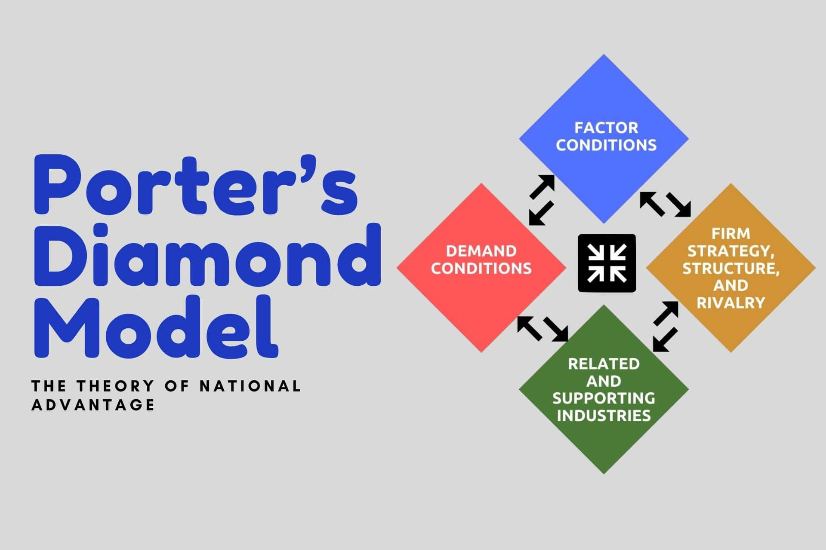

Appendix 2: Porter’s Value network


