

Assessment 1 – Reading Task Template
PART 1: Upload your photo of your A3 in-class notes here:
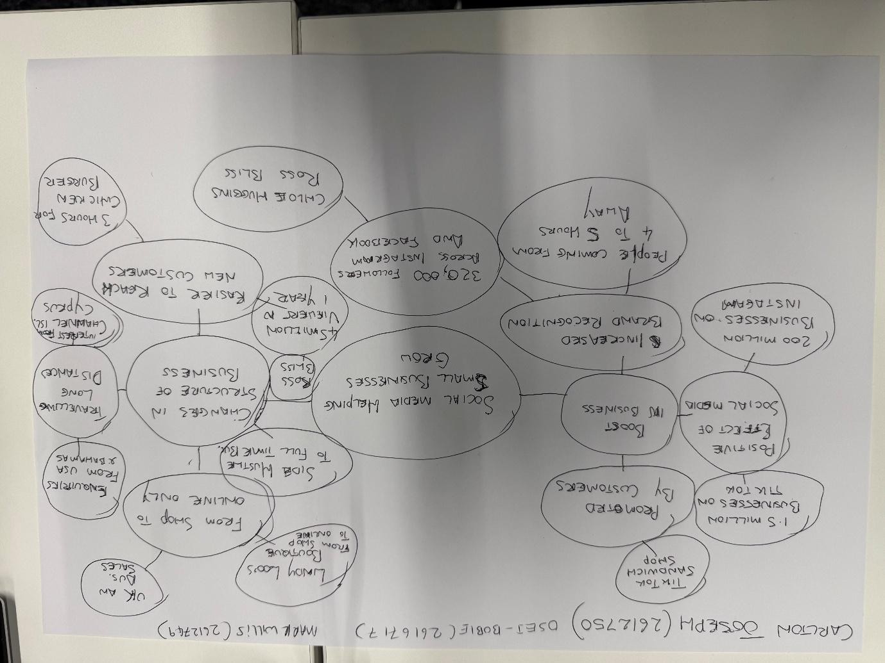

PART 2:
- Answer every question below in 1-3 full sentences.
- Use your own words. Do not use generative AI to answer these questions.
- Include a specific detail from the text when asked.
REMINDER
- The main idea is the overall message of the whole text.
- A key point helps to explain the main idea.
- A specific detail or example from the text shows that the key point is true.

- What is the main idea of the whole text?

I think the main idea of the text is to make people aware of the impact that social media platforms can have on businesses. It is reaffirmed throughout the post and seems to me to be the overarching idea for the post being created.

- What is one key point that supports the main idea, and which specific example from the text shows this?
In the first couple of paragraphs, the post refers to the viral meme “Nothing beats a jet2 Holiday.” I believe that the reason this viral internet meme is mentioned is because it shows the impact social media can have on businesses. This meme is something that most people have come across while scrolling on social media and it is a great example of the far-reaching capabilities an online moment can have on a business.

- What is a different key point that supports the main idea, and which specific example from the text shows this?

Another key point mentioned in the post is a customer quoted saying ‘Customers travelled three hours for our chicken burger.’ This is yet another noteworthy point of a customer who is seemingly delighted that potential customers are travelling further than expected to visit his place of business. I like this point because it gives an example of the power of social media. It is probably possible for the customer to find chicken burgers closer to where they live, but that the hype surrounding social media advertising has people’s curiosity peaking, and they are prepared to travel far and wide to satisfy it.

- Which part of the text do you think is most important, and why?
I believe the title is the most important part of the text; it is the part responsible for grabbing people’s attention and sparking people’s curiosity at just a passing glance. Without a compelling title, your text maybe the most interesting story imaginable, but no one will get to read it if it can’t get people interested.

Reflection:
- What did you find difficult in this task (including in-class components), and why was it difficult?
The main difficulty I faced with this task was manipulating the template provided so that I was able to upload photos and add text to it. I have personally always struggled with understanding and successfully using different types of files in a clear and organised manner.

- What helped you with this difficulty, and how did it help you?
I asked the tech guys based at UWTSD for some assistance and they informed me that this particular file needed to be altered and that I also needed to download the full Microsoft 360 package to my laptop which was limiting some of the functionality regarding most of my activities on this laptop. After which I was able to successfully use the template provided, and which has already helped me with some general issues I had using my laptop.

