
Skills for the Workplace
Module Assignment Submission
Student Name: | Jessica Valdivia Canales
Student Number: | 1917878
Module No: | BMSK4003
Module Title: | Digital Skills and Research Methods Part One

Statement of Confirmation of Authenticity
By the act of making this submission, the student declares that this is the work of the student named above. The work has not, in whole or in part, been knowingly presented elsewhere for assessment, or where assessment has been built on a previous assessment, this has been identified. Where materials have been used from other sources it has been properly acknowledged. If this statement is untrue, the student acknowledges that an assessment offence has been committed.
Attention is drawn to the plagiarism and unfair practice policies of both the University and of ILM.
Permission for ILM to use this script
ILM uses learners’ submissions – on an anonymous basis – for assessment standardisation. By submitting, both the centre and the learner agree that ILM may use this script on condition that identifying information is removed. However, if you are unwilling to allow ILM use this script, please refuse by ticking the box: □
Table of Contents
Introduction 2
The impact of 21st century technologies on the modern workplace 3
Improving workplace efficiency with modern technologies and social media 3
Modern technologies and social media at Assetivo 4
Social media for enhancing career prospects and networking 5
The right social media account 6
Facebook 6
LinkedIn 6
Twitter 6
Instagram 7
LinkedIn Profile 7
Profile picture 7
Headline 8
Background photo 9
About section 9
Experience 10
Social media risks 10
Conclusion 10
References 12
Appendix 1 13

Introduction
This part one assignment will focus on the current impact of technology and social media on modern businesses. It will look at how hardware and software can improve efficiency and productivity of businesses and employees. Social media will be discussed and how businesses can use it for marketing and brand awareness. For professional individuals, social media will be researched, and one platform chosen to develop a personal profile. The risks of modern technology and social media will also be discussed.

The impact of 21st century technologies on the modern workplace
Every area of life and everyone has been impacted by 20th and 21st century technologies such as mobile phones, computers, and software. Many digital-age businesses have made big improvements from advances in technology. Guerin (2017) puts it very simply:
These days, smartphones, email, the Internet, cloud computing, and other innovations have brought huge gains in business efficiency and productivity, allowing instant communication and access to information that would have seemed unimaginable only a short time ago.
This means if businesses can make improvements in efficiency and productivity, then that will translate into higher profits and higher shareholder satisfaction. The author states that a benefit is quicker communication and access to information. This will always mean cost savings in terms of time and resources. Not all businesses are successful at using technology to drive higher profits, productivity, and performance. Westerman et al (2014) argue that ‘digital masters’ who achieve those three Ps: profits, productivity, and performance are ‘rare’ and ‘most firms fall short of digital mastery’. Furthermore, Brown (2020) adds that ‘there is a massive and rapidly widening gulf between the capabilities of companies that invest in technology and those that don't’. Even though this is likely true, there will be opportunities for most businesses to improve their efficiency with the adoption of modern, digital technologies.

Improving workplace efficiency with modern technologies and social media
The modern workplace uses several types of hardware to achieve the business objectives and work efficiently. The most common are desktop computers, laptops, printers, tablets, smartphones, and other devices specific to the industry sector such as data collectors and cameras for instance.
One area where things have changed significantly in the 21st century is software. It can be located on a personal computer or on the ‘cloud’. Cloud-based software simply means it resides on the internet and does not need to be downloaded to a computer – and therefore will be easily accessible from anywhere. This allows for greater collaboration. Modern software can allow businesses to be more efficient by allowing video conferencing, emails, texting, performing customer service, collecting, and analysing information in databases, managing customers (CRM software), managing financial information (ERP software) and bookkeeping. The major advantage of cloud-based software is that it allows employees to work remotely from anywhere with a Wi-Fi or mobile connection.
Social media is one area where businesses and individuals can take advantage of technology. Quesenberry (2019) explains that ‘social media is computer-mediated technologies that allow creation and sharing of information, ideas, and other forms of expression via virtual communities and networks’. The author fails to mention a key point also: the social media platforms are mostly free to use. Typical social media platforms include:
- www.Linkedin.com
- www.facebook.com
- www.twitter.com
- www.instagram.com
These platforms can be incredibly useful for the business or the individual as Bodnar and Cohen (2012) suggest:
Creating fun and interesting content and amplifying its reach with social tools can humanize your business. It can give you an opportunity to show personality and point of view in an appealing, engaging way that sets you apart from your competitors.
Therefore, those businesses that would like to get ahead of the competition must use these available tools.

Modern technologies and social media at Assetivo
I work as a financial administrator at a company called Assetivo and they focus on industrial asset management, reliability, and maintenance. It is a business-to-business (B2B) company. The company uses Office 365 desktop and mobile for most of its software requirements such as Word, Excel, Outlook, and PowerPoint. It also uses Teams for talking to customers. This is particularly useful for reducing the costs associated with travelling to customer sites and travel expenses. Assetivo uses QuickBooks for its accounting. This is a cloud-based software paid for by subscription – like Office 365.
On reviewing its website (www.assetivo.com), the main page shows links to Facebook, Twitter, and LinkedIn. A review of the website and the social media pages shows that Facebook and Twitter are used mainly to redirect user back to the website. The LinkedIn page is used for company updates and links to its case studies and engineering blogs.
It makes sense for Assetivo to focus more on LinkedIn because as Quesenberry (2019) says, ‘LinkedIn has always been a business-oriented social-networking site, and that remains the focus of its users’ activities. LinkedIn can be thought of as the professional side of social networking’.
Assetivo’s company page on LinkedIn indicates that is used for brand awareness and marketing, whilst also redirecting viewers back to the main website with calls-to-action (CTAs) links.
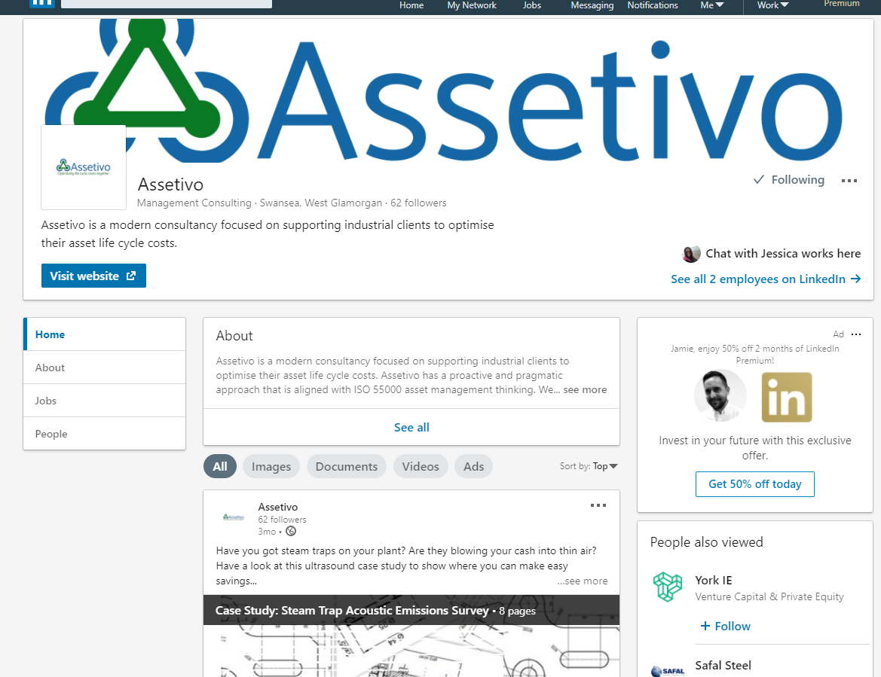
Figure 1: LinkedIn company page for Assetivo
Assetivo should use the LinkedIn platform more often and put more free content on its page to drive business leads and interest. The page has not had new content for the last 3 months. This should be improved and be kept updated.

Social media for enhancing career prospects and networking
Professional individuals can enhance their networking opportunities and career prospects by utilising social media. This applies to individual people as well as small business owners or entrepreneurs. Bodnar and Cohen (2012) say that social media helps you reach more people, increase, and share your knowledge, and engage and connect with prospects in a powerful way. A good point is made by Quesenberry (2019) who argues ‘that social media has grown in importance to compare with corporate-produced content and there has been a transfer of power from organizations to amateur-produced content’. So, these days the source of information are available from different specialists, professionals, or others, but the risk of false information is increasing in this new era.
As mentioned earlier, there are many free social media accounts available such as LinkedIn, Twitter, Facebook, Instagram. These are the most important ones. But which is the best one to use for an individual who wants to improve networking and career opportunities?

The right social media account
When looking for the best social media platforms for a person who wants to improve networking and career opportunities, the main options are Facebook, LinkedIn, Twitter, and Instagram. Each has its advantages and drawbacks.

Facebook
This is a platform that is mainly known for connecting friends and sharing content such as photos and videos. It is also well-known as a good platform for businesses to advertise their services or products. It is perceived as being a good platform for professional individuals to improve their career. Burkhart (2017) suggest that business advantages are the business page, relationship-building, and targeted advertising. It says the drawbacks of Facebook are the cost of advertising, and time-consuming updating of pages.

LinkedIn
Russell and Klassen (2019) say, ‘people who join LinkedIn are principally interested in the business opportunities that it provides as opposed to arbitrary socializing and will necessarily be providing sensitive details about business relationships, job histories, and more’. From an individual perspective it is an excellent tool for showcasing work and academic achievements. Leonard (2020) states that the platform positives are networking opportunities, news updates, and LinkedIn answers section, but she argues that a negative can be putting too much content on your page and this may cause viewers to turn off.

Twitter
Many businesses use Twitter for marketing and brand awareness. Similar to Facebook, it is seen as more of a socialising tool for individuals, rather professional opportunities. For business, Birkett (2020) says the advantages are Twitter helps you find your market, it allows you to engage on a personal level, and it can provide you with rapid feedback. He argues the disadvantages are that it takes time to build a follower list, and negative feedback can be seen by all your followers.
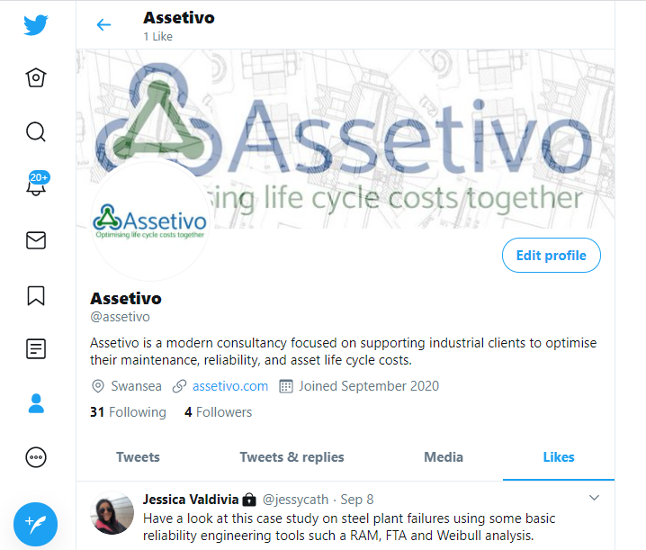
Figure 2: Assetivo's Twitter page

Instagram
This platform can be useful who professionals who want to showcase their practical work, especially if it is designed to be pleasing to the eye, i.e. photography, woodwork, cake designs, and others. Again, it is not thought to be the ideal platform for networking and career opportunities. Gaille (2016) urges use that the benefits to businesses are great visual references to your work, and hashtags make it easy to connect with people, and responses. The negatives, he argues, are it is not a platform that focuses on commerce, and there is not much room for additional content.

LinkedIn Profile
From the previous discussion, it is clear that LinkedIn is the best choice for professional networking and career opportunities. A person’s LinkedIn profile can be designed to promote and ‘forge a strong personal brand’ (Serdula, 2020).

Profile picture
The profile picture is one of the first things people see when viewing your profile. According to Serdula (2020) the profile picture is integral to your personal branding, and the individual should look straight into the camera, use a plain background, dress professionally, and smile. Figure 3 (left) shows my previous photo with a distracting background, sunglasses, and streetwear. Figure 3 (right) shows my new picture according to the best practices.
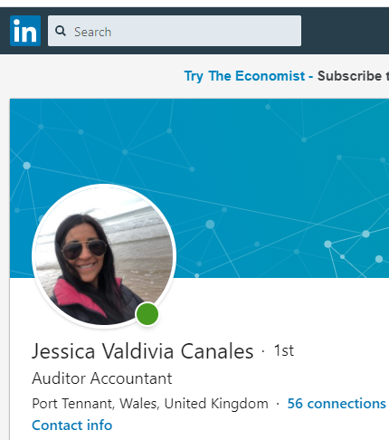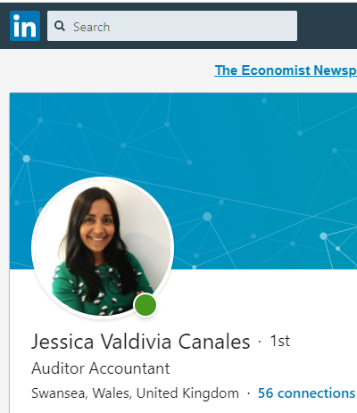
Figure 3: Before and after LinkedIn profile photos

Headline
The headline plays a very important role and it says your professional identity. Serdula (2020) suggests that the ‘LinkedIn headline communicates your value and compels people to open your profile to learn more about you’. I previously had a generic headline: Auditor Accountant. Using the author’s guidelines it has been revised to: Accomplished Accountant Professional ✔ Finances & Payroll ✔ Helping Businesses Take Care of the Numbers ✔as seen in Figure 4.
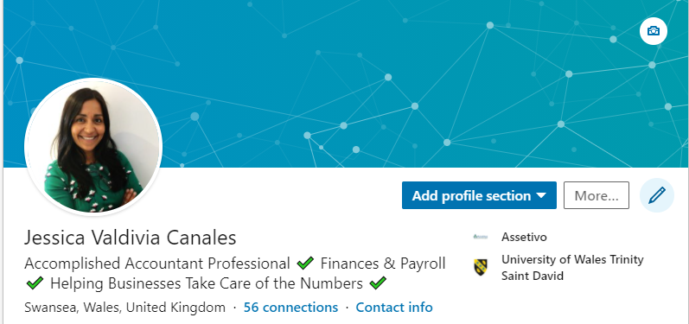
Figure 4: New profile headline

Background photo
The background photo is also important because it coincides with the first thing visitors see on your profile. Serdula (2020) suggests that it must reflect what you do and that it matches your professional brand. With this in mind, I chose a colourful, dynamic picture that reflected numbers and data:
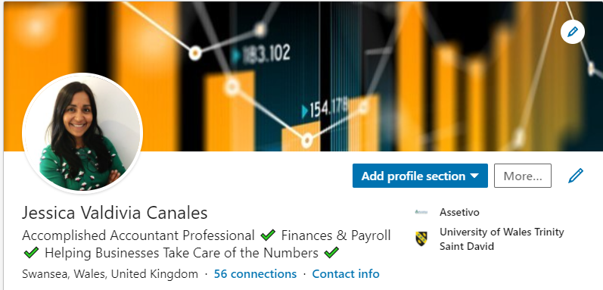
Figure 5: New profile background picture

About section
The about section is where the professional person introduces themselves to the target audience and tells their professional story in a conversational manner (Serdula, 2020). My old profile had no text in the about section. Following the author’s guidelines, I designed the ‘about’ section on my objectives for LinkedIn:
- I want to find a new job
- I want to enhance my reputation
It was written as follows:
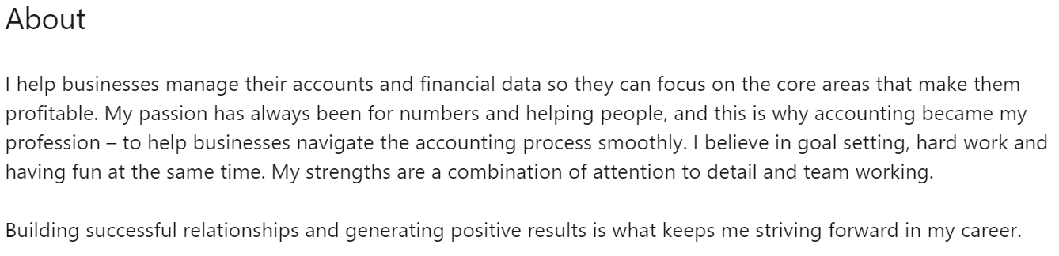
Figure 6: LinkedIn about me section

Experience
According to Serdula (2020), ‘the experience section on your LinkedIn profile is where you explain your career path and highlight your background, successes, qualifications, and abilities’. My experience section can be found here on my profile: https://www.linkedin.com/in/jessica-valdivia-canales-1b07191b/ . See Appendix 1 for a screenshot of my experience.

Social media risks
The use of social media and modern technology in general brings risks to individuals and businesses. Those individuals could be employees or members of the public. Gonzalez (2015) reports many stories of ‘companies getting into trouble because of compliance violations, loss of revenue because of reputational loss, and loss of customer trust because of confidentiality breaches’. Aside from this is the risk associated with online payments and the storage of credit card details that could be compromised by employees or hackers. The author says that for data protection (on mobile platforms) many companies use mobile data protection (MDP) strategies which means that data encryption is the main technique for keeping privacy. Lane (2003) also argues that employees must be cautious of observation from their employers: ‘advances in technology are making it possible for companies to routinely gather unprecedented quantities of information about the people who work for them’. Finally, there are also risks to personal safety from the incorrect use of social media. Users must avoid putting personal details on the profiles such as phone numbers, addresses, or any other information that could be used by people to locate them or for identity theft.

Conclusion
This part one assignment focussed on the current impact of technology and social media on modern businesses. It showed how hardware and software can improve efficiency and productivity of businesses and employees. Social media was discussed and how businesses can leverage it for marketing and brand awareness, but it also has disadvantages in that customer negative feedback can be seen by many and it needs to be constantly updated. For professional individuals, LinkedIn was the optimum social media platform to network and improve career prospects. My personal profile was developed to include new pictures, headlines, about me and experience sections. The risks of modern technology and social media were described as risks to personal safety, data loss, and observation. After completing part one, I can clearly see the importance of new technology and how individuals and businesses should go hand in hand to the future, but always be aware of the risks.

References
Birkett, P. (2020). ‘Twitter for business: The pros and cons of using Twitter to market your local business’ Available at: https://bluesquaremanagement.com/twitter-business-pros-cons-using-twitter-market-local-business/. (Accessed: 27 September 2020).
Bodnar, K. & Cohen, J.L. (2012). The B2B social media book. John Wiley & Sons: Canada.
Brown, S. (2020). The innovation ultimatum. How six strategic technologies will reshape every business in the 2020s.Wiley: Canada.
Burkart (2017). ‘Advantages and disadvantages of Facebook and how to leverage them’. Available at: https://burkhartmarketing.com/advantages-disadvantages-facebook-leverage/. (Accessed: 27 September 2020).
Gaille, B. (2016). ‘18 pros and cons of Instagram for business’. Available at: https://brandongaille.com/18-pros-and-cons-of-instagram-for-business/. (Accessed: 27 September 2020).
Gonzalez, D. (2015). Managing online risk. Apps, mobile, and social media security.Elsevier. USA.
Guerin, L. (2017). Smart policies for workplace technologies. 5edn.NOLO: USA.
Lane III, F.S. (2003). The naked employee. How technology is compromising workplace privacy. Amacon: USA.
Leonard, K. (2020). ‘The pros and cons of LinkedIn’. Available at: https://www.igvinc.com/the-pros-cons-of-linkedin/. (Accessed: 27 September 2020).
Quesenberry, K.A. (2019). Social media strategy. 2edn. Rowman & Littlefield: United Kingdom.
Russell, M.A. & Klassen, M. (2019). Mining the social web. 3edn. O’Reilly: Canada.
Serdula, D. (2020). LinkedIn profile optimization for dummies. 2edn.John Wiley & Sons: Canada
Westerman, G., Bonnet, D. & McAfee, A. (2014). Leading digital. Turning technology into business transformation.Harvard Business Review: Boston.

Appendix 1



