

LOCATION: london | LLEOLIAD: llundain
LEVEL 5 | LEFEL 5
EXAMINATION PERIOD | CYFNOD ARHOLIADAU
September 2016 | medi 2016

MODULE CODE: accc5002
LOCAL AREA NETWORKS
TIME: 2 HOURS

Local Area Networks
BSc Computer Networks (ACCC5002)

Practical Lab Assessment
Year 2/Level 5
September 2016

Name :

Student ID :

Date & Time :

This is an individual practical lab-test, held under examination conditions. You will be assigned three Switches and a Router; you should configure these devices based on the given specifications.

This paper is marked out of 100.

You will have 2 hours to complete this task.

TOPOLOGY DIAGRAM

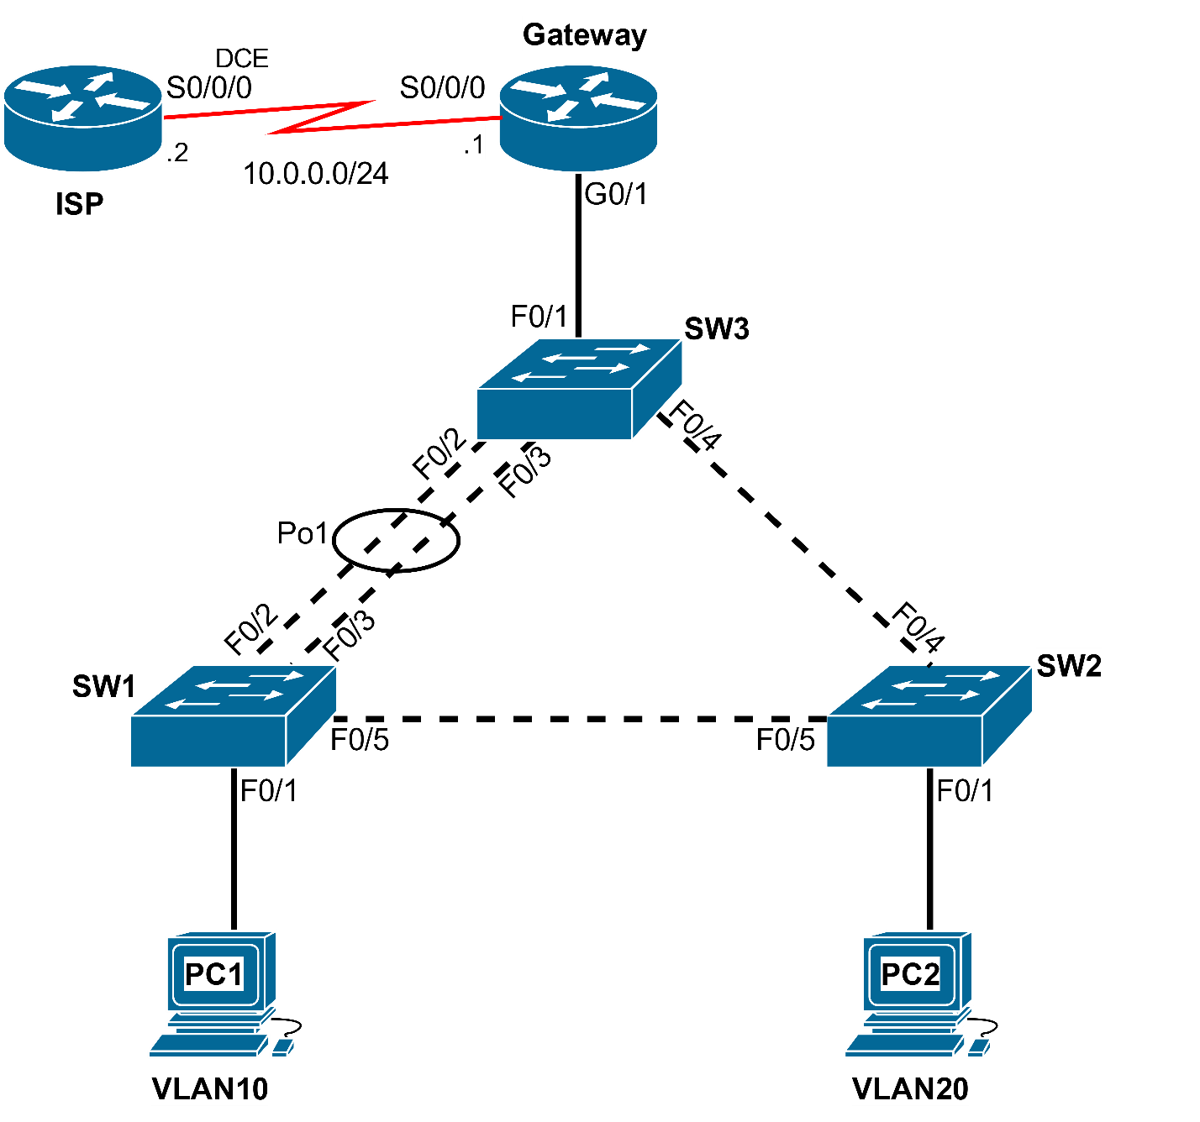

VLAN 10 – Sales: 192.168.10.0/24
VLAN 20 – HR: 192.168.20.0/24
VLAN 99 – Management: 192.168.99.0/24

Addressing Table (8 marks)

Choose the first address in each subnet for the Gateway.

Choose the fifth address in each subnet for management VLAN 99 addresses.
Device | Interface | IP Address | Subnet Mask | Default Gateway
Gateway | Ge0/0.10 |  |  | N/A
Gateway | Ge0/0.20 |  |  | N/A
Gateway | Ge0/0.99 |  |  | N/A
 | S0/0/0 |  |  | N/A
ISP | S0/0/0 |  |  | N/A
SW1 | VLAN99
SW2 | VLAN99
SW3 | VLAN99
PC1 | NIC | DHCP | DHCP | DHCP
PC2 | NIC | DHCP | DHCP | DHCP

Port Assignments

SW1
Ports | Assignment | Network
Fa0/2, Fa0/3 & Fa0/5 | 802.1Q Trunks (Native VLAN 99) | 192.168.99.0
Fa0/1 | VLAN 10 (Sales) | 192.168.10.0

SW2
Ports | Assignment | Network
Fa0/4 – 0/5 | 802.1Q Trunks (Native VLAN 99) | 192.168.99.0
Fa0/1 | VLAN 20 (HR) | 192.168.20.0

SW3
Ports | Assignment | Network
Fa0/2 – 0/4 | 802.1q Trunks (Native VLAN 99) | 192.168.99.0
Fa0/1 | 802.1q Trunk
Task 1: Prepare the Network (5 marks)
Step 1: Cable a network that is similar to the one in the topology diagram.
Step 2: Clear any existing configurations on the devices.
Task 2: Perform Basic Device Configurations (10 marks)
Configure the switches (SW1, SW2, and SW3) and routers (Gateway & ISP) according to the following guidelines:
- Configure the hostname.
- Disable DNS lookup.
- Configure an EXEC mode password.
- Configure synchronous logging for the console connection.
- Configure a password for vty connections.
Task 3: Router and Switch configuration instructions (64 marks)
- Configure SW3 as a VTP server and SW1 & SW2 as VTP clients in the class.com domain. Set the VTP password to ‘cisco’.
- Configure EtherChannel between the SW1 and SW3 as per the topology diagram.
- Create VLANs 10, 20 & 99, and name as required.
- Assign ports to appropriate VLANs as shown in the Port Assignments table (access and trunks).
  - Trunk ports with native VLAN 99 to be configured on links between switches.
  - Trunk on SW3 port F0/1 to be configured (without native VLAN 99).
- Configure Rapid PVST+ on all switches.
- Configure SW3 to be the primary root for all VLANs and SW1 to be secondary.
- Configure PortFast and BPDU Guard on the interface connected to PC1 and PC2.
- Configure SW3 as a DHCP server to provide IP addresses and default gateways to users on VLAN 10 & 20. Verify all PCs receive IP address details.
  - Don’t forget to configure the IP address helper on the Gateway router.
- Configure management IP addresses for all network switches in VLAN 99, and configure them for Telnet access (Configure default gateway for the switches on VLAN 99).

- Configure router-on-a-stick inter-VLAN routing.
  - Configure sub-interfaces on R1 to operate on VLAN 10, 20, and 99 with the address from the Address table.
- Configure the ISP and Gateway routers with appropriate IP addressing information (Refer to topology).
  - Clock rate for the DCE interface: 128000
- Configure static routes to VLAN 10 and 20 networks on the ISP Router with S0/0/0 as the exit interface.
- Configure NAT Overload and map both 192.168.10.0/24 and 192.168.20.0/24 to the S0/0/0 interface on the Gateway router.
Task 4: After configuring each host computer, record the host network settings with the ipconfig /all command. (4 marks)
Host PC1 Network Configuration
IP Address
Subnet Mask
Default Gateway
Host PC2 Network Configuration
IP Address
Subnet Mask
Default Gateway
Instructor: Ping Successful? ________________ (4 marks)
Task 5: Document the Configurations (5 marks)
All documentation for your solution should be submitted. Your name should be clearly printed on the documents. Devicename_Surname_Pno.txt
At the end of the test a pen drive will be given to you, the configuration files for all routers should be copied to the media and handed in to your instructor. It is you responsibility that you copy the files correctly.
ROUTER | SWITCH
Show running-config | Show running-config
Show ip interface brief | Show ip interface brief
Show ip route | Show vlan
Show ip nat stat | Show interface trunk
Show ip nat translations | Show spanning-tree
 | Show etherchannel summary
 | Show vtp status

