ACHA4004 Vehicle Tech – Marco Hilton Campbell
Q1 – Steel Monocoque , Bonded aluminium tub chassis with Fibreglass body Pros & Cons.
This report will discuss two types of chassis within the automotive industry discussing their key features, how the chassis are constructed, what they are used in: stating their advantages and disadvantages within their fields and general construction.
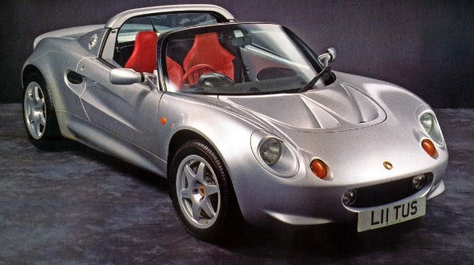
The bonded aluminium tub chassis, notably by lotus with the 1996 Elise as seen in figure 1, is a lightweight construction that is made by bonding a lightweight steel sub frame and steel roll bar with aluminium panels. This type of chassis is preferable for sport cars as the stiffness is desirable in performance orientated vehicles.
Figure 1 Lotus Elise 1996
Key aspects of the bonded aluminium tub chassis is its stiffness and low weight. As stated previously, its construction consists of a lightweight steel sub frame and roll bar that makes the car rigid in the areas where strength within the chassis is needed for key components such as the engine and suspension. This can be seen in figure 2 as the areas mentioned have thick components for support.
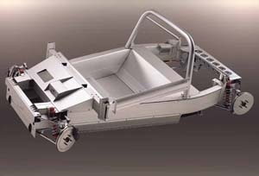
Another notable feature of the bonded aluminium tub chassis is the simplicity of construction; respectively. Chassis like these do not require complex tools however production can be limited as they are built from scratch. For a company like lotus who focus on building performance cars the limited production numbers can be dismissed as their objective is to create a lightweight sports car which doesn’t aim to be mass produced. This allows for the company to spend resources on better materials and parts for their cars.
Figure 2 Lotus Elise Tub Chassis
Performance benefits of the tub design gives the car desirable traits. For example, having a power to weight ratio advantage as the lightweight chassis paired with a fibreglass exterior helps keep the gross weight of the vehicle down. An example is the lotus only weighing around 940 kgs with a 148 hp four-cylinder engine. A perfect circuit track car with many turns and short straights. In terms of being a perfect track car, this configuration has better manoeuvrability as the centre of gravity with a tub chassis is low to the ground which helps with handling characteristics as the weight has less leverage to flip the car, which in turn keeps the car feeling more planted to the road during cornering.
This type of constructions however is not fit for daily use since factors such as comfort, lack of safety features, increased insurance, and lack of accessories. Also, in terms of safety, the car has limited areas of energy absorption as the tub chassis is very stiff comparatively. Rebuilding these chassis depend on factors which include a large margin of human error as this type of chassis is hand built, meaning cars could come out slightly different to each other.
Using this type of construction lacks the level of optimisation that a computer can give for the structure of the chassis so that a manufacturer can save material. However, it is much simpler to manufacture and does not require expensive jigs to put together and finalise.
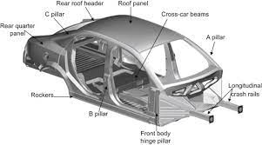
The steel monocoque is a unibody construction which is one piece that can be mass produced. This is the standard type of construction for the automotive industry which is used for most vehicles on our roads today. Figure 3 shows the traditional configuration of the monocoque chassis where we can reference areas of the vehicle such as the A pillar, Crash rails, Fire wall, etc.
Figure 3 Steel Monocoque
Key attributes of the monocoque is its ease of assembly. This type of manufacturing process acts as an easy foundation for the rest of the parts of the vehicle to easily be constructed. However, to create a monocoque requires expensive jigs that need large facilities. This process requires the use of robotic jigs that are highly accurate and are able to repeat said process quickly and with high tolerances. This is preferable for vehicles that need to be mass produced with big factories that have belt line systems which have simple and efficient assembly for robotic and human fabricators.
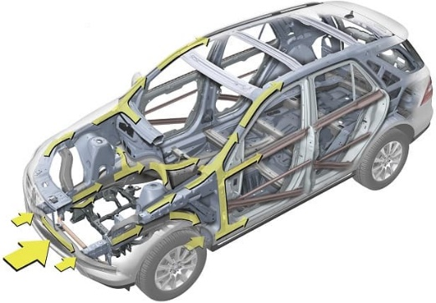
The monocoque can be designed using computer generative design which can determine how much material the structure needs and where it should be stronger with the baseline information that the manufacturer wants their product to achieve. In figure 4 the yellow arrows show how the impact at the front will disperse energy around the chassis. The more energy the car absorbs, the safer the car is for its passengers as the crumple zones allow the energy to be absorbed and dissipated reducing the risk of injury.
Figure 4 Energy Dispersion
Crash maintenance is a double-edged sword for these types of vehicles as they are relatively safe as they absorb the energy. however, the damage to the chassis renders it unusable as repairing it could be impossible. This type of construction also tends to create top heavy vehicles which can be subject to roll over in certain situations, also not suitable for performance-oriented cars as manufacturers would prefer a lower centre of gravity for performance vehicles on and off road.
The initial development of the monocoque is a disadvantage as it takes time and multiple testing to get a chassis that fit the designer’s vision as well as the car’s packaging in terms of engine, transmission, dimensions, etc. Then the initial expenses of the highly accurate robotic jigs and stampers to create these monocoques that have high tolerances to be able to take any parts within its model.
After buying these expensive jigs, production of these chassis are cheap and repeatable to the point where a manufacturer, if they make a successful car, can gain their losses from the initial investment of these stampers. For steel monocoques the jigs are simple as the material they work on is comparatively easy to form into the desired configuration. Steel ,as a material for cheap vehicles, is desirable for its ease of manufacturing and its properties in the context of an average road going vehicle. Nowadays manufactures use a mixture of processes to create a chassis using the initial ideas from these types of older processes. We can see semi-monocoque chassis that are made in sections using materials such as aluminium in sections. Varied materials can provide the stiffness and lightness needed such as carbon fibre or carbon fibre polymer that give those desirable traits from both sides.
Q2 – understanding the importance of aerodynamics in terms of what it can improve in areas of performance and explain the effects of air resistance on cars.
To show what aerodynamics can do for a car in the context of performance-oriented driving where we want to maintain high speeds as well as grips around corners; this report will touch on two main aero concepts that either use devices or forms to achieve these ideas. The two ideas that aerodynamics can affect on is fuel economy and the automobile’s overall grip, also touching on how the form of a car can affect the air resistance it experiences.
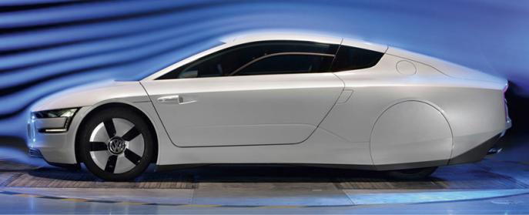
For a car to have good fuel economy, its’ aerodynamics is one of the key factors that determine how good it is. The form of a car is a big contributor to how fuel efficient a car is, so designers tend to follow the tear-drop shape, which is the most aerodynamic shape as this is taken from the form water droplets take when it rains.
Figure 5 Most fuel-efficient car
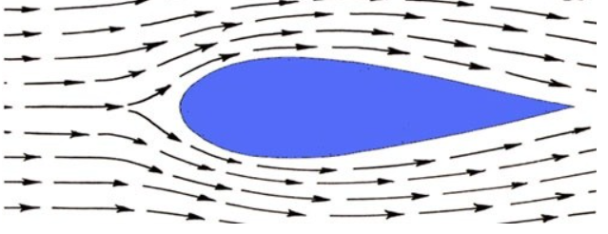
We can see this implementation of the tear-drop form in figure 5 where the designer has adapted the shape to fit the elements of a road going vehicle . The reasoning behind this is for a car to be fuel efficient, it must have a low drag coefficient. Referred to as Cd, where the tear drop shape, as shown in figure 6, has the lowest Cd at under supersonic speed of 0.05. However, Cd is relative to the size of the form, there fore it can only be compared to vehicles within its class range. This in turn improves fuel economy as the car wastes less energy on fighting against the air resistance the car experiences at speed. However, this applies to road use as cars are not experiencing significant speeds that would increase the conditions differences that would need aero devices to make the effects of aerodynamics more consistent.
Figure 6 Most aerodynamic form
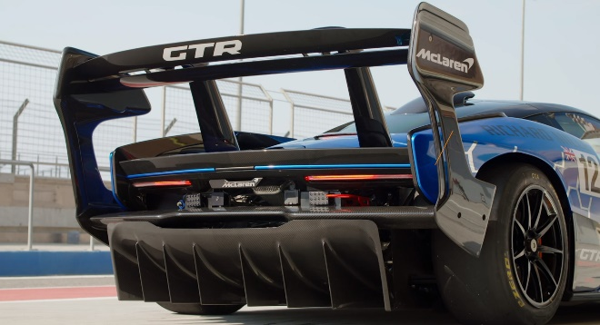
So, to improve cars that experience these stronger forces, we must consider aero devices that apply downforce to the car that improve consistency and grip. One device that has a significant effect on drag with performance cars would be a rear wing. The rear wing seen in figure 7 is from a track GTR Senna which uses the wing to create downforce at speed to plant the rear of the car.
Figure 7 Senna GTR rear wing
Figure 8 Cross section of a race wing.
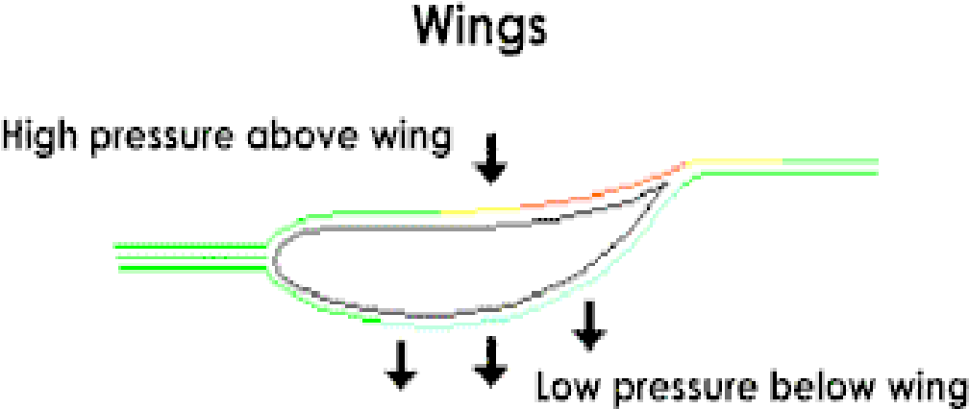
As this is a chassis mounted wing the forces affect the whole rear section of the vehicle at speed which helps with straightaways, cornering and breaking. Depending on the angle of attack of the wing can give different effects. If the angle is too far forward it can hinder the cars’ ability to reach its top speed, but in turn will have more force created on the rear tyres. Too far back and the wing can cause lift and lose traction at speed.
Figure 8 shows the effect the wing experiences against air at speed. This is just one of the devices designers and engineers can use to improve the performance of their vehicles. Other devices such as canards, splitters, channelling , etc. all make a system which can alter the cars’ handling characteristic. For more commercial uses, aerodynamics can reduce a cars fuel consumption that can be applied to city cars, long distance lorry shipping transportation, saving companies and the average consumer money.
Bibliography
Q1 – References
Pankaj Vig. (2016)What is Monocoque construction? Available at: https://autoportal.com/articles/automotive-sector-expectations-not-met-in-budget-fy-2020-21-16983.html (Accessed: 25 April 2022). Figure 4
T.B. Hilditch, P.D. Hodgson. (2015) Welding and Joining of Advanced High Strength Steels (AHSS) Available at: https://www.sciencedirect.com/topics/engineering/monocoque (Accessed: 25 April 2022). Figure 3
DRIVEMAG(2004) LOTUS ELISE Available at: https://drivemag.com/car/LOTUS/ELISE/convertible-2doors-1996-gb (Accessed: 25 April 2022). Figure 1
Rob Collingridge. (2002) S1 Chassis Available at: http://www.elises.co.uk/components/s1/chassis/index.html (Accessed: 25 April 2022). Figure 2
Joseph C. England, Homayoun Hadavinia*, Denis R. Marchant, and Akbar Aboutorabi. (2010) Design of Automotive Metal and Composite Chassis Structures Available at: file:///C:/Users/mhcam/Downloads/2010JE-HH-DM-AA.pdf (Accessed: 25 April 2022). Research
Q2 – References
KYLE.ENGINEERS(2017) What Causes Drag on Cars? Viscous and Pressure Drag Explained [video]. Available at: https://www.youtube.com/watch?v=xReTQzdocdA&list=PL6R7zR4ZbGkOny_RGsc2V3DULdd2SPwSU&index=28 (Accessed:25 April 2022). Research
Haynes (2018) Aerodynamics and how they affect fuel economy. Available at: https://haynes.com/en-gb/tips-tutorials/aerodynamics-and-how-they-affect-fuel-economy (Accessed:25 April 2022). Figure 5
‘kramer65’ (2020) Why are aerodynamic / streamlined shapes always stumpy at the front? Available at: https://physics.stackexchange.com/questions/572565/why-are-aerodynamic-streamlined-shapes-always-stumpy-at-the-front (Accessed:25 April 2022). Figure 6
BRAD ANDERSON (2020) This Is Why The McLaren Senna GTR Has Such A Massive Rear Wing. Available at: https://www.carscoops.com/2020/04/this-is-why-the-mclaren-senna-gtr-has-such-a-massive-rear-wing/ (Accessed:25 April 2022). Figure 7
Sandy Kyei Minkah (2014)Composite Car Rear Spoiler Available at: https://www.semanticscholar.org/paper/Composite-Car-Rear-Spoiler-Minkah/4ebfc698fc0bbe12d590b2169afd9edc5506e55e (Accessed:25 April 2022). Figure 8

