

BMIH5006
Sustainable Hospitality & Tourism Management

Essay: A Vision of Change: Sustainability in the Hotel Industry

Name: Vlad Alexandru Radu
ID:2111633

Table of Contents
1. Introduction 3
2. Main Body 3
3. Conclusion 8
4. References 9
5. Appendices 13

1. Introduction
Sustainability practice become a major concern for international businesses in the 21st century. It has been observed that sustainability in the business operation could make them focused on several environmental and societal issues based on which they could provide better solutions through their operational strategies. In this way, a high brand value and competitive advantage of the sector would be developed in the target market. Henceforth, sustainability in light of corporate social responsibility (CSR) becomes the prime element for the public as well as private sectors and the hotel sector is no exception from this. It can be stated that the hotel industry has a dramatic impact on the environment regarding its energy consumption, water consumption and use of consumable goods. In this way, by focusing on the government's pressures and competitor's actions, the hotel industry has started to implement sustainability strategies for ecological and societal improvement respectively.
Considering this, the following essay will discuss the way the hotel industry is responding and adopting sustainability practices regarding its operational strategy. In this way, the pillars of sustainability and its relationship with the hotel industry would be discussed in this study. Besides, the business concern of the hotel industry regarding the sustainability strategy for constant government pressures and competitor actions and the circular economy with CSR would be highlighted in this essay with significant examples of the CSR policies by the hotel industry, which would make the essay effective.

2. Main Body
Definition of sustainability in business:
As per the opinion of Spiliakos (2018), sustainability in the business industry is considered the way for doing business by focusing the ecological degradation and societal improvement. It has been stated that sustainability for the global business industries refers to doing business by avoiding negative impacts on the environment, community or society. In this way, the high brand value of the industry could be ensured. Additionally, Mollenkamp (2023) reported that sustainability ensures consideration of the business operations by focusing on the environmental, economic and social factors based on which proper decisions could be taken. In this aspect, the short-term and long-term goals of the organisations could be done as well.
Pillars of sustainability:
Purvis et al. (2018) reported that the sustainability pillars consider three main aspects including environmental, social and economic development. In this aspect, the main three pillars could indirectly influence the people, planet, purpose and profit of the business industry respectively (See Appendix 1, Figure 1). Meanwhile, Beattie (2023) stated that economic development through the sustainability practice considers the meeting of essential human needs with environmental consideration and self-reliance while social development ensures the improvement of the living standard of the local community with the help of effective business operations. Additionally, environmental responsibility considers the use of sustainable materials in the operations, green supply chain practice and relies on renewable energy for ecological improvement (Purvis et al., 2018).
Relationship of sustainability and its pillars with the hotel industry:
As reported by Kim, Barber and Kim (2019), the hotel industry become well aware of all of these aspects and three main pillars of the sustainability practice based on which their CSR become strong in the global market. It has been observed that green business practices become the major business operation and strategy for the hotel industry (Alipour, Safaeimanesh and Soosan, 2019). Additionally, by focusing on the three pillars of sustainability, the hotel industry mainly focused on four key themes such as effective sustainability planning, maximisation of social and economic benefit for the local community development, cultural heritage enrichment and reduction of negative environmental impacts (Kim, Barber and Kim, 2019).
Moreover, Ouyang, Wei and Chi (2019) supported that by focusing on three pillars of sustainability, the hotel industry started to practice green strategy regarding their operational process and supply chain management for achieving the sustainable development goal provided by the UN. The study has highlighted the practice of Egyptian hotels and their sustainability practice by focusing on SDG 6, SDG 7, SDG 12 and SDG 13 respectively (Abdou, Hassan and El Dief, 2020). In this way, it can be stated that the hotel industry become focused on its sustainability practice and its relationship with its operational strategy for better CSR outcomes.
Sustainable business concern for government pressures:
In addition, it has been stated that the government of the global countries considers the sustainability practice by all business industries and thus, implemented several rules and regulations by focusing on the CSR strategy. According to the report of Atalla et al. (2022), governments has targeted to tackle the ongoing challenges related to the environmental, social and economic aspects by implementing huge transformation across all business industries including the hotel industries. Additionally, it has been reported that the government of all countries involved in environmental sustainability practices and green economic development in recent scenarios (Khan, Yu and Umar, 2022).
Furthermore, the study by Atalla et al. (2022) pointed out that the governments of global countries have taken initiatives for sustainability policies and action for reduction of the temperature by 25 to 29⁰C, ambition targets by the end of 2030, pledges and optimistic scenarios for reduction of by 19-23 GtCO₂ e respectively (See Appendix 2, Figure 2). In this way, the continuously increasing government concern the sustainability practice has encouraged the hotel industry to implement eco-friendly practices and policies within their business code of conduct, which would help to tackle the political and legal threat imposed by the government concerning the sustainability practice respectively (Abdou et al., 2022).
Sustainable business concern for competitive pressures:
According to the report of Carroll (2021), competitive pressure could enhance sustainability practices across the global market. It has been observed that global customers become focused on sustainability practices in terms of eco-friendly practices and societal development. In this way, global business industries including the hotel industries focused on the implementation of sustainable approaches and ensured eco-friendly practices through their operation, which would help to engage a large number of customers (Mbasera et al., 2016). Furthermore, Acampora et al. (2022) stated that the competitive threat in the hotel industry become enhanced systematically, which has forced them to practice sustainability for ensuring a better competitive position in the global business market.
Besides, the external stakeholders of the hotel industry become focused on sustainability and green hospitality services (Chan, 2021). The study by Hermundsdottir and Aspelund (2021) stated that there is a significant relationship is present between sustainability innovation and firm's competitiveness, as it engages customers alongside the investors and other external stakeholders such as international hotel operators, local authorities and government. Hence, majority of the hotel organisations such as Marriott, Hilton and Hyatt have implemented sustainability practices for better organisational competitiveness and stakeholder engagement (Howusu, 2019). Considering this, to withstanding this sustainability-focused competitive threat within the hotel industry, the key business concern for the industry is sustainable hospitality service for the guests.
Circular economy and its relationship with CSR:
Further, the concept of the circular economy could be related to the CSR strategy of the hotel industry, as it could enhance the competitive advantage of the firm effectively. The study by UNCTAD (2023) reflected that the circular economy concept considers the reusing, reshaping and then extracting new resources for the business. In this way, all forms of waste could be recycled in the economy of the business and thereby ensuring better efficiency and competitive advantage respectively. Mazzucchelli et al. (2022) stated that the CSR of the hotel industry could rely on sustainability, brand reputation in society and financial performance, which are closely related to the circular economy and support each other for achieving the competitive advantage of the business respectively. In this way, it can be stated that the model of the circular economy helps to manifest the business opportunities in a cyclic way instead of the linear process, which would be related to the sustainability practice in business operations (Rodríguez-Espíndola et al., 2022).
According to the report of UNCTAD (2023), the circular economy has a significant role in the CSR practice, as it mainly focused on the three key aspects including reducing, reusing and recycling. In this way, it could help the hotels and guests to follow sustainable measures properly for ensuring better green hospitality service. Julião et al. (2018) reported that consumer sustainability awareness could directly influence the adaptation of a circular economy and green practices by the hotel industry. Hence, based on the circular economy concept, the hotel and other hospitality organisations adopted several innovation strategies, which help to reduce pollution, waste management issues and incorporate products and services, which are more environment-friendly. In this way, customer engagement becomes enhanced in the hotel industry, which put a positive impact on the market share and economic development of the hotel industry respectively (Bernard and Nicolau, 2022).
Examples of CSR strategies and policies by the Hotel industry:
Considering the above analysis, some suitable examples of policies and practices of CSR inside the hotel industries could be provided for better understanding. The study by Singal and Rhou (2017) highlighted that the hotel industry ensures a large percentage of energy and water consumption as well as waste removal, which negatively influenced the environment. In this way, the industry has implemented sustainable policies regarding water and energy savings for ensuring sustainability. Additionally, the industry started to practice social and philanthropic activities, which could be considered their CSR strategy in the global market.
It has been reported that major hotel brands in global markets such as Hilton, Marriott, Accor and others practices have several strategies and policies regarding the sustainability practice for better competitive advantage (Gentinetta, 2023). The report from Serve 360 (2023) stated that Marriott International mainly focused on the sustainability policies for environmental, community and employee management practices based on which better CSR practices in the internal and external business environment have been possible. Meanwhile, it has been stated that Hilton follows environmental policies for natural resources maintenance and water and waste management (Hilton ESG, 2023). Additionally, the hotel giant follows social policies for local community empowerment and diversity, equity and inclusion strategy for human rights protection, which ensures their high CSR practice in the global market respectively.
Consequently, Accor hotel group implement CSR policies for managing environmental sustainability, community development and employee management similar to Marriott (Accor, 2023). In this way, better sustainability practice by the hotels have been effectively understood with real-life examples. Furthermore, Milo (2022) stated that global hotels have started to use greener products and energy-efficient appliances for sustainable practices. Additionally, by using recycled water conservation, sustainable packaging, avoidance of plastics and other measures have been implemented by the global hotel industry as their code of conduct, which ensures better CSR for the environment and community development for the future respectively.

3. Conclusion
At the end of the essay, it can be stated that the sustainability practice become the major business concern for the hotel industry in the global market, which requires further improvement for better outcomes. From the above analysis, it can be stated that sustainability practices can be done through environment-friendly strategies, social improvement practices and economic development, which would help to improve the competitive advantage of the hotel industry in the global market. Additionally, three main pillars of sustainability including environmental, social and economic aspects have been considered by the hotels for engaging a large number of customers. It has been stated that external and internal stakeholders of the hotel industry become well aware of the sustainability practice and green hotel services.
Additionally, the governments of the global countries and continuous pressures from the competitors have encouraged the hotels for increasing sustainability practices, which would help them to acquire a high brand value respectively. Furthermore, the above essay has described the relationship between the circular economy and the CSR strategy of the hotel industry for effective business outcomes. In this way, both environmental and economic sustainability become achieved for the industry. Moreover, some real-life examples of major hotel brands in the global market alongside their CSR strategies have been highlighted in this essay, which ensured a better understanding and made the study comprehensive as well.

4. References
Abdou, A.H., Hassan, T.H. and El Dief, M.M., (2020). “A description of green hotel practices and their role in achieving sustainable development.” Sustainability, 12(22), p.9624.
Abdou, A.H., Hassan, T.H., Salem, A.E., Albakhit, A.I., Almakhayitah, M.Y. and Salama, W., (2022). “The Nexus between Environmentally Sustainable Practices, Green Satisfaction, and Customer Citizenship Behavior in Eco-Friendly Hotels: Social Exchange Theory Perspective.” Sustainability, 14(19), p.12791.
Acampora, A., Lucchetti, M.C., Merli, R. and Ali, F., (2022). “The theoretical development and research methodology in green hotels research: A systematic literature review.” Journal of Hospitality and Tourism Management, 51, pp.512-528.
Accor (2023) Accor - engagement, Group.accor. Available at: https://group.accor.com/fr-FR/commitment (Accessed: 21 May 2023).
Alipour, H., Safaeimanesh, F. and Soosan, A., (2019). “Investigating sustainable practices in hotel industry-from employees’ perspective: Evidence from a Mediterranean Island.” Sustainability, 11(23), p.6556.
Atalla, G., Mills, M. and McQueen, J. (2022) Six ways that governments can drive the green transition, EY. EY. Available at: https://www.ey.com/en_gl/government-public-sector/six-ways-that-governments-can-drive-the-green-transition (Accessed: 21 May 2023).
Beattie, A. (2023) The 3 pillars of Corporate Sustainability, Investopedia. Investopedia. Available at: https://www.investopedia.com/articles/investing/100515/three-pillars-corporate-sustainability.asp#:~:text=Sustainability’s%20three%20main%20pillars%20represent,%2C%20purpose%2C%20and%20profits.) (Accessed: 21 May 2023).
Bernard, S. and Nicolau, J. L. (2022) ‘Environmental certification and Hotel Market Value’, International Journal of Hospitality Management, 101, p. 103129. doi: 10.1016/j.ijhm.2021.103129.
Carroll, S. (2021) Creating competitive advantage through sustainability, Grant Thornton International. Available at: https://www.grantthornton.global/en/insights/articles/creating-competitive-advantage-through-sustainability/ (Accessed: 21 May 2023).
Chan, E. S. W. (2021) ‘Influencing stakeholders to reduce carbon footprints: Hotel Managers’ Perspective’, International Journal of Hospitality Management, 94, p. 102807. doi: 10.1016/j.ijhm.2020.102807.
Gentinetta, J. (2023) 11 examples of CSR practices in the hospitality industry, Hospitality News & Business Insights by EHL. Available at: https://hospitalityinsights.ehl.edu/csr-practices-hospitality-industry (Accessed: 21 May 2023).
Hermundsdottir, F. and Aspelund, A. (2021) ‘Sustainability Innovations and firm competitiveness: A Review’, Journal of Cleaner Production, 280, p. 124715. doi: 10.1016/j.jclepro.2020.124715.
Hilton ESG (2023) Travel with purpose: Environmental, social and governance at Hilton, Hilton ESG. Available at: https://esg.hilton.com/ (Accessed: 21 May 2023).
Howusu, C. (2019) Exploration of sustainability practices in major hotel chains through web content analysis, Researchgate. Available at: https://www.researchgate.net/publication/333320750_Exploration_of_sustainability_practices_in_major_hotel_chains_through_web_content_analysis (Accessed: 21 May 2023).
Julião, J. et al. (2018) ‘Exploring circular economy in the hospitality industry’, Innovation, Engineering and Entrepreneurship, pp. 953–960. doi: 10.1007/978-3-319-91334-6_131.
Khan, S.A.R., Yu, Z. and Umar, M., (2022). “A road map for environmental sustainability and green economic development: an empirical study.” Environmental Science and Pollution Research, pp.1-9.
Kim, Y.H., Barber, N. and Kim, D.K., (2019). “Sustainability research in the hotel industry: Past, present, and future.” Journal of Hospitality Marketing & Management, 28(5), pp.576-620.
Mazzucchelli, A. et al. (2022) ‘Do circular economy practices affect corporate performance? evidence from italian large‐sized manufacturing firms’, Corporate Social Responsibility and Environmental Management, 29(6), pp. 2016–2029. doi: 10.1002/csr.2298.
Mbasera, M. et al. (2016) ‘Environmentally-friendly practices in hotels’, Acta Commercii, 16(1). doi: 10.4102/ac.v16i1.362.
Milo, S. (2022) Implementing sustainability into the hospitality industry, Forbes. Forbes Magazine. Available at: https://www.forbes.com/sites/forbesbusinesscouncil/2022/09/29/implementing-sustainability-into-the-hospitality-industry/?sh=aadb3a76c302 (Accessed: 21 May 2023).
Mollenkamp, D. T. (2023) What is sustainability? how sustainabilities work, benefits, and example, Investopedia. Investopedia. Available at: https://www.investopedia.com/terms/s/sustainability.asp (Accessed: 21 May 2023).
Ouyang, Z., Wei, W. and Chi, C.G., (2019). “Environment management in the hotel industry: does institutional environment matter?” International Journal of Hospitality Management, 77, pp.353-364.
Purvis, B., Mao, Y. and Robinson, D. (2018) ‘Three pillars of sustainability: In Search of Conceptual Origins’, Sustainability Science, 14(3), pp. 681–695. doi: 10.1007/s11625-018-0627-5.
Rodríguez-Espíndola, O., Cuevas-Romo, A., Chowdhury, S., Díaz-Acevedo, N., Albores, P., Despoudi, S., Malesios, C. and Dey, P., (2022). “The role of circular economy principles and sustainable-oriented innovation to enhance social, economic and environmental performance: Evidence from Mexican SMEs.” International Journal of Production Economics, 248, p.108495.
Serve 360 (2023) Home - CSR-Marriott, Serve 360. Available at: https://serve360.marriott.com/ (Accessed: 21 May 2023).
Singal , M. and Rhou, Y. (2017) Corporate Social Responsibility in the hospitality sector, BU. Available at: https://www.bu.edu/bhr/2017/01/27/hospitalitycsr/#:~:text=These%20include%20attempts%20to%20increase,and%20energy%20saving%20in%20hotels. (Accessed: 21 May 2023).
Spiliakos, A. (2018) What is sustainability in business?: HBS Online, Business Insights. Available at: https://online.hbs.edu/post/what-is-sustainability-in-business (Accessed: 21 May 2023).
UNCTAD (2023) Circular economy, UNCTAD. Available at: https://unctad.org/topic/trade-and-environment/circular-economy#:~:text=A%20circular%20economy%20entails%20markets,economy%20or%20used%20more%20efficiently. (Accessed: 21 May 2023).

5. Appendices
Appendix 1:
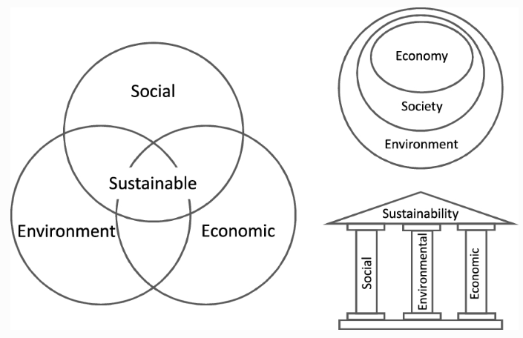
Figure 1: Three Pillars of sustainability practice
(Source: Purvis et al., 2018)

Appendix 2:
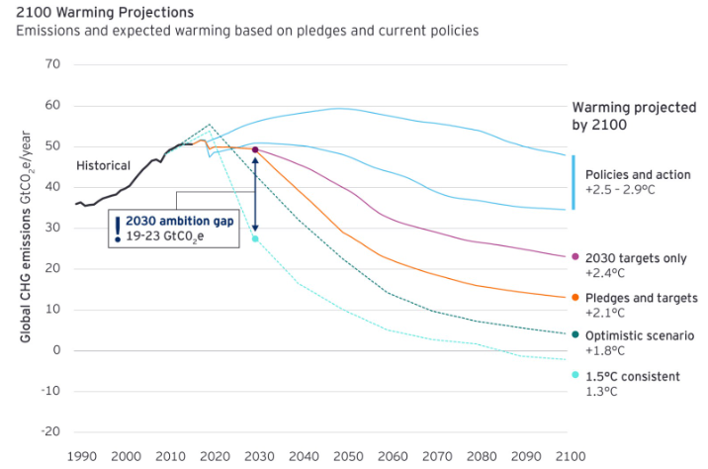
Figure 2: Government's Role for sustainability
(Source: Atalla et al., 2022)

