Victoria Richards-Green (Aneurin Bevan UHB - Pharmacy)
2110533@student.uwtsd.ac.uk
Formative submission
Decsion support for initial inhaler prescribing
Decision-making in Health and Social Care Settings

Contents
Introduction 3
Figure 1 – Compound risk assessment for inhaler selection 4
Current CDSS and proposed advance 5
Figure 2 – Twin track flow chart for inhaler decarbonisation CDSS 6
Figure 3 – Twin track flow chart for initial inhaler prescribing CDSS 7
Figure 4 – Knowledge levels for clinical decision support 8
Table 1 – MCBK applied to the proposed new CDSS 8
Evidence review 10
Evaluation of the evidence 12
Table 2 – Grading and appraisal of the available evidence 12
Gaps in the evidence base 13
Implementation issues 14
Application of the GUIDES checklist 14
Domain 1 - the CDSS Context 14
Domain 2 - the CDSS Content 16
Domain 3 - the CDSS System 19
Domain 4 - the CDSS Implementation 21
Evaluation 24
References 25

Introduction

When it comes to prescribing inhaled therapies for respiratory conditions, prescribers are faced with an array of different inhaler devices to choose from. The patient’s ability to use a given inhaler device must be considered when prescribing, adding an additional layer of complexity to the decision making. Over the past 20 years, UK prescribing habits around inhaler device choice have changed very little, despite the number of inhaler device choices significantly increasing. The most prescribed inhaler device in the UK is still the metered dose inhaler (MDi), compared with Europe where most inhaler devices are dry powder inhalers (DPi’s) (Wilkinson and Woodcock, 2022). DPi’s have been shown to improve patients’ disease control (as they generally elicit fewer critical errors (Rogueda and Traini, 2016)), resulting in delivery of a clinically effective dose as well as reducing carbon emissions (MDi’s contain propellants that contribute to global warming) (Wilkinson et al. 2022).

One of the main difficulties around selecting an appropriate inhaler for a patient, when an inhaler is first prescribed for a new respiratory diagnosis, is knowledge of all the inhaler device options. In addition to this the prescriber must also have knowledge of the different techniques required for each inhaler device and what the patient is able to use. Which is something that has be shown to be lacking (Thomas, 2015). A patient’s ability to inhale through a device at the correct speed is a critical part of inhaler technique. When the patient’s technique and the device type don’t match, the result is poor disease control (Melani et al. 2011).

Figure 1 below shows a compound risk assessment of the patient factors that should be considered before prescribing an inhaler device for a patient. The only reference to any part of this risk assessment within guidelines, is a side note to suggest the use of spacer devices with MDi inhalers. As this eliminates errors due to incorrect post-inhalation breathe hold. Relying solely on the clinician’s knowledge when considering all other factors in the risk assessment.

Figure 1 – Compound risk assessment for inhaler selection

Both national and global institutes such as: the National Institute for Health and Care Excellence (NICE), (NICE, 2019), (NICE, 2021), the British Thoracic Society / Scottish Intercollegiate Guidelines Network (BTS/SIGN) (BTS/SIGN, 2019), the Global initiative for Asthma (GINA) (GINA, 2022) and the Global Initiative for Chronic Obstructive Lung Disease (GOLD) (GOLD, 2023) have, for many years, all included the importance of patient inhaler technique in their guidance. There are plans to combine the guidance from NICE, BTS and SIGN into a single document, which is expected for publication in 2023. So why are we failing to consider the patients technique at the point of prescribing?

Guideline adherence is known to be poor within primary care (Gabbay and Le May, 2004), with most prescribers preferring to use “mindlines” in preference to a purely evidence based medicine (EBM) approach, as offered by guidelines (Wierings and Greenhalgh, 2015). Mindlines are often built from a combination of EBM and practical experience, often referred to as “knowledge-in-practice-in-context” (Gabbay and Le May, 2016). They are an acumination of practical experience in addition to the collective experience of trusted peers.

In addition to the barriers of guideline adherence, there are likely to be several logistical factors involved. With the two most significant ones linked to: knowledge of devices, and time to assess the patient (Ogden et al, 2004). Most of the clinical decisions around initial inhaler prescribing are undertaken in primary care by GP’s, rather than by respiratory specialist prescribers. So how could a clinical decision support system (CDSS) be used or adapted to support these staff in prescribing appropriate inhalers in the first instance?

Within Aneurin Bevan University Health Board (ABUHB), an in-house CDSS was developed in 2022 to guide decisions for patients already prescribed inhalers. This CDSS is linked to the decarbonisation agenda, national guidelines, and the need to assess patient’s inhaler technique. It is currently being rolled out across the health board to all staff that assess respiratory patients, with the focus on primary care assessments. It has not yet been widely adopted. It aims to support both specialist and non-specialist prescribers to provide consistence of prescribing. Could this CDSS be adapted for use for the initial prescribing of inhalers? By providing patients with the right inhaler for them, the first time one is needed, there is likely to be a reduction in workload reviewing those who have already been prescribed inhalers they cannot use.

Current CDSS and proposed advance

Medlock et al, in 2016 proposed the twin track theory, which defines CDSS as having two work streams. One based on clinical knowledge and the other based on cognitive-behavioural knowledge. To demonstrate how both clinical and cognitive-behavioural knowledge could be utilised in both the existing CDSS (for inhaler decarbonisation review) and the suggested advance (for initial prescribing of inhaler), the twin track theory has been applied. Figure 2 below, shows the twin track theory applied to the current CDSS for inhaler decarbonisation review and Figure 3 shows the theory for the proposed advance for initial prescribing of inhalers.

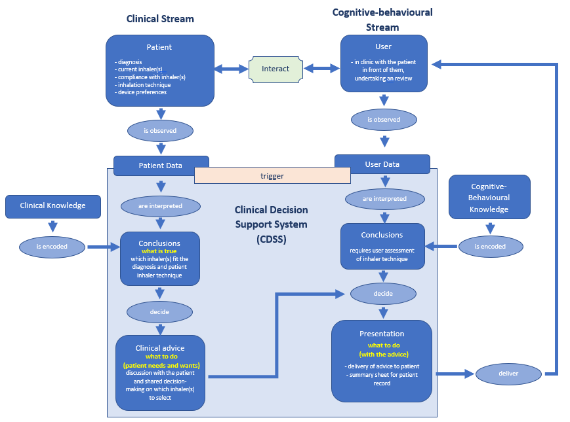

Figure 2 – Twin track flow chart for inhaler decarbonisation CDSS

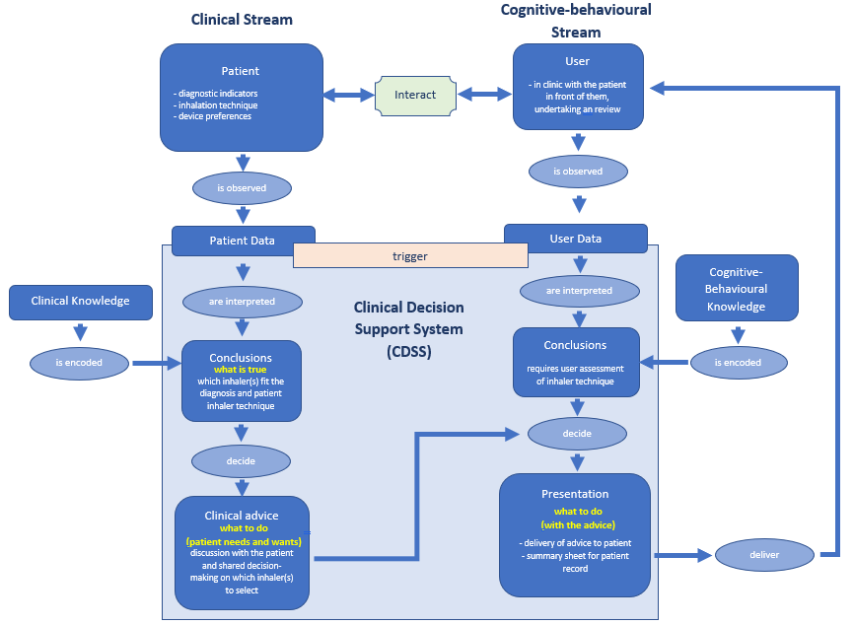

Figure 3 – Twin track flow chart for initial inhaler prescribing CDSS

The main difference between the two systems is the information that is encoded at the start. For the original system this information is generated from the patients’ current inhalers: such as drug class and strength. For the proposed system, this information will need to be generated from patient diagnostic measures, such as biometric results and symptoms. These will then need to be encoded to correspond with a starting point in the current system.

When looking at how you get from the start point, of the narrative of a problem, to encoded data, the aims of Mobilising Computable Biomedical Knowledge (MCBK) can be used to define each artifact in the flow and to assign it a knowledge level (Williams et al. 2021). The first artifact is a narrative of the problem, (as above for the initial prescribing of inhalers). This can then be converted into a semi-structured flow (e.g., by using the twin track model). From here a set of structured questions is developed where outcomes can be formulated, which can then be encoded into structured data and then finally executable data. By converting guidelines into computable flows, we can limit the inhaler choices, to a narrower more workable scope. Figure 4 below is taken from About CDS Connect | CDS Connect (ahrq.gov) and shows a pictorial representation of each of artifact.

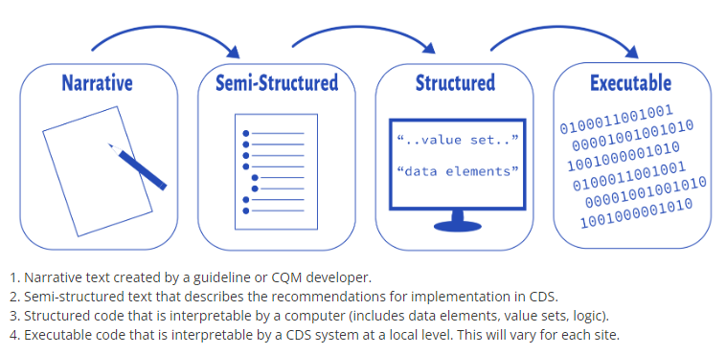

Figure 4 – Knowledge levels for clinical decision support

The descriptors in figure 4 can then be assigned to a knowledge level. Table 1 below shows how MCBK can be applied to the proposed new CDSS and is adapted from the HL7 FHIR clinical guidelines (v1.0.0).

Table 1 – MCBK applied to the proposed new CDSS

Knowledge Level | Description | Example
L1 | Narrative / Natural language | All Wales Asthma and COPD guidelines
L2 | Semi-structured / Conceptual model | Flow diagram developed from the guidelines that explicitly describes the biomedical parameters that make up the initial diagnosis of a patient and what this then means for treatment starting points. E.g., what the phenotype of COPD is classified as and what inhaled medications are then required. Represented in a way that can then be interpretable by a non-clinical CDSS developer
L3 | Structured / Logical model | Specifications for the CDSS that encode the terminologies (such as diagnosis) value sets (such as medication details around strength, class, and inhaler device resistance). Logic is expressed in a computable language sufficient for implementation
L4 | Executable / Physical model | Manifestation of the logic being used in a functional CDSS, that is live and available via the PowerApps platform

Evidence review

A google scholar search was conducted using the following search terms:
- Clinical Decision Support
- Clinical Decision Support System (CDSS)
- Personalised medicine
- Device selection
- Medical device selection
- Inhaler device
- Inhaler device selection
- Guideline adherence
- User experience (UX)
- Medication decisions
- Drug delivery
- Drug delivery system
- Inhaler technique
- Inhaler technique assessment

When relevant articles were found, a review of the references used in these articles was undertaken. This then informed other articles and search terms to utilise.
Many studies were identified on CDSS within paediatric asthma and COPD, but very little directly linked to inhaler device selection. Most were linked to general guideline adherence i.e., medication classes etc. There was also, some research around inhaler compliance via “smart” inhaler monitoring (Green and Cstello, 2019), This is a different topic area to device selection, as it is not directly linked to assessment inhalation technique. Smart inhalers are digital devices that report back varying types of physical and biometric data to a digital application. Information collected can vary from: simple data such as whether an inhaler has been primed (ready for a dose to be inhaled), to more complex data on whether the patient has inhaled at the correct inspiratory flow rate for the given device. While this data can then be used to ascertain compliancy with medication treatment, for the majority of these “smart” inhalers it still fails to confirm correct inhaler technique. For the few that do report on inhaler technique, while also stating if it is correct, there is no upfront assessment prior to the prescribing of the inhaler device. The smart inhaler simply reports back if the patient can use the device. For those highlighted and unable to use the device, another review and prescribing activity is then required.
Consideration was given to AI and machine learning within the field of respiratory medicines. However, the core principles of inhaler selection are knowledge based rather than something where AI can be adopted. A search around where AI has been used within the area of respiratory medicine, showed that most are focused on diagnosis, from physiologic factors such as reading images and X-rays etc (Gonem et al. 2020). There were no results around device selection, even when considering fields outside of respiratory medicine.
What was found, were papers linked to CDSS adoption and user experience (UX), the following review papers were highlighted for further consideration: Gao et al. 2022, Moghadam et al. 2021 and Westerbeek et al. 2021.

Gao et al 2022 was a literature review of peer-reviewed studies, with the objective to identify: barriers, facilitators, and design strategies to increase adoption of asthma CDSS by end-users. The 35 studies assessing focused on UX, and all except one were guideline based. The majority (31/35) included GP’s, with the remaining (4/35) including specialist respiratory clinicians. The conclusion of the review was that there is limited adoption of asthma CDSS, which in turn reduces their effectiveness in practise. Gao et al suggests using the GUIDES checklist to minimise barriers to adoption.

The Moghadam et al 2021 paper was a systematic independent review and meta-analysis of CDSS for the prescribing of medications and patient outcomes. It focused on whether CDSS could reduce prescription errors. While not directly related to inhaler selection, the wrong inhaler can lead to patient harm, through failure to provide disease control.
The conclusions of the review were that CDSS can have a positive effect on patient outcomes, but that there are factors that affect this. Some of the key factors highlighted from the review were:
- Usability
- Guideline adherence
- Shared decision making, between the patient and the user
- Interoperability

The systematic review undertaken by Westerbeek et al, 2021, focused on the acceptance by clinical for medication related CDSS. Focusing on qualitative studies where guidelines had been computerised to prevent prescription errors. This is linked to the proposed CDSS as it aims to map inhaler choice to guidelines and licenced indications. It showed a lack of full adoption of such systems by clinicians, citing themes such as:
- A lack of usefulness in everyday practice
- Information of limited relevance
- Poor usability

Due to a lack of directly related evidence for CDSS linked to inhaler device selection a further review of the “grey literature” was undertaken. This is defined as publicly available, open-source information, that is not accessible through the database searches used for published data (Benzies et al. 2006).
A google search for grey literature yielded information and paper-based tools to support the assessment of a patients’ inhaler technique, but nothing in the way of digital tools.

Evaluation of the evidence

For the limited evidence that was relevant to the proposed CDSS, an evaluation was undertaken to grade the evidence and its usefulness to the chosen topic. Table 2 below, shows the outcome of this grading process.

Table 2 – Grading and appraisal of the available evidence

Paper Author / Year | Type | Evidence Grading | Usefulness to proposed CDSS | Comments
Gao et al. 2022 | Literature review | High | Medium | Not a direct comparison to proposed CDSS, there was some useful information around UX linked directly to asthma CDSS
Moghadam et al. 2021 | Systematic review &  Meta-analysis | High | Medium | Re-enforces to use of guidelines to positively affect patient outcomes. Although not specific to respiratory guidelines
Westerbeck et al. 2021 | Systematic review | High | Medium | Discussed medication related CDSS acceptance by clinicals, but not respiratory specific

Gaps in the evidence base

There is currently not formal evidence around the use of CDSS to assess a patients inhalation technique as part of prescribing decision making. Despite the vast array of evidence to support the importance of this in the prescribing process, as detailed in all major national and international guidelines for both asthma and COPD. As well as evidence around predictive physical devices and assessment checklists that can be used to assess a patient actual inhaler technique. Evidence is also lacking for CDSS in the process of device selection, where the drug delivery system is patient administered. The ability of a patient to use a drug delivery system is vital to compliancy and concordance with treatment, and yet computerised support for the decision-making processes have not been invested in. Clinicians must rely of their own knowledge of the devices and an assessment of the patient ability to use them, through patient education and to an extent trial and error. As patient education alone has been shown to be an unsuccessful method of ensuring compliance and concordance with inhaled delivery systems (Thomas, 2015).

Implementation issues

There are many things to be considered when looking at meaningful use and implementation of a CDSS. Application of the five rights of clinical decision support (Campbell, 2014) is a good place to start. The rights include:
- the right information
- to the right person
- In the right format
- through the right channel
- at the right time in the workflow

Going further from the five rights, the GUIDES checklist, as described by Van de Velde et al. in 2018, is a tool that was developed with the aim of improving the successful adoption of guideline based CDSS. It lays out four domains, each consisting of four question sets. The GUIDES checklist was also referred to in the literature review by Gao 2022, which looked specifically as UX design of CDSS adoption within asthma. For the proposed CDSS the GUIDES checklist has been applied to ensure consideration has been given to all aspects. Looking in detail at each of the four question areas from all four domains. Each question is graded on the following scale:
- Strongly disagree
- Disagree
- Somewhat disagree
- Undecided
- Somewhat agree
- Agree
- Strongly agree

Application of the GUIDES checklist

Domain 1 - the CDSS Context

- “CDS can achieve the defined quality objective” (does the evidence support the outcomes of the CDSS?)

The outcome of the CDSS is to ensure a patient is prescribed an inhaler device that meets both guideline criteria on drug and dosing, but also matches the inhaler device type to the patient’s inhaler technique ability. Evidence shows that having the patient on the right inhaler device can improve outcomes (Thomas, 2015). Therefore, in this case one outcome measure we are looking at is respiratory disease control. An example of how this can be measured is through healthcare contact for acute exacerbations of the underlying respiratory condition and prescriptions for “rescue” medications.
- GUIDES grading = Strongly agree

- “The quality of the patient data is adequate” (what data is being used and is it accessible?)
There are two sets of patient data that would be used within the CDSS: The first would be clinical knowledge of the patient parameters that define their disease diagnosis and severity, such as biomarkers and symptoms. The second set of data would be generated through consultation between the users and the patient during an assessment and entered as live data into the CDSS. This data would include the patient’s ability to perform specific inhalation techniques, which would then be used to reduce the inhaler devices to only those that the patient has the correct technique to use.
- GUIDES grading = Strongly agree

- “CDS can be added to the existing workload, workflows and systems” (can this be done during a consultation? Will it save time in the longer term?)
The assessment of a patients’ inhalation technique is something that should already be including in any inhaler prescribing activity. However, it is rarely done at the point of prescribing by doctors. Resulting in the patient then attending for repeated reviews and adjustments to inhaler doses and devices, until optimum control of their respiratory disease is achieved. By investing the time at initial prescribing, time can be saved by reducing the need for future appointments for adjustments, linked to poor inhaler technique and incorrect device selection.
- GUIDES grading = Somewhat agree
N.B. But there would need to be information to users that would convince them that the time spent upfront is saved in the longer term.

- “Stakeholders and users accept the CDS” (must be easy and quick to use)
The current version of the CDSS is designed to provide a short list of inhalers to select from, following the completion of a diagnosis form and an inhaler technique form. Questions have dropdown answers, to ensure completion is as quick as possible. Figure 5 below shows the current inhaler technique assessment screen in the existing CDSS, for which initial prescribing would be a development.
- GUIDES grading = Agree

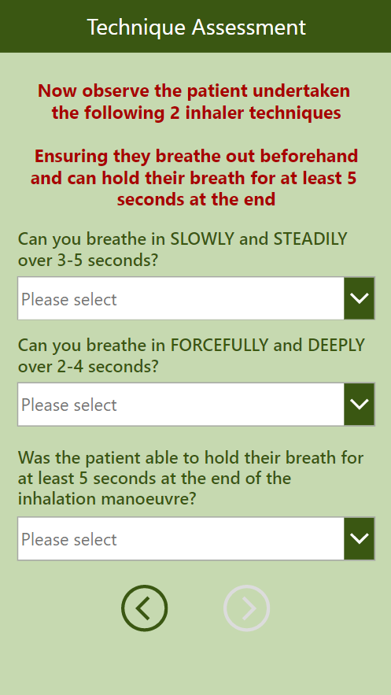

Figure 5 - Screen shot from existing CDSS for inhaler technique assessment

Domain 2 - the CDSS Content

- “The content provides trustworthy evidence-based information” (Are the guidelines fit for practise and regarded as a trusted source?)
The reason for basing both the original CDSS and this addition development, on All Wales guidelines is due to the rigorous local scrutiny and consultation process that is involved with their approval. Stakeholder engagement is at an All-Wales level, during the development, means they are usually more “usable” guidelines than those historically produced by organisations such as NICE, with greater user acceptance.
- GUIDES grading = Strongly agree

- “The decision support is relevant and accurate” (correct info in the CDSS as generated from approved sources, explainability – the CDSS gives an out-put that shows how the decision was reached)
The background information within the CDSS for all inhalers is based on licensed indications. Information such as inhaled corticosteroid strength is chelated from the widely used on-line resource Rightbreathe. Which is a central resource for inhaler information, moderated by NHS pharmacists and doctors, and thought of by healthcare professionals as a trusted source of information. The explainability element of the CDSS is the auto generation of a summary sheet, to be added to the patient record, that details the responses to all questions. This also provides a level of assurance around litigation as the CDSS selection process is documented based on answers given. Figure 6 below shows a sample post assessment summary sheet from the current CDSS for inhaler optimisation. A similar sheet would be produced to document the initial prescribing and all data used in the decision process.
- GUIDES grading = Strongly agree

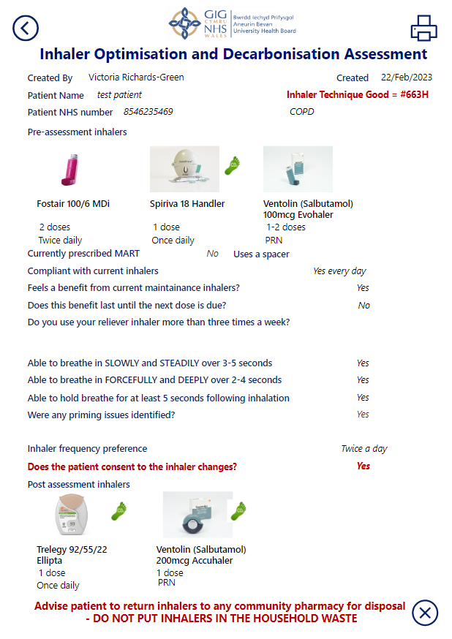

Figure 6 - Screen shot from existing CDSS for post assessment summary sheet

- “The decision support provides an appropriate call to action” (are there any targets local or national which this will support?)
With the 2021 Welsh Government (WG) target around decarbonisation linked to inhaler prescribing (Powlesland and Joyce, 2021), this CDSS would support doctors to prescribe the right inhaler for the patient, and the planet.
- GUIDES grading = Agree
N.B. this would be dependent on user buy-in to the WG targets and their roll in achieving them.

- “The amount of decision support is manageable for the target user” (are we asking them to do more than they do currently?)
This may be seen by prescribers as an additional task to be undertaken. However, the addition of the CDSS with the auto generated summary sheet allows for the impact of the task to be minimised. The longer-term benefit will be seen when the population has better respiratory disease control, resulting in less contact and demand on primary care services. It could be termed an “invest to save”, with respects to time and resources.
- GUIDES grading = Somewhat agree
N.B. this is going to be guided by current mindlines of users and would need consideration around how these mindlines can be influenced in a positive way.

Domain 3 - the CDSS System

- “The system is easy to use” (is it always working? Is it customisable per user? Does it facilitate workflow? How does the user interact with the system i.e., how do their get to it?)
The original CDSS and the additional development would sit within Microsoft PowerApps. The reliability of which is reported by Microsoft as good, but with some user feedback to suggest that on times the application can run slowly (PeerSpot, 2023). The CDSS is controlled by the in-house owners and there are currently no customisable options available. The set-up of the questions sheets within the CDSS are designed to support a shared decision-making consultation between the users and the patient. Accessibility is via the health board intranet or the PowerApps CDSS on a mobile device. For web-based access: once the CDSS page has been accessed it can be added to the favourites bar of a web browser, allowing quicker subsequent access. As most doctors in primary care are office based, this is the most likely access route. The alternative access route is via a mobile device: the PowerApps application can be downloaded to a mobile device (and following Microsoft two-factor authentication), the users can access the CDSS by opening PowerApps and searching for the title of the CDSS. Once found the CDSS can be added as a favourite, for quicker subsequent access. A training session was recorded, that can be sent out as a link, going through how to find and access the CDSS.
- GUIDES grading = Somewhat agree
N.B. first time accessibility is likely to be the weakest link here. More consideration is needed as to how this can be added to workflows.

- “The decision support is well delivered” (is it eye-catching? Does it cover the right functions? Where can it be found?)
Care has been given to the design aesthetic of the original CDSS. To ensure the user only sees what is required. There is conditional formatting based on clinical knowledge and patient responses, that lead the user to the relevant screens for questions and outputs. The importance of use of colour was also considered in the design (Horsky et al. 2013). Medlock et al 2016, refers to important information, such as warnings and alerts, being formatted for example, in red and to only show when needed. Within the CDSS such warning are for information and guidance only, so do not require acknowledgement. Therefore, reducing the need for additional “clicks”. Figure 7 on the below, shows an example from the original CDSS where a warning is presented on screen.
- GUIDES grading = Strongly agree

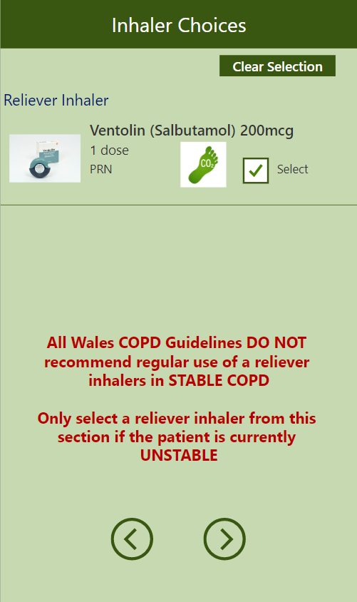

Figure 7 - Screen shot from existing CDSS demonstrating appearance of a warning for consideration

- “The system delivers the decision support to the right person” (Is it where the users’ need it? can it be sharing into the patients’ records?)
There will need to be development, to link the users to the CDSS, so that it is delivered to them when they need it. Once accessed, the CDSS is suitable for the end user, but they need to be able to see it as a prompt for use. Work would need to be undertaken to link the CDSS to current primary care systems, such as EMIS and VISION. The output can be stored in the patients record, but currently this is not automated, so work would need to be done to improve this element of the CDSS.
- GUIDES grading = Somewhat disagree

- “The decision support is available at the right time” (could it be added to an electronic template as a link?)
The integration of a link to the CDSS, into the GP consultation template, is something that is currently unavailable. There are working groups looking at templates, at a Welsh level, to support and facilitate a standardised approach to respiratory reviews and the integration of a link to the CDSS will be part of this template. However, the templates are being designed for reviewing respiratory patients rather than for the initial diagnosis phase. There will likely be a need to develop a template to cover this initial diagnosis phase.
GUIDES grading = Somewhat disagree

Domain 4 - the CDSS Implementation

- “Information to users about the CDS system and its function is appropriate” (how to inform the right people? Training? Pre-recorded?)
A network of stakeholders was engaged as part of the initial roll-out of the first iteration of the CDSS. From this, key staff were identified as early adopters and drivers. These staff have been involved in email comms and some direct face-to-face engagement sessions around the use and integration of the CDSS. To help facilitate use, a recorded session, with a demonstration of how to access the CDSS and where it can be located, was produced. This has been circulated to early adopters as well and added as a central resource on the intranet. The link to the demonstration recording is also located next to all on-line links to the CDSS, on various resource pages of the intranet. Such as the respiratory and primary care resource pages. More engagement on a local level maybe needed to ensure continued spread and adoption.
- GUIDES grading = Somewhat agree

- “Other barriers and facilitators to compliance with the decision support advice are measured / addressed” (Need to assess beliefs and attitudes that could affect compliance. Are there capacity or resources issues? Is there organisational influence?)
A potential barrier to the adoption of this CDSS could be linked to pre-developed “mindlines” of prescribers and their thoughts and attitudes around guideline adherence. There will be a requirement to break the instinctive prescribing habits that have developed over many years. The development of a community of practice (CoP) for inhaler prescribing, may be an option to support this. The principles of communities of practice have changed over the years, with no fixed definition (Li et al 2009). For the main part they are used to share expert knowledge and facilitate good practice with those with less experience. The CDSS is wider than simply inhaler prescribing and guideline adherence, there is a significant focus on patient shared decision-making and engagement (something that patients want more of (Ogden et al, 2004)). The addition of decarbonisation must also be considered. With decarbonisation currently a “hot topic” maybe a CoP with this as the main focus is a better way to engage with users?
- GUIDES grading = Agree

- “Implementation is stepwise and the improvements in the CDS system are continuous” (is there a planned stepwise rollout, with improvements based on feedback, errors resolved quickly?)
The roll-out plan is stepwise and has started with the original CDSS. Which is currently being utilised in one primary care area of the health board. With the aim to obtain user feedback before expanded it’s use to the rest of the health board. The plan for future expansion would be to undertake engagement sessions, at a local level, to allow users to ask questions of the developer and potentially a panel of experts in the clinical field.
It was based on feedback from users of the current CDSS that the proposed development was highlighted. When feedback and errors are identified within the system, they are addressed and resolves quickly. Such as adding a new inhaler to the database or changing a licensed indication. This is partly due to the CDSS being an in-house development. Which mean the owner can review and correct errors straight away, rather than waiting for the company to action a request.
- GUIDES grading = Strongly agree

- “Governance of the CDS implementation is appropriate” (are key stakeholder involved and governed in an efficient, sustainable, and equitable way?)
Within ABUHB there is a process for the approval, of in-house digital solutions. This includes compiling a standard operating procedure (SOP) for the information governance (IG) department, detailing the reason the solution was developed, what patient data is used, and how the output is documented in the patient record. In addition to the IG approval, there is also a requirement to submit the digital solution to the informatics team. Part of the review that is undertaken for all submissions, is to scrutinize the cyber security of the digital solution and assessing the business continuity requirements. Clinically there is a requirement to present the CDSS to stakeholder that may use the system, for discussion and approval.
- GUIDES grading = Strongly agree

Overall, the proposed CDSS, when assessed against the GUIDES checklist, meets most of the domains to a grading of agree or above. The two areas noted as needing improvement, to improve the likelihood of adoption, are: access to the CDSS by the right person, at the right time. These are critical parts in the process, as without this successful adoption is unlikely. To overcome these barriers, there is a requirement to look at the integration of the CDSS into primary can systems and workflow. Improving access by the right person at the right time.

Evaluation

User experience (UX)

The GUIDES checklist is very detailed and as a result would take a significant amount of time to complete. Its use to assess UX on a wider scale therefore may not yield the required level of engagement and response. To improve the response rate for general users of the CDSS, it may be better if an abbreviated version of the key elements of the GUIDES checklist was developed into a Microsoft (MS) Form. The use of an MS form allows for automated data collection, with all responses auto populating an excel spreadsheet. From which data analysis can be undertaken. As a digital form user return rates are higher. With the added ability to check response rates in real time.
For key stakeholders and some more engaged users, the full GUIDES checklist could be completed. This could be done as part of a focus group, where general discuss on the barriers and facilitators can be explored in more detail.

Effectiveness

To establish if the proposed CDSS is effective, outcome measures need to be defined and then monitored. In this circumstance one outcome measure that could be used is: established respiratory disease control. To make this a measurable outcome, there would need to be parameters that could be chelated to show that disease control has been achieved. For example, with asthma one measure of disease control (as set by NICE) is the number of “reliever” (non-treatment) inhalers that the patient has used annually. Set at a maximum of three per year. To show the CDSS has been effective in achieving the outcome of controlled asthma, patients that have been assessed could then be reviewed at a year, with the number of “reliver” inhalers used noted. To show causality with this outcome and the CDSS, baseline data from patients where the CDSS has not been used is required for comparison.

If also choosing to use the CDSS as a push for the decarbonisation agenda, then the SPIRA - Decarbonisation Dashboard can be used to show the impact of the CDSS on inhaler device type prescribing. As the CDSS will default to the lowest carbon footprint inhaler.

Other measures that could be used to assess the effectiveness of the CDSS, pre and post implementation are:
- The number of appointments needed post an initial assessment to establish disease control.
- The number of times a patients inhaler and/or device are changed in the first year after diagnosis.
- The number of prescriptions for acute medication, to treat an exacerbation of the respiratory condition per year.
- Number of hospital admission for acute respiratory disease exacerbations per year.

Safety

To an extent there are some inbuilt safety features within the CDSS. An example of which is the shared decision-making aspect of the inhaler selection. When more than one inhaler is assessed as appropriate, the user and patient decide together on a suitable choice. There is also a consent box which indicates that the patient is happy to have the inhaler(s) as selected through the CDSS
Assessment of the safety of the CDSS output would need to be done through the data that is collected back to a central database. Until the CDSS and prescribing systems are linked, there would need to be a cross check the out-puts to the patient prescription records. To show that the intervention has been actioned in full and the correct inhaler(s) issued.
Another way to assess safety would be to take a random selection of patients and undertaking an expert review and then compare the outcomes. Ensuring the CDSS decisions match to expert opinion.

Efficiency

This is likely to be the hardest element to evaluate, as currently there are limitation around the integration of such a CDSS into standard practice and workflows. Some data on this aspect could be pulled from the results of the UX MS form and the more in-depth GUIDES checklist results.

References

Benzies, K.M., Premji, S., Hayden, K.A. and Serrett, K. (2006) ‘State‐of‐the‐evidence reviews: advantages and challenges of including grey literature’, Worldviews on Evidence‐Based Nursing, 3(2), pp.55-61. DOI:10.1111/j.1741-6787.2006.00051.x

British Thoracic Society (BTS) and the Scottish Intercollegiate Guidelines Network (SIGN) (2019) SIGN 158: British guideline on the management of asthma: A national clinical guideline. Available at: https://www.brit-thoracic.org.uk/document-library/guidelines/asthma/btssign-guideline-for-the-management-of-asthma-2019/ (Accessed: 23 January 2023).

British Thoracic Society (BTS) and the Scottish Intercollegiate Guidelines Network (SIGN) (2019) SIGN 158: British guideline on the management of asthma: A national clinical guideline. Available at: https://www.brit-thoracic.org.uk/document-library/guidelines/asthma/btssign-guideline-for-the-management-of-asthma-2019/ (Accessed: 23 January 2023).

Campbell, R.J. (2014) ‘The five rights of clinical decision support: CDS tools helpful for meeting meaningful use’, Journal of AHIMA, (Fall). Available at: https://library.ahima.org/doc?oid=300027 (Accessed: 23 January 2023).

Gabbay, J. and Le May, A. (2004) ‘Evidence based guidelines or collectively constructed “mindlines?” Ethnographic study of knowledge management in primary care’, Bmj, 329(7473), p.1013. doi: DOI:10.1136/bmj.329.7473.1013

Gabbay, J. and le May, A. (2016) ‘Mindlines: making sense of evidence in practice’, British Journal of General Practice, 66(649), pp.402-403. DOI:10.3399/bjgp16X686221

Gao, E., Radparvar, I., Dieu, H. and Ross, M.K. (2022) ‘User Experience Design for Adoption of Asthma Clinical Decision Support Tools’, Applied Clinical Informatics, 13(04), pp.971-982. DOI:10.1055/s-0042-1757292

Global Initiative for Chronic Obstructive Lung Disease (2023) 2023 GOLD report. Available at: https://goldcopd.org/2023-gold-report-2/ (Accessed: 23 January 2023).

Gonem, S., Janssens, W., Das, N. and Topalovic, M. (2020) ‘Application of artificial intelligence and machine learning in respiratory medicine’, Thorax, 75(8), pp. 695-701. DOI:10.1136/thoraxjnl-2020-214556

Greene, G. and Costello, R.W. (2019) ‘Personalizing medicine-could the smart inhaler revolutionize treatment for COPD and asthma patients?’, Expert opinion on drug delivery, 16(7), pp.675-677. DOI:10.1080/17425247.2019.1628017

HL7 FHIR Release 4 (2019) “Levels” of Knowledge Representation Framing: Approach. Available at: http://hl7.org/fhir/uv/cpg/documentation-approach-06-01-levels-of-knowledge-representation.html (Accessed: 22 February 2023).

Horsky, J., Phansalkar, S., Desai, A., Bell, D. and Middleton, B. (2013) ‘Design of decision support interventions for medication prescribing’. International journal of medical informatics, 82(6), pp.492-503. DOI:10.1016/j.ijmedinf.2013.02.003

Li, L.C., Grimshaw, J.M., Nielsen, C., Judd, M., Coyte, P.C. and Graham, I.D. (2009) ‘Evolution of Wenger's concept of community of practice’, Implementation science, 4, pp.1-8. Available at: https://link.springer.com/article/10.1186/1748-5908-4-11 (Accessed: 23 February 2023).

Medlock, S,. Wyatt, J.C., Patel, V.L., Shortliffe, E.H., Abu-Hanna, A. (2016) ‘Modeling information flows in clinical decision support: key insights for enhancing system effectiveness’, J Am Med Inform Assoc, 23, pp.1001-1006. DOI:10.1093/jamia/ocv177

Melani, A.S., Bonavia, M., Cilenti, V., Cinti, C., Lodi, M., Martucci, P., Serra, M., Scichilone, N., Sestini, P., Aliani, M. and Neri, M. (2011) ‘Inhaler mishandling remains common in real life and is associated with reduced disease control’, Respiratory medicine, 105(6), pp.930-938. DOI:10.1016/j.rmed.2011.01.005

National Institute for Health and Care Excellence – NICE (2019) Chronic obstructive pulmonary disease in over 16s: diagnosis and management. Available at: https://www.nice.org.uk/guidance/ng115 (Accessed: 23 January 2023).

National Institute for Health and Care Excellence – NICE (2021) Asthma: diagnosis, monitoring and chronic asthma management. Available at: https://www.nice.org.uk/guidance/ng80/ (Accessed: 23 January 2023).

Ogden, J., Bavalia, K., Bull, M., Frankum, S., Goldie, C., Gosslau, M., Jones, A., Kumar, S. and Vasant, K. (2004) ‘“I want more time with my doctor”: a quantitative study of time and the consultation’, Family practice, 21(5), pp.479-483. DOI:10.1093/fampra/cmh502

PeerSpot (2023) Microsoft Power Apps: Reviews, Tip and Advice from Real Users. Available at: Microsoft_Power_Apps_Report_from_PeerSpot_2023-02-18_16fy.pdf (amazonaws.com) (Accessed: 22 February 2023).

Powlesland, D. and Joyce, C. (2021) NHS Wales Decarbonisation Strategic Delivery Plan. Available at: https://gov.wales/sites/default/files/publications/2021-03/nhs-wales-decarbonisation-strategic-delivery-plan.pdf (Accessed: 1 October 2022).

Rogueda, P. and Traini, D. (2016) ‘The future of inhalers: how can we improve drug delivery in asthma and COPD?’, Expert review of respiratory medicine, 10(10), pp.1041-1044. DOI:10.1080/17476348.2016.1227246

Taheri Moghadam, S., Sadoughi, F., Velayati, F., Ehsanzadeh, S.J. and Poursharif, S. (2021) ‘The effects of clinical decision support system for prescribing medication on patient outcomes and physician practice performance: a systematic review and meta-analysis’, BMC medical informatics and decision making, 21(1), pp.1-26. Available at: https://bmcmedinformdecismak.biomedcentral.com/articles/10.1186/s12911-020-01376-8 (Accessed: 19 February 2023).

The Global Initiative for Asthma – GINA (2022) 2022 GINA main report. Available at: https://ginasthma.org/gina-reports/ (Accessed: 23 January 2023).

Thomas, M. (2015) ‘Why aren’t we doing better in asthma: time for personalised medicine?’, NPJ primary care respiratory medicine, 25(1), pp.1-4. Available at: https://www.nature.com/articles/npjpcrm20154 (Accessed: 3 February 2023).

Van de Velde, S., Kunnamo, I., Roshanov, P., Kortteisto, T., Aertgeerts, B., Vandvik, P.O. and Flottorp, S. (2018) ‘The GUIDES checklist: development of a tool to improve the successful use of guideline-based computerised clinical decision support’, Implementation Science, 13(1), pp.1-12.

Westerbeek, L., Ploegmakers, K.J., De Bruijn, G.J., Linn, A.J., van Weert, J.C., Daams, J.G., van der Velde, N., van Weert, H.C., Abu-Hanna, A. and Medlock, S. (2021) ‘Barriers and facilitators influencing medication-related CDSS acceptance according to clinicians: a systematic review’, International Journal of Medical Informatics, 152, p.104506. DOI:10.1016/j.ijmedinf.2021.104506

Wieringa, S. and Greenhalgh, T. (2015) ‘10 years of mindlines: a systematic review and commentary’, Implementation Science, 10, pp.1-11. DOI:10.1186/S13012-015-0229-X/PEER-REVIEW

Wilkinson, A., Maslova, E., Janson, C., Xu, Y., Haughney, J., Quint, J.K., Budgen, N., Menzies-Gow, A., Bell, J. and Crooks, M.G. (2022) ‘Environmental Sustainability in Respiratory Care: An Overview of the healthCARe-Based envirONmental Cost of Treatment (CARBON) Programme’, Advances in Therapy, 39: pp.2270-2280. DOI:10.1007/s12325-022-02076-7

Wilkinson, A. and Woodcock, A. (2022) ‘The environmental impact of inhalers for asthma: a green challenge and a golden opportunity’, British Journal of Clinical Pharmacology, 88(7), pp.3016-3022. DOI:10.1111/bcp.15135

Williams, M., Richesson, R.L., Bray, B.E., Greenes, R.A., McIntosh, L.D., Middleton, B., Perry, G., Platt, J. and Shaffer, C. (2021) ‘Summary of third annual MCBK public meeting: Mobilizing computable biomedical knowledge—Accelerating the second knowledge revolution’, Learning health systems, 5(1), p.e10255. DOI:10.1002/lrh2.10255

