DS 1 Template

My Screenshots/Photos
- Please add 4–6 screenshots or photos of your digital life.
- You can use your phone or laptop.
- For each screenshot, write one or two sentences explaining what it shows.

Screenshot/Photo 1
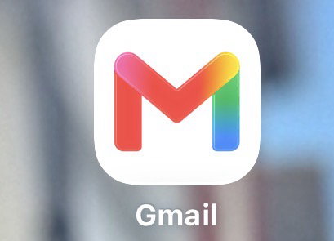
Gmail
This screenshots shows that I use gmail to communicate and manage important emails. It is an important part of my digital life because I use it for school, receiving information and staying connected with others.

Screenshot/Photo 2
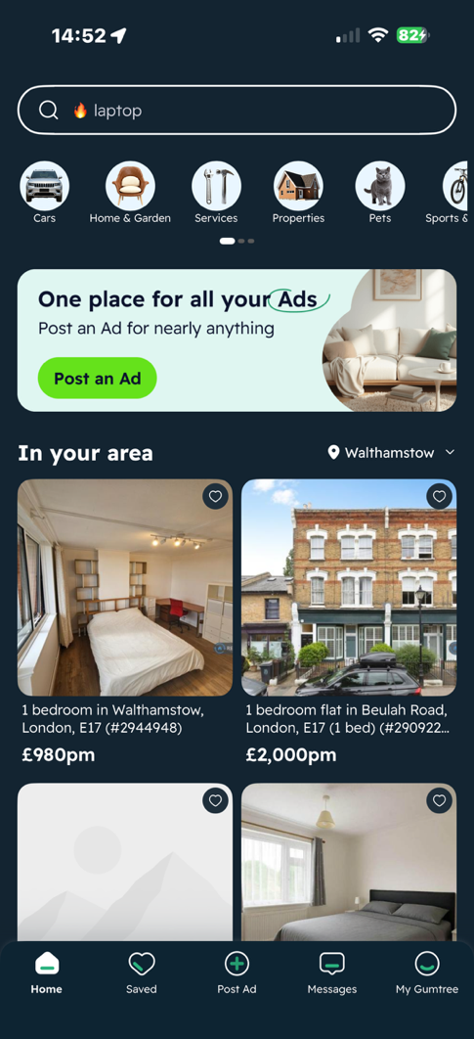
Gumtree
This screenshot shows that I use gumtree is like marketplace, to buy and sell items online. It is part of my digital life because I use the internet to find products, save money and communicate with sellers and buyers.

Screenshot/Photo 3
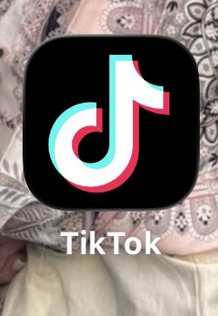
TikTok
This screenshot shows that social media is an important part of my digital life because I use TikTok for entertainment, watching videos, learning new things and keeping up with trends and other people.
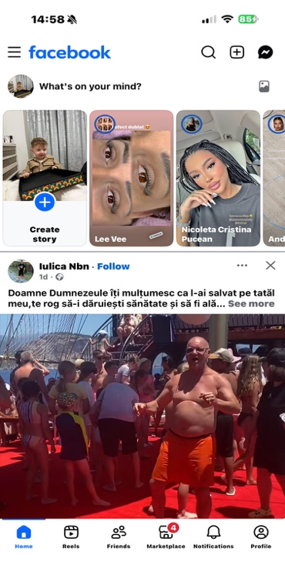
Facebook
This screenshots shows that I use facebook to communicate with friends and family share photos and update , and keep up with news and events. It is an important part of my digital life because it helps me stay connected with other people.

Screenshot/Photo 4

Screenshot/Photo 5
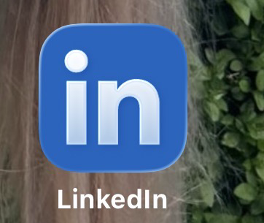
LinkedIn
This screenshot show that I use LinkedIn for professional networking and career and development. It is part of my digital life because I can connect with other professionals, look for job opportunities and learn about different industries.

Screenshot/Photo 6
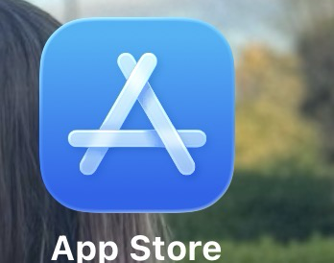
AppStore
This screenshot shows that I use the App Store to download and update apps on my phone. It is an important part of my digital life because it helps me access apps for communication, entertainment, education and everyday tasks.

My Short Reflection
- Write 5–8 simple sentences about your digital life.
- You can use the sentence starters below if helpful.
Digital skills are important for me because they help me communicate, learn and complete everyday tasks. I use apps such as Gmail, Facebook, TikTok, Gumtree and App Store in my daily life. These digital tools help me stay connected with friends and family, find information and access entertainment. I also use technology to look for opportunities and manage important emails. Technology has become and essential part of my life and helps me stay organised and informed.

