

Strategic Management (LCMB7003)

Strategic Analysis of Dell



Student name: Viralkumar Panchal
Student Number: 2210866
Lecturer: Dr Hossein Shokri
Submission Date: 08/05/2023
Table of Contents
Introduction 2
Dell Technologies’ Background 2
Dell Technologies’ Mission and Objectives 4
Macro-Environment Analysis 4
PESTEL Analysis 4
Micro-Environment Analysis 7
Industry Life Cycle 7
Porter’s Industry Five Forces Analysis 9
Internal Analysis 11
Dell's Strategic Resources and Capabilities 11
Value Chain Analysis 12
Primary activities 13
Secondary activities 14
VRIO Analysis of Distinctive Resources and Capabilities 16
SWOT Analysis 17
Strategies to Sustain Competitive Advantage 18
Growth Strategies 18
Green Strategy and CSR 21
Conclusion 23
Recommendation 23
References 24

Introduction
Strategic analysis is a crucial process for businesses, including Dell Technologies, as it enables them to gain a deeper understanding of their business environment and formulate effective strategies to achieve their goals. It involves examining internal and external factors that may affect the company's performance and profitability. Through strategic analysis, Dell Technologies can identify its strengths, weaknesses, opportunities, and threats, which can help it stay ahead of competitors and adapt to changes in the global market.
The present report will evaluate the strategic analysis of Dell Technologies through a micro and macro environment analysis. This will involve examining the company's internal factors such as its diverse portfolio of products and services, strong brand reputation, and focus on innovation and research and development, as well as external factors like increasing demand for cloud-based solutions, emerging markets, and intense competition from established players such as Apple, HP, and Lenovo. By evaluating both internal and external factors, this strategic analysis can help Dell Technologies identify potential areas for improvement, capitalize on opportunities, and mitigate potential threats.

Dell Technologies’ Background
Dell Technologies is a renowned American technology company that was founded in 1984 by Michael Dell. The company is headquartered in Round Rock, Texas and has established a reputation for designing and manufacturing computers, servers, software, and other related services. As of 2021, Dell Technologies employs approximately 165,000 individuals worldwide (Dell Technologies 2021 Annual Report). The company is known for promoting a diverse workforce and providing competitive employee benefits, including health insurance, retirement plans, and employee stock options.

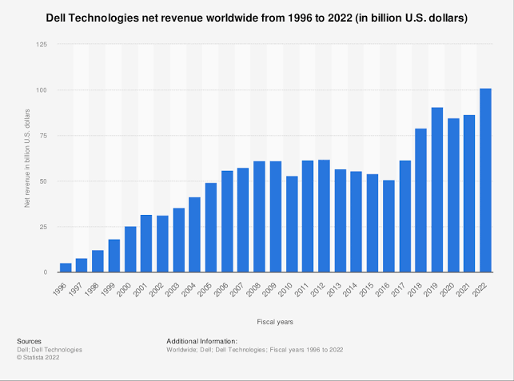
Figure 1: Growth of Dell revenue
(Source: Alsop, 2023)
Dell Technologies holds a strong financial position and is ranked among the top technology companies worldwide in terms of revenue. As of 2021, the company has been successful in generating revenue of $92.2 billion and a net income of $5.5 billion (Dell Technologies 2021 Annual Report). The company's revenue primarily comes from the sale of its flagship products, including laptops, desktops, and servers. Additionally, Dell Technologies also earns significant revenue from its services division, which includes infrastructure solutions, cloud computing, and cybersecurity.
Dell Technologies operates in several markets worldwide, including North and South America, Europe, Asia-Pacific, and the Middle East. The company's strategy to reach a global audience plays a major role in its success, allowing the company to capitalize on the growing demand for technology in emerging markets. Overall, it can be said that Dell Technologies has a rich history and a strong global presence. The company's innovative products and services have revolutionized the tech industry and have made Dell Technologies a household name. With a strong financial position and a talented workforce, Dell Technologies is well-positioned to continue its growth and success in the years to come.

Dell Technologies’ Mission and Objectives
The mission statement of Dell Technologies aims "to drive human progress through technology." This mission statement emphasizes the company's commitment to using technology to make a positive impact on people's lives. Dell Technologies aims to achieve this mission by designing and delivering innovative technology solutions to its customers that can help them transform their businesses and improve their lives.
The company follows a number of objectives that guide its operations, including a focus on innovation and the development of new products and services that meet the evolving needs of its customers. Dell Technologies also aims to maintain its position as a leading technology company by differentiating itself through the quality, reliability, and performance of its products and services. Additionally, the company is committed to sustainable business practices and aims to reduce its environmental impact through the use of renewable energy and other initiatives.

Macro-Environment Analysis
The macro-environment refers to the external factors that can have an impact on the overall performance and strategy of an organization. These external factors can be political, economic, social, technological, legal, and environmental in nature (Barkauskas et al., 2015). Conducting a macro-environment analysis allows companies like Dell Technologies to evaluate the trends and changes taking place in the external world that may affect their business. By analyzing the potential risks and opportunities associated with the business, Dell Technologies can adjust their strategies accordingly to stay ahead in the market.

PESTEL Analysis
A PESTLE analysis is a macro environment framework that helps organizations to analyze external factors that could impact their performance. For Dell, the main two countries of operation are China and the USA. The PESTLE analysis of Dell Technologies is outlined below:

External drivers | United states | China
Political | Positive: Political stability in the nation and strong rule of law will help in providing stability to Dell's supply chain and operations.  Negative: There are strict government regulations in the country, mostly in the cases of data privacy. This can increase Dell's cost of compliance along with its ability to operate. | Positive: China is stable politically with its centralized form of government. This offers a predictability to Dell's operations.  Negative: There is a lack of political freedom in the country and the government interference rate is high. This can be a threat for Dell if there are changes in regulations and it comes under government scrutiny.
Economical | Positive: The country has a highly developed economy. This allows Dell to offer its products to a large customer base.  Negative: When it comes to the United States, there is a higher level of income inequality. | Positive: The economy of China is increasing at a rapid pace along with the disposable income - thereby offering Dell with a large customer base (Ranta et al. 2018)..  Negative: There is a potential of trade and economic uncertainty with the US, which can be a barrier to maintain its operations in China.
Social | Positive: The consumers of the country are well aware and engaged with the technological products.  Negative: The customers of the nation are inclined towards sustainability and ethical business practices - creating a challenge for Dell to maintain its operations (Ranta et al. 2018). | Positive: There is increase in the disposable income in the middle class of China - thereby offering a greater customer base.  Negative: The cultural differences and differences in preferences of the customers can make it challenging for Dell to operate.
Technological | Positive: The technology is highly advanced with a highly skilled workforce.  Negative: The rapid upgradation of technology needs constant investment - making it a challenge for Dell. | Positive: China is rapidly growing in the technology sector - especially in artificial intelligence, 5G making it an opportunity for Dell to innovate.  Negative: There are poor intellectual property protection laws in China.
Legal | Positive: There are strong legal laws for protecting intellectual property - offers Dell with security.  Negative: There is an increase in regulatory policies in the US making it a burden for Dell. | Positive: There is a well defined and proper legal framework - making it easy for Dell to operate.  Negative: There is lack of transparency in the political laws and also uncertainties related to the same.
Environmental | Positive: Have a strong regulatory framework for environment protection - encouraging Dell to innovate environment friendly products (Carleton and Greenstone, 2021).  Negative: There is a chance for an increase of regulatory burdens related to environment protection. | Positive: The government of China is investing in clean and sustainable practices - Dell can use the opportunity to develop sustainable products.  Negative:There is a lack of clear and well defined environmental regulations in China.
Table 1: Pestle analysis of Dell
(Source: Self made)

Micro-Environment Analysis
The micro environment analysis of Dell Technologies involves evaluating the internal factors that affect the company's operations and performance. These factors include suppliers, customers, competitors, and stakeholders (Claudiu et al. 2011). By analyzing the strengths and weaknesses of its internal environment, Dell can develop strategies to improve its performance and gain a competitive advantage. Understanding its micro environment helps Dell make informed decisions and develop strategies to achieve its goals and improve its overall performance.

Industry Life Cycle
Dell Technologies is a multinational technology company that specializes in the design, development, and manufacture of computers and related products and services. The company has gone through several phases of growth, decline, and rejuvenation in its industry life cycle.
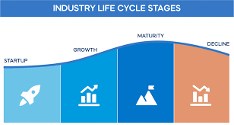
Figure 2: Industry life cycle
(Source: Kitov, 2023)
Introduction Stage (1984-1993):
The introduction stage of Dell Technologies began in 1984 when the company was founded by Michael Dell as a direct seller of IBM-compatible computers built from stock components. During this period, the company focused on delivering high-quality products at a lower cost than its competitors. In 1985, the company introduced its first computer, the Turbo PC, and in 1986, it went public.
Growth Stage (1994-2004):
During the growth stage, Dell Technologies became a dominant player in the computer industry by introducing a new business model that focused on selling directly to customers and reducing inventory costs. This allowed the company to offer lower prices and gain a competitive advantage. In 1997, Dell became the largest PC manufacturer in the world, surpassing Compaq. During this stage, the company also diversified into other products such as servers, storage devices, and printers.
Maturity Stage (2005-2013):
During the maturity stage, Dell Technologies focused on consolidating its position in the personal computer market and expanding its product line into the enterprise market. In 2005, the company introduced the XPS line of high-end computers and in 2008, it acquired the storage company EqualLogic (Hu et al. 2018). In 2009, Dell acquired Perot Systems, a leading IT services company, to expand its services offerings. However, during this stage, the company faced stiff competition from rivals such as HP and Lenovo.
Decline Stage (2014-2017):
During this stage, Dell Technologies faced declining sales of its personal computers due to the rise of mobile devices such as smartphones and tablets. In 2013, the company went private to restructure its business and focus on enterprise solutions. During this period, the company also faced criticism for its environmental practices and labor practices in its overseas manufacturing plants.
Rejuvenation Stage (2018-Present):
Dell Technologies began its rejuvenation stage by acquiring EMC Corporation, a leading data storage company, in 2016. This acquisition allowed Dell to expand its offerings in the enterprise market and become a leading player in the data center market. In 2019, Dell introduced the XPS 13 laptop, which received critical acclaim for its design and performance. The company has also focused on sustainability and has set ambitious goals to reduce its greenhouse gas emissions and increase the use of recycled materials in its products. Dell's share price has recovered during this stage, and the company is once again seen as an innovative leader in the technology industry.
In conclusion, Dell Technologies has gone through various phases of growth, decline, and rejuvenation in its industry life cycle. The company has adapted to changes in the market by reinventing itself and diversifying its offerings. Dell Technologies' focus on sustainability and innovation will continue to be crucial for its success in the future.

Porter’s Industry Five Forces Analysis
Porter's Five Forces is a strategic management framework that assists businesses in analyzing and evaluating their internal environment to gain a competitive advantage. It helps in understanding the micro environment of Dell Technologies and evaluating the various internal factors.
Threat of New Entrants:
The threat of new entrants in the technology industry is relatively low, especially for established and giant players like Dell Technologies. This is due to the high barriers to entry, which include economies of scale, brand recognition, patents, and technology (Porter, 2008). Dell Technologies has a strong brand reputation and a loyal customer base, making it challenging for new entrants to gain market share.
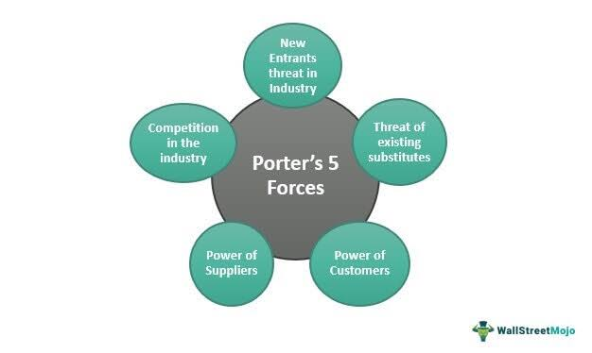
Figure 3: Porter's 5 forces
(Source: Vaidya, 2022)
Bargaining Power of Suppliers:
The bargaining power of suppliers in the technology industry is low as there are many suppliers available, thereby allowing the company to choose their substitutes (Ragulan, 202). Dell Technologies has a diversified supply chain, which includes multiple suppliers for components such as memory, processors, and screens. However, suppliers can have some bargaining power when they are the sole supplier of a critical component.
Bargaining Power of Buyers:
The bargaining power of buyers in the technology industry is relatively high, as customers have many options when it comes to electronic devices, such as laptops, desktops, and servers. This gives them bargaining power. Dell Technologies addresses this by offering a wide range of products and services that cater to different customer needs and preferences.
Threat of Substitute Products:
The threat of substitute products in the technology industry is high due to the constant innovation and advancements in technology. Customers can easily switch to alternatives, such as Apple or HP. However, Dell Technologies has been able to differentiate itself through its focus on customization, quality, and customer service.

Rivalry among Existing Competitors:
The technology industry is characterized by intense competition, with companies like Apple, HP, and Lenovo competing for market share. Despite this, Dell Technologies has managed to remain competitive by focusing on innovation, quality, and brand recognition. To maintain its position, Dell Technologies must continue to innovate as the industry evolves. Although there are threats such as substitute products, the industry's high barriers to entry and the bargaining power of suppliers and buyers make it challenging for new players to gain market share.

Internal Analysis
The internal analysis of a company can be defined as the process of evaluating its internal strengths and weaknesses. Internal analysis helps in identifying the opportunities that can be leveraged along with evaluating the areas that need improvement (Ritson, 2008). Internal analysis mainly emphasises on factors like - a company's resource and capabilities and thus determining its competitive advantage. The internal analysis also explores factors like company performance, its management practices, organizational structure, human resource, and technology used. The internal analysis is essential for strategic planning and management as it provides an in-depth knowledge into a company's ability to achieve its goals and succeed. There are a number of internal analysis tools like - value chain analysis, SWOT analysis, VRIO Analysis which would be explored in this report to get a better knowledge on the internal situation of Dell.

Dell's Strategic Resources and Capabilities
Dell has been able to maintain a strong position in the market with its effective strategic resources and capabilities. This section would discuss the strategic resources and capabilities of Dell and how they contributed to its success.
A strong brand image: In the first place, the strong brand image of Dell is a primary strategic resource that has helped the brand in maintaining a competitive advantage over the rivals. Dell is well known all across the world for their quality products, innovative technology support and top notch customer service. Dell is ranked 20 in the 2022 Forbes most valuable brand list and the brand value of Dell stands at $31.18 billion as of 2023 (Dell | Company Overview &amp; News 2022). This brand value is the result of Dell's customer centric approach which only aims to provide the best quality products and service to the customers. Dell has also made heavy investments in its advertisement and marketing and have sponsored major events like the Olympics and World Cup (McKelvey and Grady, 2008).
Efficient supply chain management: Another key capability of the company which helps it to stay ahead of its competitors is the supply chain management. Dell is well known for its direct to customer business model which allows Dell to reduce their logistics cost and offer the products at a competitive price (Landoni et al. 2020). This model has helped Dell to reduce their inventory wastage, minimize order processing time and enhance their delivery time. Dell has also maintained a healthy and strategic partnership with logistics providers and suppliers to ensure smooth and timely order delivery.
Research and development: Dell also makes heavy investments on its research and technology. The company aims to spend over $20 billion in their R&D technology. This investment has made the company to focus on areas like - cloud computing, artificial intelligence and machine learning which are primary technologies in today's world (Dell plans to spend over $20bn in 5 years as data is the world's New Oil 2023).
The strategic capabilities of Dell also gets supported with its robust financial position. In 2022, the company generated a revenue of $101.2 billion which has increased by 17% from the previous year (Dell Technologies delivers fourth quarter and full-year fiscal 2022 financial results 2022).
Strong portfolio of intellectual properties and a robust infrastructure: The strong portfolio of intellectual property and a robust infrastructure are the primary resources which helps Dell to stay ahead in the competition (Chesbrough, 2003). Dell has a large number of patents in its technology - cloud computing, storage systems which help the company to stay ahead in its competition. The robust infrastructure of the company also allows it to provide the best services to its customers.
Thus, it can be said that Dell has a number of resources and capabilities which helps it to stay ahead in the competition and manage their operations in an efficient way.

Value Chain Analysis
The value chain analysis can be defined as a framework that helps in breaking down the activities that a company performs with an aim to create value for its customers. The value chain framework is divided into two activities - primary and support activities. The primary activities in a value chain remain directly connected to the creation and delivery of products and services to the customers while support activities are needed to carry out the primary activities in an efficient and effective way (Hellin and Meijer, 2006).
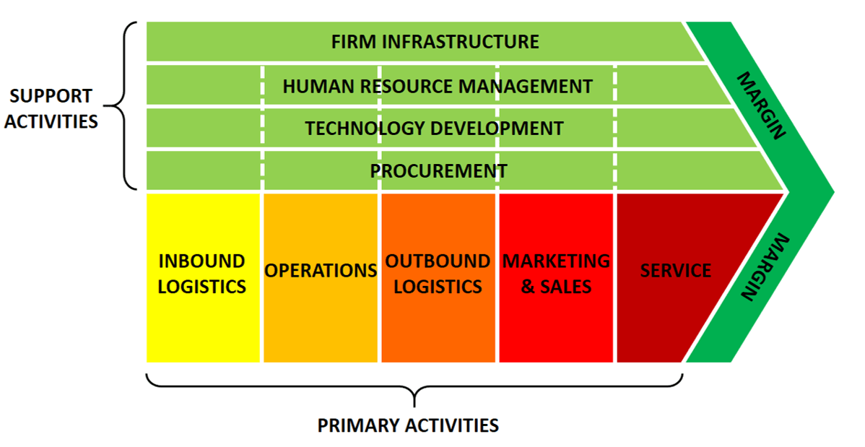
Figure 4: Value chain analysis
(Source: Bruin, 2021)
By evaluating the value chain, a company can explore the areas where it can improve its costs, operations and thus enhance the value of the products and services offered to the customers. Value chain analysis helps the companies to gain an insight on their competitive advantage and accordingly develop strategies to improve it. Thus, it can be said that value chain analysis is a significant framework which helps the companies to optimise their operations and thus add value for their stakeholders.

Primary activities
The primary activities in a value chain mainly refers to those factors which are directly associated with the creation and delivery of the products. The primary activities of Dell are mentioned below
Inbound logistics: Dell has been successfully working with more than 165000 channel partners in inbound logistics and makes an investment of $125 million as investment in this segment (Cheng, 2022). Dell has also succeeded in streamlining their supply chain which allows for just in time delivery of the components and thus helps to minimise their inventory level. The JIT strategy of Dell has also helped it to maintain a competitive edge over its rivals in terms of cost and quality (Christensen et al. 2005.)
Operations: The manufacturing process of Dell is highly automated and it uses the state of art technology (Brynjolfsson, 2003) Additionally, the company also succeeded in establishing a modular assembly process which enables it to assemble the components in a short time as per the demand and specifications provided by the customers.
Outbound logistics: The outbound logistics of Dell mainly comprises storing, transporting and delivering the finished products to their customers globally. The company has made their relationship with logistics and couriers to ensure safe and timely delivery of the products. Dell always emphasises on logistics optimization which helps it to achieve customer satisfaction.
Marketing and sales: The marketing and sales activities of Dell mainly aims to promote their products to a global audience. A wide range of marketing channels are explored by the company which consists of both traditional and modern marketing - television, print, digital marketing. Dell has succeeded in maintaining a strong online presence and connecting to their customers. The company's strategy of direct sales through websites and stores has helped it to gain high customer loyalty.
Service: The service activities of Dell mainly refers to providing the needed assistance and support to the customers all across the world. In order to offer smooth customer service, the company has set up their network of service centres globally. Dell also offers services like - support services, warranty services to its customers (Berman, 2005). This top class service has helped the company to gain customer satisfaction and loyalty.

Secondary activities
The secondary activities also termed as the support activities refers to the non primary activities which play an active role in facilitating the primary activities. Dell being one of the leading companies dealing in computer and technology, has maintained well defined support activities which helps it to offer quality products and services to its customers. The support activities are mentioned below
Procurement: Dell's procurement activities mainly remain focused on obtaining top quality raw materials and components for the manufacturing of their products and at the best possible price (Sheth et al. 2009). Dell has also maintained long term relationships with its suppliers to ensure that the supply of raw materials remains steady and of high quality. In this respect, the company also uses its purchasing power to negotiate with its suppliers and maintain favourable terms for their purchases.
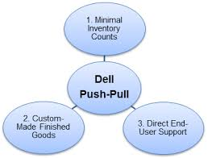
Figure 5: Dell push-pull supply chain strategy
(Source: Johnson, 2018)
Technology development: When it comes to technology development, the company makes a heavy investment to stay ahead in this factor. The company has their own research team of engineers and scientists who work on developing new products and also upgrading the previous ones. Dell also collaborates with technology companies so that it can remain updated in terms of technology updates and trends.
Human resource management: Dell has always emphasised on their HRM. In the present time, strategic HR management has become crucial for the companies to survive. As of 2018, Dell employs around 145000 (Dell, 2019) . Around 39% of the employees are employed in the USA while the rest in other parts of the world. Dell takes major steps to keep the employees motivated and retain the best talents by offering them attractive packages and perks. Furthermore, the company also ensures that all the employees are offered with onboard training so that they remain up-to-date with the latest trends in technology.
Infrastructure: Dell has maintained a strong infrastructure and is present all across the world. As in 2018, the total assets of Dell are worth $122.3 billion (Alsop, 2023). The infrastructure of the company is mainly focused on ensuring that their operations run smoothly. The company has invested heavily on their infrastructure - a sturdy network, research unit and data centres. The company also has a 24*7 support systems to ensure top notch service to the customers.

VRIO Analysis of Distinctive Resources and Capabilities
VRIO analysis is a tool that the firms use to evaluate their distinctive resources and capabilities for determining whether these resources can prove to be a source of competitive advantage for the company. The VRIO analysis of Dell is discussed in this segment.
Resources | Value | Rare | Imitable | Organisation | Competitive advantage or not
Brand value and reputation | Yes | Yes | Yes | Yes | Competitive advantage
Human resource | Yes | Yes | No | Yes | Temporary advantage
Direct model of selling products | Yes | Yes | Yes | Yes | Competitive advantage
Supply chain management | Yes | Yes | Partly | Yes | Temporary advantage
Research and development | Yes | Yes | Partly | Yes | Competitive advantage
Brand value and reputation: Dell's brand value and reputation is unique and differentiates it from the competitors. It is not imitable and is rare, thereby providing the company with a competitive advantage with its brand name.
Human resource: The human resource of Dell is valuable as it helps the company to move ahead and execute their strategies successfully. However, the talented employees can be recruited by competitors, thereby making it a temporary advantage for the business.
Direct model of selling: This is a unique model which offers the company to gain a cost advantage over its rivals. The direct model of selling allows Dell to sell its products directly to their customers without any intermediaries, thereby allowing them to offer competitive prices. This is a competitive advantage which is rare and is difficult to be imitable. Dell has a robust supply chain management helping in this direct model of selling.
Supply chain management: Dell has maintained a robust supply chain which allows it to offer the products to the customers all across the world in a timely and efficient way (Knott, 2015). The supply chain management is rare but is partially imitable as the competitors can invest is building a robust supply chain, thereby making this criteria a temporary advantage for the company.
Research and development: Dell maintains a strong research and development technology which is supported by its firm infrastructure and talented researchers. Dell also invests heavily in their research technology to innovate and update their products. Though this is a rare quality, it is partially imitable, thereby making it a temporary advantage for the company.

SWOT Analysis
The SWOT analysis of Dell is given below which provides the strengths, weaknesses, opportunities and threats associated with the company.
Strengths  - Strong brand value and reputation of the company.  - Customer loyalty.  - A robust supply chain management having a direct model of sales.  - A diversified product portfolio.  - A well developed research and development branch.  - Strong financial position of the company.  - Talented employees. | Weaknesses  - Mostly dependent on desktops, laptops and hardware.  - Poor presence in the emerging markets.  - Geopolitical risks.  - High rivalry in the industry.  - Limited differentiation in the product range.  - Dependent on suppliers for components.
Opportunities  - There is a growing demand for cloud computing and AI.  - Expanding into potential emerging markets.  - Growing inclination towards remote and online works.  - Making strategic alliances and partnerships.  - Increase in focus on sustainability. | Threats  - Economic recession and global political unrest.  - Cybercrimes and data breaches.  - Potential supply chain disruption.  - High environmental concerns and related regulations.
Thus, it can be seen that this SWOT analysis can be used by the company to leverage their opportunities using strengths and respond to their weaknesses and threats with proper strategies.

Strategies to Sustain Competitive Advantage
Over the years, Dell has been successful in retaining its position in the computer and hardware industry. The company has rightfully used Porter's generic strategy to sustain their competitive advantage in the market.
Cost leadership strategy: Dell has adopted the cost leadership strategy which allowed it to become a low cost producer in its industry. The company has successfully optimised their supply chain and automated their manufacturing units which helped in reducing costs and increasing efficiency. As reported, Dell has been able to use this strategy to offer the products at a competitive price to the customers and thus the revenue generated as of 2021 was $94.2 billion - showing a rise of 2.8% (Dell Revenue 2015-2023: Dell 2023).
Differentiation strategy: Dell has been successful in adopting the differentiation strategy. The company has invested heavily on their R&E technology to offer the best and innovative products to the customers. For instance, Dell has been a leader in the gaming laptops which are designed for the gamers - a strong demand for their Alienware and G series laptops. The gaming business of the company has witnessed a surge of 13% in its revenue in 2021 (Strong PC sales help Dell to another earnings beat 2021).
Focus strategy: When it comes to implementing the focus strategy, the company's strategy lies in identifying their target audience and thus customising the products as per their demands. For instance, Dell has focused to target the small and medium scale businesses and offered the needed solution to meet their demands. As a result, the company revenue in SMB business saw a growth of 9% year over year (Dell Technologies delivers fourth quarter and full-year fiscal 2022 financial results 2022).
Direct sales model: Dell has been able to maintain its cost leadership and differentiation strategy with their direct sales model. Dell has developed a model where it sells the products directly to its customers without any intermediaries, thereby differentiating the company from its rivals and also providing them a cost advantage. As of 2021, the direct sales model of Dell accounted for 65% of its revenue.

Growth Strategies
The company can use several growth strategies. Ansoff matrix and international expansion strategies would be used to identify the growth strategies that can be used by Dell Technologies. A company to determine strategies that will help them to sell more of their existing products and services to their existing customer base can use the market penetration quadrant in the Ansoff matrix. This strategy can be used by Dell Technologies to increase their market share in the technological market.
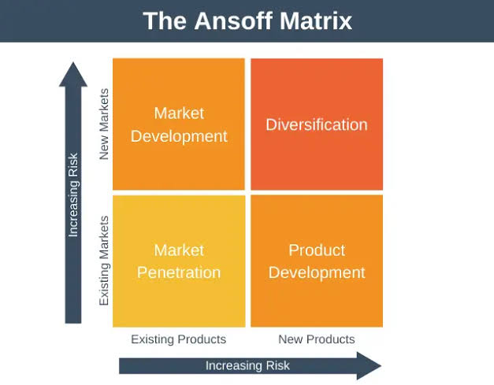
Figure 6: The Ansoff matrix
Source: (G, 2022)
Dell Technologies can use the following strategies for their overall growth using the Ansoff Matrix:
Markets | Product
Markets | Existing | Existing | New
Markets | Existing | Market Penetration  The company can increase their production capacity which will help them to reach more customers.  The company can increase their marketing investments to increase their advertising campaigns (Chiu et al. 2006).  The company can also expand their current distribution channels. This will help them to reach a higher number of customers and even help them to target newer customer segments.  Improving their distribution and supply chain systems will enable Dell to reach new customer segments.  The company can also acquire competitors in the market that will give them the leverage on reaching different customer segments. | Product Development  The company can offer new features in the old designs (Daft, 2016).  The company can launch new segments of laptops and desktops  The company heavily invests in research and development. This has contributed towards the competitive edge in the market.
Markets | New | Market Development  The company can invest more financial capital by investing towards thorough market research to identify new markets and consumer segments (Hussain et al. 2013).  The company can focus on expanding both nationally and internationally. This will allow them to have access to newer customer segments.  The company also needs to educate their customers as it will increase their understanding about the product and its offerings. | Diversification  The company can introduce vertical diversification by introducing products in existing product lines (Kipley & Lewis, 2011).  The company can facilitate horizontal diversification when the company introduces new product lines that offer advanced features.  The company can acquire existing businesses in the industry to diversify into new markets.

International expansion
The company can expand or grow by using international expansion strategies. Licensing companies in international markets (Jiang et al. 2009) can easily obtain this. With the growing dependency on digital platforms, use of desktops and laptops has become imperative to business organisations. The company can obtain international expansion by licensing where the company will allow another business owner to sell Dell’s products. It is one of the most preferred expansion strategies due to the limited government regulations that businesses has to follow while entering the market (De Luna, 2021). It is also preferred as it is one of the fastest expansion strategies to grow the business and generate income. It will also limit the liability of the company and enable them better to penetrate into the international market.

Green Strategy and CSR
Dell has been working diligently to produce a more sustainable future. The company claims to be utilising expert engineers and supply chain experts that help them to produce responsible technologies. The production plan of the company has been guided by circular principles (Dell India, 2023). The company has been committed towards reducing their dependence on developing new products and focus on reusing old products. As a result, the company wants to keep their materials and products in circulation for a longer time through repairs, recoveries and reuse, which is also known as the circular economy. The company has also taken innovative steps to create sustainable laptop designs. For example, the company has partnered with Intel and has developed “Concept Luna''(Dell India, 2023). This prototype would be responsible for exploring revolutionary ideas pertaining to development of components that are easily reusable, accessible and recyclable. The company has also involved the use of sustainable materials as a part of their green strategy. This has helped them to reduce the environmental impact of making them and recycling them. By 2030, the company aims at using 50% of their product components and 100% of product packaging by using renewable or recycled materials (Dell India, 2023). The company also commits at developing energy efficient products without components on the performance of their products. The company also uses a wide range of eco-labels that influence their sustainable efforts. These labels allow them to better understand their products and the commitment of Dell to attain sustainability. Traditional data centres also tend to put strain on the global energy demand (Dell India, 2023). The company has developed green data centre solutions by using scalable processors by using advanced cooling and power management technology to lower their carbon footprint and optimise their current data centre.
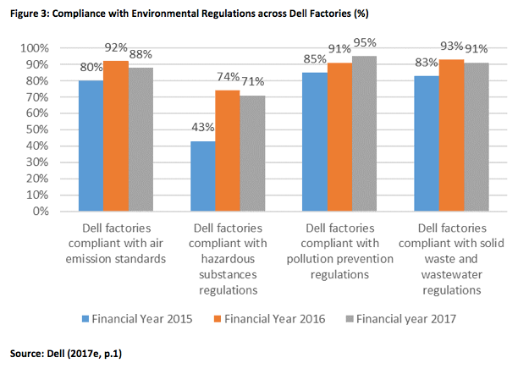
Figure 7: Dell's compliance with environmental laws
(Source: Dell's CSR and Financial Performance, 2023)
Dell believes that the company being a business citizen must focus on more than just creating profit and also must focus on efforts to develop the society that is within its reach. As a result the company believes in taking initiatives that would contribute to the welfare of different segments of the society by utilising different social and economic programs (Nirmal and Berad, 2016). Some of the csr objectives of the company involve creating commitment at all levels within the organisation, enhancing natural and environmental capital, supporting rural development, promoting education, providing clean drinking water and sanitation among others (Dell, 2023). The company is also dedicating their efforts toward creating more eco-friendly products and wants to incorporate sustainable practices in every activity that is undertaken by the company. The company has a CSR Team that would be led by a senior consultant.

Conclusion
In conclusion, it can be said that Dell has been one of the top players in the computer hardware and technology industry for many years. The micro-environment analysis of the company shows that its strengths lies in its customers centric approach, direct sales model and innovation. However, the company also has to face challenges owing to the presence of top rivals, change in customer preferences and potential supply chain disruption. When it comes to macroenvironment, the strengths of Dell lies in the technological advancements and customer preferences while the challenges lie in the change in regulations and the global economic recession.
Tackling all these challenges, Dell has been able to grow its business with its strategic planning and management. Furthermore, the company would need to emphasise on its customers centred approach, cost optimisation and innovation to maintain its position in the market.

Recommendation
From the above study, it can be identified that the company needs to focus heavily on their marketing efforts. The company uses limited promotional campaigns. Dedicating more funds towards advertisements will enable the company to raise more brand awareness among consumers and will also help to address new customer segments (Latif et al. 2014). The company can utilise social media as one of their promotional channels to target consumers from a younger age group. The company can also invest heavily towards conducting detailed market research (Javalgi et al. 2006). This will help them to identify new markets and new market segments that the company can target. These identified strategies would help the company to grow and gain more market share in the industry.

References
Alsop, T. (2023) Dell Technologies Total assets 2023, Statista. Available at: https://www.statista.com/statistics/992551/dell-total-assets/ (Accessed: April 14, 2023).
Barkauskas, V., Barkauskienė, K. and Jasinskas, E., 2015. Analysis of macro environmental factors influencing the development of rural tourism: Lithuanian case. Procedia-Social and Behavioral Sciences, 213, pp.167-172.
Berman, B., 2005. How to delight your customers. California management review, 48(1), pp.129-151.
Brynjolfsson, E., 2003. ROI valuation: The IT productivity gap. Optimize magazine, 21, pp.1-4.
Carleton, T. and Greenstone, M., 2021. Updating the United States government's social cost of carbon. University of Chicago, Becker Friedman Institute for Economics Working Paper, (2021-04).
Chiu, Y., Chen , B., Shyu, J. & Tzeng, G., 2006. An evaluation model of new product launch strategy. Technovation, 26(11), pp. 1244-1252.
Cheng, J. (2022) Sustainable competitive advantage analysis and recommendations for Dell Company to achieve success, Open Journal of Social Sciences. Scientific Research Publishing. Available at: https://www.scirp.org/journal/paperinformation.aspx?paperid=121416 (Accessed: April 14, 2023).
Chesbrough, H., 2003. The logic of open innovation: managing intellectual property. California management review, 45(3), pp.33-58.
Christensen, W.J., Germain, R. and Birou, L., 2005. Build-to-order and just-in-time as predictors of applied supply chain knowledge and market performance. Journal of Operations Management, 23(5), pp.470-481.
Claudiu, C.S., Anderei, P. and Gabriela, P.M., 2011. Internal environment analysis techniques. Annals of Faculty of Economics, 1(2), pp.731-736
Daft, R., 2016. Contemporary Strategy Analyses. New York: John Wiley & Sons.
Dell Revenue 2015-2023: Dell (2023) Macrotrends. Available at: https://www.macrotrends.net/stocks/charts/DELL/dell/revenue (Accessed: April 14, 2023).
De Luna, Y.V.V., 2021. Licensing as an International Expansion Entry Mode: Its Antecedents and Risks.
Nirmal, A. and Berad, D.N., 2016. 'Sustainability Through Corporate Social Responsibility-A Case Study of Dell'. IOSR Journal of Business and Management, e-ISSN, pp.01-03.
Dell India, 2023. Advancing sustainability: Dell India, Advancing Sustainability | Dell India. Available at: https://www.dell.com/en-in/dt/corporate/social-impact/advancing-sustainability. (Accessed: April 14, 2023).
Dell Technologies Inc.. (2021) AnnualReports.com. Available at: https://www.annualreports.com/Company/dell-technologies-inc (Accessed: April 14, 2023).
Dell | Company Overview &amp; News (2022) Forbes. Forbes Magazine. Available at: https://www.forbes.com/companies/dell/?sh=5626effe6dea (Accessed: April 14, 2023).
Dell Technologies delivers fourth quarter and full-year fiscal 2022 financial results (2022) Dell Technologies. Available at: https://investors.delltechnologies.com/news-releases/news-release-details/dell-technologies-delivers-fourth-quarter-and-full-year-fiscal (Accessed: April 14, 2023).
Dell Technologies delivers fourth quarter and full-year fiscal 2022 financial results (2022) Computers, Monitors &amp; Technology Solutions. Available at: https://www.dell.com/en-us/dt/corporate/newsroom/announcements/detailpage.press-releases~usa~2022~02~dell-technologies-delivers-fourth-quarter-and-full-year-fiscal-2022-financial-results.htm#/filter-on/Country:en-us (Accessed: April 14, 2023).
Dell plans to spend over $20bn in 5 years as data is the world's New Oil (2023) Google. Google. Available at: https://www.google.com/amp/s/www.arabnews.com/node/2016331/amp (Accessed: April 14, 2023).
Dell (2023). Corporate Social Responsibility Policy - Dell, Dell India. Available at: https://i.dell.com/sites/doccontent/corporate/corp-comm/en/Documents/india-csr-policy.pdf (Accessed: April 14, 2023).
Dell (2019) Document. Available at: https://www.sec.gov/Archives/edgar/data/1571996/000157199618000004/delltechnologiesfy1810k.htm (Accessed: April 14, 2023).
Dell's CSR and Financial Performance (2023) 15 Writers. Available at: https://15writers.com/sample-reports/the-relationship-between-dells-involvement-in-csr-and-financial-performance/ (Accessed: April 21, 2023).
G, D. (2022) The ansoff matrix - strategy training from EPM, expert. Available at: https://expertprogrammanagement.com/2022/01/the-ansoff-matrix/ (Accessed: April 21, 2023).
Hellin, J. and Meijer, M., 2006. Guidelines for value chain analysis. Food and Agriculture Organization of the United Nations (FAO), Rome, Italy.
Hussain, S., Khattak, J., Rizwan, A. & Latif, M., 2013. ANSOFF matrix, environment, and growth-an interactive triangle. Management and Administrative Sciences Review, 2(2), pp. 196-206.
Hu, K., Acimovic, J., Erize, F., Thomas, D.J. and Van Mieghem, J.A., 2019. Forecasting new product life cycle curves: Practical approach and empirical analysis: Finalist–2017 m&som practice-based research competition. Manufacturing & Service Operations Management, 21(1), pp.66-85.
Johnson, I. (2018) Dell push-pull: An order fulfillment and Supply Chain Strategy, DriveYourSucce$$. Available at: https://www.driveyoursuccess.com/2012/08/dell-push-pull-an-order-fulfillment-and-supply-chain-strategy.html (Accessed: April 21, 2023).
Kipley, D. & Lewis, A., 2011. Strategic Management: Incorporating Ansoff. New York: Pearson.
Kitov, I. (2023) The Industry Life Cycle Model explained, 365 Financial Analyst. Available at:https://365financialanalyst.com/knowledge-hub/business-analysis-and-strategy/the-industry-life-cycle-model-explained-introduction-growth-maturity-decline/ (Accessed: April 21, 2023).
Javalgi, R.R.G., Martin, C.L. and Young, R.B., 2006. Marketing research, market orientation and customer relationship management: a framework and implications for service providers. Journal of services marketing, 20(1), pp.12-23.
Jiang, M.S., Aulakh, P.S. and Pan, Y., 2009. Licensing duration in foreign markets: A real options perspective. Journal of International Business Studies, 40, pp.559-577.
Landoni, P., Dell’era, C., Frattini, F., Petruzzelli, A.M., Verganti, R. and Manelli, L., 2020. Business model innovation in cultural and creative industries: Insights from three leading mobile gaming firms. Technovation, 92, p.102084.
Knott, P.J., 2015. Does VRIO help managers evaluate a firm’s resources?. Management Decision, 53(8), pp.1806-1822.
Latif, W.B., Islam, M.A. and Noor, I.M., 2014. Building brand awareness in the modern marketing environment: A conceptual model. International Journal of Business and Technopreneurship, 4(1), pp.69-82.
Strong PC sales help Dell to another earnings beat (2021) SiliconANGLE. Available at: https://siliconangle.com/2021/05/27/strong-pc-sales-help-dell-another-earnings-beat/ (Accessed: April 14, 2023).
McKelvey, S. and Grady, J., 2008. Sponsorship program protection strategies for special sport events: Are event organizers outmaneuvering ambush marketers?. Journal of Sport Management, 22(5), pp.550-586.
Ragulan, B., 2021. Strategic Analysis of Dell Inc.
Ranta, V., Aarikka-Stenroos, L. and Mäkinen, S.J., 2018. Creating value in the circular economy: A structured multiple-case analysis of business models. Journal of cleaner production, 201, pp.988-1000.
Ritson, N., 2008. Strategic management. BookBoon.
Vaidya, D. (2022) Porter's five forces, WallStreetMojo. Available at: https://www.wallstreetmojo.com/porters-five-forces/ (Accessed: April 21, 2023).
Yie, C.E., Zhi, C.E. and Ping, N.T.S., 2021. A Critical Analysis of Internal and External Environment: Case Study of Apple Inc. Journal of International Business and Management, 4(10), pp.01-14

