University of Wales trinity saint David
Wales institute of science and art


Engine performance characteristics
Powertrain technology (ACHA 4029)

Daniel Burden
2405219
March/2026
Word count:2020

Contents
Section 1 introduction 2
Section 2 test 3
Method manual 3
Method automatic 3
Method p-curve test 3
Step test 3
Sweep test 3
Section 3 raw data 4
Section 4 calculations 6
torque 6
power 6
calculated power 6
Specific fuel consumption (SFC) 7
Brake mean effective pressure (BMEP) 7
Thermal efficiency 7
section 5 test results 8
Section 6 charts 10
Specific Fuel Consumption against engine speed 10
Lambda and SFC 11
Torque against engine speed 12
torque and power 13
Brake power against engine speed 14
Section 7 loss of power since the creation 15
Section 8 evaluation 16
Section 9 conclusion 17
Section 10 references 18
References 18
Table of tables 19
Table of figures 19

Section 1 introduction
The aim of this report was to test and use the engine dynamometer to obtain a set of results; however, due to time constraints and faulty machinery, the test did not go ahead. Using pre-recorded data, it was necessary to calculate the power, corrected power, torque, SFC, BMEP and thermal efficiency of the 1.6L Honda engine (Honda, 1988)Following this, specific graphs were analysed to gather information about the engine's performance and operating conditions, with an overall view on how the investigation could have been improved.

Section 2 test
Unfortunately, due to a combination of equipment failure and staff unavailability, the test was unable to go ahead. However, thanks to previously recorded videos, an understanding of what would have been expected during the test can be established. Below is the best explanation that could be formed from watching the videos.
Engine Dynamometer testing (Fall, 2020)
Engine Dynamometer Overview (Fall, 2020)

Method manual
With a manual set-up, there are 2 dials on the dynamometer: one that controls the magnetism to slow the engine, and one that controls the RPM speed of the engine. After ensuring all necessary statistics are confirmed and everything is working correctly, such as the fuel pump and temperature, the engine can be started. The 2 knobs are then manually turned to increase and decrease the load, or to increase the RPM, in order to obtain specific results.

Method automatic
(This method would not have been carried out on the day.)
The first step in the automatic test is to set up the test sequence, including how long to run it, how much torque to run it at, and the RPM to run it at. It would then have been as simple as letting it run until it completes all the steps that have been set.

Method p-curve test

Step test
The step test is used to test at specific values. It is necessary to capture every data point, so the test stops at every given interval. For example, from 2000 RPM to 2500 RPM, with stops every 250 RPM, it would pause for 2 seconds at 2000, 2250, and 2500 RPM. Once all the information has been gathered at every step, it can produce a calculated graph along with all the accurate data necessary to complete the table.

Sweep test
The sweep test is very similar to the step test but will give less accurate results, as it does not stop at every interval. This means the sensors lag slightly behind the engine; however, this allows it to run for longer, since not holding the engine at every RPM prevents overheating. The sweep test will also produce a graph and data output.

Section 3 raw data
Table 1 a table of results from of “the engine dynamometer results” (Harrison, n.d.)
Load | Dyno Speed | Fuel Flow Rate | Lambda
Newtons | rpm | l/min | Lambda
102.275 | 1000 | 0.0704 | 1.2658
102.756 | 1050 | 0.0724 | 1.26783
103.689 | 1100 | 0.0737 | 1.27344
104.209 | 1150 | 0.0728 | 1.28476
105.811 | 1200 | 0.0744 | 1.29181
107.51 | 1250 | 0.07895 | 1.29729
109.488 | 1300 | 0.079 | 1.29895
111.797 | 1350 | 0.0796 | 1.29469
114.268 | 1400 | 0.0835 | 1.2855
115.783 | 1450 | 0.0847 | 1.27818
116.985 | 1500 | 0.08865 | 1.2795
117.788 | 1550 | 0.0932 | 1.27766
118.471 | 1600 | 0.0959 | 1.28235
118.772 | 1650 | 0.09875 | 1.29028
118.656 | 1700 | 0.10005 | 1.29942
118.861 | 1750 | 0.10305 | 1.31053
119.584 | 1800 | 0.1093 | 1.3149
119.934 | 1850 | 0.11415 | 1.31849
120.176 | 1900 | 0.11745 | 1.31892
120.948 | 1950 | 0.12055 | 1.31484
122.157 | 2000 | 0.12555 | 1.31653
122.845 | 2050 | 0.12785 | 1.32098
123.796 | 2100 | 0.1309 | 1.32287
124.794 | 2150 | 0.13435 | 1.32164
125.137 | 2200 | 0.1377 | 1.31652
126.028 | 2250 | 0.14105 | 1.30465
126.66 | 2300 | 0.14495 | 1.29646
126.822 | 2350 | 0.14985 | 1.28229
126.69 | 2400 | 0.1537 | 1.27304
126.552 | 2450 | 0.15565 | 1.26984
126.438 | 2500 | 0.1596 | 1.27446
126.239 | 2550 | 0.1626 | 1.27876
126.161 | 2600 | 0.16805 | 1.27634
125.847 | 2650 | 0.17145 | 1.28027
124.911 | 2700 | 0.17465 | 1.28371
123.927 | 2750 | 0.1784 | 1.2812
123.689 | 2800 | 0.18005 | 1.27448
123.389 | 2850 | 0.1831 | 1.26036
122.519 | 2900 | 0.1879 | 1.2531
121.837 | 2950 | 0.19255 | 1.23943
121.709 | 3000 | 0.199 | 1.22735
121.123 | 3050 | 0.20605 | 1.2193
121.124 | 3100 | 0.21005 | 1.20692
120.851 | 3150 | 0.21605 | 1.19274
120.596 | 3200 | 0.21795 | 1.18481
120.84 | 3250 | 0.22305 | 1.17378
121.633 | 3300 | 0.2255 | 1.16118
122.181 | 3350 | 0.2285 | 1.15104
122.933 | 3400 | 0.2342 | 1.14117
123.475 | 3450 | 0.23605 | 1.12669
123.428 | 3500 | 0.24195 | 1.11975
124.205 | 3550 | 0.24545 | 1.10622
124.066 | 3600 | 0.25505 | 1.09697
123.967 | 3650 | 0.25755 | 1.09401
123.815 | 3700 | 0.26445 | 1.09659
123.767 | 3750 | 0.2651 | 1.09808
123.509 | 3800 | 0.2693 | 1.09907
122.672 | 3850 | 0.27375 | 1.10533
122.157 | 3900 | 0.2759 | 1.11704
121.184 | 3950 | 0.28285 | 1.12259
120.004 | 4000 | 0.28455 | 1.12461
118.734 | 4050 | 0.2871 | 1.1222
117.442 | 4100 | 0.28895 | 1.12394
116.5 | 4150 | 0.29305 | 1.12233
115.931 | 4200 | 0.2949 | 1.12179
115.034 | 4250 | 0.29715 | 1.12456
114.391 | 4300 | 0.3022 | 1.12278
114.016 | 4350 | 0.30605 | 1.11943
113.871 | 4400 | 0.3092 | 1.11986
113.985 | 4450 | 0.3099 | 1.11873
113.306 | 4500 | 0.31445 | 1.11563
113.074 | 4550 | 0.3171 | 1.10953
112.195 | 4600 | 0.3194 | 1.10569
111.061 | 4650 | 0.32055 | 1.09782
109.973 | 4700 | 0.3207 | 1.09558
108.654 | 4750 | 0.32485 | 1.08827
107.076 | 4800 | 0.32455 | 1.08396
105.24 | 4850 | 0.3257 | 1.08221
103.632 | 4900 | 0.3277 | 1.0846
102.335 | 4950 | 0.32845 | 1.08823
101.106 | 5000 | 0.3287 | 1.08687
99.3149 | 5050 | 0.32985 | 1.0891
97.5815 | 5100 | 0.3297 | 1.09185
95.8486 | 5150 | 0.33095 | 1.09407
94.8033 | 5200 | 0.3338 | 1.09346
93.0976 | 5250 | 0.3313 | 1.08804
91.7886 | 5300 | 0.3324 | 1.08339
90.5938 | 5350 | 0.3308 | 1.08007
89.6374 | 5400 | 0.3388 | 1.07895
88.9256 | 5450 | 0.3438 | 1.07923
88.6474 | 5500 | 0.3488 | 1.08366

Section 4 calculations
All calculations were carried out with the help of “the engine dynamometer results” (Harrison, n.d.). due to unfortunate external circumstances the test had not being completed in time for this report. As for the calculations all can be found in the master handbook (Harrison, 2020) or “Internal Combustion Engine Fundamentals” (Heywood, 1988) as the book contains all of the calculations along with descriptions of each one.

Table 2 a table used to make calculations (of “the engine dynamometer results”
Load | Dyno Speed | Fuel Flow Rate | Lambda | Baro | Humidity | Ambient temp
Newtons | rpm | l/min | Lambda | mBar | % | Deg C
102.275 | 1000 | 0.0704 | 1.2658 | 1018.9 | 46 | 27

torque
The first calculation required is torque. As stated in the handbook, “T=WR where W is engine load and R is radius” (Harrison, 2020) “R=815.776 mm=0.815776m” (Fall, 2020)and a W=102.275rpm so T=0.815776*102.275=83.43N/m with “torque being the turning force applied to a force” (x engineers, n.d.) what in this situation ends up being the crankshaft being turned by the piston what ends up giving power in the dyno.
$$T=W×R$$

power
Once the equation for torque has been found, the equation for power can be worked out as “power=(torque*engine speed*2 π)/60 (P=TN2 π/60)” (Harrison, 2020) as previously stated in this case torque 83.43N/m and an engine speed of 1000rpm putting them into the equation P=(83.43*1000*2 π)/60= 8737.135W/1000= 8.737KW to get it into a standard to assist with other equations. Power is stated as being “the rate of doing work” (x engineers, n.d.) this is used to find the rotational speed of the engine.
$$(T×N×2 π)÷60$$

calculated power
The difference between calculated power and measured power is “the difference in the pressure and the square root of the temperatures times by the original power “([1.01325/1.0189]*(sqrt[300/293])*8.737=8.791KW” (Harrison, 2020) which appears to be correct, as the temperatures on the day were higher than average, leading to lower efficiency. The lambda rating of 1.2658 indicates the engine is running lean; as stated, “running lean can cause misfiring or improper combustion” (Ross, 1994) which could be a contributing factor as to why the original power is lower than the corrected power.
$$(\left[\frac{1.0325}{Pa}\right]×\left[\sqrt{\frac{Ta}{293}}\right])×P$$

Specific fuel consumption (SFC)
For SFC, using the handbook, the equation SFC=v*0.75*3600/t*1000*p was applied to the formula. After making the relevant adjustments for the components, this eventually becomes ((ffr*60*0.745)/P)*1000, giving an answer of 360.173 g/KW.H. When looking up average values, a range was found of found “248.41–458.49g/KW.H” (Togun & Baysec, 2010)what going off the final result of 360.173 is despite being on the higher side of the average is comfortably in it.
$$(\frac{ffr×60×0.745}{P})×1000$$

Brake mean effective pressure (BMEP)
For BMEP using the equation found on mech content “BMEP=(2 π*torque*number of revolutions)/engine displacement” (Mech content, 2026) Using this formula with the given torque of 83.43 N/m and an RPM of 1000, and using the user manual to establish that the engine is a “1.6L CRX engine, equal to 0.00159 m⁻³” (Honda, 1988) which represents the cubic capacity of the piston volume and is vital in finding the BMEP, giving an answer of answer of (2 π*83.43*1000)/0.0016=655285.1pa=655Kpa.
$$\frac{2 π×T×rpm}{v}$$

Thermal efficiency
According to the handbook, the “typical thermal efficiency is from 20-30%” (Harrison, 2020)what can be seen in the chart below where the exact thermal efficiency equation is the “break power/(SFC*CF)” (Harrison, 2020) where the calorific value (CF) was found by using the user manual to confirm that the engine is a petrol engine” (Honda, 1988)and then searching for the calorific value of petrol, which is “44 MJ/KG” (engineering toolbox, 2003).
$$\frac{BP}{(SFC×CF)}$$

section 5 test results
Table 3 a table of results using the calculation
torque | power | corrected power | SFC | BMEP | therm eff
N/m | KW | KW | Kg/KW.H | KPa | %
83.43 | 8.74 | 8.79 | 0.36 | 659.41 | 23.02
83.83 | 9.22 | 9.27 | 0.35 | 662.51 | 23.62
84.59 | 9.74 | 9.80 | 0.34 | 668.52 | 24.53
85.01 | 10.24 | 10.30 | 0.32 | 671.88 | 26.09
86.32 | 10.85 | 10.91 | 0.31 | 682.20 | 27.05
87.70 | 11.48 | 11.55 | 0.31 | 693.16 | 26.98
89.32 | 12.16 | 12.24 | 0.29 | 705.91 | 28.56
91.20 | 12.89 | 12.97 | 0.28 | 720.80 | 30.05
 | 13.67 | 13.75 | 0.27 | 736.73 | 30.36
  93.22
94.45 | 14.34 | 14.43 | 0.26 | 746.50 | 31.41
95.43 | 14.99 | 15.08 | 0.26 | 754.25 | 31.37
96.09 | 15.60 | 15.69 | 0.27 | 759.42 | 31.05
96.65 | 16.19 | 16.29 | 0.26 | 763.83 | 31.33
96.89 | 16.74 | 16.85 | 0.26 | 765.77 | 31.45
96.80 | 17.23 | 17.34 | 0.26 | 765.02 | 31.95
96.96 | 17.77 | 17.88 | 0.26 | 766.34 | 31.99
97.55 | 18.39 | 18.50 | 0.27 | 771.00 | 31.21
97.84 | 18.95 | 19.07 | 0.27 | 773.26 | 30.81
98.04 | 19.51 | 19.63 | 0.27 | 774.82 | 30.81
98.67 | 20.15 | 20.27 | 0.27 | 779.80 | 31.01
99.65 | 20.87 | 21.00 | 0.27 | 787.59 | 30.84
100.21 | 21.51 | 21.65 | 0.27 | 792.03 | 31.22
100.99 | 22.21 | 22.35 | 0.26 | 798.16 | 31.48
101.80 | 22.92 | 23.06 | 0.26 | 804.60 | 31.65
102.08 | 23.52 | 23.67 | 0.26 | 806.81 | 31.69
102.81 | 24.22 | 24.38 | 0.26 | 812.55 | 31.86
103.33 | 24.89 | 25.04 | 0.26 | 816.63 | 31.85
103.46 | 25.46 | 25.62 | 0.26 | 817.67 | 31.52
103.35 | 25.97 | 26.14 | 0.26 | 816.82 | 31.35
103.24 | 26.49 | 26.65 | 0.26 | 815.93 | 31.57
103.15 | 27.00 | 27.17 | 0.26 | 815.19 | 31.39
102.98 | 27.50 | 27.67 | 0.26 | 813.91 | 31.38
102.92 | 28.02 | 28.20 | 0.27 | 813.41 | 30.94
102.66 | 28.49 | 28.67 | 0.27 | 811.38 | 30.83
101.90 | 28.81 | 28.99 | 0.27 | 805.35 | 30.61
101.10 | 29.11 | 29.30 | 0.27 | 799.01 | 30.28
100.90 | 29.59 | 29.77 | 0.27 | 797.47 | 30.49
100.66 | 30.04 | 30.23 | 0.27 | 795.54 | 30.44
99.95 | 30.35 | 30.54 | 0.28 | 789.93 | 29.97
99.39 | 30.70 | 30.90 | 0.28 | 785.53 | 29.58
99.29 | 31.19 | 31.39 | 0.29 | 784.70 | 29.08
98.81 | 31.56 | 31.76 | 0.29 | 780.93 | 28.42
98.81 | 32.08 | 32.28 | 0.29 | 780.93 | 28.33
98.59 | 32.52 | 32.72 | 0.30 | 779.17 | 27.93
98.38 | 32.97 | 33.17 | 0.30 | 777.53 | 28.06
98.58 | 33.55 | 33.76 | 0.30 | 779.10 | 27.91
99.23 | 34.29 | 34.50 | 0.29 | 784.21 | 28.21
99.67 | 34.97 | 35.19 | 0.29 | 787.75 | 28.39
100.29 | 35.71 | 35.93 | 0.29 | 792.60 | 28.29
100.73 | 36.39 | 36.62 | 0.29 | 796.09 | 28.60
100.69 | 36.90 | 37.14 | 0.29 | 795.79 | 28.30
101.32 | 37.67 | 37.90 | 0.29 | 800.80 | 28.47
101.21 | 38.16 | 38.39 | 0.30 | 799.90 | 27.75
101.13 | 38.65 | 38.90 | 0.30 | 799.26 | 27.84
101.01 | 39.14 | 39.38 | 0.30 | 798.28 | 27.46
100.97 | 39.65 | 39.90 | 0.30 | 797.97 | 27.75
100.76 | 40.09 | 40.35 | 0.30 | 796.31 | 27.62
100.07 | 40.35 | 40.60 | 0.30 | 790.91 | 27.34
99.65 | 40.70 | 40.95 | 0.30 | 787.59 | 27.37
98.86 | 40.89 | 41.15 | 0.31 | 781.32 | 26.82
97.90 | 41.01 | 41.26 | 0.31 | 773.71 | 26.74
96.86 | 41.08 | 41.34 | 0.31 | 765.52 | 26.55
95.81 | 41.13 | 41.39 | 0.31 | 757.19 | 26.41
95.04 | 41.30 | 41.56 | 0.32 | 751.12 | 26.15
94.57 | 41.60 | 41.86 | 0.32 | 747.45 | 26.17
93.84 | 41.77 | 42.03 | 0.32 | 741.67 | 26.08
93.32 | 42.02 | 42.28 | 0.32 | 737.52 | 25.80
93.01 | 42.37 | 42.64 | 0.32 | 735.11 | 25.68
92.89 | 42.80 | 43.07 | 0.32 | 734.17 | 25.68
92.99 | 43.33 | 43.60 | 0.32 | 734.91 | 25.94
92.43 | 43.56 | 43.83 | 0.32 | 730.53 | 25.70
92.24 | 43.95 | 44.23 | 0.32 | 729.03 | 25.71
91.53 | 44.09 | 44.37 | 0.32 | 723.36 | 25.61
90.60 | 44.12 | 44.39 | 0.32 | 716.05 | 25.53
89.71 | 44.16 | 44.43 | 0.32 | 709.04 | 25.54
88.64 | 44.09 | 44.37 | 0.33 | 700.53 | 25.18
87.35 | 43.91 | 44.18 | 0.33 | 690.36 | 25.10
85.85 | 43.60 | 43.88 | 0.33 | 678.52 | 24.84
84.54 | 43.38 | 43.65 | 0.34 | 668.16 | 24.56
83.48 | 43.27 | 43.55 | 0.34 | 659.79 | 24.44
82.48 | 43.19 | 43.46 | 0.34 | 651.87 | 24.38
81.02 | 42.85 | 43.11 | 0.34 | 640.32 | 24.10
79.60 | 42.51 | 42.78 | 0.35 | 629.15 | 23.92
78.19 | 42.17 | 42.43 | 0.35 | 617.97 | 23.64
77.34 | 42.11 | 42.38 | 0.35 | 611.23 | 23.41
75.95 | 41.75 | 42.02 | 0.35 | 600.24 | 23.38
74.88 | 41.56 | 41.82 | 0.36 | 591.80 | 23.20
73.90 | 41.40 | 41.66 | 0.36 | 584.09 | 23.22
73.12 | 41.35 | 41.61 | 0.37 | 577.93 | 22.64
72.54 | 41.40 | 41.66 | 0.37 | 573.34 | 22.34
72.32 | 41.65 | 41.91 | 0.37 | 571.54 | 22.15

Section 6 charts

Specific Fuel Consumption against engine speed

Figure 1 SFC against engine speed
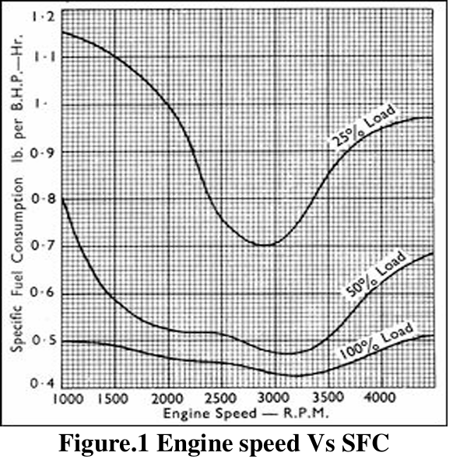
Figure 2 a comparison table of sfc against engine speed (Elavarasan G Et al, 2019)
Comparing the two graphs above, despite them being in different units one in g/KW.H and the other in “BHP-Hr”(Elavarasan, Kannan and Karthikeyan D, 2019)there is an obvious dip just after start-up, around 1000 RPM, as “there is a higher fuel consumption due to the increased friction encountered when the engine’s components and oil are at low temperatures” (Bielaczyc, et al., 2011). After start-up, it dips before slowly rising, as can be seen in the Figure 1 trendline. This is to be expected, as not only does the RPM increase, but the fuel demand also rises as the volume of air increases in line with engine speed. That the SFC remains within a reasonable range can be confirmed by the stated “range of values between 248.81 and 458.49” (Togun & Baysec, 2010) where the highest recorded result of 374 and the lowest of 270 both fall within the suggested values.

Lambda and SFC

Figure 3 lambda against SFC
Comparing lambda and SFC is useful as it shows a clear link: when the car is running at its leanest mixture of 1.32 lambda, this is almost directly proportional to the lowest SFC of 259.23 g/KW.H. This demonstrates that the leaner the mixture, the lower the overall fuel consumption, while a richer mixture is almost proportional to the highest fuel consumption. This holds true whether it occurs at the very start or the end of the test, as lambda mixtures can be identified by the principle that “rich mixtures have lambda < 1.0, and lean mixtures have lambda > 1.0.” (Al-Arkawazi, 2019) This can be demonstrated by looking at Figures 1 and 3, as both show higher fuel use at increased RPM alongside a richer mixture.

Torque against engine speed

Figure 4 torque against engine speed…
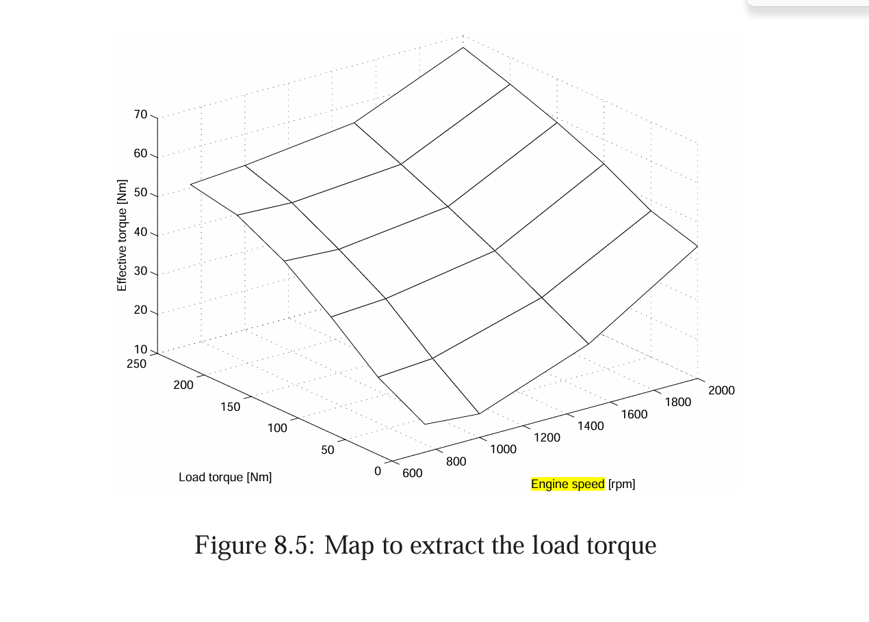
Figure 5 torque increase from 600 rpm to 2000rpm (Hellström, 2005)
The key relationship between engine speed and torque is clear from the trend line: torque will typically decrease as engine speed increases, except at the very start, where from 1000 RPM to 2400 RPM torque increases by a factor of 20%, as can be more clearly seen in “Figure 5” (Hellström, 2005)where it levels out until 5000 RPM. This can be caused by the speed of the piston overcoming internal friction, meaning that overall less work is being done, resulting in reduced resistance on the torque. This occurs alongside a period where both the inlet and exhaust valves are open simultaneously, leading to valve overlap and “air being simultaneously let in and out, as turbulence can swirl around, never drawing in quite the same amount of air each time” (Stone, 1999) leading to varying torque outputs.

torque and power

Figure 6 power against torque graph
With torque being a “rotational force produced by the crankshaft, where as power is how quickly work is done” (engineering toolbox, 2009)the difference between these two can be shown in the graph above. Torque fluctuates through peaks and troughs as the engine rotates, but overall appears to plateau, as can be seen in the trend line, dropping from approximately 100 N/m to around 87 N/m as RPM increases, since the rotational force is assisted by the increased speed. Power, on the other hand, as a measure of work, shows a much more linear increase as RPM rises, since greater rotation means work is being done more quickly, until it gradually levels off. The difference between the two is clearly shown in the trendlines, and both can be explained by friction losses, as less force is required to push the piston at higher speeds due to inertia.

Brake power against engine speed
Figure 7 power against engine speed
The power against engine speed graph clearly illustrates how the power of an engine can increase. As previously shown, torque may plateau; however, power demonstrates a rapid increase. This can be explained by the increasing demand for power as the engine works to overcome the magnetic force of the dynamometer, before continuing to produce ever-greater output as RPM rises with no further magnetic resistance. Despite the increase appearing steady and plausible, it may still contain inaccuracies, “as a dynamometer measures torque via a swing arm” (blair, 1999) and since it does not directly measure power, there may be inherent inaccuracies in the results.

Section 7 loss of power since the creation
Whilst the engine still retains some of the power it had when it was manufactured in 1988, it is clear that performance has diminished over the years. This can be attributed to a number of factors, but the main ones are the age of the engine, as the engine may experience “blowby, meaning it can lose power because it takes time for the fluids to circulate” (Lumley, 2010) which, upon start-up, can cause increased wear if the engine is not properly maintained. A further factor is general wear; as a university dynamometer, it can be used frequently but only for short periods. If it is only run to collect data, the fluids do not fully circulate, and when students are divided into groups, the number of short runs increases, further wearing out components and contributing to losses in power and torque. The final factor is that the engine is running lean, as can be seen in the lambda data. This can be caused by insufficient fuel delivery or excessive air intake, both of which will also affect power and torque output. On a colder day, the engine would have run more efficiently, likely producing results closer to its rated performance.

Section 8 evaluation
The main area that could have been improved was timing. Whilst it was unfortunate that the dynamometer was broken, it would have been beneficial to have obtained the data earlier in the term, as learning alongside completing the report would have been more useful. Three weeks is a manageable timeframe, but it would have been preferable to have had longer, particularly given the volume of other coursework due around the same time. In terms of personal improvements, it may have been better not only to carry out the test but also to look into certain aspects of it in greater depth. Whilst most topics were understood, a deeper knowledge of all areas may have been beneficial.

Section 9 conclusion
The aim of this test was to assess the performance of the engine. As has been demonstrated, despite running at a lower output than when it was new, the engine has maintained a decent power output whilst also sustaining a good fuel ratio for a petrol non-race car. With a lean lambda value, it has also maintained approximately 30% thermal efficiency, as evidenced throughout this report in the tabulated data and graphs, all of which describe why and how these outcomes came to be.

Section 10 references

References
Al-Arkawazi, F., 2019. The gasoline fuel quality impact on fuel consumption, air-fuel ratio (AFR), lambda (λ) and exhaust emissions of gasoline-fueled vehicles. cogent Engineering, 6(1).
Bielaczyc, P., A, S. & J, w., 2011. The effect of a low ambient temperature on the cold-start emissions and fuel consumption of passenger cars’. Proceedings of the Institution of Mechanical Engineers, Part D: Journal of Automobile Engineering, pp. 1253-1264.
blair, g., 1999. In: Design and Simulation of Four-stroke Engines. s.l.:s.n., p. 70.
Elavarasan G Et al, 2019. Experimental analysis to find the optimum specific fuel consumption for driver’s intimation.
engineering toolbox, 2003. Higher Calorific Values of Common Fuels: Reference & Data. [Online]
Available at: https://www.engineeringtoolbox.com/fuels-higher-calorific-values-d_169.html
[Accessed 05 March 2026].
engineering toolbox, 2009. Torque vs. Power and Speed. [Online]
Available at: https://www.engineeringtoolbox.com/electrical-motors-hp-torque-rpm-d_1503.html
[Accessed 05 March 2026].
Fall, M., 2020. engine dynamometer testing. [Online]
Available at: https://www.youtube.com/watch?v=VD9OPoaAcJU
[Accessed 4 march 2026].
Fall, M., 2020. engine dynamometer overview. [Online]
Available at: https://www.youtube.com/watch?v=-WajOAp2LUE
[Accessed 4 march 2026].
Harrison, A., 2020. master handbook, s.l.: s.n.
Harrison, A., n.d. Engine Dynamometer Results - Original, s.l.: s.n.
Hellström, M., 2005. Engine Speed Based Estimation of the Indicated Engine Torque, s.l.: s.n.
Heywood, J., 1988. Internal Combustion Engine Fundamentals. In: Internal Combustion Engine Fundamentals. s.l.: McGraw-Hill.
Honda, 1988. CRX workshop manual. s.l.:Honda.
Lumley, J., 2010. Engines: A introduction. s.l.:Google books.
Luo, Q.-h. & Sun, B.-g., 2015. Energy Conversion and Management. In: Experiments on the effect of engine speed, load, equivalence ratio, spark timing and coolant temperature on the energy balance of a turbocharged hydrogen engine. s.l.:s.n., pp. 1-12.
Mech content, 2026. Brake mean effective pressure (BMEP): Definition, Formula. [Online]
Available at: https://mechcontent.com/internal-combustion-engine/brake-mean-effective-pressure/
[Accessed 04 March 2026].
Ross, M., 1994. AUTOMOBILE FUEL CONSUMPTION AND EMMISSIONS:Effects of vehicle and driving chraratistics. In: AUTOMOBILE FUEL CONSUMPTION AND EMMISSIONS:Effects of vehicle and driving chraratistics Annual Review Environment and Resources. s.l.:s.n., pp. 179-192.
Stone, R., 1999. introduction to internal combustion engines. s.l.:s.n.
Togun & Baysec, 2010. applied energy. In: Genetic programming approach to predict torque and brake specific fuel consumption of a gasoline engine’. s.l.:s.n., pp. 3401-3408.

Table of tables
Table 1 a table of results from(Engine Dynamometer Results - Original.xlsx, no date) 4
Table 2 a table used to make calculations (Engine Dynamometer Results - Original.xlsx, no date) 6
Table 3 a table of results using the calculation 8

Table of figures
Figure 1 SFC against engine speed 10
Figure 2 a comparison table of sfc against engine speed (Elavarasan G Et al, 2019) 10
Figure 3 lambda against SFC 11
Figure 4 torque against engine speed… 12
Figure 5 torque increase from 600 rpm to 2000rpm (Hellström, 2005) 12
Figure 6 power against torque graph 13
Figure 7 power against engine speed 14

