BUILDING YOUR PERSONAL BRAND
FOR SUSTAINABLE EMPLOYMENT
Component 2: Written Assignment (Report)

Student name: Aysha Islam
Student number: 2024130412
Programme: BSc Health and Social Care
Module code: BMHP5015

Introduction
This report evaluates the employability skills required for a full-time Support Worker role in supported accommodation for young people, compares these requirements with my experience, and sets out a plan to develop my professional identity. My current support-worker role and Health and Social Care degree provide the basis for this reflection.
Support workers assist people to live as independently as possible, which may involve personal care, everyday activities, emotional support, following care plans and working with colleagues (Skills for Care, n.d.a). However, being caring is not enough by itself. Safe practice also requires communication, accurate record keeping, safeguarding awareness, reliability, professional boundaries and the ability to recognise when advice is needed. This report argues that my current experience provides a useful foundation, but sustainable progression depends on evidence of competence, reflective learning and a clear professional identity.

Job description and person specification
Support workers respond to each person’s needs, wishes, abilities and outcomes. Duties may include personal care and daily living, social participation, activities and appointments, following support plans, observing changes in wellbeing and recording relevant information. Medication support must follow training and employer procedures (Skills for Care, n.d.a).
The Care or Support Worker role category in the Adult Social Care Workforce Pathway identifies values such as compassion, honesty, reliability, respect, flexibility and willingness to learn. It also highlights effective communication, partnership working, person-centred practice, safeguarding, confidentiality and promoting choice and independence (Department of Health and Social Care, 2026). These expectations are consistent with the Code of Conduct for adult social care workers, which sets out the standards of behaviour and attitudes expected in practice (Skills for Care, n.d.b).
A person specification is likely to require clear communication, patience, emotional resilience, teamwork, time management, attention to detail and the ability to follow policies. Employers may also expect training in safeguarding, health and safety, infection prevention, moving and handling, equality, and learning disability and autism awareness. Requirements vary, so I must compare my skills with an actual vacancy rather than assume every role is identical.
The vacancy is for a permanent, full-time Support Worker in supported accommodation in Perry Barr, Birmingham, at a stated £12.72 per hour. Jordan Xavier Connect Ltd describes the role as helping young people move towards independent living through life-skills support, a safe environment, safeguarding and collaboration with social workers and managers to review progress and care plans (Jordan Xavier Ltd, 2026). These duties require communication, professional boundaries, accurate recording, teamwork and a calm, consistent approach. I would check all eligibility criteria before applying rather than assume my experience meets every requirement.
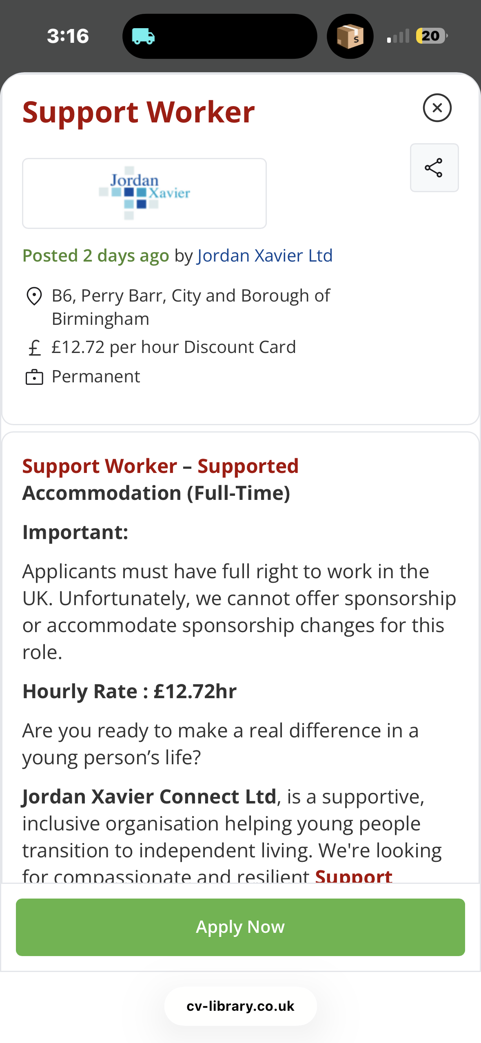

Figure 1. Screenshot of the Support Worker – Supported Accommodation vacancy advertised in Perry Barr, Birmingham.

Analysis of the employability skills required

3.1 Person-centred communication and relationship building
Communication is essential because support should reflect what matters to the individual, not simply staff routines. Personalised planning recognises a person’s priorities, strengths and circumstances (NHS England, n.d.; Skills for Care, n.d.d). Support workers should listen, check understanding, respect communication preferences and involve people in decisions wherever possible. Communication may need adapting for people with autism, learning disabilities or different levels of verbal communication. Poor communication can cause distress, misunderstandings or support that does not reflect a person’s wishes.
I have experience supporting people with autism and learning disabilities, following care plans and assisting with personal care and activities. This has helped me recognise that patience and adaptability matter, because people do not all communicate or respond in the same way. I should continue developing my confidence in explaining information clearly, checking understanding and recording important details accurately. My experience is valuable, but I must avoid assuming that knowing one person’s preferences means I understand another person’s needs.

3.2 Safeguarding, duty of care and professional boundaries
Support workers have a responsibility to recognise and report concerns, follow agreed procedures, maintain confidentiality and work within the limits of their competence. The workforce pathway includes recognising and responding to abuse or neglect, reporting unsafe practice and understanding duty of care (Department of Health and Social Care, 2026). These requirements show why professional judgement and accountability are as important as kindness. A worker must not ignore a concern or attempt to manage a situation beyond their role; they should follow policy and seek appropriate guidance.
My current role has exposed me to care plans, medication procedures and the importance of following instructions. I need to keep strengthening my knowledge through refresher training and supervision, particularly where an individual’s needs or risks change. I should also be able to explain why accurate records and prompt reporting protect the person receiving support and the staff team. Confidentiality must be maintained in everyday conversations and online: personal branding must never include identifiable information about people I support.

3.3 Teamwork, reliability and organisation
Support workers contribute to a wider team that may include colleagues, managers, families and other professionals. Reliable handovers and accurate documentation help staff provide consistent support. Time management is also important because late or incomplete tasks can affect personal care, medication routines, appointments and activities. The Code of Conduct expects workers to act responsibly and uphold standards that protect people using services (Skills for Care, n.d.b).
My employment experience has helped me understand the importance of following plans and communicating with colleagues. I can strengthen this further by asking for feedback on my record keeping, prioritisation and handovers. Teamwork does not mean agreeing with everything: professional practice also requires respectfully raising concerns and clarifying instructions when something is unclear.

Evaluation of my current skills and experience
My main strengths are compassion, patience, adaptability and practical experience. Supporting people with autism and learning disabilities has helped me understand the importance of treating each person as an individual and supporting participation in everyday activities. My experience with personal care, care plans and medication procedures provides relevant examples for a support worker application. Studying for a Health and Social Care degree is another strength because it gives me opportunities to develop my understanding of wellbeing, inclusion, ethics and professional practice.
Employability requires more than listing strengths. Dacre Pool and Sewell’s (2007) CareerEDGE model links employability with career development learning, experience, degree-related knowledge, generic skills and emotional intelligence. Tomlinson (2017) also highlights the different forms of capital that can shape graduate employability. Together, these perspectives suggest that my experience and degree are useful foundations, but I must develop career-planning and self-presentation skills. If I cannot explain what I have learned from work, employers may not recognise its value.
I can assess my development through supervision, feedback from lecturers, reflective notes and practice interviews. Gibbs’ (1988) reflective cycle provides a structure for reviewing an experience, considering my feelings and actions, evaluating what went well, analysing why, and planning how to improve. I should use reflection to identify specific learning rather than simply describe what happened. I must also be honest about limits: experience of supporting individuals does not automatically mean I am qualified for every specialist task. I should undertake tasks only when trained and authorised, and seek help when needed.
My main development needs are to improve confidence in interviews and networking, expand my evidence of training, and communicate my skills more clearly through a tailored CV and professional online profile. These are realistic areas for improvement because they can be addressed through practice, feedback and accessible learning opportunities.

Personal brand and professional identity
My personal brand is based on being caring, patient, reliable and committed to respectful, person-centred support. A personal brand is not simply a polished profile; it is the consistent impression created by values, behaviour and evidence of ability. Shepherd (2005) notes that personal branding applies branding ideas to individuals, but in a care context the brand must remain authentic and ethical. Making claims that cannot be supported by practice would undermine trust.
My professional identity should communicate my practical support-worker experience and the knowledge I am developing through my Health and Social Care degree. My strength is the combination of direct experience and academic learning, with a commitment to dignity, independence and inclusion. I can demonstrate this through truthful work examples, accurate descriptions of training and evidence of responding to feedback. I must anonymise examples and never disclose private information about people I support.
I will communicate my brand through a clear CV, a tailored supporting statement and a professional LinkedIn profile. The profile should include my degree, relevant skills, role-related training and a short summary of the type of support I aim to provide. I will check spelling and dates, avoid exaggerated claims, use a professional photograph if appropriate, and review privacy settings. Online networking may help me learn about vacancies and professional development, but it cannot replace the quality of my practice or guarantee employment.
Networking also shapes professional identity. My network includes managers, colleagues, lecturers, course peers, university careers support and personal contacts who may offer feedback, role insight and training information. I will broaden it through careers services and respectful contact with social-care professionals. Relationships should be reciprocal, not limited to asking for favours. Networking can improve access to information, although opportunities still depend on vacancies, selection criteria and demonstrated competence.

Action plan and timeline
The following SMART action plan focuses on achievable development over the next 12 months, while supporting longer-term progression in health and social care.
Goal | Actions and resources | Timescale | Evidence of progress
Improve interview confidence | Use university careers support; practise at least three competency-based answers using the STAR method; request feedback from a tutor or trusted colleague. | Within 2 months | Three written STAR examples and feedback notes.
Strengthen training and role knowledge | Review my training record with my manager; identify gaps in safeguarding, autism and learning disability awareness, medication procedures or other role-specific training; complete approved learning where required. | Within 3–6 months | Updated training record and certificates where applicable.
Improve CV and professional profile | Tailor my CV to a real support worker vacancy; update LinkedIn with accurate education, experience and skills; check privacy and confidentiality. | Within 1 month, then review quarterly | CV matched to vacancy and completed profile.
Extend professional network | Speak to university careers staff, maintain professional contact with colleagues and connect with relevant organisations or practitioners. | One new professional learning contact each month for 6 months | Record of contacts, advice received and learning points.
Prepare for progression | Review vacancies and person specifications every month; compare essential criteria with my skills and apply when suitable; discuss progression options with my tutor. | Review monthly for 12 months | Vacancy comparison notes, applications and updated development plan.
I will review the plan regularly as work, study and training opportunities change. Supervision and feedback will help me assess whether actions improve my practice, rather than merely whether activities are completed. If confidence remains a barrier, I will practise interviews and prepare examples. If a vacancy requires experience or qualifications I lack, I will use this to guide development rather than misrepresent my competence.

Resources and communication with employers
Useful resources include university careers guidance, lecturer feedback, workplace supervision, approved training, Skills for Care, the Care Certificate standards and reputable employers’ job descriptions. The Care Certificate sets out core knowledge and behaviours for people new to health and social care, including learning disability and autism awareness (Skills for Care, n.d.c). I will check which training is relevant to my role and whether courses are recognised or required before paying for them.
I will communicate my skills through a concise CV, a tailored supporting statement and interview examples that link my experience to the vacancy’s essential criteria. The STAR method—situation, task, action and result—can help me structure examples, but I must ensure that each example is truthful and demonstrates what I personally did and learned. I will also explain my degree as evidence of ongoing learning rather than suggesting it alone makes me qualified for regulated roles. This approach presents a realistic and trustworthy professional identity.

Conclusion
This report has identified communication, person-centred practice, safeguarding, reliability, teamwork, organisation and reflective learning as central employability skills for a support worker. My work at Assisted Lives and my Health and Social Care degree give me a relevant foundation, particularly through practical experience supporting people with autism and learning disabilities, following care plans and assisting with everyday activities. Nevertheless, I need to improve confidence in interviews and networking, maintain current training and communicate my skills with clear evidence.
My personal brand will be strongest when it reflects consistent professional behaviour rather than presentation alone. By using feedback, updating my CV and LinkedIn profile, extending my network and following a measurable action plan, I can strengthen my employability and prepare for sustainable progression. The priority is to continue learning while maintaining dignity, confidentiality and safe, person-centred practice.

Reference list
Jordan Xavier Ltd (2026) ‘Support Worker – Supported Accommodation (Full-Time)’. Vacancy listing, Perry Barr, Birmingham. Available at: https://jobvacancies.net/job/225705862/support-worker-b6-perry-barr-city-and-borough-of-birmingham
Dacre Pool, L. and Sewell, P. (2007) ‘The key to employability: developing a practical model of graduate employability’, Education + Training, 49(4), pp. 277–289.
Department of Health and Social Care (2026) ‘Care or support worker role category’. Available at: https://www.gov.uk/government/publications/care-workforce-pathway-for-adult-social-care/care-or-support-worker-role-category
Gibbs, G. (1988) Learning by Doing: A Guide to Teaching and Learning Methods. Oxford: Further Education Unit, Oxford Polytechnic.
NHS England (n.d.) ‘Personalised care and support planning’. Available at: https://www.england.nhs.uk/personalisedcare/pcsp/
Shepherd, I.D.H. (2005) ‘From cattle and coke to Charlie: meeting the challenge of self marketing and personal branding’, Journal of Marketing Management, 21(5–6), pp. 589–606.
Skills for Care (n.d.a) ‘Care worker’. Available at: https://www.skillsforcare.org.uk/Careers-in-care/Job-roles/Roles/Care-worker.aspx
Skills for Care (n.d.b) ‘Code of Conduct’. Available at: https://www.skillsforcare.org.uk/Support-for-leaders-and-managers/Managing-people/Code-of-Conduct.aspx
Skills for Care (n.d.c) ‘Care Certificate standards’. Available at: https://www.skillsforcare.org.uk/Developing-your-workforce/Care-Certificate/Care-Certificate-standards.aspx
Skills for Care (n.d.d) ‘Person-centred approaches in health and care’. Available at: https://www.skillsforcare.org.uk/Developing-your-workforce/Care-topics/Person-centred-approaches-in-health-and-care/Person-centred-approaches-in-health-and-care.aspx
Tomlinson, M. (2017) ‘Forms of graduate capital and their relationship to graduate employability’, Education + Training, 59(4), pp. 338–352.

