Therapy Assistant Practitioner:
Demonstrating Practice Logbook



This logbook was completed by:

Mentor’s name: Rebecca Palfrey Mentor’s signature:  Date: 12.02.2026

Learner’s name: Cerys Davies Learners’ signature:  Date: 11.02.2026

The content page includes a list of evidence to be collected as part of your portfolio:

- Log of supporting documents: | Details to include (including criteria): | Date of completion: | Mentors signature: | Appendix / page
- An observation of your practice | A supporting document from your mentor of your compliance with person centred practice (1.2 & 4.3). | 12.02.2026 |  | Appendix 1 / Page 3
- Evidence of reading and learning related to role | A minimum of 2 examples of your engagement with researching and learning on topics related to your role (8.4). | 12.02.2026 |  | Appendix 2/Page 4-5
- Log of a wide range of assessments. | A minimum of three anonymised assessments completed by you, demonstrating a range of skills and tools (1.2). | 12.02.2026 |  | Appendix 3/Page 6-7
- Copy of a recent Personal Development Appraisal Review (PDAR). | A copy of the most recent PDAR document completed with supervisor / mentor (8.1 & 8.3). | 12.02.2026 |  | Appendix 4/Page 8-10
- Copies of your recent supervision records. | A minimum of two supervision records, demonstrating attendance and contribution to supervision and agreement to actions (4.2). | 12.02.2026 |  | Appendix 5/Page 11-12
- A copy of a risk assessments you have undertaken | A formal or informal risk assessment that you have completed. This can be a case note entry, DATIX, incident report or an assessment completed due to risks (such as a falls risk assessment) (4.3) | 12.02.2026 |  | Appendix 6/Page 13-14
- Examples of any training you have participated in or delivered | A minimum of five examples of evidence that you attended or delivered training within the last 12 months (8.4). | 12.02.2026 |  | Appendix 7/Page 15-16
- Evidence of your compliance with mandatory training | A minimum of 5 examples of your mandatory training compliance over the past 12 month (4.1). | 12.02.2026 |  | Appendix 8/Page 17

***The following pages are where you can start to include your evidence:
Appendix 1 (to be completed by your mentor) - Supporting document:
Give a brief description of your relationship with the learner and a typical activity that you have overseen the learner complete:
My name is Amanda Rees, Specialist Speech and Language Therapist and Cerys is my Communication Development Officer. I supervise Cerys as part of my role. I have witnessed Cerys undertake individual Therapy sessions and create resources like ‘All About Me’ books and symbol communication books.

Does the learner demonstrate the following performance in their day to day practice: | - Yes | - No | - N/A | Signature
- Person-Centred Practice
- Actively listens to patients/carers to understand goals and concerns | ✓
- Adapts communication style to meet patient needs (such as cognitive, language, sensory) | ✓
- Respects patient dignity, respect, and personal preferences | ✓
- Involves patients in decision making and provides clear explanations | ✓
2. Professionalism & Accountability
- Arrives prepared, punctual, and appropriately presented for the clinical task. | ✓
- Follows organisational policies, procedures, and scope of practice | ✓
- Accurately reports and escalates clinical concerns to qualified therapists | ✓
- Accepts responsibility for actions and learns from feedback | ✓
- Maintains appropriate boundaries and therapeutic relationships | ✓
3. Safe & Competent Clinical Practice
- Delivers treatment sessions as prescribed by supervising clinicians | ✓
- Demonstrates safe handling, mobility, and equipment use | ✓
- Uses standardized assessments correctly and ethically |  |  | ✓
- Identifies and reports risks (falls, safeguarding, deterioration, environmental hazards) | ✓
- Documents interventions and outcomes accurately and timely | ✓

Appendix 2: Reading and learning

Article 1: Supporting meaningful participation in society by adults with developmental disabilities who need and use AAC: lived experiences, key research findings, and future directions.

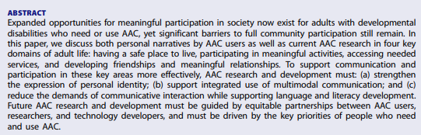

I found this article extremely interesting and thought provoking. It is an American article but the findings parallel my experience of working with individuals with a learning disability. Such as a lack of meaningful inclusion in community and leisure activities, resulting in not being fully included within their local community. The article also mentions the fact that limited use of alternative communication methods can often result in missed communication opportunities leading to communication breakdowns. Again this is something I have experienced when trying to engage staff in effectively supporting the communication of the individuals they are working with.

Reference
ISAAC (2025) Supporting meaningful participation in society by adults with developmental disabilities who need and use AAC: lived experiences, key research findings, and future directions. Available at: https://www.tandfonline.com/doi/pdf/10.1080/07434618.2025.2504497 (Accessed 10th January 2026)

Article 2: Involving people with a learning disability and autistic people in delivering The Oliver McGowan Madatory Training on Learning Disability and Autism

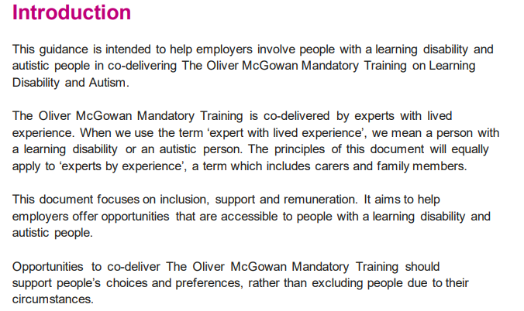

Whilst I am not involved in facilitating this training, I found the information contained the guidance very pertinent to my role. The guidance strongly advocates including people with a learning disability when facilitating training that is pertinent to supporting them. This is something we advocate as a Speech and Language Therapy department and try to do this wherever possible. I was particularly interested in the benefits as laid out in the guidance such as, bringing personal experience and knowledge, inspiring learners and modelling positive approaches. This is in line with my first experience of facilitating training alongside people with a learning disability and seeing the positive impact it has on all attendees.

Reference:
Health Education England (2022) Involving people with a learning disability and autistic people in delivering The Oliver McGowan Madatory Training on Learning Disability and Autism. Available at:
https://www.hee.nhs.uk/sites/default/files/documents/Involving%20people%20with%20a%20learning%20disability%20and%20autistic%20people%20FINAL%20.pdf (Accessed 15th January 2026)

Appendix 3: Assessments

Individual 1:

Carried out visit to day service to ascertain how Speech and Language Therapy could effectively support his communication. After observation I assessed that a symbol timetable was needed. See Care Partner case notes below.

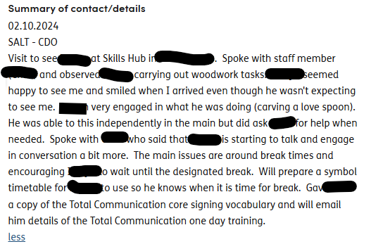

Individual 2:

I carried out work with an individual around introducing a now and next board. Having carried out several home visits and after observation and discussion with staff I assessed that he was ready to progress to next stage. See Care Partner case notes below.

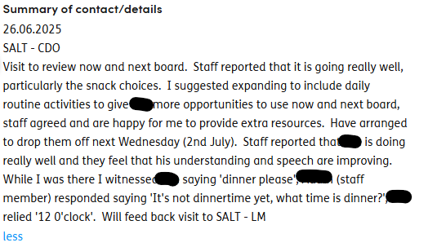

Individual 3:

Informal assessment of communicative intent during Intensive Interaction session. See below for Care Partner case notes.

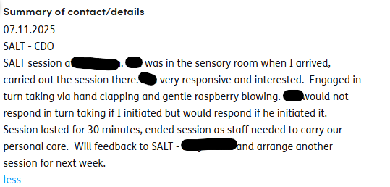

Appendix 4: PADR
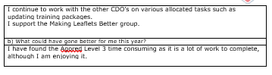
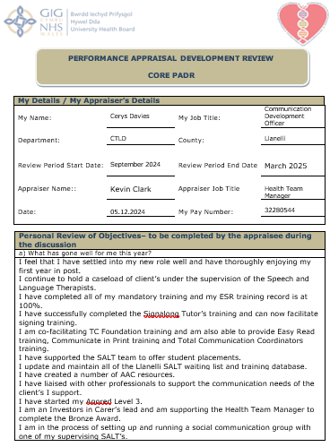

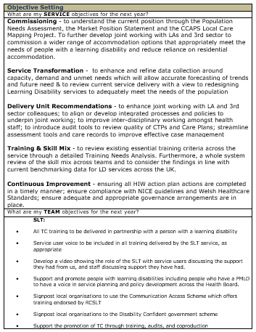

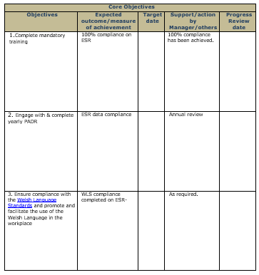
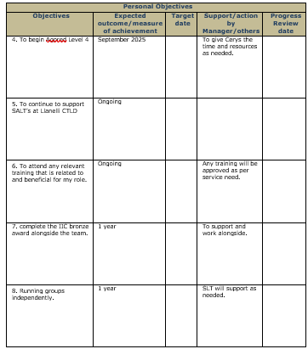

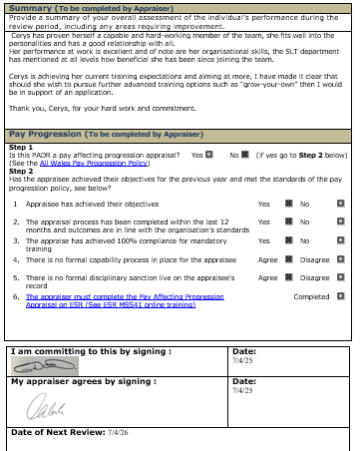
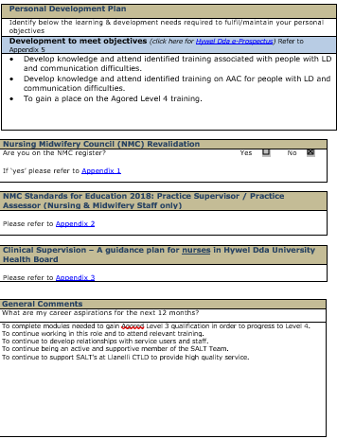

Appendix 5: Supervision
Supervision records Nov 2025 and February 2026
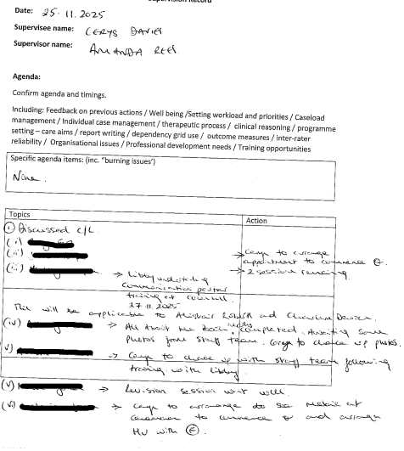

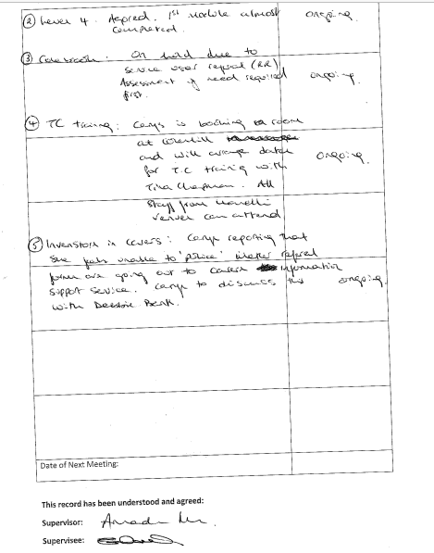


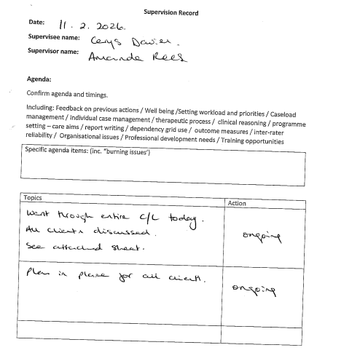

Appendix 6: Risk Assessment – Evidence of visit undertaken that needed further action

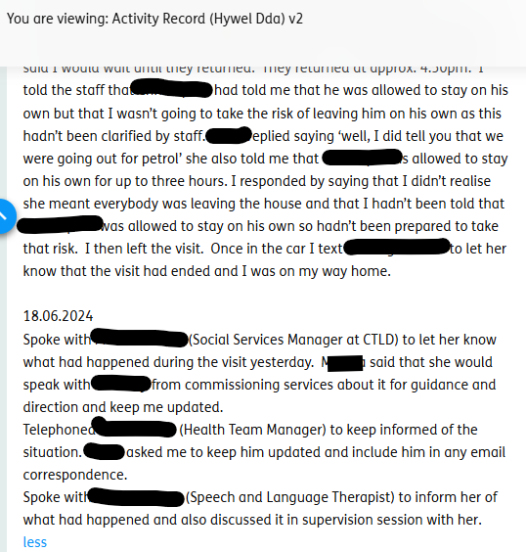
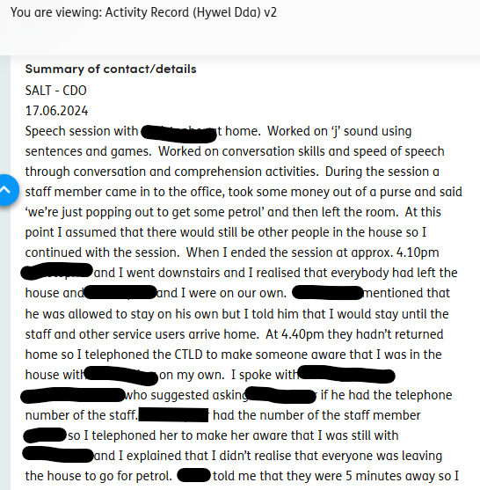

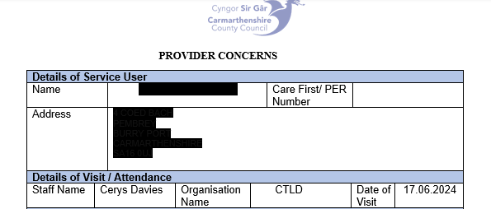
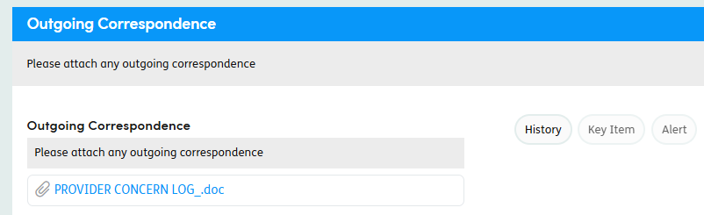

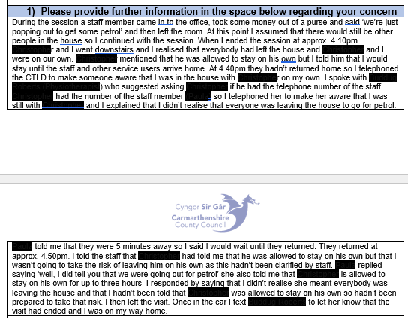

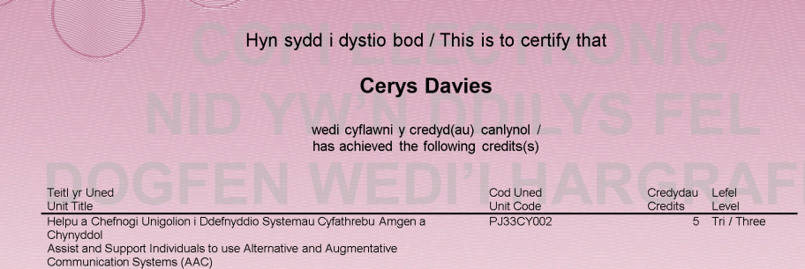
Appendix 7: Evidence of training I have undertaken:


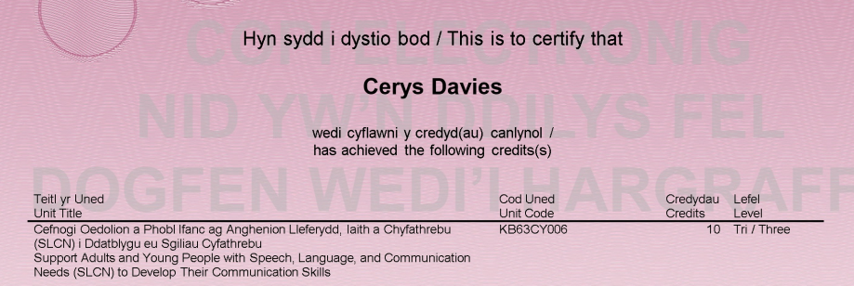
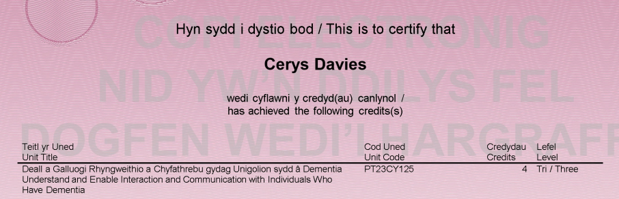

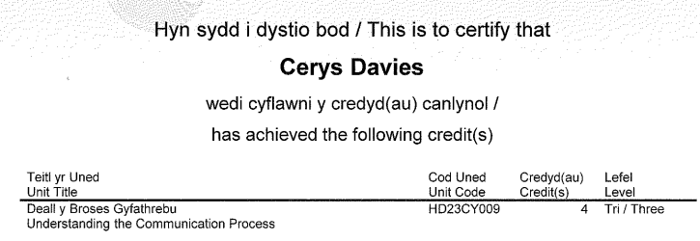

Appendix 7 continued: Training I have facilitated:

Signalong Training Total Communication Training

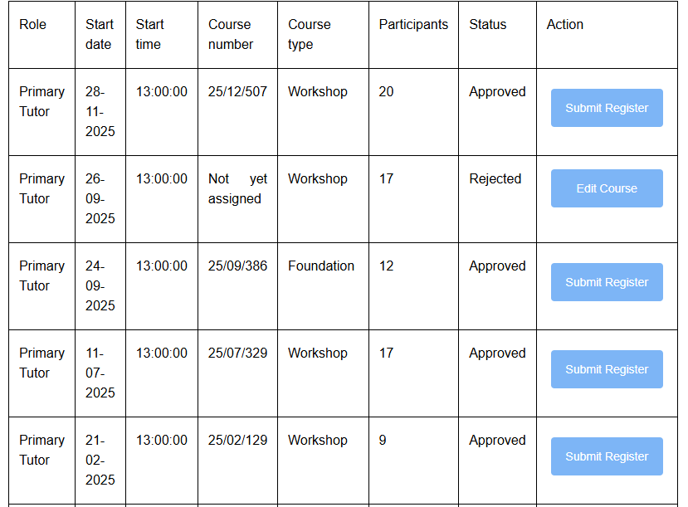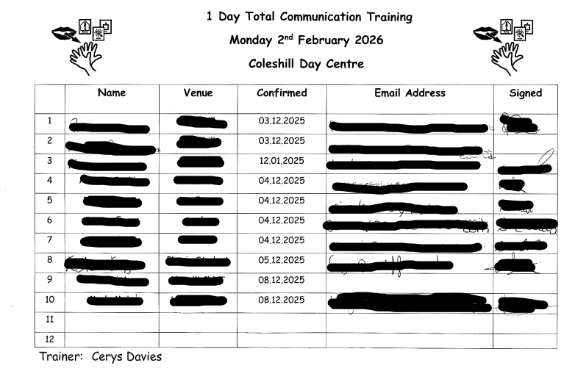

Appendix 8: Mandatory training compliance:



