Entity Relationship Diagram 1
Description of Database Schema 1
Products Table: 1
Customers Table: 1
Orders Table: 2
OrderDetails Table: 2
ServiceRequests Table: 2
Indexing Types, Query Optimization Strategies 2
Identify potential security risks and vulnerabilities and propose measures to protect sensitive customer information and ensure data integrity. Outline access control policies and authentication mechanisms to restrict unauthorized access 2

Introduction

The below report will describe the DBMS that has been designed for MelodyHWB. It will detail an entity relationship diagram, and give a description of the database schema that has been used to design the DBMS, based off the specifications required.
The report will explore database security practices looking particularly at access control and authentication. The report will also look database performance and in will explore query optimization strategies and indexing types.

Entity Relationship Diagram - MelodyHWB

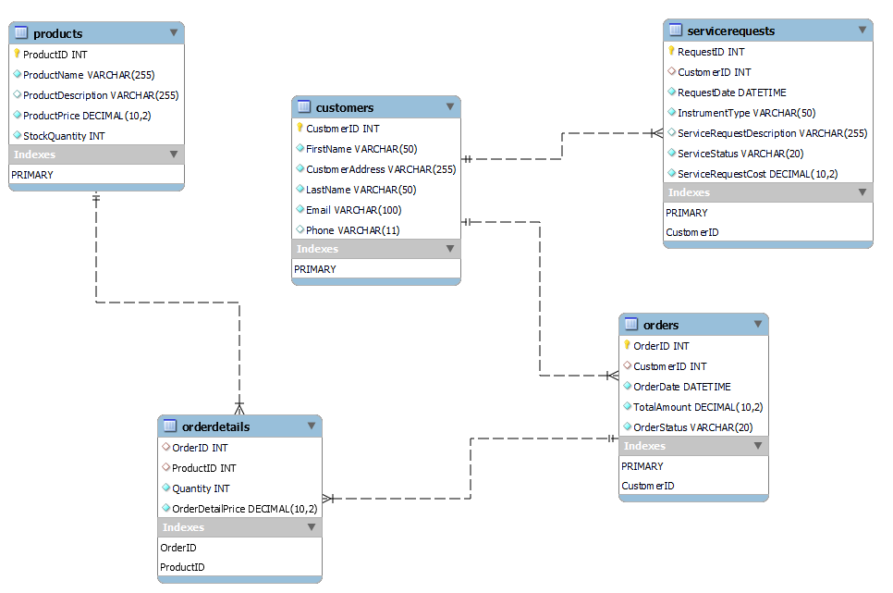

Description of Database Schema - MelodyHWB

Products Table:
ProductID (INT): Primary key, unique identifier for each product.
ProductName (VARCHAR(255)): Name of the product, not nullable.
ProductDescription (VARCHAR(255)): Description of the product.
ProductPrice (DECIMAL(10, 2)): Price of the product, not nullable, must be greater than or equal to 0.
StockQuantity (INT): Quantity of the product in stock, not nullable, must be greater than or equal to 0.

Customers Table:
CustomerID (INT): Primary key, unique identifier for each customer.
FirstName (VARCHAR(50)): First name of the customer, not nullable.
CustomerAddress (VARCHAR(255)): Address of the customer, not nullable.
LastName (VARCHAR(50)): Last name of the customer, not nullable.
Email (VARCHAR(100)): Email address of the customer, not nullable.
Phone (VARCHAR(11)): Phone number of the customer.

Orders Table:
OrderID (INT): Primary key, unique identifier for each order.
CustomerID (INT): Foreign key referencing Customers(CustomerID).
OrderDate (DATETIME): Date and time when the order was placed, not nullable.
TotalAmount (DECIMAL(10, 2)): Total amount of the order, not nullable, must be greater than or equal to 0.
OrderStatus (VARCHAR(20)): Status of the order, not nullable.

OrderDetails Table:
OrderID (INT): Foreign key referencing Orders(OrderID).
ProductID (INT): Foreign key referencing Products(ProductID).
Quantity (INT): Quantity of the product in the order, not nullable.
OrderDetailPrice (DECIMAL(10, 2)): Price of the product in the order, not nullable, must be greater than or equal to 0.

ServiceRequests Table:
RequestID (INT): Primary key, unique identifier for each service request.
CustomerID (INT): Foreign key referencing Customers(CustomerID).
RequestDate (DATETIME): Date and time when the service request was made, not nullable.
InstrumentType (VARCHAR(50)): Type of instrument for the service request, not nullable.
ServiceRequestDescription (VARCHAR(255)): Description of the service request.
ServiceStatus (VARCHAR(20)): Status of the service request, not nullable.
ServiceRequestCost (DECIMAL(10, 2)): Cost of the service request, not nullable, must be greater than or equal to 0.

Indexing Types and Query Optimization Strategies

Indexing Strategies

In the realm of indexing strategies for a relation, two primary approaches are commonly employed.
The first entails maintaining unordered tuples while creating multiple necessary secondary indexes. The alternative involves ordering tuples based on a primary or clustering index [1].
The selection of the ordering attribute depends on factors such as the attribute frequently used for the join operations, enhancing the efficiency of these operations, or the attribute frequently used for accessing tuples in a specific order [1].
Secondary indexes contribute to enhanced data retrieval efficiency by providing an extra key for a base relation. Guidelines for selecting secondary indexes include considerations for small relations, primary keys, foreign keys, frequently used attributes, and those involved in sorting operations. Achieving the right balance between performance gains and the maintenance overhead of secondary indexes is crucial [1]
Producing a "wish-list" of indexes involves considerations such as avoiding indexing small relations, indexing primary keys, adding secondary indexes to frequently accessed foreign keys, and indexing attributes involved in various operations like selection, join, ORDER BY, GROUP BY, and sorting. It's important to steer clear of indexing attributes subject to frequent updates or retrieving a significant proportion of tuples. Experimentation and monitoring the impact on update transactions help refine the wish-list [1].
The consequences of each potential index on update transactions should be assessed. Users should experiment and scrutinize the optimizer's strategy for the execution of queries to determine the effectiveness of indexes. In case of significant insertions, temporarily dropping indexes and updating database statistics may be considered [1]
Comprehensive documentation of the choice of indexes, including reasons for selection and performance considerations, is essential in the context of indexing strategies [1].

Query Optimization Strategies

Query optimization plays a crucial role in query processing by striving to choose the most resource-efficient transformation from a multitude of equivalent options for a high-level query.
The primary goal is typically to minimize the total time to execute the query [1]. Below will discuss and identify two potential methods for query optimization.
The first method that will be discussed is dynamic query optimization. In this method the decomposition and optimization will occur every time that the query is executed [1].
The advantage of this method is that all information that is required for an optimum strategy is up to date at the time that the query is run [1].
The disadvantage to this methodology is that the performance of the query will be affected as before the query is executed it must be parsed, validated and optimized [1].
The second method is static query optimization. In this method the query will be parsed, validated and optimized once [1].
The advantage of this method is that it will reduce runtime overhead, which would increase the chance of more time being available to evaluate a larger number of execution strategies, in turn this will increase the chance of a more optimum strategy being found [1].
The disadvantages for this method are that due to the data being out of date, what was optimal when the query was first run may no longer be the most optimum strategy [1].
In summation a hybrid approach could be used to overcome the shortfalls of each type of optimization strategy, the query could reoptimized when a significant change has been detected in the database statistics [1]. This may well be the most optimum strategy for the organization and careful consideration should be given for its use and the advantages and disadvantages of each method considered.

Database Security

Microsoft defines database security as “the processes, tools, and controls that secure and protect databases against accidental and intentional threats. The objective of database security is to secure sensitive data and maintain the confidentiality, availability, and integrity of the database.” [2]
An important consideration when implementing security policies is that breaches of security may affect not just the data itself but other parts of the system which interact with the database [1].
The database represents an important resource, that should be secured appropriately.
Database security can be considered under the following categories stated by Connolly and Begg [1].
- theft and fraud
- loss of confidentiality (secrecy)
- loss of privacy
- loss of integrity
- loss of availability
Microsoft also considers further aspects such as increased costs, revenue loss and data breach violation penalties. [2]

Security Risks and Vulnerabilities

A threat can arise from a situation or event involving a person, action, or circumstance that poses potential harm to an organization. This could include hackers attacking the database and physical incidents for example a fire or natural disaster [1, 2].
This harm can manifest as tangible losses, including hardware, software, data or monetary loses either through loss of business or via violation penalties as mentioned above [1, 2].
The primary challenge for any organization is to identify and recognize all conceivable threats. An organization could spend considerable time mitigating against threats that could not have a great effect on the business, it is therefore an important business consideration for the organization to the most severe threats that they may face [1].
While certain threats can be either unintentional or intentional, their impact remains consistent. Intentional threats involve individuals and can be instigated by both authorized and unauthorized users, some of whom may operate externally to the organization [1].
Every threat should be considered a potential breach of security that, if successful, will result in a specific impact. The degree to which an organization is affected by a successful threat depends on several factors, including the presence of countermeasures and contingency plans [1].
Connolly and Begg identify the below threats and the categories that they fall into:
- Using another persons credentials – Theft and Fraud, Loss of Confidentiality and Loss of Privacy [1]
- Unauthorized amendment and/or copying of data – Theft and Fraud, Loss of Integrity and Loss of Availability [1]
- Physical Damage to equipment – Loss of Integrity and Loss of Availability [1]
- Viewing and disclosing unauthorized data - Theft and Fraud, Loss of Confidentiality and Loss of Privacy [1]
- Introduction of viruses – Loss of Integrity and Loss of Availability [1]

Access Control Polices and Authentication

To combat the threats highlighted above the organization should put in place suitable countermeasures to help mitigate issues proposed by the threats listed above.

Authentication

The definition of authentication is a mechanism that can determine whether a user is who they claim to be [1].
The typical responsibility of a system administrator involves granting users access to a computer system through the creation of individual user accounts. Each user is assigned a unique identifier, which can utilized by the operating system to identify their identity. Corresponding to each user is a password, which is recognized by the operating system. This password must be provided to enable the operating system to verify the user's claimed identity [1].
Certain Database Management Systems maintain a distinct list of valid user identifiers and associated passwords, separate from the operating system's list. However, other Database Management Systems validate entries against the operating system's list based on the current user's login identifier. This prevents a user from logging onto the Database Management System with one name after logging onto the operating system with a different name [1]. Microsoft recommends utilizing a zero trust security model, this model looks to “validates identities and device compliance for every access request to protect people, devices, apps, and data wherever they're located. Instead of assuming everything behind the corporate firewall is safe, the Zero Trust model assumes breach and verifies each request as though it originates from an open network. Regardless of where the request originates or what resource it accesses, Zero Trust teaches us to "never trust, always verify." [2].

In summation utilizing appropriate authentication controls the Database Administrator can prevent unwanted access to the system, this can reduce the risk of theft and fraud, loss of integrity and loss of availability.

Access Controls

Access controls for a database system typically rely on the granting and revoking of privileges. A privilege permits a user to create or access (read, write, or modify) specific database objects like relations, views, or indexes, or to execute certain Database Management System utilities. These privileges are granted to users to fulfil the tasks essential for their roles. To maintain security, privileges should only be granted if a user cannot perform their work without them, granting of unnecessary privileges can compromise security [1]. This is further supported by guidance given by Microsoft that a principle of least privilege should be utilised. This states that “users and applications should be granted access only to the data and operations they require to perform their jobs.” [2]
Users who create database objects automatically obtain all privileges on those objects. The Database Management System keeps track of the granted and possibly revoked privileges, ensuring that only users with necessary privileges can access an object [1].
Discretionary Access Control (DAC) is a widely used approach for managing privileges in most commercial Database Management Systems, utilizing SQL commands such as GRANT and REVOKE. While effective, DAC has vulnerabilities, such as the potential for an unauthorized user to trick an authorized user into disclosing sensitive data. This necessitates an additional security approach, Mandatory Access Control, which operates based on system-wide policies that cannot be altered by individual users [1].
MAC assigns security classes to database objects and clearances to users, imposing rules on reading and writing based on these security levels [1].
The Bell–LaPadula model is a popular Mandatory Access Control model that introduces two restrictions on reads and writes [1]:
- Simple Security Property
- *-Property.
These restrictions prevent unauthorized disclosure of sensitive data. When discretionary access controls are also in place, these rules add extra layers of restriction, requiring users to have the necessary privileges and adhere to the security classes of the user and the object [1].
For applying MAC policies in a relational Database Management System, security classes must be assigned to each database object, leading to the concept of multilevel relations. These relations reveal different tuples to users with different security clearances. Polyinstantiation is introduced to address situations where users with varying clearances see different values for the same data object, preventing inference of information about higher security-classified objects [1].
In summary, access control mechanisms involve granting privileges based on user roles, and while DAC is widely used, MAC introduces additional security by enforcing system-wide policies and preventing unauthorized disclosure of sensitive information. Multilevel relations and polyinstantiation address the challenges of applying MAC in a relational Database Management System [1].
Applying these to a Database Management System much like authentication as discussed above, the database administrator can reduce the threats of theft and fraud, loss of integrity and loss of availability.

Conclusion
In conclusion by properly implementing appropriate indexing types and query optimization strategies the database can run efficiently to suit the needs of the users. By following best access control and authentication practices the databases integrity can be maintained leading to client satisfaction.
References
[1] T. M. Connolly author. T. M. Connolly author. Database systems : A practical approach to design, implementation, and management /. Database systems : A practical approach to design, implementation, and management /. Database Systems : Database Systems : 2014.
[2] (). What is database security?. Available: https://azure.microsoft.com/en-us/resources/cloud-computing-dictionary/what-is-database-security#:~:text=Database%20security%20is%20the%20processes,and%20integrity%20of%20the%20database.

