
HRM development of ANTA

Presented by： Haomiao Rao




Anta Performance Management

Deduction and punishment
• Anta’s performance management system is dominated by salary deduction and punishment
• No incentive and engagement mechanism
Problematic appraisal
• Subjective appraisal with many qualitative indicators and procedures.
• Unified appraisals without differences according to job positions
Non-strategic management
• The deviation of performance management from the strategic goals
• No incentive for employees to engage in the transformation
Incomplete management
• The employees are absent in the performance management, such as target setting, etc.
• No follow-up feedback for further improvement
Simple compensation
• Simple compensation package with salary and bonus, and nothing else
• Not attractive enough for the existing employees and potential applicants
• A gap between the compensation level of Anta and the offerings of Anta’s competitors, such as Li Ning

Anta Performance Management
Anta HRs as Strategic Partner
1Anta HRs as Strategic Partner

• The transformation of Anta towards a more direct to consumer model definitely requires the facilitation of HRM functions at the strategic level
• Besides the routine administration function of HRs, HRs should actively act as problem solvers , strategic advisors , and facilitators
• The transformation in performance management is also required to meet the major changes in demographics in Anta, tech-driven changes in A nta , to recover the falling engagement , and to compete in the relentless war for talents in the sports apparel industry in China.
• Taking the overall strategic goals as a starting point to design the performance management target for each department, each team, and each individual.
• Taking the specific job contents into the appraisal system
• Proving the follow-up feedback after the performance
• Using of data technologies to track performance and generate insights
• Designing more attractive compensation and reward packages to engage employees in the transformation and retain talents

Anta Communication Skills
Anta Employee Relation Skills

• Transformation in the Anta at the corporate level and in the HRM department indicates massive change needs to make , which may result in reluctance from employees.

• Strong interpersonal skills to develop and maintain healthy relationships with employees are required to gain more primary insights regarding performance management issues

• Employee relation management will be also useful to manage conflicts and complaints in performance management.

• How HRs in Anta can enhance employee relation skills : Traditional structured teaching, on-site practicing, coaching, etc.
• HRs deal with human capital via effective communication, both verbal and non-verbal.
• Transparent and effective communication is especially important during Anta’s period of transformation

• Performance management includes skilled negotiation, skilled feedback , and skilled consultation to solve any performance management, such as the unsatisfaction with compensation, the desire for promotion , the participation of employees i n performance management target setting, etc.

• How HRs in Anta can enhance communication skills: Traditional structured teaching, self-learning, on-site practicing, coaching, etc.

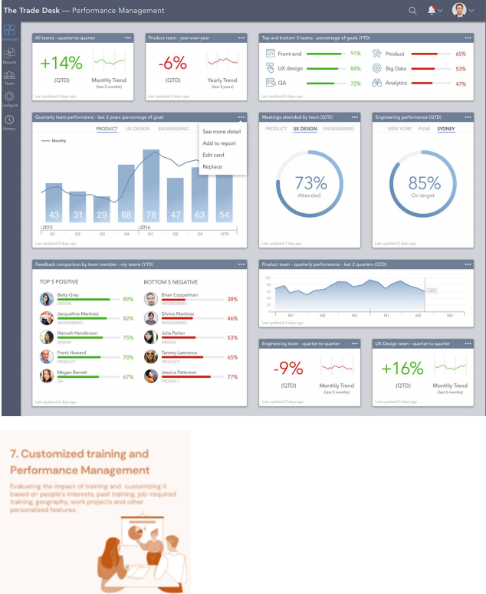
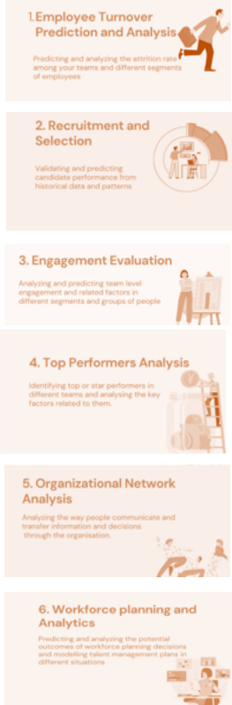
Anta People Analytic Skills

• The performance management of A nta has been highly subjective with bare interaction with data technologies.

• HRs should perceive the relevance and significance of data technologies in people analytics to track , monitor, and assess performance, as well design proper compensation packages

• The importance in this regard has accelerated by the popularity of virtual team settings in the covid-19 context

• How HRs in Anta can enhance people analytics skills: Traditional structured teaching, on-site practicing , the incorporation of IT professionals in the HRM functions,


Anta Conflict Resolution Skills

• Disputes are norms, especially during the transformation period, and HR’s responsibility is to ensure a safe and harmony workplace for all employees

• HRs in Anta should learn how to de-escalate tensions, negotiate comprises, come forward solutions, etc. through active listening and active communication.
• HRs should stay alert to conflicts , diver deeper into the underlying rationales, and address the conflicts immediately

• H ow HRs i n A nta can enhance conflict resolution skills : Traditional structured teaching, on-site practicing, participation in resolution activities ang games , virtual conflict resolution exercises, etc.

Action P lan
Month 1 | Month2 | Month3 | Month4 | Month5 | Month6 | Month7 | Month8 | Month9 | Month10 Month11 Month12
Communic  √  ationskills | √ | √
Employee  relation  skills |  | √ | √ | √ | √
People  analytics  skills  Conflict  resolution  skills | √ | √ | √ | √ | √ | √  √ | √  √ | √  √ | √  √  √
• The development of people analytics skills requires a relatively long time, as current HR professionals in Anta have relatively limited data proficiency. Thereby, it

takes approximately 10-month to develop people analytics skills and to integrate data technologies into the existing HRM functions of HRM

• The development of other skills that are relatively soft are intertwined in the next year. All events within Anta will be leveraged as an opportunity for HR professionals to develop their own soft skills, such as communications, conflicts resolution skills, etc.

• The development of these skills require the participation, collaboration, and coordination of all employees at all levels.

• The focus should not be limited in the performance management functions of Anta, but leverage performance management to facilitate the strategic realization of Anta to serve the mass sports apparel market

Video Link:
https://web.microsoftstream.com/video/12eb2dd0-9fd6-4abe-82e5-357f94559aaa

Reference List:
Aguinis, H. (2019) Performance management for dummies. John Wiley & Sons.
Anta (2021) Anta annual report 2020.
Bloomberg (2021) ANTA Brand Releases 5-year Strategic Targets and a 24-month Acceleration Plan LEAD TO WIN - Bloomberg. Available at: https://www.bloomberg.com/press-releases/2021-07-08/anta-brand-releases-5-year-strategic-targets-and-a-24-month-acceleration-plan-lead-to-win (Accessed: 18 April 2022).
Daxue Consulting (2021) Unraveling ANTA’s decline and rebirth. Available at: https://daxueconsulting.com/anta-market-strategy/ (Accessed: 18 April 2022).
Isson, J. P. and Harriott, J. S. (2016) People analytics in the era of big data: Changing the way you attract, acquire, develop, and retain talent. John Wiley & Sons.
Khan, N. and Millner, D. (2020) Introduction to people analytics: A practical guide to data-driven HR. Kogan Page Publishers.
Leonardi, P. and Contractor, N. (2018) ‘Better people analytics’, Harvard Business Review, 96(6), pp. 70–81.
Medium (2021) 7 Top People Analytics use cases. Available at: https://fatemehamiri.medium.com/7-top-people-analytics-use-cases-191332222ada (Accessed: 18 April 2022).
Thite, M. (2022) ‘Digital human resource development: where are we? Where should we go and how do we go there?’, Human Resource Development International, 25(1), pp. 87–103.
Thoman, D. and Lloyd, R. (2018) ‘A review of the literature on human resource development: Leveraging HR as strategic partner in the high performance organization’, Journal of International & Interdisciplinary Business Research, 5(1), pp. 147–160.
Wach, B. A. et al. (2021) ‘United we stand: HR and line managers' shared views on HR strategic integration’, European Management Journal, 39(4), pp. 410–422.
Yue, G., Selamat, M. H. and XiaDi, L. (2019) ‘Current Management Situation of renowned Sporting equipment enterprises in China--Take Li Ning Sports Goods Co., Ltd. as an example’, International Journal of Business and Management, 3(6), pp. 8–15.
Zheng, Y. (2018) ‘Research on the competitiveness of China's leisure sports industry based on statistical method’, Journal of Intelligent & Fuzzy Systems, 35(3), pp. 2855–2860.

