
BMIH5007
Assessment 2
Financial Management for the Hotel Industry
Student Name: Elena Caragicu
Student ID: 2244881

I confirm that I have not used any AI tools in the research and the creation of this assignment. I confirm that I have not presented any AI generated materials as my own work. I confirm that I have copies of my drafts, notes, and other resources I used, which I may be asked to provide in evidence.

Table of Content

Introduction 3
Trends and patterns of financial performance 3
Revenue structure 3
Expenses structure 4
Profitability structure 4
Liquidity structure 5
Solvency structure 6
The key reason behind the decline in profitability 7
Comprehensive Turnover Strategy 9
Conclusion 10
References 11

Introduction
The primary purpose of this report is to discuss the financial performance of The City Hotel. To evaluate the financial performance of The City Hotel, this report will provide patterns of revenue and expenditures within the periods of 2021, 2022, and 2023 on the basis of their financial statements. This report will additionally describe the profitability, liquidity, and solvency structure of the company. To describe the financial and profitable downfall of the company, this report will serve its simple considerations for key real-life economic reasons. Lastly, this report will serve as a comprehensive turnover strategy to build a better and more profitable structure for the City Hotel.

Trends and patterns of financial performance

Revenue structure
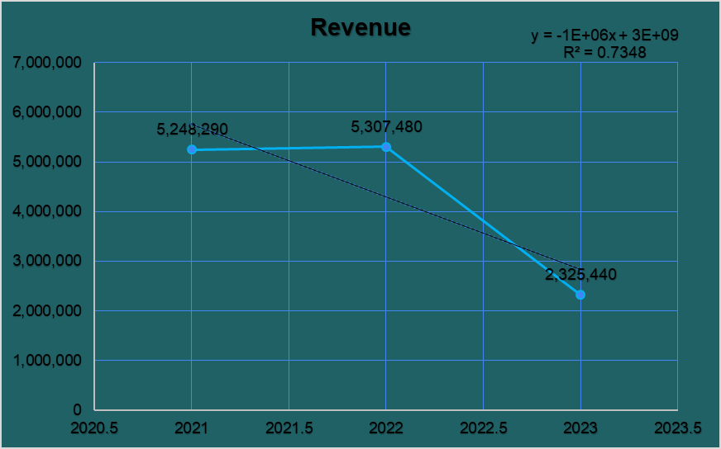
Figure 1: Revenue Structure of City Hotel
(Source: Self-Developed)
Revenue helps to determine the capabilities of business earnings by selling their effective products and services (Helmold and Helmold, 2020). By following the trend line from the above chart, a decline pattern among the revenues from 2021 to 2023 is visible. The City Hotel contained a revenue value of £5307480 in 2022, which became 2325440 in 2023, which reflects their decreasing revenue-generating capabilities.

Expenses structure
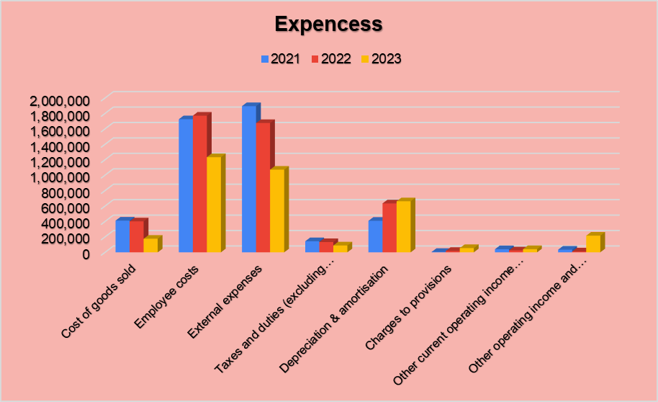
Figure 2: Expenses Structure of City Hotel
(Source: Self-Developed)
Expenses refer to the spent of money to generate the most effective outcomes from the business (Kok, 2021). The City Hotel is capable of controlling some of its expenditures whereas some of its expenditures faced increasing trends. For that, the company controlled their costs of goods sold from £411,600 in 2021 to £176,250 in 2023. In addition, they are capable of reducing their employee's costs and external expenses from £1,724,760 and £1,894,720 to £1,233,160 and £1,071,030 between the period 2021 to 2023. However, the company faced huge growth in its Depreciation & amortisation and Other operating income and expenses factors, which are £409190 and £34780 in 2021 to -661590 and £216650 in 2023.

Profitability structure
Profitability ratios help to determine the profit-earning capacity of a business by analyzing its current structure of profit (Rafid et al. 2024). For that, the net profit ratio from the table below reflects a huge loss in the year 2023 by utilizing their net profit portion as -52.41%. It additionally reflects their decreasing net profit earning capacity from 2021 to 2023.
Calculation for Profitability Ratio
Net Profit Ratio
Particulars | 2021 | 2022 | 2023
Particulars | Amount | Amount | Amount
Total Revenues | 5,248,290 | 5,307,480 | 2,325,440
Net profit | 664,160 | 674,730 | -1,218,850
(Revenue /Net profit )* 100 | 12.65% | 12.71% | -52.41%
Return on equity
Particulars | 2021 | 2022 | 2023
Particulars | Amount | Amount | Amount
Total Equity | 2,256,180 | 2,583,030 | 1,410,580
Net profit | 664,160 | 674,730 | -1,218,850
Net Profit/Total Equity | 0.29 | 3.83 | -0.86
Table 1: Profitability Ratio
(Source: Self-Developed)
The return on equity ratio is another effective profitability ratio that helps to gain knowledge about the earnings of the business by using their equity capital (Desmon and Meirinaldi, 2022). In 2022, the City Hotel Contained a return on equity ratio of 3.83, which became -0.86 in 2023. Following that, the capability of the business to provide proper profitable returns on their equities is lost. It can affect the trust of their equity holders within the operational process of the business and reduce their investments within the company.

Liquidity structure
The liquidity ratio refers to the evaluation of the assets of the business to settle down short-term obligations of the company and secure the financial structure of the company (Markonah et al. 2020). Following that, the current ratio of the City Hotel helps to determine their liquidity structure in the below table. In 2021, the current ratio of the company was 0.97, which became 0.64 in 2023. It reflects rising short-term debts and liquidity threats on the financial structure of the City Hotel.
Calculation for Liquidity ratio
Current ratio
Particulars | 2021 | 2022 | 2023
Particulars | Amount (£) | Amount (£) | Amount (£)
Current Assets | 1,891,970 | 1,965,340 | 1,285,880
Current Liability | 1,957,360 | £2,107,750 | 2,014,600
Current Assets/ Current Liability | 0.97 | 0.93 | 0.64
Quick ratio
Particulars | 2021 | 2022 | 2023
 | Amount (£) | Amount (£) | Amount (£)
Current Assets | 1,891,970 | 1,965,340 | 1,285,880
Inventories | 35,230 | 36,350 | 29,470
Current Liability | 1,957,360 | 2,107,750 | 2,014,600
Current assets - Inventories/ Current Liability | 0.95 | 0.92 | 0.62
Table 2: Liquidity Ratio
(Source: Self-Developed)
The quick ratio is another effective financial ratio that helps to determine the short-term debt-settling capabilities of the business by using the portions of assets that can easily be convertible into cash (Kumoro et al. 2020). However, the City Hotel contained a rising threat of liabilities and reducing assets, which can be convertible into cash as follows the quick ratio of 0.95 in 2021 to 062 in 2023. As follows, the long-term debt-setting capabilities of the business are deeply affected.

Solvency structure
The solvency ratio helps determine the long-term debt risks within the business and the capabilities of the company to stay solvent (Yusnita, 2023). The debt-to-assets ratio of City Hotel reflects a rising threat of debts on their structure of assets as follows the ratio of 0.66 in 2021 to 0.79 in 2023.
The calculation for the Solvency ratio
Calculation for Debt to Assets ratio
Particulars | 2021 | 2022 | 2023
 | Amount | Amount | Amount
Total Debt | 8,513,470 | 11,142,530 | 12,420,100
Total assets | 12,941,110 | 15,921,080 | 15,653,970
Total Debt / Total Assets | 0.66 | 0.70 | 0.79
Calculation for Debt to Equity
Particulars | 2021 | 2022 | 2023
 | Amount | Amount | Amount
Total Debt | 8,513,470 | 11,142,530 | 12,420,100
Total Equity | 2,256,180 | 2,583,030 | 1,410,580
Total Equity/  Total Debt | 0.27 | 0.23 | 0.11
Table 3: Solvency ratio
(Source: Self-Developed)
The debt-to-equity ratio helps to determine the risks of debts within the equity structure of the business (Tarsono, 2021). The debt-to-equity ratio of 0.27 in 2021 to 0.11 in 2023 reflects a reduction threat of long-term debts on the equity structure of the company. The reductions of debts from the equities reduced the threats to investments.

The Key reason behind the decline in profitability
Uncertainty and reduction of consumer spending
Uncertainty attached to Brexit instances, COVID-19, and recent economic turndown has resulted in careful disposable income spending within the United Kingdom. Of these uncertainty reasons, the country faced a decline in customer spending by 3.2% from 2021 which increased by only 1.4% in 2023 (Office for National Statistics, 2024). For that, it received gaps in consumer spending in the U.K. As seen from their spending habits, individuals have been inclined to reduce extra spending such as travelling and hotel accommodation. Domestic tourism, which is usually considered to be a reliable source of income for the City Hotels, has also suffered through this because people cut down their unnecessary expenditure, and the only thing that comes first is the basic needs (Office for National Statistics, 2024). Further, budget constraints for corporate travel, conferences, and events, affect City Hotels that mainly serve corporates. Since there are fewer guests and they tend to stay less, the ability of any hotel to generate per-room revenues has been affected thus the overall profitability (Office for National Statistics, 2024).
Inflation and Rising Operational Costs
The U.K., particularly after Brexit, has experienced inflationary forces that made it costly universally. The country contained an inflation rate of 2.52% in 2021 which became 11.1% in 2022 (Francis-Devine, 2024). This for hotels is inclusive of the costs of energy, food, beverages, and other necessities whose prices have also gone higher. Also, the cost of labour has gone up because new minimum wages have been introduced, which limit the availability of skilled workforce and hence raise the payroll. In the hospitality business, where the margins differ in most cases thin, such cost variations are very likely to affect the business's bottom line. Additionally, in 2023, the country faced an inflation level of 6.79%, which is the main cause of the rising operating costs of the company in 2023 (Francis-Devine, 2024). City Hotels, especially in current big cities, are most affected since their business greatly depends on business travellers and international guests who are relatively more sensitive to the price factor. When the operational cost goes up without corresponding room rates, the profitability of a hotel decreases, moving down gross margins (Francis-Devine, 2024).
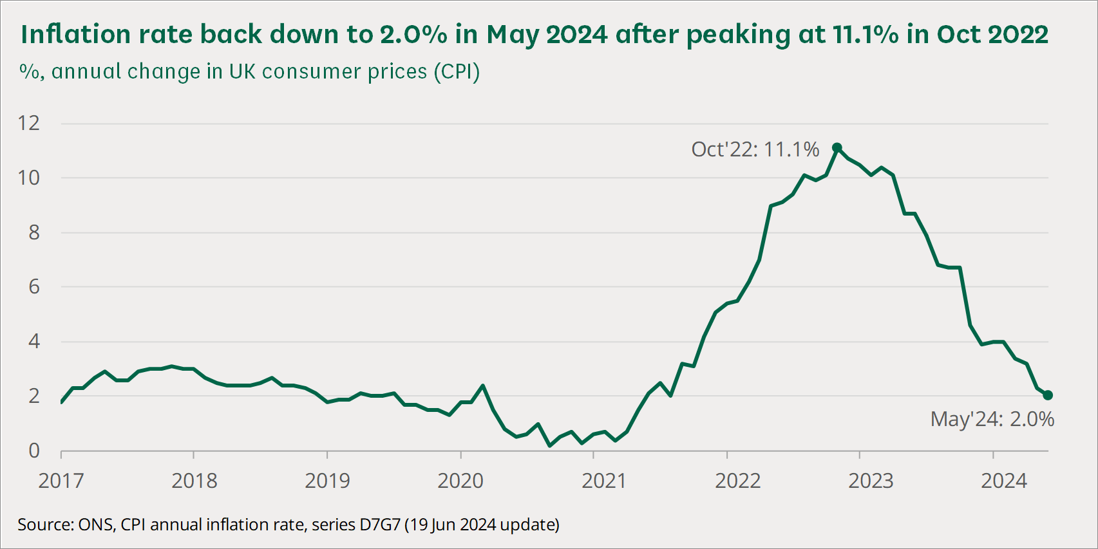
Figure 3: Higher Inflation in the U.K.
(Source: Francis-Devine, 2024)
Higher Interest rates and rising debt
Higher interest rates in the U.K. have put further pressure on operating margins in the hotel business. Most hotels rely on loans to finance their operations, expansion, or renovations, and the increased interest rates as a response to inflation made borrowing expensive for these hotels. In 2021, the interest rate of the country was 2.0%, which became 5.25% in 2021, which is the cause of higher interest in banking and corporate debts of the business (Bank of England, 2024). Higher interest rates mean higher costs of debt so this reduces the cash flow necessary for the enhancement of guest services as well as enhancement of facilities. Regarding City Hotels which predominantly depend on bank funding because the expenses on strategic spatial areas are high, the pressure is still higher (Bank of England, 2024).

Comprehensive Turnover Strategy
Optimization operational costs strategy:
As operational costs are on the rise, City Hotels should perform an evaluation of costs to determine efficient ways of cutting spending. Having L.E.D. lights, smart thermostats, or low–flow water fixtures will greatly reduce utility bills in the long run (Hayes et al. 2021). Hotels should also source their supplies locally so as to cut down on costs of transacting and also to negotiate for more favourable prices, especially for ratable items such as linen, cleaning items and food. Some of the areas identified to utilize technology are checking systems and forecasting inventory demand, and in most cases, no or less manpower is required, especially during low patronage. These are efficiencies, the effects of which, if incorporated, can guarantee massive, continuous and immediate savings that lift the profit line (Hayes et al. 2021).
Diversity of Revenue Source:
Despite the fact that room bookings are a powerful source of income, they can restrain the organization's income-making capacity in the case of low occupancy. In response to this, City Hotels should adopt a diverse service delivery system that addresses new changes and improves guest interaction. Development of coworking spaces can bring employees who work from home or are self-employed who are in most cases in search of an environment that is conducive to working but at the same time inspiring (Nguyen et al. 2022). Available day passes under the facility of a gym, swimming pool, or lounge encourage the local people the use the property during the day. Moreover, it is also necessary to create strong and long-term partnerships with local event planners that will help City Hotels brand the hotel as the right place for holding events to gain additional recognition and generate more sales (Nguyen et al. 2022).

Conclusion
This short report serves as a detailed discussion of the financial structure of the City Hotel. This report analysed the revenue and expenditure trends of the company and served their profitability, liquidity and solvency position. To reflect this position of the business, this report provides net profit ratio, return on equity ratio, current ratio, quick ratio, debt to assets ratio and debt to equity ratio. It additionally describes the reasons for the financial downfall of the business. To describe the key reasons, this report evaluated the increasing inflation and interest rates of the U.K. as well as their uncertainty crisis. It also reflects some of the effective strategies to improve the profitable structure of the company.

References
Bank of England (2024) Why are interest rates high and how quickly might they fall?, Bank of England. Available at: https://www.bankofengland.co.uk/explainers/why-are-interest-rates-in-the-uk-going-up#:~:text=We%20began%20raising%20interest%20rates,many%20people%20are%20in%20work (Accessed: 28 October 2024).
Desmon, A.R.W.A. and Meirinaldi, Y.C., (2022), January. The Effect of Return on Asset, Return on Equity and Debt to Equity Ratio on the Value of the Manufacturing Firm Listed on Stock Exchange 2015-2019. In M.I.C. 2021: Proceedings of the First Multidiscipline International Conference, M.I.C. 2021, October 30 2021, Jakarta, Indonesia (Vol. 196). European Alliance for Innovation. Available at: https://eudl.eu/pdf/10.4108/eai.30-10-2021.2315839
Francis-Devine, B. (2024) Rising cost of living in the U.K. - house of commons library. Available at: https://commonslibrary.parliament.uk/research-briefings/cbp-9428/ (Accessed: 28 October 2024).
Hayes, D.K., Hayes, J.D. and Hayes, P.A., (2021). Revenue management for the hospitality industry. John Wiley & Sons. Available at: https://www.uoguelph.ca/hftm/system/files/HTM%204250%20W19%20COURSE%20OUTLINE%20-%20MARK%20HOLMES%20.pdf
Helmold, M. and Helmold, M., (2020). Total revenue management (trm) (pp. 1-12). Springer International Publishing. Available at: https://hisp.htmi.ch/pluginfile.php/71681/mod_resource/content/0/Total%20Revenue%20Management%20%28TRM%29%20Case%20Studies%2C%20Best%20Practices%20and%20Industry%20Insights%20by%20Marc%20Helmold.pdf
Kok, W.J., (2021). Image recognition expense extraction (Doctoral dissertation, U.T.A.R.). Available at: http://eprints.utar.edu.my/4258/1/16ACB00064_FYP.pdf
Kumoro, D.F.C., Novitasari, D., Yuwono, T. and Asbari, M., (2020). Analysis of the Effect of Quick Ratio (Q.R.), Total Assets Turn Over (T.A.T.O.), and Debt To Equity Ratio (D.E.R.) on Return On Equity (R.O.E.) at P.T. X.Y.Z. Journal of Industrial Engineering & Management Research, 1(3), pp.166-183.
Markonah, M., Salim, A. and Franciska, J., (2020). Effect of profitability, leverage, and liquidity to the firm value. Dinasti International Journal of Economics, Finance & Accounting, 1(1), pp.83-94. Available at: https://eudl.eu/pdf/10.4108/eai.30-10-2021.2315839
Nguyen, N.T., Yadav, M., Pande, S., Bhanot, A. and Hasan, M.F., (2022). Impact of diversity management on organizational performance in hotel organizations: a conceptual framework. International Journal of System Assurance Engineering and Management, 13(Suppl 1), pp.186-196. Available at: https://www.researchgate.net/profile/Sagar-Pande-2/publication/355781318_Impact_of_diversity_management_on_organizational_performance_in_hotel_organizations_a_conceptual_framework/links/6184c677a767a03c14f6d682/Impact-of-diversity-management-on-organizational-performance-in-hotel-organizations-a-conceptual-framework.pdf
Office for National Statistics (2024) Cost of living insights: Spending, Cost of living insights - Office for National Statistics. Available at: https://www.ons.gov.uk/economy/inflationandpriceindices/articles/costoflivinginsights/spending#:~:text=Retail%20sales%20volumes%20(the%20amount,sales%20volumes%20in%20November%202023. (Accessed: 28 October 2024).
Rafid, M., Soukotta, A., Cakranegara, P.A., Sutiyan, O.S.J. and Nurriqli, A., (2024). Analysis Of Liquidity Ratios, Profitability Ratios, And Capital Structures On Financial Distress Conditions In Service Companies During The Covid-19 Period. Jurnal Darma Agung, 30(3), pp.614-622. Available at: https://jurnal.darmaagung.ac.id/index.php/jurnaluda/article/download/2280/2041
Tarsono, O., (2021). The effect of debt equity ratio, return on equity, net profit margin on stock prices. International Journal of Social Science, 1(4), pp.393-398. Available at: https://bajangjournal.com/index.php/IJSS/article/view/716
Yusnita, I., (2023). The Effect Of Solvency Ratio, Profitability Ratio And Activity Ratio To Company Value Of P.T. Astra Internasional Tbk. International Journal of Business and Quality Research, 1(03), pp.102-113. Available at: https://e-journal.citakonsultindo.or.id/index.php/IJBQR/article/view/500

