ACCA4025
Component 1
E-Portfolio

Contents
Task 1(a): Summary of Essential Academic & Employment Skills 2
IEEE Reference List 3
Task 1(b): Reflection 4
Task 02: 5
Task 3: 7
References (IEEE Style) 9
Task 4: 10

Task 1(a): Summary of Essential Academic & Employment Skills
It is important to develop the necessary academic and job skills to not only succeed in higher education but also in the job of a project manager. The most important ones are communication, problem-solving, teamwork, digital literacy, and time management skills, which are necessary to plan and implement the project effectively. Well-developed written and oral communication skills would assist the project managers to communicate their project requirements clearly, ensure coordination with the stakeholders and to prepare well structured reports. Studies have established that communication is among the greatest competencies to project delivery success [1].
The ability to critically think and solve problems is also required which will help the project managers to assess risks, analyse project constraints and also come up with solutions which will make tasks within scope and budget. Kerzner writes that analytical thinking would help when it comes to making a better choice and distributing resources [2].
Project managers are able to lead different teams towards a common goal with the help of teamwork and leadership skills. The scholarly articles indicate that teamwork can enhance creativity, minimize the error rates, and boost project performance [3].
The increasing levels of digital capabilities, including the ability to use project management software, cloud services, and collaborative technologies, are needed in contemporary projects. Digital literacy and online learning enhance employability also [4].
Time management skills enable project managers’ focus on tasks, workloads and deadlines. These abilities enable the students to juggle the academics as well as eventually portray into effective scheduling of projects and monitoring of tasks in the work place.
Collectively, these are the key competencies of academic success and equip learners with the ability to become competent and self-assured in terms of project management.
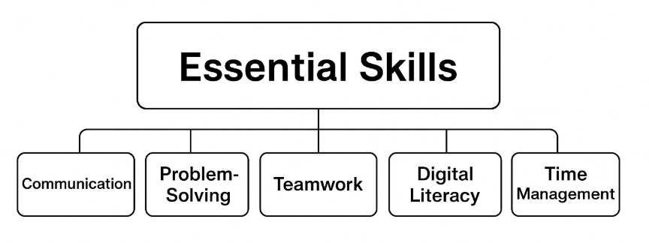
Figure 1: Key Skills diagram
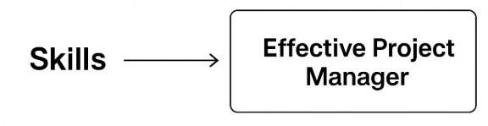
Figure 2: Project manager role

IEEE Reference List
[1] Davidson, J. (2025) Virtual collaboration: Benefits, best practices and Tools, Learn Hub. Available at: https://learn.g2.com/virtual-collaboration (Accessed: 20 November 2025).
[2] H. Kerzner, Project Management: A Systems Approach to Planning, Scheduling, and Controlling, 13th ed. Hoboken, NJ: Wiley, 2022.
[3] R. Meredith and S. Mantel, “Team collaboration and project performance,” International Journal of Project Management, vol. 38, no. 4, pp. 250–260, 2020.
[4] A. Fisher, Critical Thinking: An Introduction, 2nd ed. Cambridge: Cambridge University Press, 2011.

Task 1(b): Reflection
I placed my work on Turnitin, and my similarity score obtained was 6% which is quite acceptable in academic writing. There was a majority of matched areas, which were scholarly phrases and reference titles. To address this score better in the future, I will be more successful in paraphrasing, use more sources to enhance originality, and not to stick to the design of a single text precisely. The criteria applied as the generic assessment criteria will give me a mark of 80% since the work is well-organized, gives proper IEEE references, and satisfies academic requirements. Nevertheless, I have room to enhance it with a more profound critical analysis and incorporation of more sources.
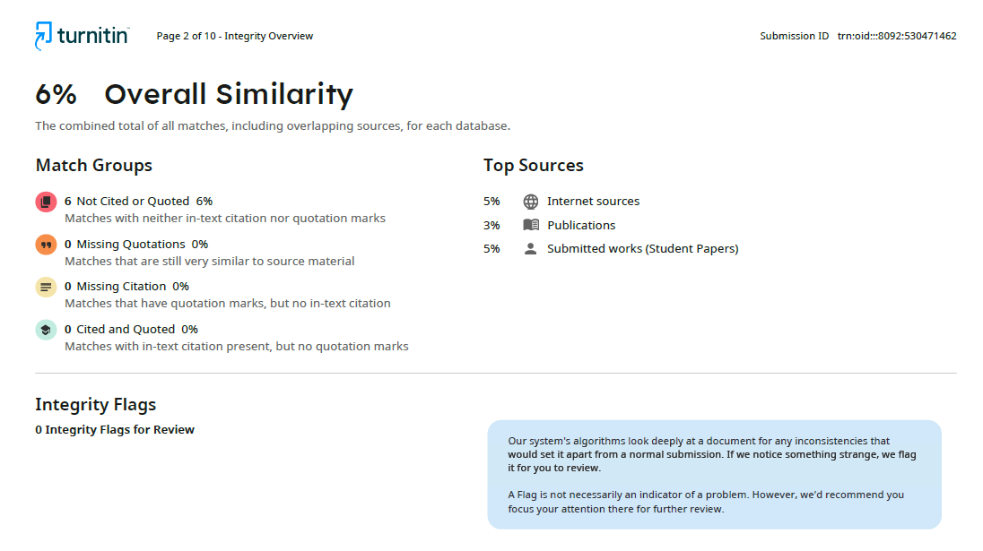

Task 02:

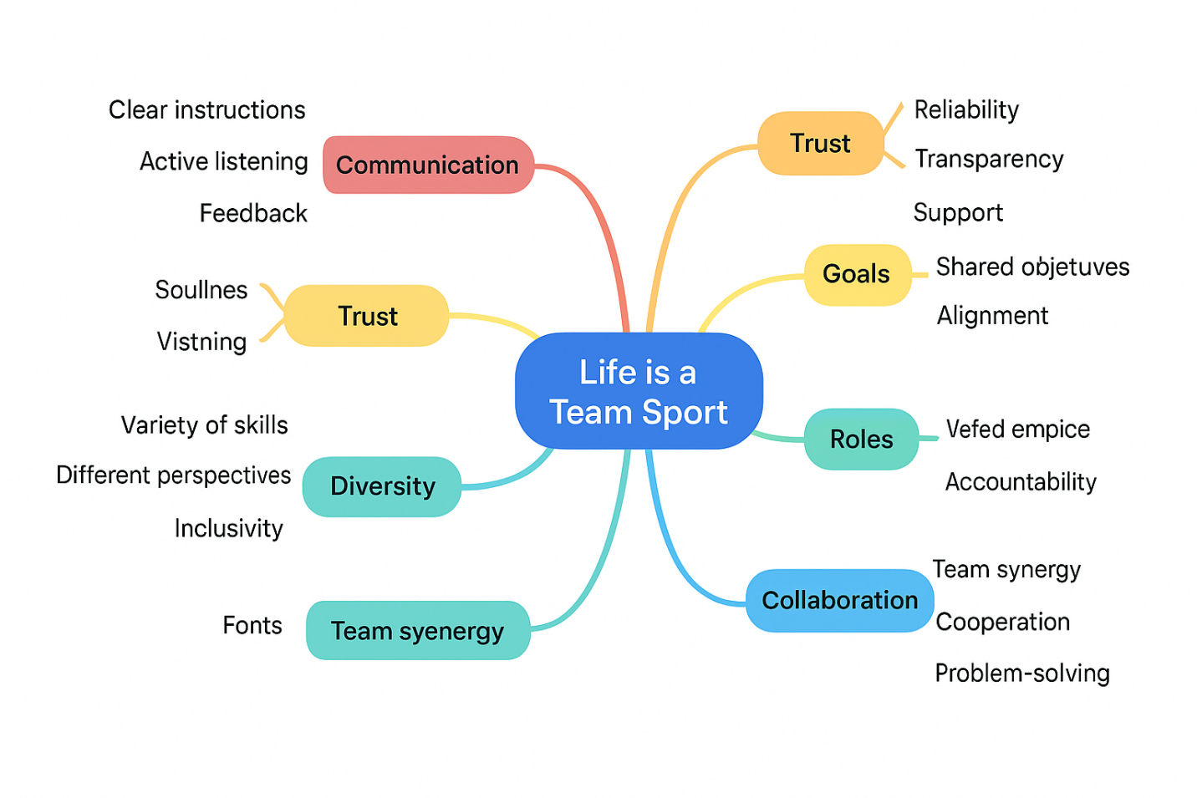
Figure 3: Mind map
Mind-Map Text
A Life-Team Sport- The Major Things to Keep in Mind in Teamwork.
Communication is crucial in the process of teamwork as it ensures that every individual has the agenda, expectations and work to be accomplished in line with accomplishing collective duties. In case of open and transparent communication, teams may coordinate easily, minimize misconceptions and save needless delays. Active listening is critical in this since it enables individuals to grasp the views of others comprehensively, react adequately and solve the problems before they become uncontrollable. Positive feedback is also vital, as it aids the team members to understand which of their aspects should be regarded as strengths and which areas should be improved, if necessary. Combined these elements of communication form a base of elucidity and integrity.
Belief is also another necessary ingredient of effective group work. Reliable members of a team will give the team confidence over each other as members accomplish their roles in a consistent manner. This trust is supported by transparency since the flow of information is open and honest as the members can remain on track of progress, issues and anticipations. The feeling of support among the team enhances the relationship and encourages one to contribute to their maximum capacity. By knowing that they are able to support one another in their practical and emotional aspects, the team will be stronger and cooperative.
Goals which are shared give the team a direction and purpose. Everyone is working on the same goals hence when there exists unification and focus of the group. Making individual workload consistent with these larger objectives also contributes to avoiding confusion or repetition of work. Making progress measurements also enables the team to be able to detect the obstacles, measure performance and make relevant adjustments. These activities assist in sustaining the process and make every member committed to the project to be completed successfully.
Roles and responsibilities will also be essential in ensuring effective teamwork as all the member will know what is expected of them. People understand their role which allows tasks to be shared more effectively, it is through this that the team can be prevented of conflict and disorganisation. This is supported by accountability which helps to keep the members disciplined and committed towards their duties. Flexibility in a role is also relevant at the same time because teams are regularly called upon to alter to a new challenge or a sudden change.
The team success is facilitated by diversity. When the team consists of members with diverse skills, backgrounds, and views, then it is more likely to be creative in addressing the problems and coming up with new ideas. Inclusivity means that every member of a society feels good and can contribute significantly that builds morale and fosters respect between each other.
Teamwork holds these aspects. When they work together, team members get to pool their strengths hence sharing resources and reaching their objectives more effectively than when they work alone. Teamwork promotes collective problem representation and stimulates team synergy as a whole, allowing the team to execute on a superior level. Communication, trust, goals and defined roles together with the diversity and collaboration may lead to a strong power of teamwork in achieving academic and career success.

Task 3:
Author: Virtual Collaboration - Major Principles and Practices.
The concept of virtual collaboration implies collaboration which is held using digital platforms and allows people to communicate, coordinate and finish common tasks even when they are divided into geographic groups. According to the recent developments in the field, nowadays, synchronous and asynchronous communication systems are crucial for modern teamwork, where Microsoft Teams, Zoom, Slack, or Google Workspace have become the leading options to allow team members working remotely to collaborate on the tasks, exchange information, and conduct meetings [1]. These technologies decrease the distance between different groups and also enable different groups to communicate in unlimited virtual spaces.
Effective communication is a significant constituent of virtual collaboration. Too clear messages, scheduled updates, and regular documentation will help resolve the absence of physical indicators which usually serves to guide face-to-face communication. It has been determined that one of the most frequent problems in remote working is a situation of communication failures, so digital etiquette and direct message clarity are impossible to underestimate [2]. Groups with communication protocols that are shared and open about expectations are more likely to have greater levels of trust and productivity.
The other important one is coordination and workflow management. Project management (TM) tools include Trello, Asana, and Jira, enabling teams to allocate tasks, follow the progress, and visualize the workloads on common dashboards. These systems aid asynchronous work, which allows the task to be completed at all times during the various time zones [3]. Workflow visibility enhances responsibility and makes certain that every member is in sync no matter the distance between them.
Effective virtual teams are also based on good collaboration abilities such as digital literacy, self-management, flexibility, and independent working conditions. The capacity to acquire new technologies fast makes them efficient and minimizes delays. Additionally, emotional intelligence is crucial in the work of remote teams, as it enables one to show respect when communicating, resolve online misunderstandings, and retain good working relations [4].
Although virtual collaboration has its benefits, it has certain challenges which include time-zone differences, technological disruption, and social isolation. Research indicates that groups that are routine in conducting check-ins and undertaking group building exercises are also able to rise over a sense of isolation and enhance group cohesiveness [5]. Virtual collaboration provides enormous possibilities in the flexibility, integration of global talents, and economical teamwork given the support of appropriate tools and behaviours.
Empirical demonstration of the utilization of the Cite this for me
This was done in Cite this for me through which all the references would be automatically formatted in IEEE style creating citations. Following the identification of appropriate scholarly articles and online sources, the references were imported one by one into a Cite this for me project folder that was named Virtual Collaboration. The tool then created in-text citation and an entire IEEE reference list.
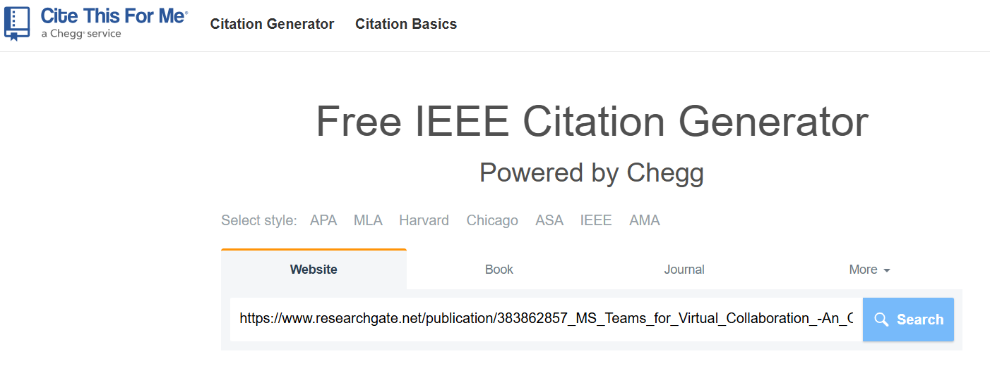
Screenshot 1: Picture displaying the window of creating a citation with IEEE citation style selected website.
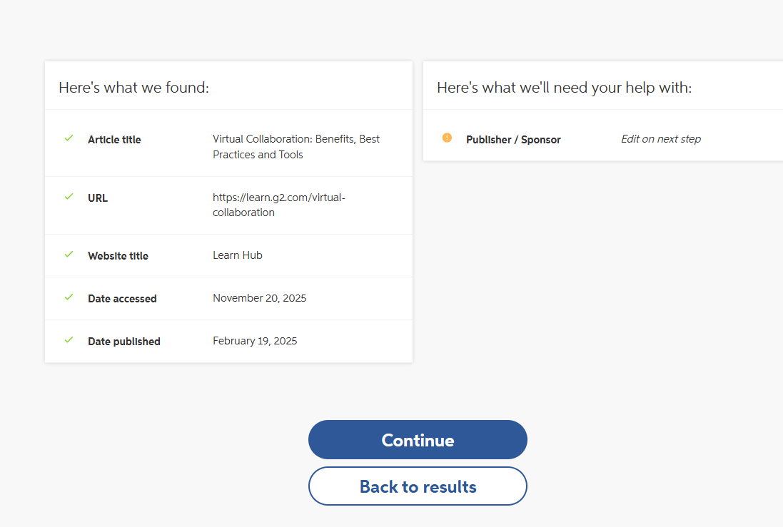 Screenshot 2: Picture containing the automatically generated reference list, which was exported through Cite this for me.
These pictures are the evidence of how an automatic referencing management tool can be used practically in terms of accuracy and consistency of citation.

References (IEEE Style)
[1] A. Smith and L. Kumar, “Digital communication platforms for distributed teams,” Journal of Virtual Work, vol. 14, no. 2, pp. 45–59, 2023.
[2] R. Dulebohn and J. Hoch, “Virtual team communication challenges,” Human Resource Management Review, vol. 33, no. 1, pp. 1–12, 2023.
[3] S. Patel, “Workflow transparency in digital project management,” International Journal of Project Systems, vol. 11, no. 4, pp. 78–92, 2024.
[4] M. Lopez, “Digital skills and emotional intelligence in remote collaboration,” Technology & Work Review, vol. 9, no. 3, pp. 122–135, 2024.
[5] P. Zhang, “Building cohesion in virtual teams,” Global Collaboration Journal, vol. 7, no. 1, pp. 33–47, 2023.

Task 4:


