Student Name: Lloyd Pennington
Course Name: Business Information Technology
Module Name: End User Computing
Lecturer Name: Beverley Holland
Submission Deadline: 17/05/2019

Contents
User Guide 3
Tables 3
Patient 3
PrivateRoom 3
PrivateRoomBooking 4
Room 4
RoomBooking 5
Treatment 5
Forms 5
Future Considerations 5
Software Appraisal 6

User Guide
This part of the report will focus on the relevant information regarding how to operate the newly designed database for “Your Teeth Our Smile”. This will cover the following pieces of information, i.e. the tables and all the data within each specific table, the forms and the data on the form and mailmerge.

Tables
The tables of the database are all in relation to the information regarding the various stages of booking a patient into a room for treatment in “Your Teeth Our Smile”.

Patient
The patient table will hold the information regarding the patients, as shown in figure 1.
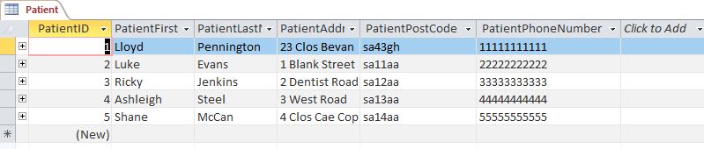
Figure 1
Figure 1 shows the information within the patient table, examples of the data would be the PatientID, this field would hold the relevant ID that is unique to each patient, this would be used for reporting and querying the data. The fields regarding the patient names, i.e. PatientFirstName and PatientLastName. Finally there is the data regarding the patient contact details and address. The patients address can be found within the PatientAddress and PatientPostCode. The field called PatientPhoneNumber would be the field where the information regarding the patient phone number can be found.

PrivateRoom
The Private room table shows the information regarding private room information, this can be shown with figure 2.
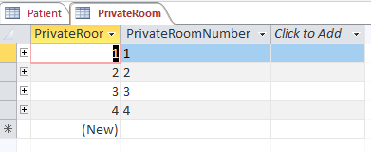
Figure 2
Figure 2 shows, as previously mentioned, the data surrounding the private rooms of Your Teeth Our Smile. The first field is called PrivateRoomID this field adds a unique ID for each of the private rooms, in this case there are four different private rooms to choose from, so there will be four different unique IDs. The next field is called PrivateRoomNumber and holds the information regarding the number of the private rooms, as previously stated, there are four private rooms, so there are four data entries.

PrivateRoomBooking
The PrivateRoomBooking table holds all the information regarding the booking of the private rooms within Your Teeth Our Smile. This is shown in figure 3.
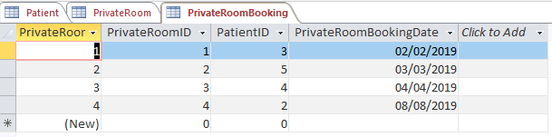
Figure 3
The first field is called PrivateRoomBookingID and this is a unique ID for every time a patient is required to go into a private room. The second field draws the information from the PrivateRoomID field in the PrivateRoom table, this is so all the data entry does not need to happen again in this table that happened in the PrivateRoom table – the same functionality works with the third field the PatientID field. The last field is the PrivateRoomBookingDate field and holds the information regarding the booking dates of the private rooms.

Room
The Room table holds the information regarding the Room information, this is shown in figure 4.
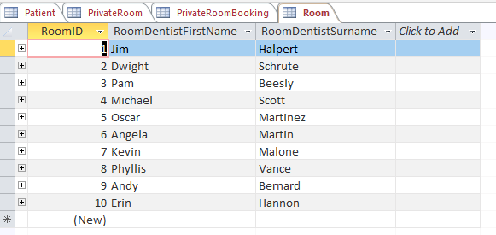
Figure 4
This table holds the information regarding the Rooms within Your Teeth Our Smile. In this case the information would be the RoomID – this is the unique ID for each room and will be used in reporting and querying of the data. The next field is theRoomDentistFirstName and holds the information regarding the first names of the dentist in correlation to each RoomID. Examples would be that RoomID 1 holds the Dentist called Jim Halpert, while RoomID 9 holds the information regarding Andy Bernard.

RoomBooking
The RoomBooking table holds the information regarding the booking of the regular rooms that a patient would go into with a regular procedure, i.e. no anaesthesia. This is shown in figure 5
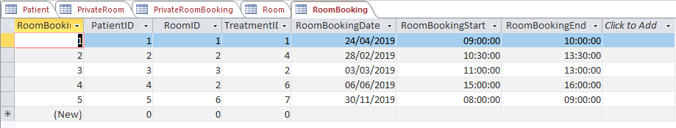
Figure 5
Figure 5 shows the entirety of the RoomBooking table and all the fields within that table. The first field would be the RoomBookingID, this field would contain the unique ID for any new bookings for the dentistry. This table borrows a lot of data from other tables as is shown in the second, third and fourth field, each of them being a foreign key field from a different table. The fifth field holds the information regarding the date of the booking, the reason there is no end data field is because the patients only stay in the dentistry for up to three hours at a time. The two final fields are called the RoomBookingDate and RoomBookingEnd fields and hold the information regarding the start time of the patient procedure and the end time of the patient procedure.

Treatment
The final table is the Treatment table. This table holds the information regarding the types of treatments that a patient can have in Your Teeth Our Smile. This is shown in figure 6.
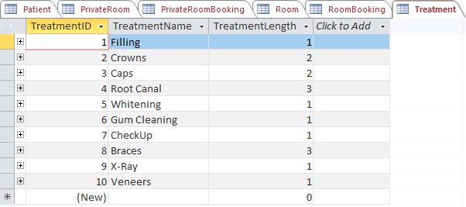
Figure 6
Figure 6 shows there are three fields within this table, these being; TreatmentID, this would be the unique ID assigned to a new type of treatment. Following on from the first field is the TreatmentName field, this field holds the names of each type of treatment that a patient can experience in the dentistry. The third, and final, field is called TreatmentLength, this field holds the information regarding the length of the different treatments in correlation to the TreatmentID and TreatmentNames.

Forms
The different forms of the database were made from the data of the various tables, this can be shown in figure 7.
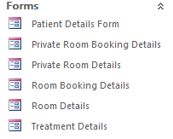
Figure 7
An example of a form can be shown in figure 8.
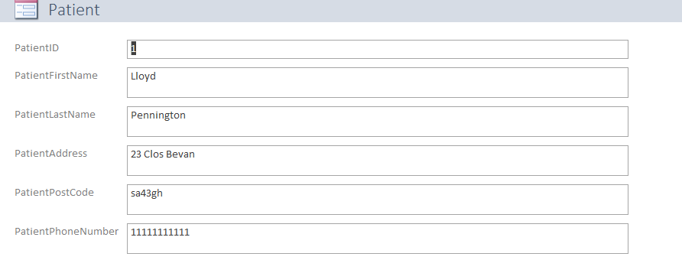
Figure 8
Figure 8 shows the form called “Patients Details Form”, this form encompasses the type of form that allows automation of the forms. What is meant by this is the use of buttons to help the user navigate between the various records. This is shown in Figure 9.


Figure 9
Figure 9 shows the buttons that are available within all the forms of the database, going from right to left there is the find first record button, there is the previous record button, the next record button, the final record button. Moving on is the new record entry button, the delete entry record, the print form button and, finally, the quit record button.

Future Considerations
There are currently three future considerations for this database, the first consideration being validation and input masks and the second consideration being to utilise the mailmerge function correctly.
The input masks and validation would make it so the information being entered into the database cannot be falsified, an example of this would be an input mask for the telephone number of the patients – this would make it so the user can only enter the 11 digits of the patients telephone number and not 12 or 10.
An example of validation would be to do with the booking dates for the RoomBooking tables. This validation would work in the way that the end date could not be before the start date or that the start date could not be before the current date.
The third future consideration would be the implementation of Queries, this would be because a Query can be used to gain information quickly and allows the user to cross check the database for the information instead of doing it manually.

Software Appraisal

Access
The software used for this build was called Microsoft Office Access. MS Access is a brilliant database tool that allows the linking of different tables using relationships to cross examine large quantities of data or, equally, small quantities of data.

Tables
The use of tables in MS Access is a wonderful feature as these allow the storing of one particular type of data. In the case of the current build the example would be the Room table, this held the information regarding the rooms and nothing else, this made it so there is no duplicate data within the database and therefore no errors within the database.
The user can create as many, or as few, tables as needed for the database they’re designing. In this case there could have been expansions on one of the tables, the Room table. Where the information regarding the dentists information is that could have been its own table, but MS Access allows the congregation of data if it makes sense to the user.

Reports
The report feature of MS Access is a phenomenal tool as it allows the user to get all the relevant information regarding a specific table and turns the data into a more easily reading format, i.e. it is easier to read one type of input at a time rather than all the inputs at once. This is also handy for printing out the data, if needed.

Buttons
Buttons are a massive feature when it comes to the reporting feature of the database. The fact that a button can be assigned one of thousands of unique commands makes it so each button has its own functionality within the database, this can make the users life a lot easier as well as making the navigation of the database a lot easier.
This can be done with the use of a printing button or an add a new record button, each of these records would mean that the user would not have to enter the actual fields within the main tables but would instead have an easier form to input the data on. In terms of navigation there is the find next record type of button where the button, once clicked, will take the user to the next record within that report or a button could be used to go to the next form etc.

MailMerge
The mailmerge aspect of the database is so that the user can take the data from one table within the database and export the data onto a different Microsoft Office application, the use in this build of the database was to make the data of the patient table be exported and implemented onto a word document. This would be done for many reasons, the main one being that the user might need to make a letter or a memo regarding the data from a specific table and utilising a mailmerge would be the best way to do that as Access does not allow the data to be made into a letter or a memo.

