
APPENDIX GA36c

LEVEL 6 ASSESSMENT SPECIFICATION

Student name: | Dominic Hole | Student ID number: | 1800402
Programme: | Outdoor Adventure Education BA
Module: | Landscape & Sustainable Recreation
Module code: | BMOE6003 | Contribution to Overall Module Assessment (%): | 50%
Lecturer: | Anthony Burns | Internal Verifier: | Roisin Mullins
Assignment Title: | Reflective Fieldwork Journal | Word count (or equivalent): | 2,500 words
Submission deadline: | 29th April 2022 | Return date of provisional marks & written feedback: | 27th May 2022
Submission method: | All written assessments, where practical and possible, must be submitted via Turnitin unless otherwise instructed by the Lecturer. (Please DO NOT put this assessment specification into Turnitin or it will match many similarities with other students’ submissions.)  Alternative submission method (if applicable):  Late submission of the assessment will result in a late penalty mark. Penalties for late submission: Up to one week late, maximum mark of 40%. Over one week late, 0%. Only the Extenuating Circumstances Panel may approve a change to submission dates.
Academic honesty / referencing: | Academic honesty is required. In the main body of your submission you must give credit to authors on whose research and ideas your work is based. Append to your submission a reference list that indicates the books, articles, etc. that you have used, cited or quoted in order to complete this assessment.

Student FEEDBACK FORM

This section details the extent to which the assessment criteria are demonstrated by you, which in turn determines your mark. The marks available for each category of skill are shown. Lecturers will use the space provided to comment on the achievement of the task(s), including those areas in which you have performed well and areas that would benefit from development/improvement.

Generic Assessment Criteria | Marks available | Marks  awarded
1. Engagement with Literature Skills
.
Your identification and use of relevant academic and other material to help inform and develop your argument. You should include at least twenty references. These should be taken form appropriate journals, textbooks and reliable websites |  | 10
2. Knowledge and Understanding Skills

Your critical discussion of the relationship between landscape and recreation and your suggestion of sustainable approaches to the interpretation and use of landscape for recreation. |  | 25
3. Cognitive and Intellectual Skills

Your critical evaluation of external and internal influences that affect the perception, interpretation and use of landscape at the fieldwork sites. |  | 30
4. Practical Application Skills

Your discussion of the nature of landscape within the context of the fieldwork locations |  | 25
5. Transferable Skills for Life and Professional Practice

Written or other presentation: clarity of expression, accuracy of grammar and spelling (please use your spell-checker, set to UK English), use of headings when appropriate, use of illustrations (captioned and referred to in the text). |  | 10
29t
Assessment Mark (Assessment marks are subject to ratification at the Exam Board. These comments and marks are to give feedback on module work and are for guidance only until they are confirmed. ) | Late Submission Penalties (tick if appropriate) |  | %
 | Up to 1 week late (40% Max) |  | %
 | Over 1 week late (0%) |  | %

Dinefwr Estate

Landscape character
Dinefwr represents a socialised landscape (Landley, 2013) and is a 970 acre landscaped park (Cadw, 2002), located in Carmarthenshire, South Wales (Figure 1). Dinefwr has multiple key elements which have impacted upon the current visible landscape, most notably are the Castle, Deer Park and Newton House.

The present deer park at Dinefwr was enclosed and established in 1660 with slaters (Cadw, 2002; Bailey, 2022), to enable deer to enter the park whilst preventing escape (Cooper and Shannon, 2017). Following 1066, the gentry of Britain enclosed large swathes of lands from the commons to create deer parks (Peterken, 1993). Their creation represents a shift in landscape management in Britain, where enhanced deer populations drastically altered the character of lands usually reclaimed from wooded ‘wastes’ (Williamson, 2016). Enclosing land for deer parks negatively influenced commoner’s perceptions of such landscapes (Peng, 2020) as they were now blocked from accessing the once common lands (Hayes, 2020; Neeson, 1996). The eating habits of deer in the artificial populations facilitated within deer parks, limit new tree growth within the park (Cote et al., 2004; Bailey, 2022). Dinefwr also housed white park cattle, as was common at the time (Peterken, 1993). Dinefwr followed the cultural norms of the 18th century with changes made following the philosophies of Capability Brown, with deer parks being incorporated within or converted to landscape parks (Peterken, 1999).

Newton House (Figure 2; 3; 4) was the Rhys family home for over 350 years after being sold to them in 1635 (Cadw, 2002). The modern Newton House was built on top of the grounds of a medieval town also called Newton for which there are no remains above ground (Dyfed Archaeological Trust, 2022). The current home had a Venetian gothic redesign in the 1850s (National Trust, 2022; Cadw, 2002) to reflect the cultural norms and perspectives of nature as art (Appendix 1; ref of cultural norms). The lands around Newton House and the Dinefwr estate include an 18th century enlightenment era landscape park built around a medieval deer park (Norman, 2022), small formal garden (Figure 4), walled garden, and walled kitchen garden (Cadw, 2002). These landscaping projects replaced the previous landscaping efforts where the house stood amongst mature trees looking down over rows of young trees (Figure 5), as painted in approximately 1690 (Appendix 1; 2). The formal garden was constructed between 1856 and 1858 and is separated from the landscape park by a stone ha-ha (Cadw, 2002). George Rhys landscaped the grounds around the house to the east and south according to naturalistic principles between 1750 and 1780 (Cadw, 2002). This landscaping included the removal of over 300 trees, hedges flattened, and ditches levelled (Cadw, 2002). These landscape changes follow a shift in western cultures to focus on the aesthetic rather than survival features of landscape (Burt and Archer, 1994). The landscape styles around the estate are not uniform with the landscape east of the house being largely tree-covered and the land to the south being moulded into gently rolling open land (Cadw, 2002). The house itself sits on a raised terrace surrounded by a ha-ha on three sides (Figure 6), with offices and two courtyard buildings to the south (Cadw, 2002).
The ownership of the Dinefwr estate has seen constant changes over the last 1000 years as separate kings and queens both took control away from the Rhys family and then subsequent rulers returned it, with Charles the 1st returning all lands to the Rhys family in the 17th century (Norman, 2022).
Figure 1(Digimap, 2022)
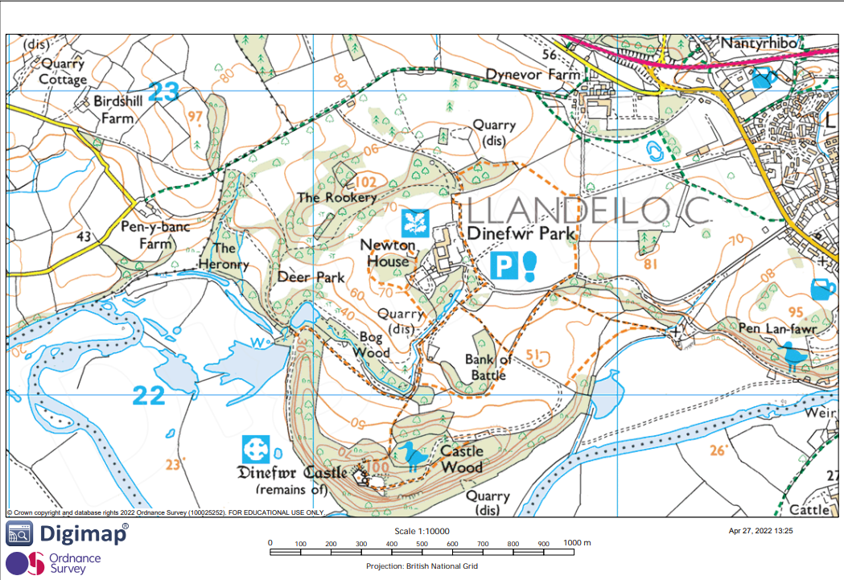
Figure 2(Digimap, 2022)
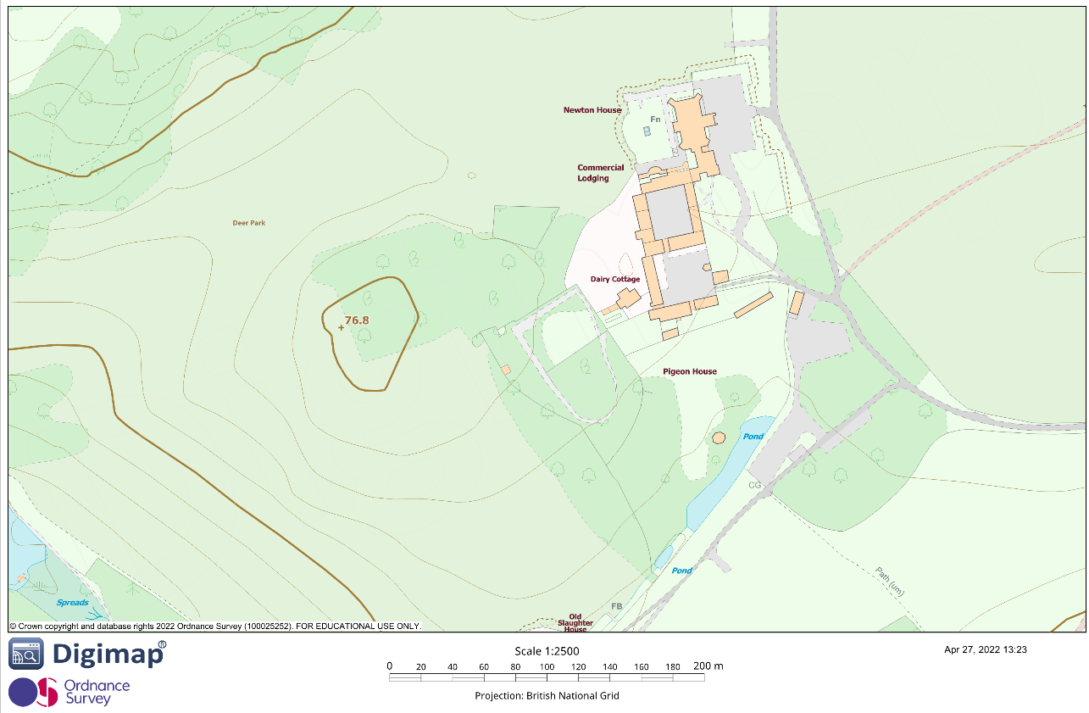
Figure 3 Newton House from Capability Brown viewing spot
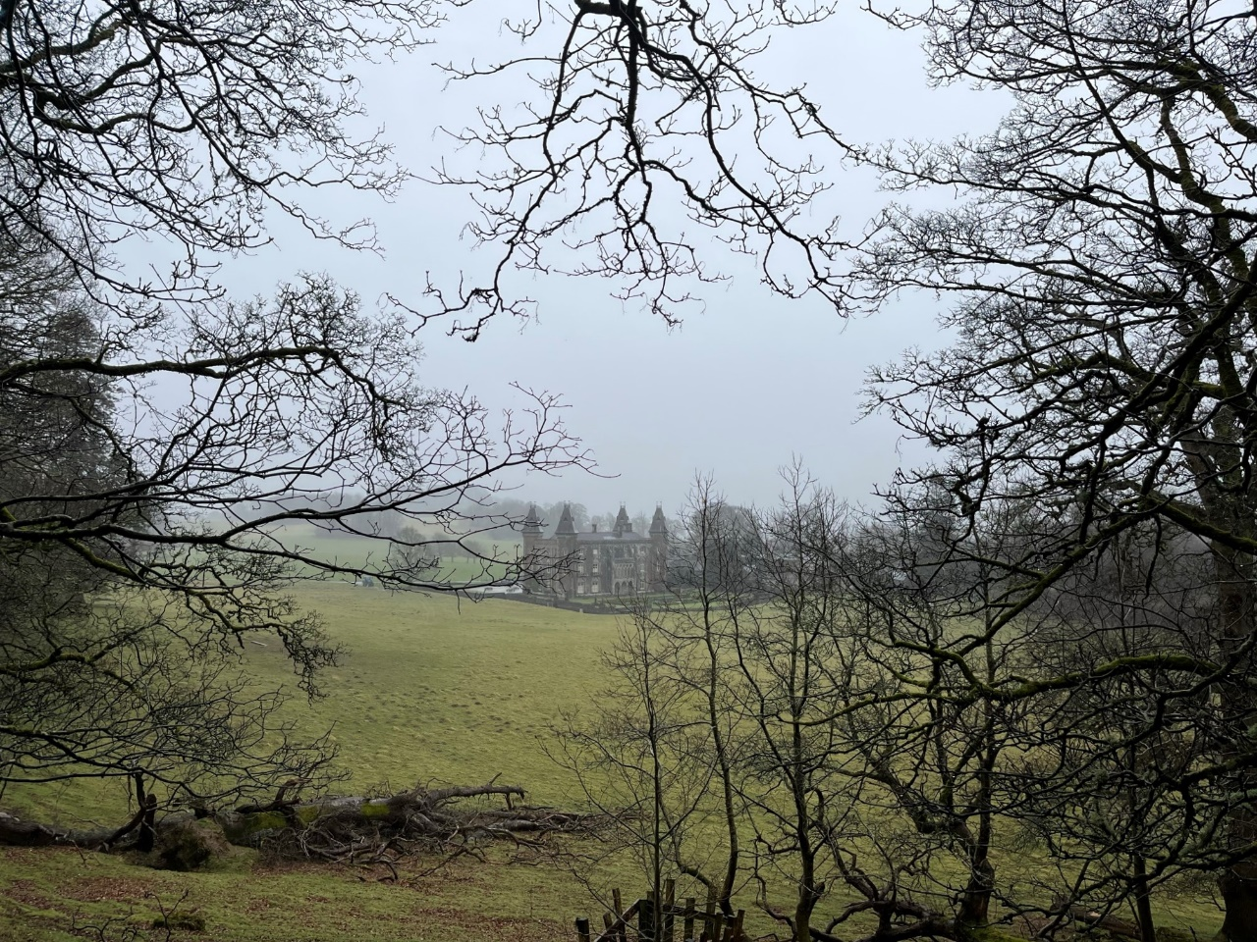
Figure 4 Newton House behind Formal Garden
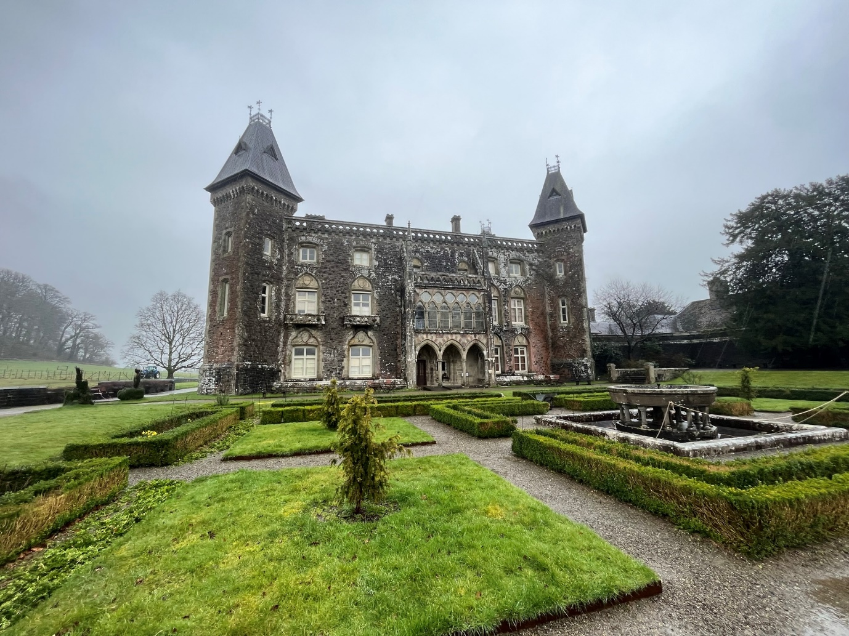
Figure 5(National Trust, 2022e)
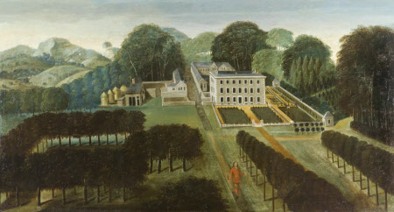
Figure 6
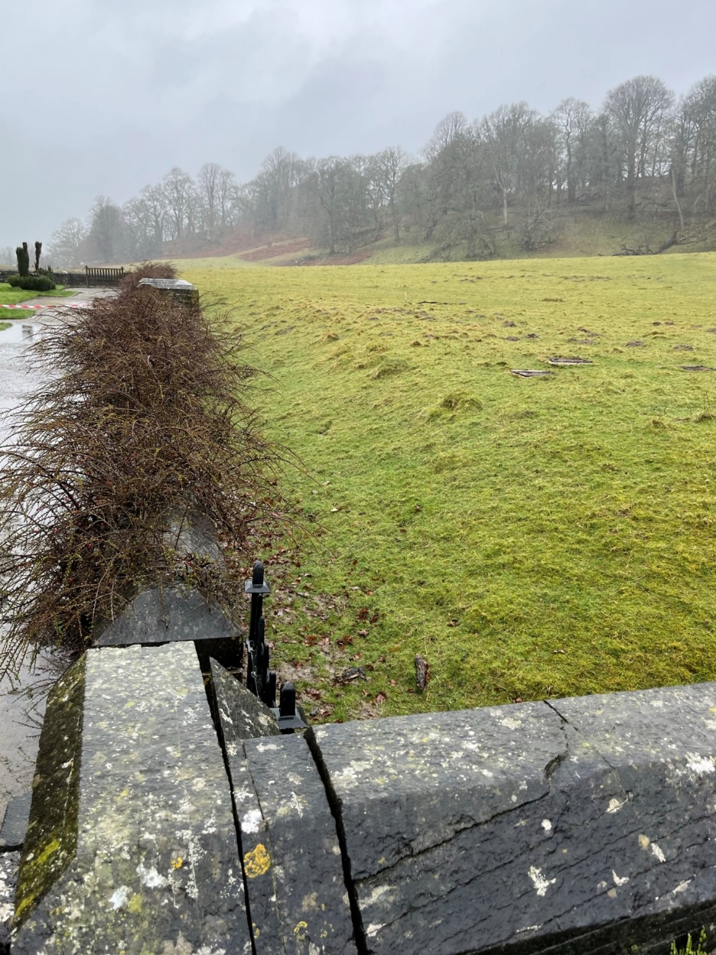

Landscape quality
Tree management at Dinefwr is influenced by safety, and aesthetic demands. These aesthetic demands are that all new trees planted on the site are based on historic tree type stocks (Bailey, 2022) in order to ensure the parkland retains its landscape quality (Cadw, 2002). The safety of visitors also informs tree management, the severity of such management is informed by the sites traffic light ranking system. Red areas are those with a high dwell time such as those in the car park (Bailey, 2022). Red areas face the most aggressive tree management, with frequent pruning or felling to reduce the chance of injury (Bailey, 2022). Amber areas are those with a high footfall but low dwell time such as footpaths with limited points where walkers are likely to stop. These amber areas will also be managed through pruning and felling, however, to a lesser degree than red areas (Bailey, 2022). Green areas are those with a low footfall and dwell time where the impact of trees or branches falling is minimal, thus management is avoided (Bailey, 2022). Tree management decisions differ throughout the estate with different techniques used in the deer park compared to outside of the deer park. Within the deer park only 20% of felled, pruned, or fallen trees are removed from the site compared to 80% removal outside of the deer park (Bailey, 2022). Replanting efforts within the Dinefwr estate are negatively impacted upon by the deer and squirrel populations eating and damaging new growth (Bailey, 2022; Figure 8). The National Trust are looking to expand the management and growing techniques currently used in the deer park into the Inner and Outer Cow Parks so they will also be managed as grazed wood pasture to recreate the 18th century design (Appendix 4). These cow parks would be grazed by white park cattle (Figure 7), a breed which has been kept at Dinefwr for over 1000 years (National Trust 2022c). This breed is also exceedingly rare with less than a thousand breeding females in the world, so the herd at Dinefwr are of upmost importance for their worldwide conservation (National Trust, 2022c).

Figure 7
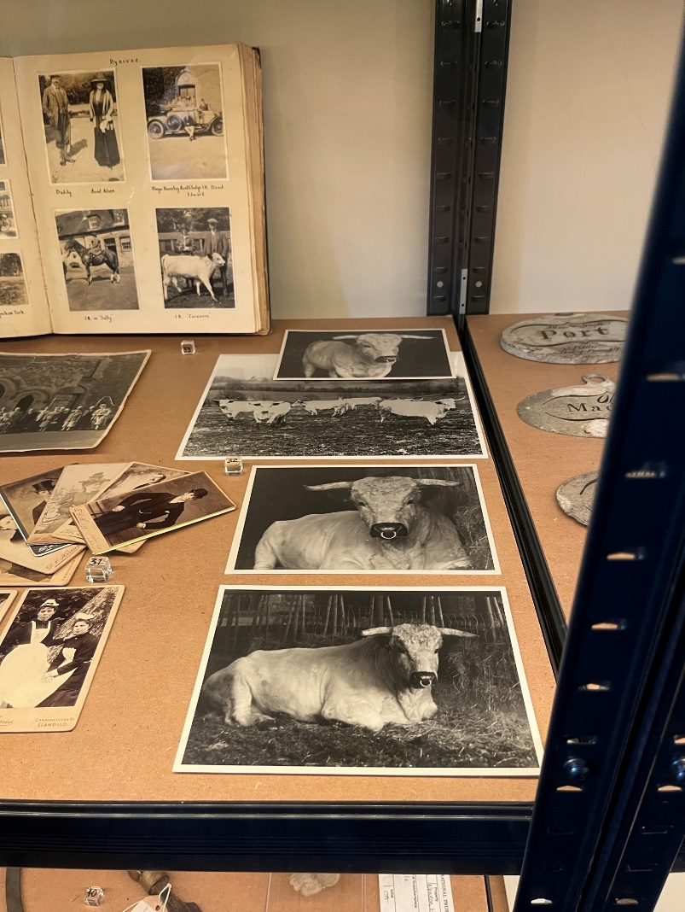
Figure 8 Squirrel Damaged Growth
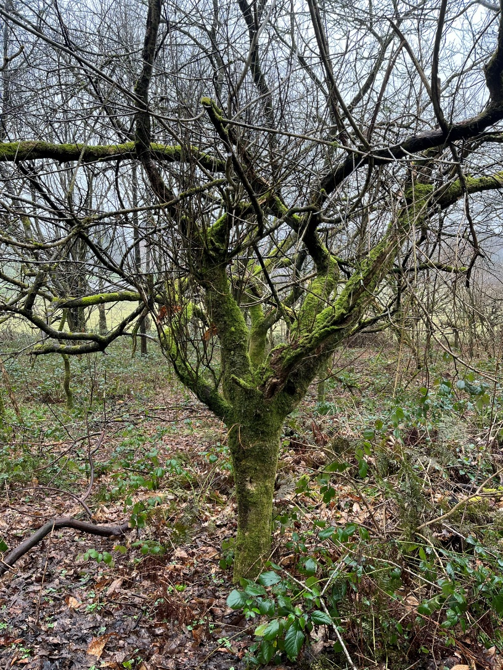

Designations
There are a host of designations for the Dinefwr estate, highlighting its significance as a cultural landscape. Dynevor castle is Grade I listed, Newton house is Grade II* listed, with the courtyard gardens, low stone wall, ha-ha, fountain, dairy cottage, dovecote, and icehouse being grade II listed. The Dinefwr estate was designated as an SSSI site in 1999 (Natural Resources Wales, 1999) and further in 2007 became Wales first parkland to be designated as a National Nature Reserve (National Trust, 2022b). Additionally the Dinefwr estate is designated as a Conservation Area and Guardianship Ancient Monument (Cadw, 2002).

Use
Dinefwr has had a wide number of uses over its history. The castle has been used as a fort and control point for armies, and the surrounding land used as homesteads for commoners in both the towns of Dinefwr and Newtown at varying points (Cadw, 2002). Prior to construction of a castle at Dinefwr the land the estate is built on was reportedly used as a fort by Roman Soldiers over many years due to its strategic location between Carmarthen and Llandovery (Appendix 5). Newton House itself has also had numerous uses outside of being a family home. During WWII it was used as an army hospital (Appendix 6), and in the 1960s it was used to host prestigious art exhibitions and performances (National Trust, 2022a). It is now used as a tourist destination, where visitors can walk around the park, house, and castle as well as being an education space with frequent historical exhibitions and school visits (National Trust 2022a; Bailey, 2022).

Access
The National Trust acquired the deer park and outer park in 1987 followed by Newton House in 1990 (Norman, 2022). There are no public footpaths through the grounds, therefore, access to the estate is managed by the National Trust (National Trust 2022d). The grounds are partly accessible for disabled users with limited disabled routes around the site (National Trust 2022d). It is located along the A40 at Llandeilo, in-between Carmarthen and Llandovery. As many parts of Dinefwr are not designed for disabled access, people’s perception of the landscape may be worsened, as accessibility issues reduce the benefits of natural spaces (Li et al., 2022).

Future potential
Education is a key influence which can shape perceptions of landscape, as such it is one of the main ways Dinefwr should focus on to continue its sustainable development (Preston and Griffiths, 2004). Dinefwr has over 160 species of lichens including several which are very sensitive to atmospheric pollution, as well as hosting a variety of rare animal life such as the saproxylic beetles (Natural Resources Wales, 1999). Dinefwr could tailor their educational school visits to focus on these rare elements through experiential learning (Kolb, 1984; Peng, 2020) to discuss conservation and sustainability in the perspective of climate issues using sensitive lichens as an example of how to identify environmentally positive environments. Furthermore, helping children identify rare species such as this may assist in reducing ecological illiteracy (Louv, 2005). Dinefwr has a rich history shaped by socio-cultural influences. Educational visits for children could include information on how land ownership and use in Wales has been affected over the years by groups such as the Romans and the English Monarchy, with a sense-of-place approach taken to allow the students to assess the impacts of such forces on their home areas. These lessons may cover how different groups have used the lands and the impacts of such uses on the sustainability and ecology of that place.

Lundy Island

Landscape character
Lundy Island represents a socialised landscape (Landley, 2013), and is situated in the Bristol Channel, 18.9 miles off the coast of North Devon (Figure 9). Lundy Island is a large granite outcrop, 5km long, 1km wide, and 451 hectares in size (LMF, 2017; Figure 10). It is made of Lundy Granite and is the southernmost igneous rock deposited as part of the British Tertiary Volcanic Province associated with the formation of the North Atlantic Ocean 60 million years ago (Stephenson, 2022). This igneous granite rock was intruded amongst Devonian era sediment deposits (Stephenson, 2022) which would form into Devonian Morte slates (Natural England, 2014). Weathering of the granite has created features like the granite tors found in nearby Dartmoor, however, the granite in Dartmoor is far older having formed around 300 million years ago (Nicholas, 2022).
Figure 9(Digimap, 2022)
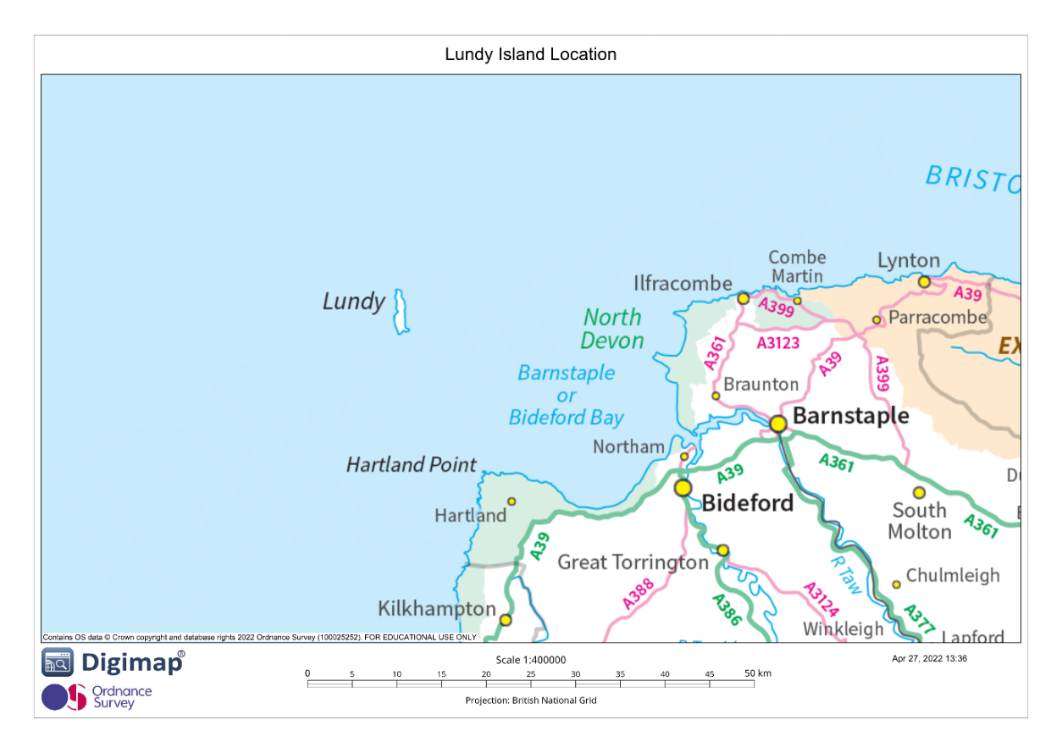
Figure 10(Digimap, 2022)
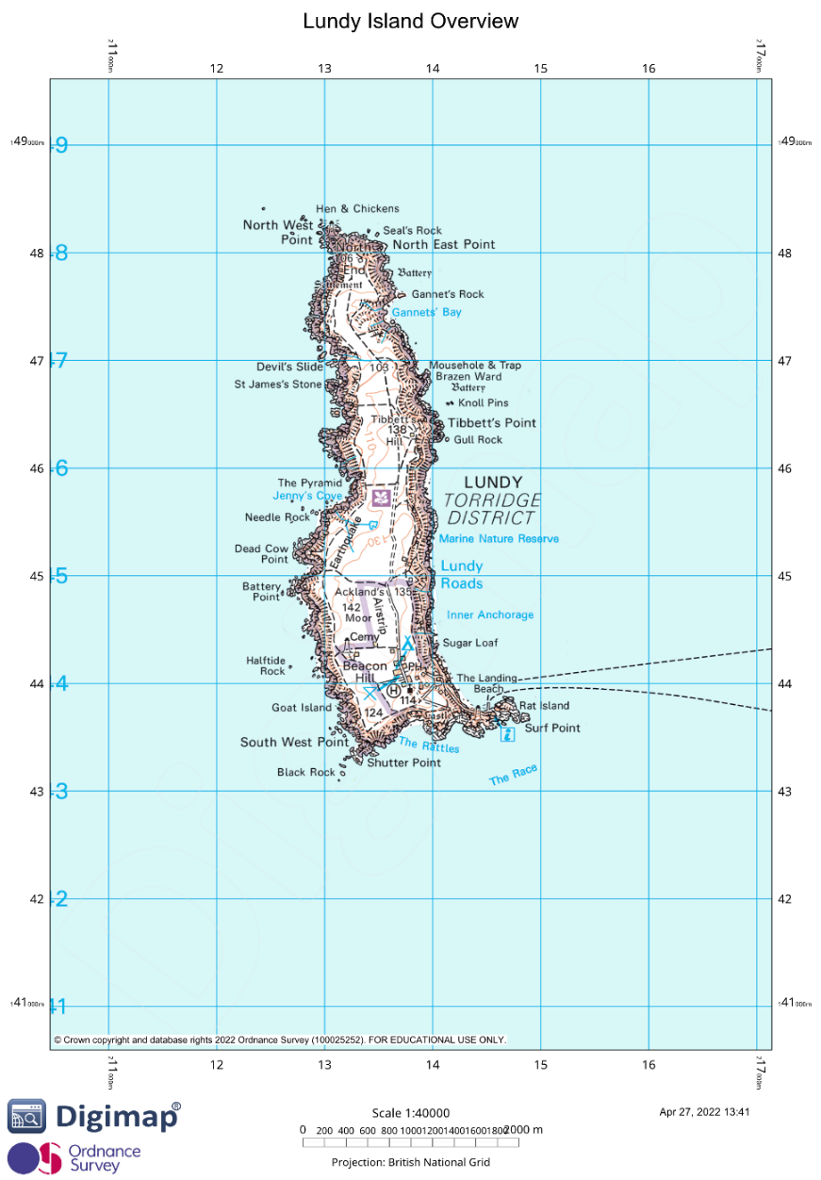

Landscape quality
Lundy has a rich cultural landscape as a result of its geology, settlement, and history (Natural England, 2014). The landscape quality of Lundy is managed to ensure that key pressures and threats for its landscape, plant, and animal life are minimised (Natural England, 2014). Lundy hosts high levels of biodiversity both on land, most notably with the Lundy cabbage (Figure 11) which is only found on the Island (Natural England, 2014), and among the surrounding marine and avian habitats (LMF, 2017). The extent of Lundy’s ecological diversity is represented in Figure 13. Lundy houses several priority habitats including maritime cliff and slope habitats, as well as two large areas of lowland heath (Natural England, 2014). Lundy has limited woodland growth, however, it does have scrubby growth made predominately of sycamore and thorn on the eastern valleys with moorland terrain covering the plateau (Figure 11), as well as acidic pools and bogs which support mosses and sundew (Natural England, 2014). The quality of grassland and moorland environments is maintained by controlling the grazing habits of domestic and feral animals (Natural England, 2014). Lundy has one small village on it, built out of stones from the quarry on the island, with small agricultural fields surrounding it (Natural England, 2014).
Figure 11(Natural England, 2014, p.8)
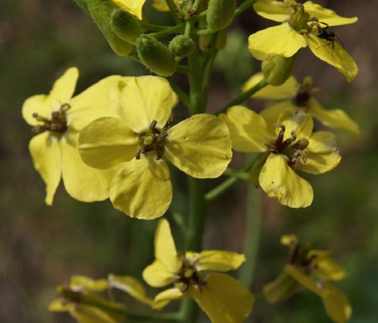
Figure 12(Natural England, 2014, p.30)
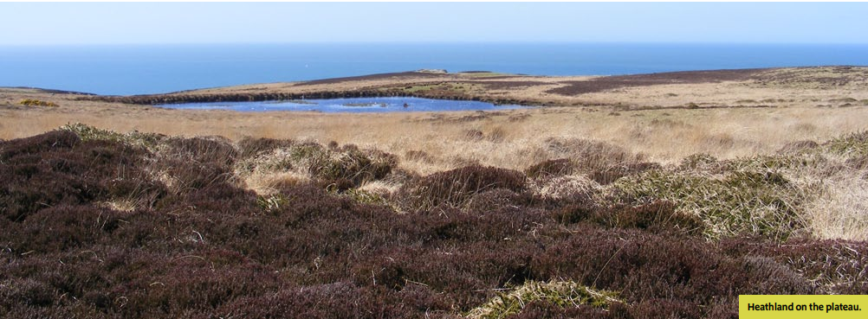
Figure 13(LMF, 2017, p.29)
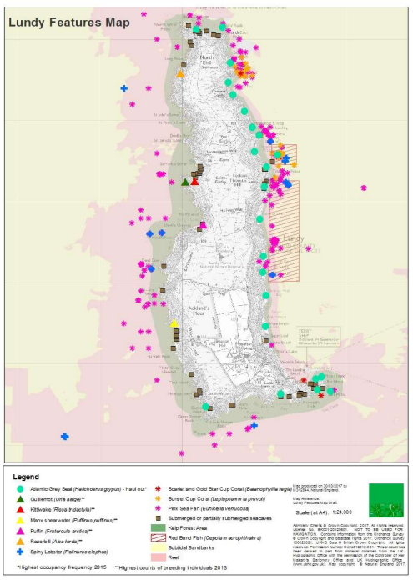

Designations
Lundy Island has a plethora of designations, signifying its high ecological and cultural importance. In 1986 the Marine area around Lundy was designated as England first Marine Nature Zone due to its ecological importance, this was upgraded in 2010 to a Marine Conservation Zone covering 31² km (DEFRA, 2013a). A Special Area of Conservation covers the same area as the Marine Conservation Zone (DEFRA, 2013b). The Special Area of Conservation includes protections for reefs, sea banks, sea caves, and grey seals, with the Marine Conservation Zone adding additional protections for spiny lobsters (DEFRA, 2013b). A 3km² zone of water around Lundy contains England’s first ‘no take zone’ for fishing (LMF, 2017; Figure 14). Additional designations for Lundy include it being a Site of Specific Scientific Interest, Heritage Coastline, having 41 Scheduled Monuments, the Habitats of Principal Importance Act, and being within the UNESCO North Devon Biosphere Reserve (Natural England, 2014; LMF, 2017). These protections allow birds to thrive, with Lundy hosting the largest colonies of cliff-nesting birds in South West England (Natural England, 2014). These designations as well as conservation methods such as the eradication of rats are showing benefits for nesting birds with most species showing large population increases, namely puffin populations have increased by 2,784% between 2000 and 2017 (Booker et al, 2018). Furthermore, the marine zone around Lundy has protections for specific species through the Wildlife and Countryside Act, and Species of Principal Importance Act (LMF, 2017).
Figure 14(LMF, 2017, p.26)
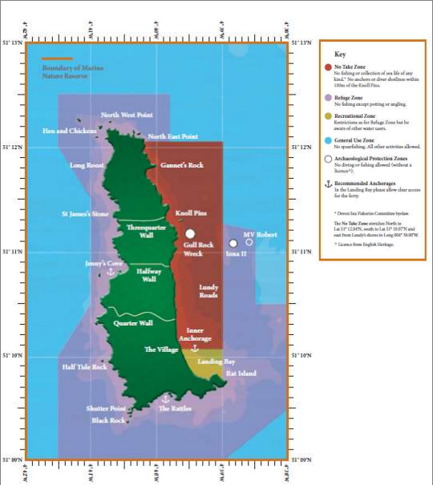

Use
Lundy has a mixed range of historical uses, it was sporadically inhabited before the 13th century with Celtic gravestones on the island dating from the 5th century (Natural England, 2014). Various pirate groups controlled and ran smuggling operations through the island between the 13th and 17th centuries (Khamis, 2011). During the 18th and 19th centuries Lundy was used to quarry granite, however, the quarry was unable to find commercial success (Natural England, 2014). The Heaven family purchased Lundy in 1834, who built the Church and Milcombe house, Lundy then passed through several hands before being bought for the National Trust in 1969 (Natural England, 2014).

Nowadays Lundy is used predominately as a tourist destination, with over 20,000 visitors per year, it is also a working farm (Natural England, 2014). There is guest accommodation on Lundy for up to 135 visitors, enabling extended trips (Natural England, 2014). People visit Lundy for a range of reasons including diving, bell ringing, walking, climbing, and birdwatching (Natural England, 2014). Climbing and Diving are examples of activities on the island which have to be sustainably managed in order to reduce damage to habitats and wildlife (Natural England, 2014).

Access
In the summer months Lundy can be reached by a daily boat service from Ilfracombe or Bideford on the North Devon coast, and in the winter months when the boats are not running a helicopter service flies from Hartland point (Natural England, 2014). There are no public footpaths on Lundy however, 76% of the island is Countryside Rights of Way Access land which the public have a right to access on (Natural England, 2014).

Future potential
Lundy has previously hosted the ‘SplashIn!’ photo competition to engage divers with marine conservation efforts (LMF, 2017). Building upon initiatives such as this, Lundy could host similar competitions for the land and avian life on Lundy to further engage visitors in both local, national, and international conservation challenges. Such efforts may further be enhanced by running art and literary competitions for the schools which visit Lundy on a yearly basis to engage the future generation in conservation efforts. This is of particular importance as ecological illiteracy in children is increasing (Louv, 2005) and if children are not exposed to the natural world and its challenges they may not be motivated to protect it (Gill, 2007).

Such conservation orientated programmes may be further enriched, especially in the age of Covid-19, by providing online classes and resources for school groups to expand the reach of Lundy’s conservation achievements and awareness. Such digital programmes could include digital lessons hosted by Lundy’s education staff, teaching conservation information not usually covered, such as the importance of Kelp forests and related species, for which greater awareness of is a goal of the Lundy Marine Management Plan (LMF, 2017). Additional digital programmes could include the use of camera traps and webcams in key animal hot zones, such as seal pupping zomes within the intertidal sea caves to allow people greater access to hidden animal world without impacting the animals through direct contact. These webcams may open opportunities for wider research efforts with volunteers being able to assist in wildlife counts and ID’s for key species such as grey seals, and other coral, plant, and animal species, another goal of the Marine Management Plan (LMF, 2017), whilst not having to be physically on the island or in hard to access locations.

Word count: 2736

References

Bailey, C. (2022) Conversation with UWTSD Outdoor Adventure Education Class of 2019 during a tour of Dinefwr, 28 February.
Booker, H., et al. (2018) ‘Cliff Nesting Seabirds On Lundy: Population Trends From 1981 To 2017’, Journal of the Lundy Field Society, 6, pp.65-76. Available at: https://lfs-resources.s3.amazonaws.com/j6/LFS_Journal_Vol_6_Part_5.pdf (Accessed: 04/04/22)
Cadw 2002: Register of Parks and Gardens of Special Historic Interest in Wales, Carmarthenshire, Ceredigion and Pembrokeshire, 68-73 (ref: PGW(Dy)12(CAM)).
Cooper, G. J., and Shannon, W. D. (2017) ‘The control of salters (deer-leaps) in private deer-parks associated with forests: a case study using a 1608 map of Leagram park in the Forest of Bowland, Lancashire’, Landscape History, 38(1), pp.43-66. DOI: 10.1080/01433768.2017.1322269
Cote, S. D. (2004) ‘Ecological Impacts of Deer Overabundance’, Annual Review of Ecology and Systematics, 35, pp.113-147. DOI: 10.1146/annurev.ecolsys.35.021103.105725
Department for Environment, Food & Rural Affairs (DEFRA). (2013a) Marine conservation 2013 designation: Lundy. Available at: https://www.gov.uk/government/publications/marine-conservation-zone-2013-designation-lundy (Accessed: 04/04/22).
Department for Environment, Food & Rural Affairs (DEFRA). (2013b) Lundy Marine Conservation Zone. Available at: http://publications.naturalengland.org.uk/file/6580875894456320 (Accessed: 04/04/22).
Dyfed Archaeological Trust (2022) 195 Dinefwr Park. Available at: https://dyfedarchaeology.org.uk/HLC/HLCTowy/area/area195.htm (Accessed: 27/04/22).
Gill, T. (2007) No Fear Growing up in a risk averse society. London: Calouste Gulbenkian Foundation.
Hayes, N. (2020) The Book of Tresspass: Crossing the Lines that Divide Us. Bloomsbury: London.
Khamis, S. (2011) ‘Lundy’s Hard Work’, Shima: The International Journal of Research into Island Cultures, 5(1). Available at: https://www.researchgate.net/publication/317351642_Lundy%27s_hard_work_branding_biodiversity_and_a_unique_island_experience (Accessed: 27/04/22).
Li, H., et al. (2022) ‘Psychological benefits of green exercise in wild or urban greenspaces: A meta-analysis of controlled trials’, Urban forestry & urban greening, 68. DOI: 10.1016/j.ufug.2022.127458
Louv, R. (2005) Last Child in the Woods: Saving Our Children from Nature Deficit Disorder. London: Atlantic Books
Lundy Management Forum (LMF). (2017) Lundy Marine Management Plan 2017. Written by Rebecca MacDonald and revised by Robert Irving. Produced for Natural England by the Landmark Trust, Lundy Island. Available at: https://www.landmarktrust.org.uk/globalassets/lundy_marine_management_plan_2017.pdf (Accessed: 27/04/22).
National Trust (2022a) Newton House at Dinefwr. Available at: https://www.nationaltrust.org.uk/dinefwr/features/newton-house-at-dinefwr (Accessed: 22/04/22)
National Trust (2022b) Parkland walks at Dinefwr. Available at: https://www.nationaltrust.org.uk/dinefwr/features/dinefwr-park (Accessed: 27/04/22).
National Trust (2022c) White Park Cattle at Dinefwr. Available at: https://www.nationaltrust.org.uk/dinefwr/features/a-living-link-to-our-distant-past (Accessed: 27/04/22).
National Trust (2022d) Dinefwr. Available at: https://www.nationaltrust.org.uk/dinefwr (Accessed: 27/04/22).
National Trust (2022e) Newton House from the East. Available at: https://www.nationaltrustcollections.org.uk/object/869192 (Accessed: 29/04/22).
Natural England (2014) Landscape character area assessment 159: Lundy. Available at: http://publications.naturalengland.org.uk/file/6668996183064576 (Accessed: 04/04/22).
Natural Resouces Wales (1999) Site of special scientific interest citation. Available at: https://naturalresources.wales/media/647921/SSSI_0629_Citation_EN00143db.pdf (Accessed: 29/04/22).
Neeson, J. M. (1996) Commoners: Common Right, Enclosure and Social Change in England, 1700-1820. Cambridge University Press: Cambrdige.
Nicholas, C. (2022) Dartmore Granite. Available at: https://devoncc.sharepoint.com/sites/PublicDocs/Environment/_layouts/15/download.aspx?guestaccesstoken=Hf6ZFuZTm7a3Jf2uxKV56KgZ26TdUPf2j4WACp1sFFY%3d&docid=0c80ff8a3a8444de2865c73f1040b2c57&rev=1 (Accessed: 04/04/22).
Norman, T. (2022) Dinefwr Park & Newton House. Available at: https://www.llandeilo.org/pl_dinefwrpark.php (Accessed: 25/04/2022).
Peterken, G. F. (1993) Woodland Conservation and Management. 2nd Edn. Chapman and Hall: London.
Stephenson, P. (2022) Lundy Granite. Available at: https://devoncc.sharepoint.com/sites/PublicDocs/Environment/_layouts/15/guestaccess.aspx?guestaccesstoken=oqhZaOTeuSWefAbgjUPYxZY8zXE4T39toY5jghz7SSg%3d&docid=0f5a3133f61d0469f93514c40ce064732&rev=1 (Accessed: 04/04/22).
Williamson, T. (2016)’ Where we are with Wood-Pasture: Two Recent Books and the Current State of Research’, Landscapes, 17(1), pp.82-88. DOI: 10.1080/14662035.2016.1169040
Preston, L., and Griffiths, A. (2004) ‘Pedagogy of connections: Findings of a collaborative action research project in outdoor and environmental education’, Journal of Outdoor and Environmental Education, 8, pp. 36-45. DOI: 10.1007/BF03400802
Kolb, D. A. (1984) Experiential Learning : Experience as the Source of Learning and Development. 1st Ed. London: Prentice-Hall.
Peng, L-P. (2020) ‘Understanding Human–Nature Connections Through Landscape Socialization’, International journal of Environmental Research, 17(20). DOI: 10.3390/ijerph17207593
Burt, R., & Archer, J. M. (Eds.). (1994). Enclosure Acts: Sexuality, Property, and Culture in Early Modern England. Cornell University Press.
Langley, C. M. (2013) ‘Storied landscapes makes us (Modern) Human: Landscape socialisation in the Palaeolithic and consequences for the archaeological record’, Journal of Anthropological Archaeology, 32(4), pp. 614-629. DOI: 10.1016/j.jaa.2013.10.001

Appendix
Appendix 1: New 18th century landscape preferences [Photo taken at Dinefwr by Dominic Hole on 28th February 2022]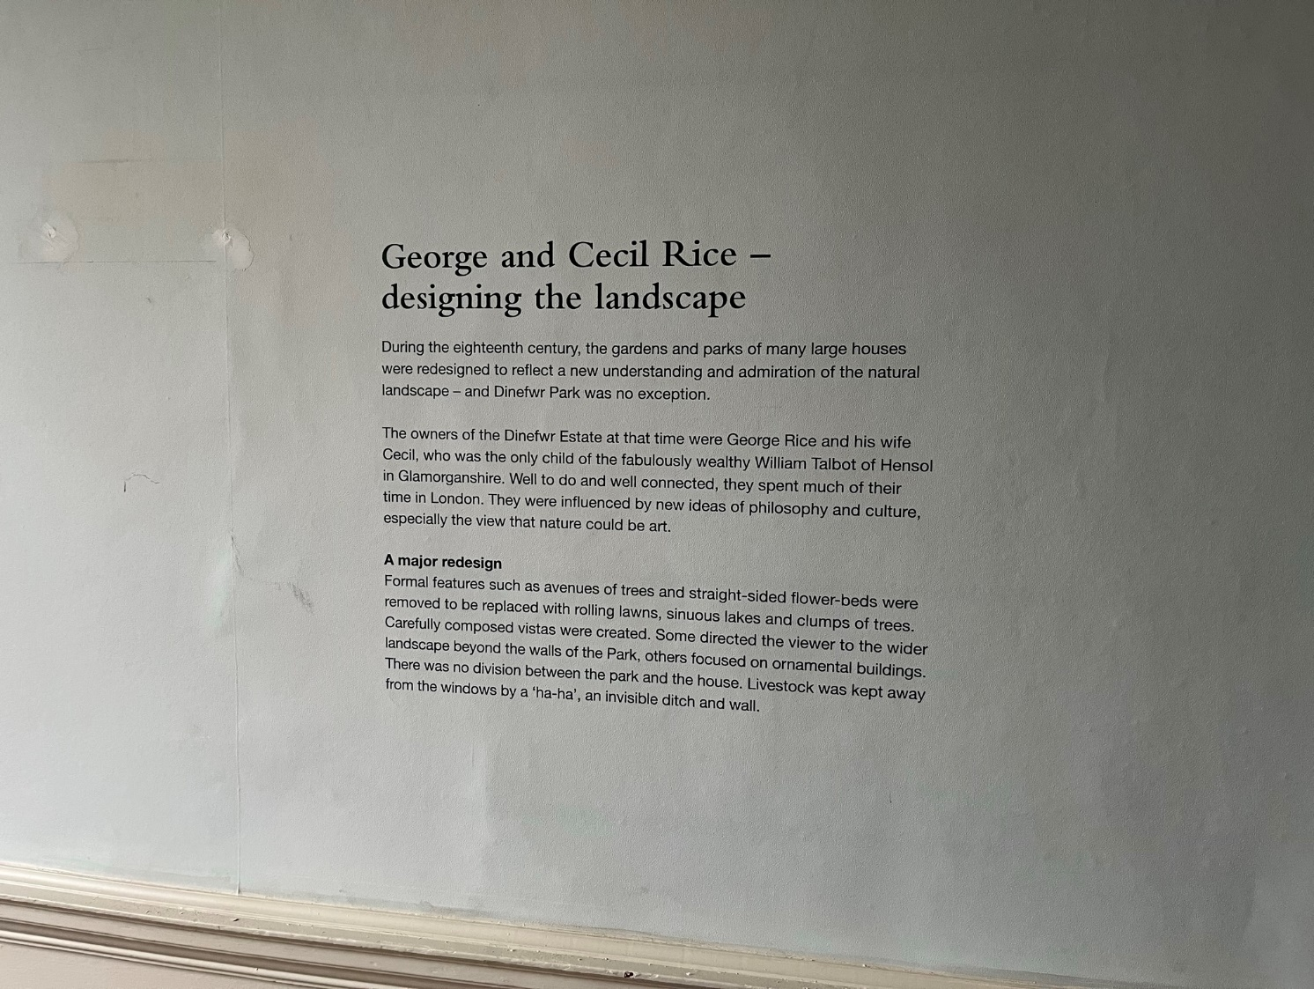

Appendix 2: Pre-18th century landscape [Photo taken at Dinefwr by Dominic Hole on 28th February 2022]
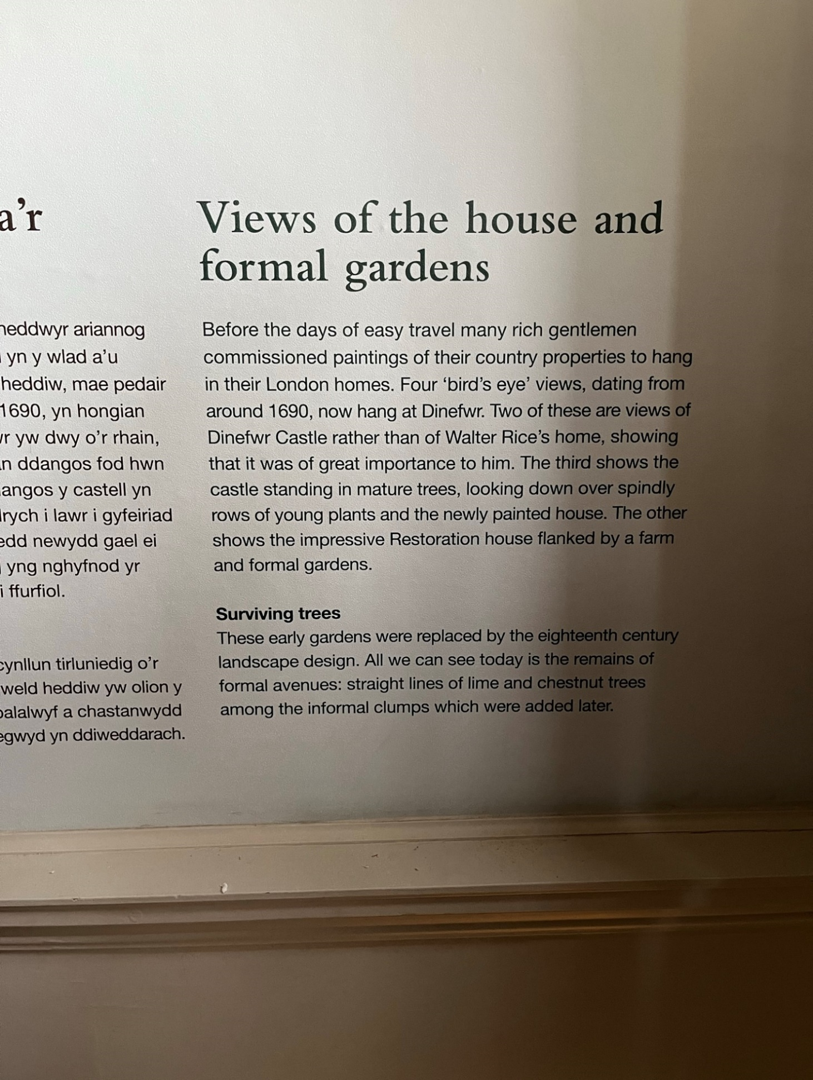

Appendix 3: Llandeilo Flags [Photo taken at Dinefwr by Dominic Hole on 28th February 2022]
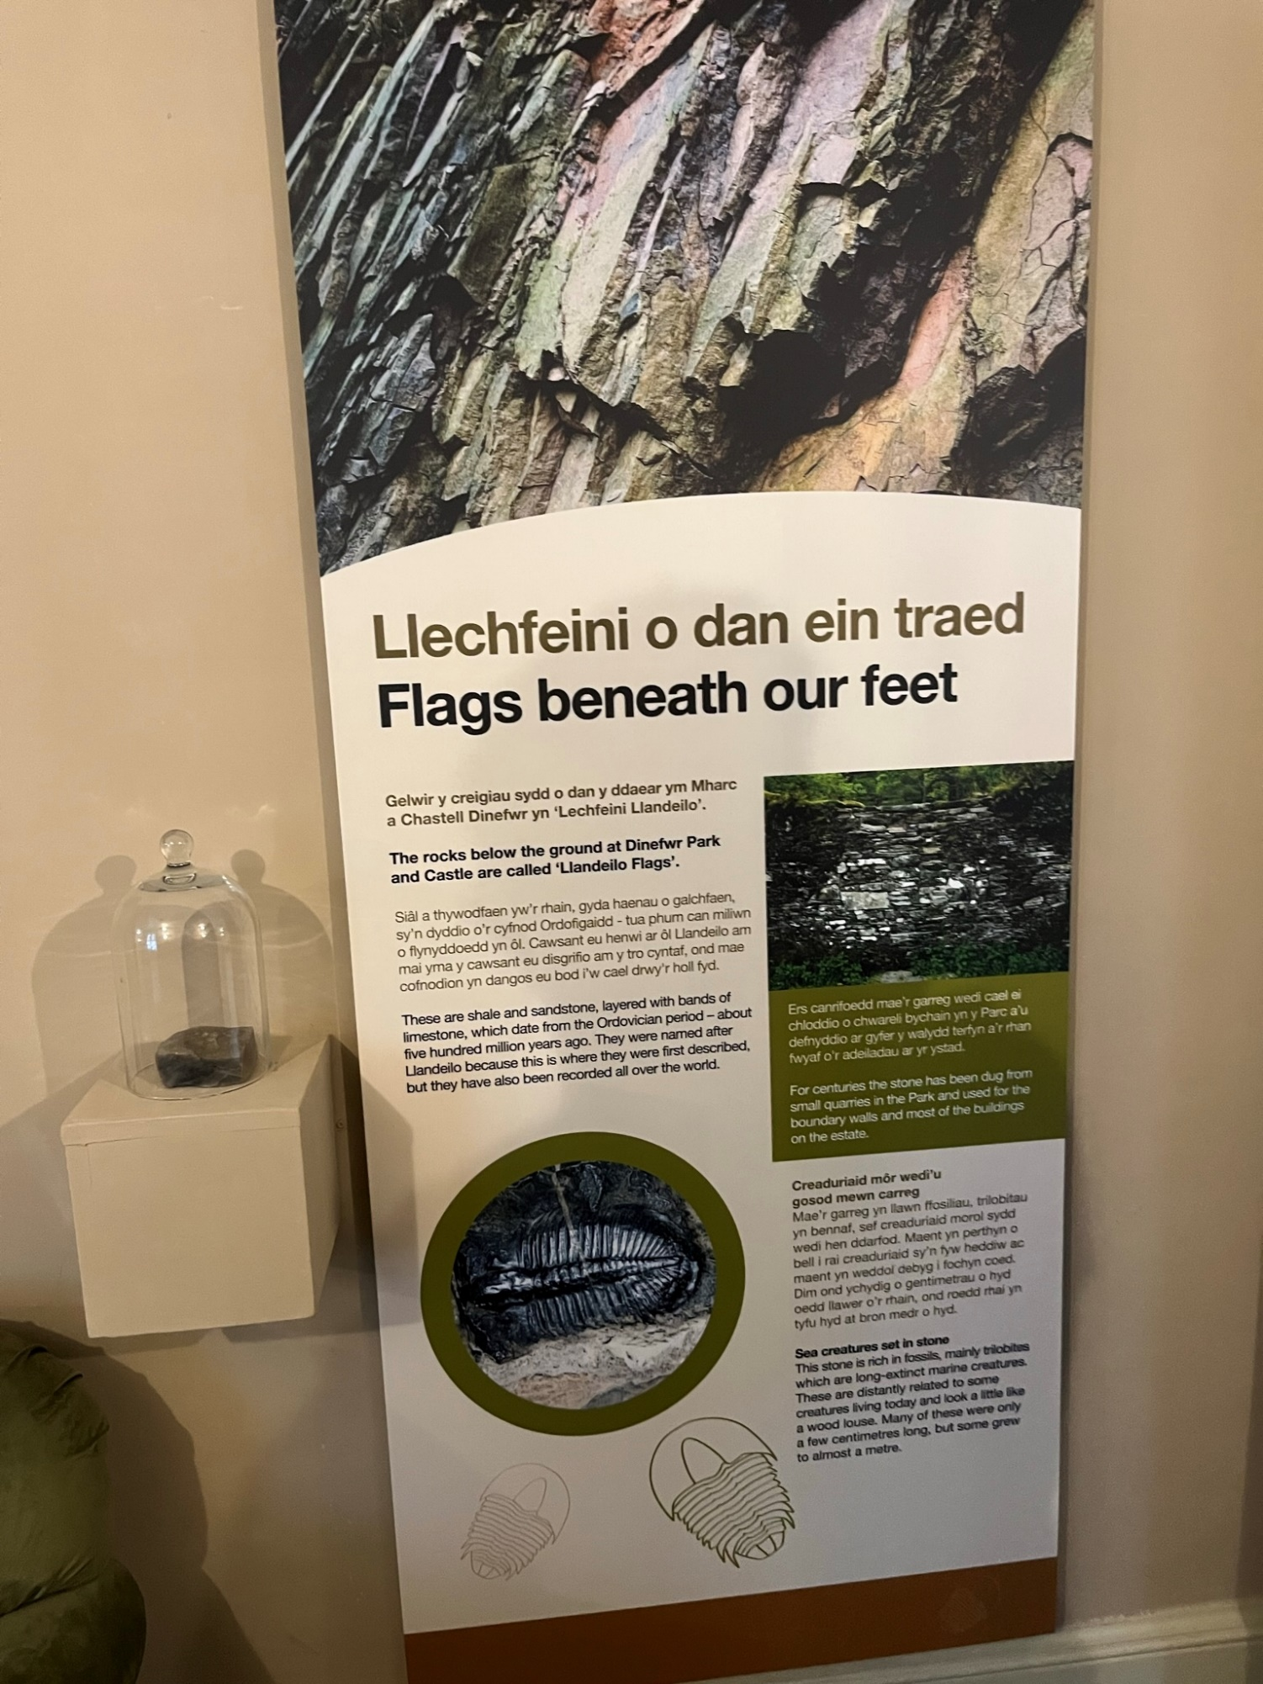

Appendix 4: Tree planting legacy [Photo taken at Dinefwr by Dominic Hole on 28th February 2022]
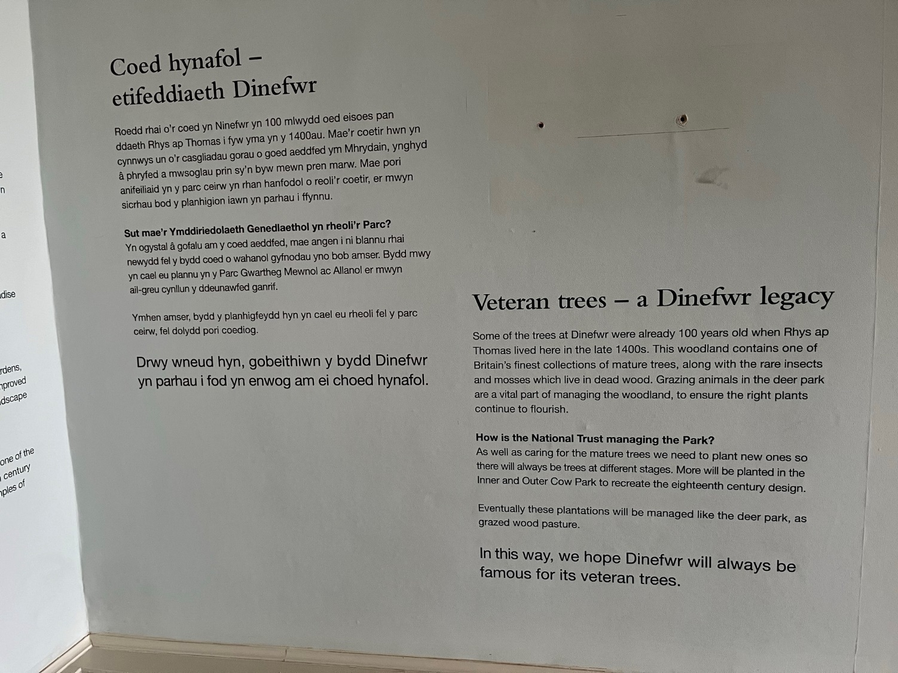
Appendix 5: Roman Fort [Photo taken at Dinefwr by Dominic Hole on 28th February 2022]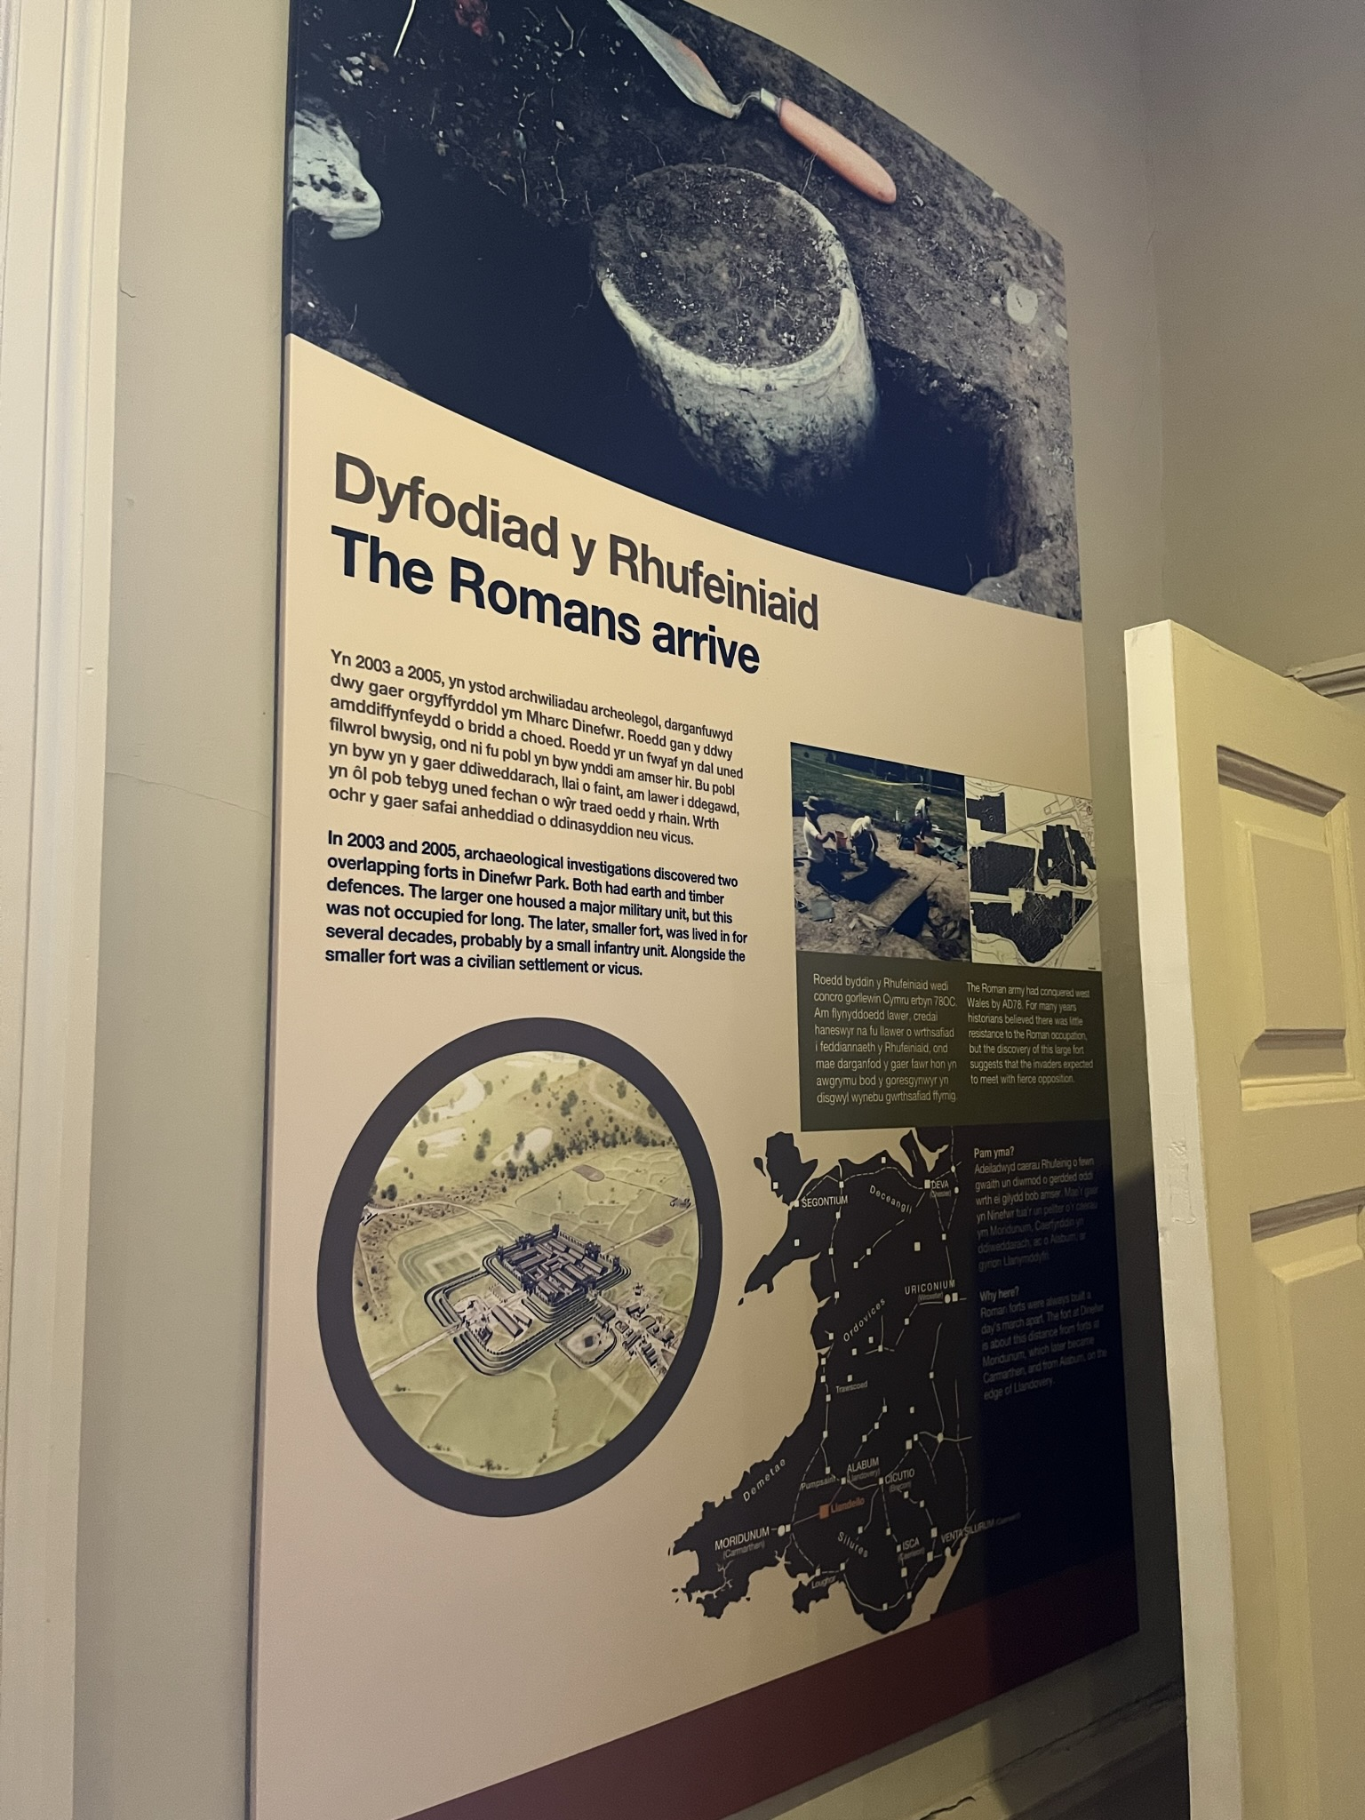
Appendix 6: Use of Newton House as WWII hospital [Photo taken at Dinefwr by Dominic Hole on 28th February 2022]

