Student Name: Thomas Wolfe

P number: 2302542

Programme of study: Graphic Design

Module: ADAD4018 Ways of Thinking

Tasks in order I received them:

Task One: Semiotic Analysis = 520 words

Task Two: Manifesto = 541 words

Task Three: Practice-based writing = 508 words

Task One Semiotic Analysis

This advertisement titled ‘snake’ was released by the company ‘Heinz’ on 21st December,2007, created by Stepan Tyller and Martin Charvat as creative directors of this campaign with credits to the agency Mark BBDO Prague, initially released at the target market of Czech Republic.

The immediate signifier to note is the classic ‘Heinz red’ that holds all hierarchy over the rest of the advertisement. The ad employs the visual element of colour to evoke the sensation of appetite and desire as this is a symbol of flavour and indulgence. There is evident use of the signified semiotic through the tomato and snake, as the tomato is a clear representation, not only of the brand but the apple from the ‘Garden of Eden’ in the Christian Bible, we can tell this from the snake wrapped around the object which implies immorality and sin. This ideology also gives another connotation to the bible with the meaning of temptation, as explained by Day, (1993), who displays why we should not give into temptation and the significance of resisting urges, giving a clearer understanding of how the snake imagery symbolises that the ‘Heinz ketchup’ is irresistible.

As we move down through the image, we can see that the meaning becomes more transparent when we get to the text that states ‘No sin’ working together with the imagery by using the semiotic of anchorage to give another connotation to the Bible, in addition, the smaller text underneath ‘More tomatoes, less sugar’ implies that sugar is a sin and that the product being advertised is better and healthier than other products.

The Heinz logo at the bottom right of the advertisement is known to change regarding each product. Although the product is not shown in this ad, we can still see that it reads ‘Fit Ketchup’, implying once again that it is healthy. The word ‘Fit’ also gives the impression of strength and in fit health, the phrasing also works with the green in the logo to create an arbitrary semiotic as “Saussure believes that language is constructed by arbitrary signs” (Najafian and Dabaghi, 2011, p 21) showing us that the brand intentionally tried to put this message across to the consumer.

It is also apparent that the colour palette of the ad plays a significant role for how audiences view the product, as stated by McLeod (2016), gives examples of how our brains make connections to memories and past experiences, hence the colour green is culturally recognised as a sign of vegetables and good health as shown in the advertisement.

The Heinz ‘Snake’ advertisement is an exceptional example of semiotics in action, taking everyday objects and transforming them into powerful symbols conveying one another. After discovering the underlaying semiotics in this image it has helped me further my understanding in the power of advertising, highlighting a message that transcends the ordinary. Upon first glance there are obvious semiotic skills used, although this advertisement may look quite minimalistic and clean, after digging deeper there are other detailed and concealed aspects that make up the clear motive behind the advertisement which are not evident to the naked eye.

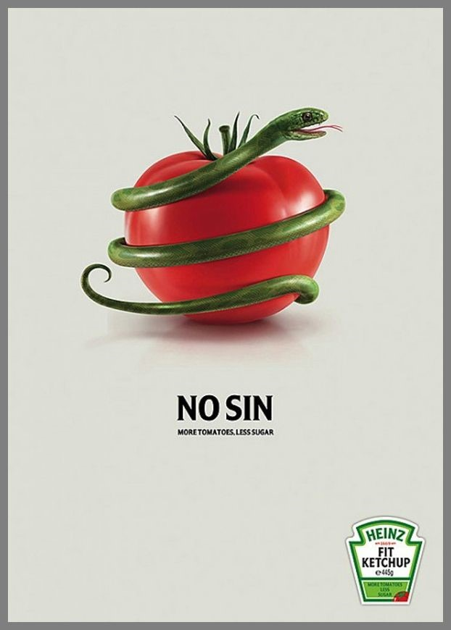

Fig. 1, Heinz No Sin Advertising Campaign, ‘Snake’, 2007.

Bibliography

Day, J.P., 1993. Temptation. American philosophical quarterly, 30(2), pp.175-181.
(Accessed on 12/11/23) Available at: https://www.jstor.org/stable/20014454
McLeod, J., 2016. Colour psychology today. John Hunt Publishing.
(Accessed on 12/11/23) Available at: https://books.google.co.uk/books?hl=en&lr=&id=W-ydDQAAQBAJ&oi=fnd&pg=PT21&dq=McLeod,+J.,+2016.%E2%80%AFColour+psychology+today.+John+Hunt+Publishing.+&ots=32UtRdoD8w&sig=6E30rIkBMKng7Kyq88r8UAo3VnY&redir_esc=y#v=onepage&q=McLeod%2C%20J.%2C%202016.%E2%80%AFColour%20psychology%20today.%20John%20Hunt%20Publishing.&f=false
Najafian, M. and Dabaghi, A., 2011, April. Hidden language of advertising: A semiotic approach. In Proceedings of the International Conference: Doing Research in Applied Linguistics (pp. 20-26).
(Accessed on 12/11/23) Available at: https://d1wqtxts1xzle7.cloudfront.net/41597922/20-26_Hidden_Language_of_Advertising-libre.pdf?1453848027=&response-content-disposition=inline%3B+filename%3DHidden_Language_of_Advertising_A_Semioti.pdf&Expires=1700170396&Signature=PpnlNeR1jcDmQDvSOoHR-GL83Xg0VSM4bYREcXjxBo5uXjRREFSTcT7sSnZJCA094babDPqU0G4Gr4kj~2jGA8sb5yTyqOz7T3PXQDO8lvFJNc72FTe1YSiXRZCl8HwWVgizHeTS0csuoq8M8itpFaltYXCy29dfvrTJhX52-Iqywy~pVIadMwyyBJuQEjQXsxjMRpmbR-CliteqrT~aW-~jhIj3oV7clgIUIkpniPx6UCie50wmJkw0PQKN6sZbfMzGBiuJyVF4eo92cJjOljmu0zzk3P8VxPoqtmm4woW0w9PyzJFwI7PMfyQm-DARn9KGO-1RS5WQMG~fgcDiDQ__&Key-Pair-Id=APKAJLOHF5GGSLRBV4ZA

List of figures

Figure 1: Heinz, No Sin, Advertising Campaign, ‘snake’, 2017 Accessed:
https://www.adsoftheworld.com/campaigns/snake-450db0df-f670-42d8-9619-d12ff4e8d721

Task Two Manifesto

- Do not change your own standpoint based on others’ beliefs.
- Always try and better your understanding of matters that are important to the people around you.
- Do not use social media as a substitute for your personality.
- Mental and physical well-being comes before any other commitment.
- You are your own person, don’t live by other people’s rules.
- In a world of art and design, put yourselves in the creator’s standpoint before deciding whether something is up to your standards.
- Give everyone the same base level of respect until they lose or build that respect.
- Have no time for people who act entitled or feel as though they are better than anyone, people are people.

Keywords and images

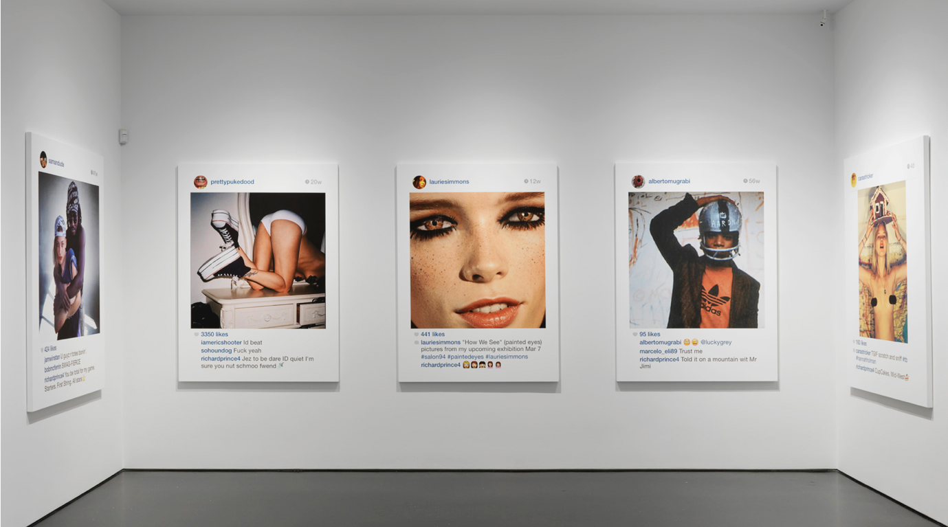
Social Media.

Fig 1, New Portraits- Richard Prince, Galerie Gagosian, 2014.

Do not use social media as a substitute for your personality, given the circumstances of accessibility and normalised consensus around posting every aspect of your life on social media instead of using it for its intended purpose, especially surrounding the younger generation of today’s population.

Discussed in Dewing’s book, Social media: An introduction (2010), “In November 2012, Facebook announced it had 1 billion users worldwide”. (2010, p.3), Goes to show how increasingly fast the digital population is growing, as within the 11 years since this book was published, the number of Facebook users stated in Dewing’s book have over tripled, meaning over a third of the world’s population have made the decision to take their life digital.

There is also evident information of how extensive social media use can lead to dependency, addiction, and depression, as explained by (Dhir et al., 2018), Who goes into detail about the mental health issues of prolonged use of social media, implying that we are the ones that are not in control and that it is effectively taking over our lives and personal well-being.


Keywords: Your own person

Fig. 2, first pride march in Bialystok, Pempel/ Reuters, 2019.

You are your own person, don’t live by other people’s rules. In a world that often imposes its expectations upon us, most of the time we forget we are individuals and feel the pressure to conform to societal conventions. According to Agassi, J in his book, Institutional individualism (1975) “The theory which ascribes the power to act to all and only to those who have the power to decide”, (1975, p.144), presents that we only have the power to resist the external expectations if we decide to do so.

Living by your own rules demands courage and self-awareness, being your quintessential self comes with judgement and criticism from those who fear deviation. Best described by Cooksey, (1996), who explores the ideology of judgement of others and how the subconscious behaviour is taught through environmental processes, reasons another motive of why we should connect to our unapologetic self and break the societal cycle through resilience and courage.

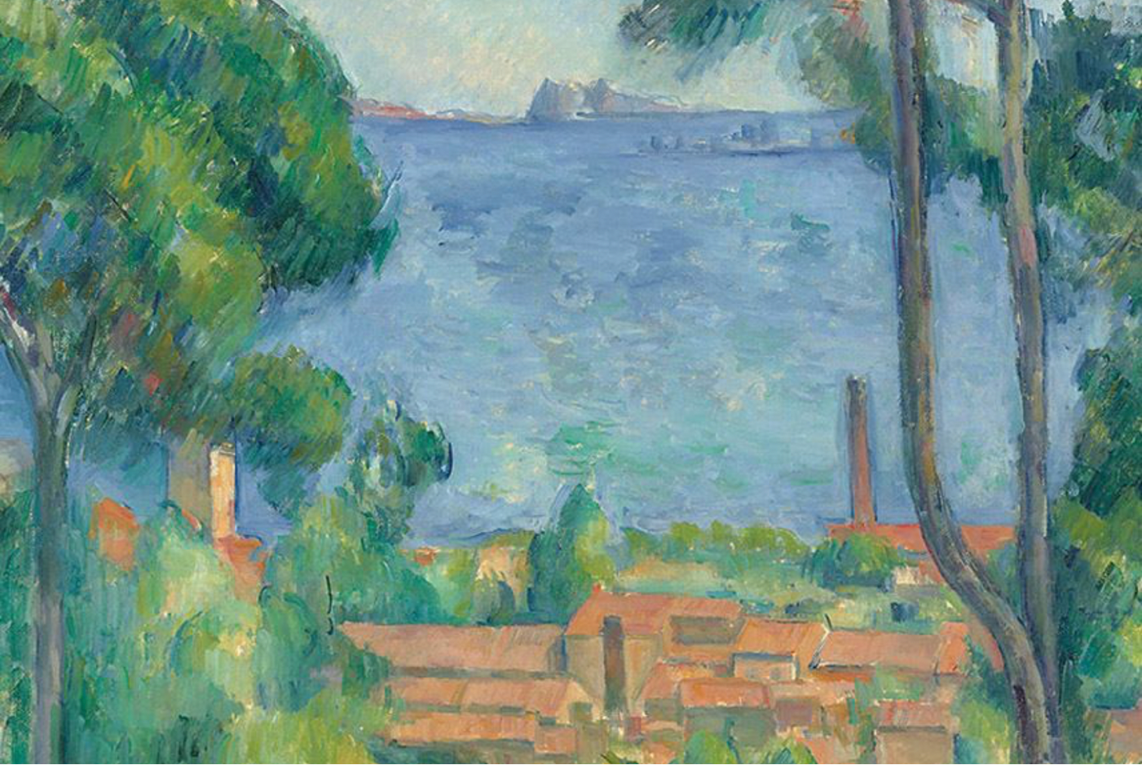
Keywords: Standards of design

Fig.3, Vue sur L’Estaque et le Château d’lf, Paul Cézanne, 1885

In a world of art and design, put yourselves in the creator’s standpoint before deciding whether something is up to your standards. For instance, Cézanne was brutally criticized for his style of modernised art, especially the painting ‘Vue sur L’Estaque et le Château d’lf, (Figure 3), As it departed from traditional artistic norms for the revolutionary period. Researching Cézanne’s several pieces, there is an evident pattern of style, indicating that these criticisms made by the media didn’t alter his design perspective, going to signify that “Ethical Objection has no place in the assessment of art” (Gaut and Levinson, 1998, p.249).
By giving the critics power over your personal art style takes away the importance and meaning to yourself, best explained by Elkins and Newman in the book The state of art criticism (2007). “Admitting one’s preferences and investments is self-exposure, not self-criticism.” (2007, p.10), exhibiting that although an artist’s bias can appear as self-deprivation, it can also mean awareness in the sense of something benign.
Bibliography

Agassi, J., 1975. Institutional individualism. The British journal of sociology, 26(2), pp.144-155. Available at: https://www.jstor.org/stable/589585 (Accessed on 25th November 2023)
Cooksey, R.W., 1996. The methodology of social judgement theory. Thinking & Reasoning, 2(2-3), pp.141-174. Available at: https://www.tandfonline.com/doi/abs/10.1080/135467896394483
(Accessed on 25th November 2023)
Dhir, A., Yossatorn, Y., Kaur, P. and Chen, S., 2018. Online social media fatigue and psychological wellbeing—A study of compulsive use, fear of missing out, fatigue, anxiety and depression. International Journal of Information Management, 40, pp.141-152. Available at: https://www.sciencedirect.com/science/article/abs/pii/S0268401217310629 (Accessed on 25th November 2023)
Dewing, M., 2010. Social media: An introduction (Vol. 1). Ottawa: Library of Parliament. Available at: https://bdp.parl.ca/staticfiles/PublicWebsite/Home/ResearchPublications/InBriefs/PDF/2010-03-e.pdf
(Accessed on 25th November 2023)
Elkins, J. and Newman, M. eds., 2007. The state of art criticism (Vol. 4). Routledge. Available at: https://books.google.co.uk/books?hl=en&lr=&id=WZE8YNttdw0C&oi=fnd&pg=PP1&dq=Elkins,+J.+and+Newman,+M.+eds.,+2007.+The+state+of+art+criticism+(Vol.+4).+Routledge.&ots=X3JYH1E0To&sig=y-E50vAtHE-hmtSq48zBlyAltaI&redir_esc=y#v=onepage&q&f=false (Accessed on 26th November 2023)
Gaut, B. and Levinson, J., 1998. The ethical criticism of art. Available at: https://books.google.co.uk/books?hl=en&lr=&id=9jBuDwAAQBAJ&oi=fnd&pg=PA247&dq=Gaut,+B.+and+Levinson,+J.,+1998.+The+ethical+criticism+of+art.&ots=-unldhF5rW&sig=FKDelBiCsokNYOq6FgUjZPscP5M&redir_esc=y#v=onepage&q=Gaut%2C%20B.%20and%20Levinson%2C%20J.%2C%201998.%20The%20ethical%20criticism%20of%20art.&f=false (Accessed on 25th November 2023)

List of figures
Figure 1: New Portraits- Richard Prince, Galerie Gagosian, 2014. Accessed:
https://gagosian.com/exhibitions/2014/richard-prince-new-portraits/
Figure 2: first pride march in Bialystok, Pempel/ Reuters, 2019. Accessed:
https://www.reuters.com/news/picture/liberals-fear-unrest-as-poland-catholic-idUSKCN1US1EN
Figure 3: Vue sur L’Estaque et le Château d’lf, Paul Cézanne, 1885. Accessed: https://www.christies.com/en/lot/lot-5869235

Task Three Practice-Based Writing

A practical and accurate reflection of Thomas Wolfe’s representation of animal hierarchy through art.

In order to convey the standpoint of how certain animals have diverse views to us as humans due to their species, I needed to showcase the raw reality of characterizing these systems. For example, in society a kitten is considered cute and harmless whilst a snake is viewed as a dangerous and temperamental beast, as stated in the book The time paradox: the new phycology of time that will change your life, by Zimbardo and Boyd (2008) “Once you understand the relationship between your perspective and the outcome to which it leads, you quickly learn to view the figure from the most rewarding perspective.”(p.13, 2008), This generalisation has filled us with the concept of animal hierarchy, leading us to treating animals differently simply based on their species. To battle this ideology, I decided to present the subconscious favouritism through art.

As shown in Figure 1, there are two contradictory factors taking place, this was the main focal point that I wanted to capsulate as there is no relationship between the two images, highlighting the difference. I chose these animals, as elephants are often worshipped especially in some Eastern cultures, as although cows are considered sacred in similar cultures, I felt as though it was necessary to focus on the irony as they get slaughtered around the world. “Some researchers believe that naming animals is a bad idea because named animals will be treated differently than numbered animals”, (Bekoff, 2007, p.3), giving reason to the message on the tag in Figure 1, stating ‘I am not a number’ as farm animals often have numbers, stripping them from their personality to us as humans.

I believe that most people have a ground understanding on animal hierarchy, however throughout my research, I was able to expand my existing knowledge on the treatment on certain animals and change my perspective on recognising the diversity between the underlying ethical implications of imposing human values onto these systems. Another faucet of my reflective journey was how critical my thinking was involving this process as I was able to use my intellectual curiosity and put forward my existing knowledge and learn something in the meantime. Lewis (2004) notes how experience is the ultimate teacher and everything else is purely a description, as my work reflects a subtle, visual representation of the issue at hand rather than leaving the audience to visualise and create their own story of what they think animal hierarchy is.

During this journey, I learnt more about the values of a creator and came to the realisation that using my skills of art and design can be used in many ways and scenarios, including representing something that you believe in. I think that something I may alter in future events would be the form of which I created these images and try and expand my adaptability to something new instead of entirely art based, although for me, it conveys the timeless message that I was looking to achieve.

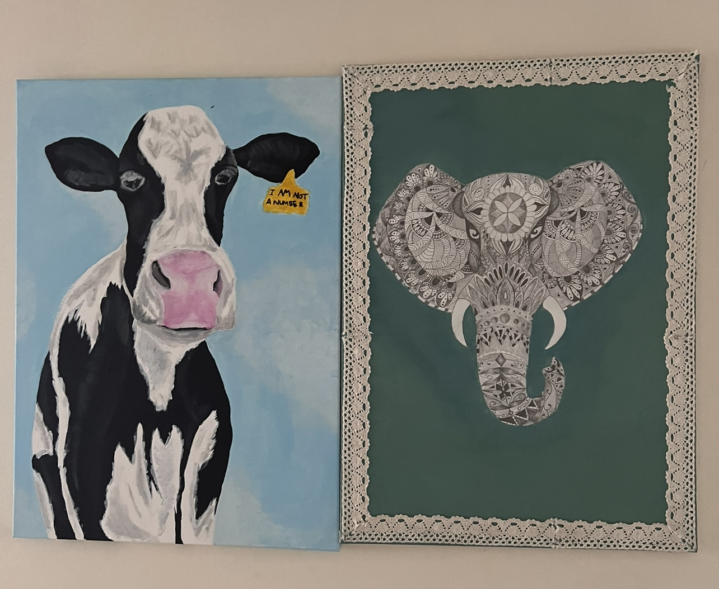
Fig 1, Animal hierarchy representation, Thomas Wolfe (2023)

Bibliography

Bekoff, M., 2007. Animals matter: A biologist explains why we should treat animals with compassion and respect. Shambhala Publications. Available at: https://books.google.co.uk/books?hl=en&lr=&id=CtQ0MK3g2J0C&oi=fnd&pg=PR13&dq=difference+in+how+animals+get+treated&ots=_mICZZ5Vmm&sig=48RFPMye8lzzMbft6g1LWzy82xY&redir_esc=y#v=onepage&q=difference%20in%20how%20animals%20get%20treated&f=false (Accessed 5th December 2023)
Lewis, D., 2004. What experience teaches. There’s Something About Mary: Essays on Phenomenal Consciousness and Frank Jackson’s Knowledge Argument, edited by Peter Ludlow, Yujin Nagasawa and Daniel Stoljar, pp.77-104. Available at: https://books.google.co.uk/books?hl=en&lr=&id=HYyubHBrVUcC&oi=fnd&pg=PA77&dq=how+does+experience+make+us+better&ots=_XC_nl4Bwj&sig=7Esi7xICFCiSZDegTqdIhmHPgpA&redir_esc=y#v=onepage&q&f=false (Accessed on 3rd December 2023)
Zimbardo, P. and Boyd, J., 2008. The time paradox: The new psychology of time that will change your life. Simon and Schuster. Available at: https://books.google.co.uk/books?hl=en&lr=&id=cE2z35C_IlwC&oi=fnd&pg=PR11&dq=Zimbardo,+P.+and+Boyd,+J.,+2008.+The+time+paradox:+The+new+psychology+of+time+that+will+change+your+life.+Simon+and+Schuster.&ots=3Zcjnw2Ohs&sig=YCIrhop_X8paiSXKdF7zVP_Iizg&redir_esc=y#v=onepage&q=Zimbardo%2C%20P.%20and%20Boyd%2C%20J.%2C%202008.%20The%20time%20paradox%3A%20The%20new%20psychology%20of%20time%20that%20will%20change%20your%20life.%20Simon%20and%20Schuster.&f=false (Accessed on 1st December 2023)
List of figures
Figure 1, Animal hierarchy representation, Thomas Wolfe (2023)

