Jessica Rees | 1703037 | December 5, 2018

Marketing Information Systems
  - NOMNOM cHOCOLATE – Assignment two

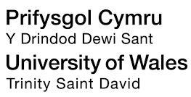

Contents Page

List of Figures…………………………………………………………Page 2
Executive Summary……………………………………………….Page 3
Introduction…………………………………………………………..Page 4
Process of appropriate marketing research…………Page 5
Benefits and Drawback of carrying out and not carrying out Marketing Research………………………………………………………………..Page 9
How Marketing Research can be undertaken, interpreted and presented……Page 10
Conclusion……………………………………………………………..Page 12
References………………………………………………………………Page 13

List of Figures

Figure One: http://kalyan-city.blogspot.com/2011/07/scope-of-marketing-research-mr-branches.html
Figure Two: https://www.researchgate.net/figure/Marketing-Research-process-Design-flow_fig2_273831425
Figure three: https://clipground.com/research-design.html

Executive Summary

This report provides an in-depth analysis and evaluation on the process of marketing research, the benefits and draw backs of conducting and not carrying out marketing research, and how the data collected can affect a business like NomNom internally and externally. NomNom Chocolate is a Welsh company that specializes in a variety of different flavor chocolate such as Welsh Vodka, Celtic Sloe Gin, Welsh Chilli and so on. Currently, they are residing in an abandoned chocolate factory in their home town of Llanboidy but are looking to turn it into a modern workplace for the 21st century. Whilst looking at their marketing sector, a Marketing Research Agency representative has approached NomNom to show them the benefits of using an agency to discover where their strengths, weaknesses, threats and opportunities. In this report, the agency will explain how marketing research differentiates from market research as “marketing research provides information relating to marketing operations.” CIM (2018) The agency will also use the 7-step process of marketing research, although time consuming, results are guaranteed to be accurate as long as the brief given to the agency from NomNom is accurate explanatory. The report will also show how the agency will decide on the best research design to suit the purpose of the project, and the relevant sources of data, such as primary, secondary, qualitative and quantitative. Once the data has been collected and interpreted, the findings will then be presented back to NomNom, typically in the format of a report and a formal meeting, which is essential for the more intricate details of the findings.

Introduction

In this report, I will be representing a Marketing Research Executive for a Marketing Research Agency as it has been identified that NomNom Chocolate marketing sector could use the help of the agency, although NomNom is unsure as to whether an external marketing agency is needed. Within this report, I will be informing the management team of what the agency can do for them.

Process of appropriate Marketing Research

Although commonly confused, market research and marketing research have two different definitions. “Market research is the process of making investigations into the characteristics of given markets, e.g. location, size, growth potential and observed attitudes.” CIM (2018) This research process is essential for any business to gather information about their customers needs and preferences and create a better business to consumer relationship. However, “Marketing Research provides information relating to marketing operations. The team embraces conventional market research as well as motivation studies, advertising effectiveness, packaging effectiveness, logistics, media research and any analysis of internal and external statistics of relevance.” CIM (2018) It is vital that any business, and in this instance the marketing agency have a clear understanding of these processes and how they in fact serve two different purposes. Unlike market research, marketing research covers a vast range of marketing areas, shown in figure one below.
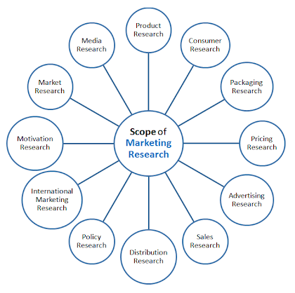

Figure one: http://kalyan-city.blogspot.com/2011/07/scope-of-marketing-research-mr-branches.html

When a business such as NomNom needs to evaluate issues within their different marketing research areas, the biggest decision is whether to do the research in-house or through an agency. Typically, the choice can be based on whether NomNom has the skills internally and with being a relatively small, nationwide business, the business would benefit from using extra expenditure to have an external research agency as it is unlikely they would already have those skills already within. For a company of the size of NomNom, a research agency would be of much benefit as this avoids interruption of internal politics or the need to bring in any specialist facilities.

Once NomNom have established the need for an agency, a selection process for an agency is then needed, although there are many types of marketing research agencies such as full-service agencies, specialist service agencies, field agencies, data analysis services and independent consultants. NomNom would benefit more from hiring a full-service agency as “external suppliers of marketing research services can be classified as being full-service agencies or specialist service agencies. Full-service agencies offer the full range of marketing research services and techniques. They will be able to offer the entire range of qualitative and quantitative research approaches as well as be capable of undertaking every stage of the research, from research design through to analysis and report writing.” Wilson (2006) During the selection process, they need to consider agencies that have had previous experience in the marketing sector and the geographical market, have the appropriate capabilities and facilities, reputation in the field, eye of professionalism, communicate fully and accurately and are well-established with financial stability. These are all the key ingredients necessary to build a good relationship with the agency and have the confidence they will carry out the required task accurately and to the best of their ability.

Marketing Research Process
Agencies take research design like a blueprint for the collection, measurement and analysis of data. Although, there are refined types of research design.

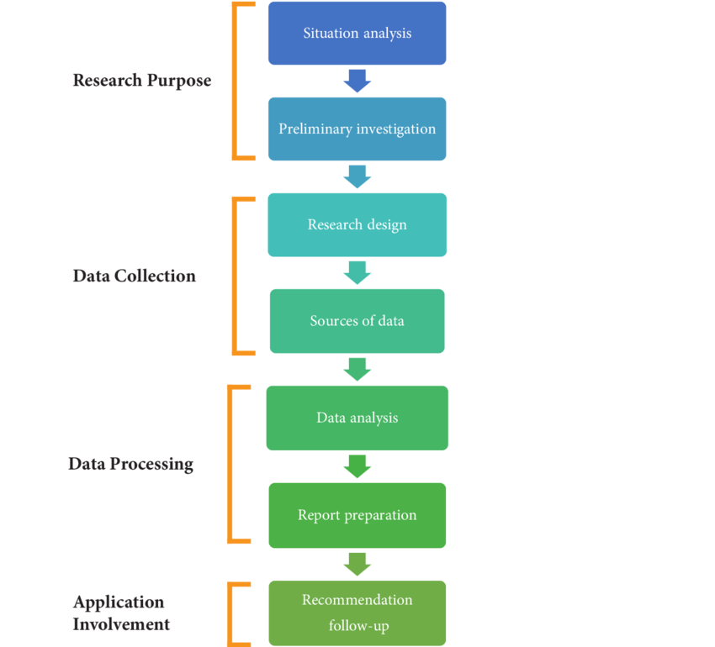

Figure Two: https://www.researchgate.net/figure/Marketing-Research-process-Design-flow_fig2_273831425
The marketing research process is a typical 6-7 step course of action. Firstly, it is important to set the background for the research purpose with a situation analysis. Setting the situation gives the agency an organizational understanding, an industrial understanding, where the area of concern is, the context of the issue and any history of the problem. “Research proposals usually are focused on a central hypothesis. A good research grant hypothesis is a testable, focused, clear, declarative statement of relationships between variables based on previous observations.” University of Michigan (2016)
The next stage in the process is problem definition. Although each step is important, problem definition is the most vital step. “Problem definition involves stating the general problem and identifying the specific components of the marketing research problem. Only when the marketing research problem has been clearly defined can research be designed and conducted properly.” Nscpolteksby.ac.id (2016) Failure to provide a clear definition could result in findings of little worth. To avoid this, NomNom need to ensure they have fully communicated any potential causes of the problem, provided alternative interpretations and have also considered problems which are ambiguous or unattainable.
The next step to the process is research design. “Research Design is a detailed outline of how an investigation will take place. A research design will typically include how data is to be collected, what instruments will be employed, how the instruments will be used and the intended means for analyzing data collected.” Businessdictionary.com (2018)
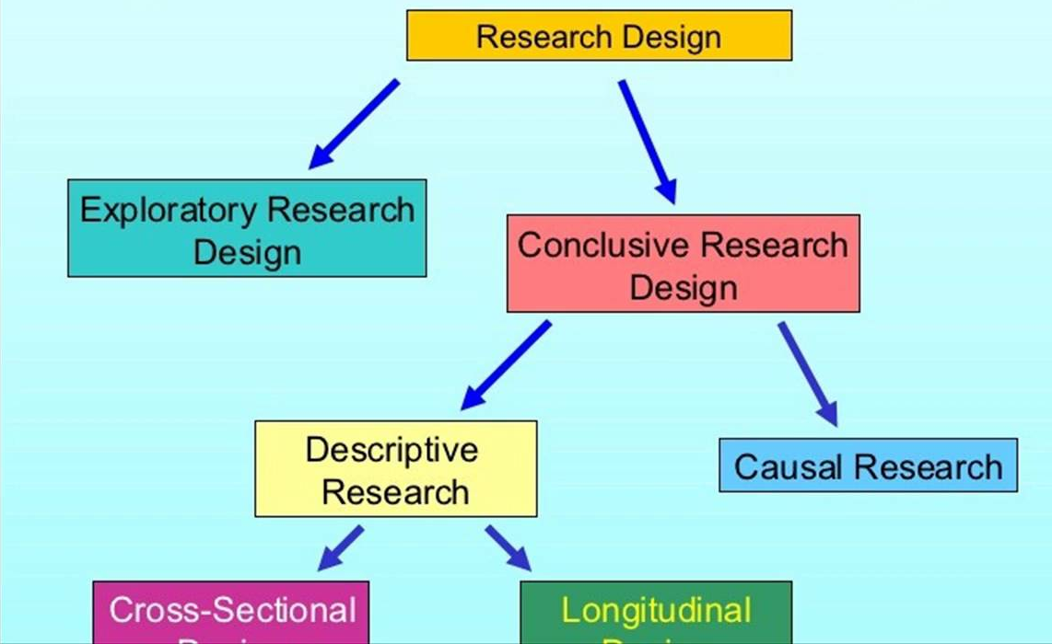
Figure three: https://clipground.com/research-design.html
Whereas there are many types of research design, the designs are based from whether the agency finds their approach fits better, exploratory and conclusive. “Exploratory research is research intended to develop initial ideas or insights and to provide direction for any further research needed.” Wilson (2006) This type of design is great for a situation involving a minimum expenditure of time and cost. Exploratory is more of a qualitative or quantitative exploration, also aimed at exploring any new interests in a new product idea or a gap in a new market. NomNom would benefit greatly from exploratory as it flexible and reflective of the initial research objectives. “Conclusive research is meant to provide information that is useful in reaching conclusions or decision-making. It relies on both secondary data.” www.uoguelph.ca (2019) Conclusive leads further into descriptive design which provides answers to who, what, where, when and how, and also causal research which analyses how one variable affects another. Cross-sectional design refers to data collection at a certain point in a specific situation. Longitudinal research refers to the opposite and looks at data collection at several points in time and then also, experimental research measures changes to one variable which for NomNom would be changes to prices, packaging, etc…of which would then have an affect on another variable which would be sales.
Next is sources of data and data analysis. There are two types of data. Primary data – which is data that has been found first hand specifically for the research purpose, unseen by anyone else which is commonly presented in surveys, archives, focus groups, etc. Secondary data, on the other hand, is data that is already collected by someone else, found in the form of sales figures, profit and loss sheets, inventory records, etc. “The data may need to be prepared for data analysis, which involves validation, editing and data entry.” Hair (2008)
As the findings are finalised, most projects are completed by the research agency preparing a formal written report and a formal meeting, to ensure all findings are communicated accurately or fully. “It may be difficult for client organisations to fully understand the research findings is not communicated fully and accurately, and by doing this, this enables the client business to take on board follow up recommendations.” Bonoma (1985)

Benefits and Drawback of carrying out and not carrying out Marketing Research

Whether Marketing Research is being carried out or not, there is always benefits and drawbacks to. So whilst an agency is carrying out marketing research for NomNom, there are many benefits aiding them in their findings, such as it allows for more opportunities to be identified in the marketplace, which for a relatively small nationwide business such as NomNom, could identify several key areas for expansion or reaching more potential customers. Conducting marketing research minimizes risk of certain business decisions. For example, NomNom may want to discover a new marketplace elsewhere but the marketing research reduces the risk of taking a plunge into a new market when it is saturated with similar products, which could also save NomNom a lot of money.
By conducting market research, NomNom will gain more marketing intelligence. “Marketing intelligence is the external data collected by a company about a specific market it wishes to enter, to make decisions. It is the first set of data which the company analyses before making any investment decision” economictimes.com (2019) NomNom would benefit from gaining intelligence in macro environments such as political, economic, social trends, technological, legal and ecological, and microenvironments regarding customers, competitors, market/industry trends, suppliers, intermediaries and stakeholders. This is known as environmental scanning; giving a company a better view of the environments, they are performing in.
Even though marketing research has many advantages, it also has its disadvantages. Overall, marketing research is a costly affair and can be lengthy and time consuming, especially since it has a limited scope into the market as it looks purely into business related problems. Since the process involves many important stages, no step can be neglected or avoided. Since NomNom has employed an agency to carry out their marketing research, they can expect a period of up to six months to solve a marketing problem.
Another disadvantage is that it cannot replace decision-making, only aid and improve the quality of any decisions made, but this cannot gurantee a 100% success rate.
It is not enough to know the answers to what, where, when, and how questions about the businesses. It is also necessary to know why people buy the products and services. The business should expect to budget at least a minimal amount of time and money for research, especially if they are starting a new business or branching out into a new direction.” bizfilings.com (2018)

How Marketing Research can be undertaken, interpreted and presented

Researchers have many different methods of research available to them, of which they will decide which is best based on the job they are doing. When we refer to qualitative nature of work, this dictates who essentially takes part. “Qualitative research is about finding out not just what people think, but why they think it. It’s about getting people to talk about their opinions so you can understand their motivations and feelings.” Bryman (2006) Qualitative research brings more of an emotive understanding to different aspects of an issue, so when data is being collected it is being interpreted. There are many types of qualitative research such as individual interviews, focus group discussions, observations, ethnographic, panels and projective techniques. These research methods can be very handy as their use can aid the researcher greatly. The reasearchers for NomNom would benefit from using individual interviews and group discussions. Individual interviews are useful as they are cost effective which, for NomNom is what they are looking for, and since they are well adaptable, they use less people and a confidential nature. Once the interviews have been conducted, recordings then collect the data, so that when the researchers interpret the data, they can identify the common key phrases and consumer body language. When the data is ready to be presented, the researcher will introduce the findings as quotations. Group discussions are also great for a company the size of NomNom as it brings together a group of similar consumers with a chairperson recording the discussion. This method is a beneficial aid in analyzing consumer behavior, establishing reasons for brand preference and to examine how purchases are made. Focus group data is collected in similar ways to individual interviews, through recordings and filming, of which recurring themes and issues will be selected and then presented through the format of quotations, themes and issues.
“Quantitative research involves the use of computational, statistical, and mathematical tools to derive results. It is conclusive in its purpose as it tries to quantify the problem and understand how prevalent it is by looking for projectable results to a larger population.” Cavana (2001) Quantitative research uses a sample of a population, which gives insights into attitudes, behavior and motivation. Within this type of research, it is very unlikely that the researcher will be able to reach every individual in the area of interest, especially since many researchers will not already have the resources to do that, so they use samples; a sample of people who represent a whole group. To be able to use a sample, a sample plan is necessary. Firstly, defining the population, which for NomNom would be mainly Welsh folk within the area of origin. Next, identifying the sampling frame, which would identify as the source material of individuals, or institutions, and from there, selecting the sampling method; simple random, systematic, stratified random or cluster. Researchers for NomNom would benefit from a simple random, although since these are probability methods, non-probability methods convenience out of judgment, quotas, or snowballing. From here, the researcher will be able to piece together exactly how these sampling decisions are implemented. Quantitative research methods include surveys, experiments, testing, modeling, statistical analysis and statistical modeling. NomNom’s researchers could use surveys as there are many survey methods to use to their advantage, such as hall tests, telephone interviews, face-to-face and so on, all of which are collected into a questionnaire, interpreted by any referencing or explanations recorded and then presented into tables, charts and figures. NomNom would also get a great advantage out of experiments and testing since they are a chocolate company. The researchers would then record the outcomes and interpret the relationships discussed resulting in tables, charts and figures of the findings.

Conclusion

To conclude, I think NomNom would benefit greatly from the services of a Marketing Research agency. In this report, the information has established that the marketing research process has many intricate steps and require the correct resources to carry out the project. By using an agency, NomNom would then be able to see where any issues are and where their strengths are, giving them a competitive advantage in the marketplace and a better marketing position internally.

Total words: 2,193

References

Assmus, G., Farley, J.U. and Lehmann, D.R., 1984. How advertising affects sales: Meta-analysis of econometric results. Journal of Marketing Research, pp.65-74.
Bickart, B.A., 1993. Carryover and backfire effects in marketing research. JMR, Journal of Marketing Research, 30(1), p.52.
Bonoma, T.V., 1985. Case research in marketing: opportunities, problems, and a process. Journal of marketing research, pp.199-208.
Bryman, A., 2006. Integrating quantitative and qualitative research: how is it done?. Qualitative research, 6(1), pp.97-113.
Cavana, R.Y., Delahaye, B.L. and Sekaran, U., 2001. Applied business research: Qualitative and quantitative methods. John Wiley & Sons Australia.
Figure One: http://kalyan-city.blogspot.com/2011/07/scope-of-marketing-research-mr-branches.html
Figure three: https://clipground.com/research-design.html
Figure Two: https://www.researchgate.net/figure/Marketing-Research-process-Design-flow_fig2_273831425
Hair, J.F., Celsi, M., Ortinau, D.J. and Bush, R.P., 2008. Essentials of marketing research. New York, NY: McGraw-Hill/Higher Education.
Haluk Köksal, M., 2008. How export marketing research affects company export performance: evidence from Turkish companies. Marketing Intelligence & Planning, 26(4), pp.416-430.
http://research-live.com
https://nscpolteksby.ac.id/ebook/files/Ebook/Business%20Administration/Marketing%20Research%20An%20Applied%20Approach%20%20European%20(2006)/Chapter2-1.pdf
https://orsp.umich.edu/research-proposals-project-purpose
https://www.bizfilings.com/toolkit/research-topics/marketing/market-research/without-market-research-you-will-miss-valuable-opportunities
https://www.theguardian.com/small-business-network/2012/sep/25/market-research-improve-business
https://www.uoguelph.ca/hftm/conclusive-research
McGivern, Y (20013) The Practice of Market Research: An Introduction, London: Financial Times Press
Tapp, A., 2008. Principles of direct and database marketing. Pearson Education.
Wilson, A., 2006. Marketing research: An integrated approach. marketing research, 15(17), pp.17-18.
www.businessdictionary.com

