

Programme: Master of Business Administration
Module: Dissertation
Module code: LCMB7035

Topic:
“The Influence of Influencer Marketing on Purchase Intentions Among Generation Z Consumers in the UK Retail Sector”

Student Name: Md Faysal Rahman
Student ID: 2436576

TABLE OF CONTENTS
1. Introduction 4
1.1 Background and Context 4
1.2 Research Problem and Rationale 4
1.3 Research Aim, Objectives and Questions 4
Research Aim 4
Research Objectives 5
Research Questions 5
2. Literature Review 6
2.1 Influencer Marketing 6
2.2 Influencer Credibility and Purchase Intention 6
2.3 Theoretical Framework 7
2.4 Research Gap 8
2.5 Conceptual Framework and Hypotheses 9
3. Methodology 11
3.1 Research Philosophy 11
3.2 Research Approach and Methodological Choice 12
3.3 Research Strategy and Time Horizon 12
3.4 Population and Sampling 12
3.5 Data Collection Instrument 12
3.6 Data Analysis 13
3.7 Ethical Considerations 13
4. Expected Findings 13
5. Limitations 13
6. Timeframe 14
7. Conclusion 14
8. References 16
Appendices 19
Appendix A: Survey Questionnaire 19
Appendix B: Operationalisation of Variables 22

1. Introduction

1.1 Background and Context
Influencer marketing is now an integral part of modern retail communication, especially on visually oriented and short-form social media like Instagram, TikTok and YouTube. Social Media influencers have become an effective way of reaching younger consumers, as they are able to combine product information with entertainment and perceived personal experience in a way that traditional advertising is not. The issue is particularly pertinent for Generation Z consumers, who are highly active online and often are targeted with sponsored product recommendations in fashion, beauty, lifestyle, electronics and food retail settings (Haenlein et al., 2020; Ofcom, 2025). But a high exposure does not equal a persuadable audience. Additionally, Generation Z consumers are digitally literate, commercially savvy and skeptical about influencer endorsements, especially when it is used for promotional purposes (Evans et al., 2017; Friestad and Wright, 1994).

1.2 Research Problem and Rationale
Existing scholarship has explored general consumer populations, non-UK markets, or certain market segments like luxury or aesthetic dermatology, and missed the opportunity to study UK retail contexts (AlFarraj et al., 2021; Chetioui, Benlafqih and Lebdaoui, 2020; Casaló, Flavián and Ibáñez-Sánchez, 2020). While Belanche et al. (2021) propose that congruence of influencer, product and consumer identity has a direct impact on marketing outcomes, this sensitivity has not yet been tested on samples of UK Generation Z particularly. Additionally, much of previous research fails to break down the construct of influencer credibility into quantifiable dimensions and understand which dimension most influences behaviour (Lou and Yuan, 2019; Ki, Chow and Li, 2023). In a systematic review of the literature, Vrontis et al. (2021) conclude that there is a lack of progress in the development of a single body of theory on credibility, especially with respect to the UK retail context. This dissertation aims to fill these gaps by focusing on specific, measurable credibility dimensions, rather than an amalgamated construct, and examining the retail consumers of Generation Z in the UK.

1.3 Research Aim, Objectives and Questions

Research Aim
The research aims to examine the influence of social media influencer credibility dimensions on purchase intention among Generation Z consumers in the UK retail sector.

Research Objectives
- To examine the influence of influencer trustworthiness on purchase intention among UK Generation Z retail consumers.
- To examine the influence of influencer expertise and attractiveness on purchase intention among UK Generation Z retail consumers.
- To determine which influencer credibility dimension most strongly predicts purchase intention among UK Generation Z retail consumers.

Research Questions
Correspondingly, the study addresses three research questions:
- How does influencer trustworthiness influence purchase intention among UK Generation Z retail consumers?
- How do influencer expertise and attractiveness influence purchase intention among UK Generation Z retail consumers?
- Which influencer credibility dimension is the strongest predictor of purchase intention among UK Generation Z retail consumers?

2. Literature Review

2.1 Influencer Marketing
Influencer marketing is defined as the use of influencers, who have online visibility, audience connections and persuasive power to promote brands, products or services (Campbell and Farrell, 2020). Unlike the traditional model of celebrity endorsements, social media influencers tend to earn their influence through the sense of relatability that they develop and create with their audience. This is important because retail consumers can be attracted not only by fame but also by perceived authenticity and credibility of the source (Schouten, Janssen and Verspaget, 2020). In retail, influencers can influence attention, brand awareness, product evaluation and purchase intention especially when visual products can be demonstrated, as well as when they are related to lifestyle identity (Chetioui, Benlafqih and Lebdaoui, 2020; Djafarova and Bowes, 2021).

2.2 Influencer Credibility and Purchase Intention
Source credibility is one of the strongest foundations for studying influencer persuasion. Hovland and Weiss (1951) suggested that a part of the effectiveness of a communication depends on the credibility of the source of the communication. Ohanian (1990) later developed a scale measuring endorser credibility through expertise, trustworthiness and attractiveness. The dimensions are still extremely relevant to influencer marketing activities as these days, social media influencers are endorsers, reviewers and content creators.
Trustworthiness is defined as the degree of honesty, sincerity and reliability that an influencer is viewed as. The trustworthiness of influencers is especially critical in influencer marketing, since sponsored material could lead to a conflict between personal suggestion and commercial persuasion. Lou and Yuan (2019) revealed that the credibility of the influencers and the value of the message have an effect on consumer trust in branded content.
Expertise refers to the perceived knowledge, competence and experience of the influencer in relation to the product category. This is crucial in retail because consumers might ask influencers to explain products, provide styling tips, show a demonstration or comparison. AlFarraj et al. (2021) identified the credibility dimensions such as expertise, influence purchase intention in an influencer context.
Attractiveness refers not only to physical appearance, but also to perceived style, appeal, likeability and aspirational image. Ohanian (1990) conceptualised attractiveness as a credibility dimension and more recently influencer studies reveal that the presentation and identification of the visual image can affect consumer attitudes (Schouten, Janssen and Verspaget, 2020). However, attractiveness alone is a weaker academic explanation if separated from credibility or product fit. While a good-looking influencer can get noticed, that doesn't automatically mean that people will want to buy his product if they don't trust him or know what they are doing.
Purchase intention is the probability or willingness of consumers to purchase a product. It is a widely used construct in consumer research of behavioural intentions (Dodds, Monroe and Grewal, 1991). As suggested by Ajzen (1991), intention is a major determinant of behaviour, but other factors such as control, price, availability and competing alternatives may still influence behaviour.

2.3 Theoretical Framework
Two complementary theories underlie this study. The primary theory is the Source Credibility Theory, which was developed by Hovland and Weiss (1951) and formalized by Ohanian (1990) in a three-dimensional model of expertise, trustworthiness and attractiveness. The theory suggests that persuasive communication is more effective when the source is credible, and that source credibility is mediated by consumers' trust, resulting in effect on consumers' behavior, such as purchase intention (Sokolova and Kefi, 2020).
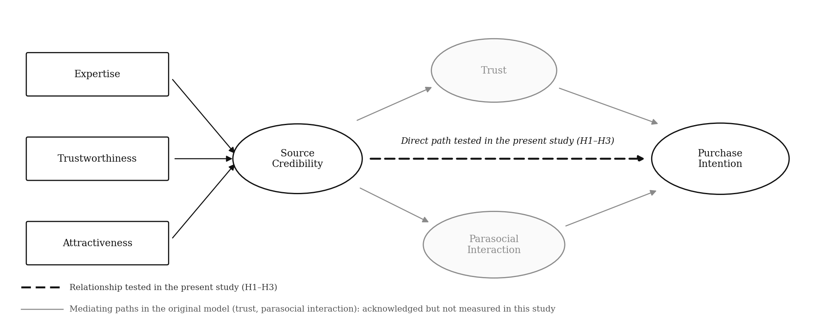
Figure 1. Source credibility
(Source: Sokolova and Kefi, 2020)
Figure 1 presents the model of Sokolova and Kefi (2020) in its complete form. The three dimensions of expertise, trustworthiness, and attractiveness combine to create source credibility, which affects purchase intention directly and indirectly by two parallel mediators: consumer trust and parasocial interaction. Therefore, parasocial interaction is a mediator variable which transmits credibility into purchase intention, not a result variable. The earlier version of the figure that did not illustrate such relationship was therefore redrawn as shown in Figure 1, which is congruent with the model in this study and the analysis. The present study adopts only the direct pathway from the credibility dimensions to purchase intention, which is shown as the bold dashed path in Figure 1 and is operationalised as hypotheses H1 to H3. While trust and parasocial interaction are recognized theoretically as mediators, they are not specifically measured as it is the relative predictive power of the three credibility dimensions that are of interest to the research.
The supporting theory, which Ajzen (1991) developed, is the Theory of Planned Behaviour (TPB). According to TPB, attitude, subjective norm and perceived behavioural control are the immediate determinants of behavioural intention, which ultimately determines behaviour ( Ajzen, 2020).
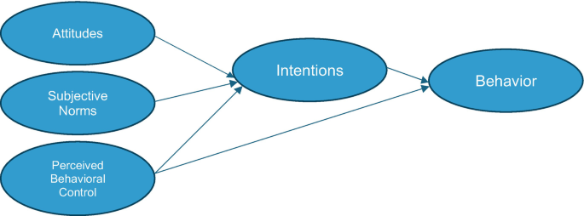
Figure 2. Theory of Planned Behaviour (Source: adapted from Ajzen, 1991).
Purchase intention is used as the behavioural intention construct, while credibility dimensions are conceptualized as antecedent factors that affect the consumer's attitude towards the recommended product, following the conceptualisation of Bosnjak, Ajzen and Schmidt (2020).

2.4 Research Gap
There are several gaps that necessitate this study. First, there is a contextual gap because much influencer marketing research has examined broad consumer samples, non-UK contexts or specific sectors such as fashion, beauty and aesthetic services, rather than focusing directly on Generation Z consumers in the UK retail sector (Chetioui, Benlafqih and Lebdaoui, 2020; AlFarraj et al., 2021; Belanche et al., 2021; Djafarova and Bowes, 2021). Second, a population gap exists due to Generation Z's active engagement with social media, and their growing commercial awareness, while also being skeptical of sponsored persuasion, disclosure practices and influencer motives (Friestad and Wright, 1994; Evans et al., 2017; Mathur, Narayanan and Chetty, 2018; Kim and Kim, 2021). Third, there is a methodological gap in that most studies on influencer marketing are conducted using general conceptual reviews, qualitative interpretation or complicated models, whereas a thorough study using SPSS based regression analysis can offer more clear evidence on the relative predictive power of the credibility dimensions in a manageable master's dissertation.

2.5 Conceptual Framework and Hypotheses
The conceptual model categorizes the independent variables as trustworthiness, expertise and attractiveness, while purchase intention is the dependent variable. The framework is based on the theory of source credibility and supported by the theory of planned behaviour. Trustworthiness is expected to affect the purchase intention as customers are more likely to trust the products that are endorsed by an honest and trustworthy influencer. The influence of expertise is expected to affect purchase intention, as an expert might decrease uncertainty in retail decision making. Attractiveness is hypothesized to affect purchase intention due to the possibility that attractive influencers could draw attention to the product, affect product desirability and product identification.
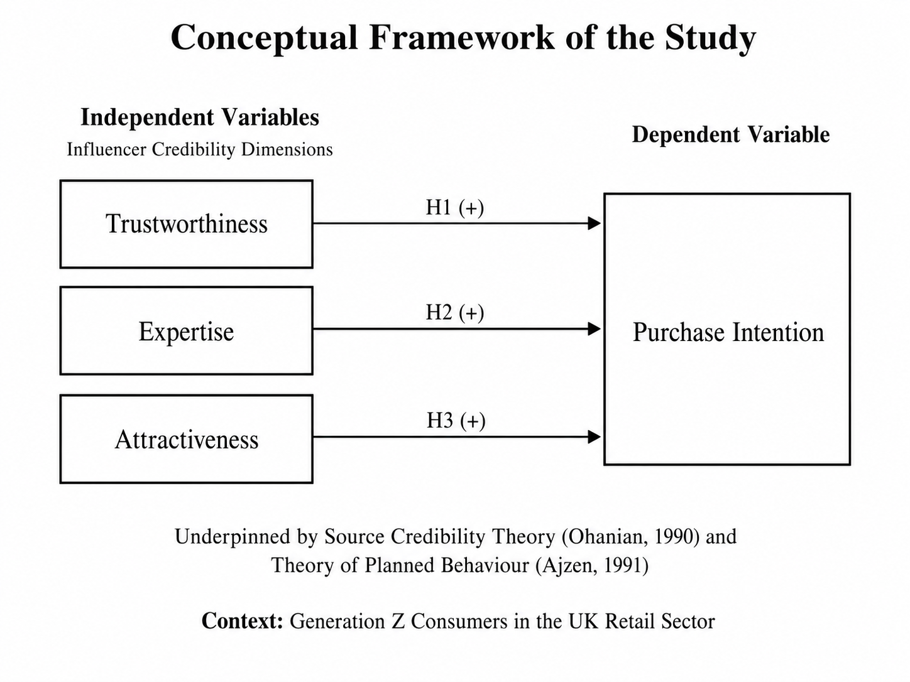
Figure 3. Conceptual framework of the study (Source: author's own construction, based on Ohanian, 1990 and Ajzen, 1991).
As shown in Figure 3, each dimension is hypothesised to exert a positive influence on purchase intention among UK Generation Z retail consumers. The following hypotheses are proposed:
H1: Influencer trustworthiness has a significant positive influence on purchase intention among UK Generation Z retail consumers.
H2A: Influencer expertise has a significant positive influence on purchase intention among UK Generation Z retail consumers.
H2B: Influencer attractiveness has a significant positive influence on purchase intention among UK Generation Z retail consumers.
H3: Among the three influencer credibility dimensions, trustworthiness is expected to be the strongest predictor of purchase intention.

3. Methodology
This methodology chapter follows the research onion model that was developed by Saunders, Lewis and Thornhill (2019), moving from philosophical assumptions to specific data collection techniques.
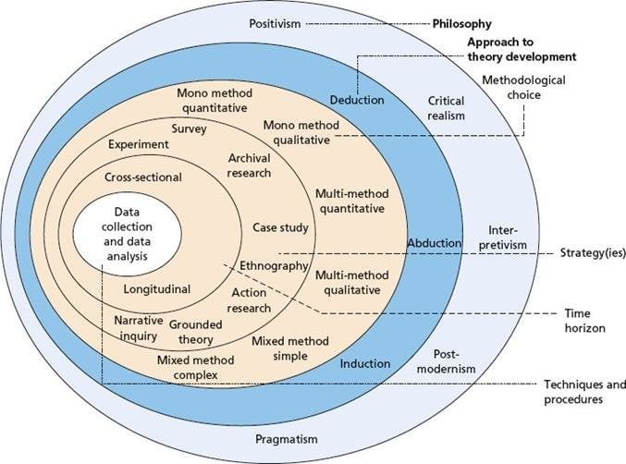
Figure 4. The research onion (Source: Saunders, Lewis and Thornhill, 2019).

3.1 Research Philosophy
The research philosophy used in this dissertation is positivist which assumes that there is a social reality to be observed objectively and measured by quantifiable indicators (Bryman and Bell, 2015). The use of positivism is suitable in this research because the purpose of this research was to test the hypotheses that have been set in advance related to the credibility dimensions that can be measured and the statistical relationship between the credibility dimension and purchase intention, without trying to interpret the meaning from the subjective point of view (Collis and Hussey, 2014).

3.2 Research Approach and Methodological Choice
A deductive approach will be adopted, where hypotheses will be tested empirically through quantitative data (Saunders, Lewis and Thornhill, 2019). This is appropriate for the theory-driven goals and allows generalization of results within a set of statistical limits (Bryman and Bell, 2015). The mono-method quantitative design will be used because quantitative methods facilitate the measurement of the four variables and allow the statistical testing of the proposed hypotheses by means of regression analysis (Pajo, 2018). Qualitative or mixed methods were not considered, since the aims are aimed at a measurable prediction instead of exploratory insight.

3.3 Research Strategy and Time Horizon
A cross-sectional survey will be used as it is appropriate to collect standardised data from a defined population within a short period of time (Polonsky and Waller, 2015). Structured online questionnaires are an effective tool to reach geographically dispersed members of Generation Z across the UK and lead to a cross sectional time horizon where perceptions are captured at one point in time not over time (Saunders, Lewis and Thornhill, 2019).

3.4 Population and Sampling
The target audience consists of UK Generation Z consumers aged 18-29, who engage with social media and have seen retail products promoted by influencers within the last three months. Given that there is no accessible sampling frame for this population (Bryman and Bell, 2015) then non-probability sampling using purposive and convenience sampling techniques will be used. A target number of one hundred to one hundred and twenty valid responses will be sought in order to achieve multiple regression with three predictors (Pajo, 2018).

3.5 Data Collection Instrument
Structured online questionnaire will be used and distributed via social media outlets and university website. The instrument consists of four sections. These are the screening questions, the demographic questions, twelve credibility dimension items comprising four trustworthiness items, four expertise items and four attractiveness items adapted from Ohanian (1990), Lou and Yuan (2019) and AlFarraj et al. (2021), and five purchase intention items adapted from Dodds, Monroe and Grewal (1991) and Sokolova and Kefi (2020). Each substantive statement in Appendix A carries an item code that identifies the construct it measures, where T denotes trustworthiness, E denotes expertise, A denotes attractiveness and PI denotes purchase intention. For all substantive items, a five-point Likert scale is used. The full questionnaire is provided in Appendix A and the operationalisation of the variables summarised in Appendix B.

3.6 Data Analysis
Data collected will be analysed using SPSS software. Respondent demographics and variable distributions will be summarised using descriptive statistics and Cronbach's alpha will be used to assess internal consistency reliability of the variables (Cronbach's alpha > 0.70 is acceptable, Bryman and Bell, 2015). To address the third research objective, bivariate relationships between credibility dimensions and purchase intention will be investigated by using Pearson correlation techniques, and the proposed hypotheses will be tested by multiple regression that will reveal the relative predictive power of each credibility dimension.

3.7 Ethical Considerations
This research will adhere to the University of Wales Trinity Saint David ethical procedures to the full and data will not be collected until full ethical approval has been gained. Any participation will be voluntary, consent will be obtained before participation and during participation all information will be anonymous (no personally identifiable information will be collected). All data will be kept securely in a university-provided OneDrive account only accessible to the researcher and supervisor.

4. Expected Findings
Consistent with Source Credibility Theory and prior evidence, this study anticipates that trustworthiness, expertise and attractiveness will each exert a statistically significant positive influence on purchase intention among UK Generation Z retail consumers. As Generation Z consumers are known to prioritize honesty and transparent disclosure, it is expected that trustworthiness will show the highest predictive correlation, as noted by AlFarraj et al. (2021) and Lou and Yuan (2019). Expertise is expected to have a moderate positive effect, which aligns with the findings of Chetioui, Benlafqih and Lebdaoui (2020); attractiveness is expected to have the weakest positive effect, consistent with the results of AlFarraj et al. (2021) that Gen Z consumers are more interested in substantive credibility than superficial appeal.

5. Limitations
This study has a number of limitations. Non-probability convenience sampling limits the generalisability of the results to the sampled population, and the cross-sectional design does not allow time trend or causal relationships to be investigated. Self-reported Likert scale data can be subject to social desirability bias which can result in an overestimate of purchase intent. When platform-specific variables, like a TikTok user base compared to an Instagram user base, are not included, there is an important lack of granularity in context. Future research could measure both mediators and estimate the indirect effects using structural equation modelling. These limitations will be addressed by appropriately stating caution in conclusions about scope and applicability, and through clear screening criteria and anonymous data collection and reporting of sample characteristics.

6. Timeframe
The dissertation will be undertaken over a period of 8 weeks following the Gantt chart in Table 1.
Table 1. Eight-week project Gantt chart.
Task | W1 | W2 | W3 | W4 | W5 | W6 | W7 | W8
Literature review and refinement of research aim
Ethics application preparation and submission
Questionnaire design and adaptation of scales
Pilot testing of questionnaire
Ethical approval confirmation
Data collection (online survey distribution)
Data cleaning and screening
Data analysis using SPSS
Drafting of findings and discussion
Supervisor review, revision and final submission

7. Conclusion
This proposal has outlined a quantitative study to investigate the effect of influencer credibility dimensions on purchase intention of UK generation Z retail consumers. The study builds on and extends the theories of Source Credibility Theory and the Theory of Planned Behaviour, with the aim of filling gaps in the literature in the areas of contextual, construct and methodological. The results should provide theoretical insight and guidance for retailers in the UK and should be extended to platform level comparisons in future research projects.

8. References
Ajzen, I. (1991) 'The theory of planned behavior', Organizational Behavior and Human Decision Processes, 50(2), pp. 179-211. doi: https://doi.org/10.1016/0749-5978(91)90020-T (Accessed: 27 June 2026).
Ajzen, I. (2020) 'The theory of planned behavior: Frequently asked questions', Human Behavior and Emerging Technologies, 2(4), pp. 314-324. doi: https://doi.org/10.1002/hbe2.195 (Accessed: 28 June 2026).
AlFarraj, O., Alalwan, A.A., Obeidat, Z.M., Baabdullah, A., Aldmour, R. and Al-Haddad, S. (2021) 'Examining the impact of influencers' credibility dimensions: attractiveness, trustworthiness and expertise on the purchase intention in the aesthetic dermatology industry', Review of International Business and Strategy, 31(3), pp. 355-374. doi: https://doi.org/10.1108/RIBS-07-2020-0089 (Accessed: 29 June 2026).
Belanche, D., Casaló, L.V., Flavián, M. and Ibáñez-Sánchez, S. (2021) 'Understanding influencer marketing: The role of congruence between influencers, products and consumers', Journal of Business Research, 132, pp. 186-195. doi: https://doi.org/10.1016/j.jbusres.2021.03.067 (Accessed: 30 June 2026).
Bosnjak, M., Ajzen, I. and Schmidt, P. (2020) 'The theory of planned behavior: Selected recent advances and applications', Europe's Journal of Psychology, 16(3), pp. 352-356. doi: https://doi.org/10.5964/ejop.v16i3.3107 (Accessed: 1 July 2026).
Bryman, A. and Bell, E. (2015) Business Research Methods. Oxford: Oxford University Press. Available at: https://www.amazon.com/Business-Research-Methods-Alan-Bryman/dp/0199668647 (Accessed: 3 July 2026).
Casaló, L.V., Flavián, C. and Ibáñez-Sánchez, S. (2020) 'Influencers on Instagram: Antecedents and consequences of opinion leadership', Journal of Business Research, 117, pp. 510-519. doi: https://doi.org/10.1016/j.jbusres.2018.07.005 (Accessed: 3 July 2026).
Chetioui, Y., Benlafqih, H. and Lebdaoui, H. (2020) 'How fashion influencers contribute to consumers' purchase intention', Journal of Fashion Marketing and Management: An International Journal, 24(3), pp. 361-380. doi: https://doi.org/10.1108/JFMM-08-2019-0157 (Accessed: 27 June 2026).
Collis, J. and Hussey, R. (2014) Business Research: A Practical Guide for Undergraduate and Postgraduate Students. Basingstoke: Palgrave Macmillan. Available at: https://www.amazon.com/Business-Research-Practical-Undergraduate-Postgraduate/dp/0230301835 (Accessed: 3 July 2026).
Djafarova, E. and Bowes, T. (2021) 'Instagram made me buy it: Generation Z impulse purchases in fashion industry', Journal of Retailing and Consumer Services, 59, Article 102345. doi: https://doi.org/10.1016/j.jretconser.2020.102345 (Accessed: 30 June 2026).
Dodds, W.B., Monroe, K.B. and Grewal, D. (1991) 'Effects of price, brand, and store information on buyers' product evaluations', Journal of Marketing Research, 28(3), pp. 307-319. doi: https://doi.org/10.1177/002224379102800305 (Accessed: 1 July 2026).
Evans, N.J., Phua, J., Lim, J. and Jun, H. (2017) 'Disclosing Instagram influencer advertising: The effects of disclosure language on advertising recognition, attitudes, and behavioral intent', Journal of Interactive Advertising, 17(2), pp. 138-149. doi: https://doi.org/10.1080/15252019.2017.1366885 (Accessed: 2 July 2026).
Haenlein, M., Anadol, E., Farnsworth, T., Hugo, H., Hunichen, J. and Welte, D. (2020) 'Navigating the new era of influencer marketing: How to be successful on Instagram, TikTok, & Co.', California Management Review, 63(1), pp. 5-25. doi: https://doi.org/10.1177/0008125620958166 (Accessed: 3 July 2026).
Hovland, C.I. and Weiss, W. (1951) 'The influence of source credibility on communication effectiveness', Public Opinion Quarterly, 15(4), pp. 635-650. doi: https://doi.org/10.1086/266350 (Accessed: 3 July 2026).
Ki, C.W.C., Chow, T.C. and Li, C. (2023) 'Bridging the trust gap in influencer marketing: Ways to sustain consumers' trust and assuage their distrust in the social media influencer landscape', International Journal of Human-Computer Interaction, 39(17), pp. 3445-3460. doi: https://doi.org/10.1080/10447318.2022.2097785 (Accessed: 28 June 2026).
Kim, D.Y. and Kim, H.Y. (2021) 'Trust me, trust me not: A nuanced view of influencer marketing on social media', Journal of Business Research, 134, pp. 223-232. doi: https://doi.org/10.1016/j.jbusres.2021.05.024 (Accessed: 29 June 2026).
Liu, X. and Zheng, X. (2024) 'The persuasive power of social media influencers in brand credibility and purchase intention', Humanities and Social Sciences Communications, 11, Article 15. doi: https://doi.org/10.1057/s41599-023-02512-1 (Accessed: 30 June 2026).
Lou, C. and Yuan, S. (2019) 'Influencer marketing: How message value and credibility affect consumer trust of branded content on social media', Journal of Interactive Advertising, 19(1), pp. 58-73. doi: https://doi.org/10.1080/15252019.2018.1533501 (Accessed: 1 July 2026).
Mathur, A., Narayanan, A. and Chetty, M. (2018) 'Endorsements on social media: An empirical study of affiliate marketing disclosures on YouTube and Pinterest', Proceedings of the ACM on Human-Computer Interaction, 2(CSCW), Article 119, pp. 1-26. doi: https://doi.org/10.1145/3274388 (Accessed: 2 July 2026).
Mintel (2025) UK Social Commerce Market Report 2025. Available at: https://store.mintel.com/report/uk-social-commerce-market-report (Accessed: 3 July 2026).
Ofcom (2025) Online Nation 2025 Report. London: Ofcom. Available at: https://www.ofcom.org.uk/media-use-and-attitudes/online-habits/online-nation (Accessed: 6 July 2026).
Ohanian, R. (1990) 'Construction and validation of a scale to measure celebrity endorsers' perceived expertise, trustworthiness, and attractiveness', Journal of Advertising, 19(3), pp. 39-52. doi: https://doi.org/10.1080/00913367.1990.10673191 (Accessed: 28 June 2026).
Pajo, B. (2018) Introduction to Research Methods: A Hands-On Approach. Los Angeles: SAGE. Available at: https://us.sagepub.com/en-us/nam/introduction-to-research-methods/book270534 (Accessed: 3 July 2026).
Polonsky, M.J. and Waller, D.S. (2015) Designing and Managing a Research Project: A Business Student's Guide. London: SAGE. Available at: https://us.sagepub.com/hi/nam/designing-and-managing-a-research-project/book259152 (Accessed: 3 July 2026).
Saunders, M.N.K., Lewis, P. and Thornhill, A. (2019) Research Methods for Business Students. 8th edn. Harlow: Pearson Education. Available at: https://www.pearson.com/en-us/subject-catalog/p/research-methods-for-business-students/P200000005358/9781292208787 (Accessed: 20 June 2026).
Sokolova, K. and Kefi, H. (2020) 'Instagram and YouTube bloggers promote it, why should I buy? How credibility and parasocial interaction influence purchase intentions', Journal of Retailing and Consumer Services, 53, Article 101742. doi: https://doi.org/10.1016/j.jretconser.2019.01.011 (Accessed: 30 June 2026).
Vrontis, D., Makrides, A., Christofi, M. and Thrassou, A. (2021) 'Social media influencer marketing: A systematic review, integrative framework and future research agenda', International Journal of Consumer Studies, 45(4), pp. 617-644. doi: https://doi.org/10.1111/ijcs.12647 (Accessed: 6 July 2026).

Appendices

Appendix A: Survey Questionnaire
1. Are you aged between 18 and 29?
2. Do you currently live in the UK?
3. Do you use social media platforms such as TikTok, Instagram, YouTube or Snapchat?
4. Have you seen retail products promoted by social media influencers in the past three months?
Note: Respondents answering no to any screening question are excluded from the sample.
5. Age group: 18 to 20, 21 to 23, 24 to 26, 27 to 29.
6. Gender: Male, Female, Non-binary, Prefer not to say.
7. Employment status: Student, Employed, Self-employed, Unemployed, Other.
8. Most used platform: TikTok, Instagram, YouTube, Snapchat, Other.
9. Retail category most influenced by social media: Fashion, Beauty, Electronics, Food and beverage, Home or lifestyle, Other.
All substantive items are measured using a five-point Likert scale, where 1 represents strongly disagree and 5 represents strongly agree.
Item codes identify the construct that each statement measures. T denotes trustworthiness, E denotes expertise, A denotes attractiveness and PI denotes purchase intention. Trustworthiness, expertise and attractiveness are the independent variables and purchase intention is the dependent variable. Item codes are not shown to respondents and are used for coding and analysis in SPSS only.
1 | 2 | 3 | 4 | 5
Strongly Disagree | Disagree | Neutral | Agree | Strongly Agree

T: Trustworthiness
Item | Statement | 1 | 2 | 3 | 4 | 5
T1 | Influencers are considered honest when they recommend retail products. | ☐ | ☐ | ☐ | ☐ | ☐
T2 | Influencers who clearly disclose paid partnerships are trusted. | ☐ | ☐ | ☐ | ☐ | ☐
T3 | Influencers are believed to be reliable when they share personal experiences with products. | ☐ | ☐ | ☐ | ☐ | ☐
T4 | Influencers are trusted more when their product reviews appear balanced rather than overly positive. | ☐ | ☐ | ☐ | ☐ | ☐

E: Expertise
Item | Statement | 1 | 2 | 3 | 4 | 5
E1 | Influencers who appear knowledgeable about the products they promote are more likely to be trusted. | ☐ | ☐ | ☐ | ☐ | ☐
E2 | Influencers with experience in a product category are more persuasive. | ☐ | ☐ | ☐ | ☐ | ☐
E3 | Influencers who explain product features clearly are valued. | ☐ | ☐ | ☐ | ☐ | ☐
E4 | A retail product is more likely to be considered when an influencer demonstrates expertise about it. | ☐ | ☐ | ☐ | ☐ | ☐

A: Attractiveness
Item | Statement | 1 | 2 | 3 | 4 | 5
A1 | More attention is paid to influencers who have an appealing style or presentation. | ☐ | ☐ | ☐ | ☐ | ☐
A2 | An influencer's visual appeal makes their product recommendations more noticeable. | ☐ | ☐ | ☐ | ☐ | ☐
A3 | Products promoted by influencers whose lifestyle is admired attract greater interest. | ☐ | ☐ | ☐ | ☐ | ☐
A4 | Retail products appear more appealing when promoted by influencers with an attractive image. | ☐ | ☐ | ☐ | ☐ | ☐

PI: Purchase Intention
Item | Statement | 1 | 2 | 3 | 4 | 5
PI1 | A retail product recommended by a credible influencer is likely to be considered for purchase. | ☐ | ☐ | ☐ | ☐ | ☐
PI2 | Further information about a product is likely to be sought after seeing it recommended by an influencer. | ☐ | ☐ | ☐ | ☐ | ☐
PI3 | A retail product promoted by a trusted influencer would likely be purchased. | ☐ | ☐ | ☐ | ☐ | ☐
PI4 | Influencer recommendations increase the likelihood of purchasing retail products. | ☐ | ☐ | ☐ | ☐ | ☐
PI5 | A product would likely be recommended to others if it was promoted by a credible influencer. | ☐ | ☐ | ☐ | ☐ | ☐

Appendix B: Operationalisation of Variables
Variable | Type | Definition | Example measurement basis
Influencer trustworthiness | Independent variable | The extent to which consumers perceive an influencer as honest, reliable and sincere. | Adapted from Ohanian (1990), Lou and Yuan (2019) and AlFarraj et al. (2021).
Influencer expertise | Independent variable | The extent to which consumers perceive an influencer as knowledgeable and competent about retail products. | Adapted from Ohanian (1990) and AlFarraj et al. (2021).
Influencer attractiveness | Independent variable | The extent to which consumers perceive an influencer as appealing, stylish or likeable. | Adapted from Ohanian (1990).
Purchase intention | Dependent variable | The consumer's likelihood or willingness to buy a retail product recommended by an influencer. | Adapted from Dodds, Monroe and Grewal (1991) and Sokolova and Kefi (2020).

