Cyber Security Analysis
University of Wales Trinity Saint David
Student Name: Robert Constantin Dan | 2507758
ACCA4024
Lecturer Name: Muhammad Azeem Abbas
Submission Deadline: 21/07/2026

Abstract

SteelForm Manufacturing Ltd (SFM) uses Industry 4.0 technologies such as IIoT, automation, and cloud systems to improve efficiency, but this has increased its exposure to cyber threats.
The main problem is the growing risk of attacks like ransomware, phishing, and unauthorised access, which could disrupt operations and compromise sensitive data. This work analysis these cybersecurity challenges and proposes solutions based on frameworks such as NIST CSF 2.0, ISO/IEC 27001, and Zero Trust.
The proposed measures include security policies, technical controls, monitoring, and staff awareness. These solutions improve SFM’s cyber resilience and help ensure secure and reliable manufacturing operations.

Contents
Abstract 1
Introduction 2
Task 3
Identification of Modern Threats 3
External Threats 3
Internal Threats 4
Modern Security Policies 6
Technical Mitigation Measures 6
Proactive Monitoring and Incident Response 8
Continuous Training and Awareness 9
Conclusion 9
References 10
Appendix 11

Figure 1 – Modern Cybersecurity Threats 3
Figure 2 – Internal and external cybersecurity threats 5
Figure 3 – Layered Security Control 7
Figure 4 – Incident Response Flowchart 8

Table 1 – Cybersecurity Challenges Facing Modern Manufacturing 2
Table 2 – Modern Cybersecurity Threats Facing SteelForm Manufacturing 4
Table 3 – Threat Prioritisation 5
Table 4 - Proposed Security Policies for SteelForm Manufacturing 6
Table 5 - Alignment of Security Policies with the CIA Triad 6
Table 6 - Technical Mitigation Measures 7
Table 7 – Incident Response Process 8
Table 8 – Cybersecurity Training Programme 9

Introduction

Cybersecurity practices are designed to protect computer systems, networks, applications, and data from unauthorised access, cyberattacks, and accidental loss. As organisations continue to adopt cloud computing, Industrial Internet of Things (IIoT), artificial intelligence (AI) and automation, cyber threats have become increasingly sophisticated and frequent, posing significant risks to business continuity, financial stability, and organisational reputation[1].
The manufacturing sector has become one of the most targeted industries due to its reliance on Operational Technology (OT), Industrial Control Systems (ICS), and interconnected production environments. The introduction of Industry 4.0 technologies has improved operational efficiency through smart sensors, automated machinery, and cloud-based production management systems[2]. These advancements have also expanded the cyberattack surface, enabling attackers to exploit vulnerabilities in connected devices, supply chains, and remote access services.
Recent malware infections, phishing emails targeting procurement staff, and unauthorised attempts to access the production network demonstrate that SFM faces increasing risks from internal and external cyber threats.
To address these challenges, this report develops a comprehensive cybersecurity and data governance strategy tailored to SFM's operational environment. The proposed solution is based on recognised cybersecurity frameworks, including the NIST Cybersecurity Framework (CSF 2.0), ISO/IEC 27001:2022, the Zero Trust security model, and guidance from the CISA Known Exploited Vulnerabilities (KEV) Catalogue.

Table 1 – Cybersecurity Challenges Facing Modern Manufacturing[1][3]
Challenge | Description | Potential Impact on SFM
Ransomware | Malware encrypts critical production systems and demands payment. | Production downtime, financial losses, delayed deliveries.
Phishing & AI-powered Social Engineering | Employees are deceived into revealing credentials or installing malware. | Credential theft, unauthorised access, data breaches.
IoT Device Vulnerabilities | Poorly secured sensors and connected devices provide entry points for attackers. | Manipulation of manufacturing processes and data leakage.
Supply Chain Attacks | Attackers compromise trusted software vendors or suppliers. | Malware infection through legitimate updates or third parties.
Cloud Security Risks | Misconfigured cloud services expose sensitive production and customer data. | Loss of confidential information and regulatory non-compliance.
Insider Threats | Employees intentionally or unintentionally compromise organisational security. | Intellectual property theft, operational disruption, reputational damage.

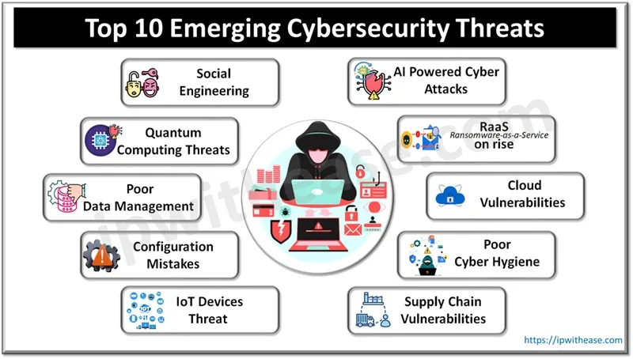
Figure 1 – Modern Cybersecurity Threats[4]

Task

Identification of Modern Threats

SteelForm Manufacturing Ltd (SFM) operates in an Industry 4.0 environment that integrates IT, OT, IoT, cloud computing, and automated production systems to improve efficiency. While these technologies enhance productivity, they also increase exposure to cyber threats, including production disruption and intellectual property theft. Identifying internal and external threats is essential to developing an effective cybersecurity strategy.

External Threats

SteelForm Manufacturing Ltd (SFM) faces several external cyber threats due to its interconnected Industry 4.0 environment. Key risks include ransomware attacks that can disrupt production and encrypt critical data, AI-powered phishing campaigns that steal employee credentials[5], supply chain compromises through trusted vendors, cloud security weaknesses caused by misconfigurations or weak access controls, and attacks on IoT and Operational Technology (OT) devices that could disrupt manufacturing processes and compromise operational safety[1]. Addressing these threats is essential to protect business continuity, sensitive data, and production systems.

Internal Threats

Internal threats at SteelForm Manufacturing Ltd (SFM) may result from intentional insider actions or accidental employee mistakes. Risks include unauthorised access to sensitive data, sharing credentials, installing unapproved software, and human errors such as falling for phishing emails, using weak passwords, or misconfiguring cloud systems. Weak access controls and excessive user permissions further increase the risk of unauthorised access[6]. Strengthening employee cybersecurity awareness and enforcing the Principle of Least Privilege (PoLP) are essential to reducing these internal risks.

Table 2 – Modern Cybersecurity Threats Facing SteelForm Manufacturing
Threat | Type | Likelihood | Business Impact | Overall Risk
Ransomware-as-a-Service (RaaS) | External | Very High | Production shutdown, financial loss | Critical
AI-powered Phishing/Vishing | External | High | Credential theft and malware infection | High
Supply Chain Compromise | External | Medium | Intellectual property theft | High
Cloud Misconfiguration | Internal/External | Medium | Data breach | Medium
IoT/ICS Attack | External | High | Production disruption | High
Insider Threat | Internal | Medium | Data leakage | High
Human Error | Internal | High | Security incidents | High
Weak Access Controls | Internal | Medium | Unauthorised access | Medium

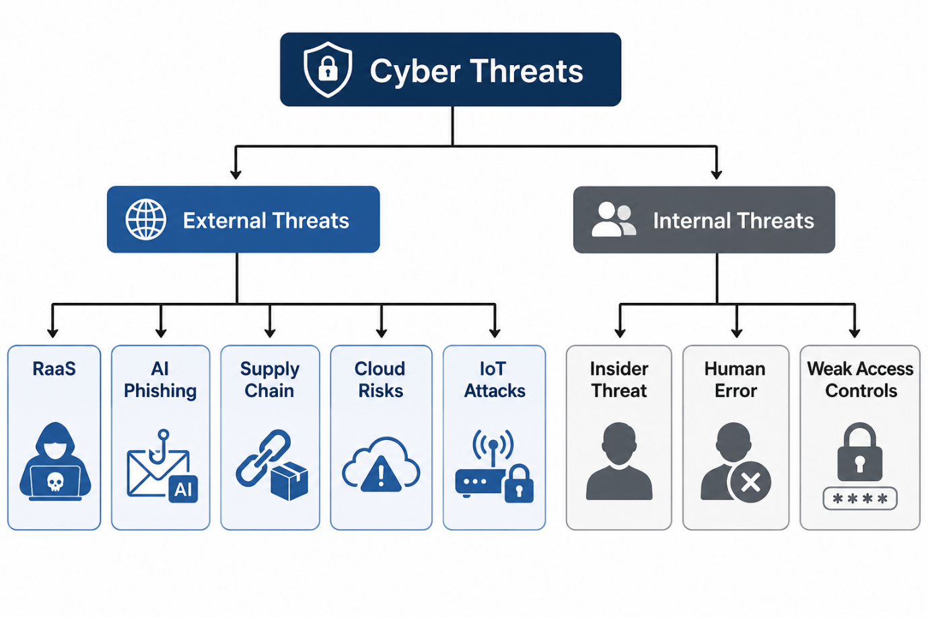
Figure 2 – Internal and external cybersecurity threats

Table 3 – Threat Prioritisation
Risk Level | Threats | Priority
Critical | Ransomware-as-a-Service | Immediate action
High | AI-powered phishing, IoT attacks, insider threats, human error, supply chain compromise | High priority
Medium | Cloud misconfiguration, weak access controls | Planned improvement
Low | Routine malware detected by endpoint protection | Continuous monitoring

The analysis demonstrates that SFM faces a diverse range of internal and external cybersecurity threats due to its adoption of Industry 4.0 technologies and interconnected manufacturing systems. External threats such as ransomware, AI-powered phishing, supply chain compromises, and IoT attacks present significant risks to operational continuity, while insider threats, human error, and inadequate access controls increase the likelihood of accidental or intentional security breaches. Understanding these threats provides the foundation for developing robust security policies and implementing targeted technical controls, which are discussed in the following section.

Modern Security Policies

SteelForm Manufacturing Ltd (SFM) should adopt cybersecurity policies based on the Zero Trust model, ensuring all users and devices are continuously verified before accessing systems. Security measures should align with the NIST Cybersecurity Framework (CSF 2.0) and ISO/IEC 27001:2022 and include Role-Based Access Control (RBAC), Multi-Factor Authentication (MFA), strong password policies, data classification, encryption, regular backups, and acceptable use policies[7]. Together, these controls reduce the risk of unauthorised access, data breaches, and operational disruption while supporting the confidentiality, integrity, and availability of organisational data.

Table 4 - Proposed Security Policies for SteelForm Manufacturing
Security Policy | Purpose | Related Framework
Zero Trust Access Policy | Verify every user and device before granting access | NIST CSF 2.0
Role-Based Access Control (RBAC) | Restrict access based on job responsibilities | ISO/IEC 27001
Multi-Factor Authentication (MFA) | Protect user accounts from credential theft | NIST CSF
Data Classification Policy | Protect sensitive business information | ISO/IEC 27001, GDPR
Backup and Recovery Policy | Ensure business continuity after cyber incidents | NIST CSF
Acceptable Use Policy | Promote secure use of company systems and devices | ISO/IEC 27001

Table 5 - Alignment of Security Policies with the CIA Triad
CIA Principle | Example Policy | Benefit to SFM
Confidentiality | MFA, RBAC, Data Classification | Prevents unauthorised access to sensitive information
Integrity | Change Management, Patch Management | Protects data from unauthorised modification
Availability | Backup and Disaster Recovery | Maintains production during cyber incidents

Technical Mitigation Measures

To reduce cyber risks, SFM should implement technical controls that protect its IT and operational technology (OT) environments. Multi-Factor Authentication (MFA) should be enabled for all user accounts to prevent unauthorised access, while Role-Based Access Control (RBAC) should ensure employees only access systems required for their roles. Regular patch management should be carried out using the CISA Known Exploited Vulnerabilities (KEV) catalogue to prioritise critical security updates.
Continuous monitoring should be achieved through a Security Information and Event Management (SIEM) system, which collects and analyses security logs to detect suspicious activity. Endpoint Detection and Response (EDR) software should be installed on all company devices to identify and isolate malware before it spreads. Fixed backups should be maintained and tested regularly to ensure production systems can be restored quickly after a ransomware attack[8].

Table 6 - Technical Mitigation Measures
Threat | Mitigation Measure | Implementation
Ransomware | Immutable backups | Daily backups with offline storage
Phishing | MFA and email filtering | Secure email gateway and MFA
Insider Threat | RBAC | Least privilege access
Malware | EDR | Real-time endpoint monitoring
Unpatched Systems | Patch Management | Updates based on CISA KEV
Cloud Risks | CSPM | Continuous cloud security monitoring

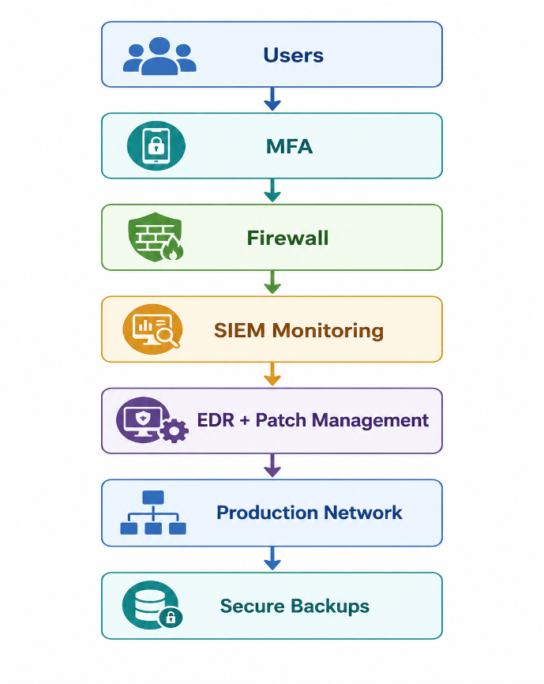
Figure 3 – Layered Security Control

Proactive Monitoring and Incident Response

SFM should implement 24/7 network monitoring to identify and respond to cyber threats before they disrupt operations. A Security Information and Event Management (SIEM) platform should collect and analyse logs from firewalls, endpoints, cloud services, and IoT devices. Automated responses using Security Orchestration, Automation and Response (SOAR) can quickly isolate compromised systems, reducing the impact of attacks such as ransomware[9].
When a security incident occurs, SFM should follow a structured response process that includes identifying the threat, containing affected systems, removing malicious activity, restoring operations from secure backups, and reviewing the incident to prevent future occurrences. Regular testing of the incident response plan will ensure the organisation is prepared for real cyber incidents.

Table 7 – Incident Response Process
Phase | Activity
Detection | Identify suspicious activity using SIEM alerts
Containment | Isolate affected devices and accounts
Eradication | Remove malware and patch vulnerabilities
Recovery | Restore systems from secure backups
Review | Analyse the incident and improve security controls

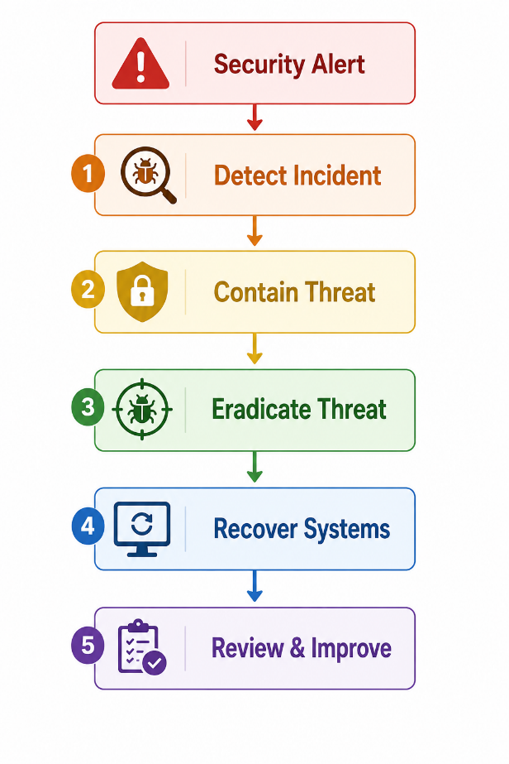
Figure 4 – Incident Response Flowchart

Continuous Training and Awareness

A continuous cybersecurity awareness programme is essential to reduce human error and strengthen SFM's security culture. All employees should receive regular training on recognising phishing emails, AI-powered vishing attacks, password security, and safe data handling[5]. Role-specific training should also be provided to IT staff, engineers, and procurement teams to address the unique risks associated with their responsibilities[9].
To measure effectiveness, SFM should conduct simulated phishing campaigns and periodic security awareness assessments. Employees who fail these exercises should receive additional training. This continuous approach helps improve staff awareness, encourages timely reporting of suspicious activities, and supports compliance with the company's security policies.

Table 8 – Cybersecurity Training Programme
Target Group | Training Topic | Frequency
All Employees | Phishing and password security | Quarterly
Procurement Staff | Phishing and Business Email Compromise | Quarterly
Engineers | OT/IoT security awareness | Every 6 months
IT Team | Incident response and SIEM | Every 6 months
New Employees | Cybersecurity induction | On joining

Conclusion

The analysis indicates that SteelForm Manufacturing Ltd faces increasing cybersecurity risks due to its adoption of Industry 4.0 technologies and connected manufacturing systems. Implementing security policies based on the Zero Trust model, supported by technical controls such as MFA, SIEM, and regular employee training, will strengthen the organisation's resilience against cyber threats. It is recommended that SFM continuously reviews its cybersecurity strategy in line with NIST CSF and ISO/IEC 27001 standards[2].
Future improvements should include adopting AI-driven threat detection, enhance IoT security, and conduct regular penetration testing to address emerging cyber risks.

References

[1] V. Pedreira, D. Barros and P. Pinto, "A review of attacks, vulnerabilities, and defenses in industry 4.0 with new challenges on data sovereignty ahead," vol. 21, no. 15, pp.5189, 2021,
[2] M. Toussaint, S. Krima and H. Panetto, "Industry 4.0 data security: A cybersecurity frameworks review," vol. 39, pp.100604, 2024,
[3] M. Al-Hawawreh, M. Alazab, M. A. Ferrag and M. S. Hossain, "Securing the Industrial Internet of Things against ransomware attacks: A comprehensive analysis of the emerging threat landscape and detection mechanisms," vol. 223, pp.103809, 2024,
[4] Rashmi Bhardwaj. "Top 10 Emerging Cybersecurity Threats 2026." www.ipwithease.com. Accessed: 20 July 2026. [Online]. Available: https://ipwithease.com/top-10-emerging-cybersecurity-threats/
[5] A. J. G. De Azambuja, C. Plesker, K. Schützer, R. Anderl, B. Schleich and V. R. Almeida, "Artificial intelligence-based cyber security in the context of industry 4.0—a survey," vol. 12, no. 8, pp.1920, 2023,
[6] R. S. Sandhu, "Role-based access control," in Advances in computers, Elsevier, 1998. pp. 237–286.
[7] I. A. Alnajjar, A. A. Salameh, L. Almazaydeh and A. Al Tawil, "Two-tier forensic readiness architecture for Zero Trust-enabled Industry 4.0 applications," pp.1–18, 2025,
[8] A. B. Ajmal, M. Alam, A. A. Khaliq, S. Khan, Z. Qadir and M. P. Mahmud, "Last line of defense: Reliability through inducing cyber threat hunting with deception in scada networks," vol. 9, pp.126789–126800, 2021,
[9] A. Alshamrani, S. Myneni, A. Chowdhary and D. Huang, "A survey on advanced persistent threats: Techniques, solutions, challenges, and research opportunities," vol. 21, no. 2, pp.1851–1877, 2019,

Appendix



