Everton Small

Module:Employability and Career Development
Student ID: 2420184
Module Code: LCLM4005
Lecturer: Sylvia Hoffmann
Group: 3

Everton Small
Flat 2 Pineview Court
3 The Ridgeway
E4 6TL
Hiring Manager,
Fathers Farm Foods
London
November 14, 2025
Dear Sir/Madam,
I am writing to express my keen interest in the position of Field Sales Representative with Fathers Farm Food that was advertised on the Indeed job platform. With 20 years of experience in this field and a proven track record, skillset and achievements, I am confident that I possess the requisite to make a significant contribution to your organisation. My previous role has given me a vast knowledge of the marketplace and couple with my enthusiasm and dedication, I believe that I can contribute to help the organisation to achieve its goals. I am therefore confident that with my help the organisation can realise a greater level of success. Thank you for your time and consideration. I have attached my resume for your review and look forward to hearing from you soon.
Yours faithfully,
Everton Small


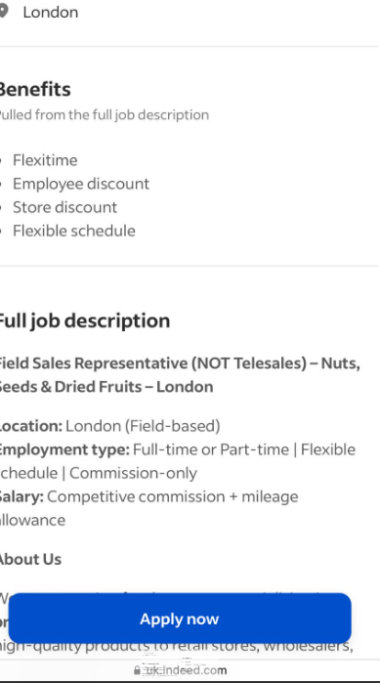

Everton Small
07506374251
Yardkore@hotmail.com

Enthusiastic and results oriented with 20 years of experience in this field and a proven track record, skillset and achievements, I am confident that I possess the requisite to make a significant contribution to your organisation.

Key Skills
- Communication skills
- Negotiating ability skills
- Interpersonal skills
- Problem solving skills
- Time management skills

Achievements
- Consistently exceeded sales targets and recognised as a Top Salesperson

Employment History
- Owned and operate Diamond Commodities Limited (July 2004- Present)

Responsibilities
- Establish new business opportunities and servicing existing clients
- Maintain excellent business repour and identify new products and services
- Manage customer relationships and maintain regular follow up
- Achieve monthly sales targets and report activity updates

Hobbies and Interest
- Camping and hiking
- Socialising and engaging in sports activities
- Passion for reading, music and travelling
- Active involvement in the church community

Reference available upon request

