Property Services Lewis Elliott Consultants(LEC) Ltd
Carmarthenshire County Council Cross Hands Industrial Estate
Block 3 Parc Myrddin, Carmarthenshire
Carmarthen,
SA31 1HP,
Carmarthenshire 16th January 2023

Project: Ysgol Glangwili
Project No: 5010

Dear Sir/Madam,

LEC Ltd is delighted to be involved in the Ysgol Glangwili scheme and assist in delivering a state-of-the-art 90 pupil primary school with a 48 PT nursey provision in the heart of Carmarthen. As you are already aware the 21st Century Schools Programme led by the Welsh Government now known as ‘Sustainable Communities for Learning’ promotes the importance of effective asset management. As requested, this letter and report provide information on how Building Information Modelling (BIM) will be incorporated into all stages of the scheme and executed to comply with all minimum standards and funding requirements.
The report is appended (Appendix 1) to this letter explaining a clear method of demonstrating Level of Information need throughout the RIBA stages and how you as the client can convey this to the bidding contractors hopefully assisting you in your requirement for whole life monitoring of the new school through a computer aided facility management system (CAFM). This document known as ‘Exchange Information Requirements’ will allow the appointed contractor to produce a BIM Execution Plan in response detailing how they will achieve your needs in relation to BIM.
BIM is a process underpinned by digital technologies (CITB,2021) which helps the industry be more innovative and exploits the never-ending advancement of technology. LEC Ltd understands that it can appear challenging as this new development is required to achieve level 2 BIM maturity, but we can assure you that the rewards are extremely beneficial not only to project efficiency during construction but also support efficiency beyond delivery (Shepherd, 2015).
BIM maturity Level 2 is defined in the Department for Business, Innovation, and Skill’s BIM Working Party strategy paper as “A managed 3D environment held in separate discipline “BIM” tools with data attached. Commercial data will be managed by enterprise resource planning software and integrated by proprietary interfaces or bespoke middleware. This level of BIM may utilise 4D construction sequencing and/or 5D cost information” (Shepherd, 2015).
To explain the above in more a simplistic way, to achieve the level 2 maturity requirements information to must be shared, coordinated, and managed in a common data environment (CDE) whilst adhering to BS EN ISO 19650 (TEJJY,2022). The EIR and BIM execution plan (BEP) form the main back bones to securing compliance and all site-specific aims and objectives are met
A CDE is a digital location where all project related information can be collated in a single place. The concept behind this environment allows for information to travel through 4 different virtual locations as its status develops through the project. Firstly, all information in relation to individual task teams as they develop their work will begin in their allocated location separate from other teams. Secondly, on completion of these concepts the information will become available to be reviewed by all team members to analyse all work before moving to the next virtual space where all reviewed information is published for construction.
Finally, the information will retire in the archives where it can be maintained for asset management and provide an audit trail. By segregating the information into these stages, it encourages collaboration and the opportunities to expose any potential input by incorporating all parties input from the beginning.
This can help in many ways towards Health and safety improvements by understanding potential risks earlier on (Mordue, Swaddle and Philp, 2016) t and help towards other Welsh Government funding requirements such as carbon reduction and energy savings by running simulations and testing lifecycle concepts in the model environment at pre-construction stages. By sharing information collaboratively through a Common Data Environment (CDE) it encourages the whole team to work together with mutual trust and cooperation as inevitably everyone is working in the same boat (Shepherd, 2015). The process follows:
Work in Progress > Sharing/collaborative input > Published > Archived
Please see Appendix 1 for examples and further information to be considered when developing your exchange information requirements. Previously, The PAS 1192-2 standard defined EIR as the Employer Information Requirements, this has now changed in line with BS EN ISO 19650 to the word exchange instead of employer to emphasise the importance and need to focus on how information is exchanged.
A BIM Execution Plan is a “Plan that explains how the information management aspects of the appointment will be carried out by the delivery team” (ISO 19650-2:2018 (3.1.3.1)). There are two BEP submission required one pre appointed which forms part of the tender stage responding to the clients BEP and one to be submitted post award defining in detail the Contractors and their appointed sub team’s information management approach with thorough plans and schedules.
The pre contract BEP should include all roles and responsibilities and demonstrate their standard protocols that are used for BIM projects and their methods for collaboration, information exchange and BIM deliverables. This document should also contain a capability and competency assessment to evidence that each sub team working on the scheme has the relevant knowledge and experience to manage the information.
After the tender has been awarded and a contractor is on board, they are required to ensure that the BEP is comprehensively developed to outline and clearly define how the EIRs will be met. It should also show at each RIBA stage what is required and who’s responsible for induvial elements.
All teams involved in the project should be included in this exercise overlooking and documenting what information is required, when the information is to be exchanged, who the information is to be exchanged with and who’s responsible for its production. This can be referred to as a responsibility matrix.
The International standard BS EN ISO 19650 outlines the concepts and principals for information management and recommendations for a framework to manage information including exchanging and recording by standardising processes specific with flexibility to accommodate site specific requirements (McPherson, 2022).
ISO 19650-1 gives an overview of the concepts and principles for the management of information throughout the entire asset lifecycle through both the delivery and operational phase.
ISO 19650-2 covers the information management process for the management of information during the delivery phase of assets.
ISO 19650-3 covers the information management process for the management of information during the operational phase of assets.
ISO 19650-4 details the effective exchange of information between parties.
ISO 19650-5 explains how to adopt a security-minded approach to managing information.
PD 19650-0-2019 is the transitional guide from the PAS 1192 to the newer BS EN 19650 standard (The BIM Centre, no date). The ISO 19650 helps you as a client achieve the benefits, already mentioned such as improving accuracy and limiting human error through collaborative working.
LEC Ltd hopes the overview provides a thorough outline of the measures required to reach BIM Maturity requirements. If you have any further queries, please don’t hesitate to contact me.

Kind Regards,

Elliott Lewis

Mr Elliott Lewis
(Lead Consultant)
Contact @ eml@LEC.co.uk

Appendix 1 – Report
Exchange Information Requirements
This report will explain the key information required in a compliant Exchange Information Requirement (EIR) document and provides example to assist in creating a site specific EIR that meets Project 5010 specific needs.
Table of Contents
1.0 EIR overview 5
1.1 Standards both international and UK 5
1.1.1 Case study example 5
1.2 Levels of Detail 5
1.2.1 Classifying Level of Detail (LOD) 5
1.2.2 Case Study examples 6
1.3 Planning of work data segregation 6
1.4 Clash Detection 6
1.5 Collaboration Processes 6
1.6 Health and Safety and Construction Design Management (CDM) 6
1.7 Naming conventions 7
1.7.1 Example Naming convention layout 7
1.8 Exchange of information 8
1.9 Competence Assessment 8
The EIR should set out that the BEP provided by the appointed contractor will be assess against the information requirements of the project which is a minimum response to the EIR (Bricks Blog, 2022) 8
1.10 A schedule of all software formats 9
1.11 Asset Information Model 9
1.12 Additional information 9
2.0 Conclusion 9
3.0 References 9
4.0 Appendices 11

1.0 EIR overview

The EIR shall include as a minimum:

1.1 Standards both international and UK
A schedule of the standards and guidance documents used to define the BIM processes and protocols to be used on the project.

1.1.1 Case study example
The appointed parties shall confirm their compliance with the following standards, as well as identify any additional standards to be complied with as part of their BIM Execution Plan.
Core BIM Level 2 Standards | Additional Standards
BS EN ISO 19650 Part 1  BS EN ISO 19650 Part 2  BS 1192-4:2014  PAS 1192-5:2015  BS 8536-1:2015  BS 8536-2:2016 | BS 7000-4  BS 8541-1  BS 8541-2  BS EN ISO 4157-2  BS EN ISO 55001
(CCC EIR)

1.2 Levels of Detail
Levels of detail requirements for information submissions at defined project stages. This information is populated in a production and delivery table (Biblus, 2022). The ISO 19650 Standard makes a conscious effort to reinforce the minimisation of information waste. It is vital to find the balance as too little information in the level of detail requirements can lead to mistakes and miscommunication while on the other hand requesting too much information is waste of time and money.

1.2.1 Classifying Level of Detail (LOD)
LOD 1 -Face value model information such as the design brief of the proposed project, specific site constraints, performance requirements
LOD 2- Model information such as responses to the brief and concept, early design development and model that assist with sequencing and basic estimates/feasibility
LOD 3- A dimensionally precise model which coincides with the initial design brief and performance requirements
LOD 4- A accurate model that can be used to assess compliance against statutory regulations and for planning permission submissions. Information that is accurate enough to begin involving specialist contractors to start their design models.
LOD 5- A fully complete accurate model including all coordinated specialist contractors deigns that can be used for coordination of fabrication information.
LOD 6- A like for like correct model of the assets as constructed on site incorporating maintenance and operation information.
LOD 7- Any revisions to the as built asset such as design changes or change of use information. Also, all performance and condition data during life cycle of the asset.

1.2.2 Case Study examples
The plan of works examples are in accordance with the RIBA 2013 Stages 0-7 alignment of information exchanges at completion of each work stage. See Appendix A and B for example Production and Delivery Tables. Appendix B demonstrates a project which is structured by data drops. A data drop is meant to capture a project at a particular design, construction, and handover stage. It must contain all the information mandated by the EIR and AIR.
As seen in Appendix A showing a production and delivery table for a school each element required is broken down. For example, a basic brief specific space planning model should be complete at RIBA stage 1. As this information develops the architects develop this to LOD 2 with basics design concepts before passing this development over to the contractor who will progress the information available to dimensionally precise drawings. And then finally by stage 6 an accurate as built model is required. This table is an effective and clear way to demonstrate what is required, when and by who.

1.3 Planning of work data segregation
It is important to set out clearly what the contractor’s requirements are. To achieve the information needed the contractor should before the production of any information complete both the pre and post appointment BEP and complete a Master Information Plan (MIDP) (Hardin and Mccool, 2015). To ensure the suitability of the MIPD the sub teams must confirm in their BEP how the information requirements of other project team members have been considered and incorporated into the MIDP. Setting out the need to agree a co-ordination procedure and the data segregation procedure will assist in having an effective CDE in place in compliance with the naming protocol in BS EN ISO 19650-2:2018 (BSIGroup,2021).

1.4 Clash Detection
Clashes can be costly and eat away at project timescales therefore to prevent any potential issues and achieve the level 2 maturity requirements the contractor should be asked to include details of the clash detection/avoidance process they intend on using (White, 2018). Software such as Bentley Navigator, Autodesk Navisworks and many others which are available help comply with preventing and managing clashes (Shepherd, 2015).

1.5 Collaboration Processes
Collaboration is key driver behind the whole BIM process and requesting the appointed contractor to provide suitable collaboration process complying with CDE requirements within BS EN ISO 19650 is vital. Information such as the frequency of information exchange, form of sharing and any model review workshops.

1.6 Health and Safety and Construction Design Management (CDM)
Both the client and appointed contractor under the CDM regulations 2015 have a responsibility to comply with their health and safety obligations (There’s no BIM like home, no date). BIM can be used to demonstrate these obligations against each RIBA stage and give an overview of key health and safety deliverables and how they can be stored.

1.7 Naming conventions
The naming protocol that is requested for the appointed contractor to follows should comply with BS 1192:2007+A2:2016 and be used consistently by all members of the design team, and others involved within the project (Bimicon, 2021). If the approach is used from the outset, it will become much easier to structure find and distribute documents and drawings therefore it is vital to make this clear in the EIR.

1.7.1 Example Naming convention layout
There are usually two standards. One for drawings/models, and the other for generic documents. See example below.
A – Unique Property Reference Number (UPRN)
B – Job Number
C – Originator
D – Roles
E – Block No.
F – Level
G – Type
H – Element
I – Drawing/Document Number
J – Description

Naming protocol for drawings / model
Example of drawing file name

2080 – 001 – LEC – A – B21 – XX – GA – (20) – 001A EXISTING FLOOR PLAN

A B C D E F G H I J
Most drawings will be named as per example.

Naming protocol for documents
Example of documents file name.

2080 – 001 – LEC – S – RP – 001 STRUCTURAL REPORT

A B C D G I J

- UPRN (Unique Property Reference Number)
This would be 5010 in the case of the proposed Ysgol Glangwili.
- JOB NUMBER
This number will need to be issued in the EIR.
- ORIGINATOR
This will be the organization responsible for the drawings / documents.
(Council, 2019)

1.8 Exchange of information
In the EIR it is important to clearly set out what information is required to satisfy the exchanged decision points at each work stages and set out triggers for when information must be updated. Examples of these triggers commonly used within the industry are following major works, performance evaluation/testing of an asset/component. At certain RIBA stages it is good practice to evaluate and ensure certain site-specific question can be answered before progressing the works to the next RIBA stage.
See Appendix C for examples of information requirement at varying RIBA stages that can be used to set out in the EIR questions that must be answered and presented to the client before each RIBA stage is signed off.

1.9 Competence Assessment

The EIR should set out that the BEP provided by the appointed contractor will be assess against the information requirements of the project which is a minimum response to the EIR (Bricks Blog, 2022)

1.10 A schedule of all software formats
This is where the EIR should set out the clients formatting needs. Example below for reference.
File Type | Format | Version
Graphical Models | Native  IFC | n/a  2x3
Non-graphical Models | Excel | 2013
2D Drawings & Documentation | PDF  DWG | No older than version 7.0  n/a
(Council, 2019)

1.11 Asset Information Model
See Appendix D showing an example AIM demonstrating the required minimum information needed to be captured for each component category.

1.12 Additional information
Other Information that should be contained within the EIR are:
- Client’s strategic purposes
- A responsibility matrix showing all discipline responsibilities for model or information production in line with the defined project stages.
- Any security and integrity requirements for the project.
- A schedule of any specific information to be either excluded or included from information models
- Compliance plan
- A schedule of any software formats

2.0 Conclusion
The above sets out the core requirements to include in the EIR, with supporting examples to assist Carmarthenshire Council in making a formal decision on how they wish to proceed.
The details provided will help determine what information is required for the Ysgol Glangwili project at each stage to achieve compliant BIM maturity and assist in the future management of the building during its entire lifecycle.

3.0 References

Biblus, T.D. (2022). Exchange Information Requirements: What is an EIR in BIM? [online] BibLus. Available at: https://biblus.accasoftware.com/en/exchange-information-requirements-what-is-an-eir-in-bim/ [Accessed 10 Jan. 2023].
Bimicon (2021). A Simple BIM Naming Convention Based on ISO 19650 Part 1 - BIMicon. Available at: https://www.bimicon.com/bim-naming-convention-based-on-iso19650-part1/#:~:text=A%20Simple%20BIM%20Naming%20Convention%20Based%20on%20ISO [Accessed 10 Jan. 2023].
Bricks blog. (2022). What is a BIM execution plan. [online] Available at: https://blog.bricksapp.io/blog/en/bim-execution-plan/#:~:text=A%20BIM%20Execution%20Plan%20%28BEP%29%20is%20a%20document [Accessed 10 Jan. 2023].
Bsigroup (2021). BS EN ISO 19650-3 Transition Guide. Available at: https://www.bsigroup.com/en-GB/iso-19650-BIM/bs-en-iso-19650-3-transition-guide/ [Accessed 09Jan. 2023].
CITB (2021) What is BIM? - CITB. Available at: https://www.citb.co.uk/about-citb/partnerships-and-initiatives/building-information-management-bim-for-site-workers/what-is-bim/. [Accessed 09 Jan. 2023].
Council, C. (2019) EIR CASE Study.
Hardin, B. and Mccool, D. (2015). BIM and construction management : proven tools, methods, and workflows. Indianapolis: Sibex A Wiley Brand.
McPherson, M. (n.d.). The Ultimate Guide to ISO 19650 in 2023. [online] 12d Synergy. Available at: https://www.12dsynergy.com/iso-19650-guide/#:~:text=Beneath%20the%20befuddling%20terminology%20and%20details%2C%20the%20basic [Accessed 09 Jan. 2023]
Mordue, S., Swaddle, P. and Philp, D. (2016). Building information modeling for dummies. Chichester, West Sussex, United Kingdom: John Wiley And Sons, Inc.
‌Shepherd, D. (2015). BIMManagement Handbook. 15 Bonhill Street, London, EC2P 2EA: RIBA Publishing, pp.1–154
TEJJY, (2022). Common Data Environments (CDE) for BIM & Construction. [online] Available at: https://www.tejjy.com/common-data-environment-for-bim/#:~:text=A%20Common%20Data%20Environment%20%28CDE%29%20is%20a%20digital [Accessed 11 Jan. 2023].
The BIM Centre. (n.d.). What you need to understand about PAS 1192. [online] Available at: https://www.thebimcenter.com/2018/11/what-you-need-to-understand-about-pas1192.html#:~:text=PAS%201192%20is%20a%20set%20of%20specifications%20for [Accessed 6 Jan. 2023].
There’s no BIM like home. (n.d.). Standards, Methods and Procedures. [online] Available at: https://bimblog.house/category/standards-methods-and-procedures/ [Accessed 10th Jan. 2023].
Virtual Building Studio (2019). What Is BIM Level 2 And What Are Its Requirements? [online] Available at: https://www.virtualbuildingstudio.com/bim-level-2// [Accessed 11 Jan. 2023].
White, S. (2018). Guidance Note 2 BIM introduction and workflow. Forum Court Office 205, Devonshire House Business Centre 29-31 Elmfield Road Bromley Kent UK BR1 1LT: Federation of Piling Specialists, pp.1–4.

4.0 Appendices

Appendix A - Example Production and Delivery Table
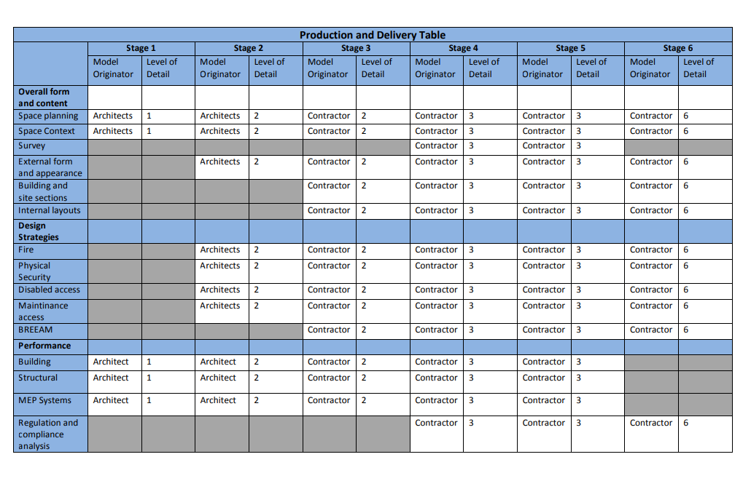
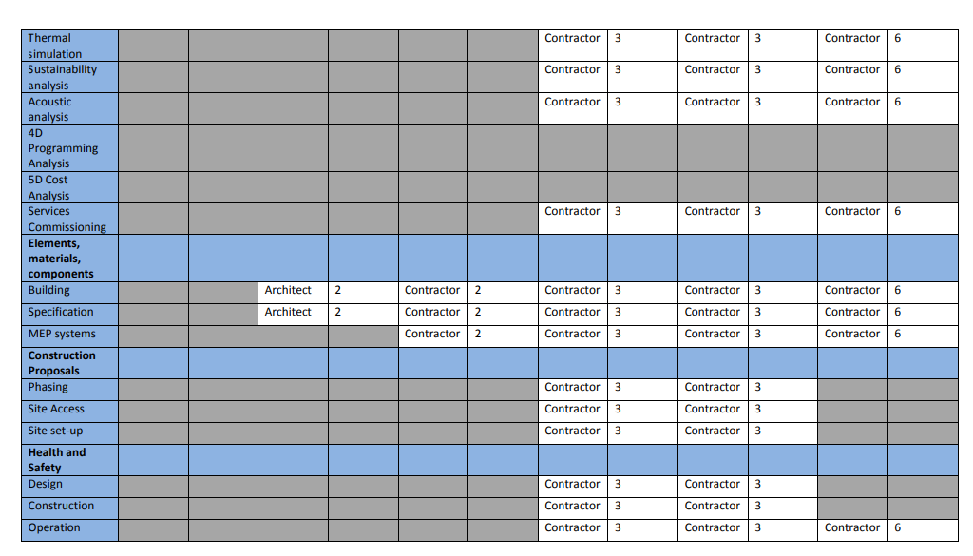
(Council, 2019)

Appendix B - BIM Management Handbook Production and Delivery Table

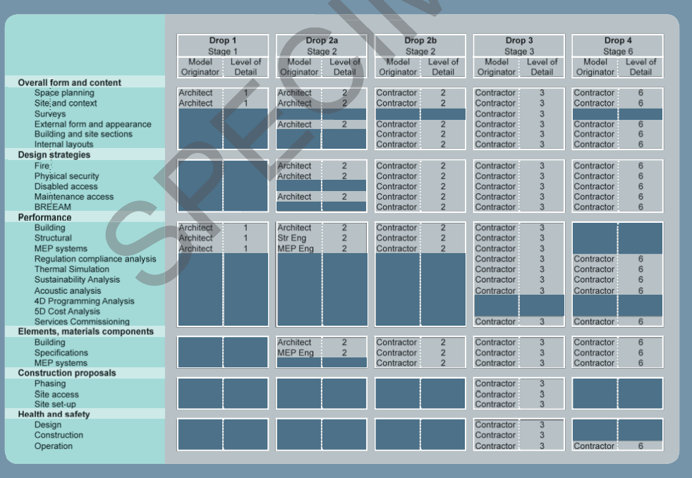

(Shepherd, 2015)

Appendix C – RIBA Stage Checklist
The following questions are to be answered at the end of this stage:
RIBA Stage 3 Developed design
1. What is the pre-design solution? In particular, what are the layouts?
2. Does the architecture represented within the model meet the vision?
3. Does the design’s performance meet the design brief?
4. What is the outline proposal for structural design?
5. What are the output requirements from services systems?
6. What is the commissioning strategy and how can it be tested?
7. Can the designers show the project can be delivered safely?
8. What is the preliminary cost estimate?
RIBA Stage 4 Technical Design
The following questions are to be answered at the end of this stage:
1. Is the model developed to demonstrate detailed proposals for planning and spatial Arrangements?
2. Is the design model developed to demonstrate detailed proposals for elevation treatments?
3. Is the design model developed to demonstrate detailed proposals for environmental systems?
4. Is the design model developed to demonstrate detailed proposals for buildability?
5. How is the asset built and what are the task durations?
6. How has health and safety been considered?
RIBA Stage 5 Construction
The following questions are to be answered during this stage:
1. How will the construction site be managed safely?
2. How will the client be consulted with respect to changes and variations?
3. How will the contractor ensure that commissioning is transparent?
4. How will changes be recorded and stored for auditing?
5. How will soft landings be managed?
6: How will Passivhaus certification be managed?

RIBA stage 6 Handover
The following questions are to be answered at the end of this stage:
1. Does the project meet the brief?
2. What changes have been incorporated?
3. What has been built?
4. How does a specific product/element perform?
5. How will the asset be operated?
6. How is the asset to be maintained?
7. Does the as-built BIM accurately represent the building?
8. Is all data integrated as per the EIR and do all datasets adhere to the correct structure and classification?
9. Has the digital health and safety file been created?
10. Has the digital project quality file been created?
11: Has Passivhaus certification been achieved and signed off?
(Council, 2019)

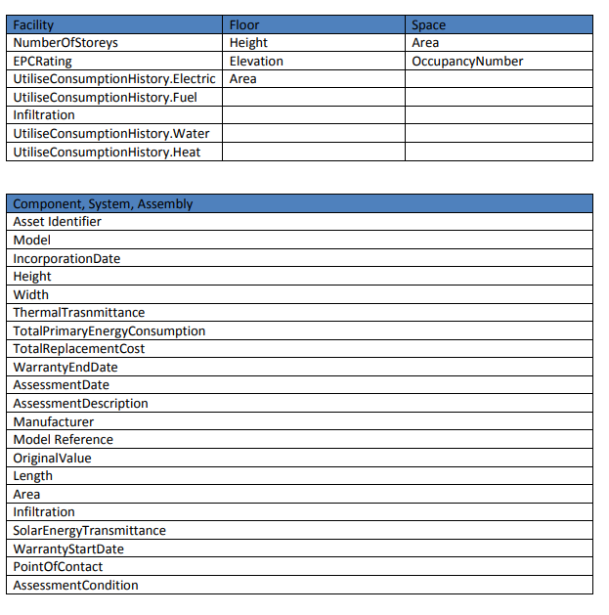
Appendix D - Data Requirements


