

School of Engineering
Aerodynamic Vehicle Testing and Analysis
Zhaocong Sun
1805164
Automotive Engineering Beng
09/01/2019
Advanced Vehicle Dynamics M6X00415

Content
Notations 3
0. Introduction 3
1. Research and study 3
1.1 Aerodynamic principles 3
1.2 Some research about $CL$ and $CD$ 4
1.3 Frontal Area 5
2. Test 6
2.1 Overall Test Plan 6
2.2 Detailed Test schedule 6
2.3. Instructions for the driver 7
3. Methodology 7
3.1 Math Channels in MoTeC 7
3.1.1 Define Static load 7
3.1.2 Calculate Corner Radius 8
3.1.3 Calculate Theoretical Steer 8
3.1.4 Calculate Longitude Weight Transfer 9
3.1.5 Calculate Aero Load 9
3.1.6 Calculate the center of pressure 9
3.1.7 Created Math Channel 10
3.2 Methodology used in MATLAB 10
4. Analysis 12
4.1 The aim of the analysis 12
4.2 Calculate $CL$ & $CD$ 12
4.2.1 Calculate $CL$ 12
4.2.2 Calculate $CD$ with EXCEL 13
4.2.3 Calculate $CD$ with MATLAB 16
4.2.4 Analysis 19
4.3 Data traces to show lift and drag 20
4.4 Total lift versus speed x-y plot 21
4.5 Lateral acceleration versus speed x-y plot 22
4.6 Indicate the downforce at f and r axles. 23
4.7 Center of Pressure 24
4.8 The effect of static ride height and rake angle 25
5. Conclusion 26
6. Reference 27

Notations
$C_{L}$-Aerodynamic lift coefficient
$C_{D}$-Aerodynamic drag coefficient
Cop-Centre of pressure

0. Introduction
Race car performance depends on many elements such as engine, geometry, suspension, drivers and aerodynamics. In recent years, vehicle aerodynamics has attracted increased attention. In addition, mass of vehicle, tire slip angle, wings angle and the static ride height has a great influence on vehicle performance.
In order to analyze the handling performance and aerodynamic performance of the vehicle, our group design and undertake practical vehicle tests to collect suitable data from the simulator. The coasting test is designed to calculate rolling resistance, $C_{L}$ and $C_{D}$, and to analyze the handling performance and aerodynamic performance. There are also many circuit tests with different ride height designed to analyze the overall performance.
In this report, MoTeC is used to create several math channels to do the majority of calculations and analysis. MATLAB is used to handle the data extracted from MoTeC. All in all, this report will focus on the aerodynamic performance and handling performance of the vehicle using data collected from Base Performance Simulator.

1. Research and study

1.1 Aerodynamic principles
When the vehicle is on motion, in addition to the force from the ground, it is also affected by the aerodynamic force and moments of the airflow around it. The force from the ground is influenced by the mass, rolling resistance coefficient and center of gravity while the aerodynamic force is influenced by the velocity, geometry and wings angle and the ride height.

1.2 Some research about $C_{L}$ and $C_{D}$
The two basic measures of aerodynamic performance are downforce(lift) and drag. An increase in downforce provides the car with extra grip force, which improves the cornering capability of the vehicle. A decrease in drag lowers the resistance to accelerate, which improves the speed through high speed corners and on long straights. But if we want to increase the downforce, the drag would increase at the same time due to the increase of the rolling resistance. On most circuits, the engineer is usually balancing this trade-off to optimize lap time, or to give the car better performance at an overtaking point.
When the race car is on motion, the air would flow around its body and produce an aerodynamic force on the car. According to a lot of trails and researches[1]:
$$F=\frac{1}{2}ρv_{∞}^{2}AC_{F} (1)$$
Where $C_{F}$ is coefficient of aerodynamic force. The acting point of the aerodynamic force is called center of pressure(C.P). The aerodynamic force could be divided into three parts: Drag, Lift and Side.
$$Drag=\frac{1}{2}ρv_{∞}^{2}AC_{D}$$
$$Lift=\frac{1}{2}ρv_{∞}^{2}AC_{L}$$
$$Side=\frac{1}{2}ρv_{∞}^{2}AC_{S}$$
Drag will influence the total resistance and Lift will influence the maximum longitude force. In conclusion, Lift and Drag is essential to the aerodynamic performance. That is why we have to calculate the $C_{L}$ and $C_{D}$.

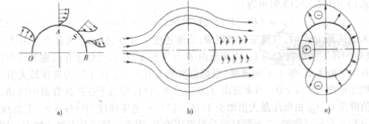
The aerodynamic drag is made of several parts: some from pressure difference, some from the friction between the air and the car body and some from Lift force.
Figure 1 Differential Pressure

The differential pressure resistance is formed by the moving air causing pressure difference in the front and rear of the car. It accounts for 50%~60% of the total aerodynamic drag of the car and is the main component of aerodynamic drag, which is shown in figure 1. The resistance caused by the friction between air and vehicle body contributes about 6% to 11% of the total aerodynamic drag. The separation of lift in the horizontal direction count 8%~15% of the total aerodynamic drag[2].

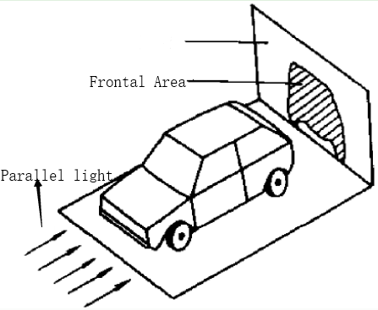
1.3 Frontal Area
Figure 2 The Frontal Area
The frontal area is defined as figure 2. When the parallel light shines into the front of the car, the shadow is the frontal area. We should use the frontal area as the area when calculating $C_{L}$ because we are calculating $C_{L}$ for the whole vehicle

2. Test

2.1 Overall Test Plan
To characterize the aerodynamic and handling performance of the GP2 Race car model, a set of vehicle tests is designed to utilize the Base Performance Simulator
Several coast down tests and circuit test were performed. The details about the test will be introduced below. In addition, some circuit tests with different wing angles and ride height are carried out for the analysis[3].

2.2 Detailed Test schedule
Test data: 2018/10/30
People: Group2 Students of AVD course
Detailed test schedule:
Table 1 Detailed test schedule
Coast down | Low f max r
Coast down | Low f mid r
Coast down | Max f Low r
Coast down | Max f mid r
Coast down | Mid f low r
Coast down | Mid f max r
Coast down | Max wings
Coast down | Mid wings
Coast down | Min wings
Coast down | Std wings
Snett | Low f max r
Snett | Max f low r
Snett | Min wings
Snett | Mid wings
Snett | Max wings
Snett | Std 58% front brake balance
Snett | Std gp2
Snett | Std wings low front rh max rear rh
Snett | Std wings max front rh low rear rh
Snett | Steady state
The detailed test schedule is shown in Table 1. Two out of the coast down tests is chosen to calculate the total aerodynamic lift coefficient ($C_{L}$) and the coefficient of drag($C_{D}$). In this report, I choose And the circuit tests with different ride heights and wings angle are chosen to analyze the overall vehicle performance.

2.3. Instructions for the driver
1) When doing the coast test, the vehicle should drive in a straight road. The driver should release the pedal until the velocity become steady and reached the set velocity value.
2) When doing the circuit test, the driver should remain their usual driving habits.
3) There should be someone helping the driver to set the parameters such as ride height, rolling resistance coefficient and so on.

3. Methodology

3.1 Math Channels in MoTeC

3.1.1 Define Static load
When the vehicle is on motion, there exits longitude weight transfer. The static load should be defined when the velocity is 0 as figure 3.
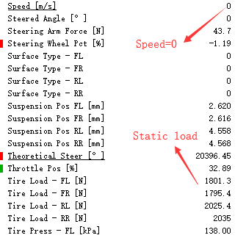
Figure 3 Tire Load data from MoTeC
Thus, define the static load(constant) as follows.
$$FL_Static=1801.3N$$
$$FR_Static=1795.4N$$
$$RL_Static=2025.4N$$
$$RR_Static=2035N$$

3.1.2 Calculate Corner Radius
The equation of centripetal force is
$$F=ma a=\frac{v^{2}}{r} (2)$$
Thus
$$Corner Radius=\frac{Mass×{Velocity}^{2}}{Lateral force}=\frac{{Velocity}^{2}}{\frac{Lateral force}{Mass×g}×g}=\frac{{Velocity}^{2}}{G Lateral force×g}$$

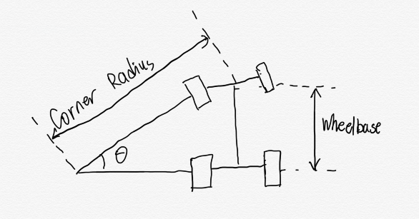
3.1.3 Calculate Theoretical Steer
According to the trigonometric function, this equation could be obtained:
Figure 4 Principle of theoretical steer
$$\cos{θ}=\frac{l}{r} (3)$$
If the $x$ is approximated to 0, $x$ is approximated to $\sin{x}$. Thus
$$Theoretical Steer θ=\sin^{-1}{\frac{wheelbase}{Corner Radius}}[rad]≈\frac{wheelbase}{Corner Radius}×\frac{180}{π}$$

3.1.4 Calculate Longitude Weight Transfer
According to the profile from Tim, the Load Transfer could be calculated with formula 4.
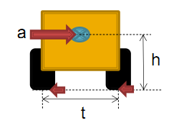
Figure 5 Load Transfer
$$Load Transfer=\frac{m×a×h}{t} (4)$$

Thus, longitude weight transfer can be calculated with :
$$Longitude weight transfer=\frac{Mass×G Force Long\left[G\right]×g×CoG}{Wheelbase}$$

3.1.5 Calculate Aero Load
Tire load is changing due to the changes of Aero Load and Longitude weight transfer. Thus, the Aero Load could be calculated as[4]:
$$Front Aero Load=Tire Load\left[FL\right]+Tire Load\left[FR\right]-{FL}_{Static}-{FR}_{Static}-Long WT$$
$$Rear Aero Load=Tire Load\left[RL\right]+Tire Load\left[RR\right]-{RL}_{Static}-{RR}_{Static}+Long WT$$

3.1.6 Calculate the center of pressure
As is taught in the course, the center of pressure could be calculated as below function[5].
$$Center of pressure=Front Aero load÷Total Aero Load (5)$$

3.1.7 Created Math Channel
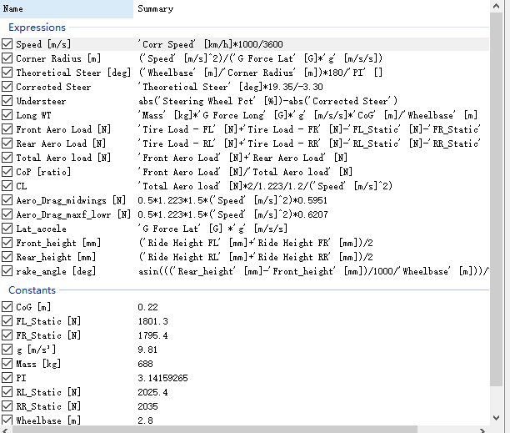
Figure 6 Created Math Channel

3.2 Methodology used in MATLAB
In the test, the rolling resistance $F_{f}$, the aerodynamic resistance $F_{w}$ and the accelerating resistance $F_{j}$ are the main resistances. During the driving process, the balance equation is:
$$F_{f}+F_{w}+F_{j}=0 (6)$$
The vehicle dynamics shows that the rolling resistance, aerodynamic resistance, inertial resistance can be expressed as follows[6].
$$F_{f}= Gfcosα=G\left(f_{0}+f_{1}u_{a}\right)cosα (7)$$
$$F_{w}=\frac{ρC_{D}Au_{a}^{2}}{2} (8)$$
$$F_{i}=δm\frac{du}{dt} (9)$$
Assume the rolling resistance is constant and take formula (7), (8), (9) into formula (6):
$$Gfcosα+\frac{ρC_{D}AV^{2}}{2}+δm\frac{dV}{dt}=0 (10)$$
In the equation, $G$ is the total mass of the racing car, N; $f$ are the rolling resistance coefficient, in this report, $f$ is assumed as constant; $α$ is the slope angle, it is zero in flat road& this report; $A$ is the frontal area of the vehicle, in this report $A$ is 1.2 $m^{2}$; $V$ is the driving speed of the vehicle, m/s; $ρ$ is the air density, in this report, $ρ=1.223 Kg∙m^{-3}$; $C_{D}$ is the aerodynamic resistance coefficient. The general truck $C_{D}$ value is 0.7-0.9, the passenger car $C_{D}$ value is 0.5~0.7, normal car $C_{D}$ value is 0.3 ~ 0.5, and the $C_{D}$ of the racing car in the test will be calculated and analysed later; δ is the conversion coefficient of rotation mass, δ = 1.03 ~ 1.04 usually[7].
Integrate formula (10) and get formula (11)
$$\int_{V_{1}}^{V_{2}}{\frac{dV}{Gfcosα+\frac{C_{D}AV^{2}}{21.15}}}=\int_{t2}^{t1}{-\frac{dt}{δm}} (11)$$
This formula will be used in MATLAB to calculate rolling resistance coefficient and aerodynamic drag coefficient[8]

4. Analysis

4.1 The aim of the analysis
Requirements & schedules for the tests:
(1) Understand, analyze and quantify the difference between 2 performances. As is required, I will calculate aerodynamic lift coefficient $C_{L}$ and aerodynamic drag coefficient $C_{D}$.
(2) Produce data traces to indicate the downforce (lift) at the front axles and rear axles.
(3) Produce data traces to show how the total lift and drag varies over the course of one complete lap.
(4) Produce a corresponding total lift versus speed x-y plot as well as a lateral acceleration versus speed x-y plot for each setup and discuss what these show.
(5) Calculate and plot the centre of pressure for each aero setup.
(6) Investigate the effect of static ride height and rake angle on aerodynamic performance and discuss the implications on overall vehicle performance. Run extra tests or create additional math channels to obtain specific data such as vehicle handling balance for this investigation.

4.2 Calculate $C_{L}$ & $C_{D}$

4.2.1 Calculate $C_{L}$
As is shown in part 1, below formula could be used to calculate $C_{L}$
$$Lift=\frac{1}{2}ρv_{∞}^{2}AC_{L}$$
Air density $ρ$ is 1.223 $Kg/m^{3}$ and the frontal area is 1.2 $m^{2}$. Then, it could be calculated directly in MoTeC.
$$C_{L}='Total Aero load' [N]*2/1.223/1.2/('Speed' [m/s]^2)$$
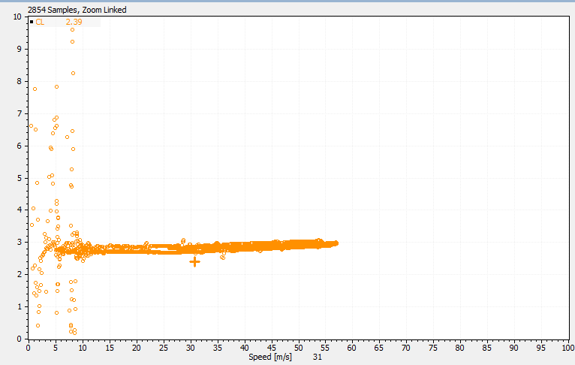
Figure 7 CL of ‘Coast down max f low r’
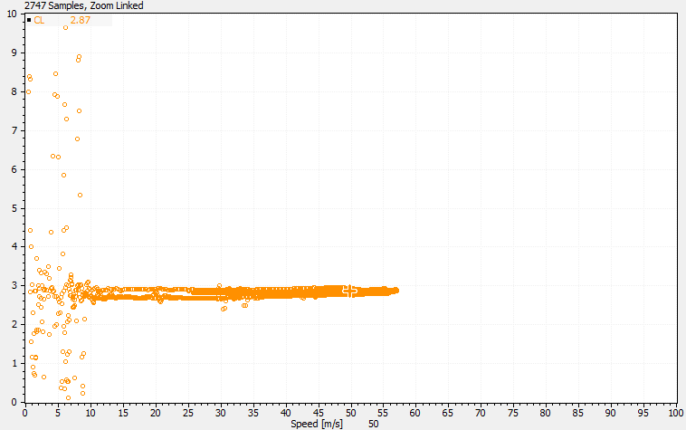
Figure 8 CL of ‘Coast down mid wings’
From figure 7 &8, it could be calculated out that CL is 2.96 for ‘Coast down max f low r’ and 2.87 for ‘Coast down mid wings’ for this racing car.

4.2.2 Calculate $C_{D}$ with EXCEL
Choose the ‘Coast down mid wings’ and ‘Coast down max f low r’ profile, and export the coast data of velocity and time to MATLAB & EXCEL, which is shown as figure 9.
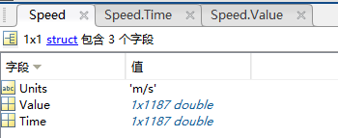
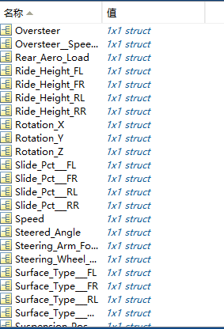
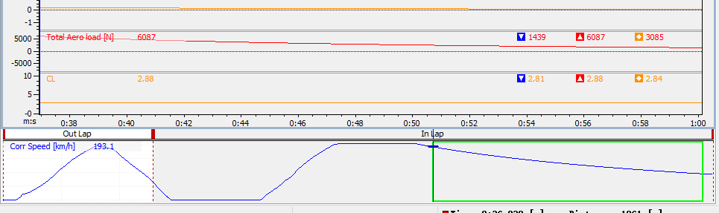
Figure 9 Export data to MATLAB
Firstly, extract the data(which is marked in green in figure 9) from MoTeC to EXCEL. Secondly, use the following formula to calculate the acceleration
$$a_{1}=Rolling resistance coefficient×9.81+\frac{\frac{1}{2}C_{D}ρAV^{2}}{mass}$$
$$a_{2}=Rolling resistance coefficient×9.81$$
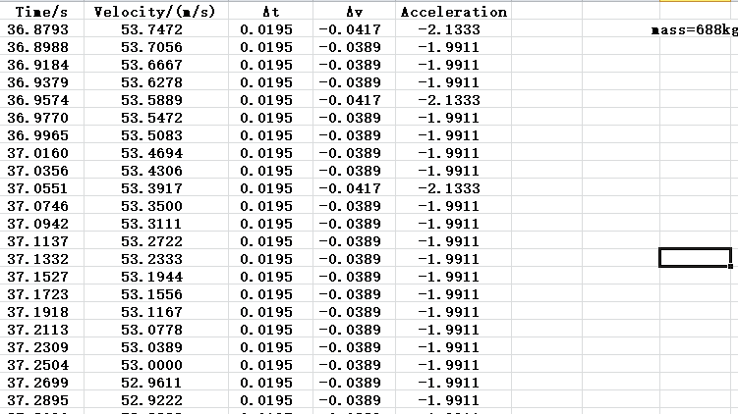
When the vehicle is fast, the resistance is consisted of rolling resistance and aerodynamic resistance(it is very big and make up the majority of the resistance). When the vehicle is slow, aerodynamic resistance becomes very small(it can be ignored).
Figure 10 The data from ‘Coast down mid wings’ in EXCEL

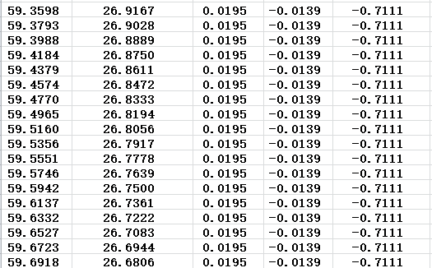
From figure 10, we could know when the velocity is about 53 m/s, the acceleration is about $-1.99/s^{2}$.
Figure 11 The data from ‘Coast down mid wings’ in EXCEL

From figure 11, we could know when the velocity is about 27 m/s, the acceleration is about $-0.71m/s^{2}$.
As calculated, CD is 0.48 while the rolling resistance coefficient is 0.072 in the test called ‘Coast down mid wings’. This method is used to be compared to the method of MATLAB.

4.2.3 Calculate $C_{D}$ with MATLAB
After that, use the methodology in 3.2 to calculate the rolling resistance and the aerodynamic drag of this racing car in MATLAB.
$$Gfcosα+\frac{ρC_{D}AV^{2}}{2}+δm\frac{dV}{dt}=0 (10)$$
Actually, formula 10 is a differential equation about V and t. We could use MATLAB to handle this equation and get the result as:
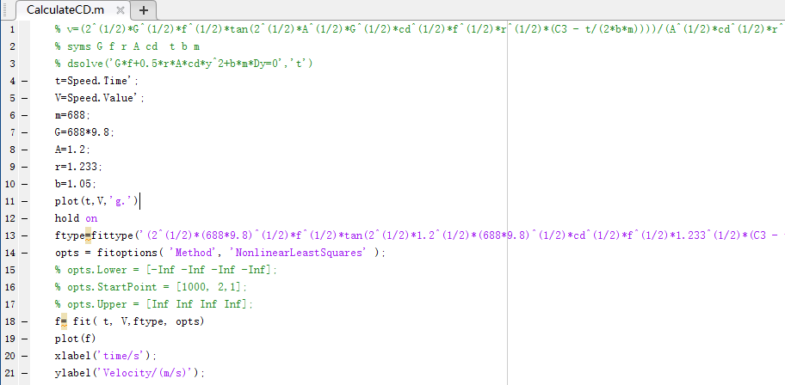
$V=f(t)$
Where constant $C_{D}$ and $f$ is unknown. The programme is shown below:
After solving the differential equation and getting the function ‘$V=f(t)$’[9], the data from MoTeC is used to fit this function and get the value of $C_{D}$ and $f$.
Figure 12 Programme in MATLAB
(1)Coast down with mid wings

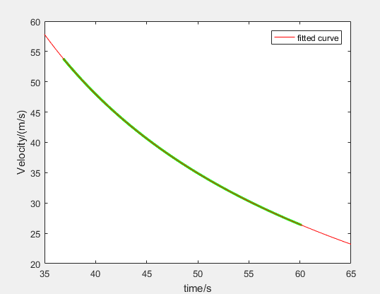
Figure 13 V-t of 'Coast down mid wings'
In figure 13, the green one is the original data from MoTeC and the red one is the fitted curve.
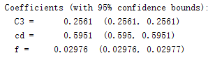
Figure 14 Result of ‘Coast down mid wings’ from MATLAB
From MATLAB, the rolling resistance coefficient $f$ is 0.02976 and the aerodynamic drag coefficient $C_{D}$ is 0.5951 of 'Coast down mid wings'

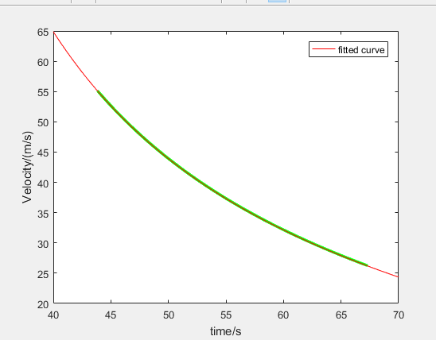
(2)Coast down Max f low r
Figure 15 V-t of 'Coast down max f low r '

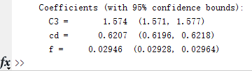
Figure 16 Result of ‘Coast down mid wings’ from MATLAB
From MATLAB, the rolling resistance coefficient $f$ is 0.02946 and the aerodynamic drag coefficient $C_{D}$ is 0.6207 of ' Coast down max f low r '.
As the calculation is very convenient, I calculated all data sets.
Table 2 $f$ and $C_{D}$ of the coast test
Parameters | $$f$$ | $$C_{D}$$
Min f Max r | 0.03082 | 0.6012
Min f Mid r | 0.03019 | 0.4742
Max f Low r | 0.02946 | 0.6207
Max f mid r | 0.02941 | 0.7341
Mid f low r | 0.02935 | 0.4839
Mid f max r | 0.03015 | 0.7225
Max wings | 0.02996 | 0.86
Mid wings | 0.02976 | 0.5951
Min wings | 0.02967 | 0.3641
Std wings | 0.02967 | 0.7939
The yellow one is chose to finish the analysis of the requirement, which includes the parameters of ‘mid wings’& ‘max f low r’.

4.2.4 Analysis
From table 2, rolling resistance coefficient $f$ is about 0.0297. $C_{D}$ is changing with the ride height. It could be seen that $C_{D}$(Max wings)＞$C_{D}$(Std wings)＞$C_{D}$(Mid wings)＞$C_{D}$(Min wings). More angle wings brings more aerodynamic resistance.
If the front height of the vehicle is stable, the higher the rear height, the bigger the aerodynamic resistance coefficient. If the rear height of the vehicle is stable, the higher the front height, the bigger the aerodynamic resistance coefficient. The reason is that the frontal area becomes bigger when the ride is high.
In my opinion, the rolling resistance coefficient calculated by MATLAB is correct. There is a common sense that the coefficient of good asphalt road is about 0.0105. Thus 0.072(calculated by EXCEL) may be wrong because the velocity is not slow enough to ignore the aerodynamic resistance.

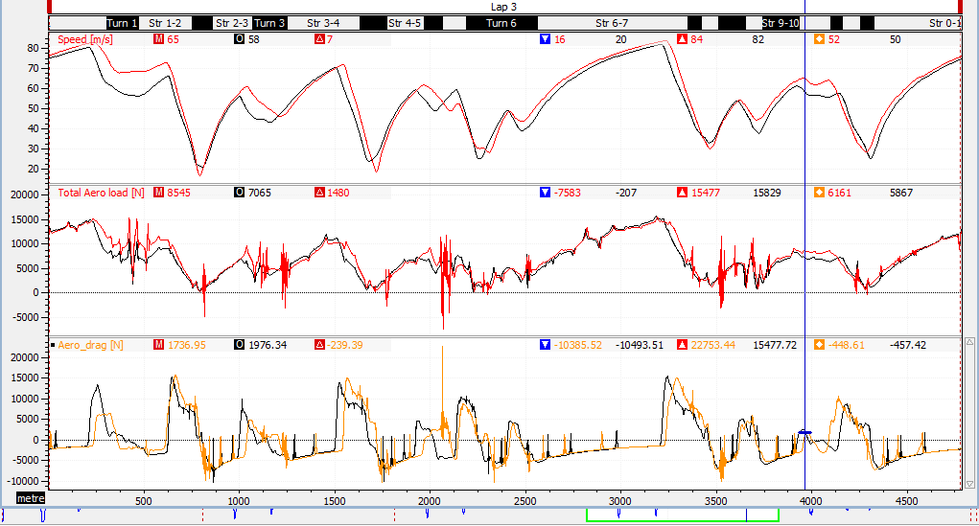
4.3 Data traces to show lift and drag
Figure 0-1 Circuit mid wings
Figure 17 Trace to show aerodynamic lift and drag
The red curve is from the test ‘Circuit mid wings’ while the black curve is from the test ‘Circuit max f low r’. From figure 17, the average velocity of ‘Circuit mid wings’ is a little bit faster than that of ‘Circuit max f low r’. When crossing the corner, the vehicle of ‘Circuit max f low r’ seems a little bit steady.

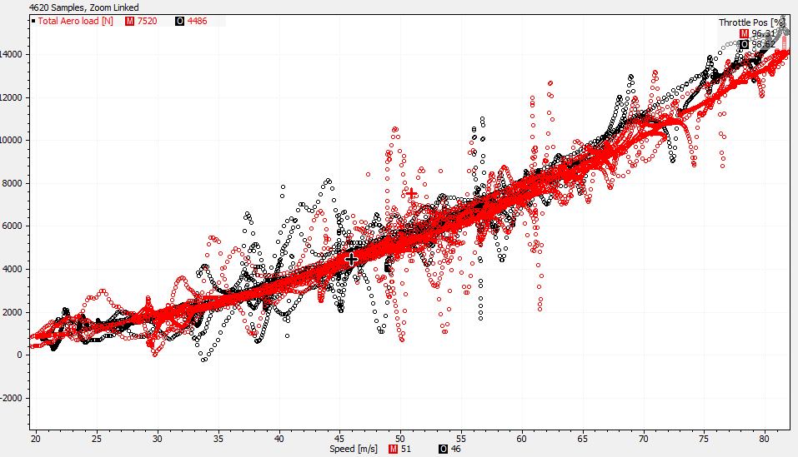
4.4 Total lift versus speed x-y plot
Figure 18 Total lift versus speed

The red curve is from the test ‘Circuit mid wings’ while the black curve is from the test ‘Circuit max f low r’. The red curve is more concentrated, which means the vehicle with ‘Circuit mid wings’ is loaded with more steady lift force and have a better handling and driving performance.
With the increase of velocity, the aerodynamic lift will increase faster and faster. The reason is that the lift is In proportion to the square of the speed

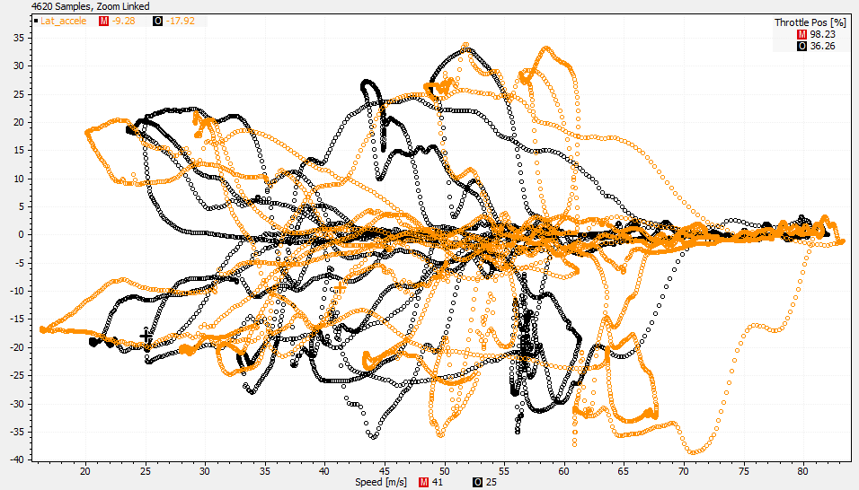
4.5 Lateral acceleration versus speed x-y plot
Figure 19 Lateral acceleration versus speed

The orange curve is from the test ‘Circuit mid wings’ while the black curve is from the test ‘Circuit max f low r’.
From figure 19, the orange curve is more concentrated when the vehicle is fast while the black curve is more concentrated when the vehicle is a little bit slow. It means that the vehicle with ‘mid wings’ will endure more lateral force when the vehicle increase the velocity.
Both curves shows that the lateral force is small when the velocity is high.

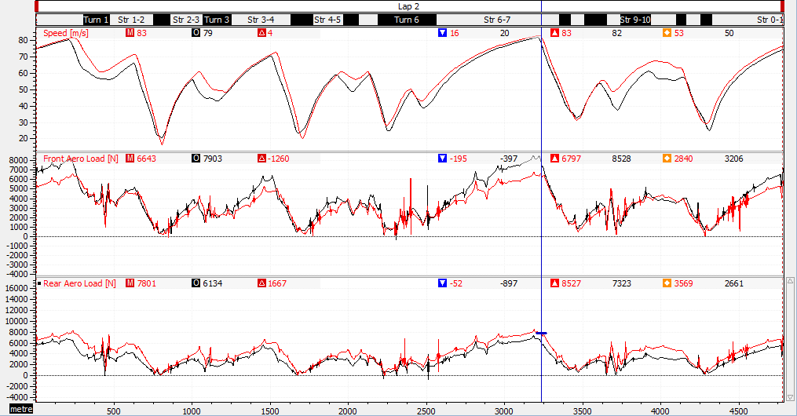
4.6 Indicate the downforce at f and r axles.
Figure 20 Downforce at front and rear axles

The red curve is from the test ‘Circuit mid wings’ while the black curve is from the test ‘Circuit max f low r’.
Longitudinal weight transfer is calculated with the formula in part 3.1.4. It could be seen from the figure that vehicle of ‘Circuit mid wings’ has more rear aero load and less front aero load than that of ‘Circuit max f low r’.

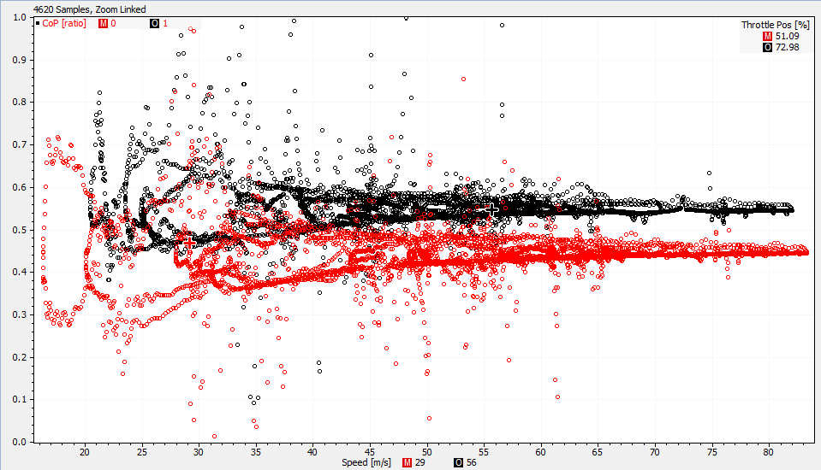
4.7 Center of Pressure
Figure 21 Scatter figure of center of pressure

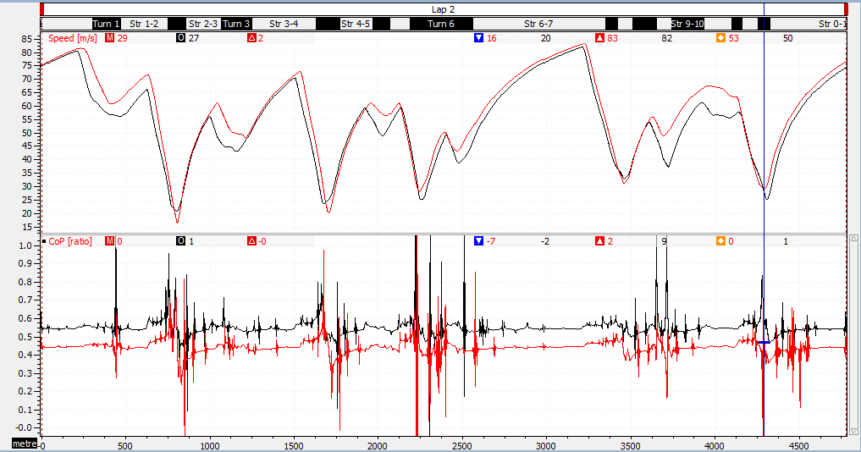
Figure 22 Center of pressure versus distance

The red curve is from the test ‘Circuit mid wings’ while the black curve is from the test ‘Circuit max f low r’.
From figure 21 & 22, the CoP of ‘Circuit mid wings’ is bigger than that of ‘Circuit of max f low r’. This is because that the percentage of front aerodynamic load of ‘Circuit mid wings’ is bigger.

4.8 The effect of static ride height and rake angle
The rake angle is calculated with:
$$Rake angle=atand⁡((Average rear height-Average front height)/Wheelbase)$$
The result of the calculation is shown as figure 23
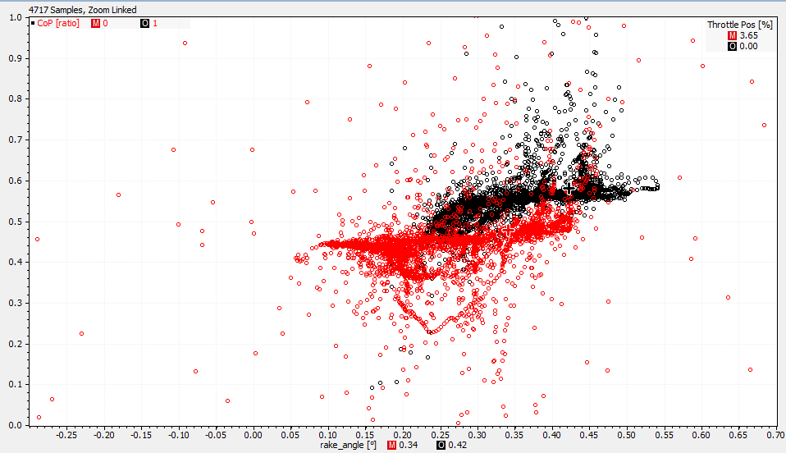
Figure 23 CoP versus rake angle
The red curve is from the test ‘Circuit mid wings’ while the black curve is from the test ‘Circuit max f low r’.
When the rake angle increases the CoP of the red curve doesn’t change a lot while the black changes a lot. It means that the load of the ‘Circuit mid wings’ is more steady than that of the ‘Circuit max f low r.’

5. Conclusion
When it comes to different corners, the maximum speed at which the vehicle could travel around this corner is changing. The key here is that the coefficient of friction is produced over 4 tires and changes dynamically. And the load across these 4 tires is not equal during cornering due to weight transfer.
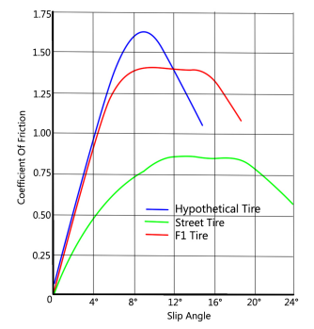
Figure 24 The figure to explain something
When the vehicle is on motion, the tire will have a slip angle at which coefficient of friction reduces. Due to the exits of slip angle, the tire begins sliding as well as slipping. The reason of OVERSTEER & UNDERSTEER is that there are difference between rear axle acceleration and front axle acceleration.
Why the Longitude force decrease when the vehicle crosses a corner? In my opinion, the lateral force and longitude force comes from the friction between the tire and the ground. The total force is limited by the vertical load. The needed lateral force increases when the vehicle crosses a corner. Thus the longitude force used to overcome the resistance decreases.
In my opinion, the $C_{L}$ & $C_{D}$ which was calculated by MATLAB is more accurate. And the differential equation is used.

6. Reference
[1] https://wenku.baidu.com/view/f348305e77232f60ddcca134.html
[2] https://www.researchgate.net/publication/284720454_DRAG_AND_LIFT_REDUCTION
[3] Aerodynamics Application Note
[4] Estimation of aerodynamic performance from constant speed and coast down testing, Aerodynamic Analysis..
[5] Joseph Katz, Aerodynamics of Race Cars, Annu. Rev. Fluid Mech,. 2006.38:27-63
[6] Wu Gaogui, Quadratic sliding measurement of air resistance coefficient of automobile. Journal of South China University of Technology (Natural Science Edition), 2000 (06): p.44-48.
[7] Han Zongqi and Li Liang, Method for Determining the Drag Coefficient of a Vehicle. Automotive Engineering, 2002 (04): pp. 364-366.
[8] Liu Fucai, Pan Jianghua and Han Zongqi, Method for Determining the Coefficient of Coasting Resistance of Automobile Based on Genetic Algorithm. Automotive Engineering, 2003 (06): p.610-612 + 616.

