UNIVERSITY OF WALES TRINITY SAINT DAVIDS
Developing Relationships at the
Workplace: BMSW5102
Sebastian Mudzamiri 1913885
Lecturer: Dr Gregory Cowan
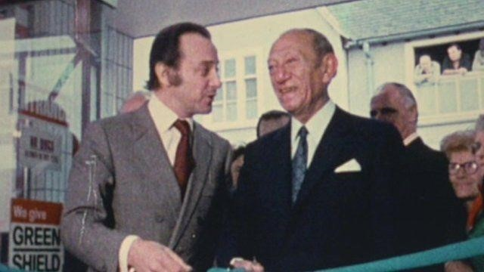
T.E. Stockwell and Jack Cohen
Tesco was started in London, 1919 by Jack
Cohen.
It was incorporated after the merger of the
businesses of Jack Cohen and T.E. Stockwell
in 1929 (thetimes100, 2021)
Tescoplc.com has over 2200 stores and 360
000
employees (tescoplc.com
2021)
Tesco operates in the UK, Ireland, the Czech
Republic, Slovakia and Hungary.
It is the largest supermarket group in the
UK. (
thetimes100, 2021)
Training and
Development
For a HR
officer
Cultivating equality, diversity and inclusion

culture.

Absence management.

Administering payroll.

Developing HR planning strategies from short to long
-
term.

Analysing training needs at Tesco.

Liaising with line managers on HR issues.

Motiva
ting staff through appropriate training needs.

Implementing a system of

360
degrees feedback.

Working as a consultant

on employment law.

(
Armstrong, M and Taylor, S.
2020)
Training and
Development
For a HR
officer
Working
with stakeholders
on
:

Staff performance, health and safety.

Negotiating on pay and conditions of service.

Deal
ing with grievances.

Implementing disciplinary

procedures.

(
2020)
Armstrong, M and Taylor, S.
Training and
Development
For a HR
officer
Recruitment and staff selection at Tesco.
Writing Job Descriptions.
Drawing up person specifications.
Preparing Job Advertisements.
Development and implementation of performance
management (Armstrong, M. and Taylor, S. 2020)

-

My Personal Skills Audit

My Competencies:
- Good with Microsoft Office Word
- Use of the Internet
- Use of the Email
- Good Communication Skills  Writing of Reports
- Delivering a training session
- Resolving disputes/ complaints
- Interviewing skills
- Open to ideas of other people, to help solve problems
Training Needs:
- Use of Excel Spreadsheet
- Use of PowerPoint
- Use of the database
- Taking notes of disciplinary procedures
- Use of specialist HR software
- Drafting of contracts of employment
- Advising on HR issues  Problem solving skills
- Produce materials to support presentations

The Benefits of Training and Development: For myself and Tescoplc.com
- Corporate strategic management
Tesco as the largest retailer in the UK needs to support its growth with properly trained staff.
This is only possible with a strong human resources management (HRM) (Armstrong, M. and Taylor, S. 2020) As an HR officer I will need to be well-versed in training staff for Tesco to maintain its competitive advantages.
- Analysis of benefits paid to employees
As an HR officer at Tesco, I will implement benefit packages that reduce the cost of staff turnover, natural wastage and replacement by new employees.
This requires expertise in economics and budgetary controls to ensure affordability by Tesco (Armstrong, M. and Taylor, S. 2020)
The Benefits of Training and Development: For myself and Tescoplc.com
- Minimising Liability exposure
As an HR officer, I need to ensure that we stick to the law in order to avoid liabilities that can arise, as a result of alleged unfair labour practises.
This can be done through, proper identification, investigation of issues and rectify the anomalies ahead of time (smallbusiness.chron.com 2019)
- Maintaining Compliance
As an HR officer at Tesco, I will make certain that the organisation is compliant with the laws and regulations of the country in which we operate (smallbusiness.chron.com 2019)

In conclusion, Human Resources Management (HRM) is the engine-room of any successful business conglomerate such as Tesco.
As an HR officer I need to know how to meet the company vision, deliver the mission statement through world-class training and development of employees.
I would vet cv’s, arrange interviews, select suitable candidates to make ‘a strategic fit’ in the Tesco culture.
I would use specialist HR software such as Human Resources Information System (HRIS) in order to assist the task of training and development of competent and highly motivated staff that deliver a competitive advantage for Tesco for the short-term, medium and long-term planning horizon.

References:
Armstrong, M. and Taylor, S.(2020) Armstrong’s Handbook of Human Resource Management Practice.(BibliU) 15th ed. London, Kogan Page, Limited.
Small business.chron.com [Online] Available at: https://smallbusiness.chron.com/10reasons-hr-important-organisation-22424.html (Accessed 16.12.2021)
Tesco Plc (2021) [Online] available at: https://www.tescoplc.com/media/757596/Ihp (Accessed 10.12.2021)
The Times100 [Online] Available at: https://thetimes100.co.uk Business Case Studies (Accessed 05.12.2021)



