

Assessment 1 – Reading Task Template
PART 1: Upload your photo of your A3 in-class notes here:
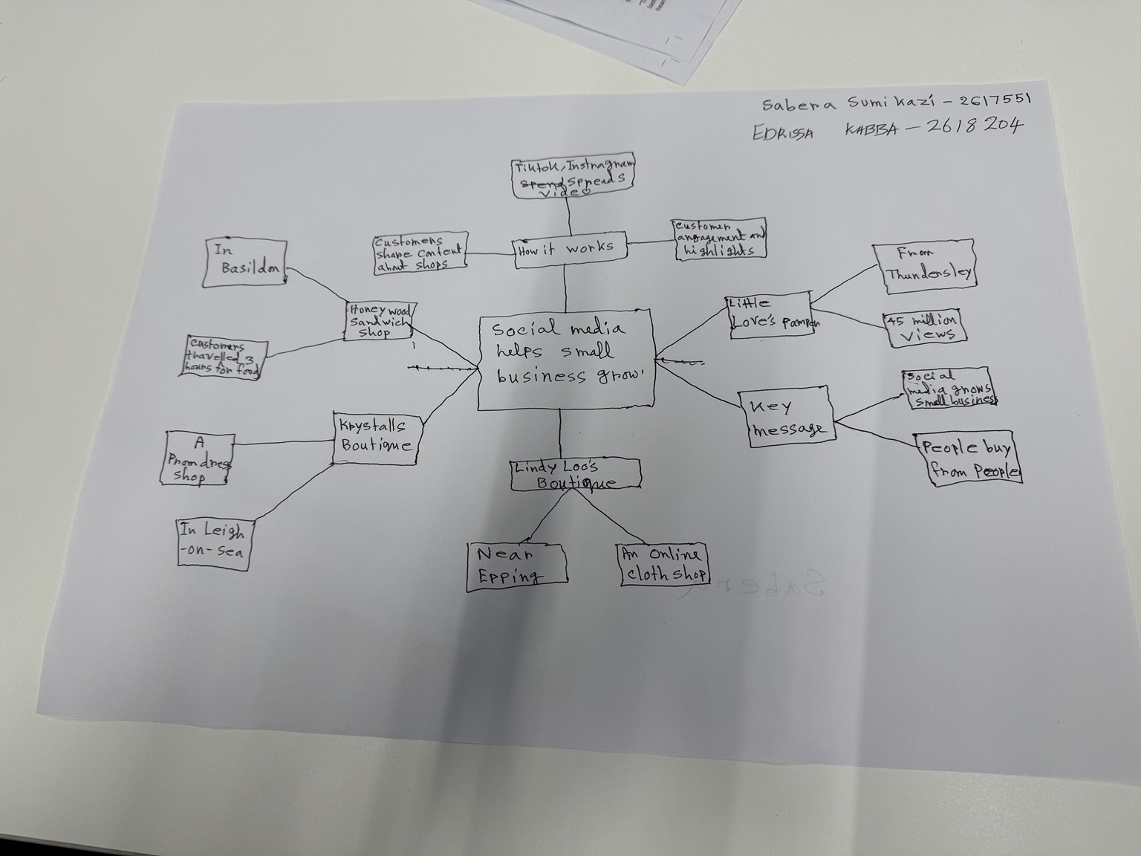


PART 2:
- Answer every question below in 1-3 full sentences.
- Use your own words. Do not use generative AI to answer these questions.
- Include a specific detail from the text when asked.
REMINDER
- The main idea is the overall message of the whole text.
- A key point helps to explain the main idea.
- A specific detail or example from the text shows that the key point is true.

- What is the main idea of the whole text?
The main idea of the text is that people can overcome challenges and achieve their goals through hard work and determination.

- What we he key point that supports the main idea, and which specie example from the
One key point is that persistence helps people succeed. For example, the text explains how the person continued working towards their goal even when they faced difficulties.

- What is a different key point that supports the main idea, and which specific example from the text shows this?
Another key point is that support from others can make a difference. The text gives an example people helping the main person and encouraging them to keep going.

- Which part of the text do you think is most important, and why?
The most important part is when the person overcomes their biggest challenge because it shows that determination can lead to success.

- What did you find difficult in this task (including in-class components), and why was it difficult?
I found it difficult to find the main idea because there was a lot of information in the text and I was not sure which point was the most important.

- What helped you with this difficulty, and how did it help you?
My notes and class discussion helped me. They helped me understand the text better and find the main ideas and supporting details.

