Inspiring Through Adventure Conference Report

Author: Resources for Change

Date

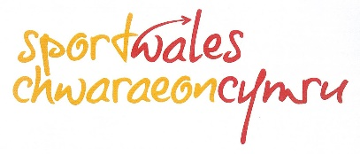
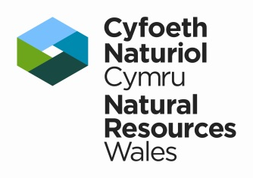
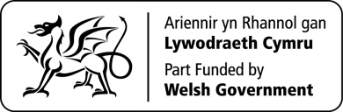
Executive Summary
This report was commissioned by Natural Resources Wales on behalf of the outdoor sector to document the points discussed at the Inspiring Through Adventure Conference.

In February 2016, Natural Resources Wales, Sports Wales and Visit Wales organised a 2-day conference “Inspiring Through Adventure”, part of Wales “Year of Adventure” 2016. The conference was attended by 90 representatives from across the outdoor sector.

The conference opened with presentations from Mari Stevens (Welsh Government) Sarah Powell (Sport Wales) and Dr Emyr Roberts (Natural Resources Wales), followed by an introduction to Sport England’s ‘Getting Active Outdoors’ research. On the second day, four key themes ran through the presentations and workshops, looking at how to inspire:

- lifelong participation in sport and physical outdoor activities
- an environmentally sustainable outdoor sector
- holistic training and development of volunteers, leaders, instructors and coaches.
- a cross-sector approach to partnership working.

During the conference, attention was repeatedly given to the impetus likely to arise from the Well Being of Future Generations (Wales) Act 2015. This Act has seven key elements and these have been used in the discussion section of the report as a framework to present the findings.

Recommendations:
The comments gathered in the workshops are outlined in the report. The facilitators have then used them to produce a set of recommendations for the outdoor sector and other key stakeholders. The recommendations have been split into two sections; actions that can be carried out in the next 12 months and those that could be worked towards in future. They have been summarised below:

In the next 12 months
- Improving partnership working and cross sector communication.
- Strengthen the working relationship between the outdoor and health sectors.
- Review the evidence that is currently available on the benefits of outdoor and adventure activities.
- Explore ways that the outdoor sector can: develop new environmental standards, improve collaboration on training and CPD, create standard pathways of engagement and progression and build on the success of the Year of Adventure.

To be developed beyond the Year of Adventure
- Use the improved cross-sector partnership to develop projects that will benefit the health and well-being of the nation.
- Carry out further research and evaluation to assess the case for more engagement in outdoor activities.
- Focus on improving participation in outdoor activities amongst young people.
- Look at ways to reduce the environmental footprint of the sector and protect sensitive landscapes.
- Improve the skills development and qualification framework to provide more incentives for people to look for work in the sector and offer a broader learning platform.

Contents
Executive Summary 1
Contents 3
Strategic Background 4
Conference Aims and Objectives 4
Conference Structure 5
Terminology 5
The Conference 6
About the Audience 6
Programme / Format 6
Presentations 6
Lowri Morgan - Chair of day one 7
Mari Stevens, Director of Marketing, Welsh Government 7
Sarah Powell, Chief Executive, Sport Wales 7
Emyr Roberts, Chief Executive, Natural Resources Wales 8
Andrew Denton, Chief Executive, Outdoor Industries Association 8
Andrew Middleton, Founding Director, TYF 9
Ken Skates, Deputy Minister for Tourism, Culture and Sport 9
Mari Davies, represented GBR and Wales for sailing 10
Tom Luddington, Business and Schools Coordinator, TYF 10
Key points arising from the presentations 11
Workshops 12
Workshop Responses 14
Workshop 1: Developing lifelong participation in sport and physical outdoor activities 14
Workshop 2: Developing an environmentally sustainable outdoor sector 16
Workshop 3: Developing holistic training and development of volunteers, leaders, instructors and coaches 18
Workshop 4: Developing cross sector approach to partnership working 21
Post workshop suggestions 24
Discussion 25
Key points for public sector policy makers 25
Key points for the outdoor sector 28
Recommendations 30
In the next 12 months 30
To be developed beyond the Year of Adventure 31
Next Steps 31
Appendix 1 - List of Invited Delegates 32
Appendix 2 - Suggestions for actions 34

Strategic Background
Welsh Government (WG), through Visit Wales (VW), has designated 2016 as the ‘Year of Adventure’. This forms the foundation of both the UK and overseas visitor marketing campaigns for Wales for this year. Future years will also be themed, with 2017 being the ‘Year of Legends’.

Also in 2016, the Environment (Wales) Act 2016 and the Well-Being of Future Generations Act (2015) came into force, placing new Duties on public sector bodies in Wales and putting sustainable development at the heart of policy development. Taken together, these Acts will make public and other bodies in Wales think more about the long term, work better with people and communities and each other, look to prevent problems and take a more joined up approach.

Visit Wales, through the WG strategy for tourism, Partnership for Growth, sets a clear direction for the industry in Wales with a focus on adventurous activities in the outdoors, a deeper appreciation of the environment of Wales and on celebrating the local and sense of place this engenders.

Sport Wales, in its Vision for Sport in Wales, sets out benefits of sport in the widest sense, not solely impacting on improving the physical health of the nation, but also in bringing communities together, building confidence in young and old, providing new skills and training and attracting investment into Wales. The relevance to the outdoor sector is clearly set out in Sport Wales priorities, including growing a skilled and passionate workforce, creating sporting communities and encouraging sporting innovation.

Natural Resources Wales, whose remit includes sustainable natural resource management, education and outdoor recreation and access, is charged with ensuring that our ecosystems are resilient, that our wildlife and landscape are enhanced and that our natural resources are carefully managed; that people are safe, that they are able to benefit from and enjoy our natural resources and they understand the relevance of these resources to our day-to-day lives and that; Wales is a ‘location of choice’ for business and enterprise and a place where best practice environmental management is adopted and encouraged.

Conference Aims and Objectives
The primary aim of ITAC 2016, organised by the three organisations above, was to work with the outdoor activity providers sector to understand how more people might be encouraged to make use of Wales’ natural, historic and cultural environments in a safe, responsible and sustainable way.

Further aims were to understand the role adventure experiences might play in catalysing behaviour change and to challenge delegates to look at ways of using available skills and resources to inspire:

- lifelong participation in sport and physical outdoor activities;
- an environmentally sustainable outdoor sector;
- holistic training and development of volunteers, leaders, instructors and coaches;
- a cross-sector approach to partnership working.

Conference Structure
The conference ran across two days, with Day One focusing on current provision, outputs and outcomes. With a particular emphasis on the impact the outdoor sector has on participation, health and well-being and the economy. Day two provided opportunities for discussion and workshops focusing on future direction.

The key themes of the workshops were organised around:

- Participation
- Environmentally sustainable business
- Training and development
- Partnership working

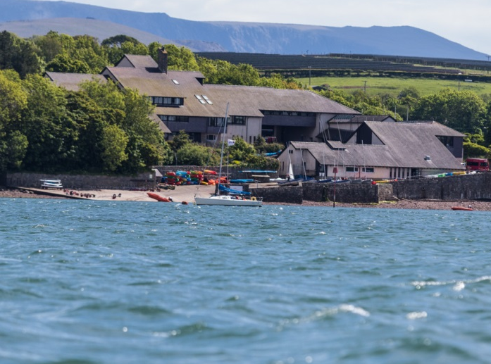
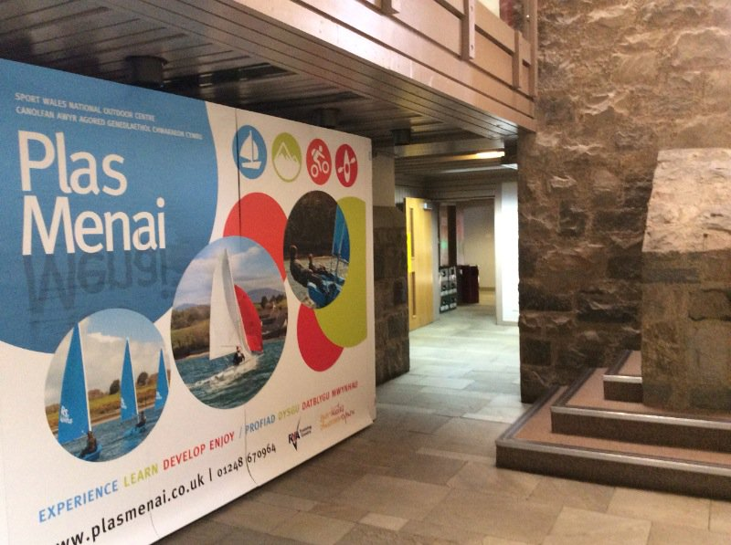
However, it was clear that delegates were keen to discuss the outdoor sector’s role in health and well-being, in addition to the key themes of the workshops. Therefore, in the discussion section, the key points which emerged from the conference are aligned to the goals of the Well-Being and Future Generations Act (Wales) 2015.
Plas Menai – The conference venue

Terminology
Sport: an activity involving physical exertion and skill in which an individual or team competes against another or others for entertainment.

Outdoor activity: physical activity undertaken within an open environment (as distinct from the confines of pitch boundaries).

Outdoor adventure: an activity involving some physical activity within an open environment which is perceived by the participant to involve some form of personal risk or uncertainty that they find challenging.

Outdoor sector: those businesses and organisations which, collectively, provide products and services to people seeking to take part in outdoor activities or adventure.

Physical activity or physical exercise: any bodily movement produced by skeletal muscles that requires energy expenditure.

The Conference

About the Audience
The conference was an invitation-only event, with invitations extended to those organisations that are perceived to have a key role to play in the development of the outdoor sector in Wales. As a result, it brought together key stakeholders from across Wales, supported by Welsh Government and inspirational speakers from the sector. A list of delegates invited to attend is provided in Appendix 1.

Programme / Format
The main components of the conference were a series of presentations from people and workshops. These components are discussed in turn below.

Presentations
Formal presentations were received from 9 speakers, each of whom is involved in outdoor adventure activities either as activists, trainers and/or government departments / agencies. Collectively, they covered a very wide range of responsibilities and experience of adventure activities. Summary of the key points outlined in each presentation was documented by the facilitators; these can be found on the following pages.

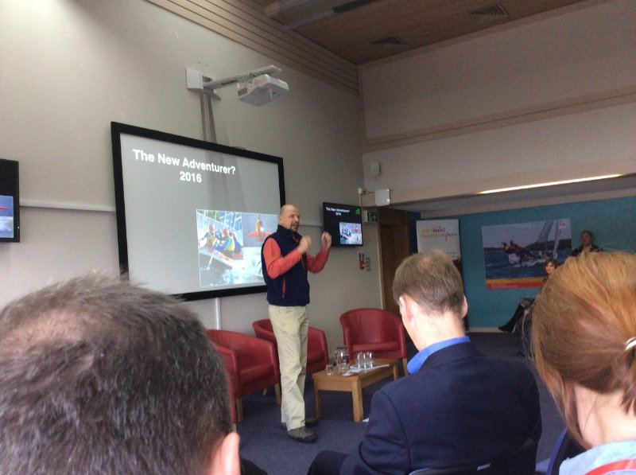
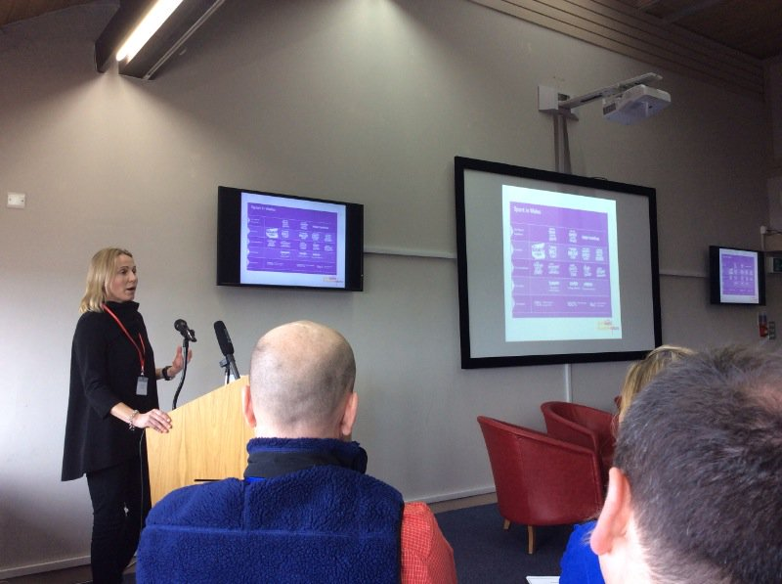
Andrew Denton (left) and Sarah Powell making their presentations

Lowri Morgan - Chair of day one
- Lowri has acted as an ambassador for Wales in all her travels;
- There are many challenges facing Wales: health, lack of resources, climate change;
- How can adventure and outdoor activities help? What role can it play?
- Lowri’s adventures have given her physical, mental and emotional fulfilment;
- Lowri attributes her involvement to an upbringing which allowed her to take risks and be adventurous;
- These opportunities were afforded to her by the Welsh countryside, which has abundant opportunities and the right infrastructure for adventure of many kinds;
- The key message is – be adventurous; try something new.

Mari Stevens, Director of Marketing, Welsh Government
- Year of Adventure has substance – it’s not just marketing hype;
- Wales has everything anyone needs for outdoor adventure for Welsh people and visitors;
- Year of Adventure is an opportunity to ‘re-brand’ Wales and promote growth in the outdoor activities sector;
- Research suggests that people want ‘experiences’ rather than just trips (referred to as ‘soft’ and ‘hard’ adventure respectively);
- The challenge is to package the experience in a way that appears authentic, innovative and sustainable;
- Aim is also to inspire a new generation of Welsh adventurers (it’s not just about tourism);
- In the Q&A session, Mari stressed the importance of getting engagement with the outdoor environment ingrained into the Welsh culture as it once was and still is amongst many nations of continental Europe.

Sarah Powell, Chief Executive, Sport Wales
- Sarah was brought up in an environment (family and friends) that encouraged physical activity and outdoor adventure;
- The Olympic legacy has been maintained in Wales (unlike England)
- Welsh people now expect to win and are disappointed rather than surprised when they don’t;
- She wants to see a nation hooked on sport and/or adventure for life;
- One million people say they want to take more exercise and half a million want to do more voluntary work in sport – need to bring them together;
- A key question is “how do we get people over the tipping point – to push someone beyond a point where they do something different?”
- There is a ‘cycle of participation’:
- Motivation and confidence
- Awareness
- Opportunity and resources
- The experience (including having fun)
- The experience feeds confidence and heightens motivation to do more, and the virtuous cycle repeats itself;
- Park Runs are a good starting point.
- In the Q&A session, Sarah suggested that the outdoor sector needs to develop a more solid evidence base about the benefits it delivers and there is scope for coming together to undertake integrated research (e.g. undertaking a single public survey rather than separate surveys).

Emyr Roberts, Chief Executive, Natural Resources Wales
- Experiences of the outdoors are much more memorable than any number of visits to the gym;
- Adventure includes an element of doubt, and how one deals with that is important in forming long-lasting memories;
- Poor health is one of the biggest challenges facing Wales (physical inactivity, obesity, age-related problems, mental health);
- Outdoor activity can play a major role in tackling this and the associated cost;
- It is vitally important that we encourage more people to be more active, more often and the outdoors offers a very cost effective and sustainable resource;
- People prefer to have outdoor opportunities close to home and Wales is fortunate in that countryside is never very far away, even in cities like Cardiff;
- NRW is working with partners to develop and maintain outdoor resources, such as forests, managed in a way that promotes sustainable use;
- Increasing participation will yield environmental, business and health benefits;
- The Q&A highlighted that an estimate of the value of the environment provided by Emyr (£8bn/yr) is probably an underestimate and a better analysis is needed.
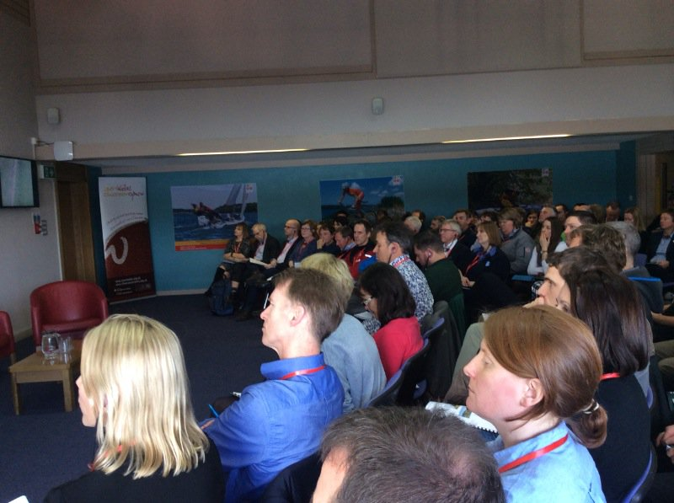
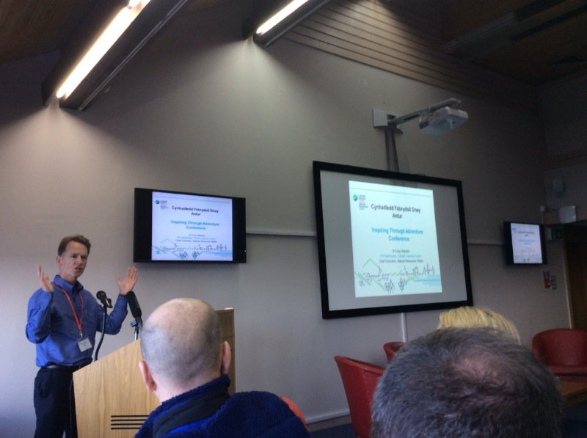

Dr Emyr Roberts (left) and a view across the room during the conference

Andrew Denton, Chief Executive, Outdoor Industries Association
- People who become active early in life will stay active throughout their lives;
- “The times they are a-changing” and quickly – for example, young people now expect to get information in short bursts delivered to them (electronically);
- Young people are motivated by different things than the conference’s audience, so we cannot project our thinking onto the ways we seek to influence the next generation;
- Young people now spend more time in front of a screen than they do sleeping, so uptake will be better if they can take/use mobile devices on the outdoor activities and if the activity exploits this;
- The outdoor industry tends to focus on those who are active and so miss out on the 80% of people who are now relatively inactive (Sport England, Getting Active Outdoors 2015), and it is amongst these people that the most worthwhile opportunities exist (commercially and for health gains);
- Most of the target audience live in cities/towns and want ‘micro adventures’ which are delivered locally to them (at least at the outset);
- Parental attitude to risk has also changed and is now more risk averse and, because the outdoors is less easily controlled, parents get nervous about exposing their children to it;
- The current generation of young people is the least active in history and will be the first to have shorter life expectancy than their parents;
- We need to focus on preventative health in future and physical activity is one way of achieving it;
- Those promoting outdoor adventure activity are competing for attention against all the other influences and what we have done so far is clearly not working and we need to change – “insanity is doing the same thing over and over again and expecting different results”;
- Many of the statistics quoted by Andrew were from the report: Getting Active Outdoors (2015).

Andrew Middleton, Founding Director, TYF
- Need to focus on the natural environment;
- Many key indicators of the health of our environment (biodiversity, soils, CO2 levels, fisheries, water resources) are all trending the wrong way;
- Indicators of human health are also worrying (£7.4bn cost of physical inactivity, £7.2bn cost of mental health);
- Any sensible risk assessment would show we are facing “very high risk”;
- “Seismic change is needed” but many good intentions fail to get scaled up to a meaningful level to have an impact;
- The cost of supporting the proactive development of the outdoor sector’s offer and its ability to deliver would be just a small fraction of this;
- The outdoor sector needs to work together to build capacity and decide what an appropriate response to this situation should be;
- Keen to explore collaborative working with the health sector and how the outdoor sector can further support the health agenda.

Ken Skates, Deputy Minister for Tourism, Culture and Sport (now the Cabinet Secretary for Economy and Infrastructure)
- It is important to recognise that “the child exists in everyone” and most of us retain a sense of adventure, although they may be deterred by fears of perceived risks;
- People need to learn to manage risk and the way to do this is by early exposure in a safe environment;
- Wales’ number 1 USP (unique selling point) is its wonderful outdoors;
- He is pleased with the way the outdoor sector has worked in partnership with government;
- Wales has huge challenges of physical inactivity and mental health, both of which can be mitigated by physical activity;
- It is often difficult to reach the people who can benefit most, and poverty is a significant obstacle, and galvanise them into being more active;
- He recommends that the sector shouts loudly to highlight its potential to address major societal problems.

The minister accepted questions:

Q: How do we get to young, hard to reach people (e.g. urban youth, especially girls)?
A: Partnership working; delivery of opportunities near to their doorsteps; but it will take time to turn around especially in the face of well-funded advertising that promotes instant gratification through consumerism and we need to plug the message that “fast food for the soul does not work”;

Q: How do we overcome the problem posed by poverty?
A: People coming together to target deprived areas. Need to promote benefits of health and activity in order to tackle obesity, smoking, alcohol consumption.

Mari Davies, represented GBR and Wales for sailing
- Mari’s roots lie in an active family and this led to her becoming an active sailor at the age of nine;
- Mari recognised that progress was possible with hard work and dedication, but this ultimately yielded great personal rewards in the form of success at ever high levels of competition;
- Mari highlighted the contrast between the investment of time and effort she has made to achieve long-term success with the “I want it and I want it now” culture that is now so dominant;
- In the process, Mari has made good friends, become physically very fit and enjoyed many experiences at an earlier stage of her life than most of her peers.

Tom Luddington, Business and Schools Coordinator, TYF
- Tom describes the ethos behind the company he works for, which is founded on sustainability and social responsibility;
- Given that we don’t live in a “limitless world” and will soon have 9bn people, things have to change, for which we need leadership;
- They try to incite change in people’s minds through their ‘Do Lectures’;
- In Tom’s work, he tries to instil “Adventure Intelligence”, an approached developed by TYF which involves putting learning from the outdoors into everyday situations;
- An important element in this is that “Failing is fine”/“Learning to fail”, in other words – it’s important to have a go, even if you fail;
- Tom challenged us to think “what are the most radical and positive changes we can bring about today using adventure in Wales and our own intelligence?”

Key points arising from the presentations
These were the main themes and messages raised repeatedly by the speakers on both days of the conference.

- Current social and environmental trends suggest that we face a deteriorating and unsustainable future, implying that change is needed sooner rather than later;

- Outdoor/adventure activity is a ‘good thing’, providing:
- social benefits in the form of better physical and mental health and self-esteem at a personal level;
- environmental benefits in the form of raised awareness through greater exposure to the natural environment;
- economic benefits in the form of reduced health costs;

- Outdoor activity is a lifelong interest that is most likely to become established when a young person is exposed to it early in life, through family and friends;

- Wales has some of the best opportunities for outdoor adventure activity;

- It has the capacity to become the Number 1 Adventure Capital destination in the UK, overtaking the Lake District and Scotland;

- The current generation of young people in Wales are the most inactive ever, and as a result the cost of ill-health (physical and mental) is projected to rise and average life expectancy to drop;

- Reversing this trend will require new thinking and approaches which recognise the way young people access information and make decisions;

- The message will need to compete effectively in an environment in which preference is given to the instant gratification available through consumerism, rather than the longer term (deferred gratification) on offer from physical outdoor adventure activity;

- The outdoor sector needs to work together to:
- strengthen the evidence base about the benefits it can deliver and demonstrate its sustainability;
- build capacity;
- show what it can offer to address the social and environmental challenges facing Wales;

- The outdoor sector also needs to work together and with government to:
- demonstrate the potential benefits it can deliver to Welsh society and economy;
- deliver opportunities for young people to get into outdoor activities which can be accessed locally, in short bursts and employ electronic gadgetry in some form;
- overcome parental concerns over health and safety, whilst still offering a genuine adventure to young participants.

Workshops
On day two, following the presentations, four workshops were organised in order to give delegates a chance to voice and record their thoughts. Each workshop was run twice, with all four workshops running concurrently during each session. Delegates had to choose which two they would attend and participants in the second session built on the outputs from the first. Each workshop was co-ordinated and recorded by a facilitator from Resources for Change (R4C).

The focus and objectives of the four workshops were described in the programme as follows:

Workshop 1: Developing Lifelong participation in sport and physical outdoor activities
There is a long tradition in Wales of engaging young people and adults with the outdoors though adventure; giving them formative experiences that will help foster a lifelong interest and participation in outdoor activities. Wales is leading the way in this area in many respects and there are examples of world class initiatives being developed here that have a proven record of providing opportunities, nurturing skills and ultimately leading to employment and other wider social benefits.

Objectives: This workshop will explore what lessons can be learnt from what is happening in Wales, and how the tourism, sport, environment and cultural heritage sectors can add value to this work.

Workshop 2: Developing an environmentally sustainable outdoor sector
Many groups, organisations and businesses take people into the heart of the Welsh environment to give them first hand experiences of our cultural and natural heritage through adventure. However, the very action of taking people into these sensitive landscapes can threaten their integrity.

Objectives: Does the sector feel that running a ‘green’ business is currently valued and supported? What mechanisms would they like to see in place to support greener working practices?

Workshop 3: Developing holistic training and development of volunteers, leaders, instructors and coaches
Outdoor instructors go through a high level of professional training to ensure that they can safely lead people in the outdoors. Some programs have an element of engagement, environment and cultural heritage training but this is not standardised across the sector. There is also a range of Continuing Professional Development (CPD) available to instructors but these are not always desirably accredited, in the right format or on the right topics.

Objectives: This workshop will explore the breadth of training and resources that the sector currently requires and where there could be opportunities to add value to this. Where are there currently gaps in provision and how could the outdoor sector work more closely with the tourism, environment, sport and culture sectors to better integrate core training and CPD?

Workshop 4: Developing a cross sector approach to partnership working
The outdoors are used by both the public and private sector organisations to engage participants in adventure activities. However, the season for this activity is generally fairly short in Wales and this can lead to a lack of security for people employed in the sector and put extra pressure on resources at busy times.

Objectives: This workshop looks at how we can make better use of joined resources. How can cross sector partnerships be developed to improve integration and collaboration between the tourism, sport, environment, and cultural heritage sectors, providing more opportunities and encouraging year round participation, at a time of reduced resources?

Workshop participants were invited to discuss and submit information and ideas to help:

- identify the main things they are aware of that are currently happening
- State what is missing or needed to improve the opportunities, overcome barriers and realise motivators;
- Identify what can be done in the next year with the resources available.

Over 500 suggestions were put forward; the chart below illustrates the split over workshop and discussion area:
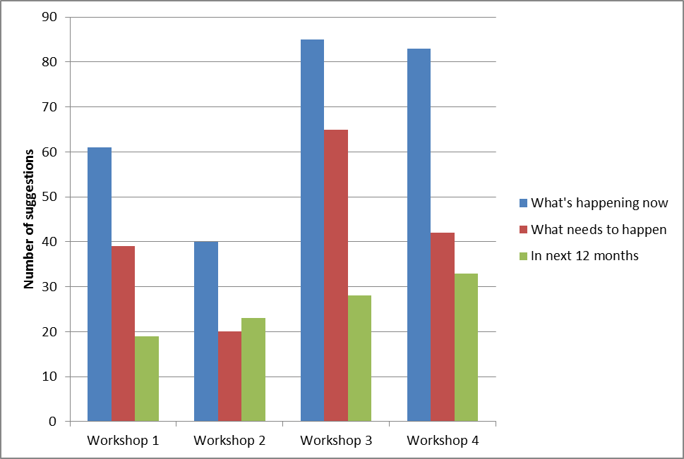

It appears from this simple analysis that more suggestions and proposed actions were provided in relation to developing holistic training and for cross-sector working (Workshops 3 and 4) than for developing lifelong participation and an environmentally-sustainable sector (Workshops 1 and 2). Even so, all workshop topics elicited a substantial number of ideas.

Workshop Responses
The main discussion points raised in the four workshops are set out in the sections below. Important note: these are the views and facts presented on the day by the delegates and collated by the facilitators, they have not been qualified or referenced. A full transcript of the responses submitted by delegates can be made available upon request by contacting: joseph.roberts@cyfoethnaturiolcymru.gov.uk

Workshop 1: Developing lifelong participation in sport and physical outdoor activities

What’s happening already?

- Gwynedd Archaeological Trust: developed a young people’s project which combined archaeology with adventure. Delivered it bilingually with Yr Urdd Glan-llyn. The Project has now ended but real potential has been demonstrated (link to video www.heneb.co.uk) - Site visits and historic environment walks have been delivered to schools – previously funded by NRW.
- The Outdoor Partnership: Welsh medium coach ed. - Partnership Primary School Awards - An increase in the no. of indigenous Welsh speaking instructors working in outdoor centres from 4% (2003) to 25% (2013) - New opportunities for under-represented groups to access the outdoors through the outdoor partnership (women and girls, disabled groups and unemployed) - Up skilling local people in preparation for employment (TOP pathways to employment programme) - Regional Coach Education programme for volunteers - Access to outdoor activity clubs in the region (about 100) with over 1000 members. Doorstep opportunities - Taster sessions and development programme for local people in NW Wales.
- Cadw: not enough at present, we have some small scale events and activities, but sport and physical activity is not core to our business at the moment (this needs to be done sensitively not just parachuting in) - archaeology, digs, volunteering etc. all getting people involved in outdoor experiences.
- National Trust: In key areas of Wales (e.g. Pembs) working with 3rd party providers to offer outdoor activities - accessible trails for people to walk, run and cycle – ‘Let the outdoors move you’ initiative - sport, physical activity programme to get more people active outdoors - matching activity with an understanding of cause – messaging natural environment.
- Duke of Edinburgh Award: providing early access to outdoors through awards.
- Outdoor Charter Groups: training delivered: Awareness of surrounding areas, Access to this with a code of responsibility for users and landowners, Knowledge of Fauna and Flora and geology.

What needs to happen?

Improve access provision: Key focus on opening up our outdoor spaces for people to enjoy, embrace and be active in; including better outdoor recreation infrastructure.

More holistic use of available funding: Link funding to other government goals (esp. well-being) to enable the outdoor sector to fund training and education; support partnership working rather than standalone regional initiatives; prioritise funding for schools to let children participate in non-standard sport activities.

More partnership working: develop a ‘whole sector approach’: Improved awareness of functions within the sector to streamline and avoid duplication; Improve linkage between outdoors and culture and heritage; better linkage between the NHS and outdoor sector (provision to offer alternative treatment options and tackle health problems).

Develop more environmental and cultural training and Continual Professional Development (CPD) for outdoor leaders: Particular focus on responsible, sustainable behaviour linked to understanding the surrounding area, environment and heritage/culture. Industry training and codes of conduct for leaders help them influence people to respect and enjoy our natural and cultural heritage. i.e projects like Archaeolegwyr Anturus Eryri.

Make the ‘outdoors’ more of a focus for in the school curriculum: There should be an outdoor education program from an early age that makes it ‘fun’ to learn. Schools should make more use of facilities on the doorstep (no transport costs, free to use). To enable this, teachers should receive CPD (as part of their initial teacher training) to unlock the huge potential the outdoors has for the curriculum based learning and cross curricular (e.g. ESDAC/PSE) making outdoor learning an integral part of their daily teaching.

Demonstrate more clearly that outdoor activity is a preventative treatment, and will save NHS money: Gather and present evidence to the NHS that links physical activity in outdoors to cost savings - health boards and GPs need to recognise and use the outdoors as a free prescription. Look at case studies where outdoor activities have been used to deliver multiple benefits, Research question: What’s the critical mass needed to create a change by cascade (i.e. inoculation strategy)?

Signposting of local opportunities and better promotion of what’s on offer: Find better routes to promote local opportunities, wider network for engaging with the public, use ‘nudge’ messages to push people towards sustainable modes of transport.

Invest more in the Welsh language: Need the Welsh language to be seen and heard in the sector. Develop projects to create sustainable, full time permanent jobs.

Reward businesses for supporting environmental projects: Incentivise the private sector to share messages / skill and job share etc. Downstream economy benefit of tourism visits needs to be maximised to local communities. Use the outdoors experiences and adventure to build sustainable local economies and bridge the gap between urban communities and the outdoors.

Clear pathways for progression from tasters to lifelong participation: Get everyone hooked on sport for life, make it possible for people to access sports after taster sessions (requires local community or club infrastructure with activities). Think of all parts of family – need to win over parents, not just young people – develop lunchtime sessions, after work/school activities (though need volunteers and support), develop a process that allow the young and old get in to coaching and support others.

Create opportunities for work in the sector: Local people need to know that there is work in the sector. This needs to be communicated more effectively. Ensure sector creates well respected jobs that pay appropriately with clear pathways leading to them (clubs / apprenticeships / NGB qualifications etc).

What can be done within the next year? (Top 5)

- Develop ways to give young people (long term) access to new sports.
- Work closer together - improving linkage between outdoor sector, culture, heritage and environment.
- Get health boards, GP clusters and Public Health Wales to take the role of the environment/outdoor activity seriously and recognise the benefits derived from it. More people, more active, more often = cost saving to NHS and Wales plc and job creation.
- Develop evidence base co-ordinate and bigger scale research – develop case studies demonstrating multiple benefits to illustrate overarching industry/sector scale, esp. economy health.
- Get more of the health budget redirected to sport, adventure and physical activity. This would need to be co-ordinated by an umbrella body and change outdoor offer to fit.

Workshop 2: Developing an environmentally sustainable outdoor sector

What’s happening already?

- General (The outdoor sector): currently engages with 10s of thousands of children, visitors and locals in the outdoors and spreading a conservation message.
- RSPB (and alike): Osprey project and similar, increasing people engagement with wildlife through tourism.
- Outdoor education centres: becoming ‘eco centres’ Keep Wales Tidy scheme.
- Field Studies Council: gaining carbon trust accreditation.
- Outdoor centres: installing solar panels and doing litter picks, and in partnerships with various bodies i.e. RSPB. Clean up days organised to co-ordinate providers maintaining and improving the condition of venue.
- Natural Resources Wales: providing on site interpretation and learning opportunities on heritage site on our land. Provide advice on sustainable use and management of the environment and access to its estate – making natural resources available for teaching in outdoors. Promoting responsible recreation – Countryside Code.
- Glandwr Cymru: offering a facility and opportunities on people’s doorstep, fun/escape without Good guidance to users from NGBs and governing bodies. Often site(s) based or activity based.
- Dwr Cymru: Llyn Brenig Reservoir – sustainable fish farming practises, water quality monitoring, managing woodland.
- Outdoor Charter Groups: Three Regional Environmental Charters promote sustainable recreation – Pembrokeshire, Brecon Beacons and North Wales 500+ signatories all eager to learn more about the environment. Signatories = outdoor providers. Environmental Charter groups working with environmental organisations to share resources and deliver training for the sector.
- North Wales charter group: history and geology workshops educating instructors and enabling them to pass on the stories from an area. Environmental Training for instructors funded by Visit Wales.
- Pembrokeshire charter group: Environmental training events for leaders, environmental resources, fact sheets, codes of conduct, Pembroke Marine Code, Volunteer code of conduct.
- Brecon Beacons charter group: Code of conduct and training for sustainability, use of fragile venues in Mellte and Sychryd gorges.
- British Mountaineering Council: Green guides - winter climbing info project.
- Mountain Training Cymru: CPD days for mountaineering/hillwalking qualifications in environmental access issues.
- Institute of Outdoor Learning: CPD provide new training, developing a cross sector applicable model for all to follow.
- Wales Adventure Tourism Organisation: provides a National Forum to discuss with all, best practise, future needs, issues, outdoor and agree sustainable action.
- National Access Forum for Wales: provides a professional network.
- General: Reports/surveys on value (economic) of outdoors - Miller report, Ramblers/BMC value of walking.

What needs to happen?

Develop a culture where environmental and sustainable messages integrated into all adventure activities: Outdoor sessions are a perfect opportunity to teach clients about the environment – making sessions not just about high adrenaline but about nature connection, enhancing client’s environment attitude in general. This should include more training for outdoor sector and requirements through the NGB training. This training should be supported by NPs / NRW / LAs (to allow activity providers to better spread the message shared by their organisations) or working in partnership with various local bodies/organisations to develop accredited programme which includes an environmental element

Develop training for providers that help them to engage with ‘the other 80%: This is in reference to the stats quoted by Andrew Denton from the Getting Active Outdoors study (2015). Developing approaches that offer multiple benefits – fun, health and well-being, economic benefits, and awareness of social/built/natural heritage. Have peer educators (14 – 25yrs) going into units and external bodies – giving activity sessions self-image, bullying, mental health, binge drinking, refugees. Engage young girls in various skills.

New cross-sector partnerships need to be formed to share resources, vision etc: There needs to be partnership working across outdoor sector, health sector, land management and government to help the outdoor sector grow sustainably, benefiting the economy, the environment and health (it does all these already but could do more).

Population scale shift in perception: There is a need to allow people access to nature to learn to love it but in a responsible and informed way. Outdoor providers are a vehicle for knowledge transfer on wide range of subjects in the outdoors. There needs to be support for this role but understanding that the function nature and wildlife play in the overall experience of outdoor adventure is not always valued and is not necessarily a given. The role of the importance of a healthy, diverse natural environment needs to come to the front of adventure campaigns such as ‘Year of Adventure’. Consider the ‘Year of the Wild’ as a theme.
Measures to safeguard Wales’s environment: There is a need to maintain and restore a biodiversity in Wales, giving it a healthy and functioning ecosystem. Management of uplands now has multiple outcomes (store carbon, water and increases wildlife, more tourism). Everyone has a role in making this shift happen, particularly this industry, using outdoor activities as a tool to inform young people about the outdoor environment and sustainability.

Development of appropriate environmental measures and standards for businesses: There is a need to incentivise businesses to act more sustainably: Sourcing food locally (especially for events), promoting close to home tourism opportunities, promoting sustainable transport (clients and providers) and equipment. Sustainable development charters (or similar) enable sharing of best practise.

What can be done in the next year? (top 5)

- Get businesses to highlight sustainable transport options and take a more active role in promoting environmental best practice.
- Deal with basic behavioural issues e.g. Litter, wild camping, by creating a series of consistent messages that can be used across the board.
- Encourage Visit Wales and tourism operators to promote local ‘on the doorstep’ adventure (in preference to visitors that fly in).
- Take steps to further integrate environmental sustainability messages into all activities especially when teaching – resources need to be provided to do this (basic core information to which specific activity/location info can be added).
- Review current National Governing Body training curriculum; mainstream environment and sustainability into training.

Workshop 3: Developing holistic training and development of volunteers, leaders, instructors and coaches

What’s happening already?

- British Canoe Union / Canoe Wales: Awards lead to the provision of activities that adventure tourism depends on.
- Brecon Beacons National Park Authority: Tourism Ambassador Scheme.
- Visit Wales: World Welcome host - creating a standard welcome pack activity focused on visitors = repeat customers.
- North Wales Wildlife Trust: provide resources to encourage visitors (and day trippers) to explore the environment; provides training and resources for instructors, participants to learn, understand and most importantly to celebrate the natural world and bilingual resources about wildlife and natural world.
- Mountain Training Association: Archaeological training provided to mountain leaders.
- Gwynedd Archaeological Trust: Heritage awareness for outdoor instructors by working with heritage sector. Development of volunteers and teachers on out of school site visits to heritage sites and monuments in the countryside.
- The Outdoor Partnership: Pathways to employment – Recruits locals/Welsh speaking people – creates ownership of the sector and quality. Paid trainee schemes – provide opportunities for people to be paid, gain employment and NGBs which leads (potentially) to employment in schools/outdoor centres; Welsh medium NGB training, pathways to employment – recruit and trains local / welsh speaking people – retains young people in rural communities.
- NRW, NT, Cadw: Site information, interpretation and best practice of codes of conduct for specific activities relating to environment, community, heritage.
- Institute of Outdoor Learning: environmental education skills. Special interest groups Accreditation scheme for instructors and leaders.
- Field Studies Council: staff qualifications and basic context to match.
- Royal Yachting Association: Green blue resources, Sailability and training athletes as ambassadors
- Mountain Training Cymru: training for all leaders involves learning about relevant cultural and environmental matters to pass on and this is assessed - works with other organisations and agencies to support education and continued development of leaders and instructors (Gwynedd Archaeology Society, Snowdonia Society, Natural Resources Wales). All leader award holders are encouraged to continue their journey with ‘CPD’ - Professional training for outdoor instructors – environmental awareness, identification and knowledge development.
- Underwater Wales: Working with North Wales Wildlife Trust on a project to ‘discover… explore… love… underwater wales’ – this element is about using outdoor activities as a way of enjoying wildlife.
- Further Education collages: Environmental programs, sports courses and activities ESDGC themes, tutorial programs Welsh BACC
- Natural Resources Wales: Training for leaders on NRW land – Come outside! - volunteering scheme ‘Cyfle’.
- Forests / NRW: Actif woods walks (Coed Lleol), Forest School (Forest school Wales), Social forestry apprenticeship LANTRA; MTB Trail fairies – volunteering for development/maintenance of MTBike trails.
- Plas y Brenin: training the trainers in a range of mountain sports. Develop leaders to deliver against a range of client needs.
- National Governing Bodies: discipline specific training i.e. RYA instructor qualification.
- Apprenticeships: formally accredited framework of industry developed qualifications. National occupational standards based qualifications within ﻿﻿﻿﻿﻿Qualifications and Credit Framework (QCF).
- Scouts/Guides: internal qualifications.
- Duke of Edinburgh Award
- Outdoor Centres: courses with centers i.e Plas Menai/ Glan-llyn introducing children to a new skill set – raises awareness of possible careers.

What needs to happen?

Better understanding of and engagement with the health sector: Understanding external partnerships (health sector) language, characteristics and how to engage. Carry out research that looks at the benefits of outdoor activities and health and mental wellbeing. Do this to facilitate backing from WG regarding health and the access to the environment. Look at learning from projects such as Come Outside! and the Outdoor Partnership.

Further develop pathways from participation to sustainable employment: Develop skills and pathways to sustainable employment by creating more trainee instructor schemes tied in the school curriculum and linked to NGBs qualifications. Expand on the Outdoor Partnership model to getting local young people from hard to reach communities to engage in outdoors, removing barriers and enable them to develop sense of place and identity. Employ local people, farmer’s etc. and try and create a culture of long term job and fair pay – the sector currently operates mostly on seasonal low pay work. Sector should provide more and better work placements to engage people in the sector as a career path.

More work to encourage participation in outdoor adventure activities at an early age: Work with trainee teachers to build capacity and confidence to enable curriculum learning outdoors. Roll out the Outdoor Partnership’s National Outdoor Award for primary schools. Identify local delivery centres to enable pupils to participate in activities that are sustainable economically. Look at the Outdoor Partnership model for engaging local young people and less accessible communities with the outdoors.

Creation of more opportunities for volunteers to help deliver adventure activities: Volunteering programme designed for 14 to 19 year old group to retain interest and leading to employment. Create adventurous activity volunteering opportunities for tourism and business students (in Further education colleges). This could also lead to health benefits.

Greater promotion/use of the Welsh language: The Welsh language should be available in all the outdoor activities. Do this by encouraging more local residents as leaders in the outdoors and Welsh Language training for existing non-welsh speaking workforce.

An audit of current training and Continual Professional Development (CPD): Audit known resources, teaching aids, training expertise and best practice and share with the sector rather than duplicate or replicate effort. Use this knowledge to test new ways of customer engagement and delivery, focusing on meeting the needs of the customer e.g. write and run course that industry needs so the output is ready to work.

Greater partnership working between NGBs: Need for NGBs to work closer together to structure their awards in a similar framework - on course content and CPD (this is being facilitated by IOL). Clear pathway needed - joint courses for certain skills sections and a simplified the process (MTC eLearning platform is a good example of this). A forum of all NGB and wider sectors could help build new key priorities (health, environment) into all training either as CPD or basic training.

Instructors with greater awareness of environmental / cultural issues: Environmental sustainability and appreciation of natural and historic world built in to all instructors’ courses. Support cross sector collaboration to provide heritage, culture and identify training opportunities for instructors, teachers, trainee teachers, trainee instructors and their tutors.

Training and CPD on health and wellbeing promotion (engaging with hard to reach communities): Design and administer specific skills and training for instructors in health issues and specific group needs (disabilities, mental health) softer leadership skills – MECC training, Behaviour change, emotional intelligence, social empathy. This could be linked to NGB training and CPD programmes to help leaders be needs supportive and inspire change in lifestyles and developing curious mind sets.

Better integration between NGB qualifications and government supported apprenticeships:
There is a need to change the apprenticeship framework in Wales to allow industries to greater influence how their apprenticeships are structured i.e. more involvement/ recognition of NGBs qualifications (removal of red tape so NGB awards can be used for apprenticeship schemes - NGBs to formally accredit their awards onto the NVQ via awarding organisations). This should then lead on to increased WG funding for apprenticeships relevant to the outdoor sector – similar to work in England with Institute for Outdoor Learning or a fully funded and extensive modern apprenticeship scheme based on the Outdoor Partnership Traineeship pilot.

What can be done over the next year? (Top 5)

- Develop more initiatives aimed at young people. E.g. roll out the Outdoor Partnership’s Outdoor Award aimed at primary schools – rewarding achievement in life skills, outdoor activities etc.
- Convene a 1 day symposium of Further Education providers of outdoor and adventure instructor training. Invite Andy Middleton as one of the speakers, identify common ground/aims.
- Bring outdoor activity NGBs to the table to develop the environmental element of their offer – this has a link to Wales Sporting Association
- A national outdoor day, no inside lessons for schools, organised activities. National publicity, politicians, news channels.
- Develop a suite of employer led apprenticeships for the Outdoor Sector.

Workshop 4: Developing cross sector approach to partnership working

What’s happening already?

- Welsh Government: Major Events Unit working with UK Sport - Raising the profile of Wales, bringing in private sector sponsorship and economic benefits.
- Visit Wales / WG: Joined up campaign year of adventure, destination advisory boards, Year of Legends 2017.
- Snowdonia Active: Green Snowdonia, linking business workshops, outdoor activity providers and acc. Providers, North Wales Adventure map, North Wales’s Environmental Outdoor Charter Group.
- Brecon Beacons Sustainable destination Partnership: – Marketing co-ordination GP, visitor transport partnership delivery group.
- Wales Adventure Tourism Organisation: Providing a forum for visit Wales, NRW, Sport Wales and the charter groups.
- Brecon Beacons National Park Authority: Ambassador scheme, close work with the South Wales Outdoor Activity Providers Group.
- Pembrokeshire Coast National Park Authority: Tourism infrastructure, sustainable tourism products and projects i.e. events, management guidance; Pembs Park our centres including Castell Henllys and Caerw Castle – linking heritage with contemporary life. LDP policy in practice, wardens and rangers, education and participation; coordinates the West Wales natural health service network, various projects including walkability your park, dark skies opportunities, creating an active walking Wales group; Sustainable development Fund – opportunities to local businesses for funding projects across a range of areas including recreation/well-being.
- Ramblers Cymru: Partnership projects with Cadw, WG and Visit Wales; working with WG delivering joined up with health and active travel, sport and culture through LWC (Lets Walk Cymru) in partnership with other NGOs and LAs; working with CRT and NT on specific project activities.
- National Trust: working with Sport Wales, share our places with communities to get more people active - “let the outdoors move you” partnership.
- The Outdoor Partnership: “pathways to employment programme” (over 300 unemployed residents now working in the sector), preparing and training NEETs for employment, 300+ per annum - FE sector; working with the North Wales health board disability development through outdoors; public, private and vol. sector representation. An increase in the number of indigenous Welsh speaking instructors from 4% (2003) to 25% (2013 Bangor University research); created partnerships with local authorities and introduced the concept of holistic activities; training community development volunteers and preparing people to inspire others with WCVS and county borough council; working with health board on disability development through outdoors.
- The Wildlife Trusts: 100 staff, 2000 volunteers, 24000 members working with over 100 partners to inspire people, developing new economic models for upland management, sustainable – reduces flooding, carbon release with WG, businesses and universities; work with NHS Wales and fire service- to get people outdoors NHS forest valleys project with fire brigade; work with +200 partners on wildlife projects throughout Wales; 200 nature reserves, 12 centres biggest tourism attractions in Wales, Montgomeryshire Wildlife Trust Osprey Project, work with over 100 corporate businesses to improve economics of business through environmental standards; working with other and NGOs to gain 1% health budgets for preventative health care.
- Cadw: we have over 1 million visitors a year working with NT, museums and library to join up our offer; we are launching historic adventures campaign on 1st March working closely with other heritage bodies; working with film and adventure companies to promote climbing/bouldering at our famous castles.
- South Wales Outdoor Activity Provider Group: Working with BBNPA on environmental and cultural training for visitors to pass on to groups; working with NRW on a concordant for sustainable use of environmental sensitive sites; working with IPMBA on a joint project on promoting the underground offer in South Wales; working with Carmarthenshire activity venue on impact review support and product development.
- TyF Group: partnerships with NRW, National Trust and PCNPA; working with Cardiff Sixth Form College and Cambridge University on practical education projects; working with innovation advisory council for Wales - health board and NHS.
- Woodland Trust: partnership work with Sainsbury and other organisations to supply free trees for communities, creating woodlands for people, ancient wood restoration, working with partners in World Wars commemoration scheme by planting new woodlands; ancient woodland restoration - NRW and local authority, creating woodlands
- Sport Wales: working with public health wales and WG.
- Disability Sport Wales: working with NHS.
- Girl Guiding Cymru: partnered with Sport Wales and working with NGBs.
- Snowdonia National Park Authority: working with GP practices developing health routes/paths.
- Plas y Brenin: working with The Outdoor Partnership and other organisations (centre of excellence).
- RYA: working with clubs /training centres.
- Other Partnerships mentioned: Beacon Way Partnership, Rural Alliances, Black mountains uplands partnership, Forest Fawr Geopark Partnership, Green Tourism Group, North Wales Economic Ambition Board.

What needs to happen?

Creation of a ‘Wales Outdoor Recreation Network’ (or similar): There needs to be better working across sectors – including more private and public sector joint working; There needs to be the creation of an outdoor network that crosses all sectors with one voice, which will help steer national cultural change through partnership working and education; this will improve communication across WG portfolios and break down silo mentality.

Extend the Outdoor Partnership model to cover the whole of Wales: Roll out the outdoor partnership across Wales, continued support for local community based outdoor activity clubs, develop programmes that inspire and engage with local people. There is additional need for financial support for the National Primary School Outdoor Award.

Build the evidence base of the links between outdoor activities and health/well-being: Identify the real links between outdoor physical exercise and physical health and well-being. Use this to levy more investment for prevention as opposed to “cure”.

Develop the profile of the outdoor sector in the health sector: The whole outdoor sector can deliver preventative health care (helping those who would benefit from getting active) huge resources of qualified outdoor leaders who can help (particularly in winter); Local Health boards need more outdoor sector input (e.g. Gwynedd and Anglesey - joint services health board currently has no one on it who’s about getting active). Scope out new community development projects for Big Lottery Funding that will demonstrate the role that the outdoor sector can play a part in.

Encourage outdoor sector to engage more with culture and heritage: Work with NT and Cadw to explore the use of outdoor adventure on their iconic sites - make links with providers. Explore mechanism for knowledge transfer between the environment and cultural heritage culture sectors and outdoor providers (use the NGBs and outdoor charter groups as a conduit for this).

Better use of nature to bring in tourism sustainably: Recognise that nature enriches tourism but don’t take it for granted. Wales is rich in natural capital but no one realises how important it is to maintain it. Find a USP for your location. i.e PCNPA: using the dark skies project to boost outdoor participation in activities. Promote the outdoors as a cross cutting opportunity to business – but – Promote responsible/sustainable use.

Develop an ‘Access / Visitor Management Partnership’: There is a need for the outdoor sector to have better links with environment sectors and understand access and sustainability; People/organisations need to understand issues around nature, transport, energy and waste, need all to know wildlife is declining. There is also a real need to continue to maintain accessible network of paths, get funding to create grid of multi used routes. Note: This is already done regionally by NPAs / NGBs and the Charter Groups.

Better funding for Tourism: Increase tourism budget in Wales, not have it slashed. Tourism is so important to the economy of Wales. Greater appreciation of value in North Wales as a tourism venue as WG funding is generally confined to South Wales.

What can be done in the next year? (Top 5)

- Explore ways of using outdoor professionals to deliver preventative activity for health in off season/throughout the year.
- Recognising opportunities for improving use of the outdoors amongst disabled people and women and girls – look at the model developed by the Outdoor Partnership.
- Developing a platform to delivering the ‘6 key principles’. Look at the Wales Adventure Tourism Organisation and The Outdoor Partnership’s role in this.
- Develop an active partnership across all sectors.
- Encourage more primary schools to engage in Outdoor Awards – delivering environment skills, outdoor skills and life skills.

Post workshop suggestions
On departure, delegates were asked to submit ideas for immediate action and many people availed themselves of the opportunity to put forward ideas. These are reproduced in Appendix 2. Some of these ideas clearly relate specifically to the points listed above.

Discussion
In the following section, the facilitators further distil the suggestions and discussion raised by the workshops into key consideration points for public sector policy makers and those directly involved with the outdoor sector.

Key points for public sector policy makers
The Well-being of Future Generations (Wales) Act 2015 imposes a duty on many public sector bodies to take account of the well-being of future generations when making decisions. Consequently, it provides a useful framework for assessing the relevance of the points arising from the conference for public sector policy makers. The Act covers seven key goals. These are listed below, together with key points which have emerged from the conference which relate to that goal.

A prosperous Wales
Goal: An innovative, productive and low carbon society which recognises the limits of the global environment and therefore uses resources efficiently and proportionately (including acting on climate change); and which develops a skilled and well-educated population in an economy which generates wealth and provides employment opportunities, allowing people to take advantage of the wealth generated through securing decent work.

Relevant points from conference:
- The outdoor sector is already responsible for generating economic benefits but there is a need for a stronger, more robust evidence base which demonstrates its potential to contribute more to society and the economy;
- Greater participation in the forms of physical activity on offer from the outdoor sector could make significant in-roads into the health budget;
- The outdoor sector will need to be innovative to entice the 80% of the young population who need to get more active, using new ways specifically designed to compete effectively for their attention and overcomes parental fears;
- The outdoor sector can provide good, sustainable, fulfilling, all-year-round jobs for local people but clear pathways for progression need to be developed;
- There is scope for more government investment in the outdoor sector to be used effectively and in a targeted way, e.g. with resource sharing and focusing on areas of deprivation, especially through partnership working;
- Upland management needs to be considered from a new perspective – as a venue for preventative health via outdoor adventure, as well as a foil for increased flood risk.

A resilient Wales
Goal: A nation which maintains and enhances a bio-diverse natural environment with healthy functioning ecosystems that support social, economic and ecological resilience and the capacity to adapt to change (for example climate change).

Relevant points from conference:
- A continuation of current trends means the country would face significant environmental challenges in the future and ‘business as usual’ is not a long-term option – change is urgently needed;
- There is concern that many people, particularly young people fixated on instant gratification, digital imagery and inactivity, are becoming disconnected from the natural environment and so have little interest in its deteriorating state;
- The outdoor sector can use its activities as a conduit for raising awareness and re-connecting people to their natural environment and cultural heritage;
- A framework of common standards for environmental education/awareness raising by outdoor instructors is needed to ensure a consistent, clear and effective message is put across to participants – this will require closer working partnerships;
- Instructors will need to be upskilled so that they can effectively deliver the relevant environmental and sustainability messages to their pupils;
- Commercial businesses should develop business models that are sustainable and environmentally friendly, so that they lead by example.

A healthier Wales
Goal: A society in which people’s physical and mental well-being is maximised and in which choices and behaviours that benefit future health are understood.

Relevant points from conference:
- A continuation of current trends means the country would face a public health and associated PHW funding crisis;
- Everyone subscribes to the view that physical activity is a great preventative ‘treatment’ but this needs to be better articulated in language that will convince those in the health sector;
- Outdoor adventure provides a more memorable and meaningful experience than those in a more controlled situation;
- The cost of developing the support infrastructure for the outdoor sector is minuscule compared to the NHS budget but this needs to be demonstrated more forcibly using robust evidence;
- The sector’s offer should embrace all abilities and allow a progression from taster sessions through to high level engagement, using ‘softer’ (i.e. interpersonal skills) more effectively;
- Closer partnerships both within the outdoor sector itself (such as through a Welsh version of an Outdoor Recreation Network) and with health sectors are needed.

A more equal Wales
Goal: A society that enables people to fulfil their potential no matter what their background or circumstances (including their socio economic background and circumstances).

Relevant points from conference:
- Pathway progressions are needed so that the sector offers employment opportunities to a wider range of people;
- There is recognition of the need to develop, and potential to achieve, activities that embraces people who are disabled, women and girls, people from low income sectors of society, people with health difficulties (physical and mental);
- For this to happen, a more ‘customer-led’ focus is needed and less of a ‘silo’ mentality;
- Instructors need to be equipped with the skills to get environmental and health messages across to groups;
- This up-skilling may need government funding, partnered with private sector support.

A Wales of more cohesive communities
Goal: Attractive, viable, safe and well-connected communities.

Relevant points from conference:
- Participation in outdoor adventure has been shown to encourage more fulfilled individuals who can contribute more to community-building;
- Partnership working is seen as being of a high priority;
- There is a strong feeling that the outdoor sector needs to be able to deploy its offerings at a very local level in order to get the participation and generate the benefits it believes it can achieve – it needs to get more local people to local events;
- All elements of the community need to work together on this.

A Wales of vibrant culture and thriving Welsh language
Goal: A society that promotes and protects culture, heritage and the Welsh language, and which encourages people to participate in the arts, and sports and recreation.

Relevant points from conference:
- The Welsh language gives Wales a USP of high cultural value and relevance;
- Use of Welsh by key players in the outdoor sector is to be encouraged and supported;
- Cross-sector working is needed to expand opportunities for volunteers with interest in this area;
- The outdoor sector can and should engage more with organisations involved in culture/heritage and make more of the iconic sites of historical interest in Wales.

A globally responsive Wales
Goal: A nation which, when doing anything to improve the economic, social, environmental and cultural well-being of Wales, takes account of whether doing such a thing may make a positive contribution to global well-being and the capacity to adapt to change (for example climate change).

Relevant points from conference:
- Wales’s environment is unique and of global appeal;
- Wales can become the Number 1 Adventure Capital destination in the UK;
- A clearer definition of the sector’s USPs is needed – not just nationally, but at business and venue level, too;
- Outdoor activity can be developed in a way that is sustainable;
- The outdoor sector faces challenges in the form of developing business practices that are truly sustainable (e.g. sustainable travel when attracting its customers and getting them to the sites for their chosen activity).

There are some possible inherent contradictions in some of these points:

- It was suggested (without contradiction) that the countryside of Wales, as elsewhere in the world, is under strain from excessive human exploitation and climate change. Yet, the overwhelming desire of both government and its agencies, and the outdoor sector is to encourage greater participation in outdoor activity by both residents and visitors (from UK and further afield). Success could impose an even greater burden on the Welsh countryside. The implication is that increases in its use would need to be managed carefully to avoid damage but still provide a rewarding experience.
- It was accepted that there is a need to wean young people away from their inactive, consumerist lifestyles into one with less dependence on shallow, short term enjoyment onto deeper more formative experiences gained from physical activity and outdoor adventure that last a lifetime. However, Wales’ desire for a prosperous economy is predicated on growth, much of which at present is consumer-led.

- There is recognition that young people need to be exposed to risk from an earlier age as its management is a valuable experience in their development. Physical activity is often offered as a means of gaining this experience, especially if it is ‘adventurous’. But, by some definitions, ‘adventure’ means a person being exposed to risk and/or uncertainty and allowed some say in how the activity is undertaken. However, many physical activities are presented as ‘adventure’ when in practice they are not. These activities are more accurately described as ‘thrills’ and are less good at developing skills in personal risk management. Clarity is needed on whether the sector can, in a society that is more risk averse than ever, really offer genuine adventure, or just thrills as a form of entertainment.

Key points for the outdoor sector
Reviewing the above points, it is possible to isolate those that are of direct relevance to the
outdoor sector. In no specific order of priority, the key points are:

- There is much to be gained for the sector to work together and to speak with one voice, articulating a common approach to standard setting and with a clear focus on building capacity so that it can scale up its offer; It also needs to come together to familiarise itself with health sector and approach with credible proposals;

- Closer partnerships both within the outdoor sector itself (such as through a Welsh version of an Outdoor Recreation Network) and with health sectors are needed.

- The outdoor sector can provide good, sustainable, fulfilling, all-year-round jobs for local people but clear pathways for progression need to be developed;

- Robust evidence is needed to support its claims for the scale of social/ economic/environment benefits that it believes can generate;

- The outdoor sector can use its activities as a conduit for raising awareness and re-connecting people to their natural environment and cultural heritage;

- In order to increase participation in outdoor activity amongst young and inactive people, each component of the sector (i.e. individual businesses) should consider how it can develop a product ‘offering’ that will appeal to this target group. The key question is “How can the deferred gratification (i.e. long-term benefits) of my product/service activity compete with the instant gratification (i.e. immediate/short term benefits) in an I-want-it-and-I-want-it-now! social climate, and in an economic environment oriented towards growth in consumption?”;

- A framework of common standards for environmental education/awareness raising by outdoor instructors is needed to ensure a consistent, clear and effective message is put across to participants – this will require closer working partnerships;

- Instructors will need to be up-skilled so that they can effectively deliver the relevant health, environmental and sustainability messages to groups;

- The sector’s offer should embrace all abilities and allow a progression from taster sessions through to high level engagement, using ‘softer’ (i.e. interpersonal skills) more effectively;

- There is recognition of the need to develop, and potential to achieve, activities that embraces people who are disabled, women and girls, people from low income sectors of society, people with health difficulties (physical and mental); For this to happen, a more ‘customer-led’ focus is needed and less of a ‘silo’ mentality;

- There is a strong feeling that the outdoor sector needs to be able to deploy its offerings at a very local level in order to get the participation and generate the benefits it believes it can achieve – it needs to get more local people to local events;

- Cross-sector working is needed to expand opportunities for volunteers with interest in this area;

- The outdoor sector can and should engage more with organisations involved in culture/heritage and make more of the iconic sites of historical interest in Wales. Use of Welsh by players in the outdoor sector is to be encouraged and supported;

- A clearer definition of the sector’s USPs is needed – not just nationally, but at business and venue level, too;

- The outdoor sector faces challenges in the form of developing business practices that are truly sustainable (e.g. sustainable travel when attracting its customers and getting them to the sites for their chosen activity). Commercial businesses should develop business models that are sustainable and environmentally friendly, so that they lead by example.

Recommendations
This final section focuses on what can be done by public sector policy makers and the outdoor sector itself to take forward the conclusions drawn from the conference. Important Note: These are recommendations have created by the facilitators by taking an overview of the array of points mentioned in earlier chapters.

In the next 12 months

Together:
- Create a national forum that stimulates closer cross-sector working and can guide future developments in the outdoor sector;
- Scope out a process to better assess the value of the outdoor sector in terms of delivering public and environmental benefits and its potential in the future;
- Convene further facilitated discussions on this subject, with greater involvement from the health sector, to review progress and decide on actions;
- Identify USPs for Wales as a whole and for specific products/locations/facilities;

For policy makers:
- Facilitate and moderate contact between the health and outdoor sectors;
- Investigate opportunities to resource and enable the outdoor sector so that it can maximise the benefits that it makes to the people of Wales and ensure it benefits those in most need;
- Continue to put its full support behind the Year of Adventure and similar designations for future years, in order to raise Wales’ status in the ‘Adventure Capital’ race;
- Identify ways to resolve policy contradictions where they exist;

For outdoor sector:
- Develop an effective channel for communication and partnership working within the outdoor sector;
- Pull together existing evidence that substantiates claims that physical activity in general, and outdoor activity in particular, generate significant health benefits;
- Work together to develop:
- Common approaches to setting environmental operating standards and business models that represent good practice in sustainability;
- An ‘in principal’ process for a more joined up approach to the training and CPD of instructors, to help them effectively deliver suitable messages on environment, cultural heritage and sustainability to clients;
- Standard pathways of progression, considering possible agreed routes from first participation, through to enthusiast, through to novice instructor, through to expert;
- Products that can be delivered locally/at a local scale.

To be developed beyond the Year of Adventure

Together
- Use the national forum to coordinate and prioritise developments in the outdoor sector;
- Develop the evidence base on the potential public benefits that the outdoor sector can deliver;
- Roll out an agreed model for pathways to participation to help get ‘more people more active more often’;
- Try and influence the development of the national curriculum to encourage greater use of the outdoors as a means of delivering learning and help more young people to participate in outdoor activities from an early age.

For policy makers:
- Bring together surveys of sport and physical activity to increase the value of the data obtained and reduce the cost of acquiring it;
- Support the creation of products that will engage with inactive young people and be led by what they might want;
- Consider the capacity of the environment, particularly the uplands, to ensure that it can cope with new demands placed upon it;
- Identify the key messages about environmental sustainability that can be delivered though the outdoor sector.

For outdoor sector:
- Work together to roll out agreed programmes of integrated training and development across all disciplines;
- Explore how to better integrate National Governing Body qualifications with apprenticeships schemes;
- Ensure instructors have the skill and resources to deliver appropriate messages to their clients (including a greater capacity to deliver these in Welsh);
- Set up procedures to monitor change in the sector.

Next Steps
Working alongside the outdoor sector, the partners involved in organising and hosting this event will review the sector’s aspirations, as outlined in the report, and look at realistic and achievable actions for taking them forward. The responsibilities for implementing these actions will be outlined in an accompanying document, to be developed with key stakeholders as part of the legacy for the Year of Adventure.

Appendix 1 - List of Invited Delegates

First Name/ Enw Cyntaf | Last Name / Ail Enw | Organisation / Sefydliad
Paul | Airey | Outdoor Education Consultant
Mark | Allen | Welsh Cycling
Anna | Astley | MB Wales
Marcus | Bailie | Adventure Activities Licensing
Rob | Baynham | ColegauCymru
Phil | Benbow | North Wales Mountain Rescue Association
Craig | Blain | sports coach UK
Jon | Brookes | Conway Centre
Jackie | Bryson | Plas y Brenin
Hannah | Buck | Pembrokeshire Coast National Park Authority
Jonathan | Cawley | Awdurdod Parc Cenedlaethol Eryri
Angela | Charlton | Ramblers Cymru
Simon | Clarke | Canoe Wales
Peter | Curran | Sport Wales
Anita | Daimond | Gwynedd Archaeological Trust
Marianne | Davies | Canoe Wales
Amanda | Davies | Gwynedd Council/Cyngor Gwynedd
Paul | Donovan | Wales Adventure Tourism Organisation (WATO)
Gabriella | Doyle | GIRLGUIDING CYMRU
Laura | Edwards | National Trust
Glyn | Evans | Sustrans Cymru
Tracey | Evans | Y Bartneriaeth Awyr Agored
Tommy | Evans | British Sub Aqua Club (Gwynedd Branch)
Belinda | Fear | Mountain Training Association
Claire | Fowler | Field Studies Council
Graham | French | Bangor University
Paul | Frost | British Horse Society
Ian | Gwilym | Duke of Edinburgh's Award
Ifer | Gwyn | Awdurdod Parc Cenedlaethol Eryri
Helen | Howard-Jones | British Sub Aqua Club (Gwynedd Branch)
Aled | Hughes | Public Health Wales
David | Hughes | Plas Heli Cyf
Tom | Hutton | OpenMTB
Ruth | Iliffe | RYA Cymru Wales
Marianne | Jackson | Conwy County Borough Council
Nia | Jones | North Wales Wildlife Trust
Jim | Jones | North Wales Tourism Ltd
Mark | Jones | Y Bartneriaeth Awyr Agored/The Outdoor Partnership
Elfyn | Jones | British Mountaineering Council
Nigel | Kendrick | Always Aim High Events Ltd
Jim | Langley | Nature's work
Mark | Lavington | PGL Travel
Haf | Leyshon | Woodland Trust
Bledd | Lloyd | National White Water Centre / Canolfan Dwr Gwyn Genedlaethol
Rich | Mehrtens | Welsh Rowing
Jethro | Moore | Adventure Beyond
Steven | Morgan | Plas Menai
Rebecca | Ode | GIRLGUIDING CYMRU
Ian | Owen | One Planet Adventure
Roz | Owen | NRW
Ed | Parsons | Dwr Cymru Welsh Water
Kate | Potter | Snowsport Wales
Paul | Renfro | Pembrokeshire Outdoor Charter Group / PCF / WATO
Andy | Robinson | Institute for Outdoor Learning
Mike | Rosser | AAIAC Adventerous Activity Industry Advisory Committee
Rachel | Sharp | Wildlife Trusts Wales
Catherine | Smith | Natural Resources Wales
Phil | Stubbington | John Muir Trust
Andrew | Stumpf | Glandwr Cymru - The Canal & River Trust in Wales
Debbie | Tanner | ScoutsCymru
Jason | Thomas | Cadw - Welsh Government
Richard | Tobutt | SkillsActive
Richard | Tyler | Brecon Beacons National Park Authority
Lowri | Tynan | Swim Wales
Anne | Vowles | Mountain Training Cymru
Matt | Ward | Runcomm Global Ltd
John | Watkins | Llywodraeth Cymru
Mared | Williams | Comisiynydd y Gymraeg
Graham | Williams | Sport Wales
Owain | Williams | Partneriaeth Awyr Agored
Catherine | Williams | Snowdonia-Active
Robert | Wix | Dwr Cymru / Welsh Water
Matt | Woodfield | SWOAPG

Appendix 2 - Suggestions for actions
Delegates were asked to submit suggestions for actions that they could directly contribute to the continuing work to develop the sector. These are the responses that were collected:

Name | Organisation | What would you like to see happening and how could your organisation help progress the conference’s agenda over the next 12 months
Rachel Sharpe | Wildlife Trusts Wales | Ideally be part of T and F group to take this forward. Offer advice and assistance of the Wildlife Trusts in developing environmental standards. Helping providers to inspire a generation about the natural beauty of Wales. Make 2019 Year of wild Wales.
Anita Daimond | Gwynedd Archaeological Trust | I will keep trying to link environment, heritage and outdoor activity in fun, engaging and positive ways bilingually.  Want to see more integrated approach and equality of opportunity which includes Welsh language.
Gabriella Doyle | Girl Guiding Cymru | Encourage girls and our volunteers to go outside and explore Wales. Hopefully help implement this through our ‘sport through guiding project’
Rebecca Ode | Girl Guiding Cymru | Try to initiate an outdoor award within Girlguiding for all ages (5-25 + leaders). The award will be split into various sections – Adventurous activity, softer activity and Environmental awareness
Matt Woodfield | SWOAPG | Let’s have a co-ordinated cross sector approach to positive change and education.  My members can be a great resource for both information gathering and passing on the message.  I will actively develop partnerships in my area to work towards shared goals.
Paul Renfro | PCF/ Pembrokeshire Outdoor Charter Group | Further meeting of a network that can pursue the idea of the conference and include the other sectors that had less representation.
Jim Langley | Natures Work | Offer training events. Promote and share the agenda. Happy to provide training in environmental awareness for free or offer free places on non-full courses.
Hannah Buck | Pembrokeshire Coast National Park Authority | Develop the West Wales Natural Health Service Network to further engage and evidence the outdoor recreation sector with health and wellbeing.
Tom Luddington | TYF | Collaboration between health and potential for preventative outdoor activity supported by outdoor professionals e.g. currently depressed – GP-tablets, move to increased provision into outdoor opportunities to key target groups likely to become depressed. Then  Depressed – GP-lots of options e.g. guided outdoor activity around social environmental adventure, guided indoor fun activities e.g. climbing wall and also tablets if necessary
Nia Haf Jones | North Wales Wildlife Trust | We will continue to celebrate the role that wildlife and the natural environment plays in adventure activities and the memorable experiences of those days when. Although you may not be aware of it, a chance encounter enriched your experience. I will promote the work that we do through Discover, Explore, Love Underwater Wales Project. I am super keen to carry on the conversation.
Anna Astley | MB Wales Chair Bikepark Wales | Work with Andy Middleton and TYF in collaboration  Investigate/develop a volunteer time for equipment hire  Research in green management awards for business  Another meeting/conference next year. More workshops and small networking groups
A Stumpf | Glandwr Cymru  Canal River Trust Wales | Happy to offer time to promote the outcomes discussed in plenary, in particular joint working and assessment of outcomes. Would attendees be willing to share their emails?
Andy Robinson | Institute of Outdoor Learning | Development of environmental elements of NGB training and awards offer. Will facilitate  Support for the outdoor Charter  Ensure key employers in Wales are aware of England apprenticeship developments and support task with Welsh Government.
Paul Airey | The Outdoor Partnership | Recognition and support for the work of the partnership.  Partnership strengthened with others  Outdoor activities available as a prescription form the GP  Primary School Outdoor award.
Paul Frost | British Equestrian Federation and The Outdoor Partnership | The industry to agree a structure to take forward the 6 key principles for the outdoors so as to buy in engagement by all the signatories and work together.
Catherine Williams | Snowdonia Active | Facilitate partnership working with outdoor providers. Our CRM is 1500 of outdoor practitioners across N Wales.
Jethro Moore | Adventure Beyond | More joined up thinking – NGBs – CPD – environmental training.  Make more from each pound 1 x 2 how?  Make the industry more sustainable, employment, environment, staffing.
Marianne Davies | Canoe Wales | Environmental standards agreement  Awards that support activity  Cluster working with other NGBs and organisations  Focus on groups not currently active
Ian Owen | One Planet Adventure | Working with Andy Middleton to help promote and lobby for the health aspect in hospitals. Work more closely to benefit the Welsh economy.
T Evans | The Outdoor Partnership | Collaboration/partnership working  All Wales Network/framework.
Ruth Iliffe | RYA Cymru Wales | Re-align strategy to embrace areas of inequality – part of whole UK strategy.  Continue to develop external marketing in line with OIA research  Work with outdoor partnership  Sign up 6 principles of Outdoor Activities WATO.

