

MASTER OF BUSINESS ADMINISTRATION

LCMB7026

INTERNATIONAL MARKETING: PRINCIPLES AND PRACTICES

ASSESSMENT COMPONENT 1: INDIVIDUAL REPORT

INTERNATIONAL MARKET ENTRY STRATEGY AND MARKETING MIX ANALYSIS OF LOUIS VUITTON IN SOUTH KOREA AND UNITED KINGDOM

Lecturer name: Dian Mayasari

Student name: Krinal Bhikhubhai Gandhi

Student ID: 2504763

Word count: 5,029

Submission date: 27th March 2026

Executive summary

This report is all about the international market entry strategy and marketing mix of one of the most well-known fashion house brands, Louis Vuitton, in two different countries, namely South Korea and the UK. The concept of international expansion has been central to the growth of luxury brands, as demand for high-quality fashion products remains strong across various markets. The report compares the macro-environment using the PESTEL framework, segmentation, targeting, and positioning strategies, an international marketing mix analysis, and ethical issues and recommendations. As per both internal and external analysis, it is analysed that the brand structure of Louis Vuitton is efficient enough in enabling this brand to expand globally while maintaining brand exclusivity and control over its creative output. On the whole, this experience of evaluating business environments has served as a part of the learning process and professional development, as it promoted constant self-reflection and self-improvement. Such a structured approach enabled the research process to be structured in a logical manner and it has been subsequently possible to cover necessary analytical frameworks in context of Louis Vuitton in these comparative markets of South Korea and UK.
Table of Contents

Section 1: International Market Entry Strategy and Marketing Mix 6
1. Introduction 6
2. Background of Louis Vuitton 6
3. Comparative Analysis of Macroenvironment (PESTEL) 7
3.1 Overview of PESTEL Framework 7
3.2 Political and Legal Factors 8
3.3 Economic Factors 9
3.4 Social and Cultural Factors 10
3.5 Technological Factors 12
3.6 Environmental Factors 12
4. STP Strategy Analysis (Segmentation, Targeting, Positioning) 13
4.1 Market Segmentation 13
4.2 Target Market 14
4.3 Positioning Strategy 14
4.4 Perceptual Map 15
5. International Marketing Mix (7Ps) Comparison 16
5.1 Overview of Marketing Mix 16
5.2 Product Strategy 17
5.3 Price Strategy 17
5.4 Place / Distribution Strategy 17
5.5 Promotion Strategy 17
5.6 People 18
5.7 Process 18
5.8 Physical Evidence 18
6. Directional Development Strategy 18
7. Ethical Issues in Marketing Mix 19
8. Recommendations for International Marketing Strategy 20
Section 2: Reflective Account 20
1. Introduction 20
2. Description of the Research Process 21
3. Feelings During the Research Process 21
4. Evaluation of Learning 22
5. Analysis of Skills Developed 22
6. Conclusion and Learning Outcome 23
References 24

List of figures and tables

Table 1: PESTEL Analysis 8
Figure 1: LV Instagram Page 10
Figure 2: Cultural Dimension of South Korea vs the UK 11
Table 2: STP Strategic Analysis 13
Figure 3: Perceptual Map 15
Table 3: Marketing Mix 17
Table 4: Ansoff Matrix 19

Section 1: International Market Entry Strategy and Marketing Mix

1. Introduction
Louis Vuitton is among the most well-known luxury fashion brands worldwide and a symbol of heritage, craftsmanship, and exclusivity in the fashion industry. The business is part of the LVMH Group and specialises in luxury handbags, leather products, clothing, jewellery, and accessories. The brand has evolved over the last century into a global luxury giant with stores in key fashion cities and a strong presence in international markets. The two markets, South Korea and the United Kingdom, are among the most appealing to a luxury fashion firm. This has resulted in the emergence of a powerful luxury culture led by young buyers in South Korea, who have been influenced by social media and by limited disposable income. The United Kingdom is one of the most advanced luxury markets in Europe, with a well-developed retail base and high spending in fashion capital cities such as London, making it a leading tourist destination (MI, 2025).
Knowledge of international marketing strategies is especially essential in the luxury fashion industry, where brands must adapt their marketing mix to suit cultural preferences, economic conditions, and consumer behaviour across markets. It is imperative for luxury fashion businesses to retain brand exclusivity while also addressing local market characteristics in order to remain competitive in the market. This report analyses the international market entry strategy and marketing mix of the Louis Vuitton brand in South Korea and the United Kingdom.

2. Background of Louis Vuitton
Louis Vuitton is a luxury goods manufacturer founded in 1954 in Paris by Louis Vuitton, who produced high-quality travelling trunks. The brand's first and most notable product was the trunks with flattops that could be stacked more easily for transport (LV, 2026). The company diversified over time and expanded into other products, including handbags, accessories, clothing, and jewellery. Today, Louis Vuitton is a subsidiary of LVMH, the world's largest luxury conglomerate, which comprises over 75 luxury brands. Its mission is “The Art of Crafting Dreams” (LVMH, 2026). The group generated revenue of €86.2 billion in 2024, and Louis Vuitton is among the most lucrative brands in its portfolio (LVMH, 2025). The brand has created substantial global value, with brand value reaching approximately €26.3 billion in 2023 (Statista, 2026). In recent years, the company has recorded a market capitalisation exceeding €350 billion, indicating its presence in the luxury fashion industry (Macrotrends, 2025).
According to Phung (2025), the brand is organised within a centralised strategic framework with robust regional retail management, which enables global brand consistency and local market adjustments. In the late 12th century, Louis Vuitton expanded globally as luxury consumption increased worldwide. The brand, Louis Vuitton, was launched by Vuitton in Paris in 1854, wherein it opened flagship stores in London's fashion districts, such as Bond Street. Its presence in South Korea was, however, in between 1980-1990, with the first store in Seoul (Diderich, 2018). The increasing luxury spending among young consumers later made South Korea one of the most significant markets in Asia. South Korea has one of the highest per-capita rates of luxury spending worldwide and continues to attract luxury brands (MI, 2025).

3. Comparative Analysis of Macroenvironment (PESTEL)

3.1 Overview of PESTEL Framework
The PESTEL framework is a strategic analysis tool used to examine macro-level external environmental factors that affect business operations. The model assesses the political, economic, social, technological, environmental, and legal forces that affect market opportunities and risks. As stated by Morrison (2025), the macro-environment is critical to international marketing strategies because conditions across countries differ and influence consumer behaviour, market-entry decisions, and marketing strategies.
PESTEL Factor | South Korea | United Kingdom
Political | Stable democratic system; strong intellectual property protection; approximately stable luxury-goods import tariffs of 8–13% | Stable political system; post-Brexit trade rules increased customs procedures; VAT on luxury goods 20%
Economic | The luxury goods market is valued at about $20–21 billion in 2025; growth rate approx. 6–7% annually | The luxury fashion market is about $17.5 billion (2024), expected to reach $22 billion by 2030
Social | One of the highest luxuries spending per capita globally, with a strong influence of K-pop and social media | London attracts over 30 million international tourists annually, and many luxury shoppers
Technological | Internet penetration 97%+; strong digital commerce adoption | E-commerce contributes about 25% of luxury retail sales
Environmental | Increasing consumer demand for sustainable fashion, strong government sustainability policies | Strong sustainability regulations and ESG reporting requirements in the fashion industry
Legal | Strict consumer protection laws and trademark protection | Strong IP protection laws and strict advertising regulations

Table 1: PESTEL Analysis
(Source: Self-Developed)

3.2 Political and Legal Factors
The international luxury markets are highly affected by political stability and government regulations. As per the analysis of Al-Tarawneh and Al-Badawi (2024), the UK is regarded as a developed economy, politically stable, with a robust legal system that safeguards intellectual property rights. Nevertheless, the regulations and customs governing luxury goods entering the UK market have changed due to Brexit. Such developments have increased import costs and the bureaucratic burden associated with the trade in luxury brands between Europe and the United Kingdom. Despite these obstacles, the UK remains one of the largest luxury markets in Europe. As per one of the market reports of Statista, the UK luxury fashion market generated approximately $17.5 billion annual revenue in 2024. It is further projected to grow at an annual rate of approximately 3.5% through 2030 (Statista, 2025).
South Korea is also highly politically stable and has a supportive regulatory environment for international brands. The nation has developed favourable trade policies and robust consumer protection laws that support international fashion firms venturing into the country. The government has also helped in the development of digital commerce and international retail. Not only this, but South Korea's luxury goods market exceeded $20 billion in 2024 and continues to grow, driven by high domestic consumption and strong tourism demand (IMARC, 2025). A favourable regulatory climate and the growing demand for high-quality fashion items have consequently made South Korea a viable market for Louis Vuitton.

3.3 Economic Factors
Economic conditions strongly affect luxury consumption patterns, as luxury goods depend on consumer purchasing power and disposable income. The UK is one of the most popular luxury markets in Europe, with substantial international tourism and consumer expenditure. The UK luxury fashion market may reach approximately USD 22 billion by 2030, with average annual growth supported by high disposable income levels among domestic consumers and tourists (MRF, 2025). Even higher growth in luxury consumption has been observed in South Korea over the past ten years. In South Korea, the luxury goods market is projected to reach approximately $21 billion by 2025 (Statista, 2025). Over the past few years, it has grown at an annual rate exceeding 6%. High consumer expenditure among millennials and Generation Z is one factor that has accelerated its growth. Digital commerce is another factor to consider in economics. It is also analysed that online luxury sales have grown substantially in recent years, with e-commerce sites accounting for over a quarter of total luxury purchases worldwide (ECDB, 2025). Such economic opportunities create favourable conditions for Louis Vuitton to expand its digital retail presence in the two markets.

3.4 Social and Cultural Factors
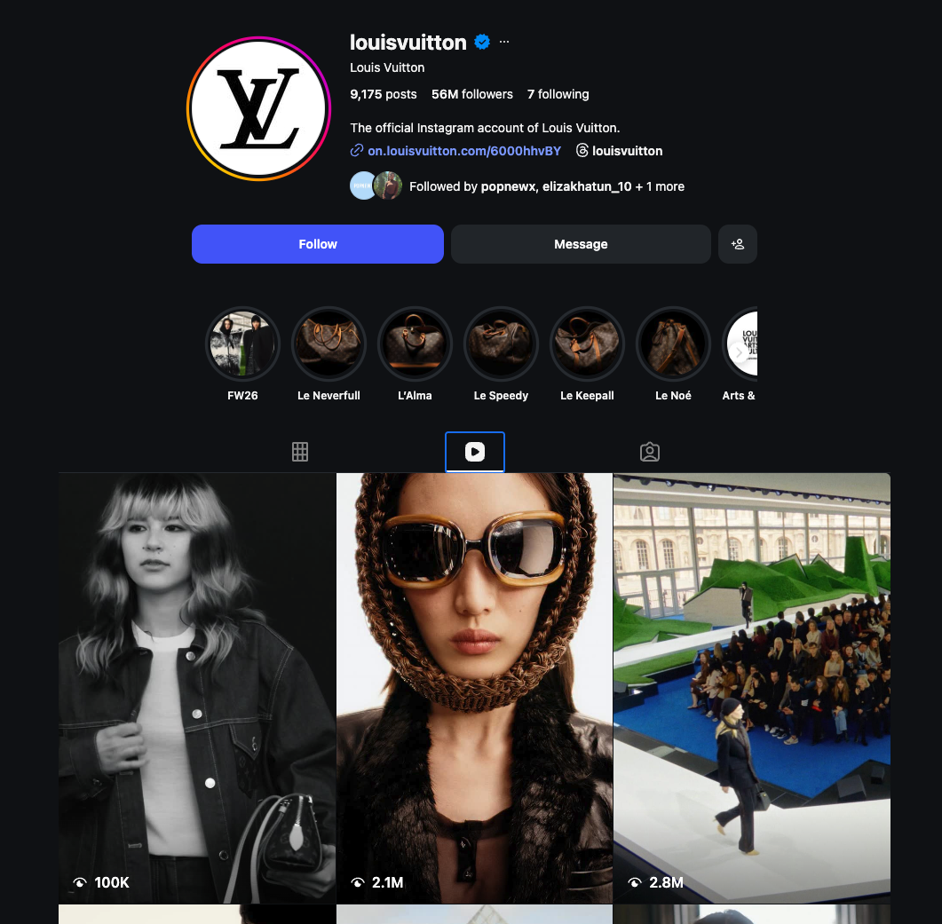

Figure 1: LV Instagram Page
(Source: Instagram, 2026)
Social and cultural influences are very strong on luxury consumption, as luxurious products tend to embody status, identity, and social prestige. South Korea is characterised by a culture of luxury, in which fashion brands symbolise social success and a modern way of life. South Korea has one of the highest per-capita rates of luxury spending worldwide, and many of its consumers allocate a large share of their income to high-end brands (SI, 2025). Digital culture and celebrity endorsement are crucial factors in consumer behaviour in South Korea. Instagram and YouTube are social media platforms that exert significant influence on consumer preferences for luxury fashion products. Räsänen (2025) explained that Louis Vuitton has capitalised on digital marketing tools to enhance brand recognition and high involvement among younger generations. Compared with the United Kingdom, a developed luxury market, heritage, craftsmanship, and brand reputation are more influential in consumer decision-making. Consumers of luxury in the UK tend to attach importance to brands' heritage and the authenticity of high-end fashion houses. Heritage storytelling and brand tradition are significant factors contributing to the luxury brand's prestige and cultural value (Temirov, 2025).
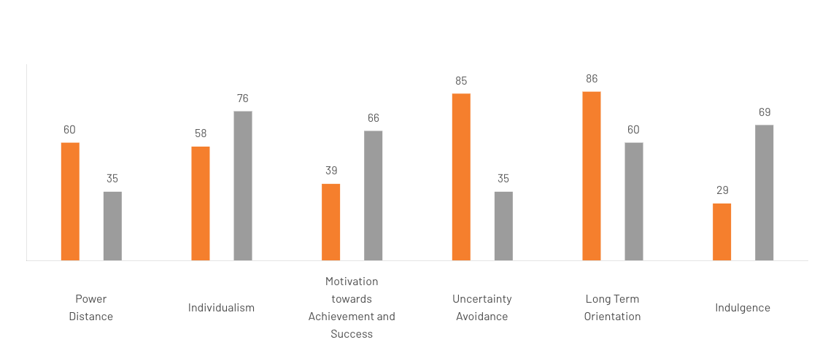

Figure 2: Cultural Dimension of South Korea vs the UK
(Source: The Culture Factor, 2025)
The Hofstede cultural dimensions are an appropriate model that can be used to explain cultural differences between the United Kingdom and South Korea. Figure 2 shows that there are evident differences in six cultural dimensions (The Culture Factor, 2025). Korea has a score of 60 in power distance as compared to the score of 35 in the United Kingdom, meaning that Korean society is more likely to accommodate hierarchical relations and authority. By comparison, the United Kingdom exhibits a much greater degree of individualism, registering a score of 76, whereas South Korea has a score of 58, indicating that British consumers are much more concerned with individual identity and the choice of individual lifestyle.
There are also some differences in motivation and success orientation. For instance, the UK has a score of 66 in motivation towards achievement and success, and South Korea has a score of 39. This, in turn, depicts that the UK market has a more competitive and achievement-oriented culture. The other key difference is seen in the uncertainty avoidance index, where South Korea has a score of 85, as compared to that of the UK of 35 (The Culture Factor, 2025). This further implies that Korean consumers value stability and structure and trusted brands in making a purchase. Furthermore, South Korea scores high on long-term orientation with a score of 86, the United Kingdom scores 60, indicating the focus of the Koreans on long-term relationships and future planning. Lastly, indulgence scores are also significantly different, with the UK scoring 69 versus 29 in South Korea, so that the consumers are more likely to be more focused on leisure and personal enjoyment in Britain. These cultural variations have a profound effect on the consumption behaviour of luxury, and these brands have to modify their marketing strategies to suit such differences (Take, 2026).

3.5 Technological Factors
It is analysed by Asfaw and Menon (205) that the concept of luxury fashion retailing has been revolutionised by technological innovation, facilitated by digital commerce, social media marketing, and immersive brand experiences. Luxury brands are becoming more interactive across online channels and physical retail stores to provide seamless customer experiences. Digital transformation enables companies to engage with consumers on a one-to-one basis through social media platforms and personalised marketing approaches. Studies indicate that another luxury brand is also investigating immersive technologies, including virtual reality, metaverse shopping, and digital fashion experiences. These technologies enhance the brand's interactivity and enable consumers to engage with luxury products in new ways. Retail experience and customer relationships are new avenues that luxury fashion firms are creating through virtual platforms and digital environments (Hu et al., 2025).

3.6 Environmental Factors
Environmental sustainability is now a significant concern in the fashion industry worldwide, driven by heightened consumer awareness of environmental impacts and ethical production practices. To reduce their environmental impact, luxury brands are turning to sustainable materials, responsible sourcing, and circular fashion practices. Green marketing efforts have been critical to upholding the brand image and aligning with consumer expectations regarding environmental responsibility. The study of Botea-Muntean et al. (2025) indicated that brand credibility and long-term competitive advantage in the fashion industry may be enhanced by adopting sustainable production and circular economy principles. Consumers in the United Kingdom and South Korea are becoming increasingly aware of luxury brands' environmental responsibility and demand greater supply chain transparency.

4. STP Strategy Analysis (Segmentation, Targeting, Positioning)
STP Element | South Korea – Key Statistics | United Kingdom – Key Statistics
Segmentation | Consumers preferring luxury fashion items are mainly aged 20–40; have high digital engagement; the luxury market value is about $21 billion (2025) | Luxury consumers are mainly aged 30–55; have high tourist spending; the luxury fashion market is about $17.5 billion (2024)
Demographic | High-income professionals and celebrities have strong purchasing power in urban cities like Seoul (≈9.6 million population) | High-income professionals and international tourists; strong luxury retail in London (≈9 million population)
Psychographic | Status-driven consumers influenced by K-pop, influencers and social media | Heritage-oriented consumers valuing brand prestige and craftsmanship
Behavioural | High luxury spending per capita globally, strong brand loyalty, and trend adoption | High tourist-driven luxury purchases; frequent luxury purchases during travel
Targeting | Millennials and Gen Z luxury buyers with high social media usage, and premium urban consumers | Affluent professionals, global tourists and luxury lifestyle consumers
Positioning | Positioned as a prestigious luxury brand symbolising status and fashion leadership | Positioned as a heritage luxury brand, emphasising craftsmanship and exclusivity

Table 2: STP Strategic Analysis
(Source: Self-Developed)

4.1 Market Segmentation
Segmentation has enabled luxury brands to market to consumers within segments that share similar characteristics, thereby enabling the development of focused marketing strategies. Luxury fashion businesses tend to segment markets by demographic, psychographic, and behavioural factors. Demographic segmentation incorporates variables such as age, income, and occupation. Luxury fashion shoppers are typically high-income individuals or wealthy professionals with strong purchasing power. Findings of Liu and Meng (2025) have shown that luxury consumers are typically upper-income individuals who earn more than 100,000 per year and reside in large cities. Psychographic segmentation is based on lifestyle, social status, and personality. Luxury consumers tend to purchase products that convey prestige, identity, and emotional satisfaction. Symbolic value is the primary driver of motivation among many luxury customers, rather than the products' functional features. Purchasing behaviour, brand loyalty, and patterns of product use are analysed within behavioural segmentation. Loyal customers of luxury brands tend to purchase multiple products from the brand and are interested in exclusivity and personalised service. The digital analytics and consumer data insights have made customer segmentation strategies more sophisticated (Chen et al., 2025).

4.2 Target Market
Louis Vuitton targets high-end customers interested in high-quality fashion products associated with luxury and status. The brand's target audience is primarily high-income professionals, entrepreneurs, celebrities, and wealthy millennials (LVMH, 2026). The younger luxury consumer has also become increasingly important as Generation Z and millennials have assumed a larger share of luxury sales worldwide. The target market in South Korea is primarily composed of young professionals and digitally focused, informed consumers who follow fashion trends and celebrity culture. The use of social media has a significant effect on purchasing behaviour in the Korean luxury market. The United Kingdom's target market comprises both domestic and international visitors to luxury retail destinations in London. This is because luxury brands benefit from high tourist spending in major shopping districts such as Bond Street and Knightsbridge. Studies indicate that international tourism accounts for a substantial share of luxury retail sales in London, thereby reinforcing the marketing capabilities of international luxury brands (MI, 2025).

4.3 Positioning Strategy
Louis Vuitton is marketed as an icon of prestige, exclusivity, and heritage craftsmanship. The brand conveys a strong luxury message through its historic heritage, high quality, and iconic design. Brand positioning. A luxury brand would focus on emotional value and symbolic meaning rather than on price competition. Brand identity and cultural heritage are common, and luxury fashion companies employ narratives to support their brand names. According to Zanola et al. (2025), brand storytelling and heritage narratives reinforce consumers' perceptions of authenticity and exclusivity in the marketing of luxury fashion products. Louis Vuitton thus ensures global positioning while adapting its communication strategies to suit regional audiences.

4.4 Perceptual Map
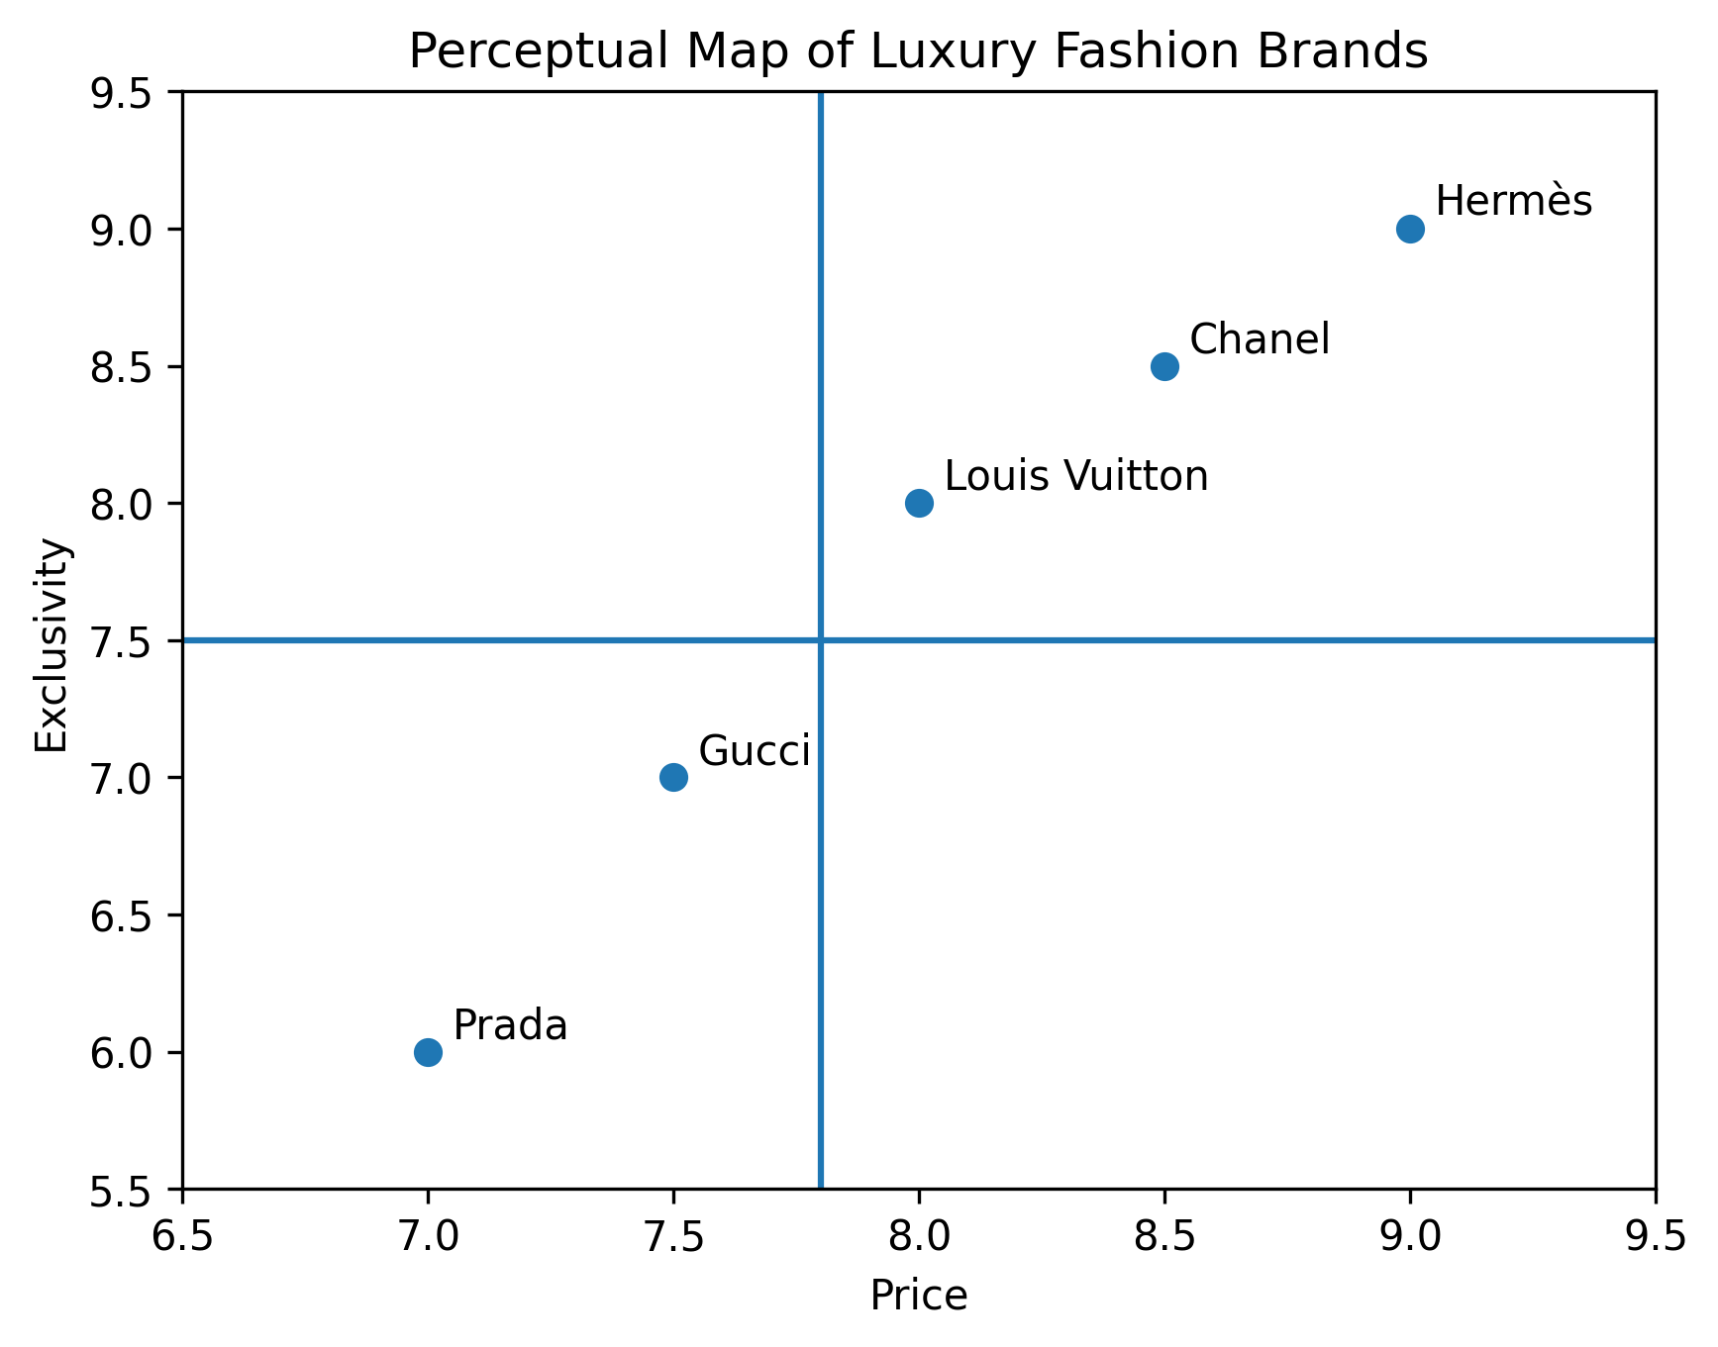

Figure 3: Perceptual Map
(Source: Self-Developed)
A perceptual map of luxury brands typically compares brands based on exclusivity and price positioning (Minh and Hue, 2025). Louis Vuitton falls within the high-price, high-prestige quadrant, alongside brands such as Chanel and Hermès. This positioning indicates the brand's strategy to maintain a premium price point and to emphasise heritage and exclusivity.

5. International Marketing Mix (7Ps) Comparison

5.1 Overview of Marketing Mix
The marketing mix is the strategy of combining the elements of product, price, place, promotion, people, process, and physical evidence employed by companies to create value for customers. The marketing mix in the luxury fashion industry needs to balance exclusivity and accessibility and ensure a consistent global brand identity. Brand perception, customer experience and competitive positioning in foreign markets are strategic decisions made by marketers (Liu, 2025).
Marketing Mix (7Ps) | South Korea | United Kingdom
Product | Luxury handbags, leather goods, ready-to-wear; strong demand among the 20–40 age group; high fashion influence from K-pop and celebrities | Luxury handbags, accessories and fashion collections; strong demand among the 30–55 age group; heritage luxury preference
Price | Premium pricing; handbags typically $1,500–$5,000+ | Premium pricing; handbags typically £1,200–£4,500+
Place | Flagship stores mainly in Seoul luxury districts (Gangnam, Myeong-dong); strong online retail adoption | Flagship stores in London (Bond Street, Harrods); strong tourist luxury retail market
Promotion | Heavy use of social media marketing and K-pop celebrity endorsements | Focus on fashion shows, luxury advertising and heritage storytelling
People | Luxury retail staff trained in personalised service and VIP customer relationships | Highly trained luxury sales associates in flagship stores and luxury department stores
Process | Integration of online and offline retail channels; fast digital customer engagement | Strong in-store luxury experience with personalised shopping service
Physical Evidence | Modern luxury store design and premium packaging; strong brand logo visibility | Historic luxury boutiques and premium visual merchandising in London

Table 3: Marketing Mix
(Source: Self-Developed)

5.2 Product Strategy
The Louis Vuitton product strategy is focused on luxury artisanship and exclusivity. Signature products like the Neverfull handbag cost around Kwon amount of $1,800–$2,200 in South Korea and £1,500–£1,800 in United Kingdom taking into consideration, the regional prices. Small runs and season had a limited quantity and perceived value. Bi (2026) mentions that luxury identity and consumer attraction is also enhanced by visual design and branding.

5.3 Price Strategy
The differentiation bases of exclusivity in the two markets through premium pricing are similar but not perceived to be similar. Luxury handbags priced between $1,500–$5,000+ are considered good status symbol among young consumers in South Korea. In the UK, comparable products at prices of £1,200–£4,500+ are focused on heritage and workmanship. According to Liu et al. (2025), luxury markets have a high level of conspicuous status that costs more and is more valued.

5.4 Place / Distribution Strategy
The primary channel through which Louis Vuitton distributes its products is exclusive flagship and limited-luxury retail outlets. The brand ensures that its distribution is strictly controlled to avoid overexposing the brand name in the market. In most cases, luxury brands prefer direct retail outlets in key cities worldwide rather than mass distribution. As per Massi et al. (2025), experiential retail space and flagship stores provide a better luxury shopping experience and build brand recognition.

5.5 Promotion Strategy
The marketing of luxury fashion focuses on emotional appeals, celebrity endorsements, and visual advertising that emphasises high standards. Louis Vuitton regularly engages with numerous celebrities, fashion influencers, and artists to enhance brand strength. Luxury advertising can emphasise prettiness, creativity, and an imagined aspirational lifestyle rather than directly promoting the product. According to Dave and Gupta (2025), aspirational advertising and influencer partnerships enhance the brand presence and interaction between consumers and luxury brands.

5.6 People
The staff and customer care associates are essential to delivering luxury brand experiences. Luxury retail employees are taught to deliver personalised customer service and individualised customer experiences. Studies indicate that luxury retail spaces have focused on highly trained employees with knowledge of brand history and product artistry. Professional service improves the perceived luxury value and makes a customer more loyal (Atwal and Bryson, 2025).

5.7 Process
Process can be defined as the systems of providing luxury retail experiences. Louis Vuitton is using digital platforms and tailor-made services on its 460+ global stores and Internet storefronts. Krsmanović (2026) further added that digital technologies and marketing data-driven assists luxury brands in improving the level of interaction with the customer and the efficiency of services provided.

5.8 Physical Evidence
Physical evidence encompasses architects of the store, packaging products and visual merchandising of products which convey the brand image of luxury. Louis Vuitton makes heavy investment on shop design and luxurious packaging to secure exclusivity and artisanship. The brand has over 460 retail outlets in over 100 countries with many situated in the high-end areas like Bond Street in London and Gangnam in Seoul. These stores also have a unique architectural design, excellent quality of materials and brand symbols that make the shopping process luxurious. Brand recognition is also enhanced by premium packaging with the recognisable orange box and monogram branding. A powerful visual presentation and store design have a great impact on consumer perception and interest in luxury fashion brands (Huang and Zhou, 2025).

6. Directional Development Strategy
Ansoff Matrix is extensively applied in assessing growth strategies of business by penetrating the market, developing the product, developing the market and diversifying it.
Strategy | Description | Louis Vuitton Example
Market Penetration (Existing Products – Existing Markets) | Increasing sales of existing luxury products in current markets through stronger marketing and retail expansion | Expansion of flagship stores in London and Seoul, and increased digital marketing campaigns
Product Development (New Products – Existing Markets) | Launching new luxury products for existing customers | Introduction of new fashion collections, jewellery, and limited-edition collaborations
Market Development (Existing Products – New Markets) | Entering new geographic markets with existing luxury products | Expansion into Asian luxury markets such as South Korea and China
Diversification (New Products – New Markets) | Developing new products for new markets | Launch of LV Café and experiential luxury retail concepts

Table 4: Ansoff Matrix
(Source: Self-Developed)
The market development strategy that Louis Vuitton has followed has primarily involved entering into the new luxury markets like South Korea where the luxury market has surpassed the 20 billion categories in 2024 and is expected to keep growing at an alarming rate. Product development through new collections, jewellery lines and digital fashion experiences is also a part of how the brand has concentrated on products development. As Zeng (2025) explains, LV Café and experiential luxury spaces are the revolutionary forms of retail that allow greater brand engagement and interaction with the customer. The tactics will contribute to the global growth of Louis Vuitton and its competitive advantage in the high-end fashion market.

7. Ethical Issues in Marketing Mix
This situation is due to the sustainability, environmental responsibility and labour practises being the key ethical issues within the luxury fashion industry. More than 70% of the globe gravitates fashion items in terms of sustainability and the luxurious business will soon exceed 380 billion dollars up to the year 2025 (Statista, 2025). The potential ethical concerns that have been encountered regarding Louis Vuitton have been linked to the environment and the quality of the supply chain where the leather is obtained and the source of carbon emissions, which is related to the global production. The stringent policies of ESR in the UK are pushing more brands to report their sustainability efforts in the market whereas the high level of consumer awareness in South Korea is pushing more pressure on ethical branding. Chen (2025) confirms that Louis Vuitton overcomes the problems with the help of sustainability communication and corporate responsibility programmes, yet constant transparency remains an issue.

8. Recommendations for International Marketing Strategy
From the perspective of Ieracitano (2023), Louis Vuitton should intensify its digital marketing campaigns in South Korea by leveraging social media influencers and interactive online retail platforms to reach young consumers. The brand is also expected to enhance its reporting on sustainable production and supply chain practices to address growing consumer concern about environmental responsibility. The company can also enhance experiential retailing in its flagship stores to reach international tourists and high-spending consumers in the United Kingdom. Lastly, to maintain a competitive edge in the evolving luxury fashion market, Louis Vuitton must continue to create immersive online experiences, including virtual fashion worlds and metaverse stores.

Section 2: Reflective Account

1. Introduction
Reflection is a valuable learning exercise that helps students to analyse their experiences to know their strengths and weaknesses and become better in the future. Reflective practice is very popular in academic and professional learning since it promotes self-improvement and critical thinking. The Gibbs reflective cycle is one of the most used reflective frameworks that offers a systematic method of interpreting experiences using descriptive, evaluating, feeling, judgment, and conclusion stages. The model assists learners in analytically looking at their actions and results in a way that would enhance future approaches to learning. As per the ideas of Dhollande et al. (2025), higher education institutions tend to employ reflective learning models that enhance analytical reasoning and professional growth. This reflection report presents a discussion on the research and preparation process of an international marketing report on Louis Vuitton in South Korea and the UK. The reflection is based on the steps of the Gibbs reflective cycle and analyses the process of conducting the research, personal experience, learning outcomes and skills gained in the course of the assignment.

2. Description of the Research Process
This assignment included a research process that took a number of phases, which were selection of topics, collection of data, analysis and writing of the report. My initial move was to select Louis Vuitton as the case study brand and focus on its established markets in South Korea and the United Kingdom as the two comparison markets. After this decision, extensive research was done based on the academic journals, market research reports and company financial data. In the analysis, I have emphasised on various marketing frameworks, such as the PESTEL analysis, segmentation, targeting and positioning, marketing mix and the Ansoff growth matrix. All these frameworks turned out to be helpful for me to rely on the collection of numerical information in terms of market size, consumer behaviour and trends in the luxury industry. The Gibbs reflective cycle puts more emphasis on organised reflection as a strategy to enhance deeper learning and systematic reflection of experiences. Ocampo and colleagues believe that reflective learning can make students learn how research experiences can be used in knowledge development and professional skills (Ocampo et al., 2025).

3. Feelings During the Research Process
The initial phase of the research process in my life was really challenging since the assignment demanded the examination of various marketing structures and the gathering of credible statistical facts. To obtain the right information on the luxury market and consumer behaviour, I have selected and analysed relevant academic and industry materials, with a lot of precision. Nevertheless, later on in the research, I felt empowered to analyse the international marketing strategies and to interpret market data. Reflective learning can also assist the students to become aware of their emotional reactions and formulate a plan to counteract the difficulties they encounter in their complicated academic activities. As per Ahmadpour et al. (2025), models of narrative reflection have also been demonstrated to enhance student awareness, academic learning, communication and critical thinking. Through these reflections, I was in a better position to learn more about my learning process and gain confidence in how to carry out academic research.

4. Evaluation of Learning
The general research process was healthy as it enhanced my knowledge of international marketing strategies and the luxury fashion industry. The assignment given was a chance to put into practice the theoretical marketing models on a real global brand, which assisted in narrowing the gap between what was taught in the books and what is actually analysed in business. Among the strengths of the learning process, one must single out the possibility to analyse the macro-environmental factors through the PESTEL framework and discuss the impact of cultural differences on marketing strategies in other countries. Nevertheless, there was also a need to handle massive data and make sure that the analysis is narrowed down to the most applicable information. Reflective learning models will guide the students to consider not only achievements but also the things to improve. Studies indicate that guided reflective cycles are important in promoting the effectiveness of learning as they stimulate critical thinking and self-evaluation when undertaking academic tasks (Beldar, 2025). This evaluation process helped me to realise that it is necessary to plan research activities and to organise information more efficiently.

5. Analysis of Skills Developed
This assignment boosted a number of scholarly and professional skills. The ability to conduct research was enhanced by locating reliable scholarly literature and market information. To perform PESTEL and marketing mix analysis, it was necessary to interpret the indicators of the economy, the behaviour of consumers, and the trends of the industry. Comparable marketing decisions were made between South Korea and the United Kingdom hence the critical thinking enhanced by estimating cultural and economic variances of marketing decisions. It also enhanced academic writing and analytical communication because the report meant the analysis of complicated information in clear and structured arguments backed by facts. Analytical and professional skills are developed with the help of reflective learning approaches. Wang (2025) points out that reflective practice can be used to develop critical thinking and professional competence. On the whole, the process made me more powerful in research, analytical and communication skills.

6. Conclusion and Learning Outcome
This reflective paper was a Gibbs reflective cycle application on assessments of the research and preparation of the international marketing report of Louis Vuitton. It emphasised on the significance of planning of research, critical analysis and effective utilisation of the academic sources. The assignment helped me to understand more about international marketing strategies especially in the area of analysis of cultural and economic variations among markets. Some important skills gained were also identified in the reflection such as research ability, critical thinking, and academic writing that are imperative in postgraduate study and future employment in business and marketing.

7. Action Plan
Given this, I will embrace a better research strategy that is more time-restricted and sources were more ordered. To enhance my application of statistical information, I will increase my involvement with industry reports. I will also increase my skills in critical thinking by exploring different viewpoints and keep practising academic writing whilst using reflective learning in applying constant enhancement.

References

Ahmadpour, N., Shariati, A. and Moghadam, M.P., 2025. Effect of narrative writing based on Gibbs’ reflective model on the empathy and communication skills of nursing students. BMC Medical Education, 25(1), p.10. https://link.springer.com/article/10.1186/s12909-024-06593-7
Al-Tarawneh, A. and Al-Badawi, M., 2024. Translating intellectual property: safeguarding corporate assets across legal systems. In Frontiers of Human Centricity in the Artificial Intelligence-Driven Society 5.0 (pp. 545-557). Cham: Springer Nature Switzerland. https://link.springer.com/chapter/10.1007/978-3-031-73545-5_46
Asfaw, B.W. and Menon, F., 2025. Exploring the impact of virtual reality on consumer purchase decisions: A strategic perspective on immersive digital marketing in the luxury fashion industry. The Business & Management Review, 16(1), pp.144-149. https://cberuk.com/cdn/publications/2025-05-29-00-16-46-AM.pdf#page=142
Atwal, G. and Bryson, D., 2025. Temporal tension and luxury brand prestige: the paradox of waiting in line. Journal of Business Strategy, 46(5-6), pp.169-179. https://www.emerald.com/jbs/article/46/5-6/169/1303791
Beldar, P.R., 2025. Case Study: Enhancing Learning in C Programming Through Gibbs Reflective Cycle. Journal of Engineering Education Transformations, pp.61-68. https://www.journaleet.in/index.php/jeet/article/view/2013
Bi, X., 2026, March. Research on Visual Communication of Luxury Brand. In Proceedings of the 5th International Conference on Economic Development and Business Culture (ICEDBC 2025) (p. 14). Springer Nature. https://books.google.com/books?hl=en&lr=&id=QqTEEQAAQBAJ&oi=fnd&pg=PA14&dq=Luxury+fashion+brand+marketing+strategy+Louis+Vuitton&ots=G-kHOw1IxR&sig=LWKMx4qMLSD6U7cfKSjQlMo7rEs
Botea-Muntean, D.R., Marinică, D., MOȘESCU, A.I. and Cosmovici, P., 2025. Green Marketing and Cultural Sustainability: Strategies for Building a Sustainable Fashion Brand in a Circular Economy. In Proceedings of the International Conference on Business Excellence (Vol. 19, No. 1, pp. 5290-5306). Sciendo. https://sciendo.com/2/v2/download/article/10.2478/picbe-2025-0405.pdf
Chen, A.Y., 2025. A case study on Louis Vuitton’s global marketing strategy to promote corporate social responsibility in sustainability corporate communications. J Textile Eng Fashion Technol, 11(1), pp.30-35. https://www.researchgate.net/profile/Yucong-Chen-3/publication/388674188_A_case_study_on_Louis_Vuitton's_global_marketing_strategy_to_promote_corporate_social_responsibility_in_sustainability_corporate_communications/links/67a1d1a38311ce680c507810/A-case-study-on-Louis-Vuittons-global-marketing-strategy-to-promote-corporate-social-responsibility-in-sustainability-corporate-communications.pdf
Chen, Q., Choi, B.J. and Lee, S.J., 2025. Tailoring customer segmentation strategies for luxury brands in the NFT market–The case of SUPERGUCCI. Journal of Retailing and Consumer Services, 82, p.104121. https://www.sciencedirect.com/science/article/pii/S096969892400417X
Dave, M. and Gupta, P., 2025. Elegance in Promotion: A Comparative Study of Advertising Techniques for Luxury Watches, Jewellery and Fashion. https://www.researchgate.net/profile/Meet-Dave-3/publication/391154181_Elegance_in_Promotion_A_Comparative_Study_of_Advertising_Techniques_for_Luxury_Watches_Jewellery_and_Fashion/links/687029aaae516743559bb948/Elegance-in-Promotion-A-Comparative-Study-of-Advertising-Techniques-for-Luxury-Watches-Jewellery-and-Fashion.pdf
Dhollande, S., Barnard, C. and Shepheard, J., 2025. Comparing reflective models within nursing education: Are they fit for purpose?. Teaching and Learning in Nursing. https://www.sciencedirect.com/science/article/pii/S1557308725001635
Diderich, J. 2018. Louis Vuitton Expands E-commerce to South Korea. Available at: https://wwd.com/business-news/retail/feature/louis-vuitton-expands-to-e-commerce-in-south-korea-11132538/#:~:text=January%2030%2C%202018%2C%209:,market%20after%20China%20and%20Japan. [Accessed on: 01 March 2026].
ECDB, 2025. Louis Vuitton Company & Revenue 2014-2026. Available at: https://ecdb.com/resources/sample-data/retailer/louisvuitton [Accessed on: 04 March 2026].
Hu, L., Olivieri, M., Giovannetti, M. and Cedrola, E., 2025. The retail strategies of luxury fashion firms in the metaverse: Enhancing brand experiences. Journal of Retailing and Consumer Services, 84, p.104202. https://www.sciencedirect.com/science/article/pii/S0969698924004983
Huang, J. and Zhou, P., 2025. Causes and effects of social media engagement in luxury fashion marketing: a comparative study over the COVID pandemic. Journal of Current Issues & Research in Advertising, 46(2), pp.224-239. https://www.tandfonline.com/doi/abs/10.1080/10641734.2024.2377547
Ieracitano, S., 2023. The Chinese luxury market and digitalization: possible strategies for Western brands and Louis Vuitton as a case study. https://unitesi.unive.it/bitstream/20.500.14247/14053/1/887009-1271790.pdf
IMARC, 2025. South Korea Luxury Fashion Market Size & Growth – 2033. Available at: https://www.imarcgroup.com/south-korea-luxury-fashion-market [Accessed on: 05 March 2026].
IMARC, 2025. UK Luxury Fashion Market Size, Share 2025-2033. Available at: https://www.imarcgroup.com/uk-luxury-fashion-market [Accessed on: 07 March 2026].
Instagram, 2026. Louis Vuitton. Available at: https://www.instagram.com/louisvuitton/reels/ [Accessed on: 07 March 2026].
Krsmanović, S., 2026. Digital marketing and the transformation of exclusivity in luxury branding. BizInfo Blace. http://bizinfo.edu.rs/index.php/bizinfo/article/view/441
Liu, T., Tan, C.S.L. and Quintero Rodriguez, C., 2025. Virtual consumption in luxury brands: consumer purchase motivations of virtual luxury fashion in virtual worlds. Journal of Fashion Marketing and Management: An International Journal, 29(5), pp.844-862. https://www.emerald.com/jfmm/article/29/5/844/1252576
Liu, W., 2025. Exploring Fashion Brand Styles and Marketing Strategies. Arts, Culture and Language, 1(3). https://lseee.net/index.php/al/article/view/198
Liu, Y. and Meng, Y., 2025. Luxury Goods Marketing Strategies from the Perspective of Consumer Psychology. In SHS Web of Conferences (Vol. 220, p. 03024). EDP Sciences. https://www.shs-conferences.org/articles/shsconf/abs/2025/11/shsconf_iclrc2025_03024/shsconf_iclrc2025_03024.html
LV, 2026. About Us. Available at: https://eu.louisvuitton.com/eng-e1/magazine/sustainability [Accessed on: 05 March 2026].
LVMH, 2025. Key figures. Available at: https://www.lvmh.com/en/investors/key-figures [Accessed on: 05 March 2026].
LVMH. 2026. OUR MISSION. Available at: https://www.lvmh.com/en/our-group/our-mission [Accessed on: 01 March 2026].
Macrotrends, 2025. Louis Vuitton Market Cap 2011-2025 | LVMUY. Available at: https://www.macrotrends.net/stocks/charts/LVMUY/louis-vuitton/market-cap [Accessed on: 07 March 2026].
Massi, M., Piancatelli, C., Vocino, A. and Rojas‐Méndez, J.I., 2025. Toward D2A: enhancing luxury fashion with seamless and immersive phygital customer experiences. International Journal of Consumer Studies, 49(2), p.e70045. https://onlinelibrary.wiley.com/doi/abs/10.1111/ijcs.70045
MI, 2025. South Korea Luxury Goods Market Size & Share Analysis. Available at: https://www.mordorintelligence.com/industry-reports/south-korea-luxury-goods-market [Accessed on: 10 March 2026].
MI, 2025. UK Luxury Goods Market Size & Share Analysis. Available at: https://www.mordorintelligence.com/industry-reports/united-kingdom-luxury-goods-market [Accessed on: 11 March 2026].
Minh, H.V. and Hue, N.T.T., 2025, October. Branding Strategies in the Luxury Goods Market: Managing Brand Identity, Customer Perception, and Competitive Positioning in a Saturated Market. In Proceedings of the International Conference on Contemporary Studies in Social Sciences (ICSSSS 2025) (p. 97). Springer Nature. https://www.atlantis-press.com/article/126016589.pdf
Morrison, M., 2025. Strategic Excellence in Global Luxury: A Porter’s Diamond Model Analysis of Louis Vuitton. Available at SSRN 5315248. https://papers.ssrn.com/sol3/papers.cfm?abstract_id=5315248
MRF, 2025. UK Luxury Fashion Market. Available at: https://www.marketresearchfuture.com/reports/uk-luxury-fashion-market-46362 [Accessed on: 07 March 2026].
Ocampo, F.A., McIntyre, B.G., Massey, D. and Saunders, R., 2025. Nursing student reflections on a research internship: A reflective discussion following the Gibbs' reflective cycle. Nurse education today, 145, p.106481. https://www.sciencedirect.com/science/article/pii/S0260691724003915
Phung, N., 2025. Organisational structure of Louis Vuitton: the secret to Louis Vuitton’s success in the high-end fashion industry. https://www.theseus.fi/handle/10024/908607
Räsänen, S., 2025. Brand Perception and Brand Image of Louis Vuitton based on its Instagram and YouTube marketing. https://www.theseus.fi/handle/10024/906313
SI, 2025. South Korea Luxury Fashion Market Size, Demand, Growth. Available at: https://www.sphericalinsights.com/reports/south-korea-luxury-fashion-market [Accessed on: 07 March 2026].
Statista, 2025. Luxury Fashion - United Kingdom | Statista Market Forecast. Available at: https://www.statista.com/outlook/cmo/luxury-goods/luxury-fashion/united-kingdom?srsltid=AfmBOopz8xGX6k-NK0XCXimCOTOCK8cbRtPcXGEdOd5NVGthfBZjqBI0 [Accessed on: 10 March 2026].
Statista, 2025. Luxury Goods - South Korea | Statista Market Forecast. Available at: https://www.statista.com/outlook/cmo/luxury-goods/south-korea?srsltid=AfmBOooNxC7x6qjaqNrXpSzMP-fwWqBc6efcEcz7uZtcuncu8ziX8Tc1 [Accessed on: 11 March 2026].
Statista. 2026. Brand value of Louis Vuitton worldwide from 2016 to 2025. Available at: https://www.statista.com/statistics/980552/louis-vuitton-brand-value-worldwide/?srsltid=AfmBOoq2CyVB5Hm6Qxm4OGY8KGd3AjmecNeMRSa_NZ5i8Gvn0q1KooqA [Accessed on: 06 March 2026].
Take, L.V., 2026, March. Research on Cultural Marketing Strategies of Global Luxury Brands in China. In Proceedings of the 2025 5th International Conference on Culture, Design and Social Development (CDSD 2025) (p. 292). Springer Nature. https://books.google.com/books?hl=en&lr=&id=RKTEEQAAQBAJ&oi=fnd&pg=PA292&dq=Luxury+fashion+brand+marketing+strategy+Louis+Vuitton&ots=HJy2EsTkUh&sig=oL9x0h9TfmzRni2XJ_K1wCuJRxU
Temirov, J., 2025, June. The Impact of Heritage and Culture to Fashion and Luxury Industry: LVMH Case. In Publisher. agency: Proceedings of the 10th International Scientific Conference «Modern Scientific Method»(June 12-13, 2025). Vienna, Austria, 2025. 185p (p. 34). University of Leoben. https://www.researchgate.net/profile/David-Aslanishvili/publication/392795434_Observation_of_Georgia's_Macroeconomic_Policy_of_late_90-s_as_the_Grounding_of_the_Country's_Economic_Advance/links/6853006d7869fe75c55a3554/Observation-of-Georgias-Macroeconomic-Policy-of-late-90-s-as-the-Grounding-of-the-Countrys-Economic-Advance.pdf#page=34
The Culture Factor, 2025. South Korea vs UK Country Comparison. Available at: https://www.theculturefactor.com/country-comparison-tool?countries=south+korea%2Cunited+kingdom [Accessed on: 14 March 2026].
Wang, D., 2025. Practice and Exploration of a Clinical Nursing Student Teaching Model Based on the Combination of Flipped Classroom, MOOCs, and Gibbs’ Reflective Cycle: A Case Study of The First Affiliated Hospital of Anhui Medical University. Pacific International Journal, 8(4), pp.176-184. https://www.rclss.com/pij/article/view/866
Zanola, E., Stachel, C. and Greco, S., 2025, June. Leveraging Heritage Argumentation Strategies in Luxury Fashion Brands’ Storytelling. In International Conference on Fashion communication: between tradition and future digital developments (pp. 53-67). Cham: Springer Nature Switzerland. https://link.springer.com/chapter/10.1007/978-3-031-99481-4_5
Zeng, S., 2025, December. Research on the Innovation of Luxury Brand Marketing Model: Taking LV Café as an Example. In 2025 7th International Conference on Economic Management and Cultural Industry (ICEMCI 2025) (pp. 792-798). Atlantis Press. https://www.atlantis-press.com/proceedings/icemci-25/126018637

