The ITT Future You Event: Planning, Portfolio and Critical Evaluation
By Matthew Evans
Student Number- 2317129

Table of Contents
- Element 1- Strategic Proposal and Pitch
- Element 2- Portfolio of Applied Evidence
2.1. Introduction and Project Context
2.2. Artefact 1: Standard Operating Procedure – Event Framework, Zones and Sponsorship Management
2.3. Artefact 2: Initial Concept Development and Expectations
2.4. Artefact 3: Stakeholder Engagement and Outreach Strategy
2.5. Artefact 4: Internal Stakeholder Engagement
2.6. Artefact 5: Planning, Coordination, and Team Dynamics
2.7. Artefact 6: Final Preparations and Event Setup
2.8. Artefact 7: Event Day Execution and Coordination
2.9. Artefact 8: Feedback Collection and Analysis
3. Element 3 - Critical Evaluation & Future Recommendations
3.1. Introduction
3.2. Critical Evaluation and Impact Assessment
3.3. Conclusion and recommendations
4. Reference List

Element 1- Strategic Proposal and Pitch

https://drive.google.com/file/d/1lRrzTUievXcgX7wh7ETpAKDButnPVsvG/view?usp=sharing

Element 2- Portfolio of Applied Evidence

2.1. Introduction and Project Context

This applied project was undertaken as part of a final year Business Management module at the University of Wales Trinity Saint David. The project involved contributing to the planning and delivery of a careers and development focused event, held at the Swansea Building Society Arena. The purpose of the event was to connect students and young people with organisations across different sectors, exposing networking and employability opportunities for attendees, but also to provide students involved in its delivery with practical experience of planning and contributing to a real world event.

Academically, the project highlights key principles within Strategic Management- particularly within stakeholder engagement and value creation. Additionally, it draws upon concepts from Organisational Behaviour- including leadership and communication inside team dynamics.

At the outset, the project appeared to be an opportunity for students to take an active role in the conceptual development and delivery of the event. As a team, our expectations were of a more integral role in the strategic planning of the event, expecting to utilise our learning throughout university to champion stakeholder outreach/management and design of the attendee experience. However- as the project progressed our involvement diminished significantly. The role of the business student team became more limited, focusing on stakeholder outreach and general support of the operation.

This shift required a significant level of adaptability and provided an opportunity to experience the realities of team/project work while dealing with a multitude of stakeholders. As Mintzberg states, instead of being utilised as originally envisioned, strategy frequently develops in action (Mintzberg, 1994). Therefore, this portfolio presents a structured recount of the project through key artefacts, displaying how theoretical knowledge was applied in practice and how value was ultimately created.

2.2. Artefact 1: Standard Operating Procedure – Event Framework, Zones and Sponsorship Management

Evidence
- Figure 1: Initial Standard Operating Procedure (SOP) for Event Planning
https://uowtsd-my.sharepoint.com/:w:/r/personal/2317129_student_uwtsd_ac_uk/_layouts/15/Doc.aspx?sourcedoc=%7B1DCF30AC-99D1-400D-A2D4-0184FB69A266%7D&file=Actual%20event%20sop.docx&action=default&mobileredirect=true&wdOrigin=APPHOME-WEB.DIRECT%2CAPPHOME-WEB.BANNER.UPLOAD&wdPreviousSession=1bc77c15-aa56-47eb-b35b-5fca8e963c93&wdPreviousSessionSrc=AppHomeWeb&ct=1778078904081

Commentary
In order to give the event’s planning and execution structure, the Standard Operating Procedure (SOP) was developed during the early stages of the project. The document lists key elements such as sponsorship strategy, budget allocation, vendor coordination, event identity and spatial design.
From a management perspective, the development of a Standard Operating Procedure (SOP) represents concepts within Operations Management, where process design is used to improve efficiency and consistency (Slack et al., 2023). The SOP sought to eliminate uncertainty and offer a clear framework for effective implementation by establishing clear guidelines, roles and responsibilities.
The document also illustrates elements of strategic planning. The identification of event zones, target audiences, revenue streams, engagement and sponsorship potential aligns with concepts derived from Strategic Management, in which organisations define objectives from the outset and allocate resources accordingly (Johnson et al., 2017). For example, the zoning approach- dividing the event into Vendor, Business, Wellbeing and Wind Street (nightlife) areas- reflects an attempt to segment the event experience and cater to different stakeholder needs, while also attempting to reflect the city’s most valuable parts to attendees in a strategic manner. In addition, the inclusion of sponsorship considerations highlights an awareness of financial awareness and stakeholder value creation- essential components of Freeman’s Stakeholder Theory (Freeman, 1984). The identification of key questions such as “What can we offer sponsors?” Shows an understanding of value exchange, which is central to basic partnership development (Mahajan, et.al, 2024)
The SOP also incorporates elements of event design- particularly through the proposed ‘continents and nations’ layout and the ‘passport’ concept. However, while the SOP provided a structured framework, its induction was limited in the event’s final form. As the project progressed, the extent to which the business team could apply this structure was diluted by both external decision making processes and lack of proactivity on our part. This reflects the distinction between planned and executed strategy, where initial frameworks are not always fully realised.
Overall, the SOP represents a significant artefact within the project, demonstrating the application of knowledge surrounding theory and practical planning. It provides evidence of structured thinking and an understanding of event management principles, even where full implementation was not achieved.

2.3. Artefact 2: Initial Concept Development and Expectations

Evidence

- Figure 2: Role allocation table 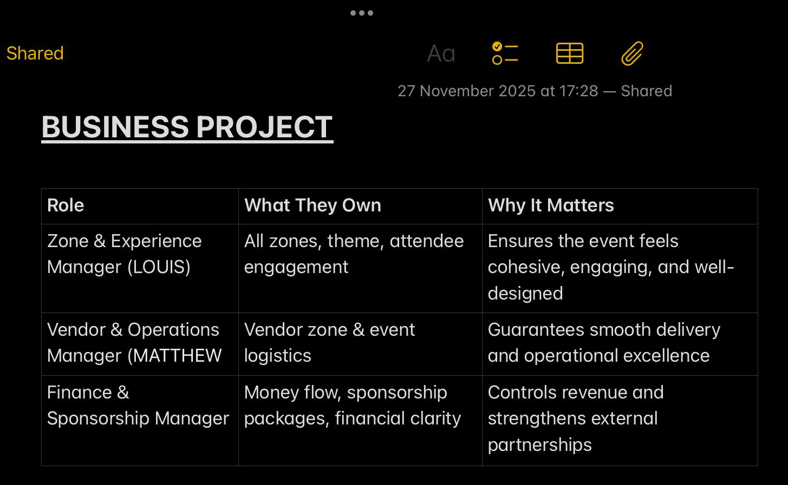
- Figure 3: Initial concept ideas (passport, zones)
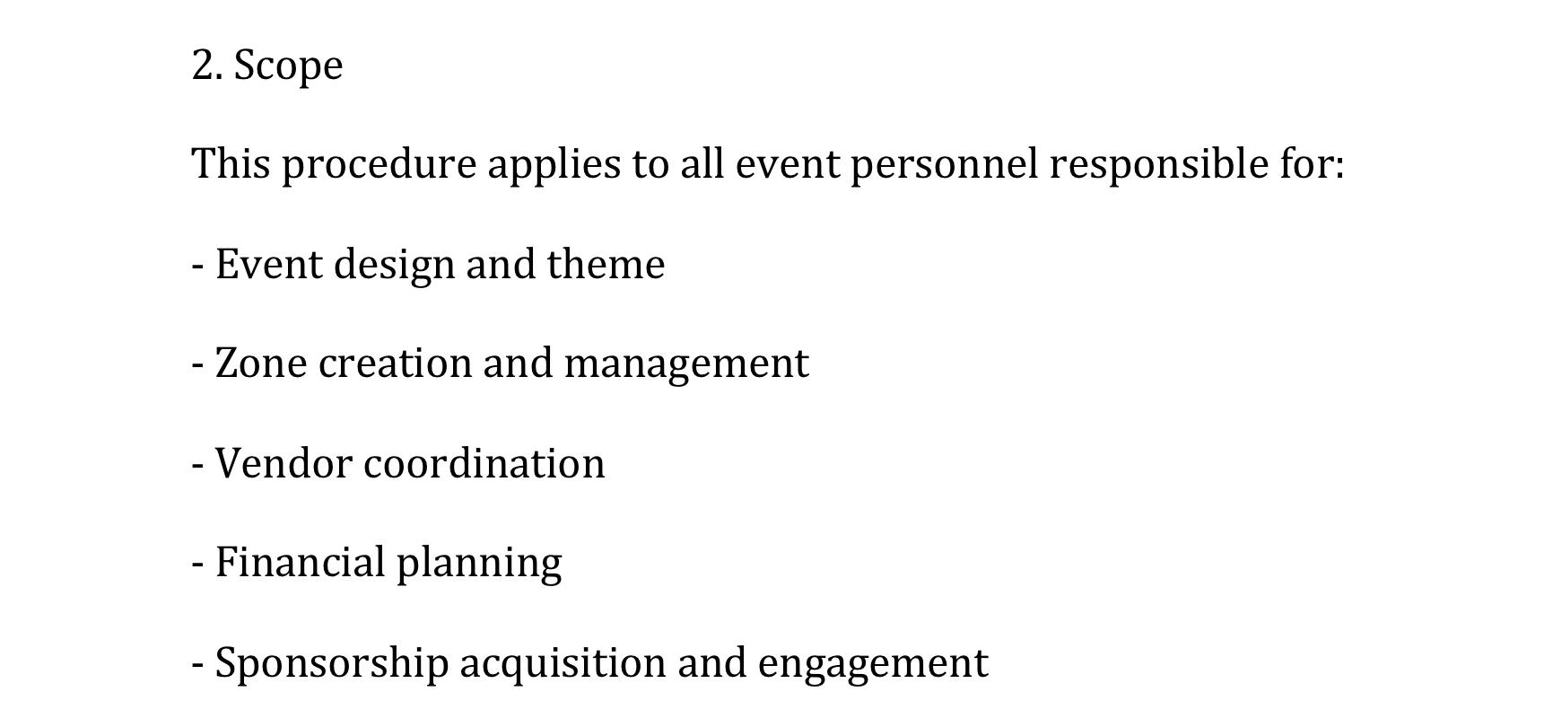

Commentary
The initial phase of the project focused on working collaboratively on idea generation and developing concepts that could enhance the existing ‘ITT Future You’ event. As the event was already an established annual event, the aim was not to create a completely new identity, but instead to contribute ideas that could improve both attendee engagement and overall experience. This supported the wider goal of assisting students with career exploration and personal development, while also giving the students involved valuable experience of contributing to a real world event.
To support this theme, several experiential concepts were suggested. As previously mentioned, one of the most prominent ideas was the introduction of an event ‘passport’, designed to encourage attendees to engage with multiple areas of the event. In addition, as shown in Figure 3, the team proposed a zoning strategy to organise the event space- including distinct business, wellbeing and vendor zones- each intended to serve a different purpose within the overall event structure. The SOP also introduced a broader ‘continents and nations’ layout concept, designed to create a more immersive and interactive attendee experience. These ideas align with experiential event theory and the ‘experience economy’, where environments are designed to encourage participation and engagement rather than passive attendance (Pine and Gilmore, 1999). Furthermore, this type of spatial planning is incorporated inside event management theory, which underpins the importance of layout in influencing attendee behaviour and overall experience (Getz, 2021).
Roles were also initially allocated within the team, displaying an understanding of the importance of responsibility. This is consistent with Belbin’s Team Roles, which highlights the need for roles to achieve effective team output (Belbin, 2010).
However, as the project progressed- it became clear that these conceptual ideas would not be fully realised. The level of control available to the business student team was limited- and decision making increasingly occurred outside of the group. This created a disconnect between not only the group, but initial expectations and actual involvement, marking the beginning of a shift towards a more constrained role.

2.4. Artefact 3: Stakeholder Engagement and Outreach Strategy

Evidence
- Figure 4: Initial Outreach Email
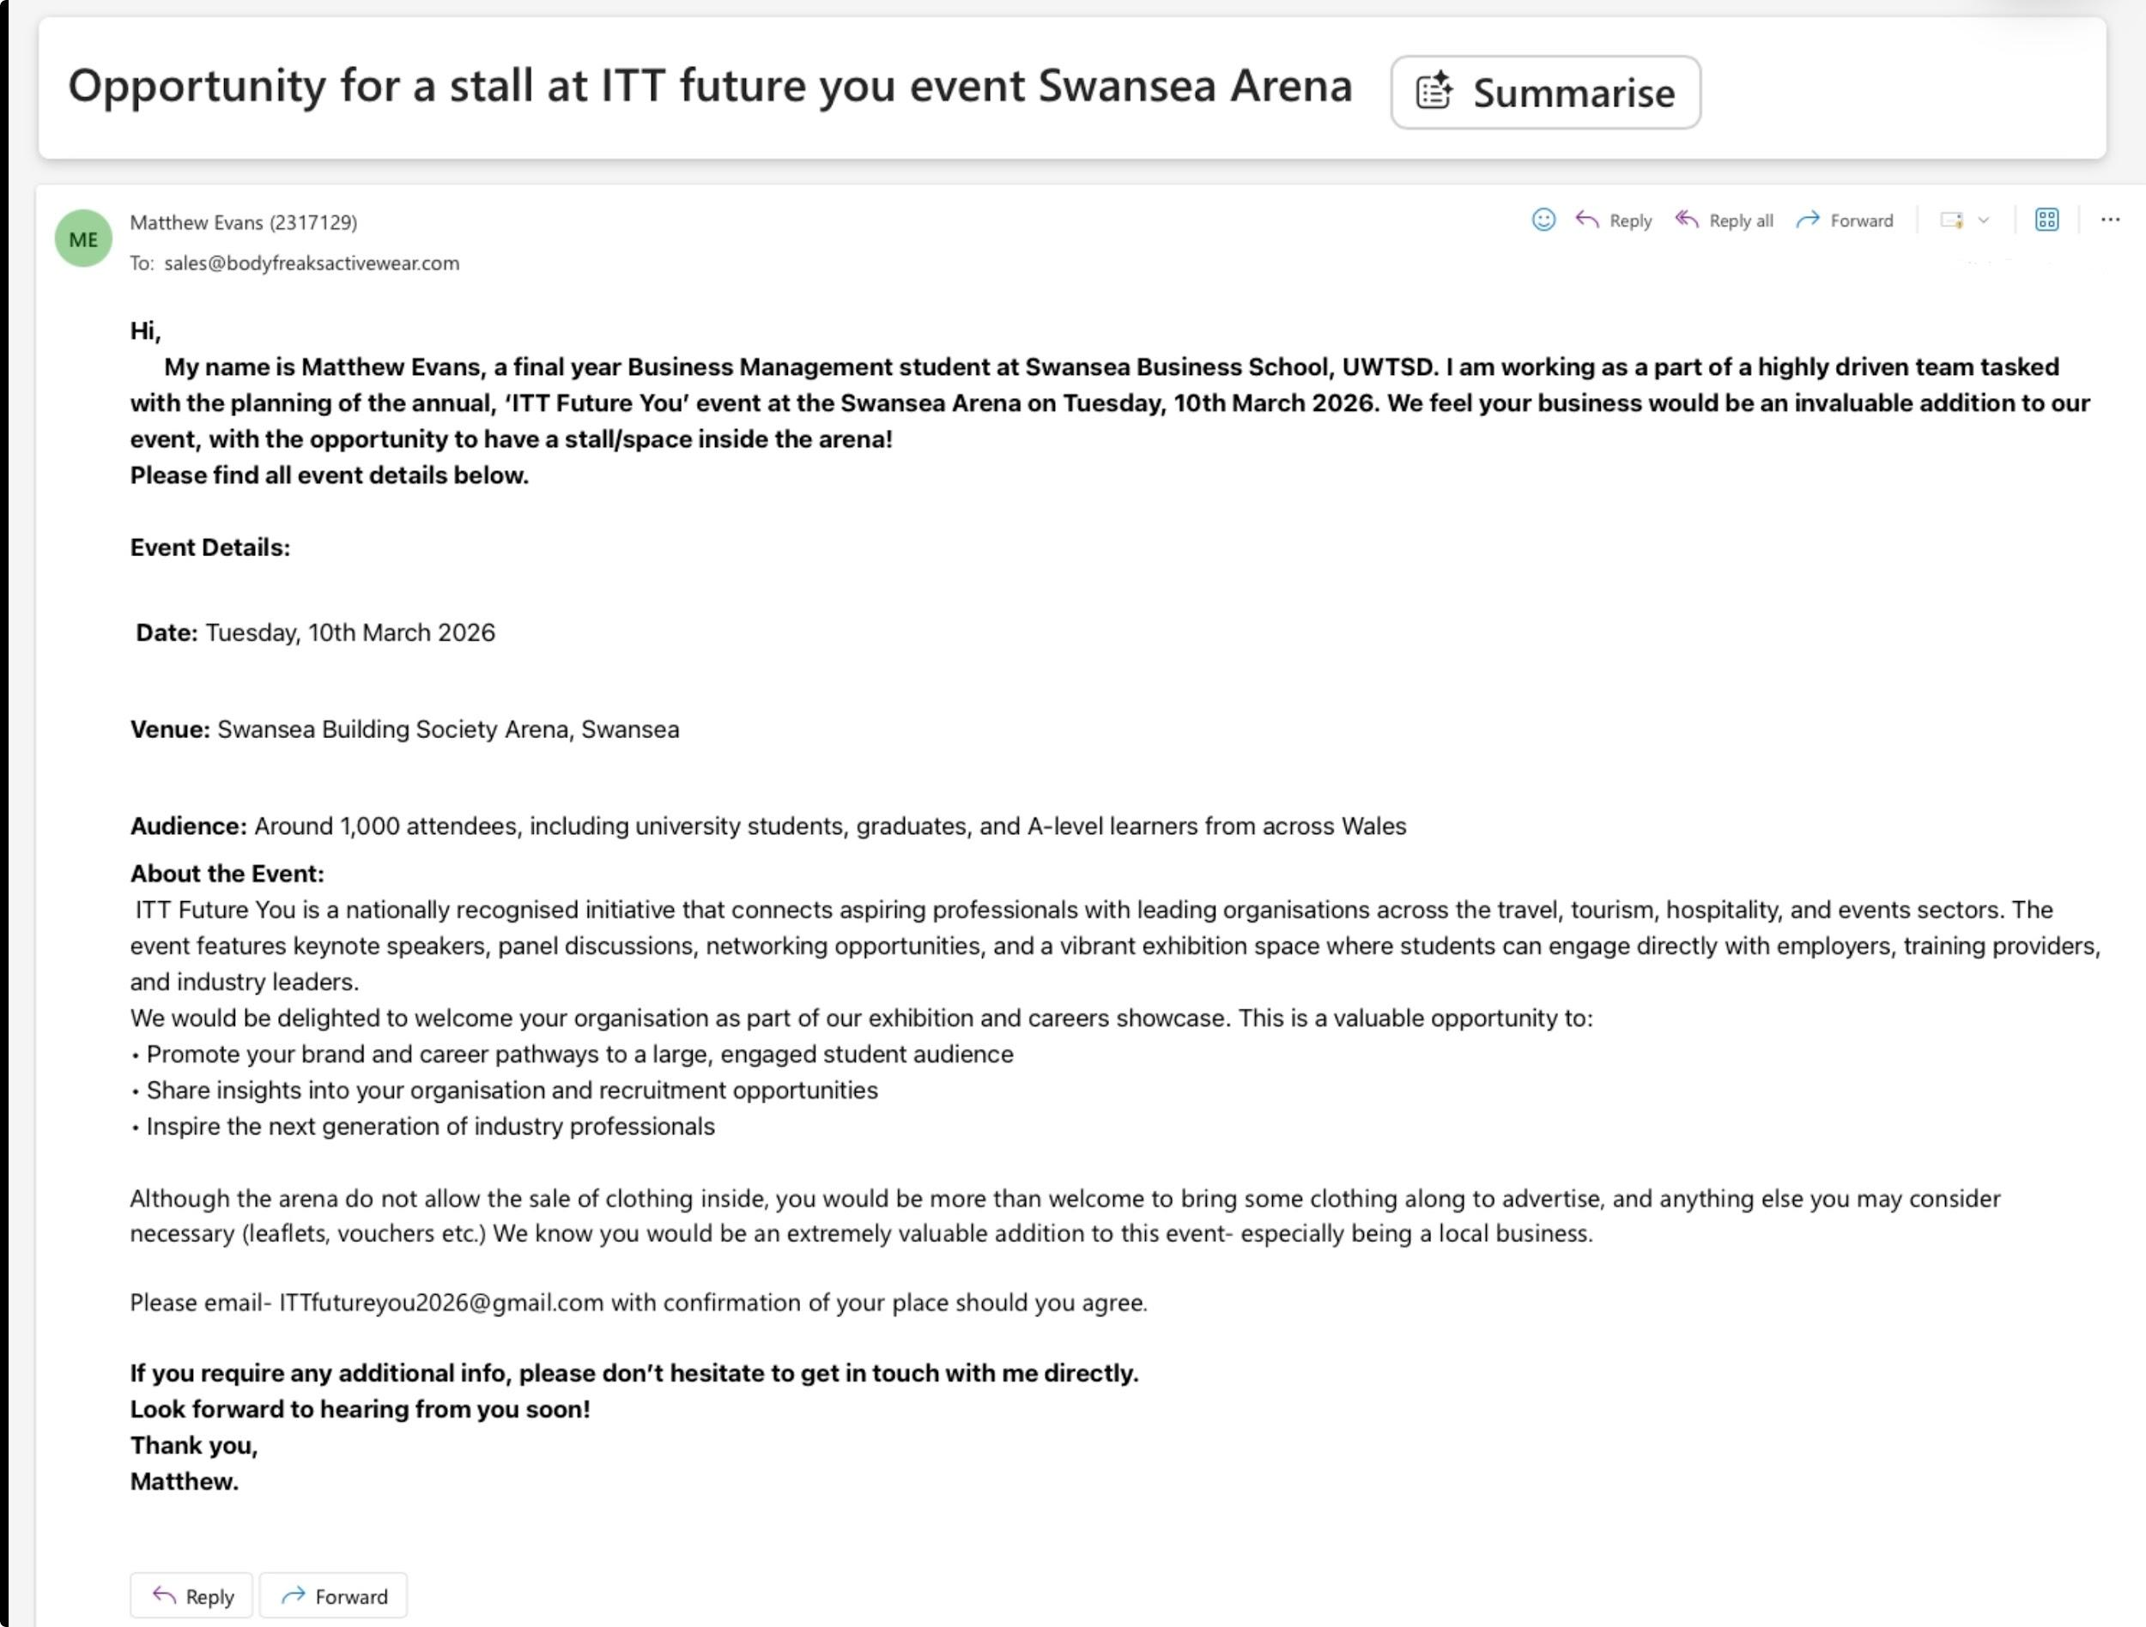
- Figure 5: Follow-up Email
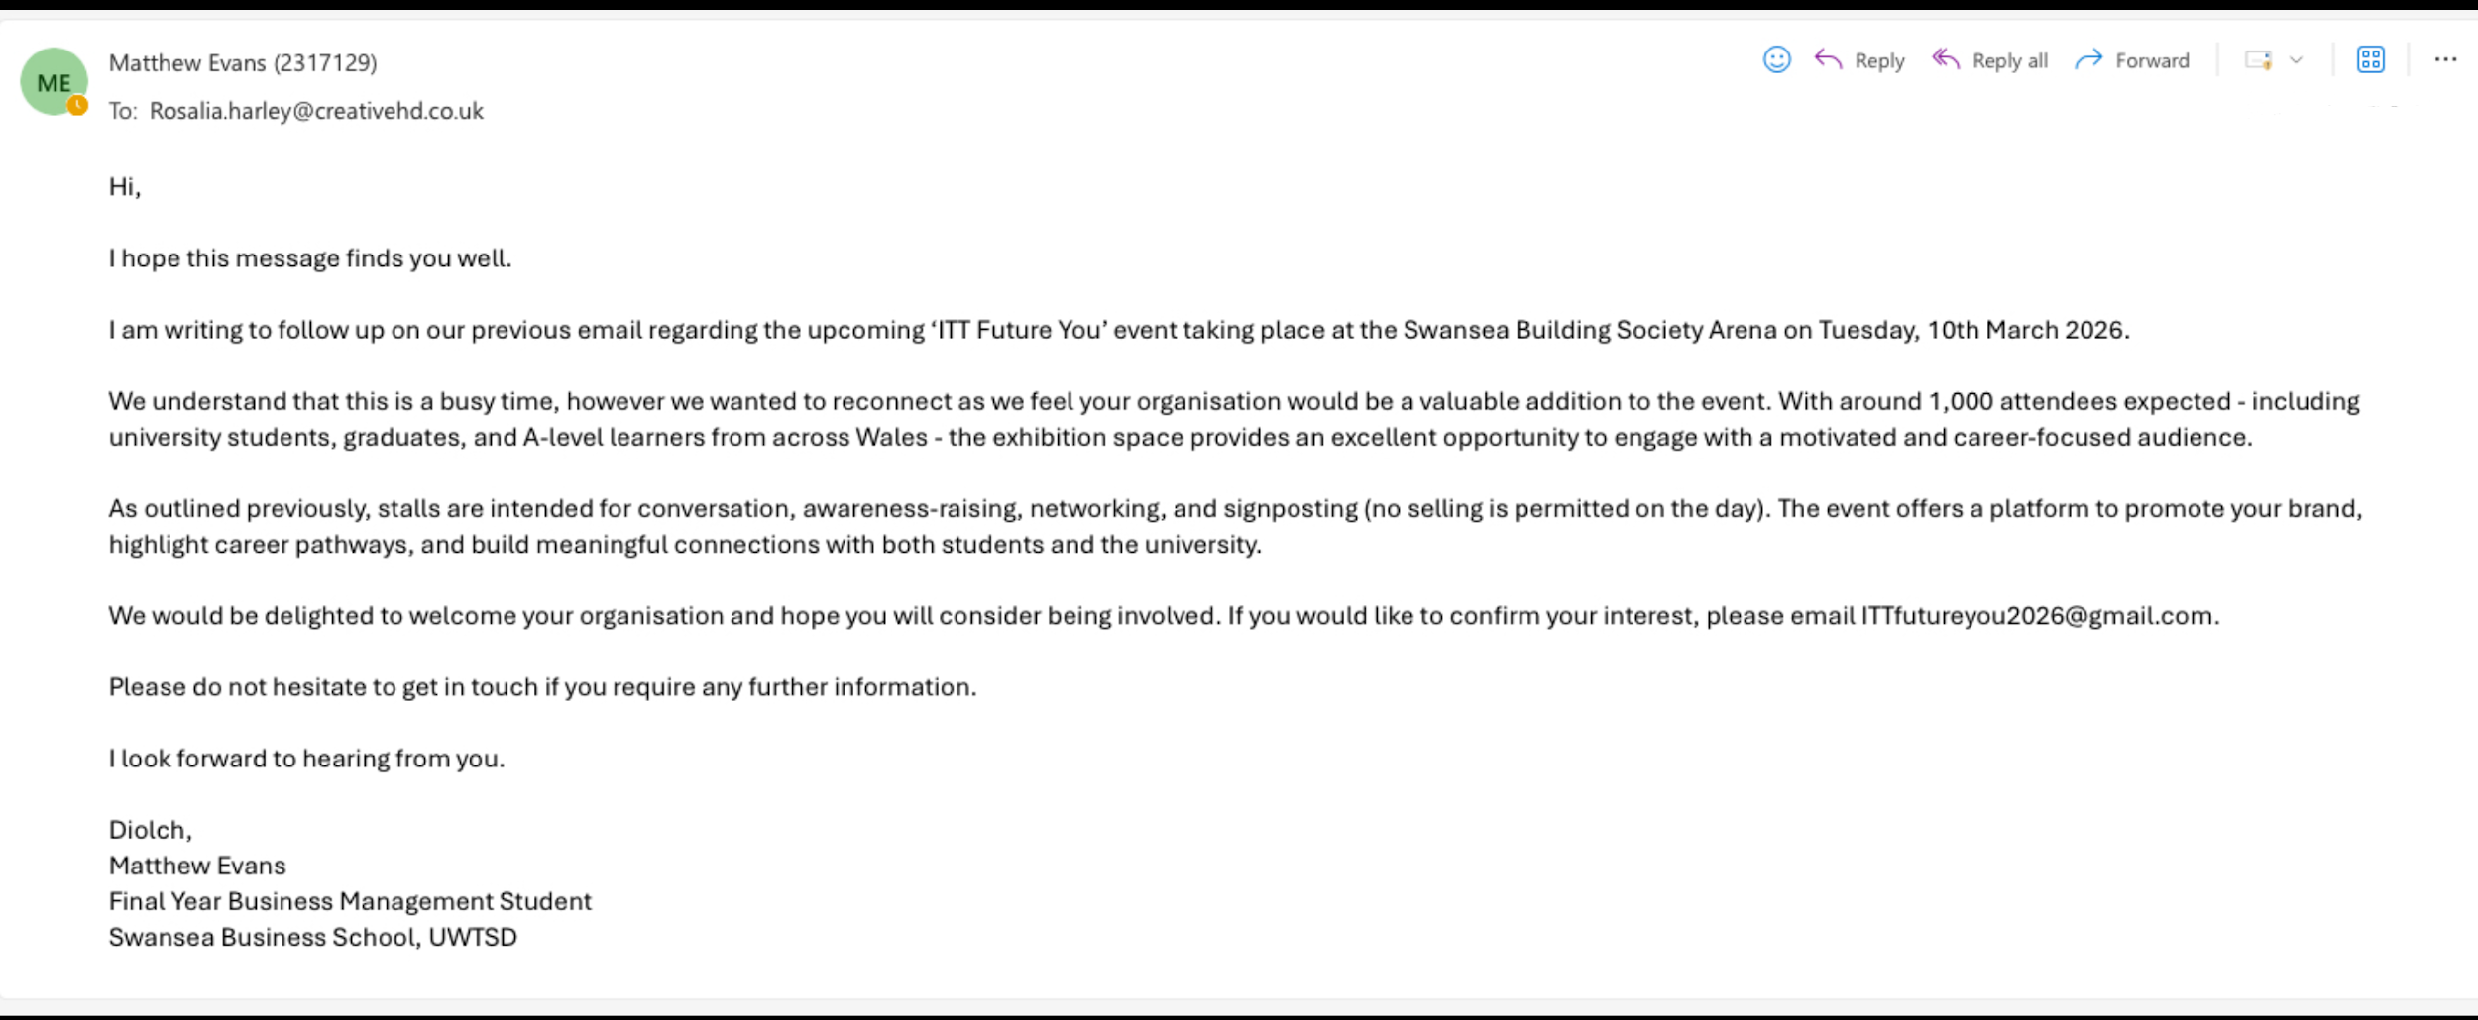
- Figure 6: Stakeholder Tracking Spreadsheet
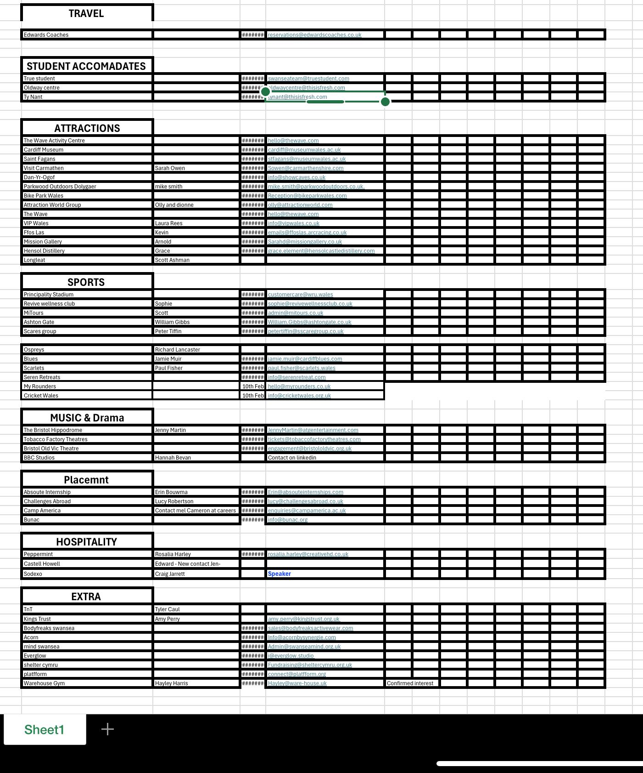
- Figure 7: Response from email
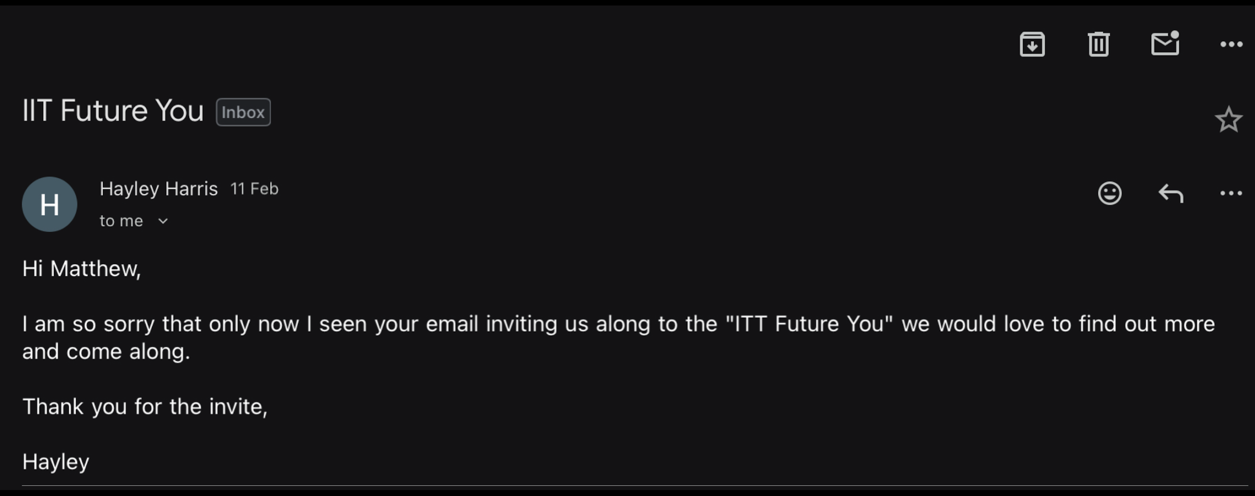

Commentary
As displayed in Figures 4-7, the stakeholder outreach process involved the use of structured email communication alongside a stakeholder tracking system to manage engagement with external organisations.
Following the early engagement phase, the business student team’s primary focus of the project shifted towards stakeholder outreach. This represented a significant portion of the work undertaken and required the creation of a structured approach to contacting potential organisations.
To manage this process effectively, a stakeholder tracking system was created in the form of a spreadsheet. This system allowed the organisations to be grouped by sector, as well as the recording of key information such as contact details, communication status, follow-up activity and whether they had confirmed interest. This is evidenced in Figure 6, which displays the spreadsheet used to organise and monitor engagement. The implementation of this system highlights an understanding of the importance of organisation within stakeholder management, concurrent with principles of customer relationship management (Buttle and Maklan, 2019). By structuring stakeholder interactions in this manner, we aimed to improve efficiency and support ongoing engagement.
The outreach strategy involved contacting approximately 30 different organisations by email. These organisations were selected based on their relevance to the event and their potential to contribute to its overall value, e.g. Mind Swansea- for their close link to wellbeing and Warehouse Gym Swansea- for their appeal to the target demographic of young people and a health-based link to wellbeing. The communication was designed to be professional, yet persuasive, clearly describing the purpose of the event and the benefits of participation. Examples of this communication are provided in Figure 4, which demonstrates the format and professional tone of the initial outreach email. This reflects elements of relationship marketing, where communication is used not only to inform, but also to gather interest and engagement.
A key aspect of this phase was the implementation of follow-up communication. Recognising that initial contact does not always generate responses, further emails were sent to the majority of organisations. This is illustrated in Figure 5, which shows an example of follow-up communication used to re-engage potential stall holders. This reflects the optimal manner in which to conduct stakeholder engagement, where persistence and repeated contact are often necessary to secure responses and even to reinforce your interest (Jobber and Lancaster, 2019). The structured follow-up process also displays an understanding of engagement as an ongoing activity as opposed to a one off interaction. (McKinsey & Company, 2014). This reflects the importance of consistency in maintaining stakeholder relationships and engagement over time.
An important observation from this phase was the distinction between interest and commitment. As displayed in figure 7- in several cases, organisations expressed a willingness to engage initially, requesting further information or indicating interest. However, this did not translate into confirmed participation. This suggests that while the communication strategy was fairly effective in creating awareness and initial engagement, it was not effective in converting that engagement into action.
From a theoretical perspective, this can be explained through social capital theory (Bourdieu, 1986), which highlights the importance of trust and relationships in encouraging cooperation. Without existing relationships, organisations may be less likely to commit, regardless of the potential value of the opportunity. This displays a clear limitation of cold outreach, particularly in situations where organisations are receiving multiple similar requests and are dealing with busy schedules.
In addition, this phase reflects the importance of stakeholder salience, where stakeholders prioritise opportunities based on relevance (Mitchell, et.al, 1997). Without an established relationship, strong Unique Selling Point or clear benefit- the outreach efforts may not have been perceived as a priority by potential stall holders.
Furthermore, external factors such as timing and communication also influenced outcomes. Periods of reduced engagement, including gaps in communication and short notice, can weaken stakeholder interest and reduce the likelihood of attendance- not only this, it can display a sense of unprofessionalism. This reinforces the importance of maintaining consistent and well timed interaction throughout the engagement process.
Overall, this phase did provide valuable insight into the harsh realities of stakeholder engagement, demonstrating that structured processes and consistent effort are necessary but not necessarily sufficient in order to succeed. It highlights the importance of matching engagement strategies to stakeholder relationships and priorities, rather than relying solely on communication processes.

2.5. Artefact 4: Internal Stakeholder Engagement

Evidence
- Figure 8: Email to internal stakeholder manager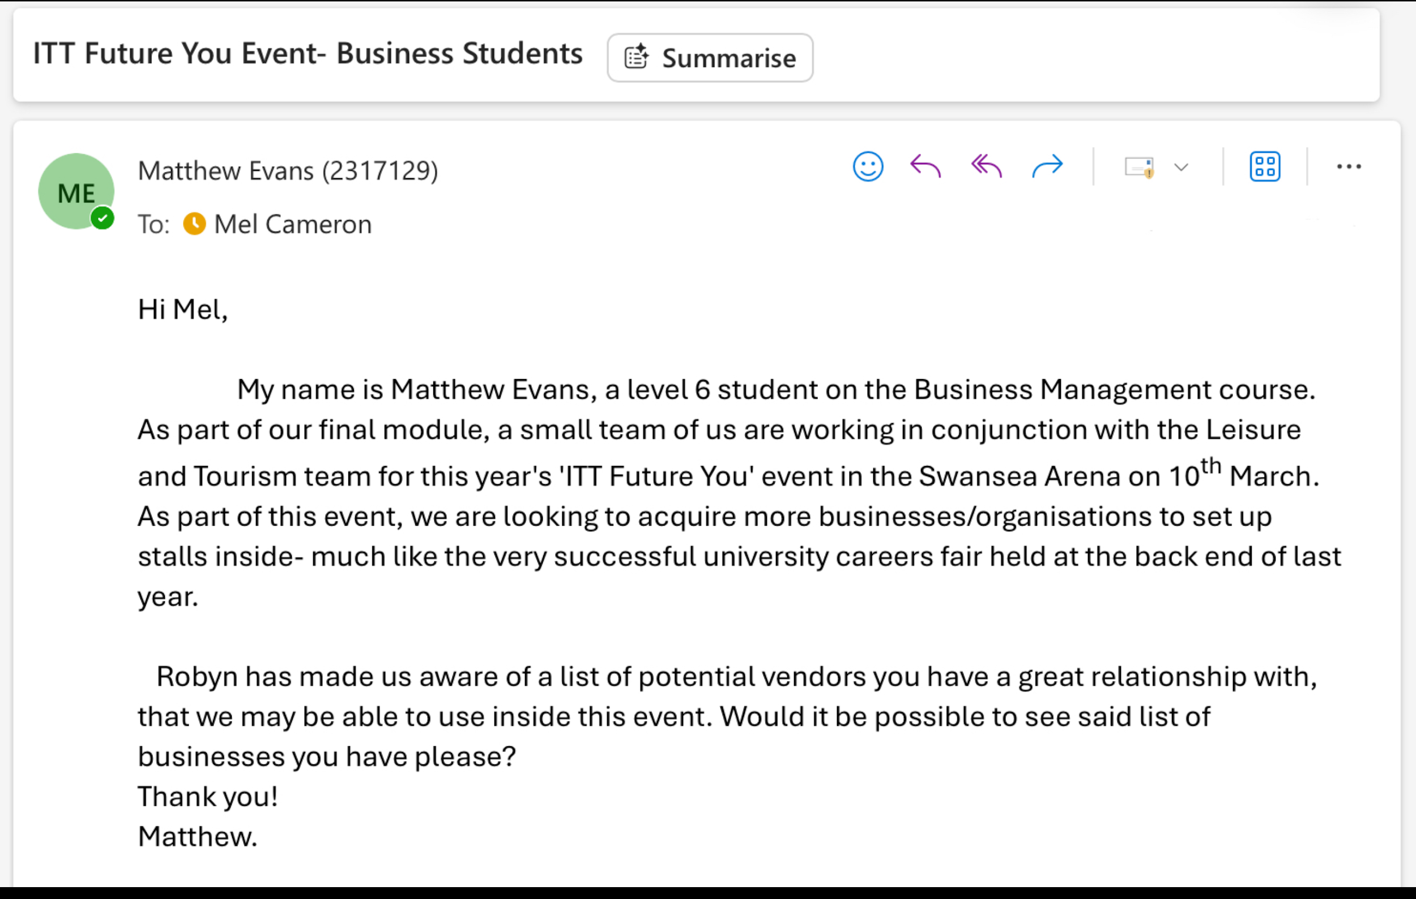

- Figure 9: List of potential stallholders through internal stakeholder manager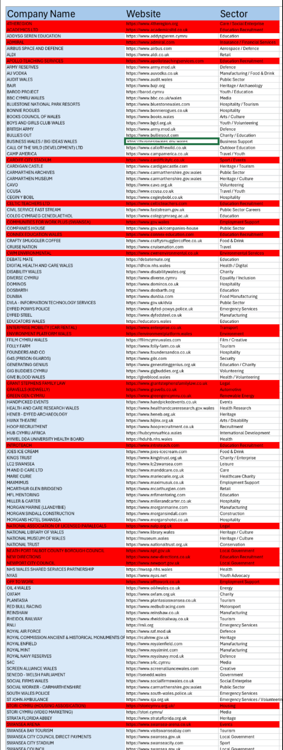

Commentary
The internal stakeholder engagement process involved direct communication with the university stakeholder manager in order to access an existing list of organisations connected to the university’s professional network. This engagement significantly influenced the success of stakeholder recruitment and is widely regarded within the group as one of the main drivers of success for the event.
The transition from external outreach to internal stakeholder engagement was a critical moment in the project and significantly altered its trajectory. Recognising the limited outcomes that came from cold outreach, a decision was made to seek support from within the university’s existing network infrastructure. This involved the independent contact of an internal stakeholder manager via email- as evidenced in Figure 8- in order to create the opportunity for accessing organisations with existing relationships to the university.
This action demonstrates not only strategic awareness, but also initiative and problem solving capability, aligning with the concept of Mintzberg’s emergent strategy (Mintzberg, 1994), where solutions are developed in response to real time challenges rather than predefined plans. By identifying and independently engaging with the internal stakeholder, access was gained to an existing list of organisations with established relationships with the university. This is evidenced in Figure 9, which presents the list of potential organisations provided by Mel, the internal stakeholder manager.
From a stakeholder theory perspective (Freeman, 1984), this shift highlights the importance of understanding stakeholder relationships. Internal stakeholders, especially those with established networks and institutional influence, often have greater ability to obtain engagement in comparison to cold contacts. In this context, the stakeholder manager effectively acted as a bridge between us event organisers and external organisations, increasing credibility within the contacting process.
The internal stakeholder manager not only identified and contacted relevant organisations directly, but also provided a more structured process for contact and engagement. This was through the medium of a centralised list. Due to GDPR restrictions, the business student team did not have direct access to any of these contacts, meaning communication had to be carried out through the stakeholder manager herself. This, however, played to our advantage as a greater level of professionalism and credibility was obtained in comparison to the earlier outreach attempts. As a result, organisations were more likely to view the event as legitimate and therefore worthwhile. This links to the idea of institutional trust, where stakeholders are more willing to engage with opportunities derived from credible and established organisations- such as a university.
The effectiveness of this approach is clearly reflected in the outcomes. A total of 72 vendors were engaged, with 65 confirmed participants. This represents an exponential increase in success compared to the previous phase and demonstrates the impact of leveraging existing relationships. These outcomes provide clear evidence of the value created through this strategic outreach.
This phase can also be analysed through the lens of Resource Based View (Barney, 1991), which suggests that organisations gain competitive advantage through access to valuable, rare and imitable- or in this case, inimitable- resources. In this context, the internal stakeholder network acted as a strategic resource, enabling access to organisations that were either not previously attainable, or would not have responded through our independent outreach. This highlights how intangible assets- such as relationships and institutional connections- can significantly influence the outcomes of any project, especially when dealing with businesses.
In addition, this phase once more demonstrates the value of adaptability in project management. The ability to recognise when an approach is ineffective and suggest a more suitable alternative is a key component of strategic management (Johnson et al., 2017). This shift highlights how strategy within real world environments is often responsive rather than fixed.
Overall, this stage highlights the most significant contribution to the success of the project, as it enabled the recruitment of the majority of stall holding organisations. It demonstrates how aligning strategy with existing resources alongside institutional credibility, can significantly enhance stakeholder engagement and, ultimately, the outcomes of the project.

2.6. Artefact 5: Planning, Coordination, and Team Dynamics

Evidence
- Figure 10: Event Planning Meeting Notes (3rd February 2026) 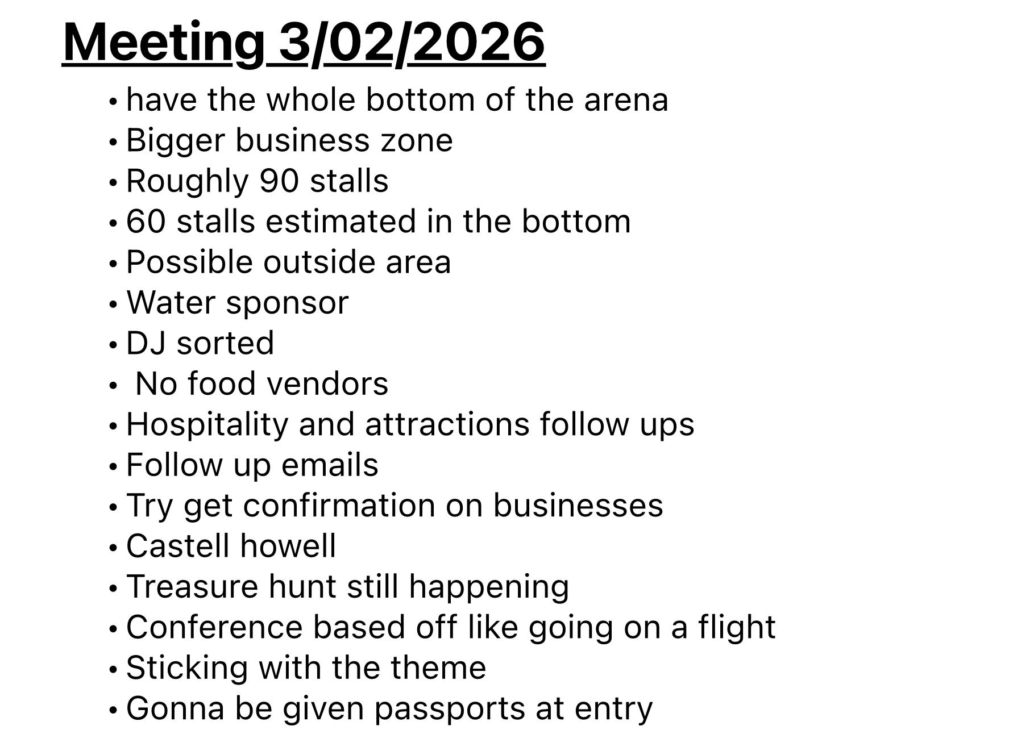
- Figure 11: Stakeholder & Coordination Notes (4th February 2026 – Mel Meeting) 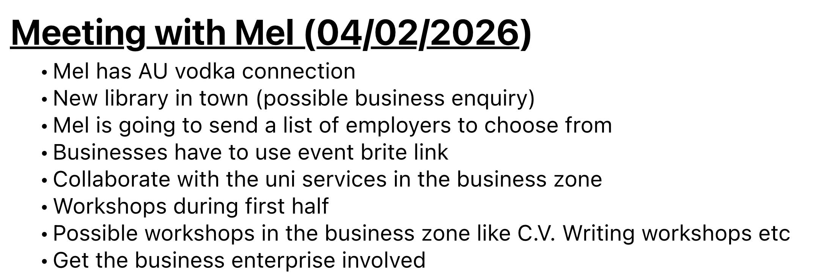
- Figure 12: Business Zone Planning Notes (19th February 2026) 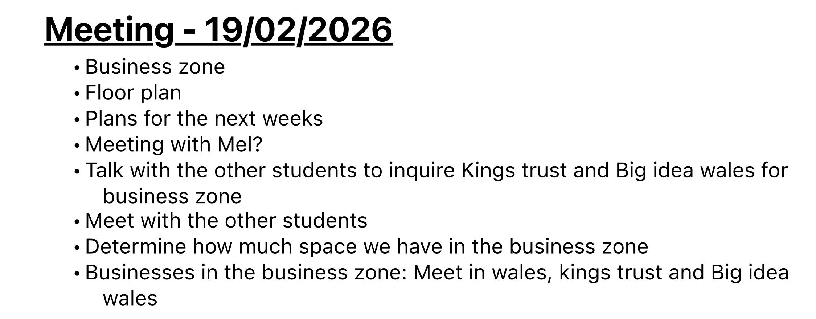
- Figure 13: Event Setup Planning Notes (24th February 2026)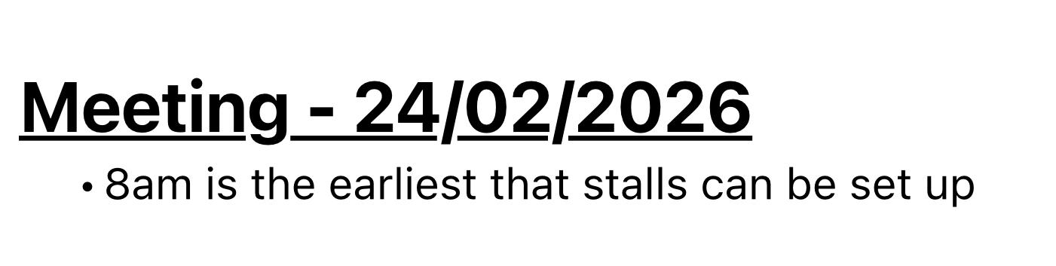

Commentary
As shown in Figures 10-13, the planning phase of the project involved a series of meetings with the intention to structure the event and align responsibilities across stakeholders. However, as the project progressed, issues began to emerge in relation to communication and overall team dynamics.
Despite initial expectations of collaborative working, there was a serious lack of alignment between the different groups involved in the project. The meeting records presented in Figures 10-13 demonstrate that while key topics such as venue layout, stakeholder engagement, operational planning and sponsorship were discussed- there was very little continuity between meetings and a lack of clear progression in decision making, seemingly revisiting the same topics without actionable outcomes. This resulted in uncertainty regarding roles and responsibilities.
Meetings were limited in frequency and often lacked clear direction, creating an environment where communication was inconsistent. While individual meetings addressed specific elements, there was limited evidence of an overarching strategy being developed and consistently communicated across all stakeholders. This fragmentation clearly impacted the coordination and made it more difficult to maintain harmony throughout the planning process.
An additional issue emerged in relation to the planned DJ entertainment element of the event. While entertainment had been identified by myself during the planning stages as an important component of the attendee experience, uncertainty later developed regarding whether the DJ setup met the venue’s compliance requirements, specifically in relation to Portable Appliance Testing (PAT) certification. Although this highlighted wider weaknesses in coordination, there were also opportunities for greater initiative on my part in confirming compliance requirements and maintaining clearer communication prior to the event. As a result, there was confusion surrounding whether the entertainment element could proceed as initially planned, demonstrating how insufficient follow-up and unclear responsibility can create uncertainty inside an event/ team environment.
From a theoretical perspective, these challenges can be understood through Tuckman’s Stages of Group Development (Tuckman, 1965). While the team initially progressed through the forming stage, it appeared to remain within the storming phase, particularly due lack of cohesion and, ultimately, poor collaboration. The absence of progression into the norming and performing stages is reflected in the meeting artefacts, where issues were recurring and identified but still not resolved.
In relation to the DJ situation specifically, elements of a defensive communication environment became apparent. At times, there was a tendency to attribute responsibility for issues rather than collaboratively addressing them with a clear outcome. This is a suggestion of blame culture, which can actively break down trust and immeasurably impact overall team performance (Bird, 2022).
The lack of clear leadership further intensified these challenges. Effective leadership is essential in providing direction (Northouse, 2019). In this case, the absence of consistent leadership is reflected in the meeting records, where action points were identified but not clearly assigned or followed through. This contributed to ambiguity and, again, reduced accountability within the team.
Furthermore, although roles had been initially defined during the conceptual phase, they were not implemented in practice. The reality of the situation was no role specific responsibilities, this is highlighted by no mention of such inside the meeting artefacts- suggesting that the structured role allocation was not implemented into the planning process. This misalignment between planned roles and actual responsibilities reflects a deviation from Belbin’s Team Roles (Belbin, 2010).
Overall, this phase highlights the importance of communication and leadership in project environments, but role clarity also plays a major role. The evidence presented in Figures 10-13 demonstrates that while planning activities were undertaken, inconsistencies in engagement and communication hindered their effectiveness and reduced the potential for full team performance.

2.7. Artefact 6: Final Preparations and Event Setup

Evidence
- Figure 14: Event Setup Photographs
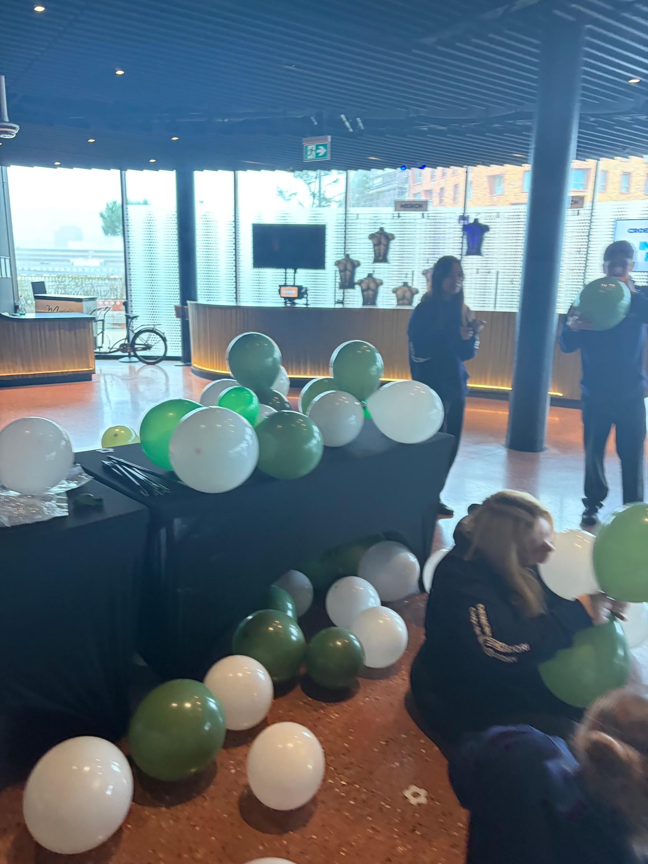

- Figure 15: Pre-Event Coordination Notes / Setup Instructions
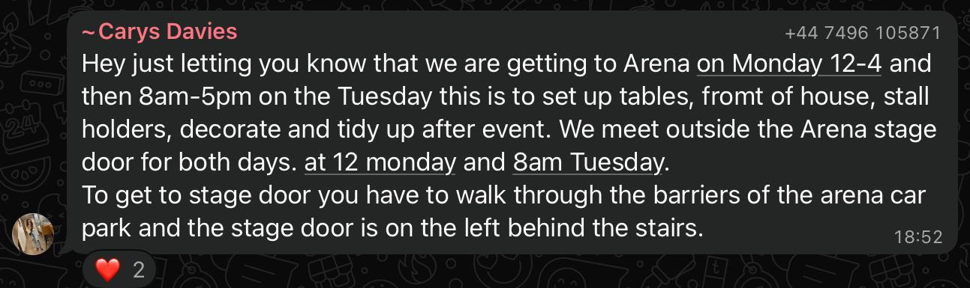

Commentary
As illustrated in Figures 14-15, the final phase prior to the event focused on operational preparation and venue setup. The team was instructed to attend the arena in advance to assist with logistical tasks, including arranging tables and preparing stall areas.
In the lead up to the event, the focus shifted away from the conceptual and strategic planning towards the practical side of operational requirements. Now, this is completely understandable as these tasks were essential to ensure that the event was physically prepared and functional. However, this phase also represented a significant shift from initial expectations of involvement, particularly in relation to strategic contribution and decision making as this seemed to be the extent of our practical involvement for this day.
The work undertaken during this phase was largely basic and operational in nature, with limited opportunity for independent input or responsibility. As shown in Figure 15, activities were primarily centred around manual setup tasks rather than role specific contributions aligned with earlier planning. This indicates a deviation from the initial role allocation and the practical execution of responsibilities during the event preparation stage.
From a theoretical perspective, this can be analysed through job design theory, specifically the model created by Hackman and Oldham, which emphasises the importance of autonomy and skill utilisation in motivation and engagement (Hackman and Oldham, 1976). In this context, the tasks assigned during the setup phase provided a very limited amount of autonomy and did not fully utilise the skills or strategic capabilities possessed by the business team. As a result, the structure of task allocation limited engagement and reduced the potential for meaningful contribution.
Additionally, the allocation of tasks was largely directive, with instructions provided rather than responsibilities being delegated. This approach reflects a more hierarchical and control based method of coordination, where tasks are assigned based on the immediate needs of the operation rather than being aligned with individual roles or areas of expertise. Mintzberg argues that overly hierarchical management structures can reduce communication effectiveness and limit problem solving within organisations (Mintzberg, 1989). The lack of role clarity and structure during setup created confusion, not alignment. The setup process, as evidenced in Figures 14-15, demonstrates that coordination was focused purely on task completion, rather than utilising the strengths of the business team in strategy. Furthermore, the lack of defined responsibilities during this phase contributed to a lack of ownership and accountability. Lencioni condemns this- arguing that lack of accountability weakens teams and accountability improves cohesion (Lencioni, 2002).
Despite these limitations, this phase provided valuable insight into the operational ongoings in an event environment. The need to adapt to immediate requirements, respond to time constraints and ensure that logistical elements were completed efficiently, highlights the importance of flexibility within event environments. From an operations management standpoint, this emphasises not only the importance of carrying out plans effectively, but the ability to respond quickly to ensure that activities can be delivered efficiently (Slack et al., 2023).
Overall, this phase demonstrated the realities of event delivery, where operational priorities can take charge over strategic involvement. While the tasks undertaken were essential to the successful setup of the event, the structure of task allocation and limited alignment with planning reduced the opportunity for role based contribution.

2.8. Artefact 7: Event Day Execution and Coordination

Evidence
- Figure 16: Event Day Photographs
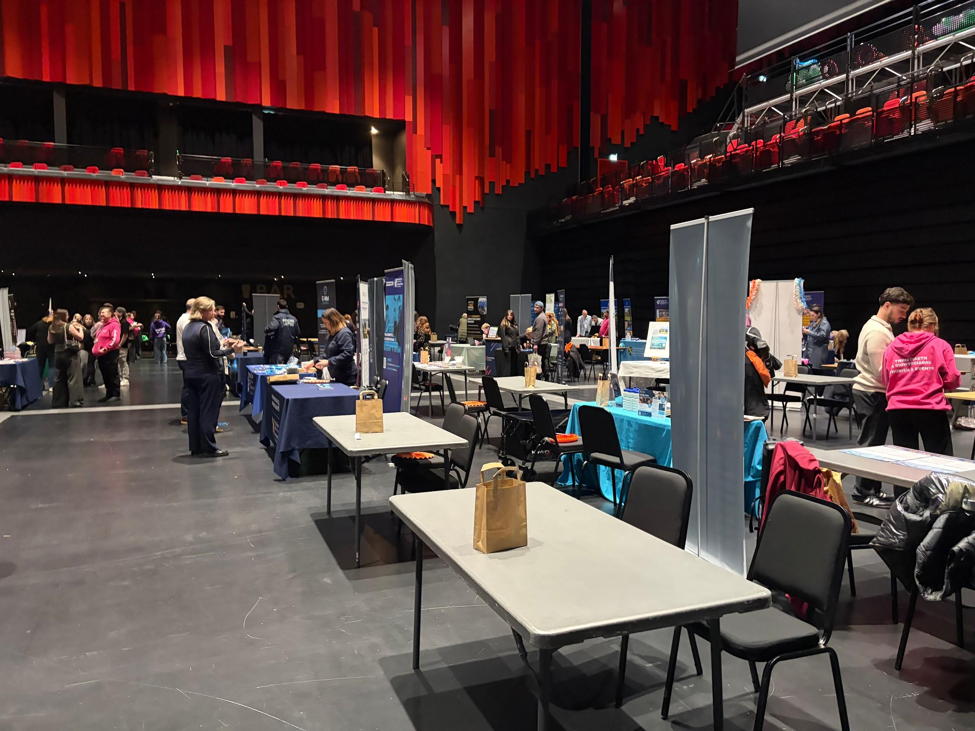
- Figure 17: Event Layout and Live Environment Observations
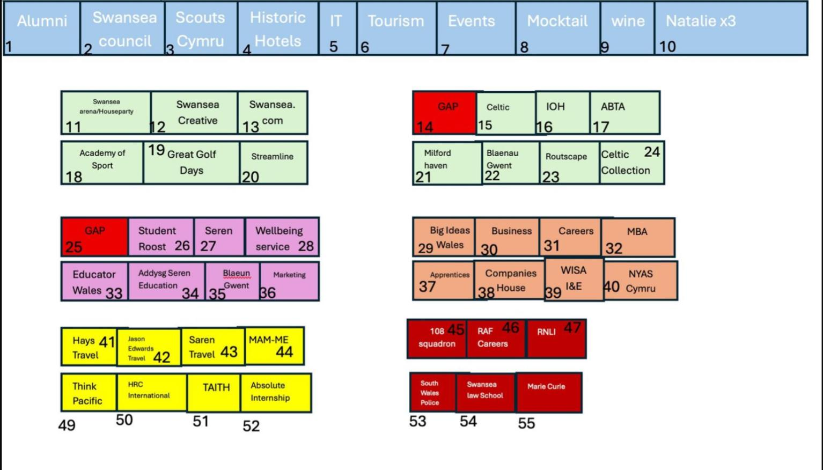

Commentary
As illustrated in Figures 16 and 17, the event day execution phase represented the final stage of the planning and preparation process- where earlier plans and ideas were put into practice within a high pressure event environment.
On the day of the event, the team arrived at 7:00am in preparation for a 9:00am start. Upon arrival at the venue, an initial briefing was conducted within one of the VIP boxes in the arena. However, despite this structured start to the day, the business team was not provided with clearly defined roles or responsibilities.
While other groups appeared to receive more direct guidance, us business students were left without a clear understanding of expectations. When clarification was sought, the response received was informal and lacked specificity, with instructions to “find something to do”. This absence of structured direction reflects a breakdown in communication and coordination at arguably the most crucial stage of the project.
From both an event management and a people management perspective, effective execution relies heavily on clear role allocation, defined responsibilities, coordinated planning and buy-in amongst the group. These elements are particularly important in high pressure environments where time constraints and real demands require clarity. In this case, the absence of these structures resulted in uncertainty, reducing the ability of the team to contribute effectively in a purposeful manner. Not only this, after months of communication and planning, the lack of direction on the day reinforced the feeling that the business students were operating separately from the wider event team. Leading to our team feeling estranged from the other group.
This situation reflected a broader disconnect between the business student team and the Leisure and Tourism team. Throughout the project, there had been limited integration between the two groups- and this became evident during the event itself. The lack of communication prior to the event- combined with the absence of collaborative planning- resulted in not only an operational separation between the teams, but also both a physical and mental separation. This was displayed through the interaction patterns at the start of the event.
As a result, involvement during the event became largely self directed. While efforts were made to contribute where possible, the absence of clearly defined roles limited the ability to add value in an efficient manner or operate strategically in any form. This contrasts with initial expectations of involvement and reinforces the previous points regarding the importance of coordination and role clarity in the execution of the project.
However, it is also important to acknowledge that responsibility for this outcome does not rest solely with one group. While there were clear gaps in leadership and communication, there were also opportunities for a more proactive approach in seeking clarity prior to the event. For example, additional efforts from our party to establish expectations or create structured communication may have supported coordination. Furthermore, during the initial planning phase, there was an opportunity for stronger leadership and clearer direction, which would have aligned well with my own strengths and skill set.
This reflects the importance of proactive communication within project environments. As highlighted by Kotter, effective teams do not rely solely on top-down direction but also take initiative in ensuring alignment (Kotter, 2025) In this context, there was a lack of both structured leadership and proactive coordination- contributing to the operational challenges above.
Overall, this phase highlights the critical role of communication and leadership inside teams in successful project delivery, but also highlights how important inter-team collaboration is to any project. The evidence presented in Figures 16-17 demonstrates that, although the event was able to run successfully, the lack of structure and coordination heavily impacted efficiency and limited the ability of the teams to function optimally- which was the main intended benefit of the event itself from the outset.

2.9. Artefact 8: Feedback Collection and Analysis

Evidence
- Figure 18: Visitor Questionnaire Design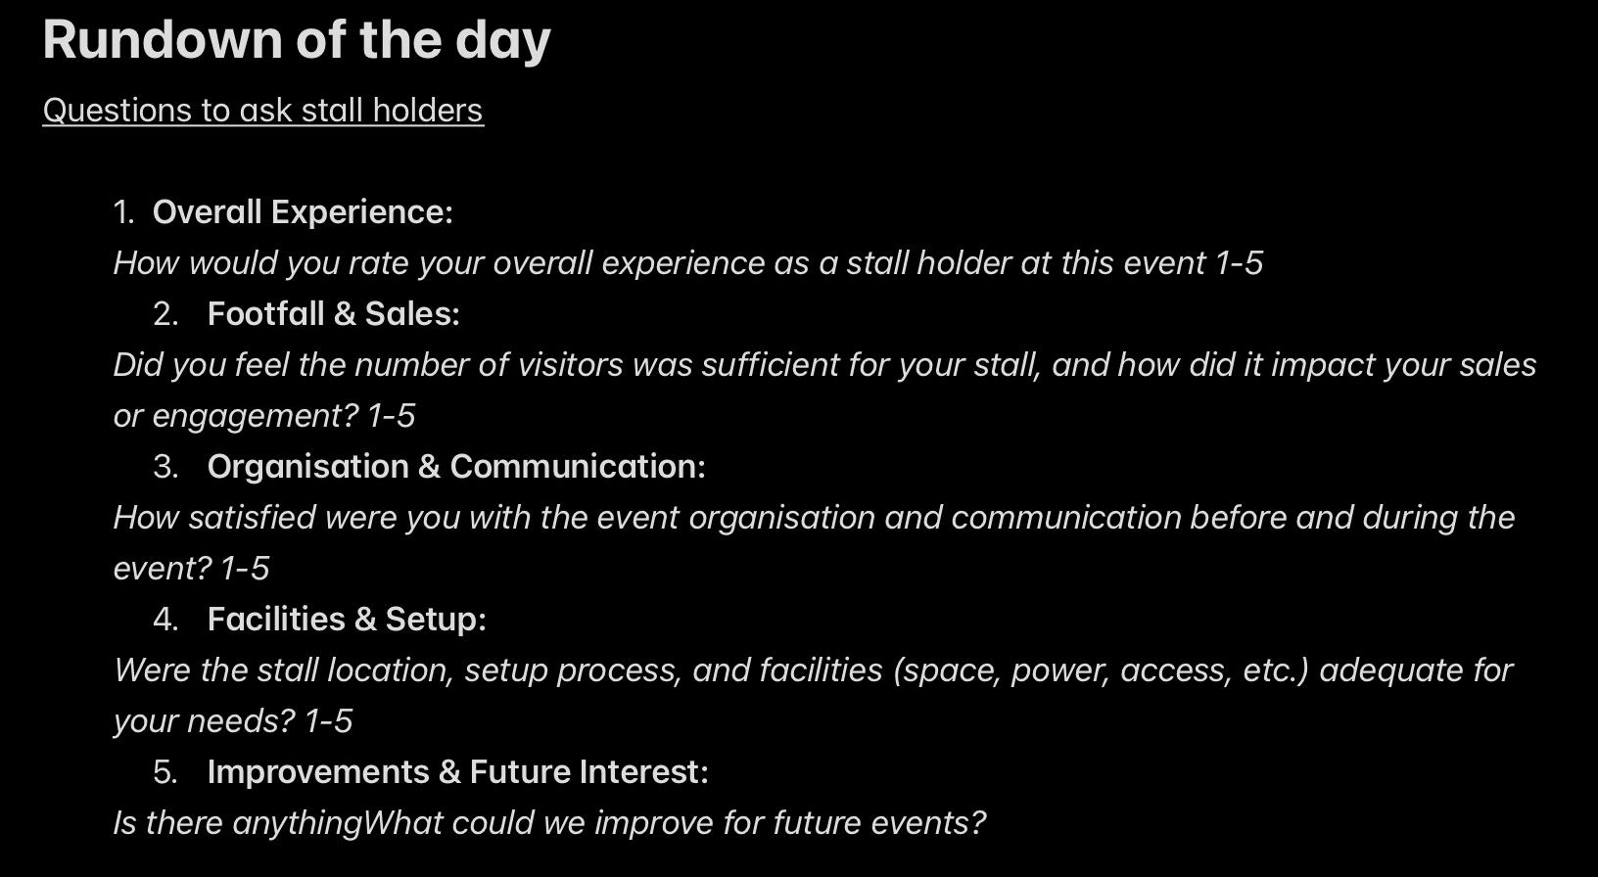
- Figure 19: Stallholder Questionnaire Design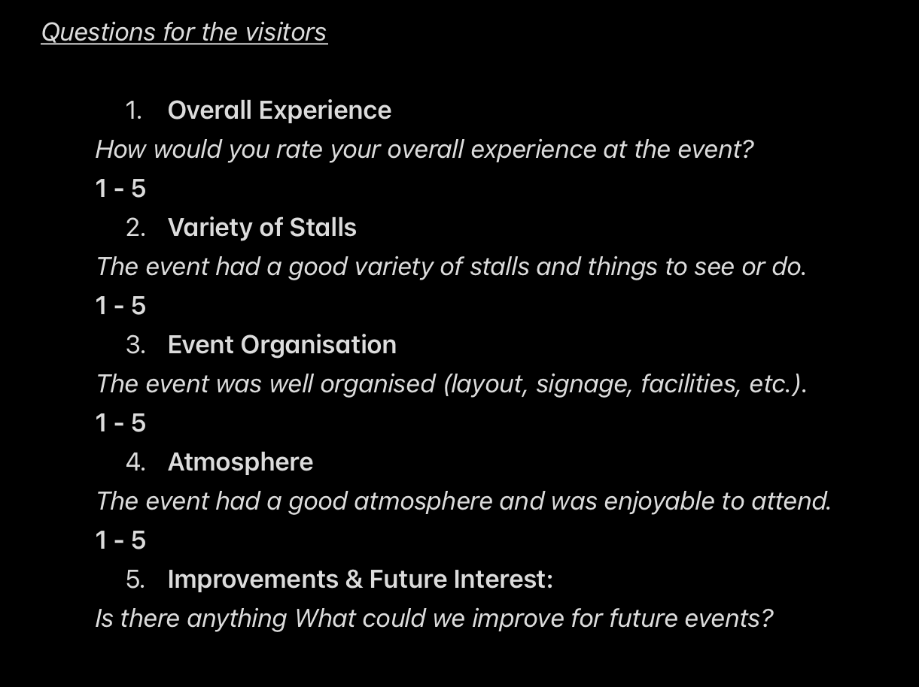
- Figure 20: Visitor Feedback Data Table
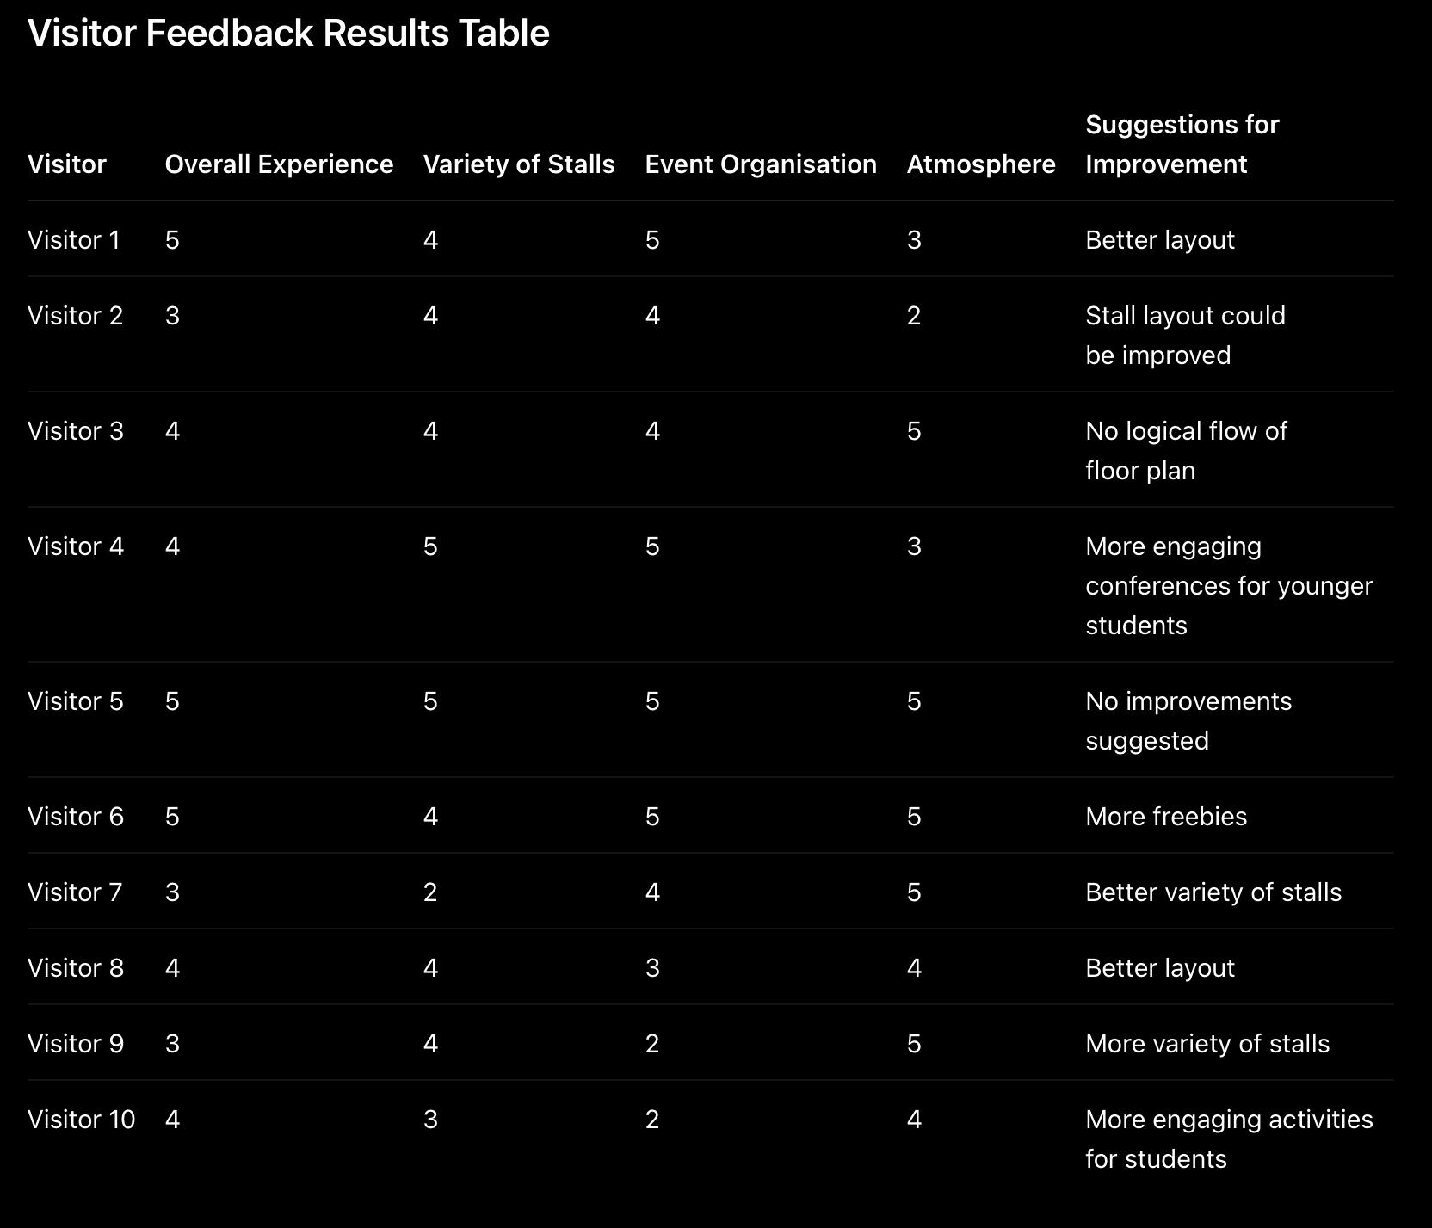
- Figure 21: Stallholder Feedback Data Table
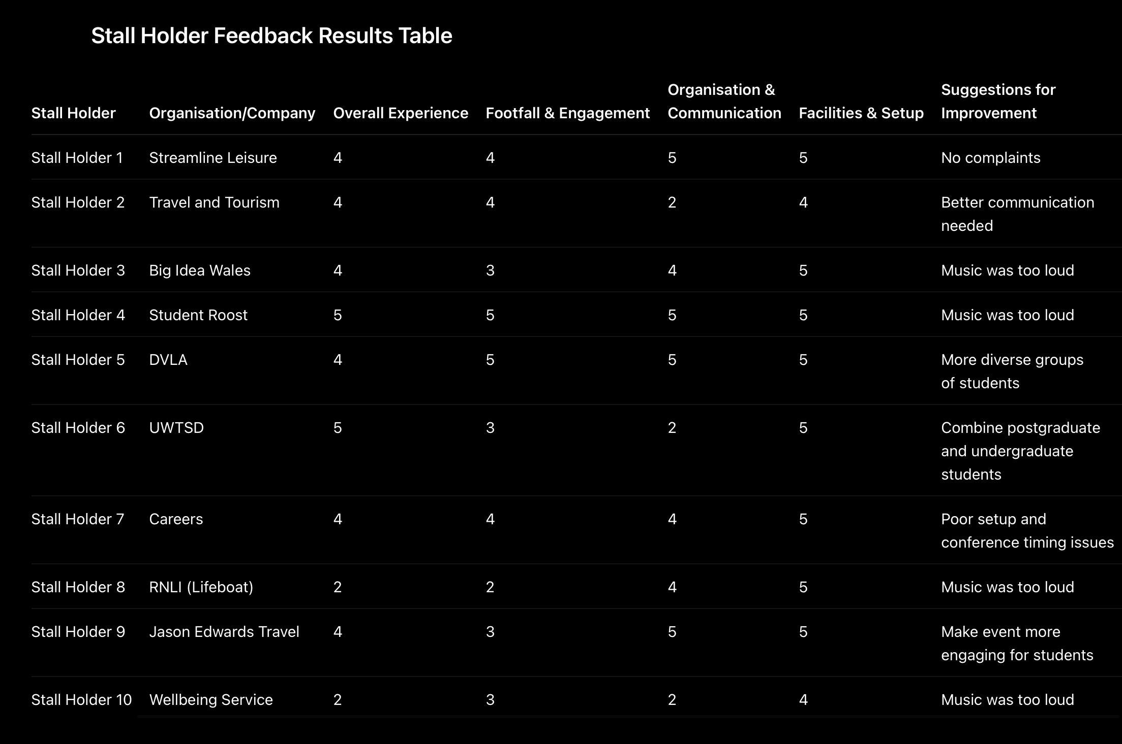
- Figure 22: Visitor Feedback Averages
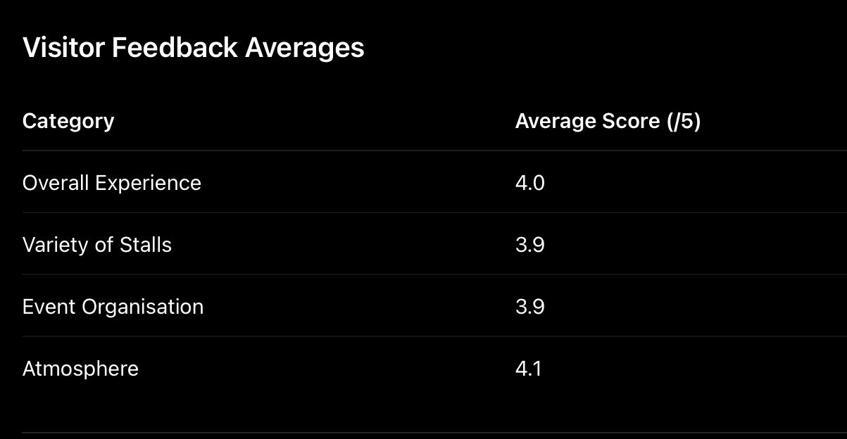
- Figure 23: Stallholder Feedback Averages
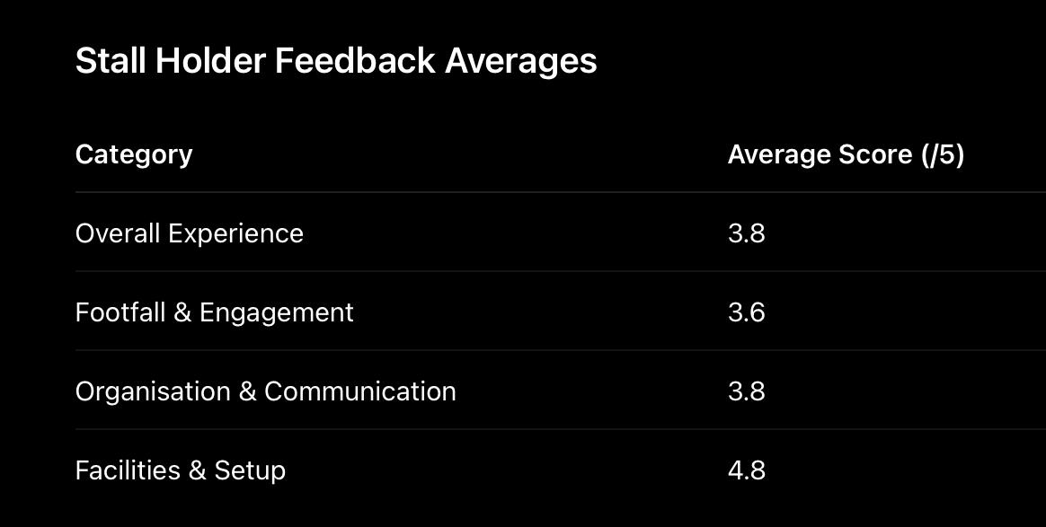

Commentary
As illustrated in Figures 18-19, an initiative was proposed by myself during the event to design and implement a structured feedback collection system, which was then carried out by the other members of the business student group. This decision was driven by- firstly, the recognition that despite limited involvement in the operational and strategic planning of the event, there remained an opportunity to contribute meaningful value through the collection of primary data and secondly, the fact that we were left feeling isolated and without responsibility on the day.
This involved the creation of two separate questionnaires: one targeting stall holders (business participants) and one targeting event attendees. The idea behind this dual approach was to gather insights from both key stakeholder groups, allowing for a well rounded evaluation of the event’s effectiveness. The questionnaires were then distributed and completed with support from my team members inside the business student group. The questionnaire designs are presented in Figures 18 and 19, demonstrating a structured yet consistent approach to data collection.
The decision to undertake the collection of data also demonstrated initiative and problem solving under limited direction. Rather than remaining passive during periods of uncertainty, an opportunity was identified to contribute something valuable and measurable to the event. This emphasises the importance of proactive behaviour within project environments, where individuals are often required to respond independently to challenges and changing circumstances.
The questionnaires were designed using a Likert scale (1–5) for the majority of questions. The thought process behind this was to enable the collection of quantitative data that could be easily compared and analysed. In addition, each questionnaire included one open ended question at the end, allowing respondents to provide more detailed qualitative feedback. This reflects a mixed methods approach, combining Quantitative Research and Qualitative Research, which is effective in generating both measurable outcomes and opinionated, deeper insights- grasping the experiential feeling amongst the different stakeholder groups.

Quantitative Analysis of Results
The results from both stakeholder groups indicate that the event was generally well received. As shown in Figures 22-23, visitor responses produced average scores of 4.0 for overall experience, 3.9 for variety of stalls, 3.8 for organisation and 4.1 for atmosphere. Additionally, stall holder responses ranged between 3.6 and 4.8, with facilities receiving the highest rating.
These results suggest that- at surface level the event was successful in delivering a positive experience. In particular, the high rating for atmosphere indicates that the event created an enjoyable environment for attendees. This is significant as atmosphere is widely recognised as a key determinant of event satisfaction (Getz, 2021).
However, while average scores provide a useful overview, they do not fully capture the variation within the data. A more detailed analysis of individual responses reveals several recurring issues that highlight underlying weaknesses in the event’s execution- reinforcing the value of the qualitative data question.

Analysis of Individual Visitor Responses
A closer examination of visitor responses demonstrates difference in experience, particularly related to organisation and layout. While some attendees rated the event highly across all categories, others provided lower scores- specifically relating to organisational structure and the variety of stalls.
Several respondents identified issues with the layout of the event. Comments such as “could’ve been better layout”, “no logical flow” and “better layout” were repeated across multiple responses. This suggests that the spatial design of the event was not effective enough in guiding attendee movement or creating a flowing experience.
From a theoretical perspective, this aligns with event design principles- which emphasise the importance of spatial layout in influencing attendee engagement , contributing to overall satisfaction (Getz, 2021). Ineffective layout design can result in limited interaction with stall holders and can create an overall poor experience for both parties.
In addition, some visitors indicated a lack of engagement, with comments suggesting the need for, “more engaging conferences” and “better variety of stalls.” This highlights a potential misalignment between what the event offered and the expectations of attendees, suggesting that the content and structure of the event could have been improved to enhance engagement.

Analysis of Individual Stall Holder Responses
The analysis of stallholder feedback provides further insight into the outcomes of the event, but from a business perspective. While overall experience scores were generally positive, there was a difference in responses relating to communication, engagement and operational coordination.
One of the most significant themes that recurred was the issue of the music volume. Multiple stallholders commented that the “music was too loud”, suggesting that this negatively impacted their ability to communicate effectively with attendees as they were within close proximity to the speakers. This highlights a lack of coordination between different elements of the event, for example between entertainment and functional objectives.
Furthermore, some stallholders identified issues with communication and organisation, with comments such as “needs better communication” and “poor set up.” These responses reinforce earlier points regarding the planning and execution phases, reinforcing the idea that there were challenges related to coordination and communication apparent throughout the project lifecycle.
Interestingly, while facilities and physical setup were rated highly overall, this contrasts with the qualitative feedback surrounding organisation and communication. This suggests that while the physical environment was sufficient, the management and coordination of the event were less effective, highlighting a gap between delivery and effectiveness- a recurring theme within this process.

Insights and Key Patterns
By combining both quantitative and qualitative data, several key themes emerged from the analysis:
- Layout and spatial design were consistently identified as areas requiring improvement
- Communication and organisation were inconsistent across different stakeholder groups
- Music volume negatively impacted some stakeholders’ experience
- Engagement and variety of content could be further enhanced
These findings demonstrate that while the event achieved a positive overall outcome, there were clear operational weaknesses that influenced stakeholder experience.

Theoretical Application and Interpretation
The findings from the feedback analysis can be linked to several frameworks. Firstly, the importance of layout and organisation touches on service quality theory, more widely known as the SERVQUAL model (Parasuraman et al., 1988), where factors such as reliability and responsiveness influence overall satisfaction.
Secondly, the issues relating to communication reflect Organisational Behaviour concepts, particularly the role of effective communication in ensuring coordination and efficiency (Robbins and Judge, 2017).
Finally, the use of feedback itself aligns with the Continuous Improvement model (Deming, 1986), where organisations use data to identify weaknesses to improve future performance.

Value of the Initiative
The development and implementation of this feedback system represented a significant contribution to the project. As there was no evaluation process already in place of any kind, there was scope to introduce a structured and evidence based method of assessing the performance of the event.
What added value here was the ability to identify gaps within the project and respond with practical solutions. It displayed important skills such as problem solving, critical thinking, adaptability and initiative- while also contributing to the overall evaluation of the event and stakeholder experience.
In addition, the data collected through this process provided a foundation for better decision making and future improvements. The feedback not only supported our academic evaluation of the project, but also offered useful insight that could help improve events of a similar nature in the future, should any of the team pursue a career in this field.

ELEMENT 3 – CRITICAL EVALUATION & FUTURE RECOMMENDATIONS

3.1. Introduction
This section critically evaluates my involvement in the planning and delivery of the ‘ITT Future You’ event through reflection and critical analysis. While the previous sections of the portfolio mainly focused on the practical aspects, planning processes, stakeholder engagement activities, operational contributions and chronological events completed throughout the project- this section evaluates how effective those contributions were in relation to the original aims and objectives of the project as a whole.
The evaluation draws upon principles within Gibbs Reflective Cycle (Gibbs, 1988), in relation to evaluation, analysis, conclusion and future action planning. However, rather than focusing solely on personal feelings, the reflection draws upon concepts from Strategic Management, Organisational Behaviour and Event Management in order to critically assess both the successes and limitations of the project,
Initially, I approached the project expecting to hold a more integral and strategically involved role within the planning and delivery of the event. My personal anticipation was significant involvement in delegating roles, stakeholder engagement, attendee experience design and ensuring everyone involved worked in a cohesive manner. However, as the project progressed- the level of involvement gradually shifted towards a more operational and reactive role.
Overall, while the project differed significantly from my initial expectations, it provided valuable practical experience and highlighted important lessons regarding the realities of working within a complex business environment.

3.2 Critical Evaluation and Impact Assessment
One of the main objectives of the ‘ITT Future You’ project was to contribute towards the delivery of an event capable of connecting students and young people with organisations across multiple different sectors. In this respect, the project achieved several positive outcomes. The event successfully attracted a range of businesses, university departments and external organisations- ultimately resulting in approximately 65 confirmed vendors participating in the event.
A large contribution towards this came through the transition from independent cold outreach towards internal stakeholder engagement. Initially, this became very frustrating because a substantial amount of effort was spent for very limited realised outcomes. However, reflecting on this experience, it demonstrated the importance of focusing on effectiveness rather than effort alone- alongside gaining valuable experience in overcoming the initial nerves of rejection that come with cold contact.
This eventually led to one of the most important strategic decisions made during the project- independently contacting an internal university stakeholder manager in order to access organisations already connected to the university network. From a theoretical perspective, this reflects principles within Freeman’s stakeholder theory (Freeman, 1984), where the legitimacy and- more importantly- credibility of stakeholders significantly impact the levels of engagement achieved. Once communication became associated with an established university stakeholder, response rates improved considerably.
In terms of measurable outcomes, the stakeholder engagement process can therefore be considered successful overall. While independent outreach generated no direct results, we demonstrated adaptability through the shift towards utilising the University’s stakeholder management- significantly improving vendor attention and overall event credibility. In addition, it is important to acknowledge that stakeholder outreach did not begin as early or consistently as it should have. Regular contact with businesses could have taken place earlier in the planning process. As a result, some outreach activity occurred quite late, reducing the chances of securing stalls from organisations already dealing with busy schedules and other potential commitments (GCS, 2020).
Another major goal was to assist with driving attendee engagement and overall event experience. During the conceptual planning, several ideas were proposed in order to improve the interaction between the event and its attendees, among them the ‘passport’ concept and thematic zones. These ideas are related to principles within experiential event theory and the ‘experience economy’ (Pine and Gilmore, 1999) where events are designed to stimulate participation as opposed to passive attendance. Although not all of these concepts were fully implemented during the final event, parts of attendee engagement remained throughout the event. Feedback collected from attendees pointed towards the atmosphere of the event being generally positive, with average visitor feedback scores ranging between approximately 3.8 and 4.1 across categories such as atmosphere and overall experience.
These results indicate that the event was capable of creating an engaging environment for attendees and lead to the atmosphere receiving some of the strongest responses in the visitor questionnaires, suggesting that the live environment itself contributed positively towards the experience of the attendees.
However, the feedback also highlighted several weaknesses related to layout and the variety of engagement. Multiple attendees commented on the lack of flow within the arena layout, while others suggested that the event could have included a wider variety of stalls or more engaging activities for younger audiences.
This highlights a disconnect between the planning stage and the actual execution of said concepts during the live event environment. While the initial ideas did demonstrate creativity and strategic thinking- which had potential to prevent some of the negative feedback- several of the project’s experiential objectives were only partially achieved during the final delivery stage.
From an event management perspective, this reinforces the importance of spatial planning and attendee flow in event satisfaction (Roberts et.al, 2022). The proposed zoning ideas had the potential to improve attendee movement and interaction- however, there was no implementation of zones whatsoever- this heavily impacted on the attendee flow.
One of the strongest contributions made during the project was the implementation of feedback collection during the event itself. The initiative was proposed to design and implement structured feedback questionnaires for both attendees and stallholders. This initiative was then carried out collaboratively by the wider business group.
The decision to undertake this initiative partly stemmed from frustration around the lack of responsibility we had during the event. This did, however, represent an important example of initiative, problem solving under limited supervision and quick adaptability under pressure. The questionnaires were designed primarily around quantitative questions using a Likert scale, as this allowed for measurable and easily comparable data while also making respondents feel more comfortable and less pressured when answering (Kircher and Zipp 2022). In addition, one qualitative question was included to gather more detailed feedback and identify potential areas for improvement.
Quantitative feedback scores suggested generally positive responses regarding atmosphere and facilities which contribute to overall experience, while qualitative feedback highlighted recurring concerns relating to communication, organisation, layout and engagement variety. Stallholder responses also brought up operational concerns- regarding music volume and event coordination. However, we must remember that the single qualitative question posed to both the attendees and stallholders requested improvements- so negativity can be expected.
Crucially, the feedback initiative created additional value because no formal evaluation process had previously been established. The ability to independently identify this gap and implement a practical solution demonstrated critical thinking. Feedback is particularly important within event management, as it allows organisers to identify operational weaknesses and make informed improvements for future events (Tay, 2021). This also aligns strongly with principles of Continuous Improvement (Deming, 1986). The initiative therefore represented not only a practical contribution to the project but also an academically backed evaluative process.
Despite these positive outcomes, the project also exposed several weaknesses that negatively affected overall success and benefit to the operation.
As highlighted previously, one of the most significant challenges throughout the project involved communication and coordination. (Smet, et.al, 2024). As the project progressed, communication between the business students and the Leisure and Tourism team became increasingly limited, reducing opportunities for collaborative planning.
More recent studies applying Tuckman’s Stages of Group Development framework to virtual teams have reinforced the importance of regular interaction and effective communication in assisting with team cohesion (Aquino, et.al, 2022). Although this project involved a physically based team, the limited in person meetings and heavy reliance on platforms such as Microsoft Teams and WhatsApp created a communication environment similar to that of a virtual team, making these more recent findings relevant to the experience of this project.
At times, responsibility for problems- namely the PAT testing issue- appeared to be attributed directly to me in a reactive manner, rather than collaborating for a positive solution. According to Robbins and Judge, this type of environment can negatively impact trust and communication- parameters essential for creating a positive and efficient team working environment. This had a great impact on me- only reinforcing the idea that we were separate groups as opposed to one team.
However, critical reflection also calls for acknowledgement of personal shortcomings. Although there were clear limitations within the wider project, there were also opportunities for greater initiative and assertiveness on my own part throughout the planning process.
For example, there were periods during the project- particularly over the Christmas break- where stakeholder outreach was non-existent. Stronger consistency in follow-up communication, stakeholder engagement and actual initiative from my side may have maintained greater momentum throughout this period and enabled us to secure businesses independently for the event.
As mentioned above, another important learning experience involved the DJ entertainment issue. Entertainment had been identified by myself during the planning stages as an important aspect of attendee engagement, so that responsibility was solely mine. However, uncertainty later developed regarding whether the DJ equipment met venue compliance requirements, specifically Portable Appliance Testing (PAT) certification. There were opportunities for greater initiative in researching and understanding compliance requirements earlier and ensuring that the operational checks had been completed before the event. In future, I will ensure that I am aware of my full responsibility and carry it out thoroughly.
This also highlighted the importance of risk management in live events. Getz explains that successful events rely not only on creative ideas and audience engagement, but also on good organisation and effective management of compliance (Getz, 2021). The DJ issue showed how small mistakes can lead to bigger problems and for that the responsibility is mine.
The feedback questionnaire represented an example of informal leadership, where initiative and problem solving both emerged independently without formal direction. This reinforces the idea that leadership is not about management necessarily, but can take many forms such as, recognising problems, proposing solutions to said problems and motivating proactive, collaborative action even inside the uncertain environment experienced. This aligns with Northouse’s view that leadership is a process of influence rather than simply a formal managerial role (Northouse, 2019).
At the same time, the project highlighted the importance of balancing criticism of other groups with personal accountability. While it would be easy to place responsibility entirely upon communication failures or leadership weaknesses elsewhere within the project, doing so would ignore the areas where independent aspects would have improved outcomes..
Although I recognise the value of event management experience, the nature of the project demonstrated that this is not currently an area I would wish to pursue professionally in the future. However, the experience also reinforced the importance of taking a more proactive role in leadership and management situations. Looking back, there were several occasions where stronger initiative, clearer communication and greater assertiveness from myself may have improved the outcomes. This is something I will continue to develop moving forward.

3.3. Conclusion and Recommendations
Overall, the ‘ITT Future You’ project represented a valuable learning experience that provided practical, hands-on experience within a live project environment.
Although the project did not fully align with the strategic role I initially anticipated, it ultimately provided important lessons regarding adaptability, accountability, initiative and professional behaviour within complex team environments.
Several recommendations emerge from this evaluation.
Firstly, future projects would benefit from significantly clearer communication structures and role allocation from the outset. Responsibilities should be formally assigned and regularly reviewed across all teams and stakeholders.
Secondly, stronger integration between groups is essential. More regular meetings- in which all members would attend- and one clear shared planning system would provide clarity and remove uncertainty alongside a clear collaboration process. This would improve cohesion and reduce the general feeling of separation experienced throughout this project.
Thirdly, from both an event planning perspective, stakeholder engagement strategies should both prioritise relationship building earlier within the planning process, and seek the assistance from the established stakeholder manager inside the organisation rather than relying heavily upon cold outreach methods alone.
Finally, future events should formally incorporate structured feedback collection and evaluation systems from the outset. The success of the questionnaire initiative demonstrated the value of evidence based evaluation in identifying strengths, weaknesses, and opportunities for improvement. This process should have existed without the business student team proactively identifying the gap and implementing a solution independently.
Overall, the experience significantly strengthened my understanding of project management, stakeholder engagement, communication, leadership and professional accountability within a real world working environment. Although the project presented several limitations and frustrations- these difficulties ultimately became some of the most valuable aspects of the experience from a developmental perspective. This project provided important insight into the realities of collaborative working and the importance of adaptability and initiative in live environments but, perhaps most importantly, the impact that communication and leadership can have on a project of this size. It also highlighted areas where I could further improve professionally- particularly in relation to proactive leadership, consistency in communication, time management and accountability. While the experience demonstrated that event management is not currently an area I would wish to pursue professionally in the future, I can say, with confidence that it provided valuable practical experience and lessons that will shape my future professional development and management approach moving forward.

4. Reference List
Aquino, J.F., Riss, R.R., Multerer, S.M., Mogilner, L.N. and Turner, T.L. (2022). A step-by-step Guide for Mentors to Facilitate Team Building and Communication in Virtual Teams. Medical Education Online, 27(1). doi:https://doi.org/10.1080/10872981.2022.2094529.
Barney, J. (1991) ‘Firm resources and sustained competitive advantage’, Journal of Management, 17(1), pp. 99-120.
Bird, J. (2022). How to spot a hidden blame culture. [online] Peoplemanagement.co.uk. Available at: https://www.peoplemanagement.co.uk/article/1741883/how-spot-hidden-blame-culture
Belbin, R.M. (2010) Management Teams: Why They Succeed or Fail. 3rd edn. Oxford: Butterworth-Heinemann.
Buttle, F. and Maklan, S. (2019) Customer Relationship Management: Concepts and Technologies. 4th edn. Abingdon: Routledge.
Roberts, C., Dolasinski, M.J., Reynolds, J., Johanson, M. and Mendez, J., 2022. Theory of events. Journal of Hospitality & Tourism Research, 46(6), pp.1147-1161
Daft, R.L. and Lengel, R.H. (1986) ‘Organizational information requirements, media richness and structural design’, Management Science, 32(5), pp. 554-571.
Deming, W.E. (1986) Out of the Crisis. Cambridge, MA: MIT Press.
Freeman, R.E. (1984) Strategic Management: A Stakeholder Approach. Boston: Pitman.
Getz, D., 2021. Dictionary of event studies, event management and event tourism. Goodfellow Publishers Ltd.
Gibbs, G. (1988) Learning by Doing: A Guide to Teaching and Learning Methods. Oxford: Oxford Polytechnic.
Government Communications Service (2020). Ensuring Effective Stakeholder Engagement - GCS. [online] Communications.gov.uk. Available at: https://www.communications.gov.uk/publications/ensuring-effective-stakeholder-engagement/.
Hackman, J.R. and Oldham, G.R. (1976) ‘Motivation through the design of work: Test of a theory’, Organizational Behavior and Human Performance, 16(2), pp. 250-279.
Jariwala, M., (2024). Contingency Planning: The Need, Benefits, and Implementation of Scenario Planning. International Journal of Trend in Scientific Research and Development, 8(333), pp.866-869.
Jobber, D. and Lancaster, G. (2015) Selling and Sales Management. 10th edn. Harlow: Pearson Education.
Johnson, G., Scholes, K. and Whittington, R. (2017) Exploring Corporate Strategy. 11th edn. Harlow: Pearson Education.
Kircher, R. and Zipp, L., (2022). Questionnaires to elicit quantitative data. Research methods in language attitudes, pp.129-144.
Kotter, J. (2025). The 8 Steps for Leading Change. [online] Kotter. Available at: https://www.kotterinc.com/methodology/8-steps/.
Lencioni, P. (2002) The Five Dysfunctions of a Team: A Leadership Fable. San Francisco: Jossey-Bass.
Mahajan, R., Lim, W.M., Sareen, M., Kumar, S. and Panwar, R. (2023). Stakeholder Theory. Journal of Business Research, [online] 166(1). doi:https://doi.org/10.1016/j.jbusres.2023.11410
Mintzberg, H. (1994) The Rise and Fall of Strategic Planning. New York: Free Press.
Mintzberg, H. (1989). Mintzberg on management : inside our strange world of organizations. Free Press.
Mitchell, R.K., Agle, B.R. and Wood, D.J. (1997). Toward a Theory of Stakeholder Identification and Salience: Defining the Principle of Who and What Really Counts. The Academy of Management Review, 22(4), pp.853-886. doi:https://doi.org/10.2307/259247.
Northouse, P.G. (2019) Leadership: Theory and Practice. 8th edn. Thousand Oaks, CA: Sage Publications.
Parasuraman, A., Zeithaml, V.A. and Berry, L.L. (1988) ‘SERVQUAL: A multiple-item scale for measuring consumer perceptions of service quality’, Journal of Retailing, 64(1), pp. 12-40.
Pine, B.J. and Gilmore, J.H. (1999) The Experience Economy: Work is Theatre and Every Business a Stage. Boston: Harvard Business School Press.
Ridwan, M.S., (2025.) Emergent Strategy, Deliberate Strategy, and Generic Approach to Strategy: A Conceptual Approach. International Journal of Scientific Engineering and Science, 9(4), pp.35-38.
Robbins, S.P. and Judge, T.A. (2017) Organisational Behaviour. 17th edn. Harlow: Pearson Education.
Slack, N., Brandon-Jones, A., & Burgess, N. (2023). Operations management (Tenth edition.). Pearson.
Smet, A.D., D’Auria, G., Meijknecht, L. and Albaharna, M. (2024). Go, teams: When teams get healthier, the whole organization benefits. [online] McKinsey & Company. Available at: https://www.mckinsey.com/capabilities/people-and-organizational-performance/our-insights/go-teams-when-teams-get-healthier-the-whole-organization-benefits.
Tay, A., 2021. Collect feedback to improve your event experience. Nature, 600(7890), pp.S83-S85.
Tuckman, B.W. (1965) ‘Developmental sequence in small groups’, Psychological Bulletin, 63(6), pp. 384-399.

