Jamie Moorman

REgeneration of Llanelli Making llanelli a better place? BSMP 4006

Introduction
Llanelli, a town with a rich history, now a shadow of its former self. The industrial heart of the world during the industrial revolution, known across the world for its coal and tin plate production, a commodity still produced over 200 years later. To this day, Llanelli is famed for its out of town attractions, such as Trostre Retail Park, Machynys Golf Course, and the WWT wetlands centre, brining in thousands of tourists each year. These attractions bring much needed tourism, yet take the attention away from centre, leaving it in dire straits. This essay will serve to analyse what and how Llanelli, specifically the town centre, can be improved, considering infrastructure, trade and the population to answer the question “How do we make Llanelli a better place?
Llanelli’s distinctiveness and fame comes from its history, with changes occurring during the industrial revolution. Prior to this, Llanelli was “simply arable land with larger estates, small coal mines/outcrops on high ground and small and low-level smelting”. (Julie Hannam, 2019) This area was already a supplier of coal, which was of a high standard, but due to developments in machinery, more coal was needed. Coupled with the increasing demand overseas for high quality coal, known as sea coal, and coal requirement boomed, and production to match it. This is where Llanelli shined, sitting on a landmine of coal, boosting its performance and importance in the industrial age.
Today, Llanelli boasts some of the best attractions in the South East of Wales, such as Parc Y Scarlets, the WWT Wetlands Centre and Machynys Golf Course. Llanelli boasts some of the most amazing coastline in Wales: The Millennium Coast Path. The coast path stretches over 7 miles from the Discovery Centre to Pembrey Country Park. The walk is a cocktail of differing scenery, from coastline to woodland walking too. Huge amounts of money have gone into improving the outer areas of Llanelli, leaving Llanelli town centre in need of some care and attention.

Decline
Llanelli town centre has suffered massively in years gone by. This is due to a multitude of reasons, however there are four primary issues:
1. Criminal activity,
2. Out of town shopping,
3. National Recession,
4. Social Deprivation,

Criminal Activity
Crime in Llanelli is a big issue. Most of the crime in Llanelli falls under ‘anti-social behaviour’ and ‘violence and sexual offences’, as shown by the graph below, taken from police.uk, detailing the comparison of crime types in the Llanelli area between March 2018 and February 2019. Looking at the graph, the number of crimes involving anti-social behaviour is a staggering 1585 counts, 31.40% of all crimes in the time space. The number of violent and sexual offences stood at 1247 counts, nearly 25% of all crimes in Llanelli. These figures speak for themselves and highlight a clear issue in Llanelli. Another huge issue crime-wise is drugs. There is a huge problem with drugs. Llanelli has many drug gangs and has become a “thriving market for class A drugs” - the guardian. These drug gangs are connected to gangs in big cities such as Birmingham and Liverpool and are sending young kids with no criminal records are being used as dealers, which in turn adds to the issue of crime amongst the youth population of Llanelli. The main reason for criminal activity is what brings us to the next issue, social deprivation.
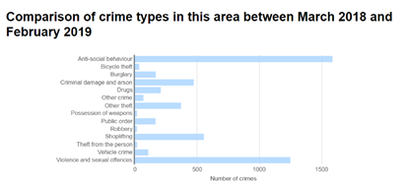

Social Deprivation
Llanelli was once a hugely famous town but nowadays has a bad reputation. The social depravity is worst amongst teenagers and young adults, who have nothing to do in Llanelli, therefore turn to anti-social behaviour as a means to keep themselves occupied. An article from ‘WalesOnline’ has stated how there’s a confirmed “increase in anti-social behaviour (ASB), committed by teenage youths”. The report goes on to state how these ASB cases were highest during the school holidays, says Inspector Justin Evans, and these actions are happening in and around Llanelli town centre, the area under scrutiny. A Facebook page known as ‘Spotted Llanelli’ states that “There are a group of children aged between 12 and 17 running riots” and “They are egging cars and people, shoplifting and breaking windows”. There have also been reports of unruly youths disrupting the annual Festival of Light service. The reason for these disruptions is due to the lack of opportunities for anyone of that age. Llanelli town centre has the same shops, such as betting shops, charity shops, pound shops and cash generator shops. None of these shops appeal to youngsters. Whilst there are events in Llanelli such as the Festival of Light offer occasions to bring the community together, these events do not appeal to the younger generation. Llanelli lacks in activities such as Laser tag, paintballing, game shops. These are all activities that young people enjoy, and without these to keep them busy in the holiday’s. One can understand the appeal of anti social behaviour as a means of something to pass the time.
Having said this, there are some assets to Llanelli that appeal to young people, such as Odeon, providing films for people of all ages and tastes. Alongside Odeon lies restaurants such as Nando’s and Costa, providing a chance to meet with friends and have a meal together, with a cinema a stone’s throw away. This area, Eastgate serves as an example of what Llanelli could be like if more money was invested, sadly this idea is easier said than done due to a glaring issue, explained in the next section.

National Recession
A recession, according to ‘Merriam-Webster’ is described as “a period of reduced economic activity”. The Great Recession occurred in 2009 in response to the Financial Crisis of 2007- 2008 and the US Real Estate collapse of 2009. Wales was particularly affected by the recession, with unemployment rising by 30% in the wake of the Great Recession, with 19,000 vacancies listed in Jobcentre Plus in Wales. - Stephen Timms (2008). 2008 Northwaleslive
Statistics from the ONS (Office for National Statistics) stated that the number of people on the dole in Wales rose from 60,848 to 134,000 in March 2010. The recession in Wales hit Llanelli massively, for example in 2010 a firm known as Spencer Davies Engineering had to lay off a third of its staff. A huge reason why this Llanelli’s history. Llanelli used to be an industrial giant, the biggest manufacturer of coal and tinplate in the world. However with the mine closures in the 80’s and the movement of coal production overseas a huge reduction in employment as there was no work, which brings on the next point.

Out of town Shopping
One of the best economic successes for the Llanelli area was Trostre Park. The first phase of development started in 1988, and consisted of a few stores such as Tescos. However, in 2008, a second expansion plan was rolled out, creating Trostre as it is today. Trostre has a plethora of shops, from clothing, to sofa shops, fast food chains and electrical shops, phone stores, and travel agents. Although not totally to blame, Trostre is in part responsible for the decline of decline of the high street. In 1989, Tesco opened its doors in Trostre, taking it away from the high street. In the years to follow, shops such as Halfords, WH Smiths, Dixons, Currys and Mothercare ditched the high street in favour of Trostre’s better location. This affected the town centre massively, with no shops to give people a reason to venture into the town centre. Tony Harker, when speaking to WalesOnline outlined the need for more in the town to attract people, saying “It’s far too quiet in town.” Another issue with the town centre is the parking. The parking in Llanelli town centre costs, whereas Trostre is free, giving another reason for people to go to Trostre. As a result, less and less money goes into the town centre, leading to the social depravity and crime that is so prevalent today. A prime example of these is Station Road, which has dwindled from being the centre of the towns nightlife to a street known for its drug abuse and anti-social behaviour. The out of town shopping taking trade away from the town centre affects the economy, which in turn makes it harder for small businesses to stay open due to the lack of custom in the town centre. During research into Llanelli, some primary research in the form of a questionnaire was given to 15 locals, asking their opinions of the town centre. When asked whether Trostre was affecting the town centre, 80% agreed that Trostre was affecting the town centre negatively.

Ways to improve the town
Llanelli has many differing problems, therefore needs many different solutions to combat each issue. Currently, the Swansea Bay City deal is looking to improve Llanelli, highlighting its unemployment statistics, which states that one area “Tyisha”, has a mean income of £16,489, 34% below the national average of £24,944. The report also informs that 34.1% have no qualifications and 9.9% have never worked or had long term employment. Other problem areas are such areas as Stepney Street have too many vacant properties which poses a large challenge. To combat this, Property Enhancement Grants are used to encourage economic investment. Another area of interest for the Swansea Bay City Deal is residential housing, which will be supported using Sustainable Living Grants, addressing key identified issues to change the perception of Llanelli. - democracy.swansea.gov.uk

Whilst these ideas are vital in achieving a better Llanelli, there are other ideas which alongside the existing plans, will further the improvement of the Llanelli area, particularly the town centre area.

More trusted shops
The first solution I am putting forward is to have more trusted brands in the town centre. What makes a town centre? Is it the shops?, the infrastructure?, the people? One could argue it’s a mixture of each of these elements. A good town centre needs good shops, which attract more people. More people means more money. More money improves the local economy, which leads to more shops opening on the high street. It is a continuous circle, each of these factors affects the others. According to an article by llanelli town council, the people of llanelli are proud of their high street, praising its Friendly community, nice market, value for money and easy accessibility, however they are also disappointed by its parking charges, abandoned buildings and lack of big brand named shops. People trust big brand names such as Tescos, M&S and ASDA to name a few. - llanellitowncouncil.gov.uk. 75% of people asked in the aforementioned questionnaire agreed that more town shopping and more trusted big brand shops would help the centre. Smaller existing shops would benefit from the bigger brands in the area too, as the notoriety of these shops will draw customers into the area, seeing the smaller shops and generating business. This idea has many stakeholders. A company’s stakeholders include “anyone affected by the company and its workings”, as described by Dr Edward Freeman. Stakeholders are split into 4 categories, Latents, who need to be kept satisfied by the decisions made as they are the most important. If they do not like where an idea is going then they can boycott the idea or withdraw funding. Promoters, who need to be managed closely, otherwise they have the power to annul an idea. They have more of an interest than latents and the same amount of power Defenders, who should be kept informed about such ideas and their progress, but are not so important, and lastly apathetics, who don’t have much interest in an idea, yet should be monitored.
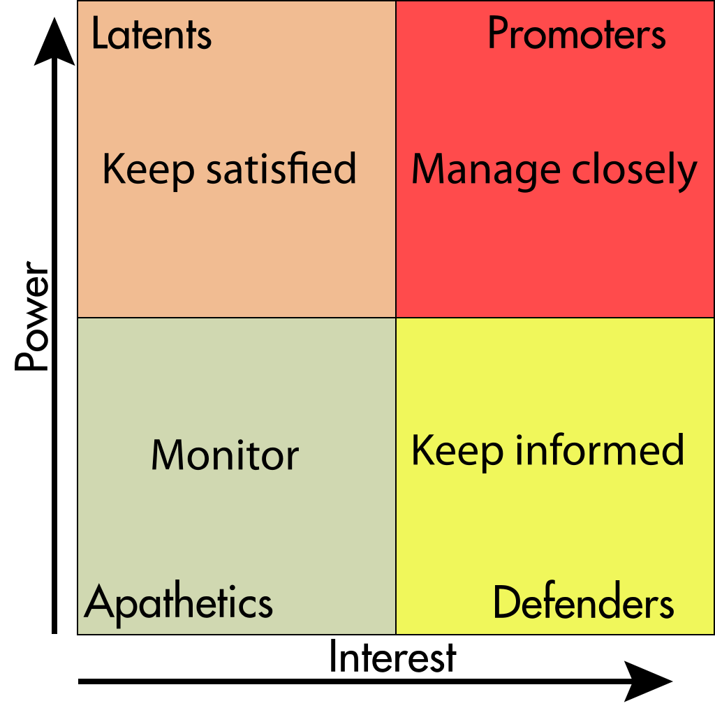

A stakeholders matrix, 2 February 2014, 01:10:03, Own work, Zirguezi

This idea is important to nearly every single person living in Llanelli, from business owners, consumers, employees, the town council, local government and tourists. Due to this, there are no apathetics, with few latents either. Business owners, employees, the local community and the press would class as defenders as they have a high interest in improvements to the area, yet do not have as much power as the local government, town council or funders, who can either shutdown or pull funding from an idea, and without support, undertaking a large idea such as this would be impossible.

Reduce drug use and crime rates
Drug use and crime occurs due to lack of facilities, ranging from education, drop in centres or even activities for youths to keep out of trouble. It is a well known fact that drug dealers target teenagers to ferry around drugs in the area, yet it is not only young people who engage in these crimes, therefore one cannot devise a plan to tackle just one demographic. There are a multitude of ways one must go about creating a more drug and crime free Llanelli. Operation Ulysses in LLanelli, launched by Dyfed-Powys Police found that 28 people suffered heroin related deaths in only 42 months, nearly 1 death a month, highlighting the need for a solution.
In the documentary - Welsh Town Tales, attention is brought to ‘Choose Life’, a not for profit organisation run by Alan Andrews, who aims to help other who are affected by drugs. Whilst this is a good idea, one drop in centre is not enough for coverage of an entire town the size of Llanelli. There is a way of combating this, and the solution is threefold in its execution;
- More drop in centres and youth clubs funded by the local government.
- Teaching the consequences of drugs and criminal activity.

Having more drop in centres and youth organisations in Llanelli will help to reduce the crime. The importance of drop in centres is giving those with a drug problem the help and support they need in a judgement free environment. There are ideas in place for a £200m Llanelli wellness village in Delta Lakes. This centre would have a rehabilitation centre, which would be a huge step in achieving a more drug free Llanelli. - https://www.bbc.co.uk/news/uk-wales-46829690. More youth organisations will help to lower the anti-social behaviour amongst the young population as it gives them something to do during holiday times. Although there is no direct link between youth crime rates and youth organisation, there is a small correlation. In 2014/15, over £600 million was spent by local authorities in England, knife crime stood at around 26,000, whereas in 2017/18 the figure dropped to just over £400m, and in the same year knife crime rose to between 37,000 and 38,000. https://www.bbc.co.uk/news/education-43668167. Although there is no direct correlation between the two, there is a slight correlation between the two in this instance. When discussing the stakeholders of this idea, the promoters would be the local government, who have the power to launch this idea or shut it down. The latents to this idea would be any funders to the idea, as their funding gives them power, yet they may not be as interested in the idea as local governments, or the local community, who are the defenders as they have lots of interest but not as much power.

Being taught consequences of crime and drug use in schools is a good step in educating the young generation. Being taught in schools reinforces the idea of having more youth clubs as the lessons on the dangers of drugs and criminal activity are taught in the classroom, giving no escape from the lessons on drug dangers. During one’s research into the area of Llanelli town centre, a questionnaire was given to 15 residents of Llanelli, asking about various issues in the town centre (see appendix 1), the question “What would you say is the main cause of the town centre’s quietness?”, and all 15 people mentioned drug misuse and crime in their answers, showing how even the inhabitants of the town centre believe drugs and crime are an issue. As stated above, many crimes are perpetrated by the younger population, and what better way to stop youths from committing crime is teaching the dangers in a social education class for 12-18 year olds. There have been studies, and drugwise.org.uk has stated that “Drug education can contribute towards decreased harm and increased safety for young people, their families and communities.” The stakeholders to this idea are similar but not equal to the first idea. The promoters to this idea are the the local government, school governing bodies, and parents of students. These three bodies have power to support this idea and roll it out, or boycott this idea. The defenders are the school pupils and the local community (excluding the parents) as they may be interested in this idea, yet do not have as much power as the promoters, they cannot boycott the idea.

Regenerate the market
Although not a bad market in its own right, in fact it is one of the largest markets in the area, the indoor market of Llanelli could seriously benefit from regeneration. This can come in a multitude of ways. The first way to generate the market would be to add a substantial farmers market. A farmers market would benefit the community as out of town farmers can share their produce with the local community, bridging the gap between the farmers and town dwellers. The trade in the area will also bring more money into the local economy, strengthening the area financially, which also helps the town centre area in a social way. With more money invested in an area, the standard of living can increase, wages may potentially increase, and with a fully functioning market and farmers market, the employment opportunities will increase tenfold, a factor that helps in the fight against anti-social crime and drug use which plagues the town.
Not only does the re need to be a farmers market, but the existing market needs to be improved aesthetically. A report published by “ymlaenllanelli” states how the majority of businesses find improving shop fronts to be a big issue to tackle, as shown on the graph below.

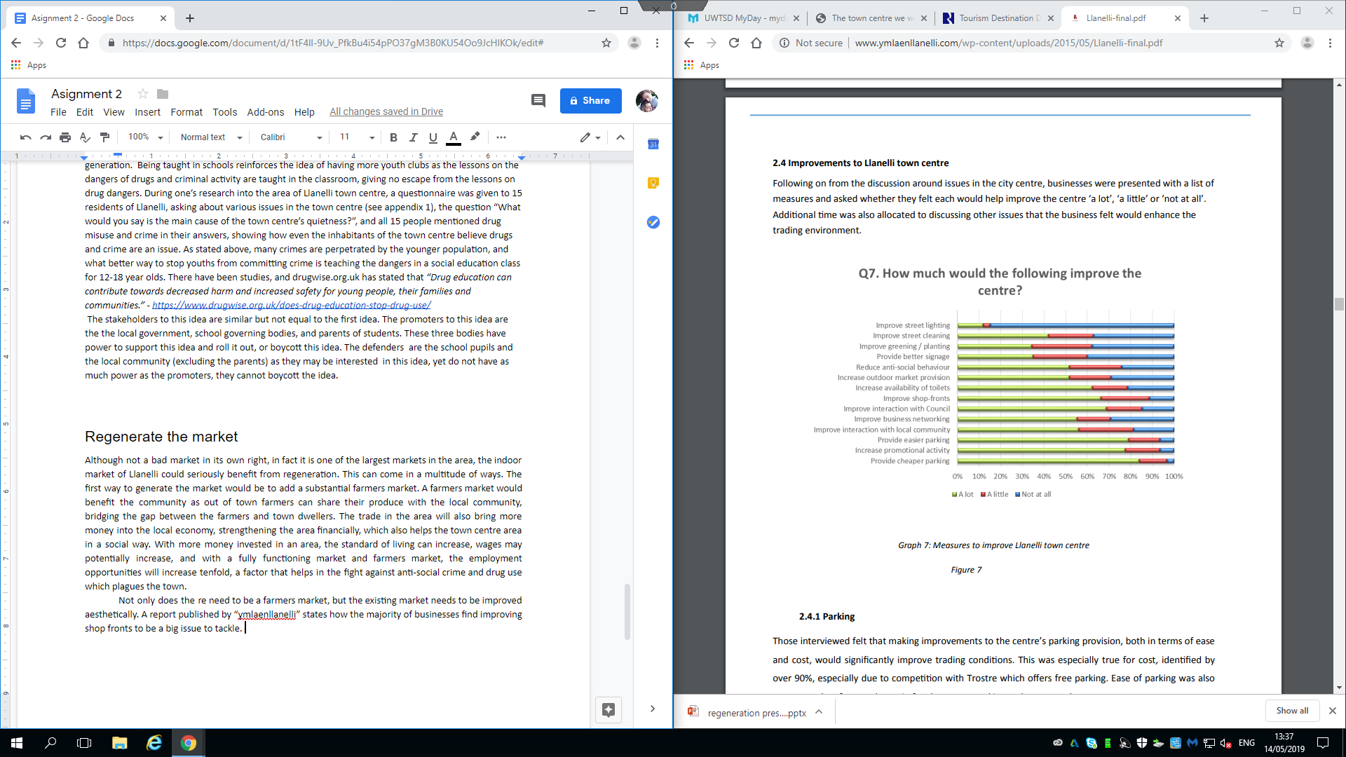

Graph taken from http://www.ymlaenllanelli.com/wp-content/uploads/2015/05/Llanelli-final.pdf

This, along with business networking, increased promotional activity and increasing the outdoor market provisions, are highlighted as some of the most important things needed for a better market. A better market can be achieved, and it isn’t difficult, in fact it is probably the easiest of the three proposed ideas, already existing, and having many promoter and defender stakeholders willing to see this idea through to the end, such as shop owners and employees, the local government, out of town farmers, funders, the local community, who would all benefit from a revitalised market and farmers market.

Conclusion
This report serves the purpose of analysing what Llanelli has. It’s assets, such as Trostre, WWT and TATA Steel, and its decline for reasons, such as crime, social deprivation and out of town shopping, to provide groundwork on how to improve the Llanelli town centre area. One has produced three different but interlinked ideas on the regeneration plans, listed how they will help revive the local economy and to what extent they will tackle the decline of such a once most industrious town. These ideas have been compared alongside what locals believe using both primary and secondary research, as well as analysing existing regeneration plans like the Swansea Bay City Deal, in order to ensure their relevance.

Bibliography
- Detailed statistics for Llanelli Town, Dyfed-Powys Police - Police.uk. (2019). Retrieved from https://www.police.uk/dyfed-powys/124/crime/stats/
- The Guardian. (2019). Llanelli hit by wave of 'county lines' drug gangs. Retrieved from https://www.theguardian.com/uk-news/2019/feb/15/llanelli-hit-by-wave-of-county-lines-drug-gangs
- Bannon, C. (2017). Gang of teens claimed to be 'running riots' in a town centre. Retrieved from https://www.walesonline.co.uk/news/local-news/gang-teens-running-riots-town-13907771
- Spotted Llanelli. (2017). Retrieved from https://www.facebook.com/SpottedLlanelli
- Definition of RECESSION. (2014). Retrieved from https://www.merriam-webster.com/dictionary/recession
- Employment in Wales hit worse by recession than anywhere else in UK. (2011). Retrieved from https://www.walesonline.co.uk/news/wales-news/employment-wales-hit-worse-recession-1822556
- Swansea Council, Pembrokeshire County Council, Cyngor Sir Gar. (2017). South West Wales Regional Plan for Regeneration [Ebook] (1st ed., pp. 14, 15). Retrieved from https://democracy.swansea.gov.uk/documents/s44968/12%202%20of%202%20-%20Appendix%20A%20South%20West%20Regional%20Plan%20for%20Regeneration.pdf
- Llanelli Community Partnership: “the town centre we want". (2018). [Ebook] (1st ed., p. All pages used). Llanelli. Retrieved from http://www.llanellitowncouncil.gov.uk/assets/images/community%20support/The-town-centre-we-want-1.pdf
- Dr. F. Edward Freeman. What Is Stakeholder Theory? | Smartsheet. (2019). Retrieved from https://www.smartsheet.com/what-stakeholder-theory-and-how-does-it-impact-organization
- A stakeholders matrix. (2014). [Image]. Retrieved from https://en.wikipedia.org/wiki/Stakeholder_analysis
- Youtube. (2010). Welsh Town Tales [Image]. Retrieved from https://youtu.be/XQItrV74wis
- Planners approve £200m wellness village. (2019). Retrieved from https://www.bbc.co.uk/news/uk-wales-46829690
- Reality Check: Have youth service cuts led to more crime?. (2018). Retrieved from https://www.bbc.co.uk/news/education-43668167
- Does drug education work?. (2017). Retrieved from https://www.drugwise.org.uk/does-drug-education-stop-drug-use/
- Swyddfa Cymru. (2014). A BUSINESS IMPROVEMENT DISTRICT FOR LLANELLI FEASIBILITY STUDY REPORT [Ebook] (1st ed., p. 12). London. Retrieved from http://www.ymlaenllanelli.com/wp-content/uploads/2015/05/Llanelli-final.pdf

Appendix



