
Skills for the Workplace
Module Assignment Submission
Student Name: | Lianne Davies
Student Number: | 1917783
Module No: | BMSK4001
Module Title: | Academic and Employability Skills

Statement of Confirmation of Authenticity
By the act of making this submission, the student declares that this is the work of the student named above. The work has not, in whole or in part, been knowingly presented elsewhere for assessment, or where assessment has been built on a previous assessment, this has been identified. Where materials have been used from other sources it has been properly acknowledged. If this statement is untrue, the student acknowledges that an assessment offence has been committed.
Attention is drawn to the plagiarism and unfair practice policies of both the University and of ILM.

Table of contents
- Research on Skills for employment and Academia studies.
  - Time management
  - Problem Solving
  - Communication
  - Evaluation of research on Employability Skills
  - Gap Analysis in employment
  - Action Plan for improvement.
Part 2
- Research into Academia studies
  - Third person writing
  - Report writing
  - Note taking
  - Evaluation of Academia skills
  - Gap Analysis in Academia
  - Action plan for improvement
Part 3
- Conclusion
- References.

1 Research on skills for employability and Academic studies
In this report I will be researching skills such as Time management, Problem solving and Communication. I want to capture information from sources, that will best reflect these skills. We will look at what the skill is and ways it can be useful. But most of all look at how I can improve my own development in these areas, to help me in my work and studies.
We will also look at different ways of writing; 3rd person writing, report writing and notetaking. We want to collect information and look at why they are useful and how they can help us learn and to use in future tasks.
Hopefully my report will give you a better understanding at the skills mentioned above, and how I will put these practices to use in future projects and continue to learn and develop myself.

Skills needed for the workplace
1.1 Time Management
The process of planning and organising your time between activities, either in the workplace, at home or in studies, this is what we call Time management. Being able to manage this in good practice can make you work smarter not harder, to enable you to get more work done within the limit of time available. After doing some research, studies conducted from 1982-2004 from different authors showed our behaviours had both a positive and negative effect on time management Claessen, b, Erde, W, Rulte, C, Roe, R (2006). Behaviours such as job satisfactory and good health showed positive effects whereas stress caused negative results. So to be able to manage your time effectively, you need to avoid all stresses. Make use of tools available to you. Some practices may help, make a list, prioritise items of importance and set yourself targets and goals. But most importantly be confident in yourself and keep a healthy mind and body. As a manager time management is necessary, in order for you to be able to conduct your job to the best way possible. It would be suitable to have a diary of a monthly view to ensure you can fit in things that needs to be done in order of importance and urgency. Having this diary would allow you to manage your time better and keep your professional image up, all while maintain a healthy attitude to you job.
1.2 Problem solving
To be able to solve an issue, you must first be able to identify it, then think of a solution to rectify the problem and fix it. Michael Kallet (2014) says critical thinking is the key to becoming a better problem solver. In his book he says ‘Everyone can be a critical thinker. Although some people are more inclined to think critically than others- and although some people become better at it than others- everyone can improve how he or she thinks when tackling problems’ His book makes for an interested read. Kallet (2014) says thinking is the foundation of everything your do. He gives you tools on how to become a better thinker, which helps you review problems differently, which in turn will give you a different outlook or idea in solving any issues. As a leader you would need this skill to enable you to dissolve problems in the most efficient way. Having knowledge about the business and the ability to make hard decisions can aid you when having to solve issues. Once presented with a problem be sure to think critically, and solve the in a timely manner, this will ensure no further issues will arise.
1.3 Communication
The act of communication is transferring information from one person to another. This can be done by either Verbal communication, written communication or nonverbal communication. Verbal and written communication are used in everyday life be it a conversation with a neighbour, text from a friend or an email from work. Nonverbal communication is where we use body language to express or thoughts or feelings. We have been using this form of communication since we were infants, not being able to verbally communicate we used other nonverbal ways to interact with our mothers and family members. Burgoon, J, Guerrerol, L, Floyd, K, (2016) pg 6.
New technology is changing the way we communicate, to be able to communicate effectively we don’t just use words, we use body language and hand gestures we also use the tones in our voices. Studies show the message received by someone in a conversation will be more affected by the nonverbal ways i.e. body language than the actual words spoken.
*53% of impact determined by body language- postures, gestures and eye contact.
*38% by the tone of voice; and
*7% by the content or words in the communication process.
Bourque.B (2009) pg3
To be in a management or leadership role, this skill is essential as you would be expected to communicate effectively through the majority means of communication.
- Face to face
- Email
- Team meetings
- Morning meetings
- One 2 one
- Notice board
- Phone call
- Text
- Fax
- Letter by post
These are all effective ways to communicate clearly in the workplace.

1.4 Evaluation of research
Researching the skills needed to aid my employability like communication, problem solving and time management in more detail, has been interesting and I feel I have learned a great deal about myself and the skills I have and will need for future employment, I have found areas where I feel I need improvement. Being a novice student, I was very apprehensive about not being able to complete the report, with researching being my biggest issue, not knowing where to start or navigate, Time management being another issue I have faced during this report. But after researching problem solving and using the tools made available to me (google scholar, critically thinking) I gained knowledge in how to go about researching other topics to help me complete the work required, and have tools to use when managing my time and tasks. I know feel I can improve on my next module by ensuring I manage my time more efficiently, if I struggle I can use critical thinking to help solve the problem and if I really hit a brick wall I can consulate my tutor, communicate my issue and ask for advice in how to rectify my problem.
I’m going to reflect a little on how these skills are used in my workplace and how I can improve on them with the information I have gathered during my research. The ways we communicate are small as we only a team of 10, we have monthly meetings, a whatsapp group and face to face contact, to enable my team to maintain high standards we are constantly communicating and updating team on Health and safety, Food hygiene, and ad hoc information we need to share. From completing this report, I have gained knowledge and confidence in being able to communicate effectively with my team. Problem Solving can prove a little difficult at times, due to lack of training and inconsistencies in presentation that cause issues. Now I can use the tool ‘Critical thinking’ Kallet, M (2014) and look at putting a solution in place to enable me to correct these issues. Time management can also be a challenge, my workplace can be fast paced and require my attention on all areas of the business, monitoring front and back of house. I now feel confident in approaching my issue with time management, I will set some gaols and targets to enable me to complete all tasks.
To enable me to complete this report we were given a tool called ‘Model of reflection’ Gibbs, G (1998) This tool helps me reflect on the skills I have learned and gained during my research, by following the steps you can when something isn’t right, but also gives you a chance to change something if it doesn’t work.
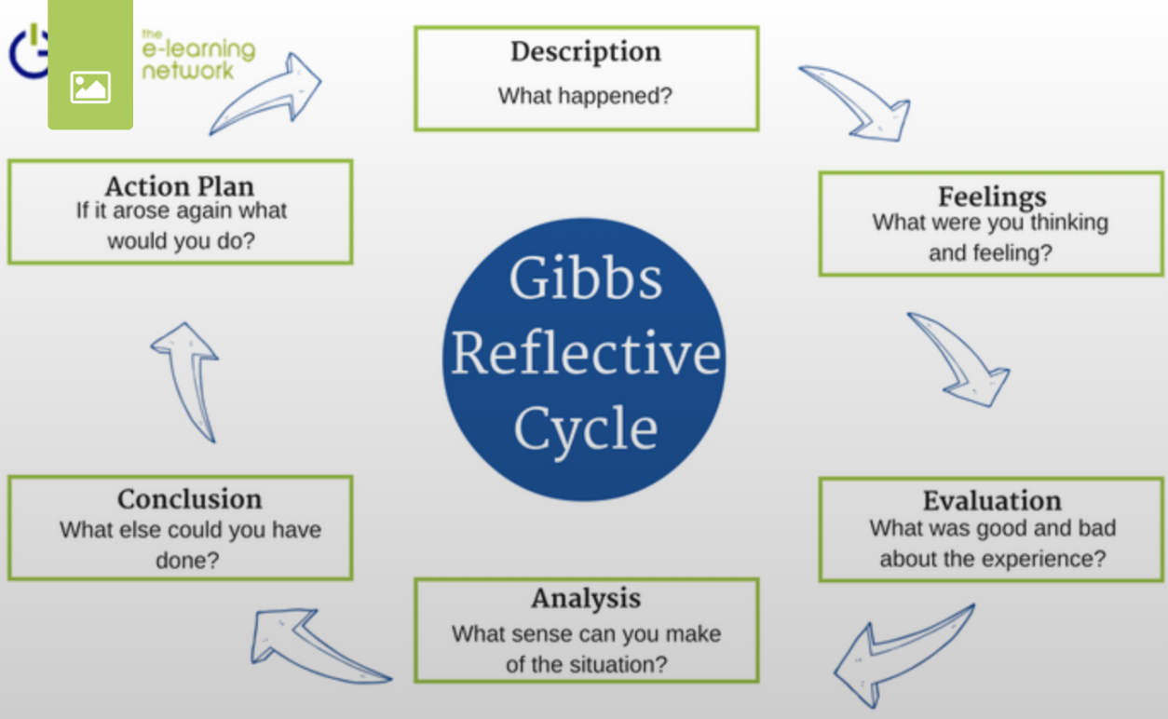

Another Tool we were given was Blakeslee (2004) CRAAP test. This tool enables me to check information I have researched was correct and from a trustworthy source.

C | Currency | *What date was the information submitted. *Does in the information need to be recent, or can you source older material.
R | Relevance | *The importance of the information you need. *Does the information answer your question or query. * Who is the intended audience. * Have you checked other sources.
A | Authority | *Who is the source or Author. *What are their qualifications. *Is the author with a company or university.
A | Accuracy | *The truth in the information. *Where does the information come from. *Are there any citations to further investigate.
P | Purpose | * What is the purpose of the information. *Are their intentions clear.  * Can you see a presence of bias.

1.5 Gap Analysis in employment

Objective | Current Position | Deficiency | Action
What do I want to do? | What can I already do? | What am I lacking? | How do I fix this?
Improve time management | Identify areas needed to improve my time | Adequate time to complete tasks i.e. paperwork, staff training | Ask management for support, Ensure all training is complete, This should free up enough time to complete other tasks.
Improve problem solving | Correct mistakes, before they hit the shop floor, Intercept and resolve customer issue on shop floor. | Team training on standards and food presentation,  Communication with front and back of house. | Ask management for support and guidance, complete all training.
Improve on communication. | Team meetings, notice board, whatsapp group. | Management support, Time management and confidence. | Ask management for support, put time aside for training etc use tools available

1.6 Action Plan for Improvement

What are you focused on? | Where would you like to be? | Where are you now? | Action plan & Time scale
Food Hygiene | Food Hygiene level 3 | Food Hygiene Level 2 | Complete Level 3 in food hygiene, Within 6 months.
Complete Team Training on Standards and Presentation. | Consistency of standards and presentation from entire team | New Menu change due. | Ensure team is trained within 1 week of release of new menu, Create a spec book for team to use if unsure, 1 week to complete.
Display fridge presentation and standards | consistency in presentation and standards | Inconsistency in presentation and standards | Ensure team trained individually within 2 weeks. Train staff on correcting dating of day dots to ensure food safety is being followed.
CertHe skills in the work place | Complete and pass course | Ensure all modules complete on time | ensure time is put aside to complete research, use all tools made available. Follow Timelines for completion and submission via course.

Now I can clearly see what I need to do to achieve my goals. I created this gap analysis to identify what I was lacking and worked out what I need to do to gain these extra skills and put them in my action plan on my personal development plan.

Part 2: Academic Skills

2.0 Research into Academic Skills

2.1Third person writing.
To define ‘Third person writing’ is to refer to authors, people or characters by name or 3rd person pronouns such as He She, It, his, Hers, Them and themselves. A lot of great authors have written books in this manner. For example, Little Women by Louisa May Alcott (1868), the way she tells the story of each of the characters helps you see them individually. Louisa wrote this way to enable her to narrate the story she intended. She was able to give the information required about each character and situation, all while telling the story. Through my research, I have discovered 3rd person writing is taught to most foreign students, in order to help them complete their English essay’s they must understand the language. Dubai is a country who ensure students learn English from an early age, studies found students had a tendency to memorise the English, but didn’t understand, some thought it was due to the language barrier, Picon, L (2015).
According to Krashen (1982) 3rd person singular s is considered to be one of the most understandable concepts to learn of English grammar.

2.2 Report writing
To write a report, it must be clear and precise, it needs to be well structured and based on fact. Reports need to be easy to understand and enable readers to find the information they seek, quick and easy. The purpose of a report is to communicate information collected which would be useful for the intended audience. They are used in many industries and education studies. A book I found on report writing set a clear objective. Bowden, J (2011) ‘It is essential that you have a clear understanding of your readership while creating the report so as to focus on their needs and expectations. A report which is perceived as reader friendly will always go down better than one that is introspective’.
Reports come in all shapes and sizes, depending on what type of report your doing the understanding must be clear, data collected must be smart and accurate. And your message must be understood by the person or persons who receive your report.
2.3 Note taking
The practice of recording information taken from a different source is called Notetaking. This is where the writer collects the main key points of information, freeing up their mind from having to recall everything. Also enabling the writer to go back too, later. Notetaking is used everywhere, for example at home taking a telephone message for a loved one, to an electrician writing measurements for a plug to a CEO taking notes in a meeting. It’s an essential tool everyone will use in their lifetime. During my research I found a paper that has reviewed data on students taking part in note taking experiments. The paper concluded that students who took notes did well on tests and revision given whereas students who didn’t take notes, didn’t do so well. The paper goes through a lot of research conducted by various authors, but little evidence is available in studies reported, that note taking itself can be useful for tests or revision. Hartly, J, Marshall, S. (1974).
Note taking will always be a useful tool, studies and papers can write and analyse data to prove this but as a human we use this in everyday walks of life, from shopping lists or to do lists for the husband. In school or college and in our work life. We can always improve on the way we take notes, ensure you collect information that can be useful to the topic you are dealing with, be clever in what you take from it and make it so u can go back at a later date and understand what you have written.

2.4 Evaluation of Academic skills
Researching these specific academic writings; 3rd person writing, Report writing and note taking. Was interesting I understood the basics of these skills so having to research them and taking a closer look, I feel I can appreciate them more. I was surprised how these skills can work both in the workplace and studies. I found Third person writing most challenging. I personally like to read, mostly fiction so I had a basic understanding of why the story is written that way, the nouns were also easy to understand, He, she or them is they are what makes it 3rd person. Here are some examples of nouns used in writing styles.
Writing | Nouns
1st person | I/We/Me
2nd person | You/ Your/ Yours
3rd person | He/ She/ They

I’m not sure why or where the 3rd writing skill would be used in my line of work, or studies. But if I ever decide to write a book, I will possess the basic knowledge needed to do so. I’m confident in the other 2 skills and I will be using the information I’ve learned from my research in future tasks.
I’ve learnt so much on this report, having to do research was a challenge for me and I kept looking in the wrong direction, but a soon as I changed my wording and switched to google scholar it all started to make sense to me, and I got into a rhythm. Reading between the lines to see if the little information shared would be useful to me and my topic. There was a lot of information I needed to go through to ensure the best experience for me and I found that when the material was interesting I could read so much more and understand it, so I was able to use it. Harvard referencing is a tool iv never worked with before and still in the early stages of understanding it to its full extent. Its quite daunting when you discover an article has 7 different authors and you have to include them all in your references. So, I understand the need to reference so your tutors can investigate your research is accurate.

2.5 Gap Analysis in Academia

Objective | Current Position | Deficiency | Action
What do I want to do? | What can I already do? | What am I lacking? | How do I fix this?
Improve my report writing skills | Use the information given to me, via notes slides and emails. Ask tutor for direction. | Confidence in being able to complete work correctly | Complete work best to my knowledge, follow all instructions given to me. Ask tutor for help.
Improve on research skills | Use the method CRAAP, to ensure information is accurate. | Knowledge and confidence in research. | Ask tutor for help and guidance, make use of tools made available i.e. google scholar. Practice research.
Complete CertHe skills in the workplace | Complete 1st module with tools given. | Confidence, and knowledge, time management | Use tools provided and utilise tools found while researching, ask tutor for help and advice.
Improve my Third person writing skills | Understanding of the nouns used in 3rd person writing. | Confidence in being able to write this way. Not sure when I can use. | Research more on the topic, talk to my tutor.

2.6 Action Plan for Improvement

Objectives | Tasks | Success Criteria | Time Frame | Resources
List your Goals | What do you need to do to achieve these goals? | How will you identify your success? | When do they need to be done by? | Who or what do you need to help you?
Complete 5 more modules in certHe skills in the work place | Attend all classes, and manage time for research and study, accordingly, use tools made available and complete and submit on time. | Ensure each module is complete and submitted. | Entire course to be completed by November 2020 | Use tools available, course tutor and classmates
Improvement on writing skills | Follow tutor instructions, research and practice. | Module scores | Follow course rota | Use tools available, speak with tutor and classmates, gain confidence.
Improve research skills | Use tools made available, practice and make notes | Research should become easier with practice, understanding what I’m reading and writing. | Follow course rota | Course tutor for help and advice

After identifying areas, I need to work on using these tools, I now have a plan of action to follow. This will help me develop my skills in these areas which will assist me academically as well as in my employment

Part 3

3. Conclusion
I have looked at several areas in employability and academic skills, such as problem solving and time management to report writing and note taking, having looked at each topic in some detail I now have a better understanding of my development needs and tools I can use in both studies and work life. With time Management being a huge issue in my life I hope to take the information I collected to use in future tasks. Using the tools I have been given Gibbs, G(1988) ‘Model of reflection’ and Blakeslee (2004) CRAAP test, I am able to process my research in a better way and look at where I need to improve my skills in my work place and studies.

- References
Claessens, B, Erde, W, Rulte, C, Roe, R (2007) A review of time management literature, reserachgate.net
Kallet, M (2014) Think Smarter, New Jersey, Wiley
Burgoon Judee, J, Guerrero, K, Floyd, k (2016) Nonverbal Communications, New York, Routledge.
Bourque, B (2009) ACSM’s Health and fitness Journal, Journals.lww.com. Pg. 32
Gibbs, G (1988) Learning by doing: A Guide to teaching and learning methods. London: FEU
Alcott, L (1868) Little Women, Boston, Massachusetts, Roberts Brothers.
Picon, L (2015) The Acquisition of the 3rd person Singulars in English: Exploring its
use by L2 learners of English in written and oral register,
Krashen, S (1982) Principles and practice in second language acquisition, Oxford, Pergamon press
Bowden, J (2011) How to write a report, uk, books on google.
Hartley, J, Marshall, S (1974) Higher Education Quarterly, academia.edu

Appendix

