https://www.mckinsey.com/mgi/our-research/generative-ai-and-the-future-of-work-in-america

For diagrams go to the original
Steve

McKinsey Global Institute

Generative AI and the future of work in America
July 26, 2023 | Report
By Kweilin Ellingrud, Saurabh Sanghvi, Gurneet Singh Dandona, Anu Madgavkar, Michael Chui, Olivia White, and Paige Hasebe
Which jobs will be in demand? Which ones are shrinking? And which ones could be hardest to fill?
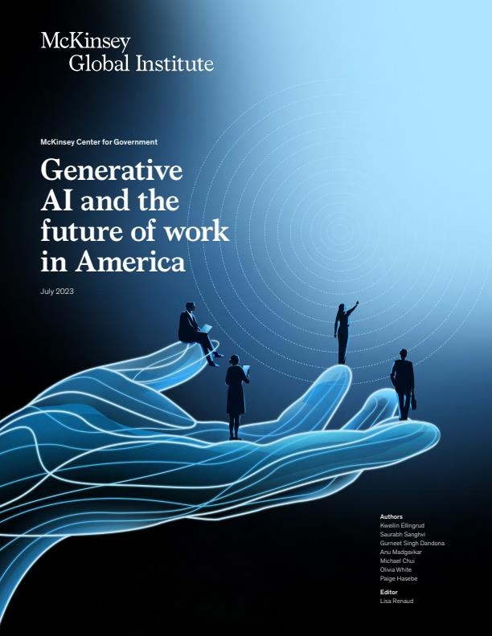
Full Report (76 pages)

At a glance
- During the pandemic (2019–22), the US labor market saw 8.6 million occupational shifts, 50 percent more than in the previous three-year period. Most involved people leaving food services, in-person sales, and office support for different occupations.
- By 2030, activities that account for up to 30 percent of hours currently worked across the US economy could be automated—a trend accelerated by generative AI. However, we see generative AI enhancing the way STEM, creative, and business and legal professionals work rather than eliminating a significant number of jobs outright. Automation’s biggest effects are likely to hit other job categories. Office support, customer service, and food service employment could continue to decline.
- Federal investment to address climate and infrastructure, as well as structural shifts, will also alter labor demand. The net-zero transition will shift employment away from oil, gas, and automotive manufacturing and into green industries for a modest net gain in employment. Infrastructure projects will increase demand in construction, which is already short almost 400,000 workers today. We also see increased demand for healthcare workers as the population ages, plus gains in transportation services due to e-commerce.
- An additional 12 million occupational transitions may be needed by 2030. As people leave shrinking occupations, the economy could reweight toward higher-wage jobs. Workers in lower-wage jobs are up to 14 times more likely to need to change occupations than those in highest-wage positions, and most will need additional skills to do so successfully. Women are 1.5 times more likely to need to move into new occupations than men.
- The United States will need workforce development on a far larger scale as well as more expansive hiring approaches from employers. Employers will need to hire for skills and competencies rather than credentials, recruit from overlooked populations (such as rural workers and people with disabilities), and deliver training that keeps pace with their evolving needs.

MOST POPULAR INSIGHTS
- Women in the Workplace 2023
- The economic potential of generative AI: The next productivity frontier
- Global Banking Annual Review 2023: The Great Banking Transition
- What is tokenization?
- What is Web3?
The US labor market is going through a rapid evolution in the way people work and the work people do. Months after MGI released its last report on the future of work in America, the world found itself battling a global pandemic.¹ Since then, the US job market has come roaring back from its sudden drop. The nature of work has changed as many workers have stuck with remote or hybrid models and employers have sped up their adoption of automation technologies. More recently, the accelerated development of generative AI, with its advanced natural language capabilities, has extended the possibilities for automation to a much wider set of occupations.
Amid this disruption, workers changed jobs at a remarkable pace—and a subset made bigger leaps and moved into entirely different occupations (Exhibit 1). Some 8.6 million occupational shifts took place from 2019 through 2022. Now even more change is in store. We expect an additional 12 million occupational shifts by 2030. The total number of transitions through 2030 could be 25 percent higher than we projected a little over two years ago.²
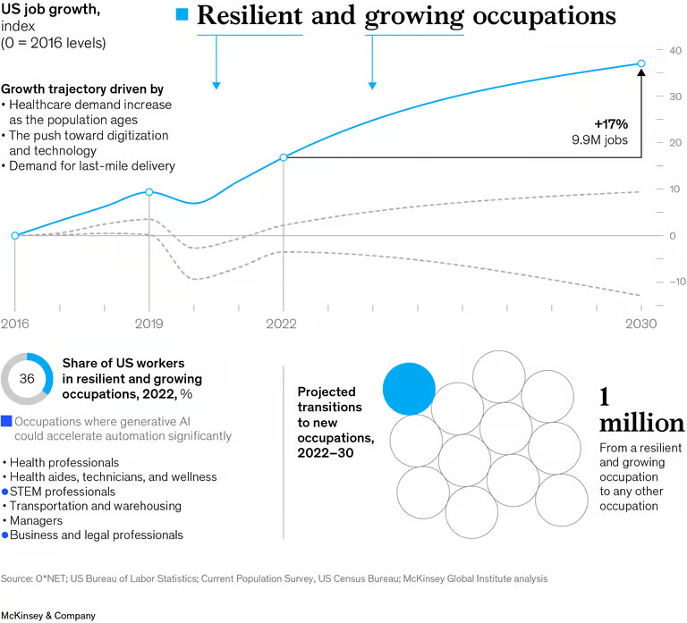

Exhibit 1
We strive to provide individuals with disabilities equal access to our website. If you would like information about this content we will be happy to work with you. Please email us at: McKinsey_Website_Accessibility@mckinsey.com
Multiple forces are set to fuel growth in certain occupations and erode jobs in others. They generally fall into three categories: automation, including generative AI; an injection of federal investment into infrastructure and the net-zero transition; and long-term structural trends such as aging, continuing investment in technology, and the growth of e-commerce and remote work. We do not forecast how aggregated employment may be affected by the business cycle in the short term; instead, we focus on how these forces may reshape the composition of labor demand over the long term.
Across a majority of occupations (employing 75 percent of the workforce), the pandemic accelerated trends that could persist through the end of the decade. Occupations that took a hit during the downturn are likely to continue shrinking over time. These include customer-facing roles affected by the shift to e-commerce and office support roles that could be eliminated either by automation or by fewer people coming into physical offices. Declines in food services, customer service and sales, office support, and production work could account for almost ten million (more than 84 percent) of the 12 million occupational shifts expected by 2030.
By contrast, occupations in business and legal professions, management, healthcare, transportation, and STEM were resilient during the pandemic and are poised for continued growth. These categories are expected to see fewer than one million occupational shifts by 2030.
Workers have shown a willingness to change career paths, while a tighter labor market has encouraged companies to hire from broader applicant pools.
For the other categories that account for the remaining one million occupational shifts still to come, the pandemic was a temporary headwind. Employment in fields like education and training should rise in the years ahead amid a continuous need for early education and lifelong learning. Demand for construction workers also stalled during the height of the pandemic but is expected to rebound strongly.
The changes estimated in our earlier research are happening even faster and on an even bigger scale than expected. It is becoming even more urgent to solve occupational and geographic mismatches and connect workers with the training they need to land jobs with better prospects. The fact that workers have been willing to pivot and change career paths, while a tighter labor market encouraged companies to hire from broader applicant pools, gives cause for optimism—but not complacency. The future of work is already here, and it’s moving fast.
By the end of 2022, employment had bounced back to its 2019 level. But a great deal was in flux.

Are pandemic-era labor shortages here to stay?
The quits rate soared to new heights during the pandemic, with roughly 48 million Americans leaving their jobs in 2021 and 51 million in 2022. What people did next is not fully evident from the data. Some moved into better jobs with higher pay. Others left the labor force, whether out of discouragement or for personal or health reasons, and it is unclear if or when they will return.
Total employment hit an all-time high after the pandemic, with many employers encountering hiring difficulties. As of April 2023, some ten million positions remained vacant; labor force participation had ticked up but was 0.7 percentage point below its prepandemic level. That translates into roughly 1.9 million workers who are neither employed nor actively looking for jobs. This erosion comes after an extended 20-year trend of steadily falling participation.
Labor supply may continue to be constrained, given that one in four Americans will be of retirement age or older by 2030. Without higher participation rates, increased immigration, or meaningful productivity growth, labor shortages could be a lasting issue as the economy and the population grow. This remains an open question confronting markets, economists, and employers.

The Great Attrition obscured deeper shifts
While most attention was focused on soaring quits rates during the pandemic, something more structural was also occurring. A subset of people did more than change employers; they moved into different occupations altogether. Based on net increases and decreases in employment, some 8.6 million occupational shifts took place from 2019 through 2022—50 percent more than in the previous three-year period (Exhibit 2).³ While it is impossible to trace individual moves, many people left their previous roles and landed better-paying jobs in other occupations.

Exhibit 2
The majority of these shifts came from people leaving jobs in food services, customer service and sales, office support, and production work (such as manufacturing). At the same time, managerial and professional roles plus transportation services collectively added close to four million jobs from 2019 to 2022. Our previous research had anticipated these types of changes over a longer time frame, but the pandemic suddenly accelerated matters. The past few years have been a preview of trends we expect to continue through the end of the decade.

More high-wage jobs—and fewer workers taking lower-wage service jobs
Overall employment in low- and middle-wage occupations has fallen from prepandemic levels, while occupations that pay more than $57,000 annually added about 3.5 million jobs. However, it is unclear how many higher-paying roles were filled by people who moved up and how many were filled by new entrants to the labor force. Meanwhile, the number of lower-wage job openings has not declined. Demand for lower-wage service work remains, but fewer workers are accepting these roles.
What is clear from the job switching and occupational shifts of the past three years is that the US labor market accommodated a higher level of dynamic movement. Spiking demand and labor scarcity forced many employers to consider nontraditional candidates with potential and train them if they lacked direct experience. While this may not hold in the future, employers and workers alike can draw on what they have learned about the potential for people to make quick pivots and add new skills.
Automation, from industrial robots to automated document processing systems, continues to be the biggest factor in changing the demand for various occupations. Generative AI is both accelerating automation and extending it to an entirely new set of occupations. While this technology is advancing rapidly, other forces are also affecting labor demand. Overall, we expect significant shifts in the occupational mix in the United States through the end of the decade.

The effects of automation and generative AI
Automation has taken a leap forward with the recent introduction of generative AI tools. “Generative” refers to the fact that these tools can identify patterns across enormous sets of data and generate new content—an ability that has often been considered uniquely human. Their most striking advance is in natural language capabilities, which are required for a large number of work activities. While ChatGPT is focused on text, other AI systems from major platforms can generate images, video, and audio.
Although generative AI is still in the early stages, the potential applications for businesses are significant and wide-ranging. Generative AI can be used to write code, design products, create marketing content and strategies, streamline operations, analyze legal documents, provide customer service via chatbots, and even accelerate scientific discovery. It can be used on its own or with “humans in the loop”; the latter is more likely at present, given its current level of maturity.
All of this means that automation is about to affect a wider set of work activities involving expertise, interaction with people, and creativity. The timeline for automation adoption could be sharply accelerated. Without generative AI, our research estimated, automation could take over tasks accounting for 21.5 percent of the hours worked in the US economy by 2030. With it, that share has now jumped to 29.5 percent (Exhibit 3).⁴
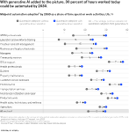

Exhibit 3

Image description: A dot plot with 17 rows for different U.S. sectors shows automation adoption by 2030 as a share of time spent on work activities, averaging about 25% overall. Each row plots one circle for automation adoption without generative A.I. acceleration and one circle with acceleration and highlights the difference between. Sectors with the greatest jump in acceleration, 14 to 16 points, include stem professionals, education and workforce training, creatives and arts management, and business and legal professionals. End of image description.

Other forces affecting future labor demand
Automation is not occurring in a vacuum, of course. Other trends are affecting the demand for certain occupations, and we expect the employment mix to change significantly through 2030, with more healthcare, STEM, and managerial positions and fewer jobs in customer service, office support, and food services.
- Federal investment: Recent federal legislation is driving momentum and investment in other areas that will affect jobs.⁵ Reaching the net-zero emissions goal is one of these priorities. Some 3.5 million jobs could be displaced through direct and indirect effects across the economy. But at the macro level, these losses should be more than offset by gains of 4.2 million jobs, primarily led by capital expenditures on renewable energy. The net-zero transition will likely be a net positive for jobs, but those jobs may be located in different places and require different skills.
Similarly, major investment in infrastructure projects across the country will bolster construction jobs, which could see employment growth of 12 percent from 2022 through 2030. However, the sector already had some 383,000 unfilled positions in April 2023. This shortage will have to be addressed to bring infrastructure projects to life from coast to coast.⁶
The CHIPS and Science Act is putting additional funding into semiconductor manufacturing as well as R&D and scientific research.⁷ This comes at a time when some companies have been adjusting their supply chains, leading to an uptick in domestic manufacturing. While manufacturing is likely to boost employment demand overall in the years ahead, the sector is becoming more high-tech. It will involve fewer traditional production jobs than in the past but more workers with technical and STEM skills.⁸
- Other structural trends: At the same time, other trends like rising incomes and education levels will sustain jobs. An aging population will need more healthcare workers in multiple roles, while the ongoing process of digitizing the economy will require adding more tech workers in every sector.
One of the biggest questions of recent months is whether generative AI might wipe out jobs. Our research does not lead us to that conclusion, although we cannot definitively rule out job losses, at least in the short term. Technological advances often cause disruption, but historically, they eventually fuel economic and employment growth.
This research does not predict aggregated future employment levels; instead, we model various drivers of labor demand to look at how the mix of jobs might change—and those results yield some gains and some losses.⁹ In fact, the occupational categories most exposed to generative AI could continue to add jobs through 2030 (Exhibit 4), although its adoption may slow their rate of growth. And even as automation takes hold, investment and structural drivers will support employment. The biggest impact for knowledge workers that we can state with certainty is that generative AI is likely to significantly change their mix of work activities.

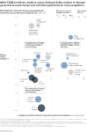

Exhibit 4

Resilient and growing occupational categories
The largest future job gains are expected to be in healthcare, an industry that already has an imbalance, with 1.9 million unfilled openings as of April 2023. We estimate that there could be demand for 3.5 million more jobs for health aides, health technicians, and wellness workers, plus an additional two million healthcare professionals.¹⁰
By 2030, we further estimate a 23 percent increase in the demand for STEM jobs. Although layoffs in the tech sector have been making headlines in 2023, this does not change the longer-term demand for tech talent among companies of all sizes and sectors as the economy continues to digitize. Employers in banking, insurance, pharmaceuticals, and healthcare, for example, are undertaking major digital transformations and need tech workers with advanced skills.¹¹ In addition, the transportation services category is expected to see job growth of 9 percent by 2030.

Declining occupational categories
The biggest future job losses are likely to occur in office support, customer service, and food services. We estimate that demand for clerks¹² could decrease by 1.6 million jobs, in addition to losses of 830,000 for retail salespersons, 710,000 for administrative assistants, and 630,000 for cashiers. These jobs involve a high share of repetitive tasks, data collection, and elementary data processing, all activities that automated systems can handle efficiently. Our analysis also finds a modest decline in production jobs despite an upswing in the overall US manufacturing sector, which is explained by the fact that the sector increasingly requires fewer traditional production jobs but more skilled technical and digital roles.¹³
We estimate that 11.8 million workers currently in occupations with shrinking demand may need to move into different lines of work by 2030. Roughly nine million of them may wind up moving into different occupational categories altogether. Considering what has already transpired, that would bring the total number of occupational transitions through the decade’s end to a level almost 25 percent higher than our earlier estimates, creating a more pronounced shift in the mix of jobs across the economy.
Overall, we expect more growth in demand for jobs requiring higher levels of education and skills, plus declines in roles that typically do not require college degrees (Exhibit 5).

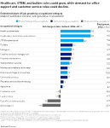

Exhibit 5

Image description: A bar chart with a row for each of the 17 U.S. sectors plots estimated future job growth over 2022 to 2030. Rising the most, from 23% to 30% are health professionals; health aides, technicians, and wellness; and stem professionals. Decreasing from 1% to 18% are office support, customer service and sales, food services, and production work. End of image description.
People in the two lowest wage quintiles (those earning less than $30,800 a year and those earning $30,800 to $38,200 a year) are up to 10 and 14 times more likely, respectively, to need to change occupations by the end of this decade than the highest earners.¹⁴ Changing occupations, as opposed to finding a new job within the same occupation, often requires adding new skills and is more challenging.
The jobs in the two lowest wage quintiles are disproportionately held today by those with less education, women, and people of color. Women are heavily represented in office support and customer service, which could shrink by about 3.7 million and 2.0 million jobs, respectively, by 2030. Similarly, Black and Hispanic workers are highly concentrated in some shrinking occupations within customer service, food services, and production work.
While our analysis shows a decrease of 1.1 million jobs in the two lowest wage quintiles by 2030, jobs in the highest wage quintile could grow sharply, by 3.8 million. Helping workers in lower-wage, shrinking occupations move into better-paying jobs with more stability will require widespread access to training programs, effective job matching, different hiring and training practices by employers, and better geographic mobility.
The overall labor market will have higher demand for social-emotional and digital skills. Although the demand for basic cognitive and manual skills is likely to decline, physical work is not going away. It may still account for just under 31 percent of time spent, driven by growth in sectors such as transportation services, construction, and healthcare.
With the pace of change unlikely to let up, the challenge will be helping workers match up with the jobs of the future. While some of this may require large-scale collaboration, individual companies can fill many of the gaps by adapting their own approaches to hiring and training.

Boosting productivity through automation and generative AI
Recent MGI research focused on how to reignite productivity growth in the United States.¹⁵ Automation and reskilling will be vital to this effort. Automation could jump-start lackluster productivity while simultaneously easing labor shortages.
Generative AI has the potential to increase US labor productivity by 0.5 to 0.9 percentage points annually through 2030 in a midpoint adoption scenario. The range reflects whether the time freed up by automation is redeployed at 2022 productivity levels or 2030 levels, with both scenarios accounting for the occupational mix expected in 2030.
Combining generative AI with all other automation technologies, the potential growth could be even larger. All types of automation could help drive US productivity growth to 3 to 4 percent annually in a midpoint adoption scenario. However, this will require significant action from stakeholders across the public and private sector. Workers will need support in learning new skills, and other risks associated with generative AI also need to be mitigated and controlled. But if worker transitions and risks are well managed, generative AI could contribute substantively to economic growth.
To capture the full benefits of generative AI to make knowledge work more productive, employers, policy makers, and broader ecosystems would need to establish clear guidelines and guardrails—and workers would need to see these tools not as job destroyers but as work enhancers. When machines take over dull or unpleasant tasks, people can be left with more interesting work that requires creativity, problem-solving, and collaborating with others. Workers will need to gain proficiency with these tools and, importantly, use the time that is freed up to focus on higher-value activities. When managers automate more of their administrative and reporting tasks, for example, they can spend more time on strategic thinking and coaching. Similarly, researchers could speed up projects by relying on automation tools to sort and synthesize large data sets.

For employers, doubling down on innovative hiring strategies
Most employers can benefit from using a broader lens in hiring. Instead of insisting on prior experience that matches the responsibilities of an open role as closely as possible, organizations can evaluate candidates on their capacity to learn, their intrinsic capabilities, and their transferable skills.
Hiring people with potential and training them on the job can be an answer to labor shortages—and give opportunities to people who need them.
A great deal of skills development happens on the job. Previous MGI research found that work experience contributes 40 percent of the average individual’s lifetime earnings in the United States.¹⁶ Skills learned through work experience are an even bigger determinant for people without educational credentials who start out in lower-wage work.
Filling the jobs of the future is an opportunity to make the labor market more inclusive. Employers may need to reconsider whether some credential requirements are really necessary. Some 60 percent of US workers have skills gained through experience but lack four-year college degrees. Initiatives like Tear the Paper Ceiling are supporting workers who have experience but not degrees by raising awareness among employers and providing resources.
Employers can also recruit from populations that are often overlooked, such as retirees who want to return to work, people with employment gaps, and the formerly incarcerated. Remote work, for example, is opening up long-needed opportunities for people with disabilities who cannot commute and those in rural communities.

Tackling other structural issues
Women left the workforce in relatively higher numbers than men during the pandemic. It took three full years for the number of working women in the United States to fully bounce back. Many women doing lower-wage work have family obligations that may leave them feeling that they can’t take the risk of going back to school or trying a new occupation. Beyond the hiring practices that can encourage and enable women to make career transitions, the need for affordable childcare remains a major barrier.¹⁷ To address it, a number of private-sector employers are expanding childcare benefits, while some state and local governments are providing tax credits, subsidies, or direct funding. In addition, historically male-dominated fields such as construction that are facing labor shortages can fill those gaps with more women, improving diversity in the process.
One key area of job demand is in caregiving, which is critical social infrastructure. We anticipate that the two fastest-growing occupations through the end of this decade will be nurses and home healthcare aides.¹⁸ Childcare workers, as noted above, provide a vital service to working families. But people have been leaving these types of jobs in droves. Meeting these growing needs will likely hinge on upgrading the quality of what are today typically low-paying jobs with little security or advancement opportunities.
While large employers may be able to handle their own training needs, the magnitude of the reskilling challenge for the nation as a whole calls for broader partnerships with industry groups, educational providers, and nonprofits as well as incentives for investing in human capital. Addressing the need for reskilling with efforts beyond individual companies would help spread the cost, addressing the concerns of employers who might be reluctant to invest in training for employees who can subsequently leave.
With millions of jobs potentially being eliminated by automation—and even more being created in fields requiring different skills—the United States needs broad access to effective training programs as well as job-matching assistance that can help individuals find opportunities. Many initiatives are in place, but it will be critical to dramatically scale up what works and take a proactive approach to filling key shortages. One promising solution, still in the early stages, involves digital learning and employment records—a kind of digital microcredential that can document how an individual worker has acquired skills and also translate across companies and over time.
The US labor market has been remarkably resilient in the face of recent challenges and rapid changes. That kind of adaptability is exactly what it will take to navigate the next chapter as well, supporting individuals while helping businesses meet their talent needs so they can continue driving growth.

ABOUT THE AUTHOR(S)
Kweilin Ellingrud is an MGI director based in Minneapolis, Saurabh Sanghvi is a McKinsey partner based in Silicon Valley, Gurneet Singh Dandona is an MGI senior expert and associate partner based in New York, Anu Madgavkar is an MGI partner based in New Jersey, Michael Chui is an MGI partner based in San Francisco, Olivia White is an MGI director in San Francisco, and Paige Hasebe is a consultant in the Boston office.

