Table Of Contents
USE OF SOLIDWORKS AND ANSYS FOR BALLISTIC IMPACT
Ben Lloyd - 2219811

- Abstract………………………………………………………………..Page 2
- Background Information……………………………………………..Page 2
- SOLIDWORKS Modelling…………………………………………...Page 3
- ANSYS Simulation…………………………………………………...Page 3
- Analysis Of Results…………………………………………………..Page 4 - 5
- Conclusion…………………………………………………………….Page 5
- Information References……………………………………………...Page 6 Onwards

- Abstract
The war in eastern Ukraine began on 22 February 2022 [1] and has recently reached its second year and the United States have made the decision to provide M1 Abrams tanks to the Ukrainian armed forces [2]. While tank-on-tank battles are very rare, there is a very real possibility that the M1 may be required to engage Russian tanks in combat). While the T-72 makes up the bulk of Russia’s tank fleet, their most modern in active service is the T-90M [3]. The purpose of this paper is to prove whether the M1 could defeat the T-90M in a simulated engagement by testing the M1’s ammunition against the T-90M’s armour.

- Background Information
The M1 is fitted with a modified version of the Rheinmetall Rh-120 120mm smoothbore gun [3]. Along with the vehicle, it has been confirmed [4] that the US will also be donating their own ammunition; for anti-armour purposes the M829 Armour Piercing Fin-Stabilising Discarding Sabot (APFSDS) is used. It is not known which version of this shell is being provided so for the purposes of this simulation, publicly available values of the “original” M829 will be used.
Various sources have been found to find the specification of the M829 and they indicate that the penetrator is is made of Depleted Uranium [5], moves at a velocity of 1670 metres per second [5] at the muzzle (velocity will eventually be lost due to drag) and has a quoted penetration value of 480mm [5] of Rolled Homogeneous Armour (RHA).
The T-90M on the other hand has a quoted Armour thickness of 550mm RHA equivalent [6] (although this jumps to 800mm if Explosive Reactive Armour is installed, but for this test it is assumed that it will not be) against Kinetic Energy penetrators (which the M829 is), this number is likely representative of the Turret’s front face where the armour as it it’s thickest, so this is the figure the simulation will use. On paper, this implies that the M829 is theoretically not able to penetrate the T-90M but the simulation will prove (or disprove) this hypothesis.
Sloped armour is a feature that modern tanks use to enhance armour thickness and increase the likelihood of an incoming round deflecting (for the simulation this behaviour will be ignored), the T-90M is no exception in this regard and the armour is angled at 68 degrees [6].
Putting all this information together, everything needed for simulation has been captured; target (in this case, the armour profile for the T-90M) thickness, slant angle and composition as well as the projectile’s velocity and composition.

- SOLIDWORKS Modelling
To simulate a ballistic impact of this nature, models for simulation must be created. Following the diagram for the M829 found in [7], a rough model can be created [8] with measurements taken from the calibre conversions [9] and applied to the model. However, some of the dimensions are not accurate to the diagram as some measurements are not listed, such as the leading-edge angle of the projectile’s fins and the “overhang” of the trailing edge of the fin from the rear of the projectile. As these dimensions are not critical to penetration of the target, a rough estimate of fin proportions has been required and will be “close enough” for the purpose of the simulation. Another feature not modelled are the interfacing grooves between the penetrator and sabot, again these are not critical to penetration and have subsequently been ignored.
As for the target, the thickness and angle have already been established (Para ii). Width has been copied from thickness of 550mm as the penetration of a real APFSDS round is far larger than the projectile itself, the (probably excessive) width is to ensure the target isn’t entirely obliterated by the impact. A model for the target has been created in SOLIDWORKS [10 and 11]

- ANSYS Simulation
As this experiment relies on a projectile being fired at a target and the subsequent material interactions being simulated, an Explicit Dynamic simulation is required. The two SOLIDWORKS models have been imported into ANSYS and combined to create the experiment as shown in [12]. Next some rules have to be implemented, as the velocity of the M829 has been established, that will be applied to the projectile and is shown in [13]. The edges of the target have been locked in place as shown in [14], otherwise the projectile would push the target, not penetrate through it.
As for the Projectile, material properties for Depleted Uranium were not available within ANSYS so a Tungsten alloy that was compatible with Explicit Dynamics was selected instead. While not accurate to the M829 shell used in this simulation, using Tungsten alloy is not outside the realm of possibility as APFSDS rounds used by other NATO countries, such as the German DM63 [15] make use of a Tungsten penetrator instead and allows the test to remain at least similar to the premise outlined within the abstract.
Material properties for RHA were also not available. However, knowing the material properties of RHA, it being a low-alloy, high tensile martensitic steel [16], a similar material matching that description (Steel 1006[12]) that is compatible with Explicit Dynamics was selected instead.
The duration of the simulation is the final component needed for this experiment to be successful. As the velocity of the projectile has been established at 1670 m/s and the length of the material that the penetrator is expected to travel through is relatively short (550mm), only a small timeframe is required. For this reason, the experiment will be run for 0.3 seconds. At that velocity, the projectile will have travelled roughly 550 metres; 100 times greater than the thickness of the armour and more than enough time for the penetrator to completely piece the target.

- Analysis of Results
For the material interactions to be modelled, a mesh was generated as seen in [17]. A problem that was encountered was tailoring the mesh size to the experiment; often the simulation crashed due to “Time Step Too Small” and that multiple sizes of mesh and multiple and simulation attempts were required to make a single successful simulation; an inefficient use of valuable simulation time. Remote use of simulation software was available but even when following the provided tutorial, the software could not be made to run so these results are all that are available.
These crashes were likely caused by the mesh elements being excessively deformed due all force being concentrated on the projectile’s tip and the software being incapable of handling damage like this because of the large energy transfer. Also worthy of note is how the real APFSDS functions; as material interaction is occurring in such a small area and the huge pressures involved, metals under these conditions begin to behave as liquids. This is known as the Hydrodynamic Effect [19] and this behaviour was not modelled. It is likely that if it were, the simulation results would look entirely different and perhaps would provide a more realistic depiction of projectile/target interaction.
Despite the simulation duration 0.3 seconds which should have provided ample time for the projectile to penetrate the target, only partial penetration has been achieved [23]. Inspecting the rear face of the target revealed that there was no evidence of energy transfer, implying that the projectile was not close to penetrating the target and had halted halfway through. According to the literature that had been collected, this is accurate as 480mm of penetrative power is insufficient to pierce 550mm of armour and as there is a 70mm figure of difference between the two, it appears reasonable that there would be no deformation on the target’s rear face.
What was not accounted for was how much the projectile would slow down once it had entered the target; it is entirely possible that friction along the length of the penetrator would cause it to slow down, while this behaviour was not specifically programmed into the simulation, ANSYS may have accounted for it anyway.
Another factor behind the partial penetration could be a behaviour exhibited by real Tungsten penetrators: mushrooming. On contact with the target, the tip of the penetrator blunts itself by “folding” backwards and the tip forms a mushroom shape [18]. The deformation of the tip increases the penetrator’s surface area, thereby decreasing force per unit area, increasing friction, and massively decreases the efficiency of penetration. Zooming in on the inside surface of the impact zone [20], it appears that this behaviour has been correctly simulated. Had the option to select a cross-sectional view been discovered during access to ANSYS equipped machines, it could provide evidence of this behaviour occurring.
What has been modelled correctly however is puckering at the impact zone. When a projectile enters a solid target, the area around the impact zone is displaced by the incoming round outwards and upwards, creating a raised section surrounding the point of penetration. This is most clearly seen in [21] and is identical to a real-world example as shown within [22], showing that ANSYS does model this aspect of ballistic impacts correctly. As this has been modelled properly, it would therefore imply that mushrooming behaviour inside the target has also been modelled.
Even though the duration of the simulation was relatively long, the partial penetration [23] could also mean that the duration of simulation was too short. If a longer simulation could be carried out (perhaps up to and over 1 second), it would provide more data to analyse and discuss. However, the 0.3 second simulation took four hours to complete with the available hardware, it stands to reason that a longer simulation would take even more time. Time that was not available during lectures and instead, a computer lab was used overnight to complete the necessary calculations.
Two methods could be used to shorten the time required; as mentioned in Para iii, it is possible to that the target plate was made excessively large and that reducing the height and width could make the simulation easier to complete by reducing the number of elements ANSYS is expected to simulate, further testing would be required to test this hypothesis but this is not an option. Secondly, using a PC with more capable hardware could be an option, a computer with more CPU cores and a more powerful GPU could speed up the simulation completion and would allow for a greater degree of experimentation within the timeframe given but such a machine was not available for this simulation.
After completion of the simulation, it was noticed that a smooth animation not available. It instantly transitions from pre-simulation conditions to the “completed” simulation, likely due to the speed the projectile is moving exceeding that of the “frame rate” of the simulation. ANSYS can’t capture the progress of the penetrator as it can’t keep up with the velocity the projectile is moving. If made aware of the option to add more frames to the simulation so the “in between” phases could be more closely examined, a more detailed analysis could be written and the results examined further.

- Conclusion
While Explicit Dynamics is an option for ANSYS, others have used ANSYS to greater effect, produced more detailed results and with fewer crashes using it to model different types of material interactions. Although this probably more to due to user error, ANSYS was not found to be ergonomic in the slightest so creating the simulations was incredibly difficult.
Compounding this difficulty was the huge energy transfers involved in this experiment which caused constant crashes and the author has formed the opinion that the software not suitable for this kind of experiment. As an additional factor, this one simulation took many modifications just to work consumed valuable time available on the software which limited the results obtained.
Finally, only a small amount of time was given to learn the software. The author is not talented in the slightest with anything software-related and learning a system as complicated as ANSYS in a short time frame is inviting mistakes to be made and frustration to be generated.
Some aspects of the ballistic impact have been modelled correctly, such as penetration occurring (even if partial) and puckering at the impact zone. While this simulation has not proven that the M829 can penetrate a T-90M, with more time to simulate longer time scales and further tweaking of the experiment, a more successful penetration test may be carried out and provide a greater level of evidence to analyse.

- References
[1] – N. Walker (18 March 2024), House of Commons Library, Conflict in Ukraine: A Timeline, https://commonslibrary.parliament.uk/research-briefings/cbp-9847/
[2] – L. Jakes (25 September 2023), New York Times, First Abrams Tanks Arrive in Ukraine, https://www.nytimes.com/2023/09/25/world/europe/us-abrams-tanks-ukraine.html
[3] – D. Kemp (13 February 2024), Shepherd Media, Improved T-90M Shown In Detail, https://www.shephardmedia.com/news/landwarfareintl/improved-t-90m-shown-in-detail-in-donetsk/#:~:text=The%20T%2D90M%20was%20publicly,ordered%20by%20India%20and%20Egypt
[4] – O. Danylov (09 September 2023), Mezha Media, The United States will supply depleted uranium shells to Ukraine, https://mezha.media/en/2023/09/07/the-united-states-will-supply-depleted-uranium-shells-to-ukraine-what-is-it/
[5] – M. Magier (May 2021), Warsaw University of Technology, Numerical Analysis of Kinetic Energy Projectile Sabot Structure Influencing the Armour Penetration Depth, https://www.researchgate.net/publication/351920104_Numerical_Analysis_of_Kinetic_Energy_Projectile_Sabot_Structure_Influencing_the_Armour_Penetration_Depth_Part_I_-_Projectile_Basic_Option
[6] – Uralvagonzavod (29 October 2016), T90 Modernized, https://web.archive.org/web/20151126060134/http://uralvagonzavod.com/products/special_products/45/
[15] – P. Valpolini (22 March 2021), European Defence Review, More on Rheinmetall tank guns and ammunition, https://www.edrmagazine.eu/more-on-rheinmetall-tank-guns-and-ammunition-evolution
[16] – Masteel UK (03 August 2017), Azom Materials, Armor Plated Steel: MIL DTL 12560K and DEF STAN 95-24, https://www.azom.com/article.aspx?ArticleID=14297#:~:text=Rolled%20Homogenous%20Armor%20Steel%20(RHA)&text=Normally%2C%20RHA%20grades%20are%20low,better%20grain%20structure%20and%20hardenability.

[18] – Rosset W.S (February 2001), Army Research Laboratory, An Overview of Novel Penetrator
Technology, https://apps.dtic.mil/sti/pdfs/ADA387329.pdf

[19] – Liden E. (2010), University of Uppsala, Interactions between High-velocity Penetrators and Moving Armour Components, https://uu.diva-portal.org/smash/get/diva2:359770/FULLTEXT01.pdf
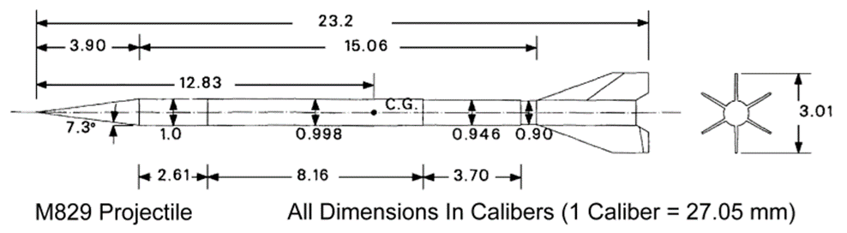
[7] - G. Cooke (22 October 2013), Diagram of M829 projectile extracted from TB 9-2350-320-14: Operator and Maintenance Information for Cartridge (M829), M256 120mm Smoothbore Gun, https://web.archive.org/web/20131022233214/http://www.inetres.com/gp/military/cv/weapon/M256.html

[8] – Model of M829 projectile created in SOLIDWORKS with figures taken from [7].
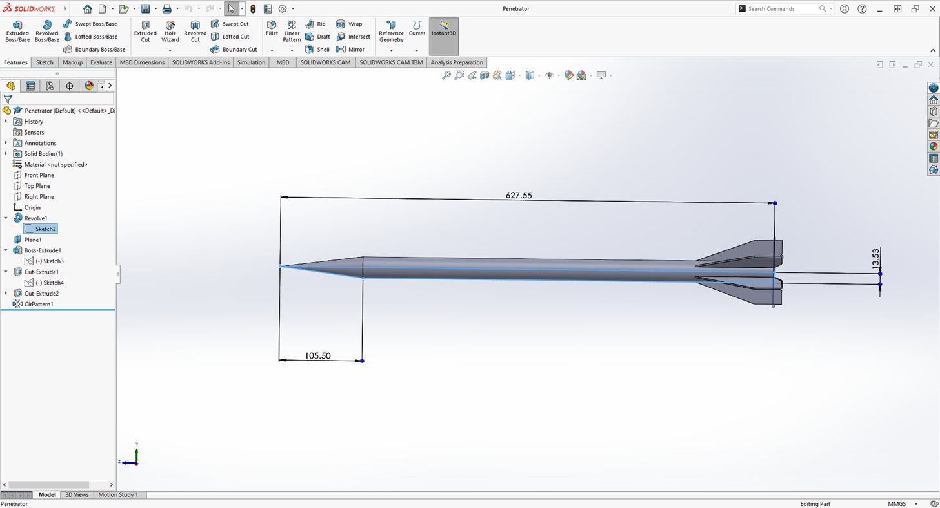

[9] – Calibre conversions of M829 projectile from [7]
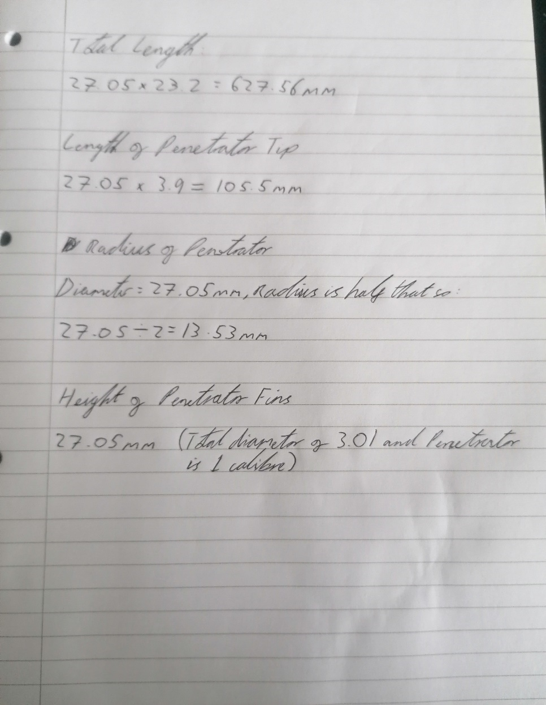

[10] – 2d SOLIDWORKS sketch of T-90M armour plating
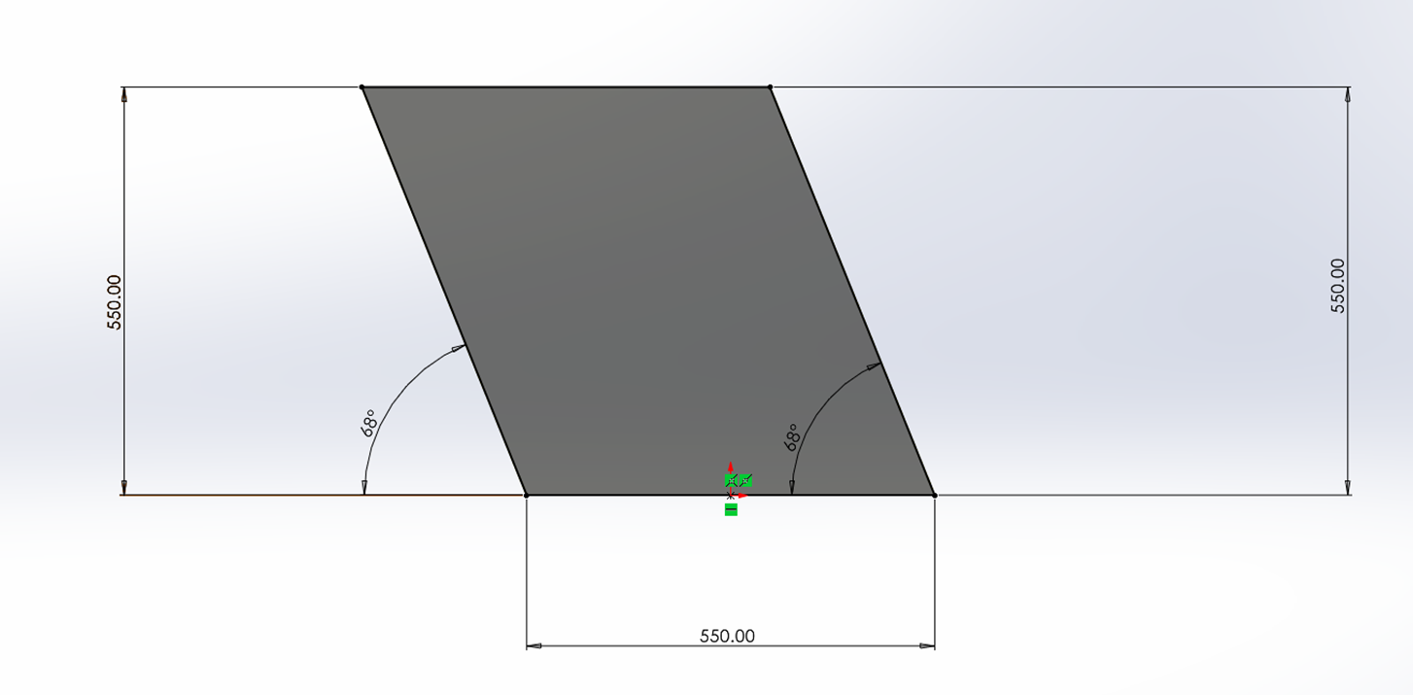

[11] – 3d SOLIDWORKS model of T-90M armour plating
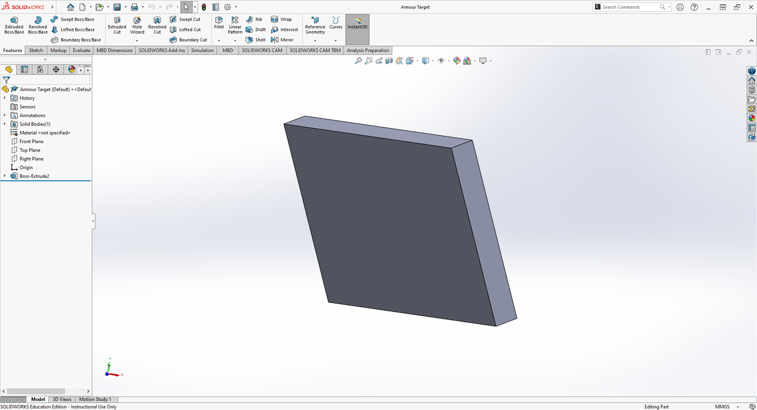

[12] – Target and projectile created in ANSYS
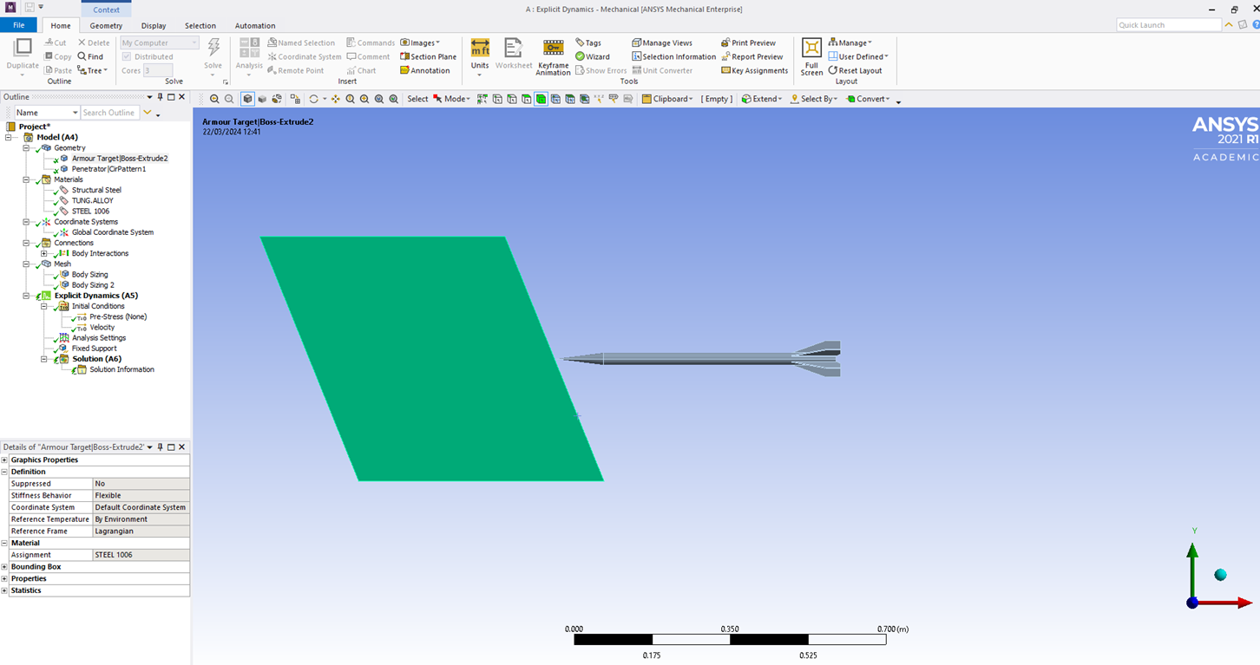

[13] – Velocity applied to the projectile
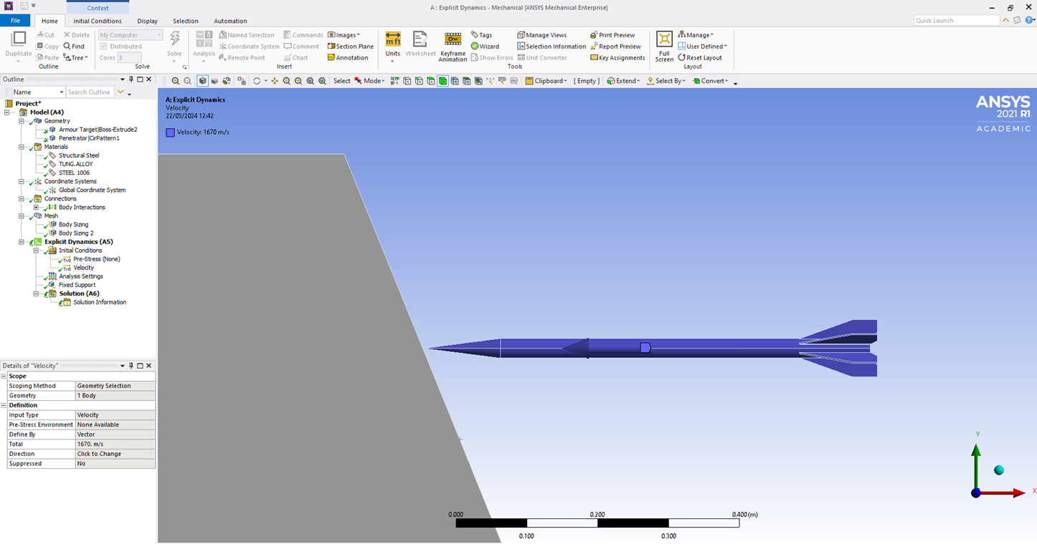

[14] – Edges of the armour plate target have been fixed in place
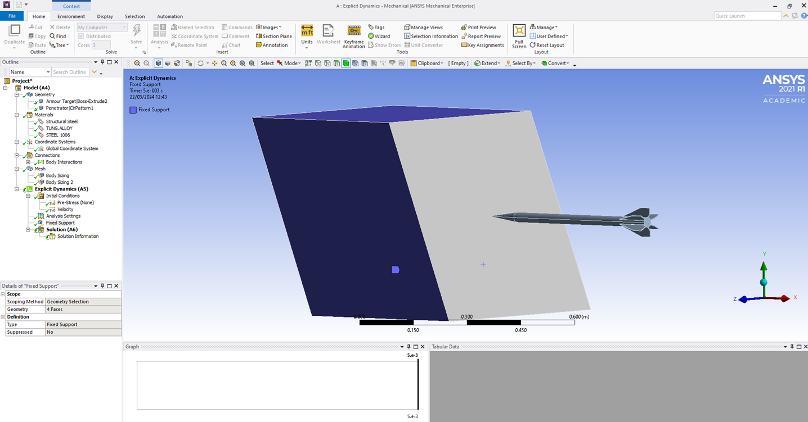

[17] – Mesh generated for both target and projectile
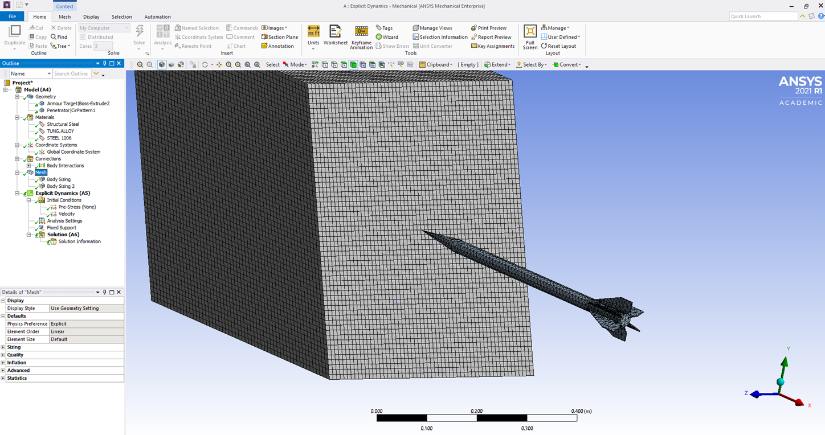

[20] – View of the target impact zone and material interaction
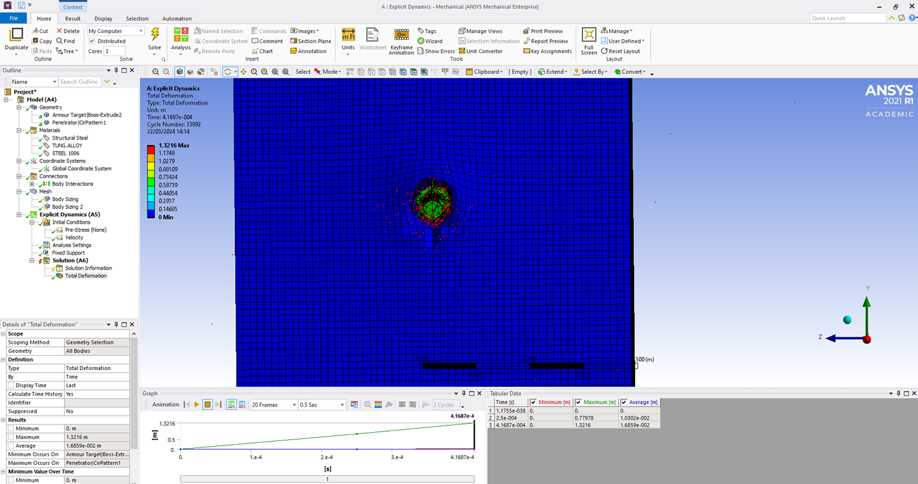

[21] – Evidence of puckering at the target impact zone
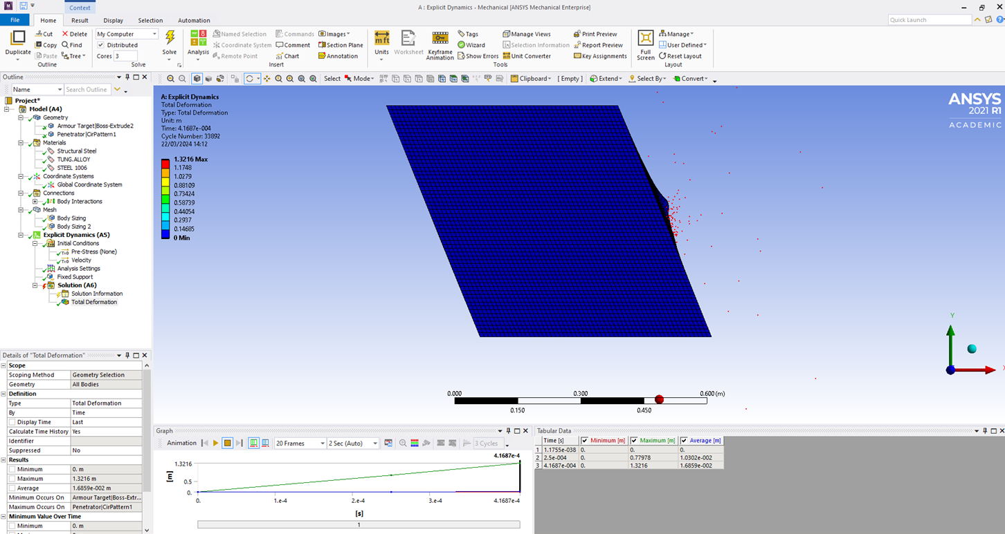

[22] – Real world example of armour puckering when penetrated, extracted from Coghe F. (June 2025), Royal Military Academy, Damage caused to metals by kinetic and chemical energy projectiles, https://www.researchgate.net/publication/278409150_Damage_caused_to_metals_by_kinetic_and_chemical_energy_projectiles
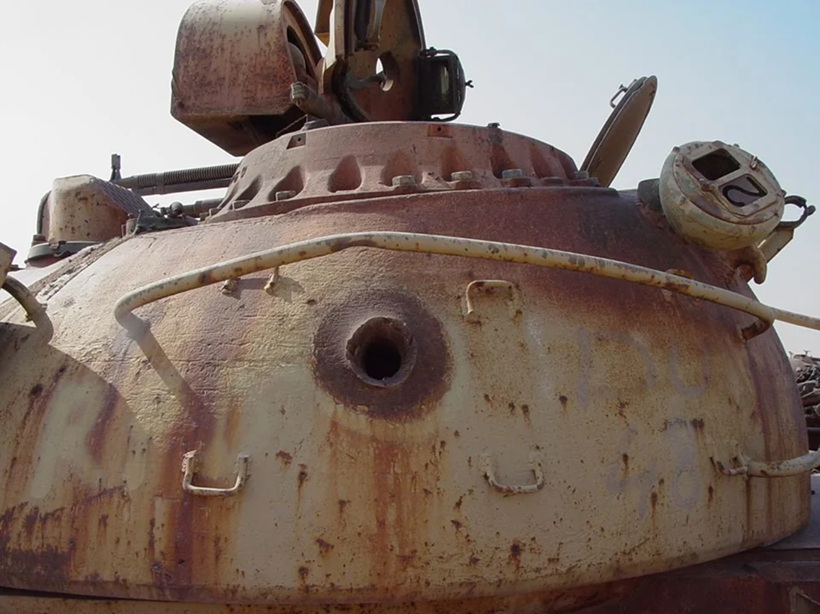

[23] – Evidence of only partial penetration being achieved


