UNIVERSITY OF WALES TRINITY SAINT DAVID

MARIA ERNILA.
STUDENT NUMBER 1816792

EFFECTIVE TEAM WORKING AND COMMUNICATION.

TUCKMAN’S TEAM DEVELOPMENT [1965].

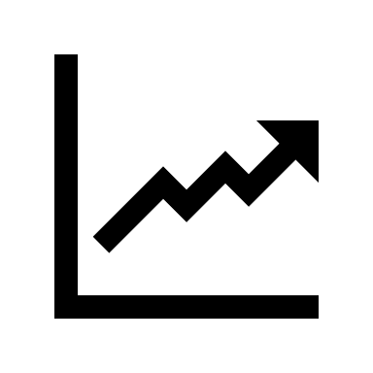

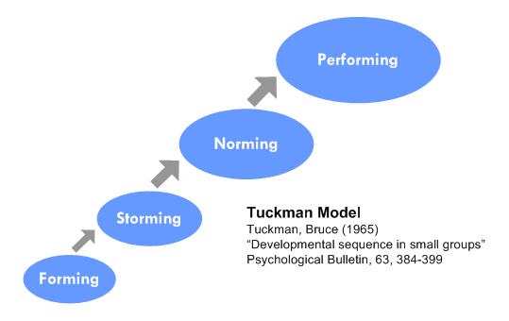
This Photo by Unknown Author is licensed under CC BY-NC-ND

TUCKMAN ‘S TEAM DEVELOPMENT.

As JOHN MAAXWELL SAYS
‘THE TEAM WORKING DREAM WORK’.

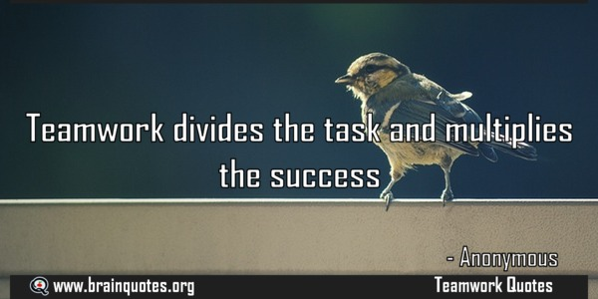
This Photo by Unknown Author is licensed under CC BY

 ‘
This Photo by Unknown Author is licensed under CC BY-SA

FORMING

It is the stage where the foundation is built that will determine how solid the team has just been formed

It is the stage where the foundation is built that will determine how solid the team has just been formed

Bibliography

Smith, M., & Bruce, W. (2014). Tuckman: Forming, storming, norming and performing in groups. Retrieved 11 7, 2019, from http://profiles.wizfolio.com/robertalt/publications/36169/216541

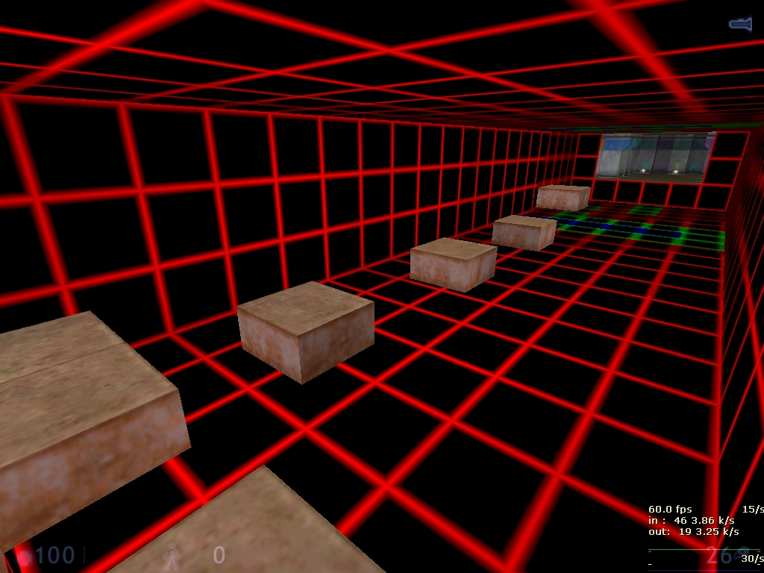
This Photo by Unknown Author is licensed under CC BY-SA

It is the stage where the foundation is built that will determine how solid the team has just been formed

On the labour market there are several models of team evelopment, but the most used system is the one introduced by BRUCE TUCKMAN 1965. model still perfectly viable today.

Tuckman talks about a 4-step 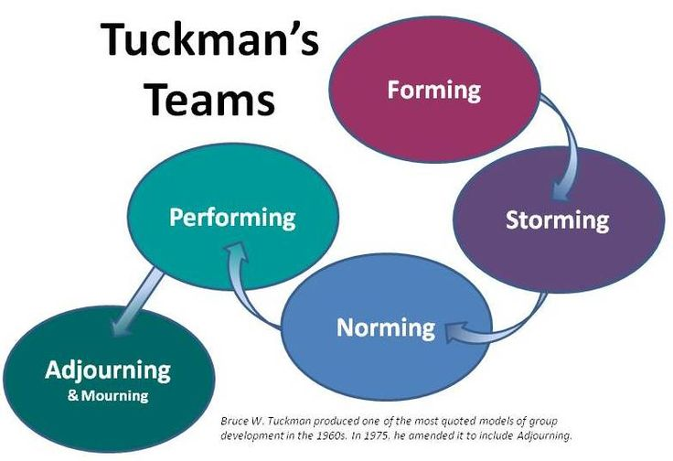system FORMING STORMING NORMING PERFORMING

It is the stage where the foundation is built that will determine how solid the team has just been formed.

Bibliography
Smith, M., & Bruce, W. (2014). Tuckman: Forming, storming, norming and performing in groups. Retrieved 11 7, 2019, from http://profiles.wizfolio.com/robertalt/publications/36169/216541

Although the names are suggestive, they need to be written line by

line to explain what exactly happens in each phase.

FORMING

At this stage the members are positive politicians some are scared anxious do not understand what is happening or what will be the role of each. At this stage people begin to know each other but make independent decisions without having common goals.

It is a team formation stage. It is a stage in which the leader has the most important role. He must give the team a direction a vision to answer many questions to be prepared for all the tests that he will be subjected to. This is the time when the members of the independent team will test the tolerance of the leader and the system and will try to figure out whether or not they can integrate into the fit is the stage where the foundation is built that will determine how solid the team has just been formed. It is the stage where the foundation is built that will determine how solid the team has just been formed.

STORMING

Often stars where there is a conflict between team members natural working natural. If the first stage be being a test for the LEADER. In the second stage it is surely the stage with the biggest failures for the whole team. This stage in my opinion remains a threshold at which many of the team companies remain blocked. In the usual language, this stage is called "clash of personality”. Unfortunately, at this stage, each member tries to impose himself and does not give back from direct confrontations. Storming is the second stage where many of them crash or self-eliminate. Now is the time when the group or team leader does not let things go, which could very easily escape control.

NORMING

It is a normative stage now in this stage the rules of working method of the value system begin to stabilize. Gradually the team moves into the norming stage begin to know and gain trust with each other. It is a stage where the leader can rely on the team. Work in the team begins to bear fruit team members exchange information. AND ALL THERE IS A DANGER that should not be neglected. If there are very strict rules and the team members are not actively involved in making the decisions that the team may have to suffer. In the case of rules violated too easily, the team is in danger and the team will suffer. In both situations the leader must take the action. In the case of rules violated too easily, the team is in danger and the team will suffer. In both situations the leader must take action to maintain balance.

PERFORMING

IT is one of the stages in which only the good ones arrive. A welded team will reach the stage where they can handle it without the leader needing to be there. Usually at this level the leader almost helps people on a different level of personal coaching development. It is the maximum point a team can reach. A truly welded team will not be able to tell you; stop I finish the job I go home, we all want a story. A story that never ends.

REFERENCE.

WWW.bussinessballs.com/team_managment/tuckman/

www.free_managment _e books.com/development.

www.toolshero.com/managment/tuckman stage of group BibliographyBibliography

Smith, M., & Bruce, W. (2014). Tuckman: Forming, storming, norming and performing in groups. Retrieved 11 7, 2019, from http://profiles.wizfolio.com/robertalt/publications/36169/216541

KEEPTHINKINGBIG.COM/WHAT _MAKES A WIMMING _TEAM.

Smith, M., & Bruce, W. (2014). Tuckman: Forming, storming, norming and performing in groups. Retrieved 11 7, 2019, from http://profiles.wizfolio.com/robertalt/publications/36169/216541.
This Photo by Unknown Author is licensed under CC BY-SA

