BA International Hotel Management
Hotel Placement Research Project
Student Name: Karolina Szmigiel
Student ID:2108830
Lecturer: Ben Ka Po Chong

I confirm that I have not used any AI tools in the research and creation of this assignment. I confirm that I have not presented any AI generated materials as my own work. I confirm I have copies of my drafts, notes, and other resources I used, which I may be asked to provide in evidence

Abstract
The following research project through a case study has examined the proposed challenges faced by Best Western Eastbourne Hotel while improving housekeeping with the help of incorporated technology. This organisation in order to maintain productive performance during the hotel placement considered its critical department housekeeping which directly affects the operation and revenue of the hotel. The case study has included SWOT analysis, PEST analysis, competitor analysis and McKinsey 7S Model to understand the affecting factors and to improve its guest experience. This portion of the task has tried to shed light on the hotel industry and the implementation of technology in the housekeeping department. Technology plays important role in attracting customers. This portion of the task has tried to showcase that aspect bu highlighting issues related to it. This includes security thef, lack of knowledge and many others. Moreover, strategies to mitigate challenges has also been included to understand the functions of technology properly. Finally, based on the above discussion and analysis, the study has suggested some key areas and strategies which can be adopted by the hostel business to mitigate its challenge. In the suggestion, technological factors, employee motivation and skill development has been considered to improve the overall performance of the business.

Table of Contents
Introduction 5
Research Background 5
Aim and Objectives 5
Literature Review 7
Identification of the different types of technologies that are used by the housekeeping department in the hotels. 7
Analysis of the technology-oriented challenges that employees are facing towards working experience in the housekeeping department 8
Evaluation of the strategies through which challenges can be mitigated while improving the employees’ productivity within the business 9
Literature Gap 10
Method 11
Case Study of the Research Project 13
Overview of the Hotel 13
Analysis of the company 13
SWOT analysis 13
PEST analysis 15
COMPETITOR analysis 17
McKinsey 7S Model 18
Theme Exploration 20
Theme 1: Popular Technologies being used in Hospitality Industry 20
Theme 2: Contemporary Technological Strands towards the Housekeeping Departments 23
Theme 3: Lack of Skills among the Employees to handle real-time Technologies 24
Theme 4: Lack of Data security During the use of Technology 25
Theme 5: Challenges with the Streamlined Shift Handovers 26
Theme 6: Significance of the Job Traning for Improved Performance 28
Theme 7: Strict Company Guidelines on the Management of Employee Performance 29
Theme 8: Implementation of Robust Shift Management Software 31
Theme 9: Bringing Inclusivity and Diversity in the Workplace 32
Conclusion 34
Recommendations 35
Reflection 37
References 41
Appendices 46
Appendix – 1 46

Introduction

Research Background
The practical learning experience that a candidate is exposed to plays a major role in the development and learning process. While it adds to the learning experience, different challenges in the workplace environment impact the ways in which the candidates perceive the business process. The inclusion of technology in the housekeeping department of the hotels has made it more complicated for the employees to manage and control their business processes. Further, the different contemporary issues have made it difficult for businesses to maintain their business operations and improve their overall efficiency to work in the organisation. The growth of tourism and the expansion of the hotel industry have been at their peak and this allows to reflect on the understanding of the need for skill development. This research thus will elaborate on the understanding of the different areas where the employees are facing issues. It will further elaborate on the different strategies that can be introduced to meet the needs of the employees and improve their overall performance while working in the housekeeping department.

Aim and Objectives
Aim
To investigate the contemporary issues and solutions related to technology the housekeeping department faces: A Case study of Best Western Hotel Eastbourne UK.
Objectives
i. To identify the different types of technologies that are used by the housekeeping department in hotels like Best Western Hotel Eastbourne UK.
ii. To analyse the different types of challenges that the employees are facing during their working experience in the housekeeping department at Best Western Hotel Eastbourne UK.
iii. To evaluate how the challenges that are faced by the candidates can be mitigated and the productivity of the employees can be improved in the business.

Literature Review

Identification of the different types of technologies that are used by the housekeeping department in the hotels.
According to Veal, (2006), the housekeeping department of the hotels is responsible for managing all sorts of hotel maintenance, and cleanliness including guest rooms, immediate surroundings, staff areas and many others. The housekeeping department is involved in various roles including changing sheets, cleaning bathrooms and many more. While doing the workplace-related work, the housekeeping department used various sorts of technologies all of which are explained in the below section.
UV cleaning technology
As directed by Molina-Castillo et al., (2023), UV light technology is a type of electromagnetic radiation which is used by the housekeeping department of the hotels for various purposes, as UV light can act as a germicide. Additionally, the housekeeping department uses this technology to clean the room entirely so that, guests can feel comfortable while entering the hotel rooms for their purposes.
Biodegradable laundry detergent
Biodegradable detergent is another sustainable discovery through which companies can be able to minimise the chances of pollution while lowering the harmfulness towards the ecosystems. As they are made up of biodegradable ingredients, therefore can break down naturally in the environment. Through this technological intervention, companies decrease water pollution and carbon footprints
Recycled-paper towels
Paper towels are considered recycled materials through which companies promote deforestation. Many companies in the UK have used recycled paper towels to maintain sustainability within their business premises. This technology supports the principles of the economy while reducing landfill waste and thereby conserving nature.
Air-purifier technology
Air-purifier technology is one of the greatest discoveries ever which is often used by the housekeepers of the hotel industry. This includes HEPA filters through which all of the pollutants from the air can be demolished and purify the air to safeguard the earth while attracting environment-concerned customers.

Analysis of the technology-oriented challenges that employees are facing towards working experience in the housekeeping department
Hotel industries are facing severe challenges while integrating technological advancement into the business operation. All of the issues are pointed out below.
Challenges related to adaptation of new technology
As opined by Francom, (2020), after the invention of the technological aspects of the business, various hotel companies have tried to upgrade their business quality by adapting technological advancement to upskill their service capabilities for performing business-related tasks. Nowadays, commercial cleaning robots are rapidly increasing in numbers as through this process housekeeping departments can save their additional efforts and time in a meaningful manner. However, many housekeepers have less idea about the usage of robotics technology in the business which might slow down the business operation of the hospitality industries negatively.
Security Theft
As per Reijers, (2021), security challenges are regarded as the prime challenges that are faced by hospitality industries after introducing technology advancement towards their business operations. Cybercriminals target hacking companies’ websites to track their data. Especially, housekeeping departments do feel not safe sharing their personal information with the companies due to the fear of privacy disruption. Employees in the hotel sector nowadays have faced this issue while tracking the performances of business operations. Due to this reason, employees face labour shortages within the hotel premises. Cybercrimes including phishing, malware and many others are hampering the business functions of the hotel industry which can lower the chances of business growth.
Lack of knowledge
After the pandemic, various hotel industries in the UK have incorporated digitalised technology so that they can operate their business smoothly and effectively without facing difficulties. Lack of digital literacy as well as lack of knowledge among employees may hinder business operations negatively. In this scenario, the housekeeping department cannot perform technological tasks with an effective approach. Thus disrupting the business functions.
Reputation related challenges
As directed by Binesh and Baloglu, (2023), brand reputation is one of the priorities that are maintained by the companies to maintain their popularity across the world while handling competitive advantages. However, negative feedback from the clients towards the business can be a huge issues that are facing by employees in recent times. For instance, if companies conduct online feedback from customers and get negative reviews based on their technical issues like lack of internet management, lack of proper technology in guest rooms like smart switches and many others can hamper the company’s career negatively. Henceforth, reputation-based challenges can create risks for the company after hampering its technological breaches.

Evaluation of the strategies through which challenges can be mitigated while improving the employees’ productivity within the business
Technology plays an important role in improving the texture of the business in terms of modernisation. Various strategies must be adopted by hotel industries to mitigate technology-related challenges which are explained in the below section
Training and development
As per Stringam and Gerdes, (2021), training and development is one of the crucial strategies that must be followed by the hotel sector while incorporating digital technology. Through employee training, companies can boost their productivity level and satisfy customers towards their business. Digital literacy is the first and foremost thing that should be present among employees so that they can perform their tasks with effective knowledge about the field.
Accessibility of Internet towards guests
The first thing that guests prefer whenever they visit the hotel is the accessibility of the internet so that they can connect with the world easily. Companies must provide and update a network through which the internet will be accessible for the hotel premises and guests can enjoy their time effectively (Cobanoglu et al., 2021). Apart from that, through internet accessibility, many customers can connect with their families, friends and others thereby increasing the morale standard of the business in front of society.
Monitoring data privacy
Data privacy must be a significant concern of companies as various cybercrimes can steal the personal data of the company. Customers who face security issues might not choose the same hotel companies again in the future. Therefore, to mitigate the privacy-related challenges, companies should monitor their systems. The HR department of hotel companies must teach their employees to monitor the software effectively so that they can easily track any bug or security-related issues.

Literature Gap
This portion of the assignment has tried to find effective ideas and information related to technological inventions towards the hotel industry. However, various journals, as well as articles, did not explain the outline of technology-related issues that are faced by the hotel industry well. Therefore, it can be denoted as the literature gap in this task assignment.

Method
Overview of case study methods
The case study method is normally categorised as the type of data collection, which goes in depth of the understanding rather than breadth. Case studies also counted as the qualitative design, that the researcher explores in a detailed manner through conducting one or more activities. Case study methods also reflect a research strategy rather than only a method or technique as well as a process of data collection (Saunders et al., 2012). The case study method is also responsible for conducting observation, experiments, structured interviews, questionnaires and relevant documentary analysis. Case study analysis within a positivistic paradigm is also subsequently guided by the tenets of a quantitative methodology in research.
Benefits of the case study method
The case study method holds a wide range of advantages for the researcher and the readers after presenting in a justified manner. The prime advantage of the case study method is the ability to see a relationship between the phenomena, context and people. It also introduces major flexibility for collecting the data through various means, which on a further note, helps in engaging the research topics and materials in a rational manner (Walton et al., 2020). Apart from these, the benefit of the case study method is the creation of the ability to capture the actual context and simultaneously live the reality of participants. The introduced flexibility needs to be used at a wide range of points within the research project, including the pilot research initiative.
Limitation of case study method
Besides holding flexibility as a prime benefit of the case study method, it also holds some limitations within the research project. The major disadvantage of case study methods is that the results of case study can be highly difficult to replicate for further research. Major researchers can also allow their own feelings to influence the case study method (Thomas, 2021). The researcher bias is also categorised as the potential limitation of the case study method within the accomplishment of a research project. Finally, the case study method can also lack important scientific methods and rigour for protecting the accuracy of the collected data. As for these initiatives, the case study method holds a wide range of limitations for the researchers.
Techniques of case study method
For the purpose of conducting a case study, the researcher can utilise a wide range of techniques like observation, interviews, and major usage of the secondary data as documents along with records (Saunders et al., 2012). These techniques have been used in a smooth manner to extract a better outcome from the research project to explore the topic of research more deeply.
Overview of other key techniques
Besides the preliminary techniques of the case study method, collective case reports, data analysis activities, exploratory statements and data collection tools are also categorised as the techniques of the case study method (Walton et al., 2020). On the contrary, the utilisation of critical instances and issues of validity and reliability activities are also categorised as key techniques of the case study method.

Case Study of the Research Project

Overview of the Hotel
The BEST Western Hotel is the largest hotel industry and is situated in Eastbourne, United Kingdom. The location of the hotel is situated near the sea, thus attracting tourists first. Additionally, the hotel sector provides various facilities towards its guests. The hotel sector offers bounces as well as discounts towards their prices at occasional times to get the attraction of customers. From a technological perspective, the company provides various smart technological features including digital television, satellite television, hairdryer, direct dial telephone, ironing board, washroom amenities and many others (bestwestern.co.uk, 2024). Besides that, the company provides high-speed internet accessibility towards their visitors so that customers can connect with the world smoothly and effectively. The company also follows sustainable business operations to safeguard the earth while meeting its business requirements accordingly.

Analysis of the company
This is very crucial for a 3-star hotel like Best Western Hotel Eastbourne to look into its affecting factors including both internal and external aspects. The integration of advanced digital technologies and equipment in the service sector has significantly affected the housekeeping departments. Therefore, the organisation needs to use different analysis methods to examine the affecting factors. For example, through SWOT, PEST, McKinsey 7S Model and Competitor analysis, the organisation will aim to investigate the issues while implementing technologies in the housekeeping process (Thalita et al., 2023).

SWOT analysis
Strengths: The company, to provide the best housekeeping is incorporating advanced technologies in their every possible service to meet their customer's needs and demands. For this Best Western Hotel has invested in different digital equipment and gadgets, for example, digital check-in and check-out and AI-powered room assistance. Further, to increase its reach in the tourism sector and improve its housekeeping the company use a global delivery model, and real-time data analytics and has streamlined its revenue management. With a strong technological foundation, the company aims to mitigate contemporary issues related to technology and improve the housekeeping department (Boitrelle et al., 2021).
Weaknesses: The company has strategically invested in technology to improve its housekeeping issues, however, there remain critical gaps which need to be addressed at the earliest. This will help the company to handle the problems of housekeeping and will help in sustainable growth. This service business entity lacks in providing housekeeping-specific technologies and is incompetent in utilising the latest technologies like walkie-talkies. Further, the company to date used a manual method for handling the room allocation process which is hectic and causes delays in tracking the real-time updates and operations. Additionally, the hotel might not be extensively using data analytics and might have been using outdated cleaning products. The organisation must not ignore the efficiency of technology. Not providing adequate training to its staff might be the reason to remain a 3-star hotel at the current time.
Opportunities: The early addressing of the weaknesses provides the hotel with a lot of opportunities to improve its housekeeping departments and mitigate technological problems. For example, the company can implement mobile technologies and invest in housekeeping-specific requirements to have a real-time update on customers, operations and employees. Further, investigating the issues will bring business opportunities for Best Western Hotel Eastbourne and ultimately help the company improve its housekeeping services. Further, with the help of enhanced and effective housekeeping, the company will be able to provide a better guest experience and increase profit (Wells, 2023).
Threats: The implementation of advanced technologies to improve the housekeeping department should be carefully handled to navigate the predicted threats and remain prepared for uncertainties. For example, the company should focus on the affecting factors that can slow down the service of housekeeping departments even after the incorporation of advanced technologies. This includes staff shortage, equipment failure, rapid advancement, economic constraints, natural disasters, cyber security threats and changing customer behaviour.
Identifying strengths and weaknesses in the service sector is important for a 3-star hotel, for example, having comfortable rooms, friendly staff and a central location is its strength. However, the existing weaknesses like limited amenities, and lack of a fitness centre and other house-keeping specific technologies are the affecting factors which might degrade the service quality. The organisation should invest strategically in the identified areas to grow in the tourism sector and Eastbourne (Pennington, 2022).

PEST analysis
The service organisation, Best Western Hotel Eastbourne, should conduct a PEST analysis to examine the external factors which might be affecting the housekeeping department.
Political factors
Political factors can affect the hotel industry from various perspectives. Various government policies can hamper the business operation of the hotel sector (Epsilon, 2024). Policies related to travel bans are one of the major issues that might be faced by companies like BEST Western Hotel that can disrupt the operational efficiency of the hotel companies. Besides that, taxation in various hotel businesses impacts the entire profit. The UK government currently focuses on reforming the tax which can be fruitful for the hotel sector to save additional money. Apart from that, elections may hamper business operations often and many visitors may not feel safe to visit to new areas during election time. Henceforth, BEST Western Hotel can be affected by those political aspects negatively.
Economic factors
The rate of inflation in the United Kingdom decreased in 2024 and reached 2.3% which was high in 2023 (commonslibrary.parliament.uk, 2024). Lower inflation indicates economic stability. The hotel sector named BEST Western Hotel can make its business operation effective by incorporating strategic initiatives based on pricing strategies. Besides that, the conversion rate as well as foreign currency in the United Kingdom is in a stable position. The more people will be attracted to the hotel sector, the higher the foreign currency will be. This hotel has many branches worldwide and currently, the hotel offers job opportunities to increase the size of their employees to upgrade their job performance. Through this scenario, the company can increase its profitability aspect in the future while uplifting its morale standard within society.
Social: The socio-cultural factors are the potential factors that affect the housekeeping department in the hotel industry. Through analysing the sociocultural factors, a company aims to analyse the change in the population's age which can affect their target market, and it analyses generational shift. For example, in the year 2017-2020, customers are highly influenced by influencers and social media campaigns. What social trends and taboos hold the potential to affect the operations and revenue of hotels? The social factors which might affect the incorporation of technologies in the housekeeping department are demographic trends, different lifestyle and cultural trends (CFI, 2024). More or less a hotel in the service industry can be potentially affected by the difference between actual and expected demographics target market, this includes customer base also. Further, the rapidly changing lifestyle, increasing awareness of sustainable tourism and expectation of having a better experience also impact the existing housekeeping departments. Following the trends has become the most important thing in the current tourism industry and keeping this in consideration is important as this makes customers feel connected (Fairlie, 2024).
Technological: Competitors with advanced technologies are the leaders in the service industry because, with their efficient technologies, they provide the best housekeeping experience. The hotel at Eastbourne, to mitigate the contemporary issues related to the housekeeping department regarding technologies, must invest and provide training for solving the issues. The company can use AI-integrated chatbots, send them personalised recommendations and provide their customer with the facility of automation tools for repetitive tasks. Further, the organisation should use environment-friendly technologies to attract conscience customers and let them have the best experience of housekeeping while staying at the hotel.

COMPETITOR analysis
Competitor analysis is a process through which the tourism business Best Western Hotel at Eastbourne can identify its competitors and analyse different strategies used by different companies. Through this, a company is able to identify its internal strengths and weaknesses compared to rivals. The competitor analysis might help the hotel achieve its aim of maintaining productivity and performance during hotel placement with the help of valuable market insights (CFI, 2024).
Helps in identifying strengths and weaknesses: This analysis helps the business to identify the areas of strengths and weaknesses and how the competitors perceive the strategies of Best Western Hotel at Eastbourne. Having knowledge about the strengths and weaknesses the company can develop strategies and invest in technologies to present themselves as unique which will help them in capitalising on their USPs (mckinsey., 2008).
Understanding market trends: The organisation while identifying the competitors, helps in looking over the factors which were not addressed earlier to remain competitive in the market. Further, the proper analysis of the affecting factors will let the business set different pricing, offer exclusive services and also help in staying ahead of the market trends to make strategies accordingly. Further, this helps the company to develop strategies according to the gap which lets the business lead from their business rivals (Fairlie, 2023).
Improve service quality: The examination of different approaches used to provide the best services to the customers in the hotel industry by using competitor analysis helps the business improve its service equality. This happens because organisations in the services industry can analyse the difference by using advanced technologies which also helps them avoid duplicating the competitors’s process. Further, the business entity can leverage technology and make plans according to their customer needs for creating value in the provided services.
Optimise pricing: The market analysis through this method helps Best Western Hotel to set benchmarks and manage pricing differentiating them according to the services provided by their housekeeping departments. Further, by analysing the competitors pricing the company can analyse whether their pricing is accurate or not to attract and retain customers (White, 2024).

McKinsey 7S Model
McKinsey 7S Model is a potential tool that might be used by the hotel to analyse the organisation design by interacting 7 key elements. These are structure, strategy, skill, system, shared values, style, and staff.
Structure: The model S represents structure and encompasses organisational structure, job description and performance metrics. Through this company can choose a suitable organisational structure to make clear lines of communication and information flow without any disruption in the operations. Further, the company can check assignments through job descriptions and measure their employee performance to improve housekeeping practices (CFI, 2024).
Strategy: Strategy includes strategies like implementing appropriate cost leadership, helping to set a unique place in the market and increasing the business focus on the specific target market. This includes a business plan with formulated planning which further helps the organisation in a sustainable competitive advantage.
Skill: Skills cover a wide range like employability skills, leadership skills and communication skills which improve the capabilities and competencies of the company. This will enable the employees of Hotel at Eastbourne to achieve their collective goals by implementing skills in housekeeping and business operations (ASANA, 2024).
System: A business through 7s of McKinsey’s helps the business improve its technical infrastructure which further helps in maintaining workflow at the workplace and outlines a chain of decision-making.
Shared Values: Through implementing the 7s, the company aims to share a common effort to achieve the mission, aims, objectives and values by strengthening the foundation of the organisation (mckinsey., 2008).
Style: Maintaining a code of conduct is very important for any organisation, this is achieved by following the positive attitude of seniors and leaders. This includes leadership style followed within an organisation, cultural aspects and potential employees a company holds (Newton, 2024).
Staff: Through this the service organisation can aim to achieve maximum potential employees for the company by analysing necessary employability skills, leadership skills, and communication skills. This includes training, a rewards system and recruiting of a peculiar business entity to make strategic planning for improving their productivity and operational efficiency (Zaluski, 2023).

Theme Exploration

Theme 1: Popular Technologies being used in Hospitality Industry
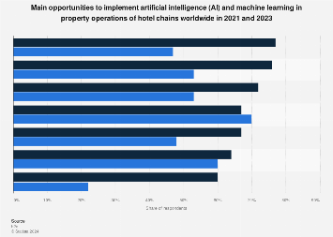
Figure 1: AI/Machine Learning Opportunities in Operations of the Property of Hotel
Source: (Statista, 2023)
The above bar chart generally shows that the global hospitality chains are effectively utilising the technological elements towards their business process. It also helps them to increase the productivity of their entire business process without any kinds of complications and also leads the hospitality businesses to fetch a high range of insights towards their business process. The above chart also depicts that around 77% of the hospitality sectors significantly utilise AI technologies towards their business process. It also assists them to utilise the predictive analytics tools towards the business process effectively. Around 30% of the hospitality businesses have utilised AI technologies to effectively monitor the rate of waste, water and energy (Statista, 2024). Therefore, the utilisation of AI generally helps businesses to increase the efficiency of the business operations of the hospitality sector.
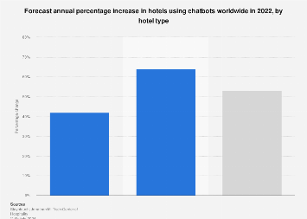
Figure 2: Utilisation Rate of Chatbots in Hospitality Industry
Source: (Statista, 2023)
Chatbots are generally considered the most effective automation tools towards the hospitality sector which also assists them in solving the queries of their customers quickly. It also increases the engagement rate of the customers towards the particular business process without any kinds of complications. The above chart shows that around 53% of the businesses in the hospitality sector have generally implemented chatbots towards their business process in the year 2022. The utilisation related to this specific technology was anticipated to enhance by around 42% towards the branded hotels and around 64% towards the independent hotels (Statista, 2024). The utilisation of the chatbots really helps them to clear all queries of their customers with a lot of efficiency.
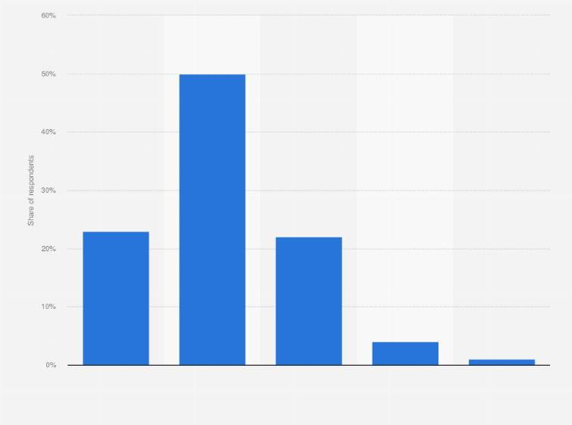
Figure 3: Importance of data analytics to travel and hospitality companies Worldwide 2020
Source: (Statista, 2023)
The above bar chart specifically depicts that in the year 2020, a wide range of executives towards the global travel and hospitality sector utilised the data analytics tools towards their business process. The data analytics tools also help businesses to analyse whether their business process is smoothly running or not. In addition, it also helps them to gather relevant data about the needs and wants of the customers which also leads them to create great awareness related to the entire business process towards the hospitality market. The above bar chart also depicts that around 50% of hospitality businesses have utilised customer data analytics tools as it generally helps them to easily bring amendments towards their business process (Statista, 2024). It also can help them to increase the efficiency of their business process effectively.

Theme 2: Contemporary Technological Strands towards the Housekeeping Departments
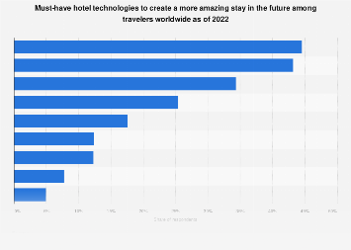
Figure 4: Popular Hotel Technologies to Impress the Global Consumer
Source: (Statista, 2023)
The above graph chart also shows the elements related to the hotel technologies that have been continuously utilised for a long decade. The above graph also shows that around 45% of the hotels are utilising a wide range of emerging technologies towards their entire business process effectively. Most businesses now utilise the chatbots towards their business process to provide a wide range of effective services towards their customers that will also allow them to generate a large customer segment towards their entire business module with a lot of significant elements. It also leads businesses to increase the overall growth rate of their entire business process effectively. Most hospitality businesses generally utilise predictive analytics tools towards their business process to predict the overall market process that can easily engage the audience towards their entire business process without any kinds of complications. It also helps them to increase the efficiency of their entire business operations effectively (Statista, 2024). Most hotels use AI technologies towards their housekeeping elements effectively to produce a reliable and comfortable accommodation element for their customers.

Theme 3: Lack of Skills among the Employees to handle real-time Technologies
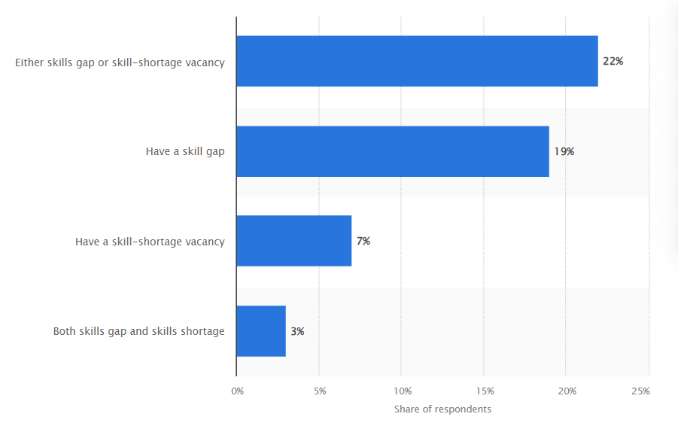
Figure 5: Proportion of employers experiencing a skills gap or skills shortage in the hotel and restaurant sector in the United Kingdom (UK) in 2017*
Source: (statista, 2023)
The hospitality sector has been largely driven by the use of technology in the economy although there has been a lack of skilled labour in the economy. The businesses have been faced with a shortage of skilled labour in the economy which has made it difficult for the business to regulate their business operations. The complex technology that is used in the hospitality industry has limited the productivity of the employees in their job roles. Research states that 22 per cent of the hotels have been experienced with the skills gap and half a skill-shortage vacancy (statista, 2023). This has made it difficult for businesses to maintain their business efficiency and has limited employee productivity. A large number of employees are unable to utilise the different technologies and tools which has led to delays and disruption in the business process. Research has concluded that a majority of the employees who have years of experience in the hospitality sector have almost reached their retirement age. The other employees who are still working in the industry are reluctant to work with the use of different technologies in the economy (Ciapponi, 2023). This has led to the hospitality businesses facing struggles with the integrated use of technology in business operations.

Theme 4: Lack of Data security During the use of Technology
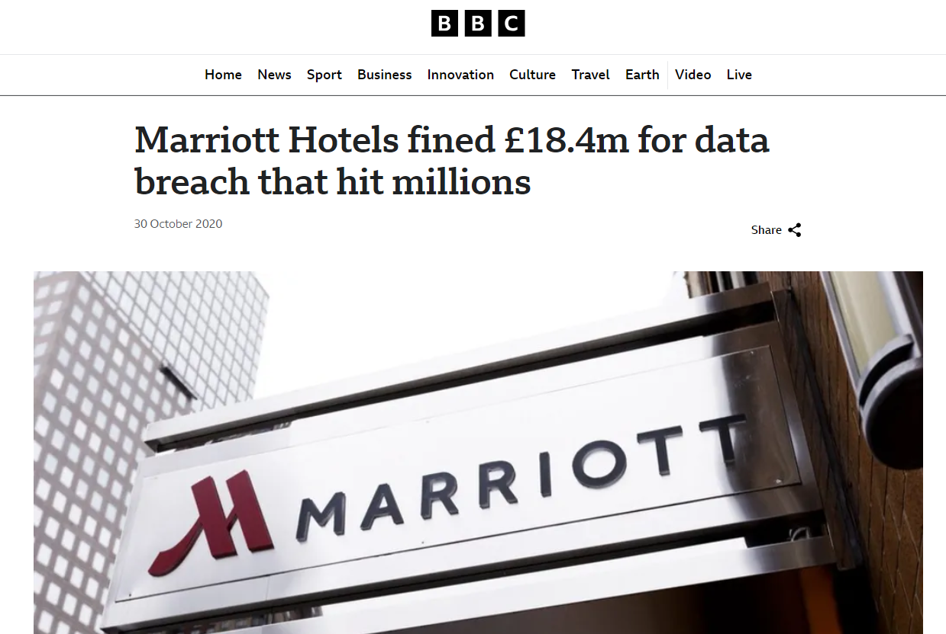
Figure 6: Marriott Hotels fined £18.4m for data breach that hit millions
Source: (bbc, 2020)
The hotel industry has been faced with the issues of data security with the use of technology which has led to struggles of the businesses to plan and manage the business process. The development of the business process is largely monitored and regulated by technologies. However, the struggles of POS intrusions, hacking of the cloud, data encryption issues, third-party vendor problems and mobile attacks and phishing has impacted the quality of the service that is offered to the customers. The hotel businesses have been faced with loss of data which has impacted the overall performance of the business. Brands like Mariott have been faced with data security issues which has led the brand into facing struggles with maintaining their customer service. This incident further impacted the overall performance of the brand and has impacted its reputation in the economy. This had a major impact on the brand as well since they had to pay a fine of £99.2m for the poor data security followed in the organisation (bbc, 2020). According to Mercan et al. (2020), other issues that have arisen in the hospitality sector are privacy issues as often there have been incidents where lack of security protocols have led to the abuse of the customers’ data. Violation of the surveillance footage and other such issues have largely impacted the overall performance of the business. These have led to a fall in the quality of the customer service limiting the potentiality of the business operations.

Theme 5: Challenges with the Streamlined Shift Handovers
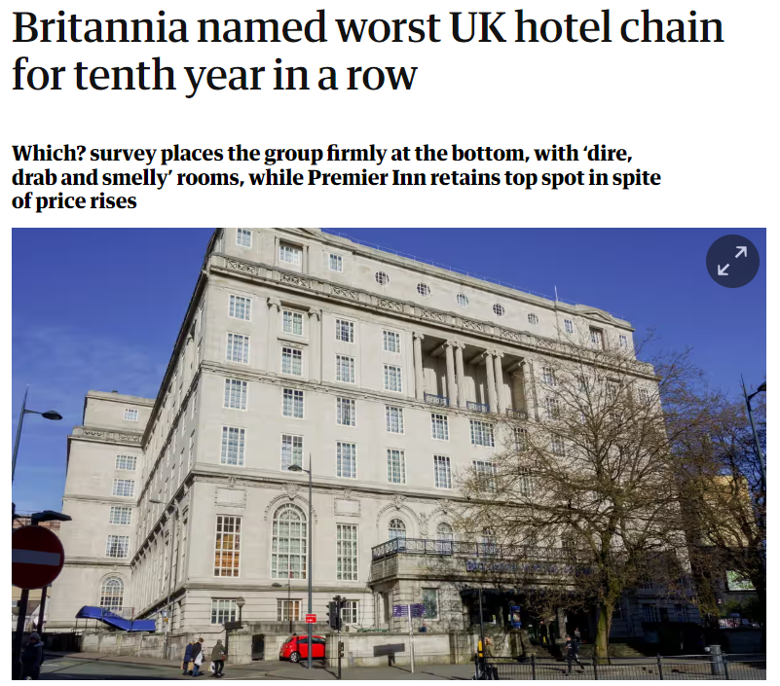
Figure 7: Britannia named worst UK hotel chain for tenth year in a row
Source: (theguardian, 2022)
One of the major issues with the streamlined flow of work and shift handovers is the struggle with the employees not having enough skills to utilise the technology efficiently. The employees fail to utilise the tools to improve the smooth transition of work between the employees working in different shifts. This has further led to an impact on the quality of service that is provided by the organisation. Due to unclear business processes, the employees faced issues with catering to the customer's needs and preferences. The employees take much longer to fulfil the customer’s requests and services that are ordered. These issues have further led to frustration among the employees in the organisation which impacts the quality of the service that is offered to the customers. The brand, Britannia Hotel has earned a negative image among the customers as the customers have over time complained about their poor customer service who failed to provide quality room service to the customers (theguardian, 2022).

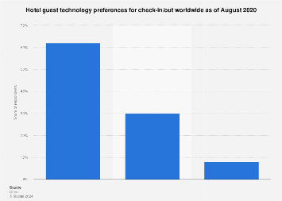
Figure 8: Global Hotel Check-in/out Tech Preferences Worldwide 2020
Source: (Statista, 2023)
The check-in and check-out are the major operations related to the housekeeping elements that also help them to keep records about how many people enter the hotel and leave the hotel. Around 62% of hospitality businesses really preferred to utilise AI software towards their check-in and check-out processes. It simply means that when a customer leaves the room, it is automatically recorded towards their business software. It really helps them to analyse the overall check-out and check-in procedure effectively (Statista, 2024).

Theme 6: Significance of the Job Traning for Improved Performance
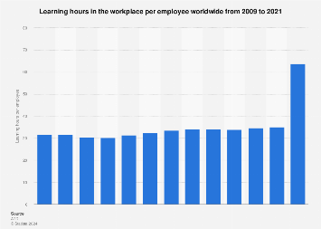

Figure 9: Learning Hours in the Workplace per Workforce Worldwide 2009 - 2021
Source: (Statista, 2023)
The above graph generally shows that the learning hours utilised per workforce towards the business sectors across the world enhanced overall between the years 2009 and 2021. In the year 2021, workforces utilised around 64 hours towards learning and development towards the workplace. It also helps businesses to increase the overall quality of their entire business process. The workforce generally gets a wide range of opportunities to improve their overall skills effectively which also helps them to gain potential and valuable business insights without any kinds of complications (Statista, 2024). The hospitality sectors have to implement an effective range of valuable training and development strategies towards their business operations. It may help them to create a wide range of potential benefits for their entire business process.

Theme 7: Strict Company Guidelines on the Management of Employee Performance
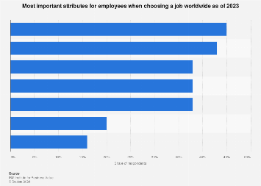
Figure 10: Leading job satisfaction factors globally 2023
Source: (Statista, 2023)
The above bar chart also depicts that around 45% of the workforce generally choose their job options by elaborating the overall regulations of the business workplace of the hospitality sectors. Therefore, the business executives of the hospitality sector have to implement a wide range of effective schedules towards their business process. It can effectively engage a wide range of people to do jobs towards the hospitality sector (Statista, 2024). The rules and regulations effectively provide a wide range of values towards the workplace.

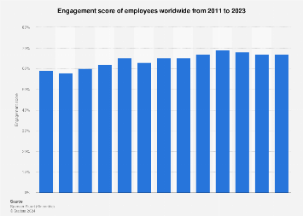
Figure 11: Engagement of employees globally 2011-2023
Source: (Statista, 2023)
The above bar chart also shows that employee engagement across the world enhanced between the years 2011 and 2020, however, it dropped slightly in the next few years. It also stood at around 67% between the years 2022 and 2023. The above report also shows that this employee engagement rate has increased to 69% in the year 2020 (Statista, 2024). Therefore, a wide range of workplace policies helps businesses to increase their workforce engagement rate effectively.

Theme 8: Implementation of Robust Shift Management Software
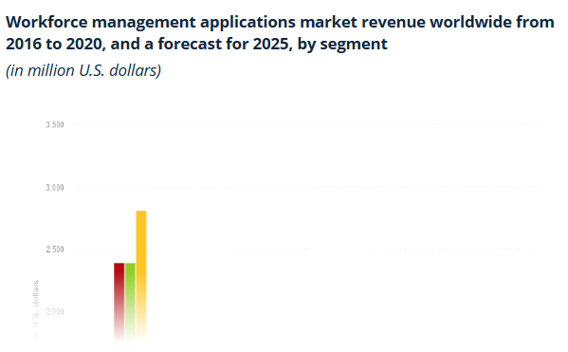
Figure 12: Workforce management applications market revenue worldwide
(Source: Statista, 2023)
Shift Management software is very essential for managing the workforce within an organisation. With the emergence of a work environment, where companies prefers working in different schedules and shifts rather than working in a single shift. This can be understood in a better way with the data of Statista, which showcases that the market of workforce management applications is significantly growing. The data shows that in 2020, the market generated 2.4 billion US dollars which was a gain of 700 million US dollars between 2018 and 2020 (statista, 2023).
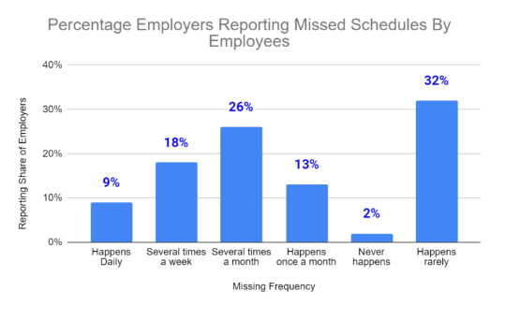
Figure 13: Percentage of Employers reporting Missed Schedules by employees
(Source: Prohance, 2024)
In addition, the data of Prohance suggests that a large percentage of employers report missed schedules by employees. The data shows the frequency is very high and around 9% happens daily, while 26% happens in a month (prohance, 2024). Thus, using shift management tools is very essential for businesses operating in the hospitality industry.

Theme 9: Bringing Inclusivity and Diversity in the Workplace
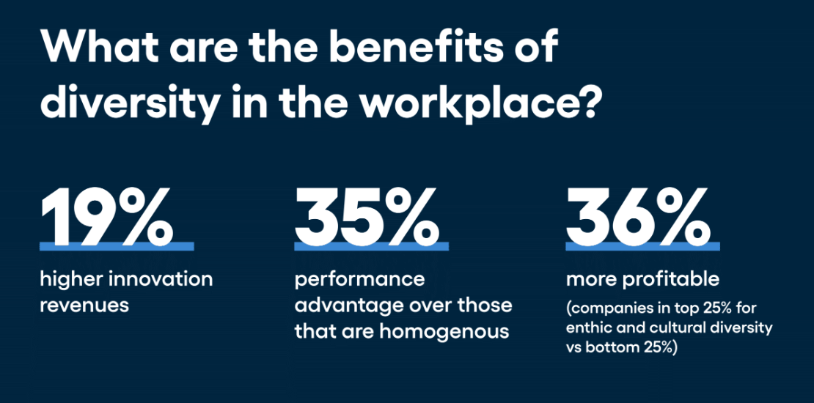
Figure 14: Benefits of diversity in the workplace
(Source: Heaslip, 2024)
Inclusivity and diversity are one of the most important aspects in the workplace which fosters sustainable development within the workforce. Even various data shows that there are bunch of benefits of bringing diversity and inclusivity to a workforce. The data suggests diversity increases 19% higher innovation revenue, while 35% higher performance along with 36% more profit in the business (Heaslip, 2024). Moreover, diversity in an organisation is also very useful in gaining new perspective which ensures long-term growth in a business. Therefore, businesses should try to foster inclusivity and diversity within their workforce in order to accelerate the pace of their business.

Conclusion
Summarising the above discussion, it has been observed that with a technological transformation, there are various new technologies and trends have emerged. With such technologies and trends, it is becoming critical for businesses to operate their business efficiently. Therefore, the study has explored various contemporary issues in the hospitality industry along with highlighting their possible solutions. In this regard, the study has incorporated the business practices of Best Western Hotel. The study has evaluated different types of technologies which are used by the housekeeping department of the hostel business. In this aspect, UV cleaning technology, Biodegradable laundry detergent and Air-purifier technology have been incorporated. The study has also analysed various technology-oriented challenges faced by the employees of the hotel business. In this context, challenges related to adaptation of new technology, security theft and lack of knowledge have been discussed. In addition to this, possible strategies to mitigate the challenges have also been suggested which can be considered by the business. Apart from that, the study has also involved a thematic analysis in which themes such as Lack of Skills, Lack of Data security, Challenges with the Streamlined Shift Handovers and Significance of Job training have been included.

Recommendations
Foster positive organisational culture and flexibility within the organisation
Organisational culture has a significant impact on the growth and success of a business. In addition, it also determines employee engagement and employee job satisfaction. A positive organisational culture significantly increases the motivation of employee as well as boosts their efficiency and productivity (Forbes, 2024). In this regard, flexibility in work dynamic is very important for employees which tends to provide them peace of mind and opportunities to maintain their personal and professional lives. Therefore, it is recommended that Best Western Hotel put efforts into fostering a positive organisational culture so that its employees can feel motivated and lively. This will certainly improve their efficiency and productivity at the same time will also enhance the overall performance of the hostel business. In addition to this, to provide flexibility to its employees, the business can also involve a hybrid working strategy which will help them manage their work-life balance.
Incorporate Employee training and Skill Development programme
From the above analysis, it has been observed that there are various new trends and technologies that are increasing day-to-day with the technological advancement in the industry. With emerging trends and technologies, it is becoming crucial for individuals to continuously improve themselves and possess themselves with future trends (Forbes, 2021). In this context, employee training and skill development programmes play a vital role. In daily operations, many businesses provide training and skill development opportunities to their employees to upskill them. This helps businesses upskill their employees at the same time increase their overall efficiency and productivity. Considering this aspect, it is suggested that the hotel business incorporate employee training and skill development programmes for its employees. This will help the business enhance its employees' skills and promote the overall performance of the organisation.
Involve new trends and technology
With the technological revolution, business dynamics have been constantly transforming. There are multiple new trends and technologies are emerging which are directly or indirectly affecting a business. It is becoming crucial for businesses they involve such trends and technologies so that they do not stay behind the world (mckinsey, 2022). Moreover, there are diverse technologies such as Artificial Intelligence and Automation which massively increase the efficiency of the organisation. Apart from that, the automation process makes the process seamless which assists businesses run their business hassle-free. Therefore, it is recommended that Best Western Hotel involves new trends and technologies in its business practices. This will make the performance of the business efficient as well as help its employees perform in a better way.
Develop a clear handover Process and prioritise handovers
When employees work in different shifts and schedules, it becomes very challenging in smoothly handovers. The challenge negatively impacts a business and affects the overall performance and workforce of a business. Thus, it is very critical for businesses to improve their handover procedures to manage their work efficiently. For this purpose, businesses develop clear handover procedures and provide proper instructions to their employees. In addition, the prioritising technique can also work in its favour in which businesses can prioritise their tasks and arrange them according to their importance. Therefore, it is recommended that the hotel business work on its handover process and develop a clear handover process. Moreover, the business can also prioritise its different tasks so that employees do not have to face many challenges.

Reflection
Housekeeping activities are a great task of responsibility, in which most of the employees attract customers to be engaged in habitual buying behaviour within the hospitality sector. Most of the responsible housekeepers also contribute to the development of brand awareness of the organisation undertaken by the hospitality industry. In this section, my actual experiences and realisations regarding the housekeeping activities within Best Western Hotel Eastbourne UK will be described appropriately (Knight et al., 2020). Being engaged in the business simulation of the mentioned company for a long time as housekeeping staff, I have gained a wide range of experiences in handling customers and controlling any kind of emergency situation. The customer base of this hotel within the hospitality, as well as tourism industry of the United Kingdom, is highly popular, which reflects a wide range of activities and management initiatives for the housekeeping employees. Primarily the activities and supervision of major professional people about our tasks have helped me in a justified manner to improve my personality and ability to conduct the housekeeping activities rationally. The initial period within this hotel to conduct the activities with a slight touch of professionalism became highly hectic and tough for me as I was unaware to understand the major international client handling activities. Therefore, with a slow and steady process along with the help of my supervisors and managers within this hotel, I have learned the major complex activities and simultaneously transformed my characteristic to be polite to address the customers calmly as well as politely. Best Western Hotel Eastbourne UK is normally popular in the hospitality market of the United Kingdom for its wider recognition in the guest attending initiatives along with high-level housekeeping aspects. Thus, during the active engagement within the hospitality business of the mentioned company I have gained the strict instructions along with a justified training session to work accordingly in my job role. With the several activities within the housekeeping job role, I have learned a wide range of things both the positive perspective as well as negative perspective which has also influenced me to face the reality and cruelty of modern society. During my job role, I have gained positive experiences that, feedback to the activities which has helped me rationally to gain an improved knowledge in the housekeeping activities (Brownlie, 2023). Therefore, continuous improvement within my job activities has also helped me a lot to finally reach a position where the managers and hotel authorities are happy with my activities and capabilities. Rapid development in the weak areas also helped me in a justified way to improve customer handling initiatives and significantly reflect enhanced customer satisfaction rates in Best Western Hotel Eastbourne UK. besides developing my activities and type of conducting the major tasks in the mentioned hotel, I have also increased my knowledge holdings in housekeeping works along with identifying the process, on which customers remain happy the most. Thus, aligning some changes in my personality, I have increased the customer retention rate of this hospitality organisation within the business environment. Throughout this improvement, the hotel authority has recognised my talent and simultaneously provided me with a lot of perks, benefits flexible job opportunities and other beneficiary initiatives. As for these initiatives, I have developed my personality and characteristics within the business atmosphere of the mentioned company and gained a wide range of recognition as well as achievements. Besides a lot of perks, beneficial activities and rewards I have also gained a wide range of employability skills within me to handle workplace problems and unnatural situations. Based on active collaboration within Best Western Hotel Eastbourne UK, I have enhanced my time-management skills, innovative skills, problem-solving skills and leadership skills. While conducting the individual job roles as per allocation and rules within proper timing I have gained impressive knowledge in time-management skills, which on a further note helped me to meet all the deadlines in a smooth manner (Knight et al., 2020). Major time-management capability is also categorised as a highly significant skill for the housekeeping staff like me which increases the customer satisfaction rate. Based on my effective communication skills I have also gained leadership skills from the job role in this hotel as after some months of working all the housekeeping staff became less aged and less experienced. This initiative has influenced me to help the interns and significantly build a leadership skill within my characteristics. Contextually, it is also notable that, major leadership activities also influenced me to gain a wide range of knowledge in problem-solving skills to handle the housekeeping staff and small misunderstandings among them. Besides these wider benefits, I also encountered several negative impacts within the job proceeding at Best Western Hotel Eastbourne UK. As I was performing at my best within the job role of housekeeping at the mentioned hotel considering my success and being a favourite to the higher authorities, some of my peer workers reflected their jealous behaviours and non-co-operative approaches. Due to this initiative, all the other housekeeping staff started to spread some illogical and totally unfair rumours about me. Further continuation of these activities has deprived me of feeling lonely and then got depressed for some time. As a result, my performance decreased from the top and I encountered a lot of misleading, scolding and job-losing threats from the higher management of the mentioned company. After some time, and in a slow manner I realised that other peer housekeeping staff were planning to remove me from this hotel as my performance was the best and I am the favourite of the management (Brownlie, 2023). Thus, I also became very stubborn to reflect on my previous personality and spirit of working which cannot be compared to the other interns as well as other housekeeping staff. As for these initiatives through conducting continuous hard work for some specific period, I have secured the top position again and rebuilt my confidence. Based on these initiatives as a housekeeping staff within Best Western Hotel UK, I have confronted many ups and downs, which finally helped me to create a suitable personality to conduct housekeeping activities in a justified manner.

References
ASANA, (2024). How to create a competitive analysis (with examples). [Online] Available at: https://asana.com/resources/competitive-analysis-example [Accessed 27 May 2024].
bbc, (2020). Marriott Hotels fined £18.4m for data breach that hit millions. [Online] Available at: https://www.bbc.com/news/technology-54748843 [Accessed 27 May 2024].
Boitrelle, F., Shah, R., Saleh, R., Henkel, R., Kandil, H., Chung, E., Vogiatzi, P., Zini, A., Arafa, M. and Agarwal, A., (2021). The sixth edition of the WHO manual for human semen analysis: a critical review and SWOT analysis. Life, 11(12), p.1368.
Brownlie, K. (2023). A penny for your thoughts: Promoting compassionate medical practice through reflection. Reflective Practice, 24(3), 389-399.
CFI, (2024). Broad Factor Analysis - PEST Factors Examples and Impacts. [Online] Available at: https://corporatefinanceinstitute.com/resources/management/broad-factors-analysis/ [Accessed 27 May 2024].
CFI, (2024). What is the McKinsey 7S Model?. [Online] Available at: https://corporatefinanceinstitute.com/resources/management/mckinsey-7s-model/ [Accessed 27 May 2024].
Ciapponi, D., (2023). The Skills Gap in the Hospitality Industry. [Online] Available at: https://www.hospitalitynet.org/opinion/4118000.html [Accessed 27 May 2024].
Fairlie, M., (2023). How to Do a Competitive Analysis. [Online] Available at: https://www.businessnewsdaily.com/15737-business-competitor-analysis.html [Accessed 27 May 2024].
Fairlie, M., (2024). What Is a PEST Analysis?. [Online] Available at: https://www.businessnewsdaily.com/5512-pest-analysis-definition-examples-template.html [Accessed 27 May 2024].
Forbes, (2021). 12 Ways To Implement Successful Employee Training Initiatives. [Online] Available at: https://www.forbes.com/sites/forbeshumanresourcescouncil/2021/07/13/12-ways-to-implement-successful-employee-training-initiatives/?sh=124477e84a8a [Accessed 28 May 2024].
Forbes, (2024). How To Build A Positive Workplace Culture. [Online] Available at: https://www.forbes.com/sites/ginnyhogan/2024/02/05/how-to-build-a-positive-workplace-culture/?sh=531dbfeb21a4 [Accessed 28 May 2024].
Heaslip, E., (2024). 6+ Powerful Benefits of Diversity in the Workplace. [Online] Available at: https://vervoe.com/benefits-of-diversity/ [Accessed 27 May 2024].
Knight, S., Shibani, A., Abel, S., Gibson, A., and Ryan, P. (2020). AcaWriter: A learning analytics tool for formative feedback on academic writing. Journal of Writing Research.
mckinsey, (2022). Tech at the edge: Trends reshaping the future of IT and business. [Online] Available at: https://www.mckinsey.com/capabilities/mckinsey-digital/our-insights/tech-at-the-edge-trends-reshaping-the-future-of-it-and-business [Accessed 28 May 2024].
mckinsey., (2008). Enduring Ideas: The 7-S Framework. [Online] Available at: https://www.mckinsey.com/capabilities/strategy-and-corporate-finance/our-insights/enduring-ideas-the-7-s-framework [Accessed 27 May 2024].
Mercan, S., Akkaya, K., Cain, L. and Thomas, J., (2020), November. Security, privacy and ethical concerns of IoT implementations in hospitality domain. In 2020 International Conferences on Internet of Things (iThings) and IEEE Green Computing and Communications (GreenCom) and IEEE Cyber, Physical and Social Computing (CPSCom) and IEEE Smart Data (SmartData) and IEEE Congress on Cybermatics (Cybermatics) (pp. 198-203). IEEE.
Newton, K., (2024). The Ultimate Guide to Competitor Analysis. [Online] Available at: https://www.brandwatch.com/blog/competitive-analysis/ [Accessed 27 May 2024].
Pennington, A., (2022). SWOT Analysis: The Most Overlooked Business Tool, And How To Use It. [Online] Available at: https://www.forbes.com/sites/forbesbusinesscouncil/2022/02/24/swot-analysis-the-most-overlooked-business-tool-and-how-to-use-it/?sh=18ce005b612a [Accessed 27 May 2024].
prohance, (2024). Shift Work Scheduling: Fundamentals, Challenges, and Benefits. [Online] Available at: https://www.prohance.net/blog/shift-work-scheduling-fundamentals-challenges-and-benefits/ [Accessed 27 May 2024].
Saunders, M., Lewis, P. and Thornhill, A. (2012) Research Methods for Business Students, FT/Prentice Hall: Harlow.
statista, (2023). Skills deficiency in the hospitality sector in the United Kingdom (UK) 2017. [Online] Available at: https://www.statista.com/statistics/899004/hospitality-sector-skill-shortage-and-skills-gap-united-kingdom-uk/ [Accessed 27 May 2024].
statista, (2023). Workforce management applications market revenue worldwide from 2016 to 2020, and a forecast for 2025, by segment. [Online] Available at: https://www.statista.com/statistics/727532/worldwide-workforce-management-applications-market-forecast/ [Accessed 27 May 2024].
Statista, (2024). Engagement score of employees worldwide from 2011 to 2023. [Online] Available at: https://www.statista.com/statistics/699977/global-employee-engagement/ [Accessed 27 May 2024].
Statista, (2024). Forecast annual percentage increase in hotels using chatbots worldwide in 2022, by hotel type. [Online] Available at: https://www.statista.com/statistics/1310836/forecast-annual-percentage-increase-hotels-using-chatbots-by-type-worldwide/ [Accessed 27 May 2024].
Statista, (2024). Hotel guest technology preferences for check-in/out worldwide as of August 2020. [Online] Available at: https://www.statista.com/statistics/1189903/hotel-check-in-out-tech-preferences-worldwide/ [Accessed 27 May 2024].
Statista, (2024). Importance level of customer data analytics to the success of travel and hospitality companies worldwide in 2020. [Online] Available at: https://www.statista.com/statistics/1249415/importance-of-data-analytics-to-travel-and-hospitality-companies-worldwide/ [Accessed 27 May 2024].
Statista, (2024). Learning hours in the workplace per employee worldwide from 2009 to 2021. [Online] Available at: https://www.statista.com/statistics/739741/learning-hours-used-per-employee/ [Accessed 27 May 2024].
Statista, (2024). Main opportunities to implement artificial intelligence (AI) and machine learning in property operations of hotel chains worldwide in 2021 and 2023. [Online] Available at: https://www.statista.com/statistics/1453892/ai-opportunities-hotel-property-operations-worldwide/#:~:text=Based%20on%20the%20survey%2C%2077,compared%20to%20the%202021%20study. [Accessed 28 May 2024].
Statista, (2024). Most important attributes for employees when choosing a job worldwide as of 2023. [Online] Available at: https://www.statista.com/statistics/1246966/job-satisfaction-factors-worldwide/ [Accessed 27 May 2024].
Statista, (2024). Must-have hotel technologies to create a more amazing stay in the future among travelers worldwide as of 2022. [Online] Available at: https://www.statista.com/statistics/1398120/must-have-hotel-technologies-guests-worldwide/ [Accessed 27 May 2024].
Thalita, D., Diva, A.F. and Mohammad, W., (2023). SWOT Analysis as a Strategic Foundation for Business Growth of De Buruan House–Food and Coffee Shop. Himeka: Journal of Interdisciplinary Social Sciences, 1(1), pp.39-47.
theguardian, (2022). Britannia named worst UK hotel chain for tenth year in a row. [Online] Available at: https://www.theguardian.com/travel/2022/nov/09/britannia-named-worst-uk-hotel-chain-for-tenth-year-in-a-row [Accessed 27 May 2024].
Thomas, G. (2021). How to do your case study. How to do your case study, 1-320.
Walton, J. B., Plano Clark, V. L., Foote, L. A., and Johnson, C. C. (2020). Navigating intersecting roads in a mixed methods case study: A dissertation journey. Journal of Mixed Methods Research, 14(4), 436-455.
Wells, R., (2023). How To Do A SWOT Analysis For Business And Career Growth In 2024. [Online] Available at: https://www.forbes.com/sites/rachelwells/2023/11/30/how-to-do-a-swot-analysis-in-2024-for-business-and-career-growth/?sh=506e9adf5c72 [Accessed 27 May 2024].
White, C., (2024). What is a Competitive Analysis — and How Do You Conduct One?. [Online] Available at: https://blog.hubspot.com/marketing/competitive-analysis-kit [Accessed 27 May 2024].
Zaluski, A., (2023). The complete guide to the McKinsey 7-S model. [Online] Available at: https://roadmunk.com/product-management-blog/mckinsey-7s-model/ [Accessed 27 May 2024].

Appendices

Appendix – 1

