Epigraphic evidence for religious affairs
from the colony Urso (Osuna), Baetica:
For abbreviations, see inscriptions handout Week 1.

No. 1 - CIL II⁵:
Apollini / Aug(usto) / Vibia Trophime / votum animo / libens solvit
No. 2 - CIL II⁵ 1024 = HEp 1997, 879 = HEp 2003/04, 599:  Cereri [--- | 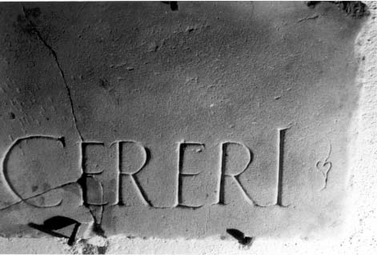
No. 3 - CIL II⁵ 1025 = ILS 2233 = HEp 1997, 890 = AE 2006, 646:  C(aius) Vettius C(ai) f(ilius) Ser(gia) / centur(io) leg(ionis) XXX / IIvir iterum / G(enio) c(oloniae) G(enetivae) Iul(iae) sacrum dat. |  |  |  | 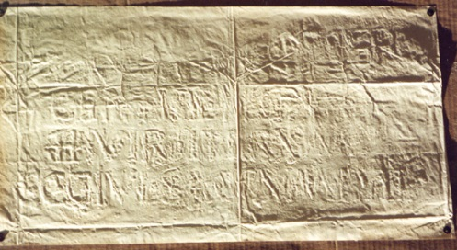
No. 4 - CIL II⁵ 1026 = HEp 1998, 445:  [---] / [taur]obolium [---] / [de su]a i<m=N>pensa [3] / [mini]strante [---] / [---]co s[acerdote----/--- |  | 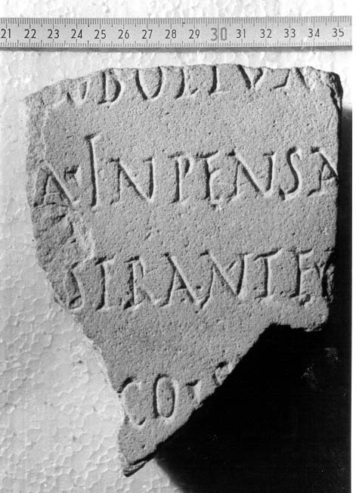
No. 5 - CIL II⁵ 1029:  ---]III[---] / Aelia Apra / Tispitana / sacerdos per/petua vixit an/nis XXXV mens(ibus) / V die(bu)s XXVIII p(ia) i(n) / [s(uis)--- | 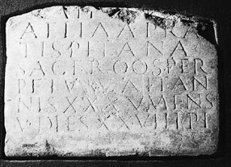
No. 6 - CIL II⁵ 1032 = CIL II 5441 = AE 1952, 120:  M(arco) Valerio M(arci) / f(ilio) Serg(ia) Sabino / IIviro ponti/fici perpetuo / c(olonorum) c(oloniae) G(enetivae) I(uliae) |  |  | 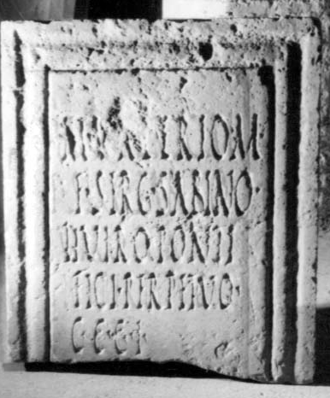
No. 7 - CIL II⁵ 1112:  from Cortijo de San Lucas (Urso):  Arbori / Sanctae /  Q(uintus) Avidius / Augustinus / ex visu posuit | 

