MODULE TITLE AND CODE: BMIH 5007 –
FINANCIAL MANAGEMENT FOR THE HOTEL INDUSTRY

STUDENT NAME: Krystal Gardner
STUDENT ID: 2027750
Word Count: 2167
Lecture: Tristan Hawkins

Contents
Introduction 3
Evaluation of Trend and Pattern 3
Revenue Analysis 3
Balance Sheet Analysis 5
Identification of Real Reasons Behind the Current Scenario of Urban Heights 7
Turnaround Plan for Urban Heights 8
Conclusion 11
References 12

Introduction
In the middle of a bustling metropolis is the Urban Heights Hotel, which offers a variety of services including a restaurant, a bar and party rooms. Recent years have been tough for the hotel, despite its prime location and plenty of amenities. Its very existence is under jeopardy due to falling revenue, occupancy, and consumer happiness. The hotel's future has the owner concerned, so he has sought expert opinion to see whether a planned turnaround will save the establishment (Vogel, 2020). Revenue, expenses, profitability, liquidity, and solvency are all part of the financial performance that the Urban Heights Hotel has been tracking over the last three years. The objective is to devise a strategy for recovery by determining what happened in the actual world and in the economy that caused the decline in profitability. In order to maintain its competitiveness in the hospitality business, this strategy will restore the hotel's finances and image. The Urban Heights Hotel is going to be successful with the support of targeted interventions and strategic planning.

Evaluation of Trend and Pattern

Revenue Analysis
As we are seeing here, the 3 years data has been given, and we are seeing here is that the value of each data is dropping. The data has been showing in 2022 to 2021 it has lost 30000 GBP revenue and the next year it lost around 40000 GBP per year in its revenue. So, we can put it in graph to check how the shape and trend analysis shows that it is declining. There are several reasons that can be associated with this. But the trend analysis shows that the real revenue for the company is ever declining from the early level.
Year | 2021 | 2022 | 2023
Revenue | £2,500,000 | £2,200,000 | £1,800,000

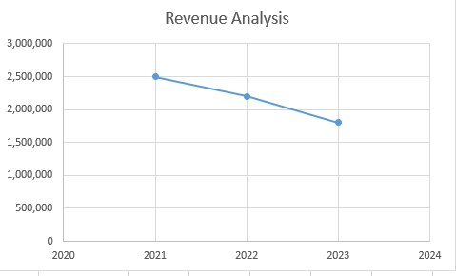
Figure 1: Revenue Analysis of Urban Heights (Source: Case Study)
Expense analysis
As we are seeing in the last 3-year trend we are seeing that the operating expense is rising. The overall expense over the year is increasing from 1,800,000 to 2,000,000 to 2,300,000. It is very problematic for the Urban Heights. As this is not going for the expansion of the program. The problem will arise mostly from continuous increase of the expense. As we have plotted the curve in the graph we are seeing the upward swing of the curve which shows that the expense is increased more and more by that.
Item | 2021 | 2022 | 2023
Operating Expenses | £1,800,000 | £2,000,000 | £2,300,000

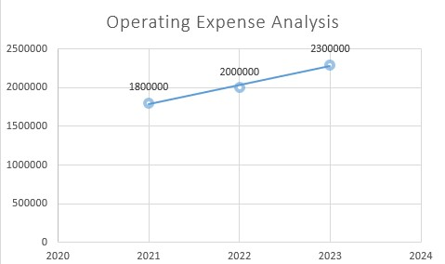
Figure 2: Operating Expense Analysis of Urban Heights (Source: Case Study)
Profitability Analysis
As the last 3 years the profit is also decreasing day by day. In last 3 years profit curve is trending downward and in last year it has made a loss of 500,000 GBP which is alarming. The profit downfall is mostly due to the fact that there is continuous increase in expense and the revenue is dropping like never before.
Item | 2021 | 2022 | 2023
Net Income | £700,000 | £200,000 | (£500,000)

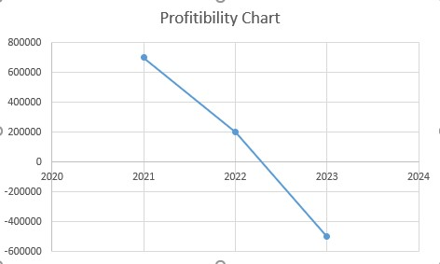
Figure 3: Net Income Analysis of Urban Heights (Source: Case Study)

Balance Sheet Analysis
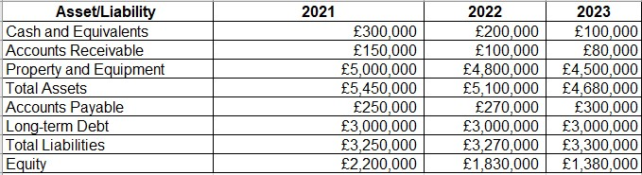
Figure 4: Balance Sheet Analysis of Urban Heights (Source: Case Study)
The financial health and direction of the organization may be seen in the 2021–2023 balance sheet statistics. Financial stability and liquidity have been on the decrease during the last three years, which points to some serious weaknesses that need fixing if we want to be around for the long haul (Ramsey et al, 2016).
From a high of £300,000 in 2021 to a low of £100,000 in 2023, the company's assets saw a drop. It seems the company may be experiencing liquidity issues, given the size of their cash reserve loss. The ability to conduct day-to-day operations, respond to unforeseen expenses, and take advantage of new investment opportunities may be negatively impacted if a company's cash reserves continue to decline (Qiu et al, 2016). A decrease in cash flow has forced the company to reevaluate its approach to financial management.
After reaching £150,000 in 2021, accounts receivable fell to £80,000 in 2023. This decline could be an indication of a more efficient method of collecting payments that swiftly turns credit sales into hard currency (Pandey, 2017). It can also mean that credit sales are down, which might mean that the customer base is smaller or that the sales are down overall. The decline in accounts receivable necessitates a review of sales strategies and customer credit policies.
From £500,000 in 2021 to £4,500,000 in 2023, the value of properties and equipment has decreased consistently. Depreciation and disposal are part of asset life cycles and might account for this decline. While it's true that all assets will eventually depreciate with time, the company's decline suggests it could be skimping on maintenance and updates, which might have a negative impact on operational efficiency.
A decrease in corporate assets was indicated by a decline in total assets from £5,450,000 in 2021 to £4,680,000 in 2023. The company is likely losing both short-term investments and long-term assets due to this decline. The depletion of the company's asset base might have a negative impact on its operations and profits.
From £250,000 in 2021 to £300,000 in 2023, accounts payable increased. The company may be delaying payments to suppliers due to cash flow issues as a result of this increase. Using credit to manage cash flow is common, but an increase in accounts payable that doesn't go downhill could put a pressure on relationships with suppliers and throw off supply chains (Pandey, 2017).
For three years, the amount of long-term debt has remained at £3,000,000. The fact that longterm debt has not decreased suggests that the firm is either unable or unwilling to pay off its current debt, even if steady debt levels do not mean that it has borrowed any more money. Putting off paying off debt may be risky for the company, especially if sales take a nosedive.
In 2023, total liabilities will be £3,300,000, up from £3,250,000 in 2021. Although the increase in liabilities is not dramatic, it does show that there are increasing financial commitments. This rise, together with falling assets, points to a deteriorating balance sheet.
Between 2021 and 2023, equity dropped sharply, going from £2,200,000 to £1,380,000. Investors and shareholders are understandably worried about the decline in the company's net value that this equity reduction represents. Equity declines when shareholder wealth is eroded, which may happen as a result of compounded losses or inadequate profitability (Palepu et al, 2020).
Reducing liquidity, declining assets, and growing liabilities characterize a financially troubled firm, according to the balance sheet. Improving cash flow management, reducing debt, and rebuilding the asset base are urgently needed strategic measures to restore financial health and assure sustainable development, as shown by the diminishing equity.

Identification of Real Reasons Behind the Current Scenario of Urban Heights
A significant decline in business profitability is shown in the financial sheet for the years 2021– 2023. This decline is due, in large part, to operational inefficiencies, falling revenues, increasing expenditures, poor asset management, and market issues.
- One of the main reasons for the decline in profitability is inefficient operations. The company may be mismanaging its business if its cash and equivalents dropped from £300,000 in 2021 to £100,000 in 2023. Operating expenditures rise and net profitability falls as a result of inefficient use of resources (Matar, 2018). High labor expenditures, low productivity, and mismanaged inventories are all possible outcomes of inefficiency. Companies usually lose money since they don't simplify their operations.
- Profitability drops as sales go down. Dropping from £150,000 in 2021 to £80,000 in 2023 might indicate a decline in sales made on credit. Greater competition, changing consumer preferences, or economic downturns might be to blame for the decline in demand for the company's products or services (Loughran et al, 2016). The drop in sales causes a decrease in both revenue and gross profit. Without sufficient revenue to cover operating expenses and generate a profit, a company's financial situation deteriorates.
- Profitability may be affected by price rises. Costs are rising, as shown by an increase in accounts payable from £250,000 in 2021 to £300,000 in 2023 (although this information is not provided by the balance sheet). Rising expenses in areas such as raw materials, labor, or operations could be to blame. Profit margins decline and profitability drops as spending outpaces revenue growth. The company will also have to shoulder the cost hikes itself, which would cut into its profits, unless it can raise prices to cover them.
- Property and equipment decreased from £5,000,000 in 2021 to £4,500,000 in 2023, a reflection of inept asset management. This decline can be due to quick depreciation, asset disposal, or inadequate maintenance. Operating efficiency and long-term expenditures might be negatively impacted by neglecting to maintain and improve equipment. In order to keep production steady and meet market expectations without going over budget, the company must practice good asset management.
- Potentially reducing profitability include market and competitive considerations. Company performance could take a hit in the event of an economic downturn, new regulations, or changes in consumer behavior. When businesses face less market share due to competition, they may feel pressured to lower prices or increase spending on marketing and innovation in order to retain customers. Because of these problems, sales might fall and costs could rise, cutting into profits.
- Lastly, throughout the last three years, the company's long-term debt has remained stable at £3,000,000, indicating that there has been no decrease in debt. This might put financial strain on the organization. Paying interest on a large amount of debt on a regular basis may eat away at a company's profit. The firm's profitability may take a hit if it can't pay down its debt with the money it makes.
The company's declining profitability may be attributed to a number of factors, including ineffective asset management, declining sales, increasing expenditures, and challenging market conditions. To tackle these issues, a holistic strategy is required to boost sales, operational efficiency, cost control, asset management, and market performance. If they are addressed, the company's profitability and growth could be revived.

Turnaround Plan for Urban Heights
If the company wants to fix its balance sheet and go back into the black, it needs a comprehensive turnaround plan. The strategy's focus should be on operational efficiency, sales, cost management, asset utilization, and market challenges. The strategies are given below:
- It is important to enhance operational efficiency first. In order to identify areas of inefficiency and waste, the company needs conduct a comprehensive analysis of its operations. Costs might be reduced and operations could be made easier with the help of lean management techniques (Loughran et al, 2016). It is possible that training and development could increase output and effectiveness. It is possible that data analytics and automation may also improve efficiency and decision-making.
- Revenue growth is also a need of the turnaround plan. In light of changing customer preferences and industry trends, the company should reevaluate its marketing strategy. To draw in and keep customers, products might be enhanced or added to the lineup. Boosting the sales team and enhancing customer service have the potential to boost sales (Loughran, 2016). Making an effort to expand into new domestic and international markets could increase revenue. It's possible that digital marketing and e-commerce may increase sales and exposure.
- To be profitable, one need to keep costs under check. The firm should be able to minimize expenses with the aid of a comprehensive cost structure assessment. Possible cost savings include stock optimization, improved supplier negotiations, and reduction of non-essential expenditure (Leuz et al, 2016). The firm may be able to achieve its cost management goals with the support of a thorough budgeting process and regular monitoring of financial performance.
- The organization's bottom line is boosted by optimizing asset use. The company has to take a close look at its assets to identify any outdated or inefficient machinery. Asset life and efficiency are both enhanced via maintenance and enhancements. The money might be redirected to other lucrative endeavors after the sale of unused or non-essential assets (Krueger et al, 2020). Leasing equipment instead of purchasing it could be a more cost-effective and flexible option.
- Aggressive action is required in response to market challenges. In response to changes in the market, the company should revise its strategies (Ji et al, 2019). Findings from market research may provide light on consumer tastes and the nature of competition. Having solid relationships with both customers and suppliers may help a business stand
out in the market. Keeping ahead of the competition and meeting market expectations may be achieved via innovation and product development.
- As a last step toward better financial health, the company should decrease debt. Make a repayment plan and try to negotiate better terms with the creditors to manage the debt. Cash flow management and financial stability may be enhanced with an efficient accounts payable and receivable system (Farrell et al, 2016).
The company may be able to get out of its financial jam, increase profitability, and grow sustainably if these plans pan out. Regular monitoring and adjustment of the turnaround plan is necessary to ensure its effectiveness and flexibility.

Conclusion
Last but not least, a turnaround plan is necessary to reverse the company's dwindling profitability. This plan must center on improving operating efficiency, increasing sales, controlling costs, optimizing assets, and adapting to the market. Simplifying processes, enhancing marketing, reducing spending, and controlling assets are all ways the firm might boost finances. Proactive market research and innovation may help manage competitive challenges (Cerutti et al, 2017). Returning to profitability and sustaining expansion are goals of these strategic activities and meticulous fiscal management. The long-term viability of the organization depends on consistently assessing progress and adjusting the strategy in response to changing situations.

References
Ahmed, M., Mahmood, A. N., & Islam, M. R. (2016). A survey of anomaly detection techniques in financial domain. Future Generation Computer Systems, 55, 278-288.
Altman, E. I., Iwanicz‐Drozdowska, M., Laitinen, E. K., & Suvas, A. (2017). Financial distress prediction in an international context: A review and empirical analysis of Altman's Z‐score model. Journal of international financial management & accounting, 28(2), 131-171.
Bottazzi, L., Da Rin, M., & Hellmann, T. (2016). The importance of trust for investment:
Evidence from venture capital. The Review of Financial Studies, 29(9), 2283-2318.
Brueggeman, W. B., & Fisher, J. D. (2018). Real estate finance and investments. McGraw-
Hill.
Cavalcante, R. C., Brasileiro, R. C., Souza, V. L., Nobrega, J. P., & Oliveira, A. L. (2016). Computational intelligence and financial markets: A survey and future directions. Expert Systems with Applications, 55, 194-211.
Cerutti, E., Claessens, S., & Rose, A. K. (2017). How important is the global financial cycle? Evidence from capital flows (No. w23699). National Bureau of Economic Research.
Charfeddine, L., & Kahia, M. (2019). Impact of renewable energy consumption and financial development on CO2 emissions and economic growth in the MENA region: a panel vector autoregressive (PVAR) analysis. Renewable energy, 139, 198-213.
Charitou, M. S., Elfani, M., & Lois, P. (2016). The effect of working capital management on firm’s profitability: Empirical evidence from an emerging market. Journal of business & economics research, 14(3).
Christensen, H. B., Hail, L., & Leuz, C. (2021). Mandatory CSR and sustainability reporting: Economic analysis and literature review. Review of accounting studies, 26(3), 1176-1248.
Corbet, S., Lucey, B., Urquhart, A., & Yarovaya, L. (2019). Cryptocurrencies as a financial asset: A systematic analysis. International Review of Financial Analysis, 62, 182-199.
Farrell, L., Fry, T. R., & Risse, L. (2016). The significance of financial self-efficacy in explaining women’s personal finance behaviour. Journal of economic psychology, 54, 85-99.
Ji, Q., & Zhang, D. (2019). How much does financial development contribute to renewable energy growth and upgrading of energy structure in China?. Energy Policy, 128, 114-124.
Krueger, P., Sautner, Z., & Starks, L. T. (2020). The importance of climate risks for institutional investors. The Review of Financial Studies, 33(3), 1067-1111.
Leuz, C., & Wysocki, P. D. (2016). The economics of disclosure and financial reporting regulation: Evidence and suggestions for future research. Journal of accounting research, 54(2), 525-622.
Loughran, T., & McDonald, B. (2016). Textual analysis in accounting and finance: A survey. Journal of Accounting Research, 54(4), 1187-1230.
Matar, A., & Eneizan, B. (2018). Determinants of financial performance in the industrial firms:
Evidence from Jordan. Asian Journal of Agricultural Extension, Economics &
Sociology, 22(1), 1-10.
Palepu, K. G., Healy, P. M., Wright, S., Bradbury, M., & Coulton, J. (2020). Business analysis and valuation: Using financial statements. Cengage AU.
Pandey, K. (2017). Financial management. Lulu. com.
Qiu, Y., Shaukat, A., & Tharyan, R. (2016). Environmental and social disclosures: Link with corporate financial performance. The British Accounting Review, 48(1), 102-116.
Ramsey, S. D., Bansal, A., Fedorenko, C. R., Blough, D. K., Overstreet, K. A., Shankaran, V., & Newcomb, P. (2016). Financial insolvency as a risk factor for early mortality among patients with cancer. Journal of clinical oncology, 34(9), 980.
Vogel, H. L. (2020). Entertainment industry economics: A guide for financial analysis.
Cambridge University Press.

