Marketing plan written for
Hilton

Student Name:
Marius Victor Gostin

Student ID number:
2117741

Marketing Essentials BMIH4005

Lecturer name:

Chris Wilkin

Words number:
1677
Introduction
Hilton Worldwide is a global conglomerate that constructs, owns, leases, manages, and franchises properties throughout the planet. The Hilton brand spectrum includes resorts, full-service hotels, luxury and leisure inns, and service-focused hotels. The management and franchising segment also constructs, purchases, and leases hotels in addition to brand licencing (Hilton, 2021a).
The chosen business is a leader in the hotel industry, with a presence all over the world and an advanced marketing network. This marketing plan will describe how the hotel chain uses contemporary technologies to collect visitor information, as well as make suggestions for ways to improve the marketing process and do SWOT and PESTLE analyses.

Marketing mix
- Product – In the hotel sector, it is crucial to portray Hilton Hotels and Resorts as a full-service organisation. The business provides a wide range of services, including meeting spaces, wedding and banquet facilities, special celebration services, restaurants and bars, catering, private pools, gift shops, and retail outlets (Hilton, 2021a).
- Price – Determine the high cost of products that are more valuable and can be thought of with more features and advantages. The premium pricing method is this. The bulk of the hotels owned by Hilton Worldwide are in the premium and high pricing ranges. They might be categorised as premium as a result.
- Place – Hilton Hotels & Resorts' distribution strategy makes considerable use of web technology and data innovation. Because it has many functionalities and features that provide customers with the necessary support, such as booking a venue, planning events and ceremonies, setting up meetings, and setting up flight pickups, the company's official website serves as an effective framework for the services to be delivered.
- Promotion – As part of the group's promotional operations, the firm has teamed with payment institutions, several restaurants for the selection of food suppliers, and many other organisations to expand access to Hilton hotels. Various consumer analysts have also exploited content from reputable sources for extra advertising.

The Marketing Environment (Micro-SWOT)
Strengths:
- There are 4610 properties worldwide owned by Hilton (Hilton, 2022b). One of its stronger points, financially speaking, is having a sizable property portfolio.
- The Hilton HHonors programme, one of the business's most effective guest loyalty programmes, is another asset (Ewen, 2022).
- To preserve visitor health and promote attendance in order to battle the disease, Hilton developed a sanitation plan focused on hotel sanitation and cleanliness across 18 trademarks (Hilton, 2022a).
- Weaknesses:
- Hilton is heavily indebted, which could make it difficult to secure additional funding and maintain its current financial strength. His total debt as of January 1, 2021 is $10.7 billion (Hilton, 2021b).
- The elimination of routine maintenance, several facilities rooms, and shutting of restaurants and stores are some of the services eliminated throughout a pandemic and have adverse effects (Thier, 2021).
Opportunities:
- For its products' advertisement, Hilton may use various social media channels, including Instagram, Facebook, Pinterest, and others (Wilson, 2022).
- Hilton Worldwide may consider forming partnerships and alliances with Indian, Chinese, and Japanese hospitality-related businesses.
Threats:
- Because of its great solid reputation and performance, Hilton risks having its good name tarnished by franchisee non-compliance.
In order to attend hotels, gyms, and restaurants in Europe and Canada, one must have a vaccination passport (Gebicki, 2021).

The Marketing environment (Macro) PESTEL
- Political - A particular example may be the terrorist attacks in London on July 7, 2005; the UK momentarily gained a reputation for hosting several radical religious groups (BBC, 2015). The likelihood of fewer tourists visiting London, the UK, and the United Kingdom had a detrimental effect on Hilton's performance in this specific market.
- Economic - Increased trade regulation liberalization by the United States (Banton, 2021) may enable Hilton Worldwide to expand its investments in areas currently off-limits to the company.
- Socio-cultural - Immigration: Americans generally have a negative attitude toward immigration (Felter, Renwick, and Cheatham, 2020). This could limit Hilton Worldwide's ability to employ management and executives from other countries to conduct business there.
- Technological - The life cycle of a product has been reduced, and suppliers may now create new goods more promptly (Bashin, 2019). It has placed a strain on Hilton World wide’s marketing staff to promote various items to satisfy the vendors. It increased Hilton Worldwide's operating expenses.
- Environmental – Alternative energy is another area of ​​interest for Hilton Worldwide. Take advantage of current market trends. US offers financial support to companies looking to invest in renewable energy (USAID, 2022).
- Legal - Hilton Worldwide needs to consider whether the US has a reliable system to guard and prevent security breaches.

Creating Customer Value & Engagement
The majority of hotels may employ a variety of technologies as a byproduct to discover more about their clients. A booking engine or PMS is a very efficient tool that may produce useful statistics, even though they don't capture all the essential data you need for success.
Given the existing environment, knowing what to enhance and when to do it can raise the company chances of success in the lodging industry. The utilisation of all data sources is required. Long-term success may be achieved with ease by making wise use of the new technologies that are required to accomplish this. The Hilton hotel business has made considerable advances in gathering consumer feedback and data and has availability to it because of its scale.
This marketing strategy places a strong emphasis on the digital world because the organisation is actively involved in everything linked to it. We must apply extremely sophisticated management strategies while processing them, in addition to methods that let us draw out valuable data from huge databases.

Effective Use of digital Marketing
Digital marketing is frequently viewed as a novel way for companies to communicate with customers and understand their behaviour. It shares many concepts with traditional marketing. Businesses typically combine traditional and digital marketing techniques in their marketing strategies (Veleva and Tsvetanova, 2020). Hilton Hotels leverages the new mainstream press to keep good client relationships and solicit feedback via websites like Instagram and Twitter. This allows visitors to write tales about their stays at Hilton Hotels. Additionally, this enables Hilton Hotels to continuously update clients about new events and promotions (Crocker, 2013).
However, it is recommended that machine learning algorithms be utilised to improve performance and streamline employee duties despite the firm already having a well-established and integrated digital marketing plan.
Machine learning has gained popularity in a number of industries, including healthcare, transportation, and manufacturing (Burns, 2021). Since innovations were created and are still being developed for the hotel industry, it is also not exempt from this development. One method to decide the best time to start campaigns and special offers is to use market trend predicting software (Parvez, 2020). These ML-based services will compile historical data and notify the business of potential opportunities in the hotel industry (Agarwal, 2016). The hotel chain can make the most of its efficient advertising network by leveraging this technology. It can also decide when it is necessary to utilise it and when it is ideal to launch marketing efforts to draw in new consumers.

Conclusion
Gauging client interaction and exploiting the digital marketing ecosystem really aren't problems for Hilton Hotels. What can be done with the obtained data is the most important question, particularly how they may help with adopting effective strategies for which machine learning algorithms have been created. Understanding demand patterns and when to launch the company's conscious marketing campaigns are crucial for the hotel industry.
Because these algorithms employ environmental data to gather broad knowledge, they may both satisfy current customers more and attract new ones. When it comes to factors that might have an impact on a business' operations, Hilton's internal situation with regard to its debt level is where it struggles the most. This component is rendered all the more challenging by the income blockade experienced during the COVID-19 shutdown and the increased investments undertaken to address the post-pandemic scenario.

References
- Agarwal, P. (2016). Machine Learning Toolbox. Machine Learning and Applications: An International Journal, 3(3), pp.25–34. doi:10.5121/mlaij.2016.3303.
- Banton, C. (2021). Trade Liberalization Explained. [online] Investopedia. Available at: https://www.investopedia.com/terms/t/trade-liberalization.asp.
- Bashin, H. (2019). What is Technology Life Cycle? 4 Stages of Technology Life Cycle. [online] Marketing91. Available at: https://www.marketing91.com/technology-life-cycle/.
- BBC (2015). 7 July London bombings: What happened that day? BBC News. [online] 3 Jul. Available at: https://www.bbc.com/news/uk-33253598.
- Burns, E. (2021). What Is Machine Learning and Why Is It Important? [online] SearchEnterpriseAI. Available at: https://www.techtarget.com/searchenterpriseai/definition/machine-learning-ML.
- Crocker, J. (2013). Going Places with DoubleTree by Hilton: Digital Engagement in the Travel Market. [online] Available at: https://www.thinkwithgoogle.com/_qs/documents/251/going-places-with-doubletree_articles.pdf.
- Ewen, N. (2022). Complete guide to Hilton Honors elite status in 2022 - The Points Guy. [online] Available at: https://thepointsguy.com/guide/what-is-hilton-elite-status-worth/.
- Felter, C., Renwick, D. and Cheatham, A. (2020). The U.S. Immigration Debate. [online] Council on Foreign Relations. Available at: https://www.cfr.org/backgrounder/us-immigration-debate-0.
- Gebicki, M. (2021). The countries that are excluding (or banning) unvaccinated people. [online] Traveller. Available at: https://www.traveller.com.au/vaccine-passports-around-the-world-the-countries-excluding-and-banning-unvaccinated-people-h1yobf.
- Hilton (2021a). Hilton Brands | Global Hospitality Company. [online] Hilton.com. Available at: https://www.hilton.com/en/corporate/.
- Gebicki, M. (2021). The countries that are excluding (or banning) unvaccinated people. [online] Traveller. Available at: https://www.traveller.com.au/vaccine-passports-around-the-world-the-countries-excluding-and-banning-unvaccinated-people-h1yobf.
- Hilton (2021a). Hilton Brands | Global Hospitality Company. [online] Hilton.com. Available at: https://www.hilton.com/en/corporate/.
- Hilton (2021b). Hilton Reports Fourth Quarter and Full Year Results. [online] Available at: https://ir.hilton.com/~/media/Files/H/Hilton-Worldwide-IR-V3/quarterly-results/2021/q4-2021-earnings-release.pdf.
- Hilton (2022). Hilton Management Services | Portfolio of Properties. [online] managementservices.hilton.com. Available at: https://managementservices.hilton.com/en/properties/.
- Hilton (2022a). Hilton Travel Flexibility and Safety Standards. [online] Hilton. Available at: https://www.hilton.com/en/p/what-to-expect/.
- Parvez, M.O. (2020). Use of machine learning technology for tourist and organizational services: high-tech innovation in the hospitality industry. Journal of Tourism Futures, ahead-of-print(ahead-of-print). doi:10.1108/jtf-09-2019-0083.
- Thier, J. (2021). Hilton CFO: ‘We’re not big believers in new normals’. [online] CFO Dive. Available at: https://www.cfodive.com/news/hilton-cfo-were-not-big-believers-in-new-normals/604236/.
- USAID (2022). Scaling Up Renewable Energy | Programs | Energy | U.S. Agency for International Development. [online] www.usaid.gov. Available at: https://www.usaid.gov/energy/sure.
- Veleva, S.S. and Tsvetanova, A.I. (2020). Characteristics of the digital marketing advantages and disadvantages. IOP Conference Series: Materials Science and Engineering, [online] 940(1), p.012065. doi:10.1088/1757-899x/940/1/012065.
- Wilson, J. (2022). How to market your hotel on Instagram. [online] blog.typsy.com. Available at: https://blog.typsy.com/how-to-market-your-hotel-on-instagram.

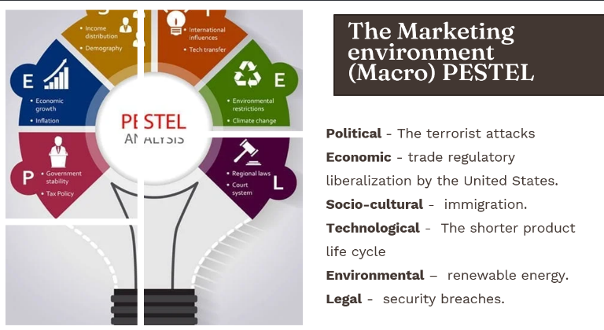
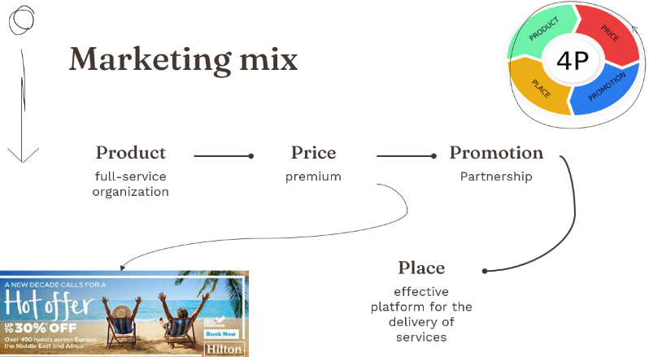
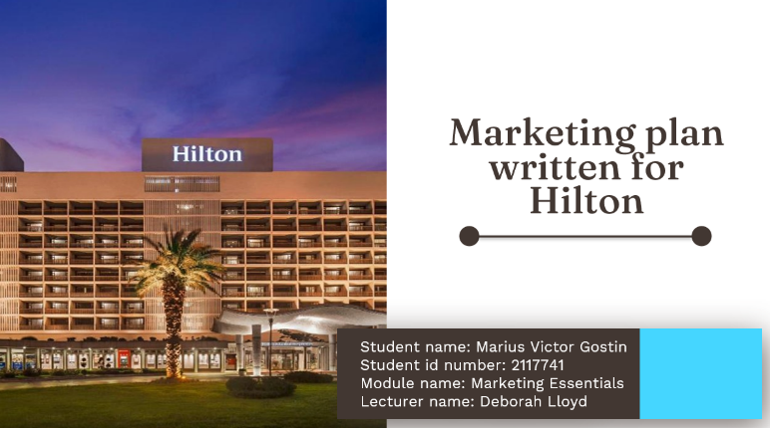
4
2
1
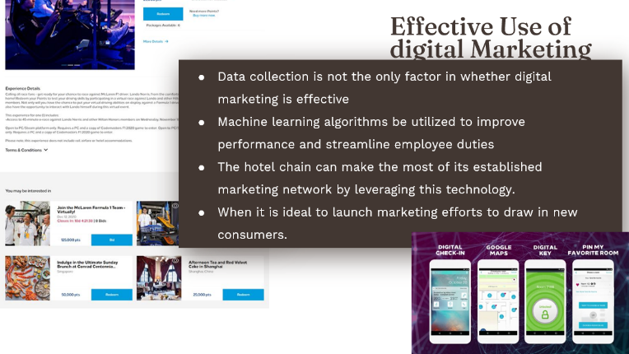
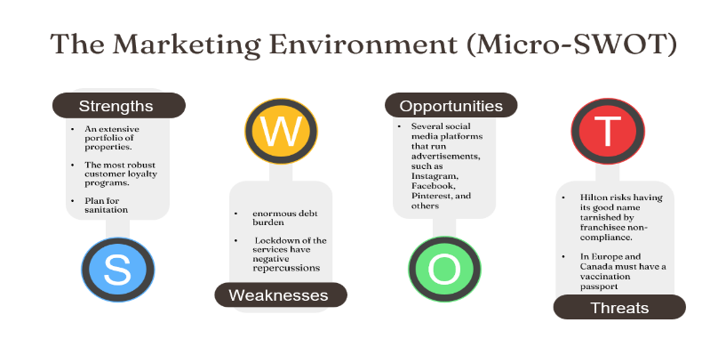
6
5
3

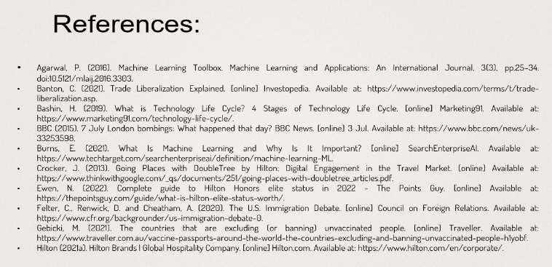
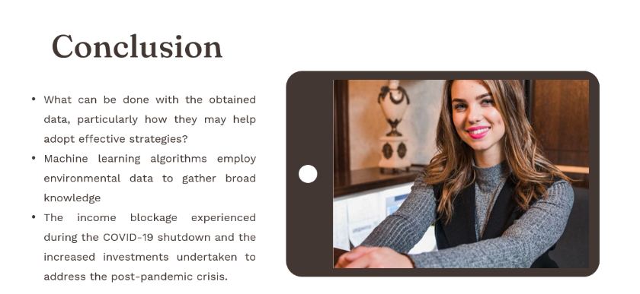
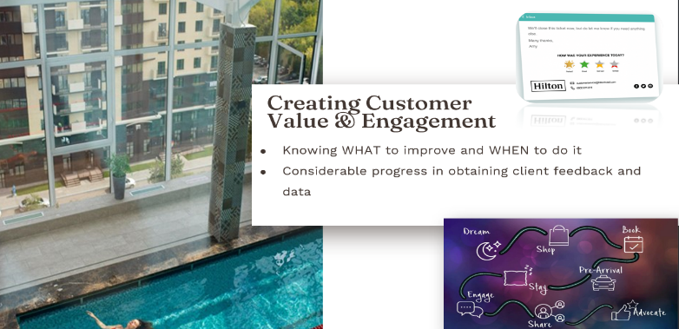
8
7

