


Advanced Cyber Security (ACS)

Lab 7

Faculty of Architecture, Computing & Engineering
School of Applied Computing
Mount Pleasant Campus
Swansea
SA1 6ED

Class Activity – Creating Codes

Objectives
Secret codes have been used for thousands of years. Ancient Greeks and Spartans used a scytale (rhymes with Italy) to encode messages. Romans used a Caesar cipher to encrypt messages. A few hundred years ago, the French used the Vigenère cipher to encode messages. Today, there are many ways that messages can be encoded.
In this lab, you will create and encrypt messages using online tools.

Background / Scenario
There are several encryption algorithms that can be used to encrypt and decrypt messages. Virtual Private Networks (VPNs) are commonly used to automate the encryption and decryption process.
In this lab, you and a lab partner will use an online tool to encrypt and decrypt messages.

Required Resources
- PC with Internet access
  - Search for an online encoding and decoding tool.
There are many different types of encryption algorithms used in modern networks. One of the most secure is the Advanced Encryption Standard (AES) symmetric encryption algorithm. We will be using this algorithm in our demonstration.
    - In a Web browser, search for “encrypt decrypt AES online”. Several different tools will be listed in the search results.
    - Explore the different links provided and choose a tool. In our example, we used the tool available from:
http://aesencryption.net/
  - Encrypt a message and email it to your lab partner.
In this step, each lab partner will encrypt a message and send the encrypted text to the other lab partner.
Note: Unencrypted messages are referred to as plaintext, while encrypted messages are referred to as ciphertext.
    - Enter a plaintext message of your choice in the text box. The message can be very short or it can be lengthy. Be sure that your lab partner does not see the plaintext message.
A secret key (i.e., password) is usually required to encrypt a message. The secret key is used along with the encryption algorithm to encrypt the message. Only someone with knowledge of the secret key would be able to decrypt the message.
    - Enter a secret key. Some tools may ask you to confirm the password. In our example, we used the cyberops secret key.
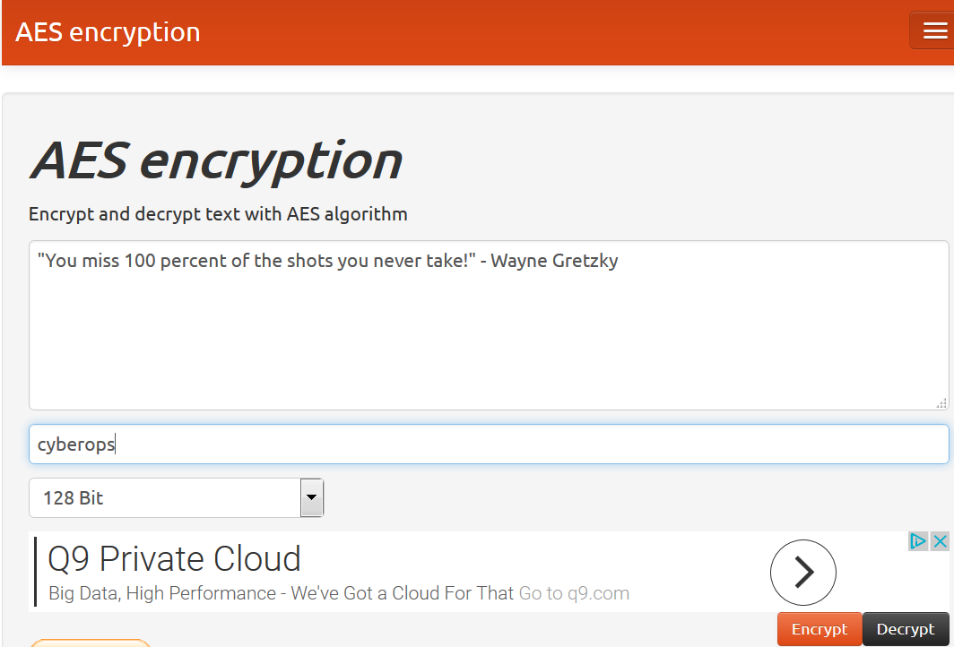
    - Next click on Encrypt.
In the “Result of encryption in base64” window, random text is displayed. This is then encrypted message.
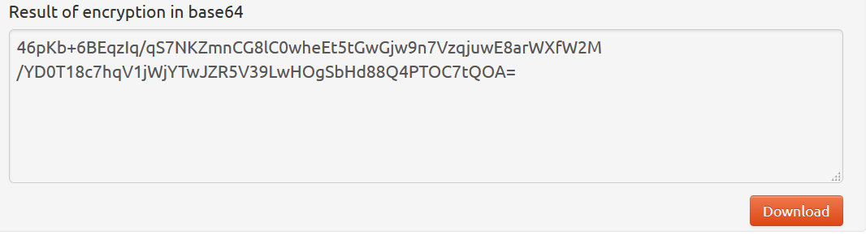
    - Copy or Download the resulting message.
    - Email the encrypted message to your lab partner.
  - Decrypt the ciphertext.
AES is a symmetric encryption algorithm This means that the two parties exchanging encrypted messages must share the secret key in advance.
    - Open the email from your lab partner.
    - Copy the ciphertext and paste it in the text box.
    - Enter the pre-shared secret key.
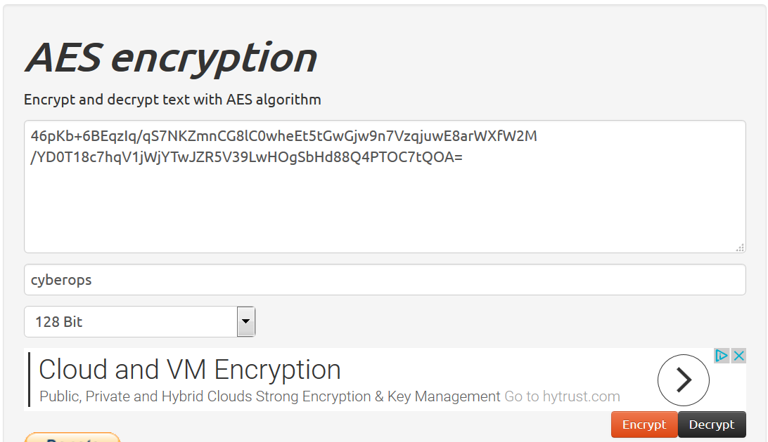
    - Click on Decrypt and the original cleartext message should be displayed.
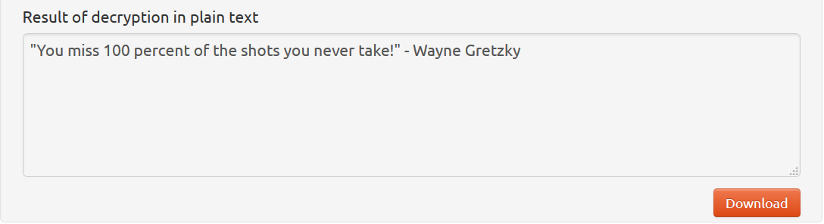
What happens if you use a wrong secret key?
____________________________________________________________________________________
____________________________________________________________________________________

Lab - Encrypting and Decrypting Data Using OpenSSL

Objectives
Part 1: Encrypting Messages with OpenSSL
Part 2: Decrypting Messages with OpenSSL

Background / Scenario
OpenSSL is an open source project that provides a robust, commercial-grade, and full-featured toolkit for the Transport Layer Security (TLS) and Secure Sockets Layer (SSL) protocols. It is also a general-purpose cryptography library. In this lab, you will use OpenSSL to encrypt and decrypt text messages.
Note: While OpenSSL is the de facto cryptography library today, the use presented in this lab is NOT recommended for robust protection. Below are two security problems with this lab:
        - The method described in this lab uses a weak key derivation function. The ONLY security is introduced by a very strong password.
        - The method described in this lab does not guarantee the integrity of the text file.
This lab should be used for instructional purposes only. The methods presented here should NOT be used to secure truly sensitive data.

Required Resources
- CyberOps Workstation Virtual Machine
- Internet access
- Encrypting Messages with OpenSSL
OpenSSL can be used as a standalone tool for encryption. While many encryption algorithms can be used, this lab focuses on AES. To use AES to encrypt a text file directly from the command line using OpenSSL, follow the steps below:
    - Encrypting a Text File
      - Log into CyberOPS Workstation VM.
      - Open a terminal window.
      - Because the text file to be encrypted is in the /home/analyst/lab.support.files/ directory, change to that directory:
[analyst@secOps ~]$ cd /home/analyst/lab.support.files/
[analyst@secOps lab.support.files]$
      - Type the command below to list the contents of the encrypted letter_to_grandma.txt text file on the screen:
[analyst@secOps lab.support.files]$ cat letter_to_grandma.txt
Hi Grandma,
I am writing this letter to thank you for the chocolate chip cookies you sent me. I got them this morning and I have already eaten half of the box! They are absolutely delicious!

I wish you all the best. Love,
Your cookie-eater grandchild.
[analyst@secOps lab.support.files]$
      - From the same terminal window, issue the command below to encrypt the text file. The command will use AES-256 to encrypt the text file and save the encrypted version as message.enc. OpenSSL will ask for a password and for password confirmation. Provide the password as requested and be sure to remember the password.
[analyst@secOps lab.support.files]$ openssl aes-256-cbc -in letter_to_grandma.txt -out message.enc
enter aes-256-cbc encryption password:
Verifying - enter aes-256-cbc encryption password:
[analyst@secOps lab.support.files]$
      - When the process is finished, use the cat command again to display the contents of the message.enc file.
[analyst@secOps lab.support.files]$ cat message.enc
Did the contents of the message.enc file display correctly? What does it look like? Explain.
____________________________________________________________________________________
____________________________________________________________________________________
      - To make the file readable, run the OpenSSL command again, but this time add the -a option. The -a option tells OpenSSL to encode the encrypted message as Base64 before storing the results in a file.
Note: Base64 is a group of similar binary-to-text encoding schemes used to represent binary data in an ASCII string format.
[analyst@secOps lab.support.files]$ openssl aes-256-cbc -a -in letter_to_grandma.txt -out message.enc
enter aes-256-cbc encryption password:
Verifying - enter aes-256-cbc encryption password:
      - Once again, use the cat command to display the contents of the, now re-generated, message.enc file:
Note: The contents of message.enc will vary.
[analyst@secOps lab.support.files]$ cat message.enc
U2FsdGVkX19ApWyrn8RD5zNp0RPCuMGZ98wDc26u/vmj1zyDXobGQhm/dDRZasG7
rfnth5Q8NHValEw8vipKGM66dNFyyr9/hJUzCoqhFpRHgNn+Xs5+TOtz/QCPN1bi
08LGTSzOpfkg76XDCk8uPy1hl/+Ng92sM5rgMzLXfEXtaYe5UgwOD42U/U6q73pj
a1ksQrTWsv5mtN7y6mh02Wobo3A1ooHrM7niOwK1a3YKrSp+ZhYzVTrtksWDl6Ci
XMufkv+FOGn+SoEEuh7l4fk0LIPEfGsExVFB4TGdTiZQApRw74rTAZaE/dopaJn0
sJmR3+3C+dmgzZIKEHWsJ2pgLvj2Sme79J/XxwQVNpw=
[analyst@secOps lab.support.files]$
Is message.enc displayed correctly now? Explain.
____________________________________________________________________________________
____________________________________________________________________________________
Can you think of a benefit of having message.enc Base64-encoded?
____________________________________________________________________________________
____________________________________________________________________________________
- Decrypting Messages with OpenSSL
With a similar OpenSSL command, it is possible to decrypt message.enc.
      - Use the command below to decrypt message.enc:
[analyst@secOps lab.support.files]$ openssl aes-256-cbc –a -d -in message.enc -out decrypted_letter.txt
      - OpenSSL will ask for the password used to encrypt the file. Enter the same password again.
      - When OpenSSL finishes decrypting the message.enc file, it saves the decrypted message in a text file called decrypted_letter.txt. Use the cat display the contents of decrypted_letter.txt:
[analyst@secOps lab.support.files]$ cat decrypted_letter.txt
Was the letter decrypted correctly?
____________________________________________________________________________________
____________________________________________________________________________________
The command used to decrypt also contains -a option. Can you explain?
____________________________________________________________________________________
____________________________________________________________________________________

Lab - Encrypting and Decrypting Data using a Hacker Tool

Objectives
Part 1: Create and Encrypt Files
Part 2: Recover Encrypted Zip File Passwords

Background / Scenario
What if you work for a large corporation that had a corporate policy regarding removable media? Specifically, it states that only encrypted zipped documents can be copied to portable USB flash drives.
In this scenario, the Chief Financial Officer (CFO) is out-of-town on business and has contacted you in a panic with an emergency request for help. While out-of-town on business, he attempted to unzip important documents from an encrypted zip file on a USB drive. However, the password provided to open the zip file is invalid. The CFO contacted you to see if there was anything you could to do.
Note: The provided scenario is simple and only serves as an example.
There may some tools available to recover lost passwords. This is especially true in situations such as this where the cybersecurity analyst could acquire pertinent information from the CFO, such as the length of the password, and an idea of what it could be. Knowing pertinent information dramatically helps when attempting to recover passwords.
Examples of password recovery utilities and programs include hashcat, John the Ripper, Lophtcrack, and others. In our scenario, we will use fcrackzip which is a simple Linux utility to recover the passwords of encrypted zip files.
Consider that these same tools can be used by cybercriminals to discover unknown passwords. Although they would not have access to some pertinent information, with time, it is possible to discover passwords to open encrypted zip files. The amount of time required depends on the password strength and the password length. Longer and more complex passwords (mix of different types of characters) are more secure.
In this lab, you will:
- Create and encrypt sample text files.
- Decrypt the encrypted zip file.
Note: This lab should be used for instructional purposes only. The methods presented here should NOT be used to secure truly sensitive data.

Required Resources
- CyberOps Workstation Virtual Machine
- Internet access
- Create and Encrypt Files
In this part, you will create a few text files that will be used to created encrypted zip files in the next step.
    - Create text files.
      - Start the CyberOps Workstation VM.
      - Open a terminal window. Verify that you are in the analyst home directory. Otherwise, enter cd ~ at the terminal prompt.
      - Create a new folder called Zip-Files using the mkdir Zip-Files command.
      - Move into that directory using the cd Zip-Files command.
      - Enter the following to create a text file called sample-1.txt.
[analyst@secOps Zip-Files]$ echo This a sample text file > sample-1.txt
[analyst@secOps Zip-Files]$ echo This a sample text file > sample-2.txt
[analyst@secOps Zip-Files]$ echo This a sample text file > sample-3.txt
      - Verify that the files have been created, using the ls command.
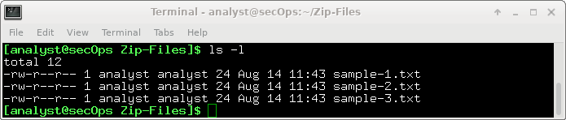
    - Zip and encrypt the text files.
Next, we will create several encrypted zipped files using varying password lengths. To do so, all three text files will be encrypted using the zip utility.
      - Create an encrypted zip file called file-1.zip containing the three text files using the following command:
[analyst@secOps Zip-Files]$ zip –e file-1.zip sample*
      - When prompted for a password, enter a one-character password of your choice. In the example, the letter B was entered. Enter the same letter when prompted to verify.
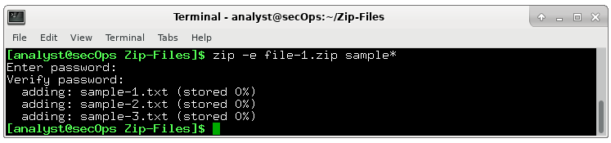
      - Repeat the procedure to create the following 4 other files
- file-2.zip using a 2-character password of your choice. In our example, we used R2.
- file-3.zip using a 3-character password of your choice. In our example, we used 0B1.
- file-4.zip using a 4-character password of your choice. In our example, we used Y0Da.
- file-5.zip using a 5-character password of your choice. In our example, we used C-3P0.
      - Verify that all zipped files have been created using the ls command.
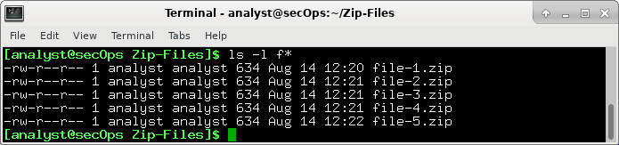
      - Attempt to open a zip using an incorrect password as shown.
[analyst@secOps Zip-Files]$ unzip file-1.zip
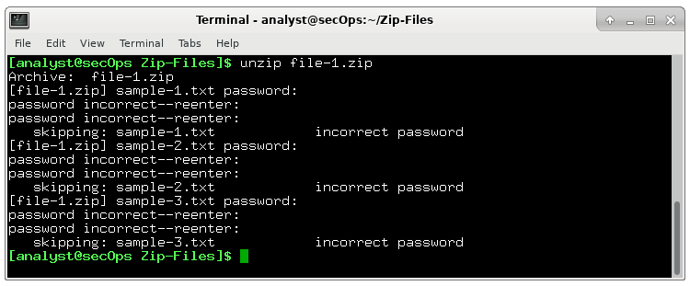
- Recover Encrypted Zip File Passwords
In this part, you will use the fcrackzip utility to recover lost passwords from encrypted zipped files. Fcrackzip searches each zip file given for encrypted files and tries to guess the password using brute-force methods.
The reason we created zip files with varying password lengths was to see if password length influences the time it takes to discover a password.
    - Introduction to fcrackzip
      - From the terminal window, enter the fcrackzip –h command to see the associated command options.
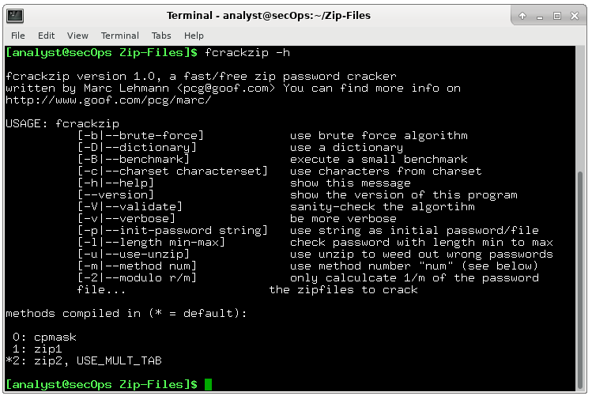
In our examples, we will be using the –v, -u, and -l command options. The -l option will be listed last because it specifies the possible password length. Feel free to experiment with other options.
    - Recovering Passwords using fcrackzip
      - Now attempt to recover the password of the file-1.zip file. Recall, that a one-character password was used to encrypt the file. Therefore, use the following fcrackzip command:
[analyst@secOps Zip-Files]$ fcrackzip -vul 1-4 file-1.zip
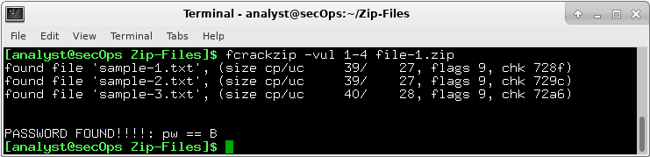
Note: The password length could have been set to less than 1 – 4 characters.
How long does it take to discover the password?
____________________________________________________________________________________
      - Now attempt to recover the password of the file-2.zip file. Recall, that a two-character password was used to encrypt the file. Therefore, use the following fcrackzip command:
[analyst@secOps Zip-Files]$ fcrackzip –vul 1-4 file-2.zip
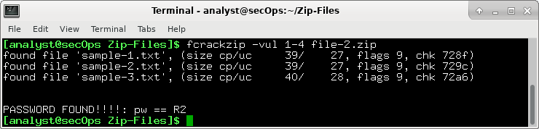
How long does it take to discover the password?
____________________________________________________________________________________
      - Repeat the procedure and recover the password of the file-3.zip file. Recall, that a three-character password was used to encrypt the file. Time to see how long it takes to discover a 3-letter password. Use the following fcrackzip command:
[analyst@secOps Zip-Files]$ fcrackzip –vul 1-4 file-3.zip
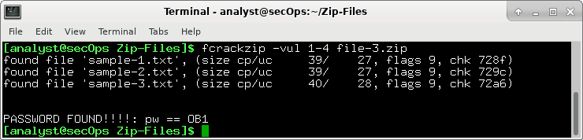
How long does it take to discover the password?
____________________________________________________________________________________
      - How long does it take to crack a password of four characters? Repeat the procedure and recover the password of the file-4.zip file. Time to see how long it takes to discover the password using the following fcrackzip command:
[analyst@secOps Zip-Files]$ fcrackzip –vul 1-4 file-4.zip
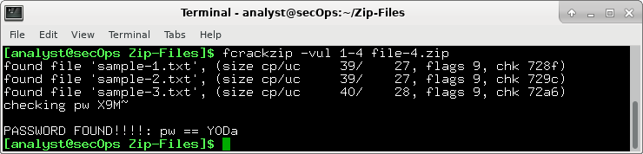
How long does it take to discover the password?
____________________________________________________________________________________
      - How long does it take to crack a password of five characters? Repeat the procedure and recover the password of the file-5.zip file. The password length is five characters, so we need to set the -l command option to 1-5. Again, time to see how long it takes to discover the password using the following fcrackzip command:
[analyst@secOps Zip-Files]$ fcrackzip –vul 1-5 file-5.zip
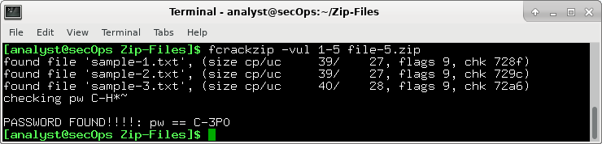
How long does it take to discover the password?
____________________________________________________________________________________
      - Recover a 6 Character Password using fcrackzip
It appears that longer passwords take more time to discover and therefore, they are more secure. However, a 6 character password would not deter a cybercriminal.
How long do you think it would take fcrackzip to discover a 6-character password?
____________________________________________________________________________________
To answer that question, create a file called file-6.zip using a 6-character password of your choice. In our example, we used JarJar.
[analyst@secOps Zip-Files]$ zip –e file-6.zip sample*
      - Repeat the procedure to recover the password of the file-6.zip file using the following fcrackzip command:
[analyst@secOps Zip-Files]$ fcrackzip –vul 1-6 file-6.zip
How long does it take fcrackzip to discover the password?
____________________________________________________________________________________
The simple truth is that longer passwords are more secure because they take longer to discover.
How long would you recommend a password needs to be for it to be secure?
____________________________________________________________________________________

Lab - Examining Telnet and SSH in Wireshark

Objectives
Part 1: Examine a Telnet Session with Wireshark
Part 2: Examine an SSH Session with Wireshark

Background / Scenario
In this lab, you will configure a router to accept SSH connectivity and use Wireshark to capture and view Telnet and SSH sessions. This will demonstrate the importance of encryption with SSH.

Required Resources
- CyberOps Workstation VM
- Examining a Telnet Session with Wireshark
You will use Wireshark to capture and view the transmitted data of a Telnet session.
  - Capture data.
    - Start the CyberOps Workstation VM and log in with username analyst and password cyberops.
    - Open a terminal window and start Wireshark. Press OK to continue after reading the warning message.
[analyst@secOps analyst]$ sudo wireshark-gtk
[sudo] password for analyst: cyberops

** (wireshark-gtk:950): WARNING **: Couldn't connect to accessibility bus: Failed to connect to socket /tmp/dbus-REDRWOHelr: Connection refused
Gtk-Message: GtkDialog mapped without a transient parent. This is discouraged.
    - Start a Wireshark capture on the Loopback: lo interface.
    - Open another terminal window. Start a Telnet session to the localhost. Enter username analyst and password cyberops when prompted.
[analyst@secOps ~]$ telnet localhost
Trying ::1...
Connected to localhost.
Escape character is '^]'.

Linux 4.10.10-1-ARCH (unallocated.barefruit.co.uk) (pts/12)

secOps login: analyst
Password:
Last login: Fri Apr 28 10:50:52 from localhost.localdomain
[analyst@secOps ~]$
    - Stop the Wireshark capture after you have provided the user credentials.
  - Examine the Telnet session.
    - Apply a filter that only displays Telnet-related traffic. Enter Telnet in the filter field.
    - Right-click one of the Telnet lines in the Packet list section of Wireshark, and from the drop-down list, select Follow TCP Stream.
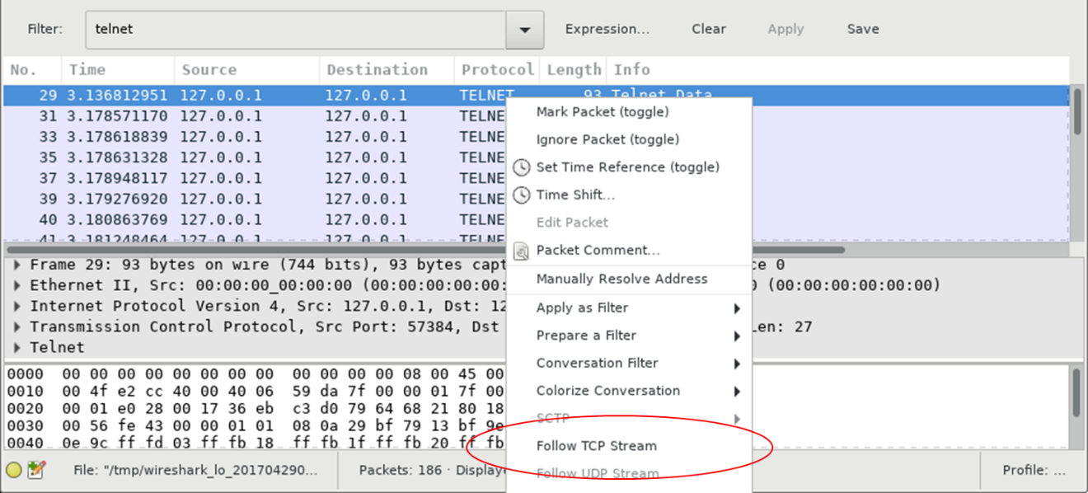
    - The Follow TCP Stream window displays the data for your Telnet session with the CyberOps Workstation VM. The entire session is displayed in plaintext, including your password. Notice that the username that you entered is displayed with duplicate characters. This is caused by the echo setting in Telnet to allow you to view the characters that you type on the screen.
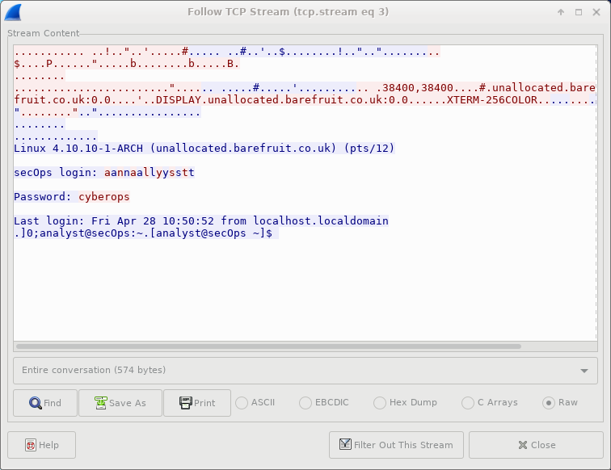
    - After you have finished reviewing your Telnet session in the Follow TCP Stream window, click Close.
    - Type exit at the terminal to exit the Telnet session.
[analyst@secOps ~]$ exit
- Examine an SSH Session with Wireshark
In Part 2, you will establish an SSH session with the localhost. Wireshark will be used to capture and view the data of this SSH session.
    - Start another Wireshark capture.
    - You will establish an SSH session with the localhost. At the terminal prompt, enter ssh localhost. Enter yes to continue connecting. Enter the cyberops when prompted.
[analyst@secOps ~]$ ssh localhost
The authenticity of host 'localhost (::1)' can't be established.
ECDSA key fingerprint is SHA256:uLDhKZflmvsR8Et8jer1NuD91cGDS1mUl/p7VI3u6kI.
Are you sure you want to continue connecting (yes/no)? yes
Warning: Permanently added 'localhost' (ECDSA) to the list of known hosts.
analyst@localhost's password:
Last login: Sat Apr 29 00:04:21 2017 from localhost.localdomain
    - Stop the Wireshark capture.
    - Apply an SSH filter on the Wireshark capture data. Enter ssh in the filter field.
    - Right-click one of the SSHv2 lines in the Packet list section of Wireshark, and in the drop-down list, select the Follow TCP Stream option.
    - Examine the Follow TCP Stream window of your SSH session. The data has been encrypted and is unreadable. Compare the data in your SSH session to the data of your Telnet session.
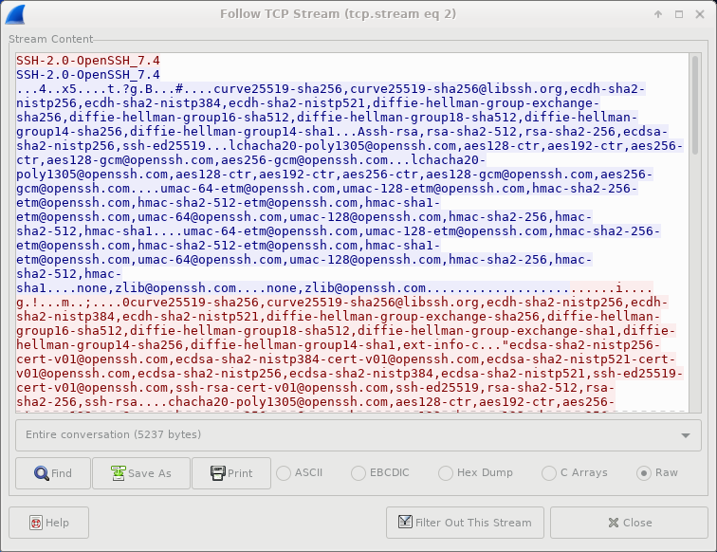
    - After examining your SSH session, click Close.
    - Close Wireshark.

Reflection
Why is SSH preferred over Telnet for remote connections?
_______________________________________________________________________________________
_______________________________________________________________________________________
_______________________________________________________________________________________
_______________________________________________________________________________________
_______________________________________________________________________________________
_______________________________________________________________________________________

Lab – Hashing Things Out

Objectives
Part 1: Creating Hashes with OpenSSL
Part 2: Verifying Hashes

Background / Scenario
Hash functions are mathematical algorithms designed to take data as input and generate a fixed-size, unique string of characters, also known as the hash. Designed to be fast, hash functions are very hard to reverse; it is very hard to recover the data that created any given hash, based on the hash alone. Another important property of hash functions is that even the smallest change done to the input data yields a completely different hash.
While OpenSSL can be used to generate and compare hashes, other tools are available. Some of these tools are also included in this lab.

Required Resources
- CyberOps Workstation VM
- Internet access
- Creating Hashes with OpenSSL
OpenSSL can be used as a standalone tool for hashing. To create a hash of a text file, follow the steps below:
    - Hashing a Text File
      - In the CyberOps Workstation virtual machine, open a terminal window.
      - Because the text file to hash is in the /home/analyst/lab.support.files/ directory, change to that directory:
[analyst@secOps ~]$ cd /home/analyst/lab.support.files/
      - Type the command below to list the contents of the letter_to_grandma.txt text file on the screen:
[analyst@secOps lab.support.files]$ cat letter_to_grandma.txt
Hi Grandma,
I am writing this letter to thank you for the chocolate chip cookies you sent me. I got them this morning and I have already eaten half of the box! They are absolutely delicious!

I wish you all the best. Love,
Your cookie-eater grandchild.
      - Still from the terminal window, issue the command below to hash the text file. The command will use MD5 as hashing algorithm to generate a hash of the text file. The hash will be displayed on the screen after OpenSSL has computed it.
[analyst@secOps lab.support.files]$ openssl md5 letter_to_grandma.txt
MD5(letter_to_grandma.txt)= 8a82289f681041f5e44fa8fbeeb3afb6
Notice the format of the output. OpenSSL displays the hashing algorithm used, MD5, followed by the name of file used as input data. The MD5 hash itself is displayed after the equal (‘=’) sign.
      - Hash functions are useful for verifying the integrity of the data regardless of whether it is an image, a song, or a simple text file. The smallest change results in a completely different hash. Hashes can be calculated before and after transmission, and then compared. If the hashes do not match, then data was modified during transmission.
Let’s modify the letter_to_grandma.txt text file and recalculate the MD5 hash. Issue the command below to open nano, a command-line text editor.
[analyst@secOps lab.support.files]$ nano letter_to_grandma.txt
Using nano, change the first sentence from ‘Hi Grandma’ to ‘Hi Grandpa’. Notice we are changing only one character, ‘m’ to ‘p’. After the change has been made, press the <CONTROL+X> keys to save the modified file. Press ‘Y’ to confirm the name and save the file.
      - Now that the file has been modified and saved, run the same command again to generate a MD5 hash of the file.
[analyst@secOps lab.support.files]$ openssl md5 letter_to_grandma.txt
MD5(letter_to_grandma.txt)= dca1cf6470f0363afb7a65a4148fb442
Is the new hash different that hash calculated in item (d)? How different?
____________________________________________________________________________________
____________________________________________________________________________________
____________________________________________________________________________________
      - MD5 hashes are considered weak and susceptible to attacks. More robust hashing algorithms include SHA-1 and SHA-2. To generate a SHA-1 hash of the letter_to_grandma.txt file, use the command below:
[analyst@secOps lab.support.files]$ openssl sha1 letter_to_grandma.txt
SHA1(letter_to_grandma.txt)= 08a835c7bcd21ff57d1236726510c79a0867e861
[analyst@secOps lab.support.files]$
Note: Other tools exist to generate hashes. Namely, md5sum, sha1sum, and sha256sum can be used to generate MD5, SHA-1 and SHA-2-256 hashes, respectively.
      - Use md5sum and sha1sum to generate MD5 and SHA-1 hash of the letter_to_grandma.txt file:
[analyst@secOps lab.support.files]$ md5sum letter_to_grandma.txt
dca1cf6470f0363afb7a65a4148fb442 letter_to_grandma.txt

[analyst@secOps lab.support.files]$ sha1sum letter_to_grandma.txt
08a835c7bcd21ff57d1236726510c79a0867e861 letter_to_grandma.txt
[analyst@secOps lab.support.files]$
Do the hashes generated with md5sum and sha1sum match the images generated in items (g) and (h), respectively? Explain.
____________________________________________________________________________________
____________________________________________________________________________________
____________________________________________________________________________________
Note: While SHA-1 has not yet been effectively compromised, computers are becoming more and more powerful. It is expected that this natural evolution will soon make it possible for attackers to break SHA-1. In a proactive move, SHA-2 is now the recommended standard for hashing. It is also worth noting that SHA-2 is in fact, a family of hashing algorithms. The SHA-2 family is comprised of six hash functions, namely SHA-224, SHA-256, SHA-384, SHA-512, SHA-512/224, SHA-512/256. These functions generate hash values that are 224, 256, 384 or 512 bits long, respectively.
Note: The CyberOPS VM only includes support for SHA-2-224 and SHA-2-256 (sha224sum and sha256sum, respectively).
- Verifying Hashes
As mentioned before, a common use for hashes is to verify file integrity. Follow the steps below to use SHA-2-256 hashes to verify the integrity of sample.img, a file downloaded from the Internet.
      - Along with sample.img, sample.img_SHA256.sig was also downloaded. sample.img_SHA256.sig is a file containing the SHA-2-256 computed by the website. First, use the cat command to display the contents of the sample.img_SHA256.sig file:
[analyst@secOps lab.support.files]$ cat sample.img_SHA256.sig
c56c4724c26eb0157963c0d62b76422116be31804a39c82fd44ddf0ca5013e6a
      - Use SHA256sum to calculate the SHA-2-256 hash of the sample.img file:
[analyst@secOps lab.support.files]$ sha256sum sample.img
c56c4724c26eb0157963c0d62b76422116be31804a39c82fd44ddf0ca5013e6a sample.img
Was the sample.img correctly downloaded? Explain.
____________________________________________________________________________________
____________________________________________________________________________________
____________________________________________________________________________________
Note: While comparing hashes is a relatively robust method detect transmission errors, there are better ways to ensure the file has not been tampered with. Tools such as gpg provide a much better method for ensuring the downloaded file has not been modified by third parties, and is in fact the file the publisher meant to publish.

Lab – Certificate Authority Stores

Objectives
Part 1: Certificates Trusted by Your Browser
Part 2: Checking for Man-In-Middle

Background / Scenario
As the web evolved, so did the need for security. HTTPS (where the ‘S’ stands for security) along with the concept of a Certificate Authority was introduced by Netscape back in 1994 and is still used today. In this lab, you will:
- List all the certificates trusted by your browser (completed on your computer)
- Use hashes to detect if your Internet connection is being intercepted (completed in the CyberOps VM)

Required Resources
- CyberOps Workstation VM
- Internet access
- Certificates Trusted by Your Browser
HTTPS relies on a third-party entity for validation. Known as Certification Authority (CA), this third-party entity verifies if a domain name really belongs to the organization claiming its ownership. If the verification checks, the CA creates a digitally signed certificate containing an information about the organization, including its public key.
The entire system is based on the fact that web browsers and operating systems ship with a list of CAs they trust. Any certificates signed by any of the CAs in the list will be seen by the browser as legitimate and be automatically trusted. To make the system more secure and more scalable, CAs often spread the task of creating and signing certificates among many child CAs. The parent CA is known as the Root CA. If a browser trusts a Root CA, it also trusts all of its children CAs.
Note: While the certificate stores are similar across browsers, this lab focuses on Chrome 56 and Firefox 51. The menu and graphics may be different for other versions of the web browser.
Follow the steps to display the CA store in your browser:
    - Display the Root Certificates in Chrome.
If you use Firefox, proceed to Step 2. If you use a browser other than Chrome or Firefox, search the Internet for the steps to display your root certificates.
Note: The menu and graphics may be different for other versions of the Chrome browser.
      - Open the Chrome web browser on your PC.
      - Click the three dot icon on the far right of the address bar to display Chrome’s options.
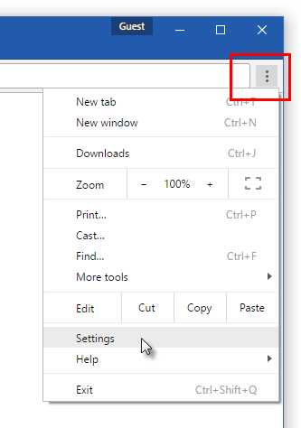
      - Click Settings and then click Show advanced Settings.
      - Scroll down the page and click the Manage certificates… button, under the HTTPS/SSL section.
      - In the Certificates window that opens, select the Trusted Root Certification Authorities tab. A window opens that shows all certificates and certificate authorities trusted by Chrome.
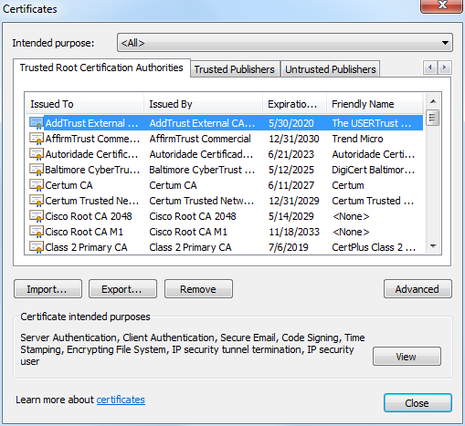
    - Display the Certificates in the CA Store in Firefox.
Note: The menu and graphics may be different for other versions of the Firefox browser.
      - Open Firefox and click the Menu icon. The Menu icon is located on the far right of the Firefox window, next to the address bar.
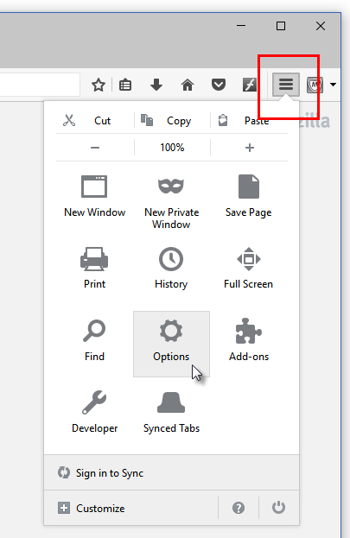
      - Navigate to Options > Advanced.
      - Select the Certificates tab.
      - Click View Certificates. A window opens that shows the certificates and certification authorities trusted by Firefox.
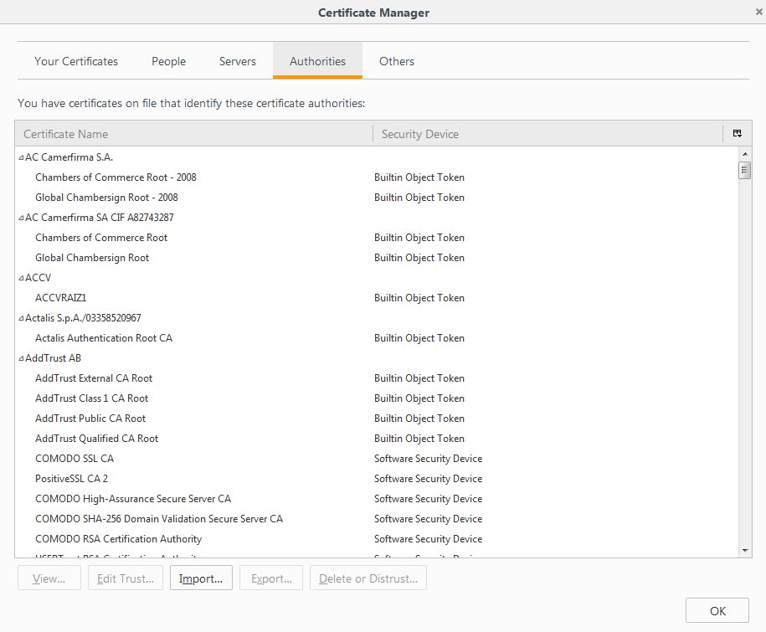
- Checking for Man-In-Middle
This part is completed using the CyberOps Workstation VM.
A common use for hashes is to verify data integrity, but they can also be used to detect HTTPS man-in-the-middle attacks.
To protect user data, more and more websites are switching to encrypted traffic. Known as HTTPS, sites use protocols such as TLS/SSL to encrypt user traffic from end to end. After the traffic is properly encrypted, it is very difficult for any party other than the user and the site in question to see the contents of the encrypted message. This is good for users but it creates a problem for organizations that want to look into that traffic. Companies and organizations often choose to peek into employee-generated traffic for monitoring purposes. They needed to be able to look into TLS/SSL-encrypted traffic. This is done by using an HTTPS proxy.
Web browsers trust the identity of a visited web site if the certificate presented by that web site is signed by one of the CAs installed in the browser’s certificate store. To be able to peek into its users’ TLS/SSL- encrypted traffic, a company or organization simply adds another CA into the user’s browser list of installed CA.
Consider the following scenario: Company X hires a new employee and provides him with a new company laptop. Before handing over the laptop, the company IT department installs all the software necessary for the work. Among the software and packages that are installed, the IT department also includes one extra CA to the list of trusted CAs. This extra CA points to a company-controlled computer known as the HTTPS proxy. Because the company controls traffic patterns, the HTTPS can be placed in the middle of any connection. It works like this:
- The user attempts to establish a secure connection to HTTPS web site H, hosted on the Internet. H can be any HTTPS site: a bank, online store, email server, etc.
- Because the company controls traffic patterns, it makes it so that all user traffic must traverse the HTTPS proxy. The HTTPS proxy then impersonates web site H and presents a self-signed certificate to prove it is H. The HTTPS proxy essentially says “Hi there, I am HTTPS site H. Here’s my certificate. It’s has been signed by… myself.”
- Because the presented certificate is signed by one of the CAs included in the laptop’s CA store (remember, it was added by IT), the web browser mistakenly believes it is indeed communicating with H. Notice that, had the extra CA not been added to the CA store, the laptop would not trust the certificate and immediately realize that someone else was trying to impersonate H.
- The laptop trusts the connection and establishes a secure channel with the HTTPS proxy, mistakenly believing it is communicating securely with H.
- The HTTPS proxy now establishes a second secure connection to H, the web site the user was trying to access from the beginning.
- The HTTPS proxy is now the end point of two separate secure connections; one established with the user and another established with H. Because the HTTPS is the end point of both connections, it can now decrypt traffic from both connections.
- The HTTPS proxy can now receive TLS/SSL-encrypted user traffic destined to H, decrypt it, inspect it, re-encrypt it using TLS/SSL and send it to H. When H responds, the HTTPS proxy reverses the process before forwarding the traffic to the user.
Notice that process is mostly transparent to the user, who sees the connection as TLS/SSL-encrypted (green marks on the browser). While the connection is secure (TLS/SSL-encrypted), it has been established to a spurious web site.
Even though their presence is mostly transparent to the user, TLS proxies can be easily detected with the help of hashes. Considering the example above, because the HTTPS proxy has no access to the site H private keys, the certificate it presents to the user is different than the certificate presented by H. Included in every certificate is a value known as a fingerprint. Essentially a hash calculated and signed by the certificate issuer, the fingerprint acts as a unique summary of all the contents of the certificate. If as much as one letter of the certificate is modified, the fingerprint will yield a completely different value when calculated. Because of this property, fingerprints are used to quickly compare certificates. Returning to the example above, the user can request H’s certificate and compare the fingerprint included in it with the one provided when the connection to the web site H was established. If the fingerprints match, the connection is indeed established to H. If the fingerprints do not match, the connection has been established to some other end point.
Follow the steps below to assess if there’s a HTTPS proxy in your connection.
    - Gathering the correct and unmodified certificate fingerprint.
      - The first step is to gather a few site fingerprints. This is important because these will be used for comparison later. The table below contains a few site certificate fingerprints from popular sites.
Table 1 - Popular Sites and Their SHA-1 Certificate Fingerprints
Site | Domains Covered By Certificate | Certificate SHA-1 Fingerprint
www.cisco.com | www.cisco.com | 7A:48:D0:1C:55:C5:38:90:F6:5B:6D:E5:FD:2E:4F:13:D8:DE:23:9A
www.facebook.com | *.facebook.com | 93:6F:91:2B:AF:AD:21:6F:A5:15:25:6E:57:2C:DC:35:A1:45:1A:A5
www.wikipedia.org | *.wikipedia.org | 58:66:84:EF:77:3E:A0:B8:5F:23:38:73:CB:46:10:E8:D0:E0:8C:B3
twitter.com | twitter.com | 23:5A:79:B3:27:0D:79:05:05:E0:BE:A2:CF:5C:14:9F:90:38:82:1B
www.linkedin.com | www.linkedin.com | 90:32:6F:12:3C:CF:C2:6C:C8:27:85:3E:3C:B6:78:F4:ED:A3:07:F0
What are the fingerprints? Why are they important?
____________________________________________________________________________________
____________________________________________________________________________________
____________________________________________________________________________________
____________________________________________________________________________________
Who calculates fingerprints? How to find them?
____________________________________________________________________________________
____________________________________________________________________________________
____________________________________________________________________________________
____________________________________________________________________________________
    - Gather the certificate fingerprint in use by the CyberOps Workstation VM.
Now that we have the actual fingerprints, it is time to fetch fingerprints from a local host and compare the values. If the fingerprints do not match, the certificate in use does NOT belong to the HTTPS site being verified, which means there’s an HTTPS proxy in between the host computer and the HTTPS site being verified. Matching fingerprints means no HTTPS proxy is in place.
      - Use the three piped commands below to fetch the fingerprint for Cisco.com. The line below uses OpenSSL to connect to cisco.com on port 443 (HTTPS), request the certificate and store it on a text file named cisco.pem. The output is also shown for context.
[analyst@secOps ~]$ echo -n | openssl s_client -connect cisco.com:443 | sed -ne '/-BEGIN CERTIFICATE-/,/-END CERTIFICATE-/p' > ./cisco.pem
depth=2 C = US, O = "VeriSign, Inc.", OU = VeriSign Trust Network, OU = "(c) 2006 VeriSign, Inc. - For authorized use only", CN = VeriSign Class 3 Public Primary Certification Authority - G5
verify return:1
depth=1 C = US, O = Symantec Corporation, OU = Symantec Trust Network, CN = Symantec Class 3 Secure Server CA - G4
verify return:1
depth=0 C = US, ST = California, L = San Jose, O = Cisco Systems, OU = ATS, CN = www.cisco.com
verify return:1
DONE
[analyst@secOps]$
      - Optionally, use the cat command to list the contents of the fetched certificate and stored in the cisco.pem text file:
[analyst@secOps]$ cat cisco.pem
-----BEGIN CERTIFICATE-----
MIIG+DCCBeCgAwIBAgIQIpPAP1dwOYev9c4la/DImjANBgkqhkiG9w0BAQsFADB+
MQswCQYDVQQGEwJVUzEdMBsGA1UEChMUU3ltYW50ZWMgQ29ycG9yYXRpb24xHzAd
BgNVBAsTFlN5bWFudGVjIFRydXN0IE5ldHdvcmsxLzAtBgNVBAMTJlN5bWFudGVj
IENsYXNzIDMgU2VjdXJlIFNlcnZlciBDQSAtIEc0MB4XDTE2MDEyODAwMDAwMFoX
DTE4MDEyODIzNTk1OVowczELMAkGA1UEBhMCVVMxEzARBgNVBAgMCkNhbGlmb3Ju
aWExETAPBgNVBAcMCFNhbiBKb3NlMRYwFAYDVQQKDA1DaXNjbyBTeXN0ZW1zMQww
<some output omitted>
Sh6uGk+n3PvpTJqKJ/VKq9piiURhnwrdk/0592YPNY+wD2SfzbmS+BH83FiWsl4P
iFz/Q4xWexhOecbYFDPjYYUxSDPLNJZM7FW4ES6ix9eKYS9ZzTDdTsbRjI+lVyCO
ey95SKm9B22RgYnZH8qeDbNoUCJ2EnCaiaeZEK6aZygRk6QcVKsBqeKQ73t7cAgn
HU/8V4zZEzp1tJb8tkszqbqcnEDQPwVKYYQcXTs/pEAcr87L+EYNu6GzSEoIvN3i
4xjf9EKogicBLVnGzhvG1RmPg5SgSGqRzWm/JLnixY7sIeH3MltwXwwxyTjw/mto
0/lUKuH3VEEs0wWH
-----END CERTIFICATE-----
[analyst@secOps]$
      - Now that the certificate is saved in the cisco.pem text file, use the command below to extract and display its fingerprint:
[analyst@secOps lab.support.files]$ openssl x509 -noout -in cisco.pem -fingerprint -sha1
SHA1 Fingerprint=7A:48:D0:1C:55:C5:38:90:F6:5B:6D:E5:FD:2E:4F:13:D8:DE:23:9A
[analyst@secOps lab.support.files]$
What hash algorithm was used by OpenSSL to calculate the fingerprint?
____________________________________________________________________________________
Why was that specific algorithm chosen? Does it matter?
____________________________________________________________________________________
____________________________________________________________________________________
____________________________________________________________________________________
____________________________________________________________________________________
    - Compare the Fingerprints
Use Table 1 to compare the certificate fingerprint acquired directly from the Cisco HTTPS site with the one acquired from within your network.
Do the fingerprints match?
_______________________________________________________________________________________
_______________________________________________________________________________________
What does it mean?
_______________________________________________________________________________________
_______________________________________________________________________________________
_______________________________________________________________________________________
_______________________________________________________________________________________
Is this method 100% foolproof?
_______________________________________________________________________________________
_______________________________________________________________________________________
_______________________________________________________________________________________
_______________________________________________________________________________________
- Challenges (Optional)
      - Check the fingerprints for the sites shown in Table-1 but using your web browser’s GUI.
Hints: Find a way to display the fingerprint through the browser’s GUI. Remember: Google is useful in this exercise, and Windows often refers to the Fingerprint as Thumbprint.
      - Use the OpenSSL (Part 2, Steps 1 through 3) to check all the fingerprints listed in Table-1

Reflection
What would be necessary for the HTTPS proxy to work?
_______________________________________________________________________________________
_______________________________________________________________________________________
_______________________________________________________________________________________

