DECLARATION

This work has not previously been accepted in substance for any degree and is not being concurrently submitted in candidature for any degree
Signed Francesca Langdon-Jones

Date…05/04/2019

STATEMENT 1
This dissertation is being submitted in partial fulfilment of the requirements for the degree of BA.

Signed Francesca Langdon-Jones
Date…05/04/2019

STATEMENT 2
This dissertation is the result of my own independent work/investigation, except where otherwise stated.

Other sources are acknowledged by footnotes giving explicit references. A bibliography is appended.

Signed Francesca Langdon-Jones
Date… 05/04/2019

STATEMENT 3
I hereby give consent for my dissertation, if accepted, to be available for photocopying and for interlibrary loan, and for the title and summary to be made available to outside organisations.

Signed Francesca Langdon-Jones
Date…05/04/2019

STATEMENT 4

I hereby give consent for my dissertation, if accepted, to be available on the university’s IT system to those who have consent to use the system.

Signed Francesca Langdon-Jones
Date…05/04/2019

What techniques should be employed within a hospital setting to improve quality of life for those living with Dementia?

Francesca Louise
Langdon-Jones

Dissertation submitted as part of the requirements for the award BSc (Hons) Health and Social Care

ACKNOWLEDGEMENTS

I would like to take this opportunity to thank all the staff who have helped me in my studies over the last three years. Special thanks to my dissertation supervisor Karen Burton who has been a real diamond in keeping me calm and ensuring I was kept on course.

I would also like to thank my University number one Catrin Boulton for supporting me through these years of study and being the one person who knows how to get the best out of me.

My penultimate thanks goes to my two beautiful children Franca and Niall. You are the reason I have put myself through all of this to try and give us as a family a better future and to instil in you the value that hard work pays off! You guys rock and are my reason for waking up every day or cause should I add lol!!

Finally, I want to thank my husband Mark Jones, without his pushing me to join this course and constant assertive kick up the bum required, I would not have got through this course with my almost weekly moan of ‘I can’t do this I am quitting!!’. Thank you I love you.

Without all the people mentioned above this last three years would not have been possible so I wholeheartedly thank you for your patience and support, I know it has been challenging and I truly appreciate you all xxx.
ABSTRACT

Aim: The objective of this study is to discover the techniques required within the hospital ward setting that would to ensure the Quality of Life (QoL) for a person living with dementia (PLD) upon admittance to the hospital setting.
Methodology and Methods: This study implemented a systematic review of primary empirical research. The critical appraisal tool CASP was utilised to ensure rigour in the study.
Findings: results found an emergence of four significant themes resultant from the thematic analysis of the available research. These themes are:
- The Physical Environment: The research suggested that the physical environment can have a noticeable effect on the well-being and QoL of a PLD. These effects range from the negative environment causing agitation to aggression and the dementia friendly environment leading to a higher QoL and better well-being for the PLD.
- Staff Training and Confidence: The very essence of staff training found that even when trained the staff often feel overwhelmed by the demands placed upon them by the PLD. However, numerous staff agree that when they receive the correct training they are then equipped to provide the optimal care for the patient resulting in the patient possessing a higher QoL.
- Person Centred Care: the subject of person-centred care is all the rage at present but nowhere is it more apt than in the care of those living with dementia. Research results highlight how important it is for each patient to be seen as an individual and that the treatment they receive be catered to their needs. These needs are not being met at present as the staff are not always allowed the time needed to implement the PCC for the PLD.
- Activities: Boredom for the elderly and those living with dementia is prevalent and in this research there was an abundance of literature relating to the subject of the need for activities and therapies to ensure the patients well-being and QoL
Conclusions
Findings suggest that there is a plethora of evidence highlighting the needs of those living with
dementia and techniques that can be implemented to aid well-being and QoL, however, there is a
requirement for more research to be carried out into the needs and requirements of those living with
dementia and to gain a better understanding of how to measure the QoL of a person living with
dementia.
Key Words
Person living with dementia, Quality of life, well-being, admittance to hospital, hospital
Environment.

Contents
Declaration i
Title Page iii
Acknowledgements v
Abstract vi
Table of Contents vii-viii
1 Chapter 1: Introduction 1
1.1 Background 1
1.1.1 Dementia 1
1.1.1.1 Quality of Life (QoL) 2
1.2 Hopital Environment 3
1.3 Justification 4
1.4 Aim and Objectives 5
2 Chapter 2: Methods and Methodology 7
2.1 Introduction 7
2.2 Methods and Methodology 7
2.3 Methods Used 8
2.4 Ethical Considerations 9
2.5 Creation of Themes 9
3 Chapter 3: Thematic Analysis of Literature 11
3.1 Introduction to Chapter 11
3.1.1 Findings and Gaps in the Literature 11
3.1.1.1 Methodological Weaknesses 12
3.2 The Physical Environment 12
3.3 Activities 15
3.4 Person Centred Care (PCC) 18
3.5 Staff Training and confidence 21
3.6 Chapter Conclusion 24
4 Chapter 4: Conclusion and Recommendations 25
4.1 Overall Conclusion 25
4.2 Recommendations 27
4.3 Future Research 28
References 29-43
Bibliography 44
Appendix 1: Search Strategy 45-47
Appendix 2: Planning Gantt Chart 48
Appendix 3: Example of CASP Questionnaire 49-51
Appendix 4: CASP serach sheet 52
Appendix 5: Evidence of CASP Questionnaire Usage 53-60
Appendix 6: Evidence of creation of Themes 61-64
Appendix 7: Research Recording Table 65
Appendix 8: Thesis Search Sheets 66-83

1. CHAPTER 1: INTRODUCTION AND BACKGROUND

Introduction to Thesis

This dissertation examines the techniques that would prove beneficial to the Quality of Life (QoL) of patients with dementia upon implementation into the hospital ward setting. The worldwide total of people living with dementia is set to rise by 204% by 2050 (Dementia Statistics, 2019) and as a result it is paramount that these techniques are initiated and perfected to ensure that these persons can receive quality care within a hospital setting whilst having a semblance of QoL. This is where the Dementia Friendly Hospital Charter 2018 (Dementia Action Alliance, 2018) should come into action as its aim is to provide a framework that ensures the person living with dementia (PLD) and their family members are able to gain access to dementia friendly hospital services. Within the Charter are The Dementia Statements (2017) which if adhered to should allow an improved experience for the patient living with dementia upon hospital admittance. The improvement in patient experience can only aid in improving the QoL of the patient and these QoL measurements are an integral part of dementia care through aiding in the identification the interventions required (Römhild et al, 2018). The following section will examine the background of the subjects: Dementia, QoL and Current Techniques implemented within the hospital setting. These subjects will be discussed, and all definitions will be explained.

1.1 Background
1.1.1 Dementia
The umbrella term ‘Dementia’ (Collier et al, 2015) refers to a group of syndromes that the World Health Organisations ICD-11 (2018) specifies as being a progressive syndrome, that by its very nature produces a deterioration in a person’s cognitive functions that is unrelated to that of the usual ageing process. This syndrome’s progression eventually disables the person as they lose the skills that they once acquired to live their life independently (Eastham and Cox, 2016). In addition to dementia causing complications with the person’s cognitive processes, dementia also causes disturbances with the psychological and behavioural side of the person and this can severely affect the person’s QoL (Pink et al, 2018).
Within Wales there are currently 21,895 people who have received a dementia diagnosis (Welsh Government, 2018) and evidence suggests that a reported 56% increase in the number of people gaining a diagnosis of dementia was recorded between the years of 2010/11 and 2015/16 (Alzheimer’s Research UK, 2018b). Even with the increase in diagnosis recent research estimates that the amount of people living with dementia in Wales is far more prevalent with between 38,444 and 55,829 people affected (Jones, 2018). Current statistics declare that the total amount of people estimated to be living with dementia in the United Kingdom (UK) is 850,000 (Alzheimer’s Research UK, 2018a) with a recent study reporting that 1 in 2 women and 1 in 3 men will inherit this disease (Licher et al, 2018).
There is an unprecedented strain being placed upon the National Health Service (NHS) due to the increasing ageing population that is causing a financial burden on the already over stretched service (Robertson et al, 2017). There is no sign of this problematic increase lessening with Guzman- Castillo et al (2017) claiming that the ageing population is set to increase by 19.4% between 2015 and 2025 and with the risk factor of developing dementia substantially increasing the older a person gets the prevalence of dementia is likely to increase (Alzheimers Society, 2016). The NHS strain is further intensified by the bed occupancy that the dementia patients acquire on the acute wards, with 25% and above bed occupancies being occupied by the persons living with dementia within the UK hospital system (Handley et al, 2017).
Although dementia typically affects the over 65’s age group, 5% of all those diagnosed with dementia in the UK are below this age and these 42,000 people are classed as having Young-onset Dementia (YoD) (Young Dementia UK, 2018). There are real concerns arising for those diagnosed with YoD as the mainstream services are predominately designed for the older generations and are found to be unsuitable for the requirements of those living with YoD (Rabanal et al, 2018).
1.1.1.1 Quality of Life (QoL)
When searching for the definition of QoL there are a plethora of definitions unearthed, (Barcaccia et al, 2013) and the consensus is that QoL is problematic to define, however, Theofilou (2013), Chaturvedi and Muliyala (2016) and Murgas (2016) all agree that it is a multifaceted subjective concept that emanates from the feeling of having a good life. The QoL of a person living with dementia is hard to equate nevertheless, it can be said that the QoL is largely related to the quality of care the person receives (Bökberg et al, 2017).
1.2 Hospital Environment
The PLD is usually afflicted with 3-4 comorbidities running alongside their dementia diagnosis. These comorbidities require numerous hospital admissions that will generally last five times longer than that of a patient without dementia (Timmons et al, 2016 and Alzheimer’s Society, 2016). The environment within a hospital is not conducive to the care of the PLD, with the patient often suffering adversely with falls and a loss of function attributed to the inadequate care received by the patient, resultant of staffing issues and insufficient staff training (George et al, 2013). The Alzheimer’s Society (2009) Counting the cost report, emphasised that 54% of dementia patients claim their hospital admittance had damaging effects upon them resulting in an aggravation of their symptoms, with a further 77% claiming dissatisfaction with the care received. The year 2012 was a landmark year for the PLD as the Dementia Action Alliance partnered up with the NHS Institute for Innovation and Improvement in an attempt to improve the care for those living with dementia upon admission into acute hospitals (Blackburn et al, 2012). This led to the dementia friendly hospital initiatives being introduced. The amount of hospital trusts signed up to become dementia friendly following the 2012 call to change is unclear, however, it is clear that there are still copious amounts of improvement required in the provision of care that is received by the dementia patient whilst admitted to the hospital environment (Alzheimer’s Society, 2015).
Several Techniques currently employed within the hospital setting
- The ‘This is me’ form (Alzheimer’s Society, 2018).
This form is a useful tool that can be used in a multitude of settings. It allows the health and social care staff to have an insight into who the PLD is allowing the person to be seen as an individual and aiding in the delivery of person-centred care.
- The Butterfly Scheme (Butterfly Scheme, 2017).
The butterfly scheme is a system that has been created in order to allow an easy identification system for those PLD whilst admitted to hospital. Usual practice is to display a butterfly above the patient’s bed and on all paperwork to ensure that all the staff are aware of the person’s diagnosis and can proceed with the patient’s best interest in mind.

- Admiral Nurses (Dementia UK, 2017).
These nurses provide specialised dementia support for the PLD and the families. These highly experienced nurses can provide a real lifeline when difficulties are encountered.
- NHS Staff trained in dementia care
The Department for Health announced in the Delivering high quality, effective, compassionate care: Developing the right people with the right skills and the right values mandate that all NHS staff would be able to access training in Dementia care (Crown, 2014).
- Dementia Friends initiative
The initiative allows the dementia friend to gain an understanding of life for a PLD and then putting this knowledge into action. This action can be through volunteering to be a friend to someone living with dementia or just simply reiterating the knowledge gained with others to educate them about the initiative and dementia (Dementia Friends, 2017).
- Advanced Care Planning
This type of planning is whereby the individual can deliberate and decide on their wishes and make important decisions for the future at a time when they still have the capacity to make these decisions for themselves. The advance care planning usually consists of 3 parts: future needs and wishes statements, refusal of treatment advance decision making and power of attorney (Social Care Institute for Excellence, 2015a).

1.3 Justification
A PLD struggles with unfamiliar environments (NHS, 2017). The hospital ward can prove overwhelming for a person living with dementia (NHS Education for Scotland, 2016) as many wards are not designed for the needs and requirements of the dementia patient with no thought for the physical and psychosocial elements of the ward (Brooke and Semlyen, 2017). When the wards are faced with housing 25% of the beds to persons living with dementia it can prove to be a challenging environment for the staff and the patients alike (Porock et al, 2015). The PLD often reacts in a disruptive manner as the unfamiliar environment of the hospital ward is traumatic for the patient and can result in adverse behaviours manifesting (Digby et al, 2016). In addition to the stress felt by the dementia patient there is also the fact that most PLD are required to remain in hospital for longer periods than other patients (Timmon et al, 2015).
Andrews and Butler (2014) highlight the problems faced within a hospital setting for those PLD. In the Trusted to Care Review concerns were raised regarding staff training, the lack of use of the dementia schemes in place, inappropriate sedation of patients and ward environments being unfit for dementia patients. The trusted to care review only examined two hospitals, however, the problems addressed in this review are not exclusive to these two hospitals as the quality of care for dementia patients hospitalised is acknowledged to be of a poor standard universally (Tanajewski et al, 2015; Goldberg and Harwood, 2013 and Beardon et al, 2018). In a report by The Lancet (2018) it is testified that persons in receipt of poor care standards will have a reduced QoL and for care of those living with dementia to be improved bold changes need to be made within the infrastructure of hospital settings. With the significance of this study now having been set out the subsequent section will discuss the aims and objectives of this dissertation.
1.4 Aim and Objectives
The primary aim of this dissertation is to examine and evaluate techniques that should be employed within a hospital setting emphasising on the improvement of the QoL for those living with Dementia. To ensure this is accomplished, an analysis of all the current techniques that are currently implemented within the hospital setting will be necessary and a thorough investigation into the current difficulties faced by those living with dementia upon hospital admission.
The objectives of this research are to:
- Define and describe Dementia, QoL and the current techniques that are employed within a hospital setting.
- Complete thorough a literature review of techniques that should be implemented to improve the QoL of persons living with dementia.
- Examine the scientific evidence supporting these techniques and that of new techniques.
- Evaluate the techniques and the affect they have on QoL.
- Discuss the requirement for Dementia friendly hospitals and wards.
- Make recommendations for improvement of techniques to be implemented.
This undertaking has emphasised the absence of adequate staff training, the unsuitability of the acute wards for the dementia patient, the lack of person-centred care available and the boredom that arises in the dementia patients due to an absence of interaction and activity. These issues highlight the need for dementia friendly wards that are operated by fully trained staff who have an understanding of the person-centred care required for dementia patients. The following chapter will discuss the methodology and methods employed within this dissertation.

2. CHAPTER 2: METHODS AND METHODOLOGY

2.1 Introduction to Chapter
Chapter one has outlined the necessity for techniques to be implemented within the hospital setting to ensure a marked improvement in the QoL for the PLD whilst admitted to hospital. The subjects of Dementia, QoL and Hospital Environment were discussed in detail. The intention of this section: Chapter 2 is to discuss the methodology and methods used in the research and planning of this dissertation.

2.2 Methodology and Methods
A methodology is the design, utilisation and implementation of appropriate research methods specific to the area of study whilst providing the researcher with the opportunity to design the appropriate research strategy for the study (Greetham, 2014).
The methodology utilised within this study is a systematic review. A systematic review is defined as a systematic search of the evidence and in the case of this dissertation primary empirical data identified and appraised in the specified area is then synthesised together with all the best evidence found and sourced (Gopalakrishnan and Ganeshkumar, 2013 and Mahtani et al, 2018). Gough et al (2017) explains that systematic reviews are deemed important in the research process as they are a reliable method of gaining evidence through a meticulous review of all available material in the subject area. Bonfield et al (2018) suggest that in the interest of obtaining quality research it is imperative that all relevant studies be critically reviewed. It has been argued that systematic reviews do not provide studies with enough rigour that is present when conducting primary research (Ham-Baloyi and Jordan, 2016), however, alternatively it has been argued that systematic reviews are more rigorous because of the systematic method used in the gathering, selection and evaluation of the evidence (Gough et al, 2017).
A systematic review is being used in this dissertation as it was deemed the most appropriate method to provide a thorough summary of primary research (Clarke, 2011). A systematic review allows areas of inadequate evidence to be identified through the critical appraisal of all relevant materials that have been collected. Every systematic review requires a strategy to limit bias in the production of the research (Egger et al, 2013 and Charrois, 2015). Bell and Water (2010) and Grewal et al (2016) state that the reviewing of literature can be both demanding and time-consuming, however, the review of literature allows for a systematic approach to research to be adopted and produces good evidence-based information that is clear, concise and free from bias (Aveyard, 2014 and Faggion Jr et al, 2016).
To ensure rigour within the research the information retrieved was thoroughly reviewed through the employment of a Critical Appraisal skills tool. This tool will provide assistance in ensuring that there is thorough understanding of the subject area. The intention to use the critical appraisal skill tools will ensure that all the research used within this study meets the required criteria. The critical appraisal skills tool chosen for this research as aforementioned will be the CASP qualitative checklist (See Appendix 3). CASP consists of a 10-question checklist primarily designed to aid the understanding of qualitative research. The questions intentions are to screen the research literature, supporting the researcher in the decision-making process, as to whether the literature is valid and worth proceeding with (CASP, 2018). The utilisation of CASP ensured the research employed in this study was beneficial and all inadequate research be excluded. CASP is a quality appraisal tool that allows studies being reviewed to be thoroughly assessed to check the study for rigour (Smith and Noble, 2016).
When the search strategy was put into practice it became evident that it was not going to be straightforward finding the relevant material for this dissertation. This made it fundamental to the research that a good search strategy method be implemented to ensure that the research unearthed the pre-eminent material for this dissertation. Bramer et al (2018) suggest that it is important to follow a step by step method to ensure good results and to keep the research process on track when conducting a search strategy. In the case of this dissertation, an extensive search strategy was employed (See Appendix 1) and to ensure that the dissertation was kept on track a Gantt chart was produced with a timescale set for each segment of the study (see appendix 2).

2.3 Methods Used (CASP)
When using the CASP questionnaire the first two questions help the researcher to screen the journals found. These questions are important as they aid the researcher in decision making concerning the validity of the journal and allow them an opportunity to decide whether to proceed with using this journal. Therefore, when performing the CASP questionnaire and the first two answers were ‘NO’ or ‘Can’t Tell’ it was decided to not continue with the questionnaire and disregard that journal as a way of saving time. The process of research is a time consuming, lengthy process and wasting time on unusable journals was only going to result in less time available for the informative journals.
(See Appendix 3 for example of CASP Questionnaire and Appendix 4 for CASP search sheet and Appendix 5 for evidence of CASP sheets completed)

2.4 Ethical Considerations
The ethical considerations in research are a prerequisite and fundamental in all good research (Denscombe, 2014). Sibingha (2018) and Yip et al (2016) agree that ethics are an important factor of research and are employed to ensure that the consent of the participants are obtained and to safeguard that there is no risk of harm to the participants.
It is important to note that persons living with dementia are often excluded from research (Groen-van de Ven et al, 2017), however, recommendations have recently been made that persons living with dementia should be involved in all areas of research, especially in studies that are based on the realities and subjective experience of living with dementia (Morbey et al, 2019 and Cridland et al, 2016). In the past the lack of available guidelines has deterred studies from including those living with dementia (Doyle et al, 2013). The difficulties faced with the inclusion of the PLD are numerous and keeping this at the forefront of the research was important. This dissertation assessed all studies to ascertain that the ethical considerations were taken when these individuals were interviewed and used as part of the studies.
This thesis will conduct secondary qualitative research and as a result will not require ethical reviews to be in place. The empirical research sourced for the thesis will be examined to ensure that ethical considerations were made and upheld. All material sourced will be held to the highest standards of good practice and will ensure all work carried out meets with the Research Ethics & Integrity Code of Practice of the University.

2.5 Creation of Themes
The thematic analysis of the research allowed for any overriding themes in the evidence to become apparent. When conducting this analysis it was imperative to ensure refinement of the searches were made to ensure all relevant material was found. This included different search terms being utilised and further refinement required in order to find the most up to date current material. The whole process proved to be very time consuming and frustrating, however, the analysis stage of the material identified that there were four overwhelming themes.
These four themes were unearthed in journals that had been deemed valuable to the study following the implementation of rigorous search protocol strategies. Upon discovery these journals were then studied and the findings recorded in order to find any emerging patterns. To ensure this process was less problematic a Research Recording Table (RRT) was created to record all of the important information down for each of the journals. This RRT recorded the authors name and date of publication first, followed by the aim of the paper, type of study, the key findings and the strengths and weaknesses of the journal (see Appendix 7). It was in the key findings section that the themes became apparent. Upon completion of studying the journals and the RRT completed, it became obvious which of the key findings were in higher quantity and a pattern emerged. The themes that recurred more frequently were recorded as being the themes that would be utilised for the purpose of this study.
The themes that emerged were:
- The Physical Environment
- Activities
- Person Centred Care
- Staff Training and confidence
For evidence of the creation of themes see Appendix 4.
These themes will be further examined in greater detail in Chapter 3.

3. CHAPTER 3: THEMATIC ANALYSIS OF LITERATURE

3.1 Introduction to Chapter There is an abundance of interest surrounding the topic of Dementia. This interest has resulted in a plethora of themes being discovered that have been investigated by researchers. A limitation of this study is that it would prove impossible to examine each of these themes individually and as a direct result of this studies limitation, the decision was made to focus attention on the following four recurring themes: the Physical Environment, staff training and confidence, the use of person centred care and Activities.

3.1.1 Findings and Gaps in Literature
As aforementioned in Chapter 2 there is a shortage of research that embraces the testimony of the PLD. This lack of research indicates a gap in the research literature. There are practices accessible that can be instilled into research to eradicate this, one such practice being the utilisation of proxy consent, whereby the spouse or caregiver consents on behalf of the individual (Higgins, 2013). It had become common practice to exclude the PLD from all research, although, there is a real drive to promote the inclusion of these individuals into research studies especially in matters pertaining to dementia care and services on offer (Lepore et al, 2017). The Nursing Times (2013) indicate that dementia research is to the understanding of this debilitating condition and claim that there is growing demand for research into dementia due to the conditions lack of treatments and cure. However, for the PLD to participate in research there are serious ethical considerations that must be overcome and considered, and if this is to become a reality there is a necessity for there to be further development into the ethical guidelines concerning this matter (Hegde and Ellajosyula, 2016). Researchers often cite the inability to gain the individuals consent as the reason the PLD are not included research studies (Helmchen, 2015). Lee et al (2018) support this view and conclude that there is a genuine demand for the development of an instrument that would specifically have the ability to assess the QoL of the PLD.

This dissertations question relates directly to the hospital setting; however, upon studying the literature it was discovered the majority of studies relating to the dissertation question were undertaken within the care home setting. Whilst this could be interpreted as a limitation of the study it accentuated the fact that this dissertation is considering a question that has not been thoroughly examined. Additionally, none of the studies that were found in the search have looked at the QoL of the PLD that has YoD. This may be a result of the search terms used as YoD was not entered, however, having the testimony of the PLD with YoD would have added real weight to the dissertation.

3.1.1.1 Methodological Weaknesses Identified
The recruitment process of participants within numerous studies observed that the PLD was habitually not included in the research. This subject surfaced in several of the studies with the testimony of carers and family members taken in relation to the PLD and their perceived QoL. The communication problems arising around the PLD is often cited, however, requesting someone try to perceive another’s QoL is bound to create uncertainty in the results.

When using Bi-Proxy consent it is important to air on the side of caution as whilst it is useful for gaining the consent for the PLD to participate in research, it is often the perceived views of the caregiver that are given in regards to the answers provided and not that of the PLD and thus may not represent a true account of the individuals beliefs and feelings (Arons et al, 2013).

3.2 The Physical Environment
The following section will discuss the theme of the physical environment and how the environment can instigate an improvement in the QoL for the PLD during their hospital admittance. Acknowledgement is made that hospitals are struggling in their provision of appropriate environments for the dementia patients (Yates-Bolton et al, 2012). Chaudhury et al (2018) suggest that the physical environment is important for those with cognitive impairments and add that due to the growing body of evidence in this area the physical environment is of real importance and demands recognition. Similarly, Waller and Masterson (2015), Mobley et al (2017) and Woodridge et al (2018) claim that the environment a person lives within has an overwhelming effect on a person’s physical and psychological wellbeing, all agree that the physical environment and surroundings can have a direct effect on the QoL of the PLD, conversely, Palm et al (2017) somewhat disagree as their study failed to find a difference between those living within a dementia friendly ward and an acute ward and their level of QoL.

Fisher et al (2017) conducted a study aimed at gaining understanding of how building design can affect the QoL of the PLD. This case study adopted a methodical approach using semi-structured questions directed to the n=15 participants. The participants were invited to take part in the study rather than recruited and consisted of ten residents from a care home and 5 staff members. A hybrid opportunity sample was performed for the convenience of the participants and the researchers. In an attempt to gain a good rapport with the participants the researchers adopted the use of shared interests. As mentioned in the study, this type of approach to research can be susceptible to bias due to the small sample of participants. Future research in this area should look to expand the sample size of participants in order to lessen the bias as small sample sizes can compromise the findings of a study (Faber and Fonseca, 2014).

The outcome of the Fisher et al (2017) study suggested that there is a necessity for a safe environment for both the residents to reside in and the staff to work within, this is a view that Ames et al (2017) agree with, stating that the staff must feel safe and secure in work whilst also providing a safe and secure environment for the PLD. Upon the physical survey of the care home it was revealed that many doors and exits were kept locked and when questioned regarding this matter, the residents stated that they felt controlled and anxious, conversely, the staff claimed that the doors remain locked to ensure the residents own safety. The environment that the residents are currently living in is in fact causing frustration and agitation to the residents as they feel trapped inside the home, however, Stevenson et al (2010) argue that a secure locked facility can prove useful for the care of those patients who are problematic to care for, a view that Eastham and Cox (2016) agree with as their study discovered that an environment providing security was conducive to a high wellbeing score amongst their participants.

Eastham and Cox’s (2016) study observed that the design of the ward environment promoted patient’s well-being. This small-scale study of n=8 participants worked full time on an acute dementia friendly ward. The recruited participants were deemed a valuable representation of the multidisciplinary team within the hospital and the selection process used a snowball sampling technique. This technique could have caused limitations in the study as there was a potential for bias that can be found in the convenience sampling of the snowballing approach (Stangor, 2014), however, the researchers took great care during the recruitment process to limit the possibility of bias. The study chose a mixed methods approach implementing a questionnaire designed specifically for the study and the employment of an environmental assessment tool designed by the King’s Fund (2014). The data collected was analysed using thematic analysis. The analysis highlighted that the participants all agreed that the physical environment of the ward being dementia friendly was beneficial to the patients, as it produced a positive effect on the patient’s mood. Marquardt et al (2014) are in agreement that the physical environment is beneficial to the PLD as they discovered in their study that the built environment can have a beneficial results for the PLD in relation to mood and behaviours, a finding which is supported by the study conducted by Fleming et al (2016).

Fleming et al (2016) designed their study to explore the relationship between the physical environment and the person living with dementia. Participants were chosen from a group of 35 general care homes, with a total number of participants deemed eligible to take part being n=275. The data collected was wherever possible collected from the residents themselves, a real strength of the study as who better to testify about their feelings towards the physical environment than the person who it effects (Frank and Forbes, 2017). However, on occasion it was essential to speak with staff, to make observations or to gain access to participant’s clinical records. The data was analysed utilising linear regression. The assessments relating to the environment were performed separately to the QoL assessments. The researchers used the Environmental Audit Tool (EAT) (Bennett and Fleming, 2013) in this study to assess the environment of the residential homes, whilst the QoL was assessed using DEMQOL, which is a reported outcome measure that was designed to measure QoL for persons living with dementia (Hendriks et al, 2017). The limitation of the Fleming et al (2016) study arise in the participants themselves. Only 60% of those deemed eligible had received a formal diagnosis of dementia with the other 40% of participants having only reported some memory loss. Therefore, this could result in the findings proving inconclusive, as the studies very aim pertains to those living with dementia, this is an issue that could have been avoided if the researchers had used purposive sampling as this type of sampling identifies the diverse population required for the study (Martinez-Mesa et al, 2016). Additionally, the researchers state the studies limitations were that the study did not consider the quality of care of the patient which has a strong link to quality in environment (Kieft et al, 2014). The findings of this research support the view that there is a positive relationship between the environment and the QoL of the person living within it, this is in direct contrast to the study performed by Bicket et al (2010) which demonstrated that QoL was not associated with environment. Additionally, the study highlighted that higher QoL was found in homes that provided activities for the residents, a view supported by Active Minds (2016) stating that activities for PLD reduce boredom and depression. The theme of activities will be discussed in greater detail in the next section of this chapter.

The three studies Fisher et al (2017), Eastham and Cox (2016) and Fleming et al (2016) that are described in detail in this section, demonstrate that the physical environment has an overriding effect on the QoL and well-being of the PLD, thus supporting the physical environment as a theme in this dissertation.

3.3 Activities
This section examines in detail the theme of Activities combined with the effect activities have on the QoL of the PLD. NICE (2013) suggest in the Quality Standards on the mental wellbeing of older people in care homes, that residents in care homes should be offered the opportunity to participate in meaningful activities that promote their wellbeing. Similarly, Ruthirakuhan et al (2012) discovered that dementia patients were less likely to feel depressed and have a higher QoL when they were able to perform activities and therapies. The patients in Ruthirakuhan et al (2012) study are reported to have expressed that they felt activities were the only thing they were able to do for themselves. Särkämö et al (2014) discovered that musical activities can result in improvements in the cognitive and emotional well-being of the PLD and make suggestion that these type of therapies should be implemented into dementia care as standard, however, Ojagbemi and Akin-Ojagbemi (2019) found little evidence in their study to support activity and exercise as having a positive effect on the QoL of the PLD, furthermore, Orrell et al (2017) add weight to this with their studies finding disputing this theory, stating that therapies and activities do not have a marked improvement on the dementia patients QoL.

Godwin and Poland (2015) proposed in their study to examine how a person with dementia feels about their sense of self and their emotions. The mixed methods study had the participants chosen purposively with the participants n=10 all being residents in a care facility or residential home. The participants were exposed to semi-structured empathetic interviews, these interviews concentrated on the persons feelings rather than fact in an attempt to avoid any questioning that may cause the participant to feel panicked or humiliated. The researchers found that gaining the data was challenging with all participants being in the early stages of advanced dementia, which often lends to the patient being unable to verbally communicate accurately. The researchers decided that at no point in the study would the word ‘dementia’ be used in an effort to avoid provocation of fear or negative feelings. Data analysis proved difficult with the communication impairment present due to the nature of dementia. The Social Care Institute for Excellence (2015c) asserts that there are difficulties faced in terms of communication as dementia progresses as the condition generates a barrier to understanding of conversations and explaining feelings which becomes problematic leading to feelings of isolation. The limitations and strengths of this study lie in the participants. The limitations being in the small sample of participants recruited as Malterud et al (2015) suggest a small sample size can lead to a lack of saturation in the study. The strength of the study is found in the utilisation of the PLD within the research, a concept that is strongly championed by the prime minister who has set a challenge that 10% of all those taking part in dementia research must have received a dementia diagnosis (Alzheimer’s Research UK, 2019). The findings of this research discovered a continued sense of wellbeing in the participants especially those living in the homes that offered a wide range of activities, however, it was noted that participants still reported boredom at times, a common theme that was apparent in the Chung et al (2017) study which found that often the individual is bored through lack of encouragement to engage in activities and in this study the PLD was encouraged to engage by their carers or family members.

Chung et al (2017) unearthed in their study the link between activity and a person’s wellbeing. This bi-phase study included the use of in-depth interviews and focus groups with the participants being the carers of the individuals living with dementia. Phase 1 was the interviews stage which employed the use of n=15 participants and Phase 2 consisted of five focus groups with participants totalling n=21. The participants included ex-carers, this allowed for an examination into all stages of the condition, Saunders et al (2018) suggest that this brings strength to a study as it provides the study with saturation of concepts. Both phases were recorded and transcribed verbatim with data entered into the Nud*ist software package to successfully manage the large amount of data collected. The data analysis was carried out through the researcher’s constant discussions. The study found that the carers provided a sense of wellbeing for those they cared for through supporting the individual to undertake enjoyable activities. This was apparent even when the individual’s cognition was in decline and they wished for inactivity which was refused by the carers in an attempt to maintain meaningful interactions and activities. The strengths of this study lay in the experienced data that was collected and the knowledge and insight gained from the carers whom had been involved in a longevity of care. Smebye et al (2012) would somewhat disagree with the carer being insightful into the perceptions of the PLD as in their study inconsistencies were found in how well the carers opinions coincided with those of the PLD. However, Chung et al (2017) have utilised the PLD in their research, stating that the PLD is the most insightful person to question about the subject, a view the Alzheimer’s Society (2017) advocate through their plan to ask the experts about dementia with the expert being the PLD. The limitations of the study also lie with the participants, as in the role of care giver the onus is on the care and best interest of the cared for person and this can lead to inconsistencies in the information gathered with the participant giving their personal feelings and beliefs about the individual rather than getting the information from the cared for person themselves. However, what was undeniable in the research was that there is a clear link established between the initiation of meaningful activities for the individual by the care giver and the individuals perceived well-being, similarly, Wright (2016) found that the introduction of activity enhanced the individual living with dementias positive well-being.

Wright (2016) in his study sought to discover how the person living with dementias wellbeing was affected when they were involved in community-based exercises including walking, dancing and exercise groups. The study implemented an ethnographic approach of interviews and participant observations. The recruitment of participants adhered to the Mental Capacity Act 2005, whereby, the person diagnosed with dementia is assumed to have capacity until a diagnosis of lack of capacity is made, this is very important in the case of the PLD as it ensures that they are safeguarded from potential harm and ethics are upheld (Alzheimer’s Society, 2019). The recruitment process was the same for the interview stage and also the participant observation stages and was carried out during meetings with the individuals at day centres. At these meetings the researcher would gauge the interest of each person and once there was a sense of interest the person was then asked for consent (if unable to give consent due to lack of capacity the consent was sought from another source). Participants were of a mixed ethnic group: in the interview stage n=11 were persons diagnosed with dementia whilst the participant observations stage n= 26 consisted of 19 persons diagnosed with dementia and 7 carers both informal and formal. All data collected was analysed using constructionist theoretical perspectives. The findings of this study support the evidence base signifying that PLD feel positively about activity and embrace the chance to be involved in it (Cohen-Mansfield, 2018 and Social Care Institute for Excellence, 2015b) and resulting from this a higher sense of well-being was achieved by the PLD. The limitations of the study as stated by Wright (2016) were the participants themselves as they were all PLD, however, it could be argued this is a strength of the study as it takes into account the views of those living with dementia which is a prerequisite of the NICE guidelines (2019) which declares that the PLD should be involved in all aspect concerning their care. Windle et al (2016) took this into account when recruiting their participants as they chose to obtain testimony from the PLD as well as carers and staff thus ensuring depth in their findings.

The three studies: Godwin and Poland (2015), Chung et al (2017) and Wright (2016) clearly support activities as a theme in this dissertation. All the studies argue that QoL and well-being can become heightened for the PLD when they are encouraged to engage in activities and therapies.

3.4 Person Centred Care (PCC)
According to NICE (2018) the principles of PCC endorse good dementia care with the principles promotion of the person as an individual with their own personal needs, perspectives and relationships. Terada et al (2013) and Rokstad et al (2013) agree that PCC leads to an improvement in the individuals care that then results in a higher QoL for the individual. Conversely, there is a requirement to be realistic about the constraints and barriers that are placed upon the staff within the hospital settings in their performance of PCC, the main issue arising from the time constraints set upon staff, with most stating that the majority of their time is being spent engaged in the personal care of the patient leaving very little time for the time consuming PCC (Moore et al, 2016 and Golberg et al, 2014); nevertheless, Kim and Park (2017) have reported that PCC when performed significantly improves the QoL of the PLD.

Ballard et al (2018) conducted their study within three hubs in the South and North London and Buckinghamshire areas. These recruited hubs consisted of 69 nursing homes with the studies duration being over a period of nine months. The researchers performed a randomised controlled cluster two-arm trial comparing the Improving wellbeing and health for people with dementia programme (WHELD) against the treatment as usual (TAU). The participating nursing homes received training for their staff in PCC and social interaction and education about antipsychotic medicines. Participants were screened through the use of the Clinical Dementia Rating (CDR) which detects the criteria for a dementia diagnosis and the participants had to score one or greater to be considered. At the outset of the study n=1,006 individuals consented to participate and n=847 were randomly chosen to either receive TAU or WHELD. Follow up of the initial study saw participation by only n=553 participants with mortality cited as a factor.

The limitations of this study were found to be in the assessment of the patient group as persons with dementia are cognitively challenged and this can often cause problems in assessment. Nevertheless, as aforementioned the participants being PLD can also be the strength of the study as their testimony adds real weight to a study concerning the PLD. The study’s findings were that the WHELD programme presented an improvement in QoL and rates of agitation with a marked increase in the positive interactions between dementia patient and staff in comparison to TAU programme. The WHELD programme benefits those living with dementia within a care home as the programme promotes the use of PCC which has been proven to have significant benefits in improving QoL (Fossey et al, 2014). The study concludes that the implementation of programmes that enhance PCC is in the PLD best interest, a view agreed with by the Baillie, Sills and Thomas (2016) study.

Baillie, Sills and Thomas (2016) in their study aimed to investigate the personal perception felt by members of staff following watching the films called Barbara’s Story. This ethnodrama follows Barbara an elderly woman who is in the early stages of dementia and exposes her experiences whilst in hospital and out in the community as her dementia progresses. Barbara’s story initiative was a project launched in the NHS in England which aimed to promote engagement between staff and dementia patient in relation to their experiences within healthcare. The film series identified the need for the use of PCC when presented with a patient with dementia.

This qualitative study implemented focus groups in a two-phase longitudinal design run over a six month period. Participants were chosen using purposive sampling methods set for the inclusion of all the different professions varying from nursing staff to allied health professionals. Participants n=80 took part in the focus groups with varying sizes ranging from 2-14 as the researchers found they had to be flexible due to the nature of the participants acute work environment. Following the viewing of the films the groups were interviewed using a combination of open questioning and then more direct questions to probe into the participants personal feelings. These sessions were recorded in the presence of two researchers one of whom was recording the non-verbal communication that was displayed and the recording were transcribed following the sessions. Data analysis was carried out using the five-stage framework approach which is the familiarisation of the data, identification of a thematic framework, indexing, charting and mapping and interpretation (Ritchie and Spencer, 1994).

The strengths of this study were found to be in the longitudinal design whereby the perception of the participants was acquired over a period of time and additionally, there was strength found in the rich data that was gathered from the multi-disciplinary participants. The limitations of the study were in that the views of those persons with dementia were not considered within the trust. The study’s findings were that following the viewing of Barbara’s story staff became more empathetic and reflective in their own practices when interacting with patients living with dementia. Often the staff in the Baillie, Sills and Thomas (2016) study felt able to spend more time with the patient when circumstances allowed to perform the PCC, however, finding time to implement PCC was a problem faced which was also found to be the case in the Chenoweth et al (2014) study, whereby staff faced time constraints when implementing PCC to the PLD. The limitations of this study

The Chenoweth et al (2014) study employed a cluster randomized control trial of PCC and environment for PLD. The studies recruitment was spread across 38 residential care homes within Australia. The participants n= 601 were selected from the 60 years and over residents who had a dementia diagnosis and were able to give consent. The residents were then randomly assigned to one of the four intervention groups setup: 1. PCC group 2. Person centred environment group (PCE) 3. PCC+PCE group and 4. No intervention group. The outcomes were measured before the study began, four months and then eight months after commencement. The results of the study found that PCC+PCE did not improve the QoL even when improvements in care were present, this can be attributed to the difficulties reported in the measuring of QoL. The study did find that positive care interaction quality improved the QoL of the PLD. The limitation of this study lie in the inconsistent findings that have been attributed to the difficulty in the measuring of the QoL, however, this study was the first of its kind to thoroughly research the effect environment has on the well-being and QoL of those PLD.

The Ballard et al (2018), Baillie, Sills and Thomas (2016) and Chenoworth et al (2014) studies support the suggestion that the instigation of PCC into the care of the PLD not only increases the wellbeing of the PLD but results in a higher QoL for the PLD. These studies correspond with the themes within this dissertation.
3.5 Staff Training and Confidence
Clisset et al, (2013) claim in their study that staff within hospital settings seem ill-equipped to deal with patients with dementia, with leading nurses speaking out on the subject (University Hospital Southampton NHS Foundation Trust, 2014). Adler et al (2015) and Surr et al (2017) are in agreement that the education and training of staff within the healthcare profession is paramount as it supports clinical excellence and improves patient care. Handley et al (2017) suggest that staff need to feel confident when performing care for the demented patient with evidence implying that with effective training provisions the staff member can gain the confidence to care for the PLD (Harwood et al, 2018). Additionally, Kim and Park (2017) claim that educational staff training is required in order to enhance the QoL of the PLD. In this section the theme of staff training will be discussed in relation to how good training improves the QoL of PLD.

Wilkinson et al (2016) performed a study that carried out analysis on two NHS trusts in the London area. Trust A was a general hospital in South London that had Dementia Champions (DC) amongst their junior doctor population, whilst Trust B consisted of two general hospitals in South west London with no DC in their junior doctor population. Trust A the DC were exposed to a voluntary focus group using a purposeful sampling in the selection process. These Junior Doctors (JD’s) were involved in a semi-structured discussion that was recorded with their permissions and the recordings were then transcribed verbatim and uploaded to Dedoose qualitative analysis software. Trust B were provided anonymously with electronic questionnaires aimed at the impact that being a DC has on JD’s sent to all JD’s on the staff. The questionnaires were comprised of scenario based and open ended multiple-choice questions. The results from the questionnaires were analysed on Microsoft Excel and interpretive phenomological analysis was performed on all the results. Trust A included n=6 volunteers and Trust B included n=20 volunteers.

The limitations of this study were found to be in the small amount of participants that were involved. Hackshaw (2008) argues that whilst small amounts of participants are useful when you have time limitations and require quick results, a small group can lead to difficulties in the analysis of the results. Further limitations were found in the lack of exploration into different populations of participants regarding the questionnaires. Those who answered the questionnaires had not received any interaction with the dementia championing scheme and as a direct result may have caused bias in the study.

The Wilkinson et al (2016) study’s findings state that the JD’s DC’s felt their participation in the project had resulted in an improved standard of care for the dementia patients in the hospital, which resulted from the newly gained skills and development and the JD’s hoped this new skillset would have a knock-on effect in the achievement of superior care for the dementia patients. The study indicated a prerequisite for skills and development to be implemented for the staff at the hospital to ensure the improvement in care for the dementia patient, this view is shared by The Royal College of Nursing (2017) and Griffiths et al (2014) who reach agreement that staff who possess the correct skillset can provide better care for the patient, whilst Marx et al (2014) opposes this and asserts that staff members can be in receipt of abundant training and knowledge base and still fail to deliver adequate patient care. In the Griffiths et al (2014) study the findings declare that the initial training the hospital staff receive is inadequate and to enhance the patient experience for the PLD an improved delivery of training is required, further strengthening the requirement for effective staff training in the care of the PLD.

The objective of the Griffiths et al (2014) study was to examine the opinions of doctors, nurses and allied health professionals about preparedness to care for the confused elderly patient on the general wards within the hospital. The methods of this study utilised a quota sampling strategy within the hospital inclusive of 11 general wards within this UK hospital. The participants n= 60 were presented with a semi structured interview and following this the gained data was analysed using consensual Qualitative Research Approach which consists of semi structured open ended questions and multiple perspectives obtained from numerous judges. The participants testified the feeling of inadequacy and negative job satisfaction at times when caring for a patient they felt unequipped to care for, however, those trained to deal with the complex patients felt confidence in the care they offered to the patient. The participants appear aware of the knowledge gap and are feel discouraged concerning this matter. The result of the participants issues at the lack of training received is problematic as it has led to poor staff morale, absenteeism and retaining issues. This study’s limitations are that the study was only conducted at one hospital which may limit the generalisation of findings, furthermore, the perceptions of the patient and carers were not surveyed in this study a view that the World Health Organization (WHO) (2015) disagree with as WHO (2015) assert that the PLD and their carers should be recruited into research concerning the care of the PLD. The real strengths of this the study are in the provision of a multi-professional participant perspective on the workforces ability to provide care for confused older patients within the general hospital setting, similarly, another strength of the study is in the delivery of the interviews as they were performed by independent researchers rather than hospital staff which enabled the participants to be forthright in response to the questions. The study provided evidence that staff dissatisfaction in lack of training demonstrates a requirement for appropriate staff training a view that is shared by the Surr et al (2017) study.

Surr et al (2017) implemented a repeated measures study with the implicit aim of evaluating the effectiveness of staff undertaking a training programme for the acute hospital staff concerning the caring of the PLD. The study was completed in an NHS trust in the North of England using a convenience sample of recruited participants n=40 from the acute hospital staff (90% of which were nurses). The study consisted of a repeated measures design. T1: the measures preceding the programme initiation, T2: carried out four to six weeks after the completion of the foundation learning and T3: three to four months following completion of the intermediate training. The study questionnaires that implemented the use of three validated measures: The Approaches to Dementia Questionnaire (ADQ), The Staff Experience of Working with Demented Residents Scale (SEWDR) and the Caring Efficacy Scale (CES). The data that was collected from the questionnaires was analysed utilising SPSS-PC software, alongside descriptive statistics being used in the description of the participant’s characters and any gained experience previously with dementia training and education. The findings of the study suggested that basic PCC training was ineffective with minimal change in staff satisfaction being recorded, however, the comprehensive PCC training resulted in a marked enhancement in staff attitude toward the PLD and there was an increase in the satisfaction and care received.

The limitations of the Surr et al (2017) study are found in the representation and size of the sample of participants. The participants in this study fail to represent the broader populace of the acute staff within the hospital, a result of the selection process. Participants were selected through a convenience sample of nominated persons. This method can be problematic as a convenience sample often results in the study becoming biased and is not representative of the wider population (Etikan et al, 2016). Surr et al (2017) suggest that in future studies a larger sample should be utilised, however, there is evidence that larger samples can actually increase the bias within a study causing errors in the results (Kaplan et al, 2014) and evidence that suggests sample sizes that are too large or too small can raise ethical issues surrounding the outcome of results (Biau et al, 2018).

The studies of Wilkinson et al (2016), Griffiths et al (2013) and Surr et al (2017) all provide support for the opinion that staff training and confidence have a direct effect on the staff and their well-being. This positive staff well-being results in improved care provisions for the PLD that improves the sense of well-being for the PLD and provides a higher QoL.

3.6 Conclusion
The thematic analysis findings from the research carried out have been presented in this section. The themes have all illustrated the techniques that would be beneficial to be implemented into the hospital setting in order to improve the well-being and QoL of the PLD. The analysis of the four themes have added weight to the research and have allowed the researcher to demonstrate the knowledge that has been gathered. There is abundant research available to both agree and disagree with the themes found as part of this study and as such, suggestion is made that further research is required in the areas highlighted in this section.

The following chapter will conclude this study and there will be recommendations made for future research in this area.
4. CHAPTER 4: CONCLUSION AND RECOMMENDATIONS
This section of the dissertation will examine the thematic analysis that was performed in chapter 3 and bring a conclusion to this dissertation, finishing with recommendations for future research.

4.1 Overall Conclusion
The aim of this dissertation was to determine the techniques that should be implemented into the hospital ward setting to ensure the PLD has QoL whilst admitted to the hospital. In Chapter 1 it was necessary to define and describe Dementia, Quality of Life, the Hospital Environment and the current techniques that are employed within the hospital setting. It was discovered that Dementia is a degenerative disease with no known cure and due to the increasing ageing population is set to increase in the coming years. The definition of QoL was difficult to clarify as QoL is a subjective concept that is personal to each individual, however, it was ascertained that it is usually linked to the feelings of having a good life and receiving good care in relation to the PLD. Definition of the Hospital environment revealed that a person with dementia can be afflicted by 3-4 comorbidities alongside their dementia which can lead to being hospitalised for these comorbidities and upon admission can expect to remain in hospital five times longer than those without dementia. The techniques currently available within the hospital setting discovered the following techniques: ‘This is Me’ form, the butterfly scheme, Staff training in dementia care, dementia friends initiative and advanced care planning. Finally, chapter 1 gave justification for the dissertation stating that the acute hospital wards are not a suitable environment for the PLD. The following objectives were set at the beginning of this dissertation and were met:

- Define and describe Dementia, QoL and the current techniques that are employed within a hospital setting.
- Complete thorough a literature review of techniques that should be implemented to improve the QoL of persons living with dementia.
- Examine the scientific evidence supporting these techniques and that of new techniques.
- Evaluate the techniques and the affect they have on QoL.
- Discuss the requirement for Dementia friendly hospitals and wards.
- Make recommendations for improvement of techniques to be implemented.
The methodology and methods were examined in Chapter 2 and the utilisation of a systematic review was analysed. All literature sourced, was through an electronic literature search using secondary research to source primary empirical data. The online databases of ProQuest Central, Google Scholar and Google were utilised to source data and CASP was employed to critically appraise literature and ensure rigour in the research. All literature was refined down through the use of keywords, selecting only peer reviewed scholarly journals that were published in the last five to ten years with publishing in the UK. Additionally, the search strategy was described (moved to appendices), the creation of themes were identified and the ethical considerations and their importance were discussed.

In Chapter 3 the thematic analysis was performed of the four themes that emerged during the review of the literature. The four themes are:
- Physical Environment
- Activities
- Person Centred Care
- Staff training and Confidence
The Findings and gaps in literature and methodological weaknesses were identified. The outcomes identified were the deficiency of utilisation of the PLD being used in the research concerning dementia. The thematic analysis has revealed:
Theme 1: that the physical environment can have a detrimental effect on the mood and behaviours of the PLD resulting in a lower standard of QoL.
Theme 2: that activities can improve the PLD well-being, sense of self and QoL when encouraged to engage in the activities offered.
Theme 3: Person centred care when implemented improves the level of care for the PLD and has exhibited signs of an improvement in the QoL of the PLD.
Theme 4: exposed the fact that adequate training for staff is not routinely on offe, however, when training is provided the staff feel more confident in their provision of care and the result of this is improved levels of care for the PLD that improves the well-being and QoL of the PLD.

The final chapter of this dissertation, Chapter 4 provides an overall conclusion to this body of work. The concluding chapter outlines and explains the consistency of the chapters that preceded chapter 4. The literature retrieved through the systematic review has provided evidence that improvements are required in the care of the PLD to ensure a good QoL when admitted to the hospital setting. Hospital wards and staff are required to improve and implement further techniques to ensure the safety and comfort of those dementia patients who find themselves admitted to the acute wards within the hospital system. Ultimately, without change the burden of caring for the PLD will cause irrevocable issues for the hospital wards, the staff and the PLD.

4.2 Recommendations
Hospital environments
As aforementioned constantly throughout this dissertation, the general hospital environment is an unfavourable environment for the PLD. This unfamiliar setting often causes stress, fear and agitation in the patient and can lead to a poor QoL for the remainder of the admittance. Therefore, however challenging it may be, the ward environment has to embrace change and produce environments that are beneficial to the PLD.

Implementation of activities on wards
Boredom has been cited as a real problem for those patients who have dementia. The often regimental ward setting offers the PLD very little stimulation and can cause agitation and isolation. Recommendations are made that the ward staff should offer these patients some form of interaction or activity to do at different intervals of the day. The activities will reduce the boredom of the patient and improve their mood and well-being.

Application of Person Centred Care (PCC)
The evidence base behind the notion of PCC speaks for itself. The provision of care that is catered to the personal and preferential needs of the patient can only produce positive results. In the case of the PLD, PCC provides the individual with the necessary and often complex care required. This outcome of PCC then produces a higher sense of well-being which then produces a better QoL for the patient during their hospital admittance.

Staff require more in-depth training to instil confidence.
The analysis of the themes have exposed the ever apparent necessity for change in the provision of care and QoL of the PLD whilst in hospital, for this to become a reality it is imperative that the needs of the staff are also considered, especially concerning the training to enable the staff to provide the best care for those patients who live with dementia and have complex needs. The staff within the hospitals express their worries that the basic training that is provided is not adequate and fails to provide the staff with the confidence to provide the appropriate care for the patient. The reality of the condition compared to the training is insufficient in many people’s views. The wards are often faced with 25% and over of their beds being filled with dementia patients, therefore, all staff on all wards should receive the prerequisite training to enable them to be able to provide the tailored care that is required by the PLD and have the confidence in the provision of said care.

4.3 Future Research
Recommendations are made that further research be carried out into the subject surrounding the QoL of the PLD when admitted to hospital and that the people questioned related to this subject be the PLD themselves. This recommendation is supported by an evidence base suggesting that the PLD is the best advocate for the condition of dementia and the care that the PLD requires. There is a realisation that including the PLD in research is a complex and often difficult process and raises many questions concerning the ethics of such research, however, those persons who live day in and day out with the effects of dementia surely hold the fountain of wealth of knowledge concerning the condition and their perceived quality of life.

Referencing and Bibliography
References
Active Minds. (2016). ‘Social Impact Report 2016’. Active Minds 2016.
Adler, G., Lawrence, B.M., Ounpraseuth, S.T. and Asghar-Ali, A.A. (2015). ‘A Survey on Dementia Training Needs Among Staff at Community-Based Outpatient Clinics’. Educational Gerontology, 41, 12, p.p. 903-915.
Alzheimer’s Research UK. (2018a), available at https://www.dementiastatistics.org/statistics/diagnoses-in-the-uk/ 30/10/2018 Accessed 30th October 2018.
Alzheimer’s Research UK. (2018b), available at https://www.dementiastatistics.org/statistics-about-dementia/prevalence/ Accessed 5th November 2018.
Alzheimer’s Research UK. (2019) Getting people involved in dementia research, available at https://www.alzheimersresearchuk.org/about-us/our-influence/policy-statements/getting-people-involved-dementia-research/ accessed 30th March 2019.
Alzheimer’s Society. (2009). ‘Counting the cost Caring for people with dementia on hospital wards’. Alzheimer’s Society 2009, code 841.
Alzheimer’s Society. (2015). ‘Dementia 2015: Aiming higher to transform lives’. Alzheimer’s Society, 2015, July.
Alzheimer’s Society. (2016). ‘Fix Dementia Care: Hospitals’. Alzheimer’s Society 2016.
Alzheimer’s Society. (2017). How can we revolutionise dementia care research? By asking the experts, available at https://www.alzheimers.org.uk/blog/revolution-dementia-care-research-asking-experts accessed 2nd April 2019.
Alzheimer’s Society. (2018), available at https://www.alzheimers.org.uk/get-support/publications-factsheets/this-is-me Accessed 6th November 2018.
Alzheimer’s Society. (2019). Mental Capacity Act, available at https://www.alzheimers.org.uk/get-support/legal-financial/mental-capacity-act accessed 3rd April 2019.
Ames, D., O’Brien, J. and Burns, A. (2017). Dementia, 5th Ed. CRC Press Taylor and Francis Group:London.
Andrews, J. and Butler, M. (2014). ‘Trusted to Care- An independent review of the Princess of Wales Hospital and Neath Port Talbot Hospital at Abertawe Bro Morgannwg University Health Board’. Dementia Services Development Centre and The People Organisation, 2014, May, 6.
Arons, A.M.M., Krabbe, P.F.M., Schölzel-Dorenbos, C.J.M., van der Wilt, G.J. and Olde Rikkert. M.G.M. (2013). ‘Quality of life in dementia: a study on proxy bias’. BMC Medical Research Methodology, 2013, 13, 110.
Aveyard, H. (2014). Doing A Literature Review in Health and Social Care: A Practical Guide 3rd Ed. Open University Press: Maidenhead.
Baillie, L., Sills, E. and Thomas, N. (2016). ‘Educating a health service workforce about dementia: a qualitative study’. Quality in Ageing and Older Adults, 17, 2, p.p.119-130.
Ballard, C., Corbett, A., Orrell, M., Williams, G., Moniz-Cook, E., Romeo, R., Woods, B., Garrod, L., Testad, I., Woodward-Carlton, B., Wenborn, J., Knapp, M. and Fossey, J. (2018). ‘Impact of person-centred care training and person-centred activities on quality of life, agitation, and antipsychotic use in people with dementia living in nursing homes: A cluster randomised controlled trial’. PLoS Medicine, 15, 2.
Barcaccia, B., Esposito, G., Matarese, M., Bertolaso, M., Elvira, M. and De Marinis, M. G. (2013). ‘Defining Quality of Life: A Wild-Goose Chase?’. Europe’s Journal of Psychology, 9, 1, p.p. 185-203. doi:10.5964/ejop.v9i1.484
Beardon, S., Patel, K., Davies, B. and Ward, H. (2018). ‘Informal carers’ perspectives on the delivery of acute hospital care for patients with dementia: a systematic review’. BMC Geriatrics, 18.
Bell, J. and Waters, S. (2018). ‘Doing Your Research Project: A Guide for First-time Researchers 7th ed’. Open International Publishing: London.
Bennett, K. and Fleming, R. (2013). ‘The Environmental Audit Tool Handbook’. Designing for People with Dementia, NSW Ministry of Health.
Biau, D.J., Kernéis, S. and Porcher, R. (2008). ‘Statistics in brief: the importance of sample size in the planning and interpretation of medical research’. Clinical orthopaedics and related research, 466, 9, p.p. 2282–2288.
Bicket, M.C., Samus, Q.M., McNabney, M., Onyike, C.U., Mayer, L.S., Brandt, J., Rabins, P., Lyketos, C. and Rosenblatt, A. (2010). ‘The physical environment influences neuropsychiatric symptoms and other outcomes in assisted living residents’. International Journal of Geriatric Psychiatry, 2010 10, p.p. 1044-54.
Bökberg, C., Ahlström, G. and Karlsson, S. (2017). ‘Significance of quality of care for quality of life in persons with dementia at risk of nursing home admission: a cross-sectional study’. BMC Nursing, 2017.
Bonfield, M., Fearnside, L. and Cramp, F. (2018). ‘A Personal Experience of Performing a Systematic Literature Review’. Journal of allied health, 47, 3, p.p. 167-171.
Blackburn, S., Hughes, J., Stokes, G. and Ayling, G. (2012). ‘The Right Care: creating dementia friendly hospitals’. Dementia Action Alliance and NHS Institute for Innovation and Improvement, 2012.
Bramer, W.M., De Jonge, G.B., Rethlefsen, M.L., Mast, F. and Kleijnen, J. (2018). ‘A systematic approach to searching: an efficient and complete method to develop literature searches’. Journal of the Medical Library Association, 106, 4, pp. 531-541.
Brooke, J. and Semlyen, J. (2017). ‘Exploring the impact of dementia-friendly ward environments on the provision of care: A qualitative thematic analysis’. Dementia, 0, 0, p.p.1-16.
Butterfly Scheme. (2017), available at http://butterflyscheme.org.uk/what-we-do/ Accessed 5th November 2018.
CASP. (2018). CASP Qualitative Checklist, available at https://casp-uk.net/casp-tools-checklists/ Accessed 7th November 2018.
Chaudhury, H., Cooke, H.A., Cowie, H. and Razaghi, L. (2018). ‘The Influence of the Physical Environment on Residents with Dementia in Long-Term Care Settings: A Review of the Empirical Literature’. The Gerontologist, 58, 5, 14 September 2018, p.p.325–337.
Charrois, T.L. (2015). ‘Systematic reviews: what do you need to know to get started?’ The Canadian Journal of Hospital Pharmacy. 2015, 68, 2, p.p. 144-8.
Chaturvedi, S.K. and Muliyala, K.P. (2016). ‘The Meaning in Quality of Life’. Journal of Psychosocial Rehabilitation and Mental Health, 3, 2, p.p. 47-49, 2016.
Chenoweth, L., Forbes, I., Fleming, R., King, M.T., Stein-Parbury, J., Luscombe, G., Kenny, P., Jeon, Y., Haas, M. and Brodaty, H. (2014). ‘PerCEN: a cluster randomized controlled trial of person-centered residential care and environment for people with dementia’. International Psychogeriatrics, 26, 7, p.p. 1147-1160.
Chung, P.Y.F., Ellis-Hill, C. and Coleman, P. (2017). ‘Supporting activity engagement by family carers at home: maintenance of agency and personhood in dementia’. International Journal of Qualitative Studies on Health and Well-Being, 12, 1, p.p. 1-14.
Clarke, J. (2011). ‘What is a systematic review?’. Evidence-Based Nursing, 2011, 14, 64.
Clissett, P., Porock, D., Harwood, R.H. and Gladman, J.R.F. (2013). ‘The challenges of achieving person-centred care in the acute hospital: A qualitative study of people with dementia and their families’. International Journal of Nursing Studies, 50, 11, 2013 November, p.p. 1495-1503.
Cohen-Mansfield J. (2018). ‘The impact of group activities and their content on persons with dementia attending them’. Alzheimer's research & therapy, 10, 1, p.p. 37.
Collier, E., Knifton, C. and Surr, C. (2015) ‘Dementia education in Higher Education Institutions’. Nurse Education Today, 35, 6, 2015, June, p.p. 731-732.
Cridland, E., Phillipson, L., Brennan-Horley, C. and Swaffer, K. (2016). ‘Reflections and recommendations for conducting in-depth interviews with people with dementia’. Qualitative Health Research, 26, 13, p.p. 1774-1786.
Crown. (2014). ‘Delivering high quality, effective, compassionate care: Developing the right people with the right skills and the right values. A mandate from the Government to Health Education England: April 2014 to March 2015’. Crown National Archives, 2014.
Dementia Action Alliance. (2018). ‘Dementia-Friendly Hospital Charter Revised 2018’. Dementia Action Alliance, 2018.
Dementia Friends. (2017). ‘What is a Dementia Friend?’, available at https://www.dementiafriends.org.uk/WEBArticle?page=what-is-a-friend#.XGa5Fej7Q2w Accessed 14th February 2019.
Dementia Statements. (2017). ‘The Dementia Statements’. Dementia Action Alliance, 2017.
Dementia Statistics. (2019). Statistics about Dementia. available at https://www.dementiastatistics.org/statistics-about-dementia/ accessed 14th February 2019.
Dementia UK. (2017). ‘Strategy 2017-2020: Admiral Nurses: the specialist dementia support that families need’. Dementia UK, 2017.
Denscombe, M. (2014). The Good Research Guide. (5th Ed). Open University Press: Maidenhead.
Digby, R., Lee, S. and Williams, A. (2016). ‘The experience of people with dementia and nurses in hospital: an integrative review’. Journal of Clinical Nursing, 26, p.p.1152-1171.
Doyle, C., Dowson, L. and Roberts, G. (2013) ‘Involving people living with Dementia in Research: What are the ethical issues and how is it covered in advance care planning?’ British Medical Journal Supportive & Palliative Care, 2013, 3, 237.
Eastham, A.H. and Cox, D. (2016). ‘A review of the literature and pilot study of patient interaction and daily activity engagement’. International Journal of Health Governance, 22, 1, 2017, p.p. 25-36.
Egan, M., MacLean, A., Sweeting, H, and Hunt, K. (2012). ‘Comparing the effectiveness of using generic and specific search terms in electronic databases to identify health outcomes for a systematic review: a prospective comparative study of literature search methods’. British Medical Journal: Public Health Review, 2, 3.
Egger, M., Davey-Smith, G. and Altman, D. (2013). Systematic Reviews in Health Care: Meta-Analysis in Context. BMJ: London.
Etikan, I., Musa, S.A. and Alkassim.R.S. (2016). ‘Comparison of Convenience Sampling and Purposive Sampling’. American Journal of Theoretical and Applied Statistics, 5, 1, 2016, p.p. 1-4.
Faber, J., and Fonseca, L.M. (2014). ‘How sample size influences research outcomes’. Dental press journal of orthodontics, 19, 4, p.p. 27-29.
Faggion, C.M., Wu, Y.C., Tu, Y.K., and Wasiak, J. (2016).’ Quality of search strategies reported in systematic reviews published in stereotactic radiosurgery’. The British journal of radiology, 89, 1062.
Fink, A.G. (2019). Conducting Research Literature Reviews: From the Internet to Paper. (5th Ed). Sage: London.
Fisher, L.H., Edwards, D.J., Parn, E.A. and Aigbavboa, C.O. (2017). ‘Building design for people with dementia: a case study of a UK care home’. Facilities, 36, 7/8, p.p. 349-368.
Fleming, R., Goodenough, B., Low, L-F., Chenowoth, L. and Brodaty, H. (2016). ‘The relationship between the quality of the built environment and the quality of life of people with dementia in residential care’. Dementia, 15, 4, p.p. 663-680.
Fossey, J., Masson, S., Stafford, J., Lawrence, V., Corbett, A. and Ballard, C. (2014). ‘The disconnect between evidence and practice: a systematic review of person‐centred interventions and training manuals for care home staff working with people with dementia’. International Journal of Geriatric Psychiatry, 29, 8.
Frank, C. and Forbes, R.F. (2017). ‘A patient's experience in dementia care: Using the "lived experience" to improve care’. Canadian family physician Medecin de famille canadien, 63, 1, p.p. 22–26.
George, J., Long, S. and Vincent, C. (2013). ‘How can we keep patients with dementia safe in our acute hospitals? A review of challenges and solutions’. Journal of the Royal Society of Medicine, 106, 9, p.p. 355-61.
Godwin, B. and Poland, F. (2015) ‘"Bedlam or bliss? Recognising the emotional self-experience of people with moderate to advanced dementia in residential and nursing care"’. Quality in Ageing and Older Adults, 16, 4, p.p. 235-248.
Goldberg, S.E. and Harwood, R.H., (2013). ‘Experience of general hospital care in older patients with cognitive impairment: Are we measuring the most vulnerable patients’ experience’. BMJ Quality & Safety, 22, 12, p.p. 977.
Goldberg, S.E., Whittamore, K.H., Pollock, K., Harwood, R.H. and Gladman, J.R.F. (2014). ‘Caring for cognitively impaired older patents in the general hospital: A qualitative analysis of similarities and differences between specialist Medical and Mental Health Unit and standard care wards’. International Journal of Nursing Studies, 51, 2014, p.p. 1332-1343.
Gopalakrishnan S. and Ganeshkumar P. (2013). ‘Systematic Reviews and Meta-analysis: Understanding the Best Evidence in Primary Healthcare’. Journal of Family Medicine and Primary Care. 2013, 2, 1, p.p. 9-14.
Gough, D., Oliver, S. and Thomas, J. (2017). An Introduction to Systematic Reviews. Sage: London.
Greetham, B. (2014). Palgrave Study Skills: How to write your Undergraduate Dissertation. Macmillan Education Palgrave: London.
Grewal, A., Kataria, H. and Dhawan, I. (2016). ‘Literature search for research planning and identification of research problem’. Indian journal of anaesthesia, 60, 9, p.p. 635-639.
Griffiths, A., Knight, K., Harwood, R. and Gladman, J.R.F. (2014). ‘Preparation to care for confused older patients in general hospitals: a study of UK health professionals.’ Age and Ageing, 43, p.p. 521-527.
Groen-van de Ven, L., Smits, C., de Graaff, F., Span, M., Eefsting, J., Jukema, J. and Vernooij-Dassen, M. (2017). ‘Involvement of people with dementia in making decisions about their lives: a qualitative study that appraises shared decision-making concerning daycare’. Health Services Research, 2017.
Guzman-Castillo, M., Ahmadi-Abhari, S., Bandosz, P., Capewell, S., Steptoe, A. and Singh-Manoux, A. (2017). ‘Forecasted trends in disability and life expectancy in England and Wales up to 2025: a modelling study’. The Lancet, 2017, May, 23.
Hackshaw, A. (2008). ‘Small studies: strengths and limitations’. European Respiratory Journal, 32, 5, p.p. 1141-1143.
Ham-Baloyi, W. and Jordan, P. (2016). ‘Systematic review as a research method in post-graduate nursing education’. Health S A, 21, 1, pp. 120-128.
Handley, M., Bunn, F. and Goodman, C. (2017). ‘Dementia friendly interventions to improve the care of people living with dementia admitted to hospitals: a realist review’. BMJ: British Medical Journal, 2017, 7, 7.
Harwood, R.H., O’Brien, R., Goldberg, S.E., Allwood, R., Pilnick, A., Beeke, S., Thomson, L., Murray, M., Parry, R., Kearney, F., Baxendale, B., Sartain, K. and Schneider, J. (2018). ‘A staff training intervention to improve communication between people living with dementia and health-care professionals in hospital: the VOICE mixed-methods development and evaluation study’. HEALTH SERVICES AND DELIVERY RESEARCH, 2018, 6, 41.
Hegde, S. and Ellajosyula, R. (2016). ‘Capacity issues and decision-making in dementia’. Annals of Indian Academy of Neurology, 19 (Suppl 1), S34-S39.
Helmchen, H. (2015). ‘Research with dementia patients?’ Ethics, Medicine and Public Health, 2, April-June 2015, p.p. 260-267.
Hendriks, A.A.J., Smith, S.C., Chrysanthaki, T., Cano, S.J. and Black, N. (2017). ‘DEMQOL and DEMQOL-Proxy: a Rasch analysis’. Health and quality of life outcomes, 15, 1, p.p. 164.
Higgins, P. (2013). ‘Involving people with dementia in research’. Nursing Times, 109, 28, p.p. 20-23.
ICD-11. (2018). https://icd.who.int/browse11/l-m/en#/http://id.who.int/icd/entity/546689346 Accessed 1st November 2018.
Jones, C.H. (2018). ‘Research Briefing A Global and National Perspective on Dementia’. National Assembly for Wales, 2018.
Kaplan, R.M., Chambers, D.A. and Glasgow, R.E. (2014). ‘Big data and large sample size: a cautionary note on the potential for bias’. Clinical and translational science, 7, 4, p.p. 342–346.
Kelly, J., Sadeghieh, T. and Adeli, K. (2014). ‘Peer Review in Scientific Publications: Benefits, Critiques, & A Survival Guide’. The Journal of the International Federation of Clinical Chemistry and Laboratory Medicine, 25, 3, p.p. 227-43.
Kieft, R.A.M.M., de Brouwer, B.J.M., Francke, A.L. and Delnojj, D.M.J. (2014). ‘How nurses and their work environment affect patient experiences of the quality of care: a qualitative study’. BMC Health Services Research, 2014, 14, 249.
Kim, S.K. and Park, M. (2017). ‘Effectiveness of person-centered care on people with dementia: a systematic review and meta-analysis’. Clinical interventions in aging, 12, p.p. 381–397.
Lee, C., Cheng, S., Lin, H., Liao, Y. and Chen, P. (2018). ‘Quality of Life in Patients with Dementia with Lewy Bodies’. Behavioural Neurology, 2018, 8320901.
Lepore, M., Shuman. S.B., Wiener, J.M. and Gould, E. (2017). ‘CHALLENGES IN INVOLVING PEOPLE WITH DEMENTIA AS STUDY PARTICIPANTS IN RESEARCH ON CARE AND SERVICES BACKGROUND PAPER March 2017’. Research Summit on Dementia care: Building Evidence for Services and Support, 2017.
Licher, S., Darweesh, S.K.L., Wolters, F.J., Fani, L., Heshmatollah, A., Mutlu, U., Koudstaal, P.J., Heeringa, J., Leening, M.J.G., Kamran Ikram, M. and Arfan Ikram, M. ‘Lifetime risk of common neurological diseases in the elderly population’. Journal of Neurology, Neurosurgery & Psychiatry, 2018;
Mahtani, K.R., Jefferson, T., Heneghan, C., Nunan, D. and Aronson, J.K. (2018). ‘What is a ‘complex systematic review’? Criteria, definition, and examples’. Evidence - Based Medicine, 23, 4, p.p. 127.
Malterud, K., Siersmal. V.D. and Dorrit Guassora, A. (2015). ‘Sample Size in Qualitative Interview Studies: Guided by Information Power’. Qualitative Health Research, 2015, 1–8.
Martínez-Mesa, J., González-Chica, D.A., Duquia, R.P., Bonamigo, R.R. and Bastos, J.L. (2016). ‘Sampling: how to select participants in my research study?’. Anais brasileiros de dermatologia, 91, 3, p.p. 326–330.
Marquardt, G., Bueter, K. and Motzek, T. (2014). ‘Impact of the Design of the Built Environment on People with Dementia: An Evidence-Based Review’. HERD : Health Environments Research & Design Journal, 8, 1, p.p. 127-157.
Marx, K.A., Stanley, I.H., Van Haitsma, K., Moody, J., Alonzi, D., Hansen, B.R. and Gitlin, L.N. (2014). ‘Knowing Versus Doing: Education and Training Needs of Staff in a Chronic Care Hospital Unit for Individuals with Dementia’. Journal of Gerontological Nursing, 40, 12, p.p. 26–34.
Mobley, C., Baylor, M.S., Leigh, K. and Malinin, L. (2017). ‘Examining Relationships between Physical Environments and Behaviors of Residents with Dementia in a Retrofit Special Care Unit’. Journal of Interior Design, 42, 2, p.p. 49–69.
Moore, L., Britten, N., Lydahl, D., Naldemirci, O., Elam, M. and Wolf A. (2016). ‘Barriers and facilitators to the implementation of person-centred care in different healthcare contexts’. Scandinavian Journal of Caring Sciences, 2016, 31, 4.
Morbey, H., Harding, A.J.E., Swarbrick, C., Ahmed, F., Elvish, R., Keady, J., Williamson, P.R. and Reilly, S.T. (2019). ‘Involving people living with dementia in research: an accessible modified Delphi survey for core outcome set development’. Trials. 2019, 20, 1.
Murgas, F. (2016). ‘Geographical conceptualization of quality of life’. Ekológia; Bratislava 35, 4, p.p. 309-319, 2016.
NHS. (2017). Symptoms of Dementia, https://www.nhs.uk/conditions/dementia/symptoms/#common-early-symptoms-of-dementia Accessed 14th February 2019.
NHS Education for Scotland. (2016). ‘Supporting People with Dementia in Acute Care’. NHS Scotland, 2016.
NICE. (2013). Mental wellbeing of older people in care homes, available at https://www.nice.org.uk/guidance/QS50 Accessed 22nd March 2019.
NICE. (2018). Dementia: assessment, management and support for people living with dementia and their carers, available at https://www.nice.org.uk/guidance/ng97/chapter/Person-centred-care Accessed 18th March 2019.
NICE. (2019). Dementia: assessment, management and support for people living with dementia and their carers: NICE guideline, available at https://www.nice.org.uk/guidance/ng97/resources/dementia-assessment-management-and-support-for-people-living-with-dementia-and-their-carers-pdf-1837760199109 accessed 2nd April 2019.
Nursing Times. (2013). Involving people with dementia in research, available at https://www.nursingtimes.net/roles/older-people-nurses/involving-people-with-dementia-in-research/5061102.article, Accessed 25th March 2019.
Ojagbemi, A. and Akin-Ojagbemi, N. (2019). ‘Exercise and Quality of Life in Dementia: A Systematic Review and Meta-Analysis of Randomized Controlled Trials’. Journal of Applied Gerontology, 38, 1, p.p. 27–48.
Orrell, M., Yates, L., Leung, P., Kang, S., Hoare, Z., Whitaker, C., Burns, A., Knapp, M., Leroi, I., Moniz-Cook, E., Pearson, S., Simpson, S., Spector, A., Roberts, S., Russell, I., de Waal, H., Woods, R.T. and Vasiliki, O. (2017). ‘The impact of individual Cognitive Stimulation Therapy (iCST) on cognition, quality of life, caregiver health, and family relationships in dementia: A randomised controlled trial’. PLoS Medicine, 14, 3.
Palm, R., Trutschel, D., Sorg, C.G.G., Dichter, M.N., Haastert, B. and Holle, B. (2017). ‘Quality of Life in People with Severe Dementia and Its Association with the Environment in Nursing Homes: An Observational Study’. The Gerontologist, gny017.
Pink, J., O'Brien, J., Robinson, L. and Longson, D. (2018). ‘Dementia: assessment, management and support: summary of updated NICE guidance’. BMJ: British Medical Journal, 361.
Porock, D., Clissett, P., Harwood, R.H. and Gladman, J. R. (2013). ‘Disruption, control and coping: responses of and to the person with dementia in hospital’. Ageing and society, 35, 1, p.p. 37–63.
Rabanal, L.I., Chatwin, J., Walker, A., O’Sullivan, M. and Williamson, T. (2018). ‘Understanding the needs and experiences of people with young onset dementia: a qualitative study’. BMJ Open, 8, 10.
Ritchie, J. and Spencer, L. (1994). “Qualitative data analysis for applied policy research”, in Bryman, A. and Burgess, R.G. (Eds), Analyzing Qualitative Data, Routledge: London.
Robertson, R., Wenzel, L., Thompson, J. and Charles, A. (2017). ‘Understanding NHS financial pressures: How are they affecting patient care?’. 2017, March.
Rokstad, A.M.M., Røsvik, J., Kirkevold, Ø., Selbaek, G., Saltyte Benth, J. and Engedal, K. (2013). ‘The Effect of Person-Centred Dementia Care to Prevent Agitation and Other Neuropsychiatric Symptoms and Enhance Quality of Life in Nursing Home Patients: A 10-Month Randomized Controlled Trial’. Dementia and geriatric cognitive disorders, 36, 5-6, p.p. 340-53.
Römhild, J., Fleischer, S., Meyer, G., Stephan, A., Zwakhalen, S., Leino-Kilpi, H., Zabalegui, A., Saks, K., Soto-Martin, M., Sutcliffe, C., Rahm Hallberg, I., Berg, A., RightTimePlaceCare Consortium. (2018). ‘Inter-rater agreement of the Quality of Life-Alzheimer's Disease (QoL-AD) self-rating and proxy rating scale: secondary analysis of Right Time Place Care data’. Health and quality of life outcomes, 16, 1, p.p. 131.
Royal College of Nursing. (2017). ‘Safe and Effective Staffing: Nursing Against the Odds’. Royal college of Nursing, 2017, September, 006 415.
Ruthirakuhan, M., Luedke, A.C., Tam, A., Goel, A., Kurji, A. and Garcia, A. (2012). ‘Use of Physical and Intellectual Activities and Socialization in the Management of Cognitive Decline of Aging and in Dementia: A Review’. Journal of Aging Research, 2012.
Särkämö, T., Tervaniemi, M., Laitinen, S., Numminen, A., Kurki, M., Johnson, J.K. and Rantanen, P. (2014). ‘Cognitive, Emotional, and Social Benefits of Regular Musical Activities in Early Dementia: Randomized Controlled Study’. The Gerontologist, 54, 4, August 2014, p.p. 634–650.
Saunders, B., Sim, J., Kingstone, T., Baker, S., Waterfield, J., Bartlam, B., Burroughs, H. and Jinks, C. (2018). ‘Saturation in qualitative research: exploring its conceptualization and operationalization’. Quality and Quantity, 52, 4, p.p. 1893-1907.
Social Care Institute for Excellence. (2015b). ‘Activity in the later stages of dementia: Do activities matter for a person in the later stages of dementia?’ available at https://www.scie.org.uk/dementia/living-with-dementia/keeping-active/activity-in-later-stages.asp Accessed 31st March 2019.
Social Care Institute for Excellence. (2015a). ‘Advance care planning in dementia’. available at https://www.scie.org.uk/dementia/supporting-people-with-dementia/decisions/advance-care-planning.asp Accessed 16th February 2019.
Social Care Institute for Excellence. (2015c). ‘Communicating well with a person with dementia’, available at https://www.scie.org.uk/dementia/after-diagnosis/communication/ accessed 3rd April 2019.
Smebye, K L., Kirkevold, M. and Engedal, K. (2012). ‘How do persons with dementia participate in decision making related to health and daily care? a multi-case study’. BMC health services research, 12, 241.
Smith, J. and Noble, H. (2016). ‘Reviewing the literature’. Evidence-Based Nursing 2016, 19, p.p. 2-3.
Stangor, C. (2014). Research Methods for the Behavioral Sciences. Cengage: USA.
Stevenson, G.S., Menon, A. and Gallacher, N. (2010). ‘A psychiatric intensive care unit for older adults’. Journal of Psychiatric Intensive Care, 2, 2, p.p. 103-110.
Surr, C.A., Smith, S.J., Crossland, J. and Robins, J. (2016). ‘Impact of a person-centred dementia care training programme on hospital staff attitudes, role efficacy and perceptions of caring for people with dementia: a repeated measures study’. International Journal of Nursing, 53, 2016, January, p.p. 144-151.
Surr, C.A., Gates, C., Irving, D., Oyebode, J., Smith, S.J., Parveen, S., Drury, M. and Dennison, A. (2017). ‘Effective Dementia Education and Training for the Health and Social Care Workforce: A Systematic Review of the Literature’. Review of educational research, 87, 5, p.p. 966-1002.
Tanajewski, L., Franklin, M., Gkountouras, G., Berdunov, V., Harwood, R.H., Goldberg, S.E., Bradshaw, L.E., Gladman, J.R.F. and Elliot, R.A. (2015). ‘Economic Evaluation of a general Hospital Unit for Older People with Delirium and Dementia (TEAM Randomised Control Trial) PloS one, 10, 12, 0140662.
Terada, S., Oshima, E., Yokota, O., Ikeda, C., Nagao, S., Takede, N., Sasaki, K. and Uchitomi, Y. (2013). ‘Person-centered care and quality of life of patients with dementia in long-term care facilities’. Psychiatry Research, 205, 1-2, p.p. 103-108.
The King’s Fund. (2014). Is your Ward dementia friendly? The EHE environmental assessment tool, available at https://www.kingsfund.org.uk/sites/default/files/EHE-dementia-assessment-tool.pdf accessed 20th March 2019.
The Lancet. (2018). ‘Dementia in the UK: preparing the NHS for new treatments’. The Lancet, 391, 10127, p.p. 1237.
Theofilou, P. (2013). ‘Quality of Life: Definition and Measurement’. Europe's Journal of Psychology, 9, 1, p.p. 150-162.
Timmons, S., Manning, E., Barrett, A., Brady, N.M., Browne, V., O’Shea, E., Molloy, D.W., O'Regan, N.A., Trawley, S., Cahill, S., O'Sullivan, K., Woods, N., Meagher, D., Ni Chorcorain, A.M. and Linehan, J.G. (2015). ‘Dementia in older people admitted to hospital: a regional multi-hospital observational study of prevalence, associations and case recognition’. Age and Ageing, 44, 6, 1 November 2015, p.p. 993-999.
Timmons, S., O’Shea, E., O’Neil, D., Gallagher, P., de Siun, A., McArdle, D., Gibbons, P. and Kenelly, S. (2016). ‘Acute hospital dementia care: results from a national audit’. BMC Geriatrics BMC series – open, inclusive and trusted, 2016, 16, 113.
University Hospital Southampton NHS Foundation Trust. (2014) Leading nurse warns many hospitals 'ill equipped' to care for patients with dementia, available at http://www.uhs.nhs.uk/AboutTheTrust/Newsandpublications/Latestnews/2013/Leading-nurse-warns-many-hospitals-ill-equipped-to-care-for-patients-with-dementia.aspx Accessed 31st March 2019.
Waller, S. and Masterson, A. (2015). ‘Designing dementia-friendly hospital environments.’ Future Hospital Journal 2015, 2, 1, p.p. 63-68.
Welsh Government (2018). ‘General Medical Services Contract: Quality and Outcomes Framework Statistics for Wales, 2017-18’. Welsh Government, 2018, September 27.
Wilkinson, I., Coates, A., Merrick, S. and Lee, C. (2016)’ Junior Doctor Dementia champions in a district general hospital (innovative practice)’. Dementia, 15, 2, p.p. 263-272.
Windle, G., Newman, A., Burholt, V., Woods, B., O'Brien, D., Baber, M., Hounsome, B., Parkinson, C. and Tischler, V. (2016). ‘Dementia and Imagination: a mixed-methods protocol for arts and science research’. BMJ Open, 6, 11.
Woodbridge, R., Sullivan, M.P., Harding, E., Crutch, S., Gilhooly, K.J., Gilhooly, M., McIntyre, A. and Wilson, L. (2018). ‘Use of the physical environment to support everyday activities for people with dementia: A systematic review’. Dementia (London, England), 17, 5, p.p. 533–572.
World Health Organization. (2015). ‘Ensuring a human rights-based approach for people living with Dementia’. World Health Organization 2015.
Wright, A. (2016). ‘Exploring the relationship between community-based physical activity and wellbeing in people with dementia: a qualitative study’. Ageing and Society, 38, 2018, p.p. 522-542.
Yates Bolton, N., Yates, K., Williamson, T., Newton, R. and Codinhoto, R. (2012). ‘Improving hospital environments for people with dementia. Listening event report’. The University of Salford, Salford, UK.
Yip, C., Han, N. R. and Sng, B. L. (2016). ‘Legal and ethical issues in research’. Indian journal of anaesthesia, 60, 9, p.p. 684-688.
Young Dementia UK. (2018). available at https://www.youngdementiauk.org/young-onset-dementia-facts-figures Accessed 5th November 2018.

Bibliography
Dening, T. and Sandilyan, M.B. (2015) ‘Dementia: definitions and types’. Nursing Standard, 29, 37, p.p. 38-42.
George, J., Long, S. and Vincent, G. (2013) ‘How can we keep patients with dementia safe in our acute hospitals? A review of challenges and solutions’. Journal of the Royal Society of Medicine, 106, 9, p.p. 355-361.
Higgs, P. and Gilleard, C. (2015). ‘Interrogating personhood and dementia’. Aging & Mental Health, 2016, 20, 8, p.p. 773-780.
Hunter, P.V., Hadjistavropoulos, T., Smythe, W.E., Malloy, D.C. Kaasalainen, S. and Williams, J. (2013). ‘The personhood is Dementia Questionnaire (PDQ): Establishing an association between beliefs about personhood and health providers’ approaches to person-centred care’. Journal of Aging Studies, 27, 2013, p.p. 276-287.
Levin, P. (2008) Excellent Dissertations. Open University Press: Maidenhead.
Rudestam, K.E. and Newton, R.R. (2014) Surviving Your Dissertation. Sage: London.
Zubair, M., Chadborn, N.H., Gladman, J.R.F., Dening, T., Gordon, A.L. and Goodman, C. (2017). ‘Using comprehensive geriatric assessment for quality improvements in healthcare of older people in UK care homes: protocol for realist review within Proactive Healthcare of Older People in Care Homes (PEACH) study’. BMJ Open, 2017, 7, 017270.

Appendix 1- Search Strategy
The section that follows provides an extensive description of the search strategy that was utilised within this dissertation.

- Definition of the topic area
The topic area is determined by the dissertation question: What techniques should be employed within a hospital setting to improve quality of life for those living with Dementia? Therefore, the topic areas of this dissertation are: PLD, Techniques employed within the hospital setting, hospital environment and Quality of Life.
- Decision on the type of literature to be utilised
This study decided as aforementioned on the utilisation of the summarisation of primary empirical data through secondary research. This resulted in the researcher not having to carry out primary research themselves and rather was able to gather together other researchers work and utilise the work to answer the dissertation question it was deemed advantageous for this dissertation. The research primarily sourced evidence from other researchers who had already carried out the primary research.
- Choosing of the sources to be used in the research process
When deciding what sources to use in the research it was evident that most of the searches would be performed using the internet, therefore it was essential that an electronic literature search (ELS) was implemented as ELS are necessary in the conducting of a systematic review (Egan et al, 2012). When operating the search for the required material, the searches was performed on online databases. These online databases that were predominantly utilised will be ProQuest Central and Google Scholar (others may be considered in the event of insufficient material emerging). On commencement of the search for the relevant research material, it will be imperative to ensure that the literature best suited to resolving the question be found as speedily and accurately as is possible. To ensure this, when performing a search, it was crucial to refine search criteria in order to obtain the most relevant and current literature that is available. It may be essential to use some books as well as journals in the research, however, if books are utilised it will be ensured that these books are indeed relevant to the topic and current.
- Keywords
Specific keyword searches will assist in unearthing the valuable material required. These keywords will be subject specific to the dissertation question. So as aforementioned the keywords that will be searched for are: Dementia, Quality of Life, Hospital setting, Techniques. When these keywords were searched for the results/hits obtained were unmanageable and therefore it was imperative to refine the searches down further to produce fewer results that were better suited to the answering of the proposed question. The generic search terms brought about such large quantities of results that were deemed unmanageable. ‘Dementia’ for example when searched on ProQuest Central gave 862,327 results. It was evident from this the further refining of the search criteria was required. The decision was made that in order to reduce the quantity of results found that the search protocol would seek out journals that were Peer reviewed, scholarly journals that were written within the last 10 years and were located within the UK (Some papers may be from other countries depending on their accuracy and validity to the study, however, wherever is possible papers from the UK will be utilised). This refining of the searches outcome did result in a further reduction in the amount of results produced, however, the broad term ‘dementia’ was always going to produce large amounts of results. Following the implementation of these refinements the results found were reduced greatly to the amount of 2856 results. This quantity of returned results was still classed as unmanageable and so was evident that the search protocol would need further amending. Aveyard’s (2014) selection process of relevant data to ascertain the appropriate journals for the study through the reading of the abstract of the journal was then implemented. Decision was reached that if the first few journals found were not relevant following the reading of the abstract that then Fink’s (2019) recommendation of the application of a Boolean operating method would then be employed. This method requires numerous words be entered into the search bar to further refine results. This Boolean operating method was utilised and found to be invaluable in gaining the required information for the study. For example, when ‘Symptoms’ was added after ‘Dementia’ in the search bar the immediate results were far more refined with 182,614 compared to the 862,327 that were sourced when ‘Dementia’ was searched for singularly. This search strategy proved advantageous to the study, as after performing all of the different stages of refinement the searches provided valuable information to utilise in the study.
- Refining of the results
As aforementioned, alongside the keywords searches it was necessary to refine the search information. The refining was performed through ensuring that journals utilised in the research were those that were peer reviewed. Peer reviewed journals are the preeminent journals that will have been thoroughly scrutinised by peers who are experts in their fields (Kelly et al, 2014). To further refine literature the date range of publication was set within the last five-ten years to ensure that the current and up to date information was discovered and to ensure it was valid to the research the location of publication was set to the UK. Any literature that was outside of the ten-year date refinement was only used when there was a lack of current or relative material to be found after thorough searching.
- Recording of research
When performing the systematic review searches, the research process was recorded on the thesis search sheets (see appendix 6). This allowed for a record of what had been searched for, how many results were recovered and whether information gathered had been prudent to the research.

Finally, when all appropriate literature was collated together and synthesised into topic areas it was at this point that the write up of the research was began, as the themes of the research had then become evident to the researcher.

Appendix 2- Planning Gantt chart
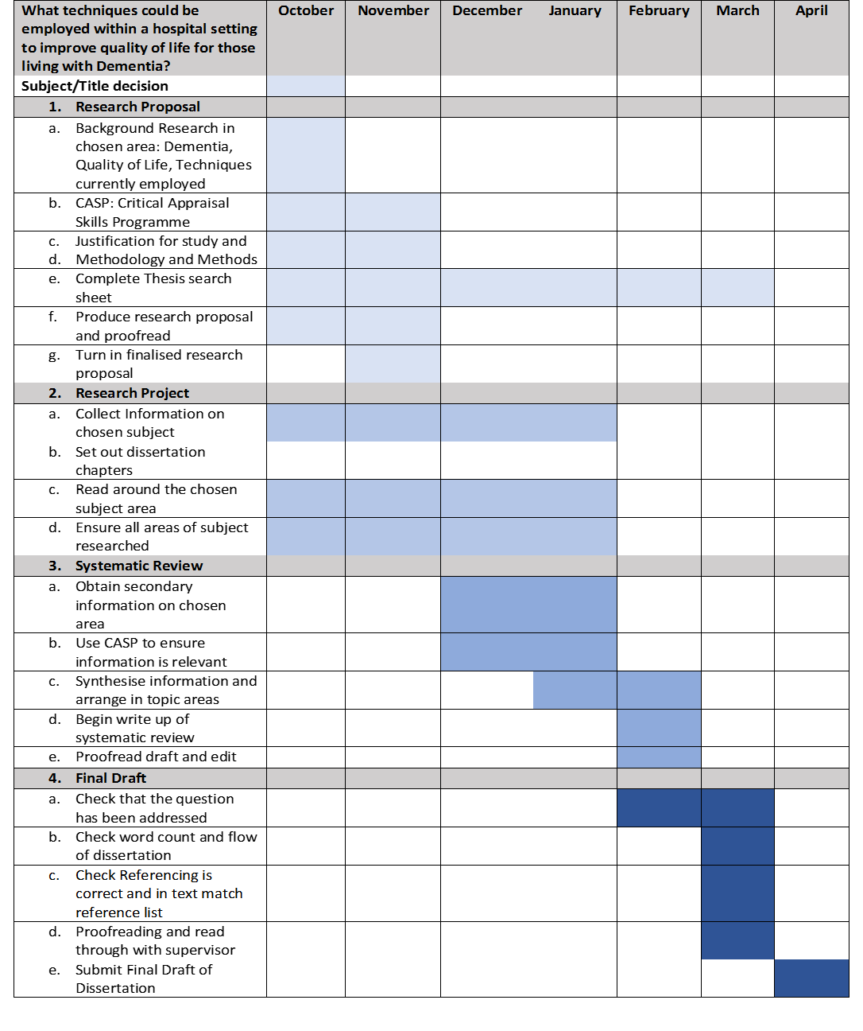
Appendix 3
Appendix 1- Example of the CASP Questionnaire used in this dissertation
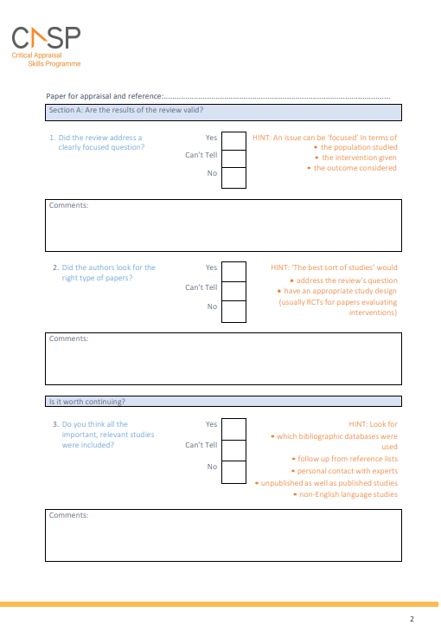

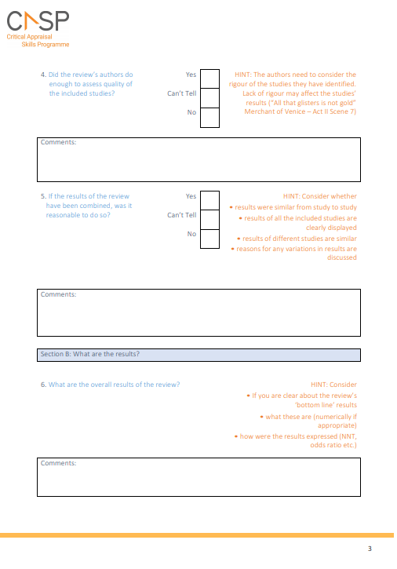

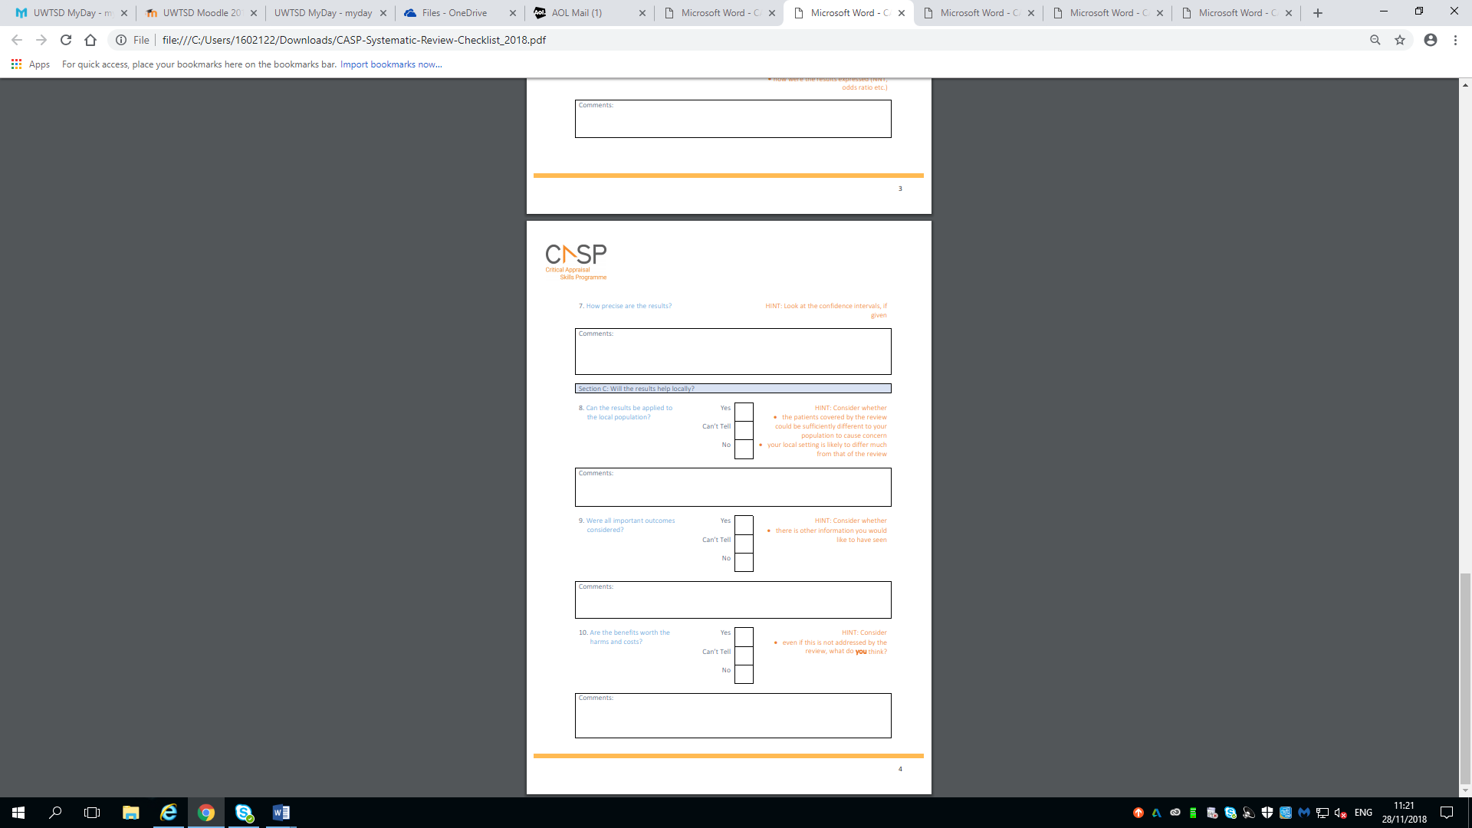
Appendix 4: CASP Search sheet and evidence of CASP sheets completed for Journals
Journal Article | 1 | 2 | 3 | 4 | 5 | 6 | 7 | 8 | 9 | 10
Designing Dementia-Friendly hospital environments | x | x | x
Multidisciplinary attitudes to people with dementia; | √ | √ | √ | √ | √ | ? | √ | x | √ | √
Dementia and Imagination: a mixed methods protocol for arts and science research | √ | √ | √ | √ | √ | √ | √ | x | √ | √
Exploring the relationship between community-based physical activity and wellbeing in people with dementia: a qualitative study | √ | √ | √ | √ | x | √ | √ | √ | √ | √
Preparation to care for confused older patients in general hospitals: a study of UK health professionals | √ | x | ? | √ | √ | √ | √ | √ | ? | √
The challenges of achieving person-centred care in acute hospitals: a qualitative study of people with dementia and their families. | √ | √ | √ | x | √ | √ | √ | √ | √ | √
Junior doctor dementia champions in a district general hospital (innovative practice) | ? | √ | √ | ? | √ | √ | √ | √ | √ | √
Improving Physical Environments for Dementia Care: Making Minimal Changes for Maximum Effect | √ | x | x
The Physical Environment for People with Dementia | √ | x | x
Impact of person-centred care training and person-centred activities on quality of life, agitation, and antipsychotic use in people with dementia living in nursing homes: A cluster randomised controlled trial | √ | √ | √ | √ | x | √ | √ | √ | √ | √

Appendix 5: Evidence of CASP Questionnaire usage
Journal paper being considered for use in thematic analysis about to complete CASP questionnaire for:
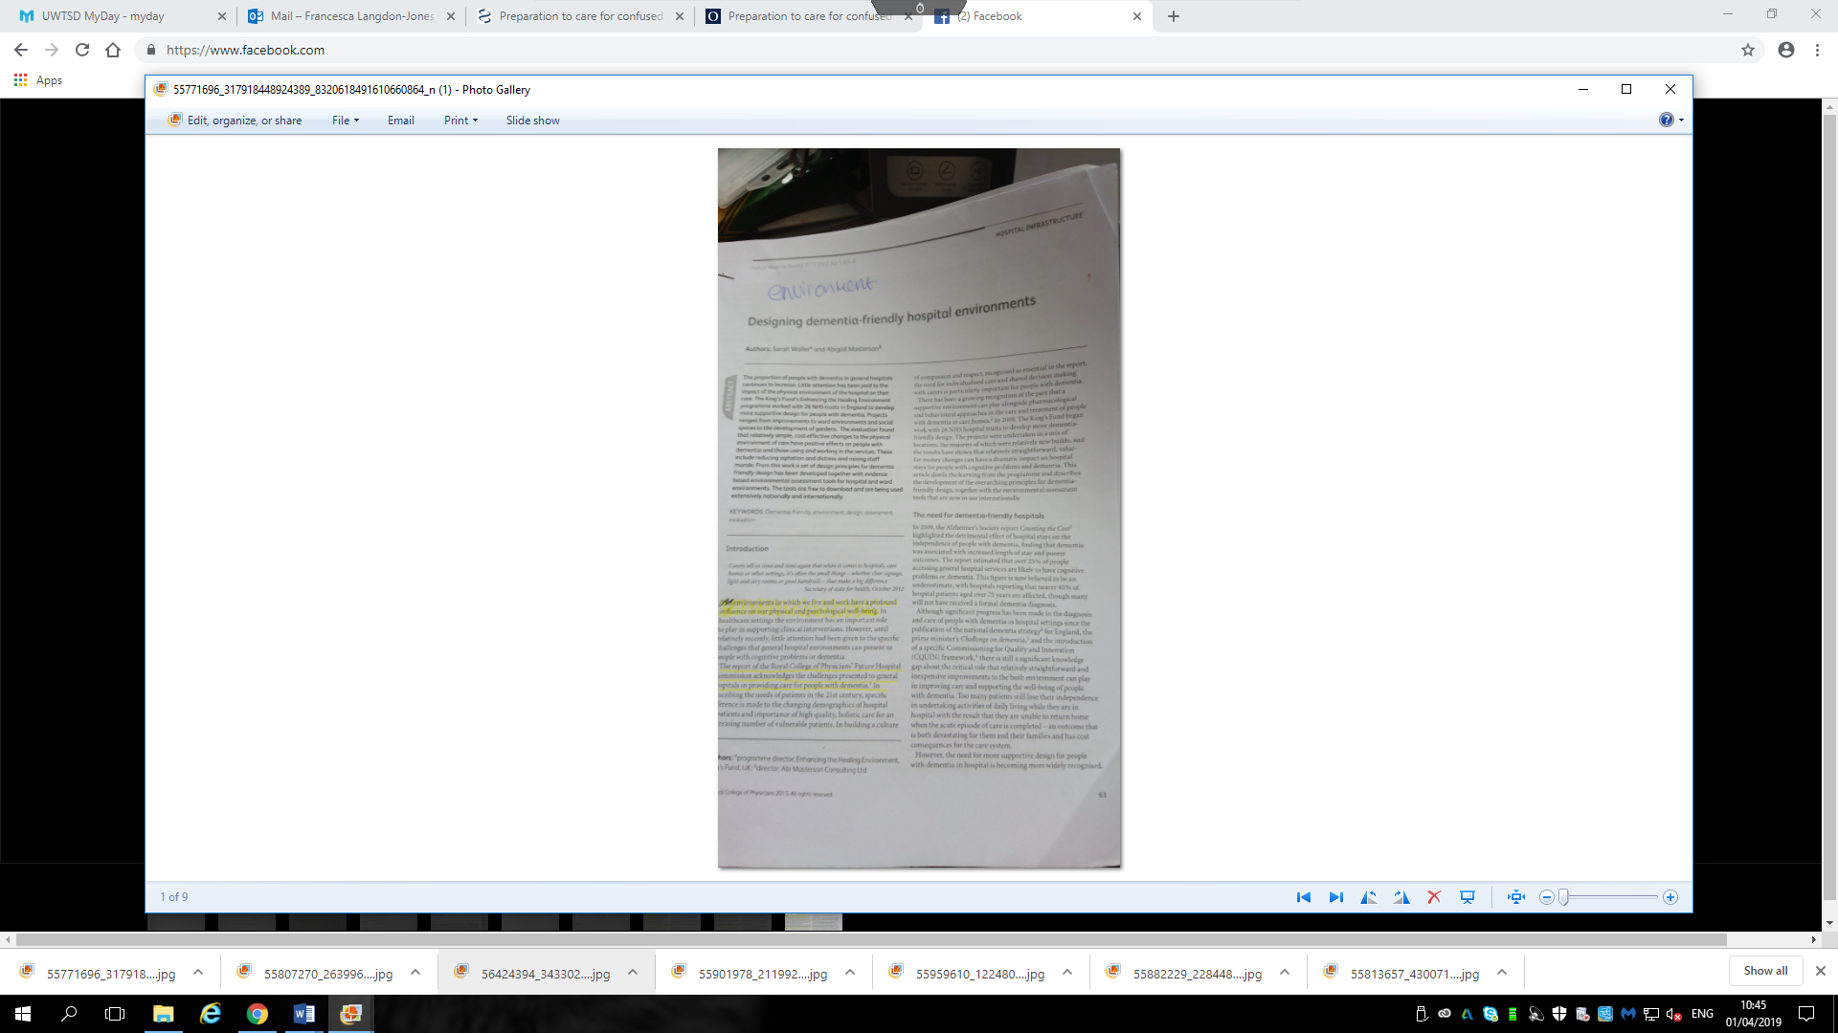
It was discovered that this paper was not a suitable journal to be used in the thematic analysis as the screening questions ruled it out within the first three questions, therefore there was no need to continue with the questionnaire. This paper was however, suitable for use in the introduction section of the dissertation, due the good factual content concerning Dementia.
Questions 1-3 of CASP Questionnaire:
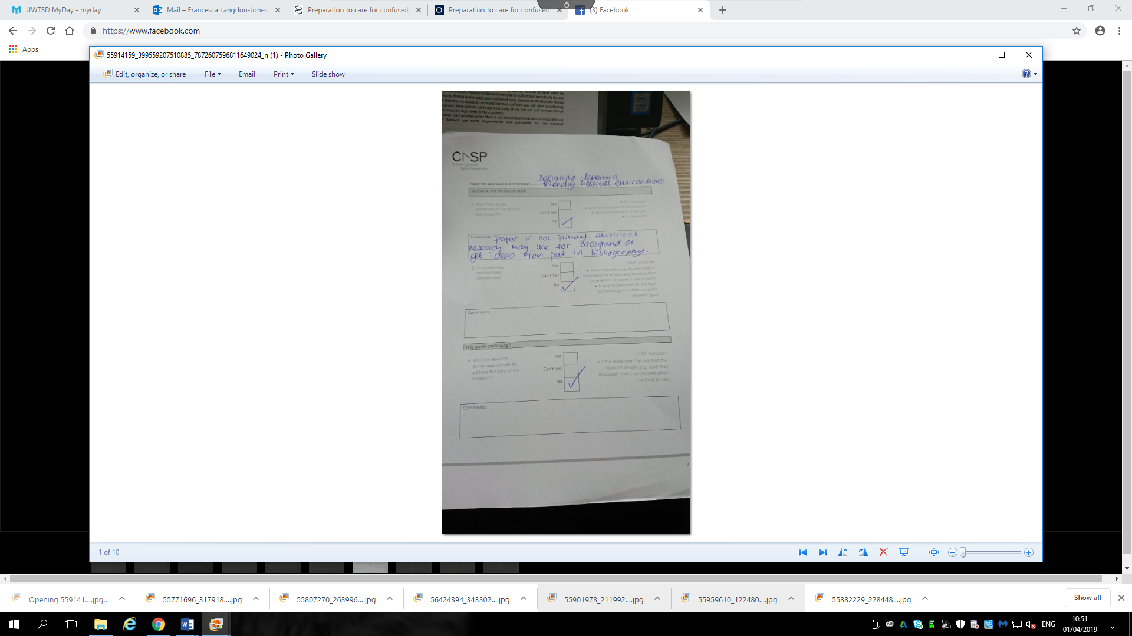

Journal paper being considered for use in thematic analysis about to complete CASP questionnaire for:
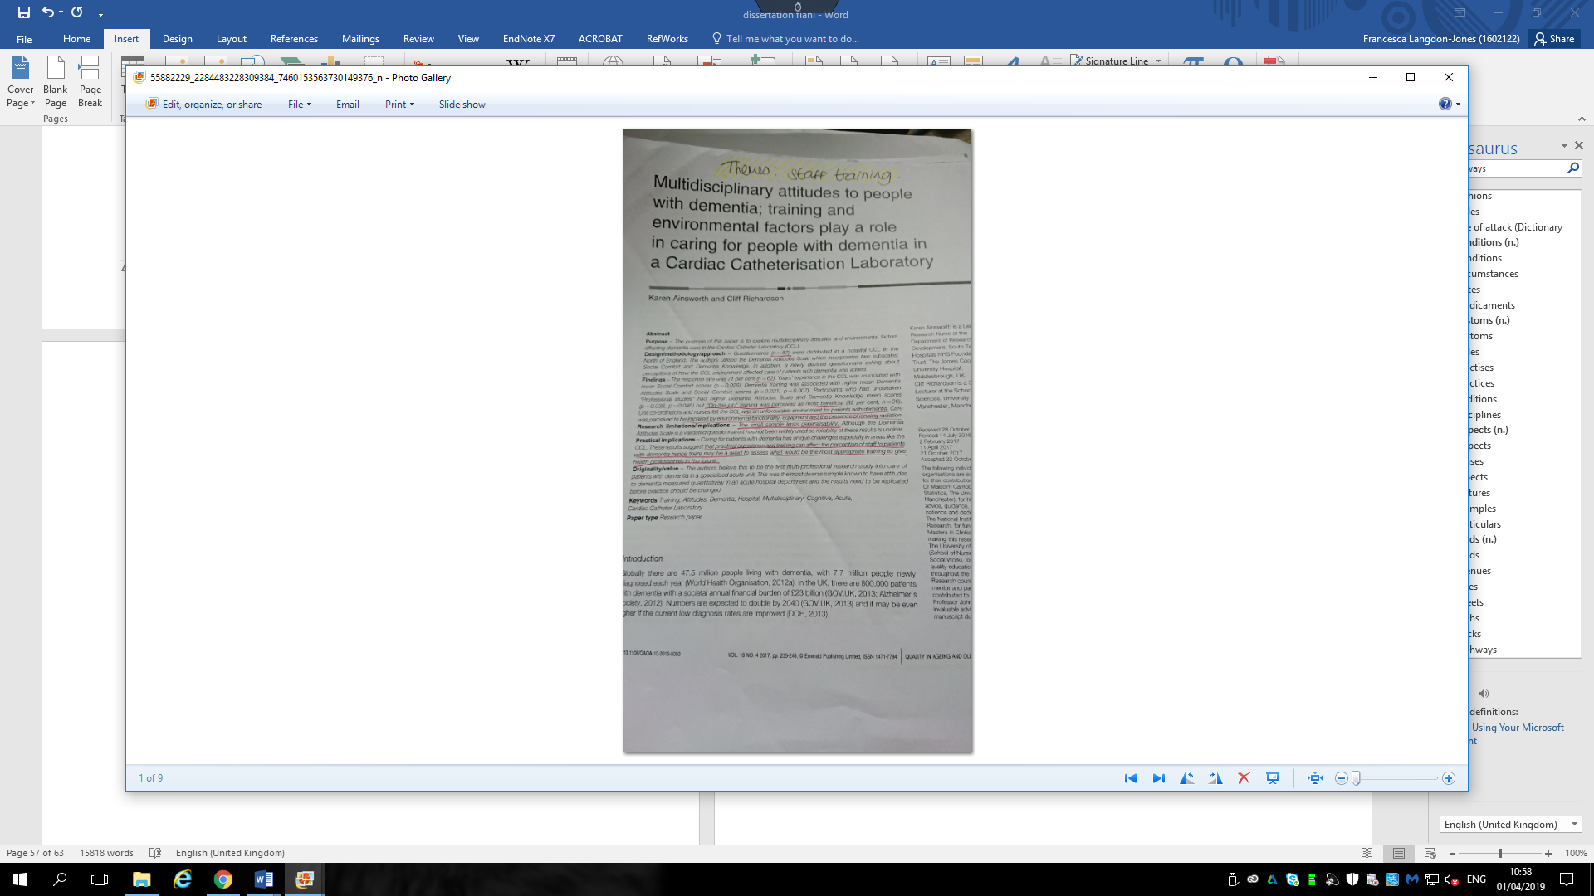

This CASP questionnaire helped to determine that this journal was suitable for use within the thematic analysis of the dissertation:
Questions 1-3 CASP Questionnaire
Question 4-5 of CASP Questionnaire:

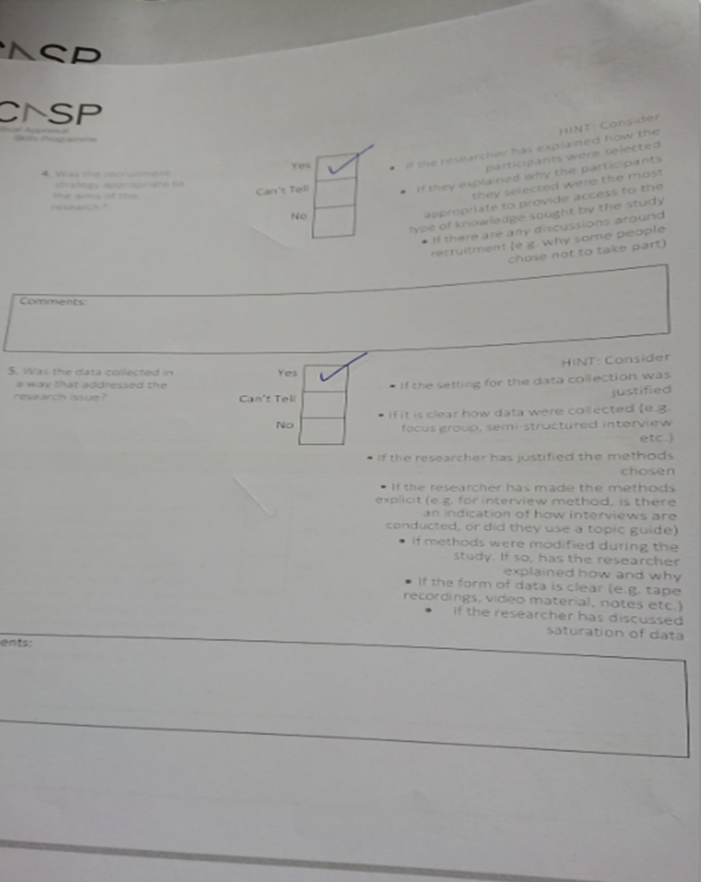
Question 6-7 of CASP Questionnaire:

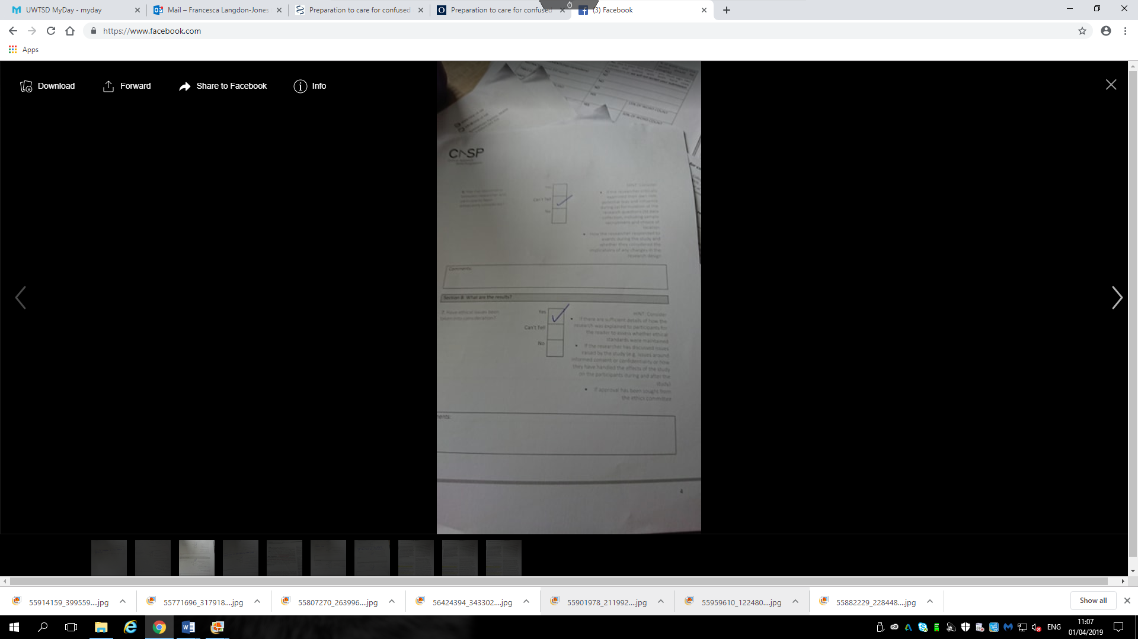
Question 8-9 of CASP Questionnaire:
Even though the sample of participants was deemed too small this journal remained a good journal to use as the small sample size would prove to be a limitation of the study that was worth discussing in the thematic analysis.

Question 10 of CASP Questionnaire:


Appendix 6: Evidence of creation of themes
Journals that were found through the systematic search and had been approved through utilisation of the CASP questionnaires, were then read through to examine them and perform thematic analysis. The themes were highlighted when found and a list compiled of all the different themes that were found. When all journals had been looked at it was then that the themes with the most hits were chosen for use in the dissertation.
Thematic analysis identified the theme as Staff Training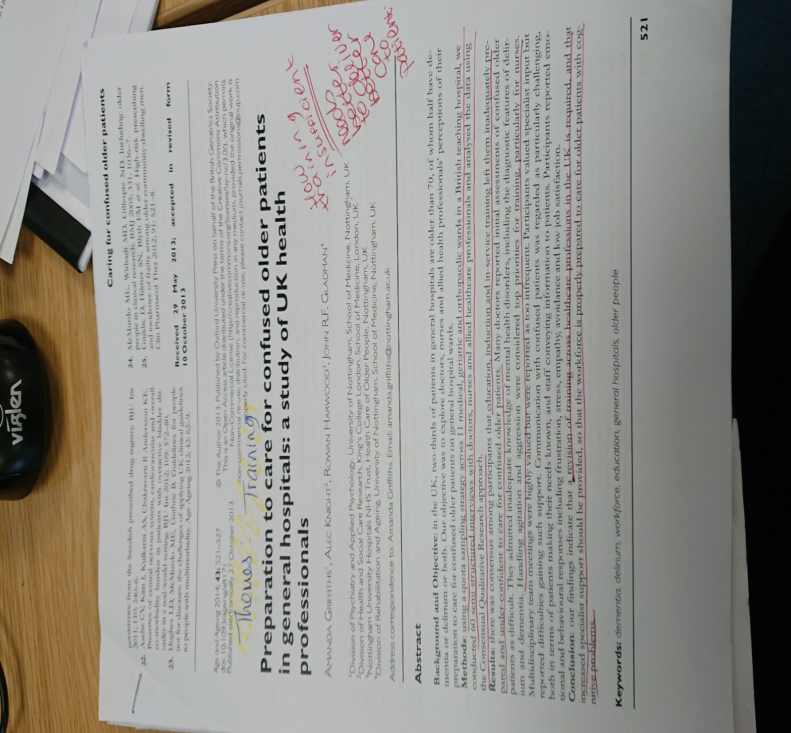
Thematic analysis identified the theme as Staff Training
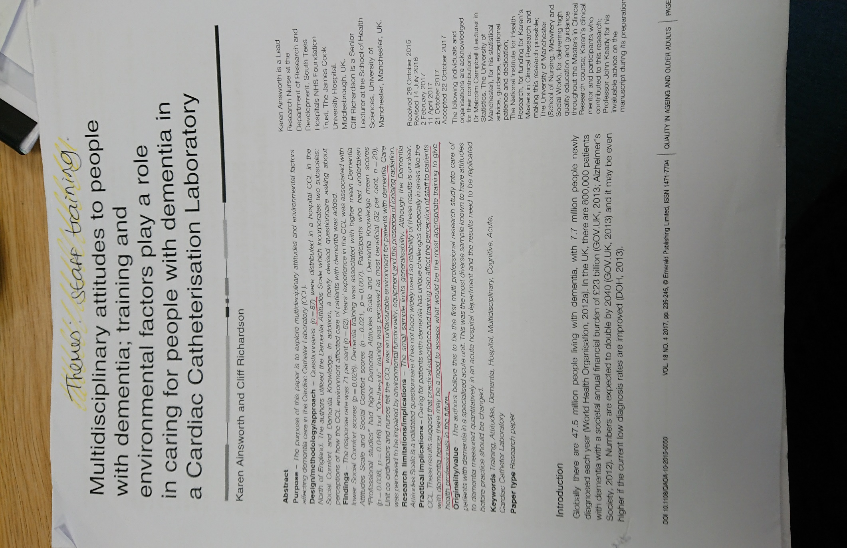

Thematic analysis identified the theme of Activities
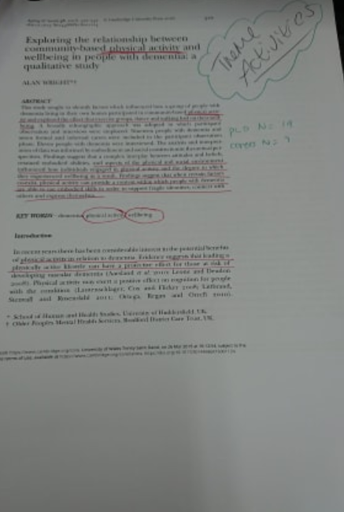
Thematic Analysis identified the theme of Activities
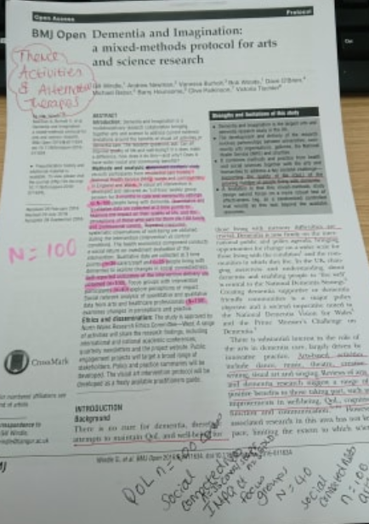
Appendix 7
Research Recording Table

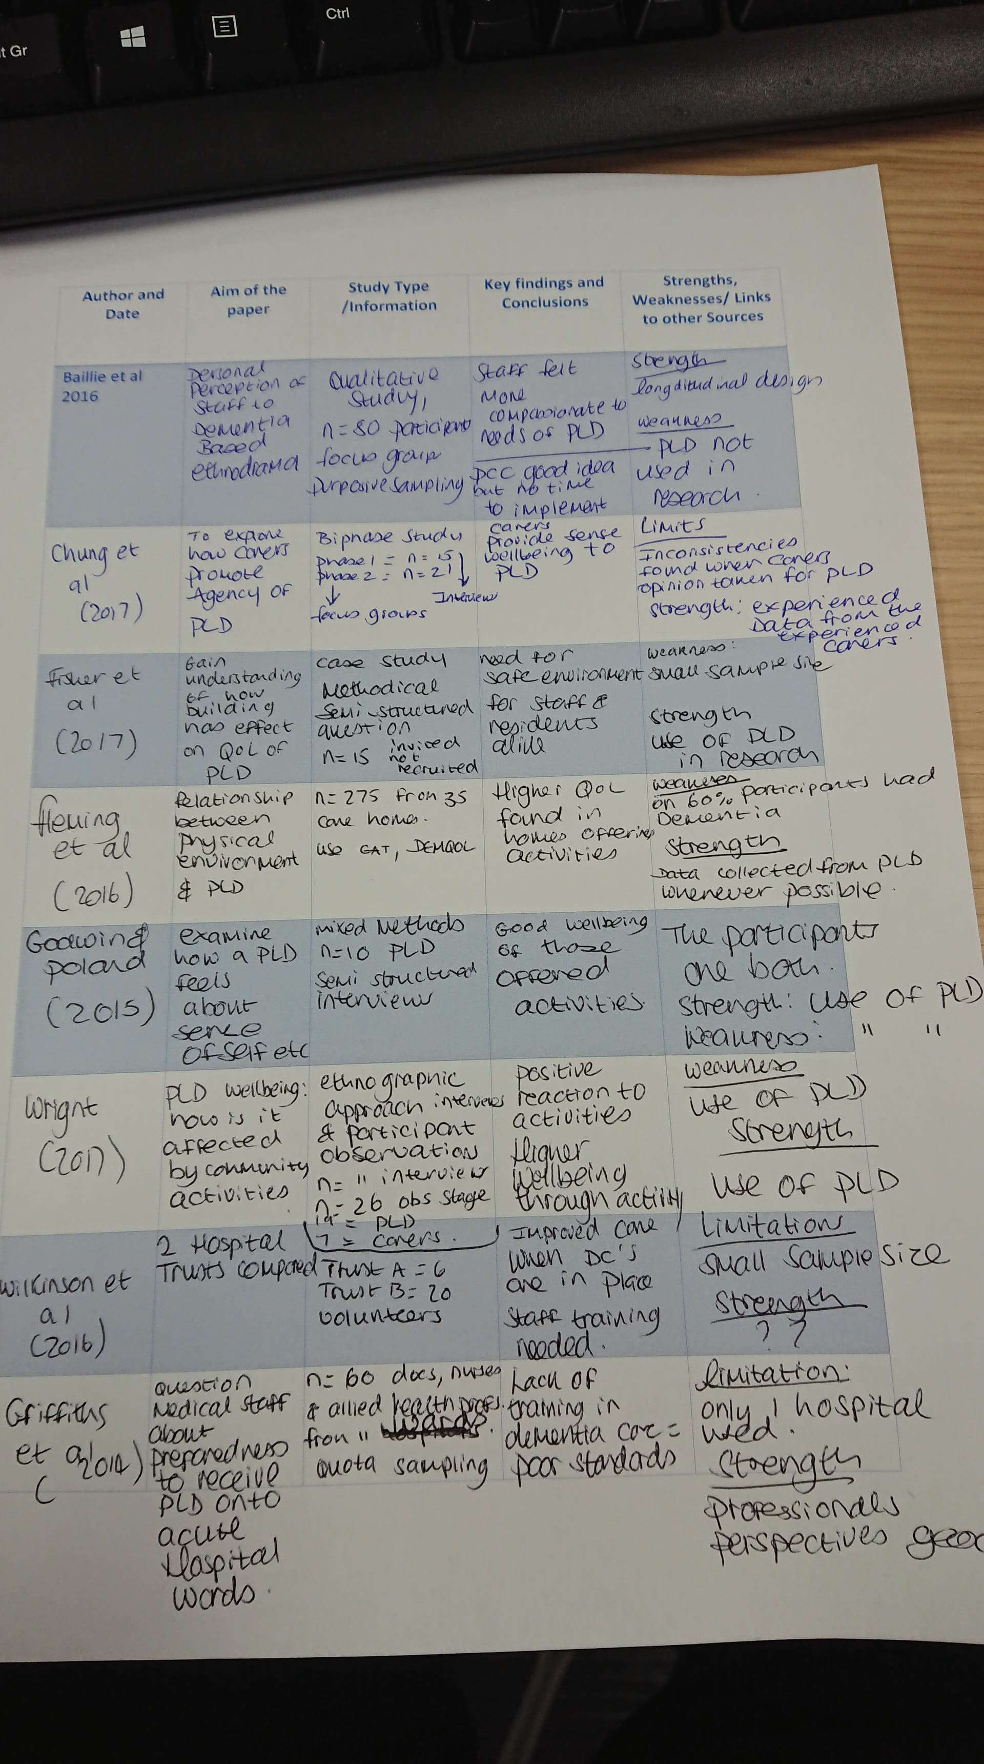

Appendix 8 Thesis search Sheet
Thesis Search Sheets: Francesca Langdon-Jones 1602122

My research question / aim /objective: |  | What techniques could be employed within a hospital setting to improve quality of life for those living with dementia at all ages?
Places to search for information: |  | Online databases: ProQuest Central, Google Scholar, Google
Date | Database Name |  | Search Terms | No of Results | Comments
03/10/18 | ProQuest Central |  | “techniques within hospitals to improve the quality of life of dementia patients” | 18,581 | Too many. Need to narrow down.
03/10/18 | ProQuest Central |  | “techniques within hospitals to improve the quality of life of dementia patients”  Publication Dates changed to  2013-2018 | 8368 | Still too many results.
03/10/18 | ProQuest Central |  | “techniques within hospitals to improve the quality of life of dementia patients”  Publication Dates changed to  2013-2018  Chose Scholarly Journals only | 3294 | Search results are further minimised but still too many.
03/10/18 | ProQuest Central |  | “techniques within hospitals to improve the quality of life of dementia patients”  Publication Dates changed to  2013-2018  Chose Scholarly Journals only  Chose Location as United Kingdom | 143 | I feel this is a more manageable amount to research but am not getting exactly what I want.
03/10/18 | ProQuest Central |  | “techniques within hospitals to improve the quality of life of dementia patients”  Publication Dates changed to  2013-2018  Chose Scholarly Journals only  Chose Location as United Kingdom  Chose subject as Dementia  Added Peer reviewed | 42 | A much better amount for me to research and the material displayed is in keeping with my title.  Found: Dementia-Friendly interventions to improve the care of people living with dementia admitted to hospital: a realist review  From this Journal a few interesting journals have been discovered and will be further looked at. These are the journals of interest:  Designing dementia-friendly hospital environments. Future Hospital Journal 2015;2:63–8.
8/10/18 | ProQuest Central |  | techniques used in the care of person with dementia within hospital settings | 19350 | Search required to be narrowed down as there are too many results
8/10/18 | ProQuest Central |  | techniques used in the care of person with dementia within hospital settings  Select only Scholarly Journals | 8346 | Further narrowing down required
8/10/18 | ProQuest Central |  | techniques used in the care of person with dementia within hospital settings  Select only Scholarly Journals  Date range set to 2013-2018 | 3535 | Still too many further refinement needed
08/10/18 | ProQuest Central |  | techniques used in the care of person with dementia within hospital settings  Select only Scholarly Journals  Date range set to 2013-2018  Limit search to peer reviewed only | 3432 | That did not narrow the field all that much
08/10/18 | ProQuest Central |  | techniques used in the care of person with dementia within hospital settings  Select only Scholarly Journals  Date range set to 2013-2018  Limit search to peer reviewed only  Limit to UK only | 178 | Still more results than I would like to look through
8/10/18 | ProQuest Central |  | techniques used in the care of person with dementia within hospital settings  Select only Scholarly Journals  Date range set to 2013-2018  Limit search to peer reviewed only  Limit to UK only  Set up subjects as:  Dementia  Nursing  Nursing Care and  Activities of daily living | 72 | A far more manageable number of journals to look through.  Found some interesting info about personhood Tom Kitwood as a technique so going to research it a bit ready for systematic review.
9/10/18 | UWTSD Library Catalogue |  | Tom Kitwood’s Personhood Dementia | 207 | A good amount however, further refinement required as nothing relevant found in first page of results
9/10/18 | UWTSD Library Catalogue |  | Tom Kitwood’s Personhood Dementia  Selected Peer Reviewed | 169
09/10/18 | UWTSD Library Catalogue |  | Tom Kitwood’s Personhood Dementia  Selected Peer Reviewed  Selected Subject Dementia | 103
09/10/18 | UWTSD Library Catalogue |  | Tom Kitwood’s Personhood Dementia  Selected Peer Reviewed  Selected Subject Dementia  Set dates to 2013-2018 | 73 | Far better amount of results
30/10/18 | Google |  | Dementia Diagnosis on the increase | 33000000 | This amount is ridiculous but luckily the first result was a good place to start  https://www.dementiastatistics.org/statistics/diagnoses-in-the-uk/  Through this website found some statistics for Dementia in Wales. The information came from:  Wales: General medical services contract: Quality and outcomes framework 2017/18. This was an interesting read and will be used in the research proposal.
30/10/18 | ProQuest Central | NHS Crisis | 118,775 | Too many results need to narrow down the field
30/10/18 | ProQuest Central | NHS Crisis  Selected Scholarly Journals | 15,618 | Further narrowing down required
30/10/18 | ProQuest Central | NHS Crisis  Selected Scholarly Journals  Date range selected as 2013-2018 | 6563 | Still far too many results
30/10/18 | ProQuest Central | NHS Crisis  Selected Scholarly Journals  Date range selected as 2013-2018  Selected Peer reviewed | 6311 | Did not really make a difference to the results, will try to select United Kingdom publications to see if this narrows down the field more.
30/10/18 | ProQuest Central | NHS Crisis  Selected Scholarly Journals  Date range selected as 2013-2018  Selected Peer reviewed  Selected Location of Publication as United Kingdom | 1355 | This has narrowed it down further but further reduction of search results required.
30/10/18 | ProQuest Central | NHS Crisis  Selected Scholarly Journals  Date range selected as 2013-2018  Selected Peer reviewed  Selected Location of Publication as United Kingdom  Subject area chosen was hospitals and quality of life | 6 | This search did not bring up an article that related to the topic of the crisis in the NHS but it did uncover a great article relating to Dementia:  Economic Evaluation of a General Hospital Unit for Older People with Delirium and Dementia (TEAM Randomised Controlled Trial)
31/10/18 | Google | Searched for  “dementia putting strain on the NHS” | 425,000 | The third result displayed was for the Guardian Newspaper “NHS faces staggering increase in cost of elderly care, academics warn”. I felt this related to what I wanted so took a look at the article and found the link to a report that they were referring to. The report published in the Lancet “Forecasted trends in disability and life expectancy in England and Wales up to 2025: a modelling study”  This report discusses how with the people living longer the prevalence of dementia will also increase.
31/10/18 | ProQuest Central | Searched for “definition dementia” | 86,791 | This amount is far too many for me to search through so I am going to try and narrow down the field.
31/10/18 | ProQuest Central | Searched for “definition dementia”  Chose only scholarly journals that are peer reviewed  Set Date Range to 2013-2018  Set Location to UK | 591 | Found one article but could not find access to it so had to take the name and authors and search on google.
31/10/18 | Google | Searched for:  Dementia: definitions and types Dening, Tom; Sandilyan, Malarvizhi Babu. Nursing Standard (2014+); London Vol. 29, Iss. 37, (May 13, 2015): 37. | 6 | First result took me to research gate and offered the full version of the article.  Going to look at ICD-10 for definition of dementia
31/10/18 | ICD-10 Version: 2016 | Dementia |  | Found a good definition of Dementia  Chapter V  Mental and behavioural disorders  (F00-F99)  Organic, including symptomatic, mental disorders  (F00-F09)
31/10/18 | ProQuest Central | Dementia | 862,327 | Unmanageable results will need to further reduce this down with refining of the results
31/10/18 | ProQuest Central | Dementia  Select only:  Peer reviewed, scholarly journals, produced in the last 10 years and are located within the UK | 2856 | Still there are unmanageable amounts to search through so will set date range to last five years to further reduce the search results.
31/10/18 | ProQuest Central | Dementia  Changed date range to last 5 years | 2163 | Refining the date range has reduced the search results slightly. Will look at first 10 abstracts to see if any of the papers are relevant to my dissertation
31/10/18 | Google | Searched for “Definition of Dementia” | 73,800,000 | A few too many but noticed that the World Health Organisation had a definition and used that http://www.who.int/news-room/fact-sheets/detail/dementia  Will use this unless I can find a better source for the definition of dementia.
1/11/18 | ProQuest Central | Search For:  “What is quality of Life?” | 4,971,396 | Search field needs to be refined more so that the right results for this work are found.
1/11/18 | ProQuest Central | Search For:  “What is quality of Life?”  Selected Peer Reviewed material | 879,012 | Still far too many further refining required
1/11/18 | ProQuest Central | Search For:  “What is quality of Life?”  Selected Peer Reviewed material  Selected Scholarly Journals | 874,347 | Did not make a great deal of difference more refining required
1/11/18 | ProQuest Central | Search For:  “What is quality of Life?”  Selected Peer Reviewed material  Selected Scholarly Journals  Set date range as 2013-2018 | 353,311 | Not refined enough keep refining
1/11/18 | ProQuest Central | Search For:  “What is quality of Life?”  Selected Peer Reviewed material  Selected Scholarly Journals  Set date range as 2013-2018  Set Location to United Kingdom | 10,811 | Definitely better but still too many to search through
1/11/18 | ProQuest Central | Search For:  “What is quality of Life?”  Selected Peer Reviewed material  Selected Scholarly Journals  Set date range as 2013-2018  Set Location to United Kingdom  Selected subject content to include only Quality of life | 767 | A more manageable amount  After searching through first 20 articles realised none answered the question so I made the decision to try asking a different question of Definition of quality of life.
1/11/18 | Google Scholar | Searched for:  Definition of Quality of life | 1,740,000 | Few too many will set date range to last five years.
1/11/18 | Google Scholar | Searched for:  Definition of Quality of life  Set date range 2013-2018 | 26,300 | Still too many to search through
1/11/18 | Google Scholar | Searched for:  Definition of Quality of life  Set date range 2013-2018  Changed date to published in the last year | 3790 | Still a great amount and found one journal that maybe considered  Europe's Journal of Psychology  ejop.psychopen.eu | 1841-0413  Quality of Life: Definition and Measurement Paraskevi Theofilou* a  Europe's Journal of Psychology, 2013, Vol. 9(1), 150–162, doi:10.5964/ejop.v9i1.337 Received: 2012-04-06. Accepted: 2012-05-31. Published: 2013-02-28.
1/11/18 | Google | Searched for:  what is the concept of quality of life | 573,000,000 | Although far too many to search through found a good article  Chaturvedi, S.K. and Muliyala, K.P. (2016). ‘The Meaning in Quality of Life’. Journal of Psychosocial Rehabilitation and Mental Health, 3, 2, p.p. 47-49, 2016.
1/11/18 | Google | After discovering in a few journals that quality of life is often linked with a person’s  well-being, a search was performed:  The term Qol is often times teamed with well-being | 588,000 | Found this journal that fitted well with what I was trying to say:  Barcaccia, B., Esposito, G., Matarese, M., Bertolaso, M., Elvira, M., & De Marinis, M. G. (2013). ‘Defining Quality of Life: A Wild-Goose Chase?’. Europe’s Journal of Psychology, 9, 1, p.p. 185-203. doi:10.5964/ejop.v9i1.484
1/11/18 | World Health Organisations  ICD-11 (2018) | Dementia |  | Wanted a definitive definition of dementia and found it on here.
5/11/18 | ProQuest Central | Dementia symptoms | 182,614 | More than I would like so will refine the search
5/11/18 | ProQuest Central | Dementia symptoms  Set date range to 2013-2018 | 80,913 | Still too many to look through
5/11/18 | ProQuest Central | Dementia symptoms  Set date range to 2013-2018  Set to peer reviewed | 34,513 | Better but still far too many and this is a niche subject so need to whittle it down further.
5/11/18 | ProQuest Central | Dementia symptoms  Set date range to 2013-2018  Set to peer reviewed  Changed to Scholarly Journals Only and set location to United Kingdom | 886 | A far better amount to try and search through.  Found this journal useful  Pink, J., O'Brien, J., Robinson, L. and Longson, D. (2018). ‘Dementia: assessment, management and support: summary of updated NICE guidance’. BMJ : British Medical Journal, 361.
5/11/18 | Google | Early onset dementia statistics | 3,370,000 | A huge result so will look at first 109 and if none are suitable will refine the search.  Found this website: https://www.youngdementiauk.org/young-onset-dementia-facts-figures  which then in turn directed me for statistics to:  https://www.alzheimers.org.uk/about-dementia/types-dementia/younger-people-with-dementia#content-start  This website gave me the statistics I required.
5/11/18 | Google | amount of people living with dementia in the UK | 37,300,000 | A lot of results as before if no useful results in first ten search results the search will be refined.  Found this website:  https://www.dementiastatistics.org/statistics/numbers-of-people-in-the-uk/  which had all the information I required.
5/11/18 | ProQuest | Butterfly Scheme Dementia  Refined searches to results with only:  Scholarly Journals  Peer reviewed  Date Range 2013-2018 | 48 | There were some great results but I have already used most of the journals in the results or I was unable to access the full journal due to having to pay for them. Decision made to search for butterfly scheme through Google.
5/11/18 | Google | Butterfly scheme Dementia | 429,000 | Quite a lot of results will look at first ten then decide if further refining required.  Found the website for the actual Butterfly scheme so going to use this.  http://butterflyscheme.org.uk/what-we-do/
6/11/18 | ProQuest Central | Importance of ethics in research | 522,120 | Too many to examine will have to refine the search
6/11/18 | ProQuest Central | Importance of ethics in research  Chose peer reviewed Scholarly Journals only.  Set date range to 2013 - 2018  Selected ethics as subject  Set location to:  United Kingdom--UK | 558 | A much easier amount to examine  Could not find anything that fitted what I was trying to put across
6/11/18 | Google Books | importance of ethics in research | 812,000 | Found a good book, the first one in the results:  Ensuring Research Integrity and the Ethical Management of Data by Sibinga, Cees Th. Smit
6/11/18 | Google | ethical issues in research methodology | 40,800,000 | Found a Journal that fitted with what I wanted to say:  Yip, C., Han, N. R., and Sng, B. L. (2016). ‘Legal and ethical issues in research’. Indian journal of anaesthesia, 60, 9, p.p. 684-688.
7/11/18 | ProQuest Central | quality of life of dementia patients | 169 | Found some really interesting journals and articles  Goldberg, S.E. and Harwood, R.H., (2013). ‘Experience of general hospital care in older patients with cognitive impairment: are we measuring the most vulnerable patients' experience?’ BMJ Quality & Safety, 22, 12, p.p. 977.  Tanajewski, L., Franklin, M., Gkountouras, G., Berdunov, V., Harwood, R.H., Goldberg, S.E., Bradshaw, L.E., Gladman, J.R.F. and Elliot, R.A. (2015). ‘Economic Evaluation of a general Hospital Unit for Older People with Delirium and Dementia (TEAM Randomised Control Trial)
7/11/18 | ProQuest Central | poor quality of care in hospitals dementia  Set to find :  Peer reviewed Scholarly Journals  Date Range to be: 2013 - 2018  Location set to: United Kingdom  Set subject to dementia | 132 | Found a good journal  The Lancet. (2018). ‘Dementia in the UK: preparing the NHS for new treatments’. The Lancet, 391, 10127, p.p. 1237.
7/11/18 | ProQuest Central | Systematic review important | 599,814 | Too many to search through will look through and see if I find anything good in first 10 results.  Found this journal and it was useful  Jahan, N., Naveed, S., Zeshan, M., & Tahir, M. A. (2016). ‘How to Conduct a Systematic Review: A Narrative Literature Review’. Cureus, 8, 11, e864. doi:10.7759/cureus.864
7/11/18 | Google Books | Systematic Reviews | 2,410,000 | Although there were a lot of results to look through the first book had exactly what I wanted in it.  Gough, D., Oliver, S. and Thomas, J. (2017). An Introduction to Systematic Reviews. Sage: London
7/11/18 | Google Scholar | Why do we use systematic reviews? | 2,600,000 | Too many to search through try another way to search
7/11/18 | Google 117,000,000 | Why do we use systematic reviews? | 117,000,000 | That’s a lot of results  However there was an article third in the list of results that caught my eye so I am going to examine it more thoroughly.  Gopalakrishnan S. and Ganeshkumar P. (2013) ‘Systematic Reviews and Meta-analysis: Understanding the Best Evidence in Primary Healthcare’. Journal of Family Medicine and Primary Care. 2013, 2, 1, p.p. 9-14.  And another one  Charrois, T.L. (2015) ‘Systematic reviews: what do you need to know to get started?’ The Canadian Journal of Hospital Pharmacy. 2015, 68, 2, p.p. 144-8.
7/11/18 | ProQuest Central | Critical appraisal skills tools  Selected:  Peer reviewed Scholarly Journals  Within last 5 Years  Location set as United Kingdom--UK | 467 | A good journal found  Bonfield, M., Fearnside, L. and CRAMP, F. (2018). ‘A Personal Experience of Performing a Systematic Literature Review’. Journal of allied health, 47, 3, p.p. 167-171.
8/11/18 | ProQuest Central | lack of services for young-onset dementia  Search refined as:  Peer Reviewed Scholarly Journals  Date Range 2013 - 2018  Location Set as United Kingdom--UK | 16 | Good easy amount to sift through  Found this journal very useful  Rabanal, L.I., Chatwin, J., Walker, A., O’Sullivan, M. and Williamson, T. (2018). ‘Understanding the needs and experiences of people with young onset dementia: a qualitative study’. BMJ Open, 8, 10.
8/11/18 | Google Scholar | Why use peer reviewed articles? |  | Found a good journal  Kelly, J., Sadeghieh, T., and Adeli, K. (2014). ‘Peer Review in Scientific Publications: Benefits, Critiques, & A Survival Guide’. The Journal of the International Federation of Clinical Chemistry and Laboratory Medicine, 25, 3, p.p. 227-43.
29/01/19 | ProQuest Central | Dementia Friendly Hospitals | 18,329 | Far too many results will need to further refine the search parameters
29/01/19 | ProQuest Central | Dementia Friendly Hospitals  Peer Reviewed  Scholarly Journals  Date Range 2014-2019 | 1467 | Still too many results to look through
29/01/19 | ProQuest Central | Environment effects on dementia patients | 53,748 | A large result will require some refinement
29/01/19 | ProQuest Central | Environment effects on dementia patients  Peer Reviewed  Scholarly Journals  Date Range 2014-2019  Location UK | 468 | A much smaller result will look at first x20 results and if no good will refine or try a different search
29/01/19 | ProQuest Central | Advanced search  Dementia AND Environment  Scholarly journals  Peer reviewed  English Language  Date range 2014-2019 | 27 | A very manageable result having found nothing in previous search I changed the search strategy. None of the results were suitable as most were lit reviews
29/01/19 | Google | physical environment of wards effect on dmentia patients | 8,440,000 | A massive amount of results will skim through first 10 results and decide if any of these results are relevant to my study. The third result was a good paper on dementia and the environment
14/2/19 | Google | Dementia statistics | 40,200,000 | A huge amount of results, however I was really lucky as the first result harboured the facts and statistics I was searching for.
14/2/19 | Google Scholar | Quality of life for dementia patients | 182,000 | The returned results were numerous but after looking at the first two results I had discovered the information I needed to support my work.
14/2/19 | Google scholar | Hospital wards under pressure with dementia patients  Set Date range to 2013-2019 | 18,200 | Too many results to look through however decided to look at first x10 and was relieved to find the third journal found included the information I was seeking out for my work.
14/2/19 | Google Scholar | Wards not designed for the dementia patient  Set Date range to 2013-2019 | 17,700 | The first result had the information I required within it so no need to further refine the search parameters.
14/2/19 | Google Scholar | Living with dementia hospital admissions  Set Date range to 2013-2019 | 5890 | Quite a few results decided to check first 10 and was happy to find the information needed in these journals.

