DS 1 Template

My Screenshots/Photos
- Please add 4–6 screenshots or photos of your digital life.
- You can use your phone or laptop.
- For each screenshot, write one or two sentences explaining what it shows.

Screenshot/Photo 1
Modules
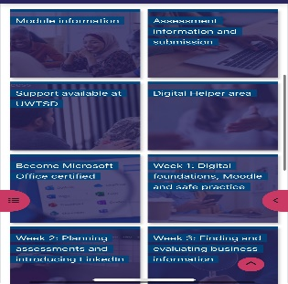

This is a screenshot of my modules where I access the app 2 a week or maybe more because I do homework

Screenshot/Photo 2
A Facebook and google platform

Facebook is where I talk to my family and google is where I use Ai to get information

Screenshot/Photo 3
CRAAP
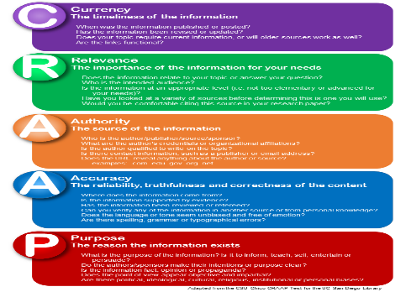
CRAAP is a test where you can see the right information like when is published or when it was dates

Screenshot/Photo 4
Online grocery shopping

Grocery shopping is verry simple but also very complicated because they might not have the same items and also can be scammed

Screenshot/Photo 5
Business plan

A business plan can help you invest and also grow and make you benefit more also ,making customers happy with special deals .

Screenshot/Photo 6
Class work
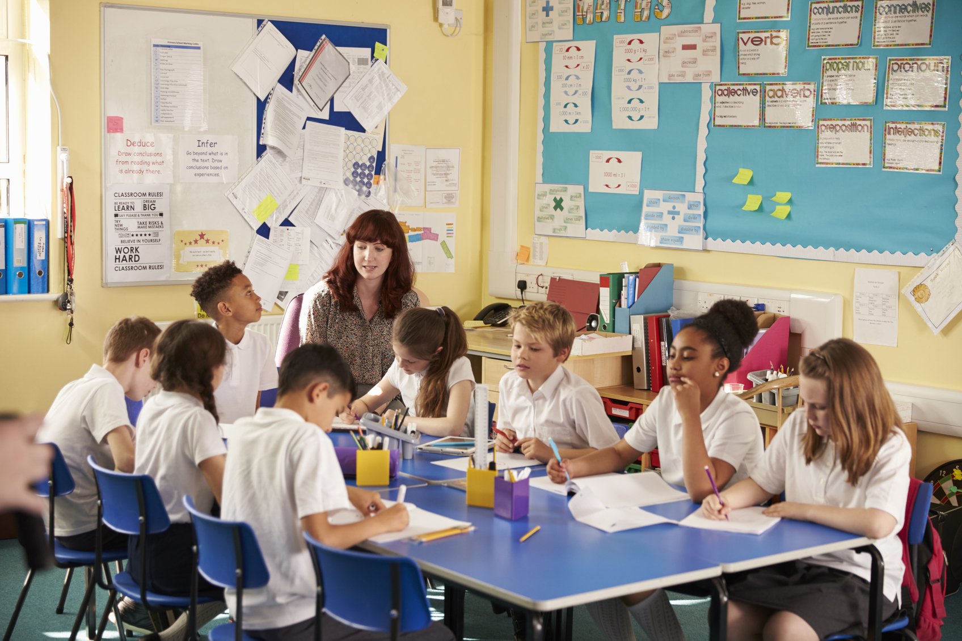
In class we can hear everybody’s opinion and communicating in class with ideas and the teacher giving us the right answers

My Short Reflection
- Write 5–8 simple sentences about your digital life.
I use digital skills tools to see class work and homework
I feel confident when I understand the work in class
I wan to improve taking more notes
I often use these tools when I’m in class and when I’m at home
I sometimes feel nervous about not understanding the homework from class
I hope this module will help me improve my digital skills and hopefully get a good grade
Digitals skills are important for me because I can see my records and all the information I need

- You can use the sentence starters below if helpful.

Sentence starters
- I use digital tools to …
- I feel confident when I …
- I want to improve …
- I often use these tools: …
- I sometimes feel nervous about …
- I hope this module will help me …
- Digital skills are important for me because …
You can write more if you want.

Submission Checklist
Before you submit, please check:
​​​ ☐ I added 4–6 screenshots
☐ I wrote short sentences for each screenshot
☐ I wrote my short reflection
☐ My work is my own
☐ My file opens correctly
​​☐ My file opens correctly

