Individual Project Report Lecturer Name: Dr. Essa Bah
Lcbb4005_birm – global business management
Student name: catalina vilcea student number:2228224
Table of Contents
Introduction 1
Background 2
PESTLE Analysis 3
Political Outlook 3
Economic Outlook 4
Social Outlook 5
Technological Outlook 5
Legal Outlook 6
Environmental Outlook 6
Overall Outlook 7
Porter’s Five Forces Analysis 8
Rivalry among competing sellers 8
Potential entry of new competitors 8
Threats of substitute products or services 8
Bargaining power of suppliers 8
Bargaining power of customers 9
Conclusion 9
References 9

Introduction

This report is going to cover an analysis about Apple Incorporated, a company that produces electronics such as phones, tablets, and laptops. The report is going to cover the business overview and what environmental problems this company tackles while manufacturing its products and what good or bad services they provide to the environment. Information regarding PESTLE as well as Porter’s Five Forces will be provided in this report, analysing whether this company’s elements are either opportunities or threats, and how different environmental factors impact this company.

Background

Apple (Apple Inc.) was firstly created in Santa Clara Valley, California, by founders Stephen Gary Wozniak and Steve Paul Jobs. At first, the company was producing computers, while later would start producing smartphones, laptops, and other type of electronics. At first the company was called Apple Computers Inc. in 1976 when it was founded, later changing its name in Apple. Jobs, who founded Apple, left the company in 1985 due to losing an internal power struggle with the new CEO at the time, John Sculley, but later returned to Apple in 1997.

As a company, Apple has left a huge mark on history, getting from 2 employees at first, having just the original founders working there to having more than 20,000 employees across the globe in 2009. Apple has made more than $24 billion and earned $3.5 billion in profit in fiscal 2007, having no more debt than $15 billion in cash at the time. Shockingly, in 1995 to 1996, Apple has gone bankrupt, lacking leadership, so as when Jobs returned in 1997, everything took a turn as Jobs decided to take matters into his own hands, employing only the best and bringing Apple to a success, this being one of the greatest business turnarounds in the history of business, which will make the history of Apple forever remembered.

Apple has also gained a lot of revenue throughout the years, making itself as a company reach peaks that most companies struggle to achieve, going from $42.9 billion in 2009 to $260.17 billion in 2019, only 10 years later where the company’s revenue went up to more than 6 times, the most revenue reaching at $394.33 billion in 2022. Below is a graph of Apple’s global revenue from 2004 to 2022.
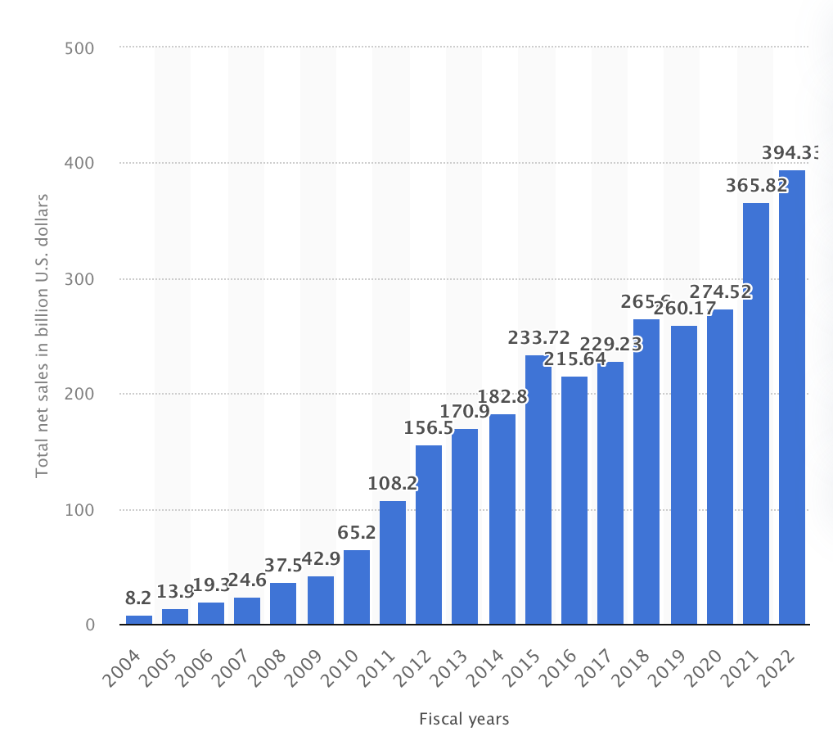

Firstly opened in 2017, but starting as a normal building in 1993, Apple Inc.’s headquarters is situated in Cupertino, California, United States. This so called ‘Apple Park’ has been the home to more than 12,000 employees. Cupertino has a total population of 60,381 (2020), a very small number compared to the whole of California or United States itself. The currency used is the United States Dollar, and throughout the years Apple has had many partnerships such as AT&T, Verizon Communications, Intel, Toshiba, and Samsung Electronics.

PESTLE Analysis

PESTLE analysis is a structure of a macroeconomics environment that is formed of Political, Economic, Social, Technological, Legal and Environmental outlooks, used by different businesses and companies to find possible factors that can or will affect their organisation as a whole, whether we are talking about environmental or technological limitations or positive and negative externalities, to put it in simple words, this PESTLE analysis is all about identifying different opportunities or dangers that a business or organisation can or might face while developing.

Political Outlook

As a big company, Apple has had an impact on the entire world, now having different stores, offices, and warehouses all around the world, exposing itself as an organisation to many more political problems than other businesses. The place where Apple has got it biggest supplier is Asia and the most sales that have contributed to the total number of sales for Apple has come from outside of the United States, meaning even more danger that Apple is exposed to when talking about politics. One of the biggest political problems that Apple is facing is domestic stress, which through a lot of employees are experiencing not just in the United States, but all around the world. Another problem that Apple was struggling with was that some of the components needed for the iPhone were banned in the United States, making it even harder for Apple to prosper. To have a better political look upon the situation and location Apple is situated in, observing the corruption index in the United States over time might be able to explain some of the problems that Apple has been facing. Below is a diagram showing the corruption index in United States.
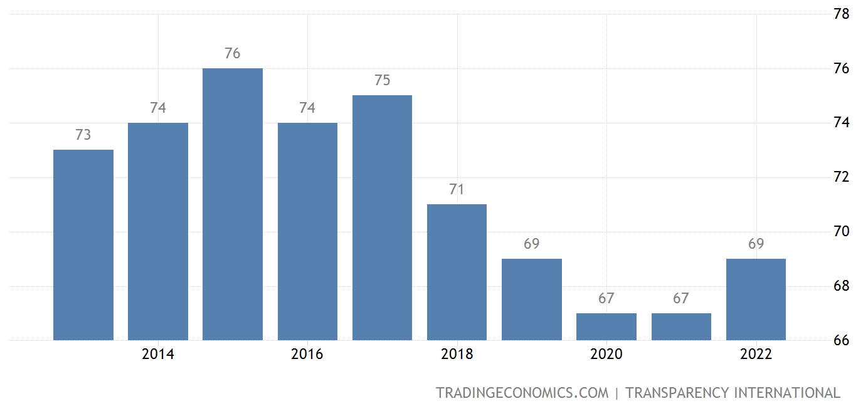

Economic Outlook

As once Apple has gone bankrupt in the past, now that it has such huge economic power, being situated in United States, one of the countries with the highest economic growth, when being compared to developing economies such as Japan, China and other countries from Europe, Apple has been affected by crisis, as in 2012-2013, unemployment in the United States was increasing exponentially, being 7.9% while in countries such as China or Japan it was under 5%, making it difficult for Apple to handle other competitors. Another crisis that Apple has went through was also in 2012-2013 when sales in all major regions, these being Europe and China, have fallen from 31% to 4% in Europe and from 78% to 13% in China. Also observing the growth of Apple, we can see that mostly there has only been an increase and not many declines in Apple’s growth, as reinforced by these charts, running from 2010 to 2022.
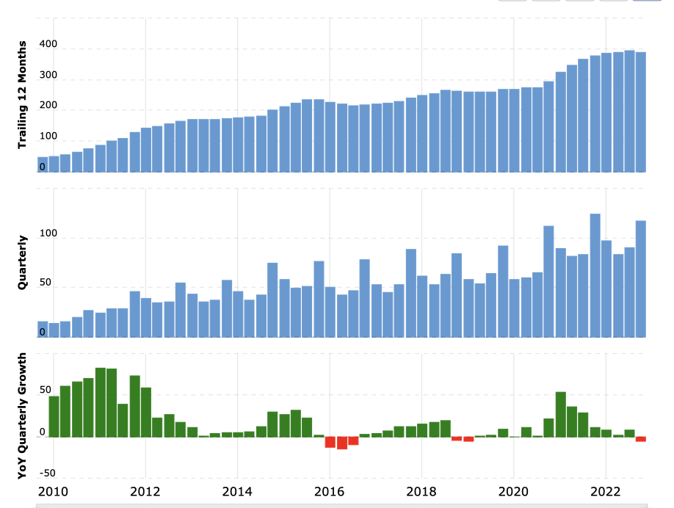

Social Outlook

As I have mentioned before, Apple has had a lot of partnerships in the past, making changes and improvements in order to satisfy and attract more customers, for example when Apple has bought companies such as Topsy and Embark in order to improve the quality of their products and alliances with businesses such as Sony which is also one of their competitors or as mentioned before AT&T as a business insider. In India, 2013, Apple has had their sales increased by a lot, resulting in Apple making more investments in stores, warehouses, and other assets in India in order to promote their products and to ensure their growth as an organisation.

Technological Outlook

Apple has seen in the past a lot of improvements and investments in order to make their products better and more innovative. By being different to their competitors and arguably better, Apple has managed and succeeded to convert more than 20% of different customers into using iOS, their software that is only available to products produced by Apple, keeping 49% of its customers loyal to the brand and software. Of course there are a lot of sectors that can be improved, one main problem being their batteries for the iPhones, as they are presented as only lasting an approximately 2 years of life, which not only is not good for the consumers as they will have to purchase new products every now and then, but also it can affect the environment, as after these batteries have been used, getting rid of them correctly is very dangerous and costly. This might not be the case for all iPhones, as some of them get to have a longer life than 2 years, meaning that the batteries get to live longer, but there are more cases of batteries dying sooner than 3 years, reinforcing the point made before. Throughout the years, Apple has improved all of their products, the best example being the screen size of the iPhones and iPads, which their consumers not only requested but also enjoyed as soon as their wishes and expectations were met, again winning more customers over and promoting their business even more. However, Apple still has to invest more and more and research and development, as a lot of their competitors are now getting better and better, making this for Apple harder and giving consumers more options to choose from.

Legal Outlook

United States has a very simple legal system, where are the federal laws are judged by the judicial branch, where they assess each law that is either new or old, or if it needs improvements, then they are passed to the Congress and in the end signed by the President. United States uses a common law legal system just like many more countries.
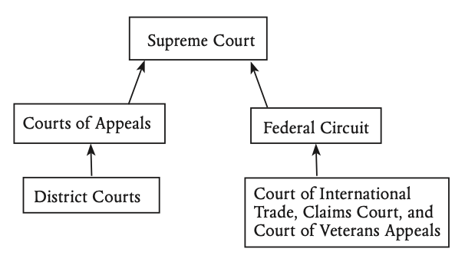
Each of the 50 states in United States has its own state constitution, governmental structure, legal codes, and judiciary, but as a whole, all states have very similar legal systems.

Environmental Outlook

Apple has had many environmental issues throughout the years, more recent than old. As more and more products are being manufactured, more pollution is being produced and made. Apple says that ‘70% of its carbon emissions come from manufacturing alone.’, which looking at it is not good at all, as it has been estimated that iPhone manufacturing will generate around 17 megatons of CO2 emissions in 2022, and this is just iPhones alone. Going back to the batteries of their products, lithium powered batteries are used, mostly for iPhones, these being very bad for the environment as ‘about 2.2 millions of water is needed to produce just a single ton of lithium.’, which does not only make it an environmental problem, but also water that could be used by those in need is taken away from them in order to produce a component of these batteries. Another big environmental issue for Apple is their chargers. The ports and cables that are being used contain small amounts of gold, which not only is very hard to produce and in order to acquire these components even more pollution is done through mining, but it is also very hard to recycle or get rid of them safely, as they are combined with many more other components, making it almost impossible to recycle.
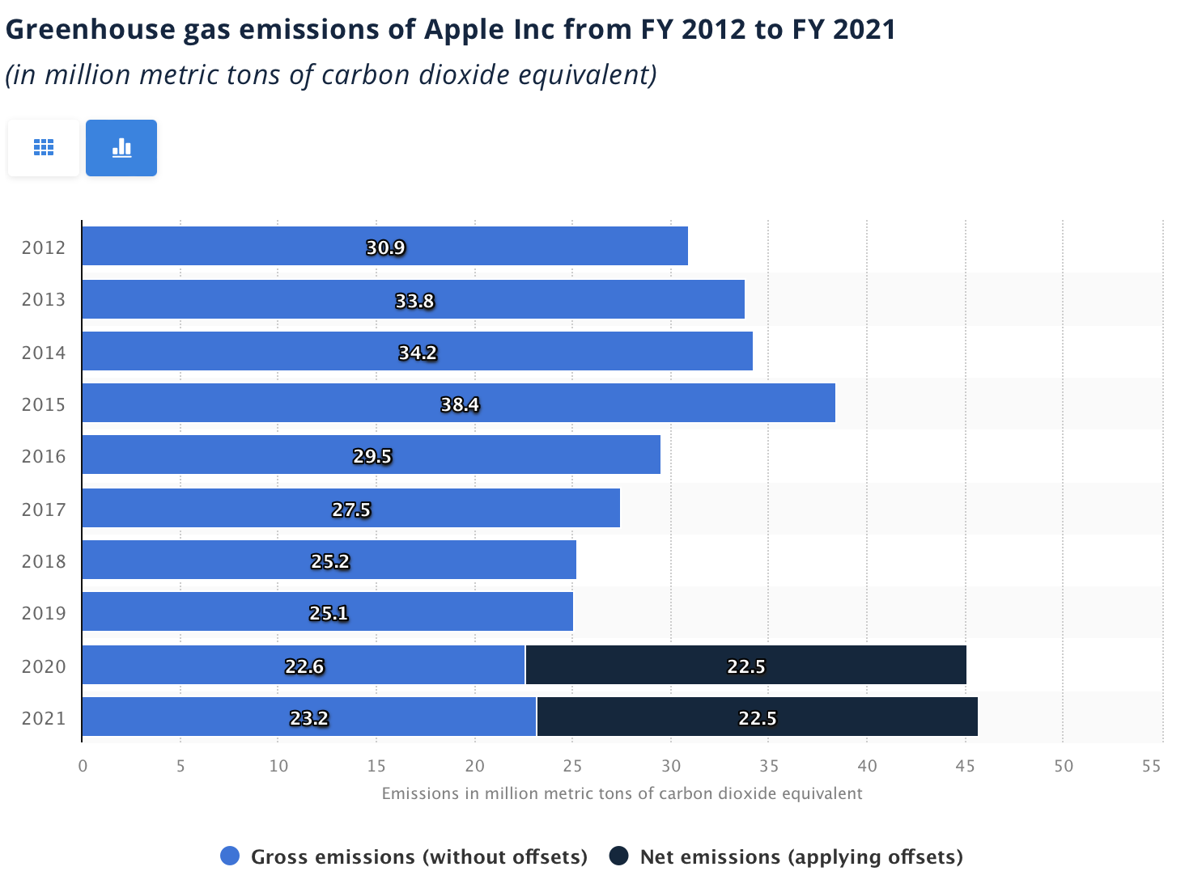
This graph presents the amount of emissions Apple has produced from 2012 to 2021, which compared to other rival companies is quite a difference.

Overall Outlook

As things are looking so far, Apple will continue to improve and thrive as an electronics producer and provider, ruling over the market, and slowly making better decisions when it comes to environmental issues, but it will not be realistically possible to get to a point where there will be more positive and negative externalities. Apple will continue to expand itself and make even more innovative products over time, where different choices will be made, such as the charger, as discussions are already taking place in order to change the chargers and also different laws from different countries are thinking of banning or taxing more the chargers if they are not going to be changed. Overall, Apple, without question, was, is and will continue to generate more profits and revenue over time.

Porter’s Five Forces Analysis

Rivalry among competing sellers

Apple has always had a huge impact on the global market when it comes to hardware and software, therefore making it very difficult for competitors to compete with Apple, as not just iPhones, but more different hardware is produced, making it a more diverse producer with the opportunity of pleasing more customers at one time. Having its own original software and designs of hardware, Apple is easily winning when it comes to originality, gaining more loyal customers over time. Moreover, the way Apple is distributing their products is very smart and diverse, as having stores and outlets all over the world, while also having distributors such as Amazon to sell their products, making the market extremely competitive and leaving room for more investments in research and development.

Potential entry of new competitors

As Apple has a huge control over the market, the threat for Apple is extremely low if new entrants in the market were to appear. The main reasons Apple has had such a success is due to originality and innovation of their products, therefore laws such as copyright and patents protect Apple and their products from being used or copied by others, meaning it gets to keep their power over the market.

Threats of substitute products or services

In the hardware and software market, Apple products can be easily replaced as there are lots of products that can be used as substitutes from Apple’s competitors, but as I said before, Apple’s originality and innovative creations cannot be beaten. Apple’s operating system is still one of the best, if not the best operating system on the market, leaving customers to choose for Apple products instead of substitutes in order to access all these benefits.

Bargaining power of suppliers

Over the history, Apple has had a very diversified source of suppliers and they still do. This means that Apple has a lot of power as it has where to choose from and because Apple normally buys in large quantities, higher buying power is gained.

Bargaining power of customers

Apple has always been known of being different, but not in a bad way. Apple has always been producing new products in their own way and always making them better than the competitors have always done. Customers are normally loyal to the company, as their products can be seen as unmatching and unbeatable.

Conclusion

After using PESTEL analysis and Porter’s Five Forces analysis, it can be clearly said that no matter how being a company or business is, it can still be affected by environmental factors. Apple itself has been affected, and despite political corruption and other factors that should directly impact Apple, all that Apple had to directly fight against was all the environmental problems they have faced so far. It is easy to say that there are more negative than positive impacts in the creation of different hardware, even for a big company like Apple. However, over time changes have been visible and slowly but surely, Apple will be more environmentally friendly while protecting their power over the market.

References

- Newman, L. (2022), Apple Isn’t as Green as It Pretends to Be: Here’s Why, https://www.makeuseof.com/apple-isnt-as-green-as-it-pretends-to-be/
- Tiseo, I. (2023), Apple’s GHG emission 2012-2021, https://www.statista.com/statistics/528604/carbon-emissions-from-apple-by-segment/
- U.S. Embassy Argentina (2016), The U.S. Legal System: A Short Description, https://ar.usembassy.gov/wp-content/uploads/sites/26/2016/03/U_S__Legal_System_English07.pdf
- Transparency International (2022), United States Corruption Index, https://tradingeconomics.com/united-states/corruption-index
- Khan, U.A., Alam, M.N. and Alam, S. (2015), Volume 3, International Journal of Economics, Commerce and Management, A Critical Analysis of Internal and External Environment of Apple Inc, https://www.researchgate.net/profile/Md-Alam-5/publication/282274921_A_CRITICAL_ANALYSIS_OF_INTERNAL_AND_EXTERNAL_ENVIRONMENT_OF_APPLE_INC/links/56ff003908aea6b77468d502/A-CRITICAL-ANALYSIS-OF-INTERNAL-AND-EXTERNAL-ENVIRONMENT-OF-APPLE-INC.pdf
- Macrotrends (2022), Apple Revenue 2010-2022, https://www.macrotrends.net/stocks/charts/AAPL/apple/revenue

